INDOOR AIR QUALITY ASSESSMENT

Sutton Early Learning Center
409 Boston Road
Sutton, Massachusetts 01590

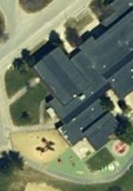

Prepared by:
Massachusetts Department of Public Health
Bureau of Environmental Health
Emergency Response/Indoor Air Quality Program
August 2007

Background/Introduction
At the request of Roger Raymond, Facilities Director, Sutton Public Schools, the Massachusetts Department of Public Health (MDPH), Center for Environmental Health (CEH), provided assistance and consultation regarding indoor air quality concerns at the Sutton Early Learning Center (SELC), 409 Boston Road, Sutton, Massachusetts. The request was prompted by concerns of water damage and potential mold growth due to chronic roof leaks and poor indoor air quality.
On May 3, 2007, a visit to conduct an assessment of the SELC was made by Cory Holmes an Environmental Analyst in BEH’s Emergency Response/Indoor Air Quality (ER/IAQ) Program. Mr. Holmes was accompanied by Jill Healy, Head Teacher and Mr. Raymond during the assessment. The SELC was originally constructed in 1973. The building was renovated in the late 1990s and an addition was added. Windows throughout the building are openable.

Methods
Air tests for carbon dioxide, carbon monoxide, temperature and relative humidity were conducted with the TSI, Q-TRAK™ IAQ Monitor, Model 8551. Air tests for airborne particle matter with a diameter less than 2.5 micrometers were taken with the TSI, DUSTTRAK™ Aerosol Monitor Model 8520. Screening for total volatile organic compounds (TVOCs) was conducted using a Thermo Environmental Instruments Inc., Model 580 Series Photo Ionization Detector (PID). MDPH staff also performed a visual inspection of building materials for water damage and/or microbial growth. Moisture content of porous building materials (e.g., gypsum wallboard (GW), ceiling tiles, insulation) was measured with Delmhorst, BD-2000 Model, Moisture Detector with a Delmhorst Standard Probe.

Results
The SELC houses approximately 485 pre-kindergarten through second grade students and approximately 100 staff members. Tests were taken during normal operations at the school. Results appear in Table 1.

Discussion

Ventilation
It can be seen from Table 1 that carbon dioxide levels were below 800 parts per million (ppm) in all areas surveyed, indicating adequate air exchange. Mechanical ventilation is supplied by air-handling units (AHUs) located in mechanical rooms. Fresh air is drawn into the AHUs through air intakes located on the exterior of the building. Ceiling or floor-mounted air diffusers distribute fresh, tempered air to the spaces. Return air is ducted back to the AHUs via wall or ceiling-mounted vents. These systems were operating during the assessment.
To maximize air exchange, the MDPH recommends that both supply and exhaust ventilation operate continuously during periods of school occupancy. In order to have proper ventilation with a mechanical supply and exhaust system, the systems must be balanced to provide an adequate amount of fresh air to the interior of a room, while removing stale air from the room. It is recommended that HVAC systems be re-balanced every five years to ensure adequate air systems function (SMACNA, 1994). The date of the last balancing was unknown at the time of the assessment.
The Massachusetts Building Code requires that each room have a minimum ventilation rate of 15 cubic feet per minute (cfm) per occupant of fresh outside air or openable windows (SBBRS, 1997; BOCA, 1993). The ventilation must be on at all times that the room is occupied. Providing adequate fresh air ventilation with open windows and maintaining the temperature in the comfort range during the cold weather season is impractical. Mechanical ventilation is usually required to provide adequate fresh air ventilation.
Carbon dioxide is not a problem in and of itself. It is used as an indicator of the adequacy of the fresh air ventilation. As carbon dioxide levels rise, it indicates that the ventilating system is malfunctioning or the design occupancy of the room is being exceeded. When this happens, a buildup of common indoor air pollutants can occur, leading to discomfort or health complaints. The Occupational Safety and Health Administration (OSHA) standard for carbon dioxide is 5,000 parts per million parts of air (ppm). Workers may be exposed to this level for 40 hours/week, based on a time-weighted average (OSHA, 1997).
The Department of Public Health uses a guideline of 800 ppm for publicly occupied buildings. A guideline of 600 ppm or less is preferred in schools due to the fact that the majority of occupants are young and considered to be a more sensitive population in the evaluation of environmental health status. Inadequate ventilation and/or elevated temperatures are major causes of complaints such as respiratory, eye, nose and throat irritation, lethargy and headaches. For more information concerning carbon dioxide, see Appendix A.
Temperature measurements ranged from 71º F to 78º F, which were within the MDPH recommended comfort range during the assessment (Table 1). The MDPH recommends that indoor air temperatures be maintained in a range of 70º F to 78º F in order to provide for the comfort of building occupants. In many cases concerning indoor air quality, fluctuations of temperature in occupied spaces are typically experienced, even in a building with an adequate fresh air supply.
The relative humidity measurements ranged from 15 to 31 percent during the assessment, which were below the MDPH recommended comfort range. The MDPH recommends a comfort range of 40 to 60 percent for indoor air relative humidity. Relative humidity levels in the building would be expected to drop during the winter months due to heating. The sensation of dryness and irritation is common in a low relative humidity environment. Low relative humidity is a very common problem during the heating season in the northeast part of the United States.

Microbial/Moisture Concerns
The building is reported to have chronic roof leaks, which was evidenced by repairs to seams and numerous patches (Pictures 1 through 3). MDPH staff examined the roof and found the roof surface to be rippled and bulging in various areas (Picture 4). Also observed were breaches in sealant around gymnasium/cafeteria skylights (Picture 5). These problems can eventually result in damage to the roof membrane and create breaches in the building envelope enhancing water penetration into the building.
Evidence of past and present roof leaks were observed in the form of damaged ceiling tiles, GW, insulation around ductwork, interior drainage systems and containers above ceiling tiles to collect leaks the building (Pictures 6 through 10). Active roof leaks were observed in the boiler room, which were being diverted by plastic sheeting into buckets. Not only are these leaks a potential source for mold growth but they should be considered a safety concern due to the presence of high voltage power equipment directly beneath leaks (Pictures 11 and 12).
Exposure to mold and related particulates can result in irritant symptoms, particularly in sensitive individuals (i.e. those with pre-existing conditions such as allergies, asthma and respiratory disease). At the time of the CEH assessment, visible mold growth was observed on GW in the hallway outside the music room and in the kitchen bathroom (Pictures 13 and 14), would necessitate its replacement.
In order for building materials to support mold growth, a source of water exposure is necessary (e.g., roof/plumbing leaks). Identification and elimination of water moistening building materials is necessary to control mold growth. Materials with increased moisture content over normal concentrations may indicate the possible presence of mold growth. CEH staff conducted moisture testing of porous building materials (e.g., GW, insulation, carpet) in a number of areas likely impacted by water infiltration. Elevated moisture measurements were recorded in GW in room 12 and in pipe insulation above the ceiling plenum in room 18/19 at the time of the assessment (Table 1/Pictures 15 and 16).
It is important to note that moisture content of materials is a real-time measurement of the conditions present in the building at the time of the assessment. Repeated water damage to porous building materials can result in microbial growth. The US Environmental Protection Agency (US EPA) and the American Conference of Governmental Industrial Hygienists (ACGIH) recommend that porous materials be dried with fans and heating within 24 to 48 hours of becoming wet (US EPA, 2001; ACGIH, 1989). If not dried within this time frame, mold growth may occur. Once mold has colonized porous materials, they are difficult to clean and should be removed.
Other IAQ Evaluations
Indoor air quality can be negatively influenced by the presence of respiratory irritants, such as products of combustion. The process of combustion produces a number of pollutants. Common combustion emissions include carbon monoxide, carbon dioxide, water vapor and smoke (fine airborne particle material). Of these materials, exposure to carbon monoxide and particulate matter with a diameter of 2.5 micrometers (μm) or less (PM2.5) can produce immediate, acute health effects upon exposure. To determine whether combustion products were present in the school environment, BEH staff obtained measurements for carbon monoxide and PM2.5.
Carbon monoxide is a by-product of incomplete combustion of organic matter (e.g., gasoline, wood and tobacco). Exposure to carbon monoxide can produce immediate and acute health affects. Several air quality standards have been established to address carbon monoxide and prevent symptoms from exposure to these substances. The MDPH established a corrective action level concerning carbon monoxide in ice skating rinks that use fossil-fueled ice resurfacing equipment. If an operator of an indoor ice rink measures a carbon monoxide level over 30 ppm, taken 20 minutes after resurfacing within a rink, that operator must take actions to reduce carbon monoxide levels (MDPH, 1997).
The American Society of Heating Refrigeration and Air-Conditioning Engineers (ASHRAE) has adopted the National Ambient Air Quality Standards (NAAQS) as one set of criteria for assessing indoor air quality and monitoring of fresh air introduced by HVAC systems (ASHRAE, 1989). The NAAQS are standards established by the US EPA to protect the public health from six criteria pollutants, including carbon monoxide and particulate matter (US EPA, 2006). As recommended by ASHRAE, pollutant levels of fresh air introduced to a building should not exceed the NAAQS levels (ASHRAE, 1989). The NAAQS were adopted by reference in the Building Officials & Code Administrators (BOCA) National Mechanical Code of 1993 (BOCA, 1993), which is now an HVAC standard included in the Massachusetts State Building Code (SBBRS, 1997). According to the NAAQS, carbon monoxide levels in outdoor air should not exceed 9 ppm in an eight-hour average (US EPA, 2006).
Carbon monoxide should not be present in a typical, indoor environment. If it is present, indoor carbon monoxide levels should be less than or equal to outdoor levels. On the day of assessment, outdoor carbon monoxide concentrations were non-detect (ND) (Table 1). Carbon monoxide levels measured in the school were ND (Table 1).
The US EPA has established NAAQS limits for exposure to particulate matter. Particulate matter is airborne solids that can be irritating to the eyes, nose and throat. The NAAQS originally established exposure limits to particulate matter with a diameter of 10 μm or less (PM10). According to the NAAQS, PM10 levels should not exceed 150 microgram per cubic meter (μg/m³) in a 24-hour average (US EPA, 2006). These standards were adopted by both ASHRAE and BOCA. Since the issuance of the ASHRAE standard and BOCA Code, US EPA proposed a more protective standard for fine airborne particles. This more stringent PM2.5 standard requires outdoor air particle levels be maintained below 35 μg/m³ over a 24-hour average (US EPA, 2006). Although both the ASHRAE standard and BOCA Code adopted the PM10 standard for evaluating air quality, MDPH uses the more protective proposed PM2.5 standard for evaluating airborne particulate matter concentrations in the indoor environment.
Outdoor PM2.5 concentrations were measured at 3 μg/m³, and indoor levels ranged from 3 to 9 μg/m³; both of which were below the NAAQS of 35 μg/m³ (Table 1). Frequently, indoor air levels of particulates can be at higher levels than those measured outdoors. A number of mechanical devices and/or activities that occur in schools can generate particulates during normal operation. Sources of indoor airborne particulate may include but are not limited to particles generated during the operation of fan belts in the HVAC system, cooking in the cafeteria stoves and microwave ovens; use of photocopiers, fax machines and computer printing devices, operating an ordinary vacuum cleaner and heavy foot traffic indoors.
Indoor air quality can also be negatively influenced by the presence of materials containing volatile organic compounds (VOCs). VOCs are carbon-containing substances that have the ability to evaporate at room temperature. Frequently, exposure to low levels of total VOCs (TVOCs) may produce eye, nose, throat and/or respiratory irritation in some sensitive individuals. For example, chemicals evaporating from a paint can stored at room temperature would most likely contain VOCs. In an effort to determine whether VOCs were present in the building, air monitoring for TVOCs was conducted during the assessment. An outdoor air sample was taken for comparison. Outdoor TVOC concentrations were ND (Table 1). Indoor TVOC concentrations were ND in all areas surveyed (Table 1).
In an effort to identify materials that can potentially increase indoor TVOC concentrations, BEH staff examined classrooms for products containing these respiratory irritants. The majority of classrooms contained dry erase boards and dry erase board markers. Materials such as dry erase markers and dry erase board cleaners may contain VOCs, such as methyl isobutyl ketone, n-butyl acetate and butyl-cellusolve (Sanford, 1999), which can be irritating to the eyes, nose and throat. Cleaning products were found in some classrooms. Like dry erase materials, cleaning products contain VOCs and other chemicals that can be irritating to the eyes, nose and throat of sensitive individuals.
Several personal fans and return/exhaust vents had accumulated dust and debris. Dust can be a source for eye and respiratory irritation. If exhaust vents are not functioning, backdrafting can occur and aerosolize dust particles. Personal fans with dust can serve to distribute particles once activated.
Finally of note was the amount of materials stored inside classrooms. In some classrooms items were observed on windowsills, tabletops, counters, univents, bookcases and desks. The stored materials in classrooms provide surfaces for dust to accumulate. Accumulation of these items (e.g., papers, folders, boxes) makes cleaning difficult for custodial staff.

Conclusions/Recommendations
Evidence of past and present roof leaks were observed in the form of water damaged ceiling tiles, insulation, interior drainage systems and containers both above and below the ceiling tile system to collect leaks throughout the building. In some cases water penetration has resulted in visible mold growth and/or elevated moisture levels measured in porous building materials, necessitating their replacement. Due to the scope of roof leaks and water damage observed throughout the building, the Sutton School Department should consider plans for school-wide roof replacement including the removal of historical “patches” intended for temporary repair.
In view of the findings at the time of the visit, the following recommendations are made:
- Until the roof can be replaced or repaired, school officials should continue working with their roofing contractor to making roof repairs as needed to prevent further water penetration.
- Discard/replace water-damaged/mold colonized porous materials (e.g., GW ceilings/walls, pipe insulation, fiberglass insulation in ceilings). This measure will remove actively growing mold colonies that may be present. This work should not be conducted at a time when occupants are present in the area. Once work is completed, ensure that the area is thoroughly cleaned and disinfected with an appropriate antimicrobial prior to reoccupancy. Dust and particulates generated from remediation activities should be vacuumed with a high efficiency particulate arrestance (HEPA) filtered vacuum cleaner.
- Conduct remediation activities in a manner consistent with recommendations in “Mold Remediation in Schools and Commercial Buildings” published by the US Environmental Protection Agency (US EPA, 2001). This document can be downloaded from the US EPA website: http://www.epa.gov/iaq/molds/mold_remediation.html.
- Due to the current condition of the roof, maintenance staff should continue to monitor the ceiling during heavy rains for active leaks. School occupants should also notify the main office if leaks are observed for prompt remediation.
- Empty buckets used to collect leaks regularly to prevent standing water, mold growth and associated odors. Clean and disinfect buckets and surface areas around leaks with an appropriate anti-microbial as needed.
- For buildings in New England, periods of low relative humidity during the winter are often unavoidable. Therefore, scrupulous cleaning practices should be adopted to minimize common indoor air contaminants whose irritant effects can be enhanced when the relative humidity is low. To control for dusts, a high efficiency particulate arrestance (HEPA) filter equipped vacuum cleaner in conjunction with wet wiping of all surfaces is recommended. Drinking water during the day can help ease some symptoms associated with a dry environment (throat and sinus irritations).
- Store cleaning products properly and out of reach of students.
- Relocate or consider reducing the amount of materials stored in classrooms to allow for more thorough cleaning. Clean items regularly with a wet cloth or sponge to prevent excessive dust build-up. To control for dusts, a HEPA filter equipped vacuum cleaner should be used.
- Clean exhaust/return vents and personal fans of accumulated dust periodically to prevent the aerosolization of dirt, dust and particulates.
- Consider adopting the US EPA (2000) document, “Tools for Schools”, to maintain a good indoor air quality environment in the building. This document can be downloaded from the Internet at http://www.epa.gov/iaq/schools/index.html.
- Refer to resource manuals and other related indoor air quality documents for additional building-wide evaluations and advice on maintaining public buildings. These materials are located on the MDPH’s website: http://www.state.ma.us/dph/MDPH/iaq/iaqhome.htm.
References
ACGIH. 1989. Guidelines for the Assessment of Bioaerosols in the Indoor Environment. American Conference of Governmental Industrial Hygienists, Cincinnati, OH.

ASHRAE. 1989. Ventilation for Acceptable Indoor Air Quality. American Society of Heating, Refrigeration and Air Conditioning Engineers. ANSI/ASHRAE 62-1989
BOCA. 1993. The BOCA National Mechanical Code/1993. 8th ed. Building Officials and Code Administrators International, Inc., Country Club Hill, IL
MDPH. 1997. Requirements to Maintain Air Quality in Indoor Skating Rinks (State Sanitary Code, Chapter XI). 105 CMR 675.000. Massachusetts Department of Public Health, Boston, MA.
OSHA. 1997. Limits for Air Contaminants. Occupational Safety and Health Administration. Code of Federal Regulations. 29 C.F.R 1910.1000 Table Z-1-A.
Sanford. 1999. Material Safety Data Sheet (MSDS No: 198-17). Expo® Dry Erase Markers Bullet, Chisel, and Ultra Fine Tip. Sanford Corporation. Bellwood, IL.
SBBRS. 1997. Mechanical Ventilation. State Board of Building Regulations and Standards. Code of Massachusetts Regulations. 780 CMR 1209.0.
SMACNA. 1994. HVAC Systems Commissioning Manual. 1st ed. Sheet Metal and Air Conditioning
US EPA. 2006. National Ambient Air Quality Standards (NAAQS). US Environmental Protection Agency, Office of Air Quality Planning and Standards, Washington, DC. http://www.epa.gov/air/criteria.html.
US EPA. 2001. “Mold Remediation in Schools and Commercial Buildings”. Office of Air and Radiation, Indoor Environments Division, Washington, DC. EPA 402-K-01-001. March 2001. Available at: http://www.epa.gov/iaq/molds/mold_remediation.html
US EPA. 2000. Tools for Schools. Office of Air and Radiation, Office of Radiation and Indoor Air, Indoor Environments Division (6609J). EPA 402-K-95-001, Second Edition. http://www.epa.gov/iaq/schools/tools4s2.html

Picture 1

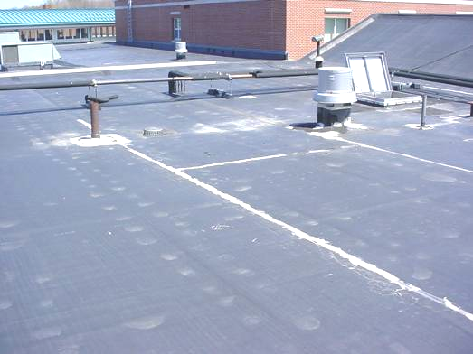

Roof Patches and Seam Repair as Indicated by Light Shaded Areas

Picture 2

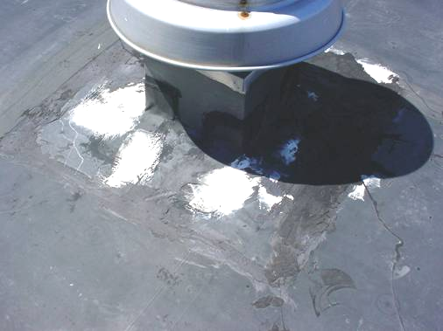

Roof Patches and Seam Repair as Indicated by Light Areas

Picture 3

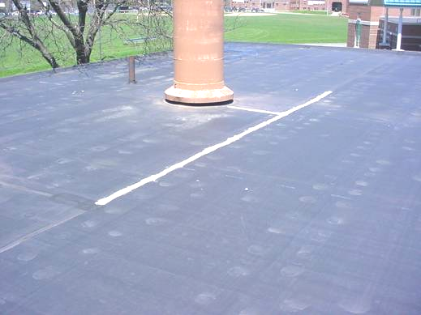

Roof Patches and Seam Repair as Indicated by Light Areas
Picture 4

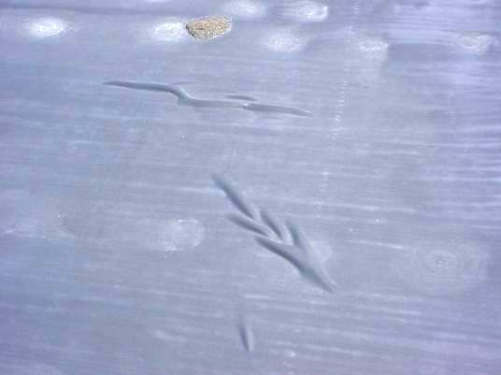

Rippling Roof Membrane
Picture 5

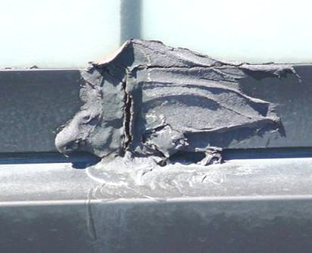

Open Seam in Sealant Rooftop/Cafeteria/Gym Window System

Picture 6

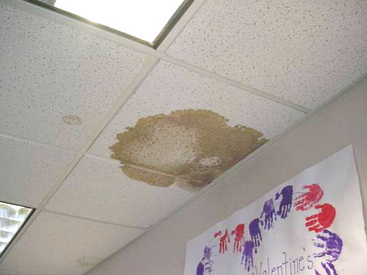

Water Damaged Ceiling Tile
Picture 7

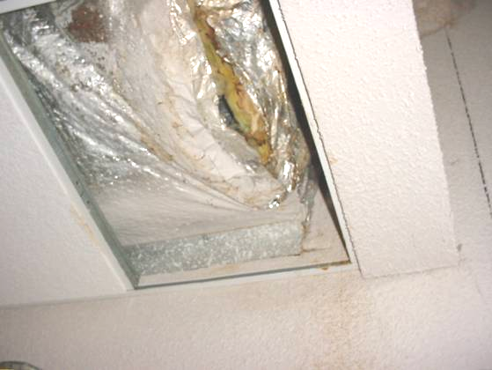

Water Damaged Insulation

Picture 8

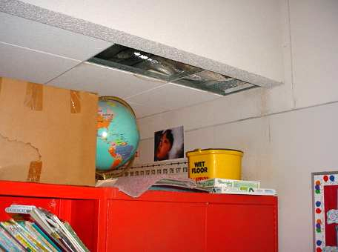

Missing/Water Damaged Ceiling Tiles, Note Water Stains on Wall and Bucket to Catch Leaks
Picture 9

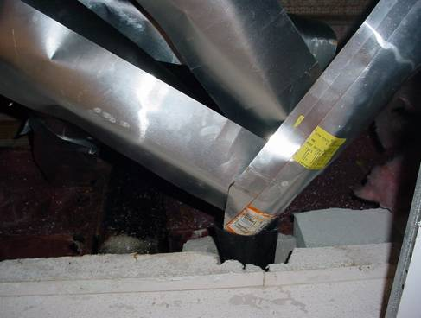

Improvised Drainage System Made of Sheet-Metal above Ceiling Tile System in Music Room to Divert Water into Plastic Container

Picture 10

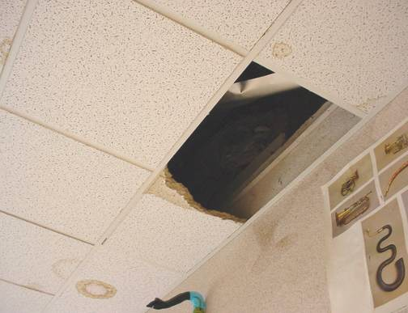

Water Damaged Ceiling Tiles and Water Stains on Wall of Classroom
Picture 11

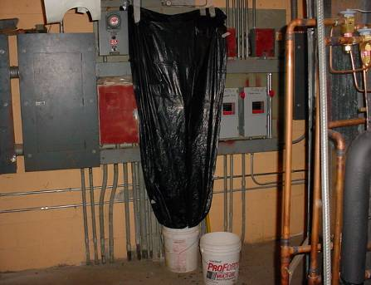

Active Roof Leak in Boiler Room, Note Leak is Directly above High Voltage Power Panels

Picture 12

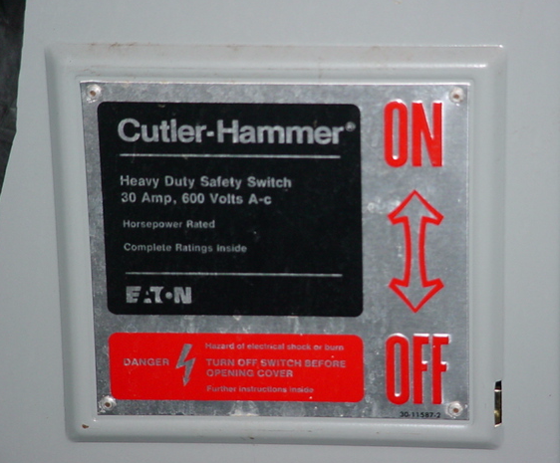

High Voltage Power Panel near Roof Leak in Boiler Room
Picture 13

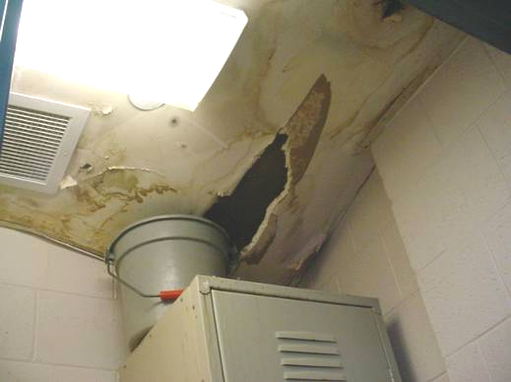

Water Damaged/Mold Colonized GW in Kitchen Bathroom

Picture 14

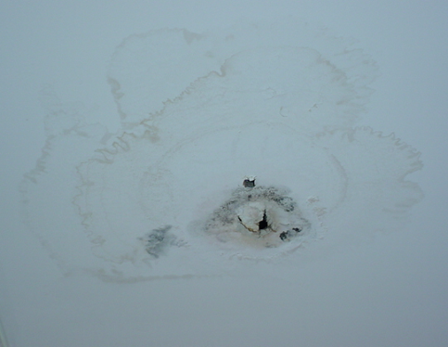

Water Damaged/Mold Colonized GW in Hallway near Music Room
Picture 15

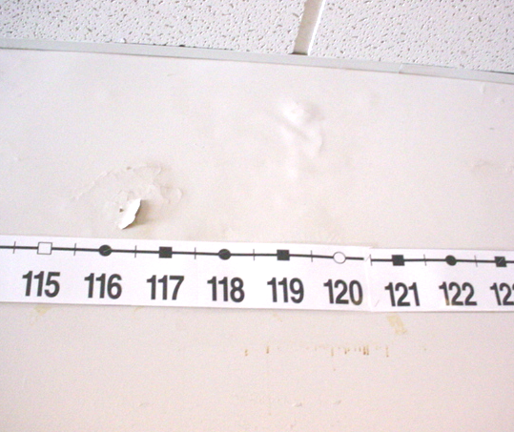

Wet/Water Damaged GW in Room 12, Note Water Stains and Peeling Paint

Picture 16

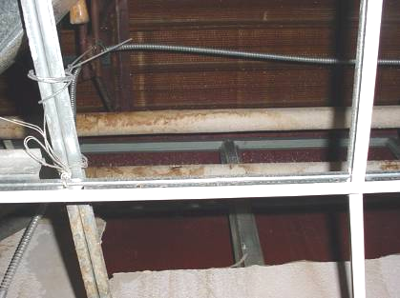

Wet Pipe Insulation above Ceiling in Room 18/19
Location/ Room | Occupants  in Room | Temp  (°F) | Relative  Humidity  (%) | Carbon  Dioxide  (ppm) | Carbon Monoxide  (ppm) | TVOCs  (ppm) | PM2.5  (µg/m3) | Windows  Openable | Ventilation |  | Remarks
 |  |  |  |  |  |  |  |  | Supply | Exhaust | Remarks
Background |  | 61 | 23 | 386 | ND | ND | 3 |  |  |  | Clear, sunny, warm
Auditorium | 0 | 71 | 31 | 644 | ND | ND | 4 |  | Y | Y | WD CP
Music | 21 | 74 | 26 | 703 | ND | ND | 4 |  | Y | Y | I CT left out due to reoccurring leaks, drainage system above ceiling to collect water, water damaged insulation, DEM
Therapy room 1 | 1 | 75 | 24 | 689 | ND | ND | 3 |  | Y | Y | 5 CT, DEM
Therapy room 2 | 2 | 76 | 23 | 724 | ND | ND | 3 |  | Y | Y
1 | 7 | 74 | 23 | 663 | ND | ND | 3 |  | Y | Y | WD GW-low (e.g., normal moisture)
2 | 6 | 78 | 23 | 680 | ND | ND | 3 | Y | Y | Y
Speech | 2 | 74 | 24 | 690 | ND | ND | 3 | Y | Y | Y | Window open, DEM
8 | 7 | 74 | 23 | 690 | ND | ND | 3 |  | Y | Y | DEM, PF, 3 WD CT
11 | 0 | 73 | 17 | 560 | ND | ND | 4 |  | Y | Y | DEM, 20 occupants at lunch, 1 CT
6 | 25 | 73 | 17 | 512 | ND | ND | 4 |  | Y | Y | DEM
7 | 24 | 73 | 18 | 543 | ND | ND | 4 | Y | Y | Y | Exhaust-weak, DEM
Tech Dir Office | 1 | 76 | 24 | 706 | ND | ND | 6 |  | Y | Y
3 | 4 | 76 | 22 | 626 | ND | ND | 4 | Y |  |  | 8 WD CT, window AC
4 | 0 | 73 | 17 | 518 | ND | ND | 4 |  | Y | Y | DO, DEM, occupants gone 10 mins
5 | 25 | 73 | 19 | 552 | ND | ND | 3 | Y | Y | Y | Accumulated items
14 | 1 | 74 | 18 | 599 | ND | ND | 7 |  | Y | Y | 24 occupants gone 7 mins, DEM, 2 WD CT, DO
16 | 3 | 74 | 18 | 537 | ND | ND | 3 | Y | Y | Y | DEM, 34 occupants gone 5 mins, WD insulation & GW-low moisture
Sped Office Director | 1 | 71 | 18 | 530 | ND | ND | 5 |  |  |  | GW-low moisture  CT-low moisture, roof drain-leak-beam above CT-condensation
Sped | 0 | 75 | 21 | 631 | ND | ND | 4 |  | Y | Y | DO, dusty vents, PC
10 | 0 | 76 | 18 | 560 | ND | ND | 7 |  | Y | Y | DO, 20 occupants at lunch, 1 WD CT
9 | 0 | 76 | 22 | 685 | ND | ND | 3 |  | Y | Y | 24 occupants gone 10 mins, DEM
13 | 0 | 76 | 20 | 704 | ND | ND | 4 | Y | Y | Y | 4 WD CT, 23 occupants gone 15 mins, windows open
12 | 1 | 76 | 21 | 603 | ND | ND | 5 | Y | Y | Y | 21 occupants gone 15 mins, GW-elevated/high moisture
Cafeteria/  Gym | 50 | 73 | 19 | 611 | ND | ND | 5 | Y | Y | Y | 10 WD CT, leak under roof drain
Teachers Lounge | 5 | 73 | 18 | 562 | ND | ND | 3 |  | Y | Y | 5 WD CT
20 | 0 | 74 | 15 | 511 | ND | ND | 5 |  | Y | Y | DEM, 6 WD CT
Science Room | 16 | 74 | 17 | 553 | ND | ND | 5 |  | Y | Y | DO, 6 WD CT
Main Gym Café | 100 | 73 | 25 | 796 | ND | ND | 9 |  | Y | Y | Leak in storage/office, visible mold growth in kitchen bathroom
18/19 | 0 | 71 | 21 | 574 | ND | ND | 3 |  | Y | Y | Leak near interior wall, WD GW-low moisture, pipe insulation-elevated moisture-rec removal, section of GW removed-no visible mold in wall cavity
Boiler Room |  |  |  |  |  |  |  |  |  |  | Active leaks-directly over electrical panels-covered with plastic and directed into buckets
14 | 24 | 72 | 19 | 620 | ND | ND | 5 |  | Y | Y | DEM
Main Office | 2 | 74 | 24 | 702 | ND | ND | 3 |  | Y | Y | WD carpet-low moisture,  WD GW-low moisture

