INDOOR AIR QUALITY ASSESSMENT

Sutton Elementary School
407 Boston Road
Sutton, Massachusetts

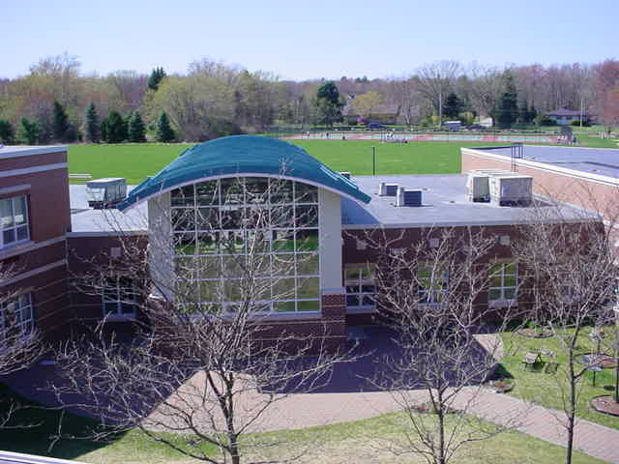

Prepared by:
Massachusetts Department of Public Health
Bureau of Environmental Health
Indoor Air Quality Program
December 2019

Background

Building: | Sutton Elementary School (SES)
Address: | 407 Boston Road, Sutton, Massachusetts
Assessment Requested by: | Roger Raymond, Facility Manager, Sutton Public Schools
Reason for Request: | General indoor air quality (IAQ) concerns, with a focus on odors and chronic moisture, mainly in rooms surrounding the courtyard.
Date of Assessment: | September 26, 2019
Massachusetts Department of Public Health/Bureau of Environmental Health (MDPH/BEH) Staff Conducting Assessment: | Mike Feeney, Director, IAQ Program
Building Description: | SES is a combination one and two-story, multi wing, red brick building. The school is built on a concrete slab and contains grades 3-5 with an enrollment of 313 and staff of approximately 60. Most areas have tile floors and suspended ceiling tile systems.
Windows: | Openable

Methods
Please refer to the IAQ Manual and appendices for methods, sampling procedures, and interpretation of results (MDPH, 2015).

IAQ Testing Results
The following is a summary of indoor air testing results (Table 1).
- Carbon dioxide levels were below the MDPH guideline of 800 parts per million (ppm) in all but one area, indicating adequate air exchange.
- Temperature was within or close to the MDPH recommended range of 70°F to 78°F the day of the assessment.
- Relative humidity was at the high end or above of the MDPH recommended comfort range of 40 to 60% on the day of assessment. It is important to note that three quarters of areas measured had relative humidity above the outdoor measurement (56%), which may indicate:
  - poor exhaust ventilation, and/or
  - a source of water vapor in or drawn into classrooms.
- Carbon monoxide levels were non-detectable (ND) in all areas tested.
- Fine particulate matter (PM2.5) concentrations measured were below the National Ambient Air Quality (NAAQS) limit of 35 μg/m³ in all areas tested.

Ventilation
A heating, ventilating and air conditioning (HVAC) system has several functions. First it provides heating and, if equipped, cooling. Second, it is a source of fresh air. Finally, an HVAC system will dilute and remove normally-occurring indoor environmental pollutants by not only introducing fresh air, but by filtering the airstream and ejecting stale air to the outdoors via exhaust ventilation. Even if an HVAC system is operating as designed, point sources of respiratory irritation may exist and cause symptoms in sensitive individuals.
The HVAC system consists of unit ventilators controlled by a computerized system. Univents draw air from the outdoors through a fresh air intake located on the exterior wall of the building and return air through an air intake located at the base of the unit. Fresh and return air are mixed, filtered, heated or cooled and provided to rooms through an air diffuser located in the top of the unit (Figure 1). In some rooms items were on top or in front of univents, which can interfere with air circulation. Exhaust ventilation is provided by ceiling-mounted vents ducted to rooftop motors. Without proper supply and exhaust ventilation, common indoor air pollutants can build up (e.g., carbon dioxide) and lead to IAQ/comfort complaints.
The HVAC system controls include a carbon dioxide sensor system to control the amount of fresh air into the building. The system has reportedly been in use for approximately 4 years, and the controls are set for 800 ppm, which is the carbon dioxide level recommended by MDPH. However, it is important to note that these systems need to be regularly maintained/calibrated in accordance with manufacturer’s instructions to ensure proper function.

Microbial/Moisture Concerns
Odors were reported by SES school staff and also detected during the assessment (Table 1). Odors were particularly reported in classrooms with exterior walls facing the interior courtyard. IAQ staff examined the exterior walls of the courtyard and found conditions in the courtyard and courtyard exterior walls which are the likely source of the reported odors.
Note that the relative humidity inside the building was found to be 2-10 percent higher than outdoor relative humidity measurements on the day of the assessment. In the experience of IAQ staff, one source of increased indoor relative humidity is a lack of exhaust ventilation, since exhaled water vapor from building occupants is not vented from the building by the HVAC system. Another possible source of increased water vapor is conditions within the interior courtyard. This courtyard is configured such that a micro-environment is created where a temperature inversion may exist to trap water vapor in the courtyard. This excess humidity would then be drawn into the building through the univents that face the courtyard, as discussed in the sections below.

Temperature inversion conditions
A Temperature Inversion is defined as “a layer of the atmosphere in which air temperature increases with height. When the layer's base is at the surface, the layer is called a surface-based temperature inversion; when the base of the layer is above the surface, the layer is called an elevated temperature inversion.” (NOAA, 2009) In general, outdoor air temperature decreases with height from the ground. Temperature inversion occurs when warmer air forms a layer above cooler air. This condition will trap materials such as particles and vapors, since these materials can no longer be drawn upward and disperse. Areas that have an abrupt change in ground altitudes can be prone to temperature inversion, such as valley between mountains. A small, artificial, temperature inversion micro-environment may exist in the interior courtyard of the SES. Air and various pollutants will become trapped inside the courtyard when a breeze with a warmer air temperature passes over the roof.
Due to the lack of adequate water drainage within the courtyard, water that does not drain evaporates to become water vapor trapped within the courtyard. This trapped water vapor can then be captured by univents, and drawn into the building. Poor drainage in the courtyard can also lead to odors that can be drawn by univents or enter classrooms through open windows.

Building exterior conditions
The exterior of the building and courtyard were examined for conditions that may lead to water infiltration and the following was found:
- Clinging plants hold moisture against the building and can damage exterior brick/mortar and lead to water infiltration;
- Plants were near air intakes in some areas, which can be a source of pollen and moisture into the building when these intakes are in use;
- Tree branches in close proximity to exterior walls, which can lead to damage to roofing materials or clogged univent intakes (discussed further below);
- Mulch against exterior walls (Picture 1), which can hold moisture against walls and provide harborage for pests; and
- Clogged weep holes, which prevent drainage from the wall interstices.

Exterior wall construction
It is important to note that the SES is built on a slab with exterior curtain walls that have weep holes. In order to explain how water penetration occurs through exterior wall systems, the following concepts concerning moisture and wall systems must be understood:
- Brick, cement and mortar contain water, which allows moisture movement through these materials;
- Wind driven rains increase water penetration through brick, cement and mortar;
- Gravity will direct water in a building towards the ground; and
- Brick, cement and mortar must dry in a timely fashion to prevent microbial growth.
Modern exterior wall systems should be designed to prevent moisture penetration into the building through the use of a drainage plane within the wall system to redirect water outdoors and allow for building components to dry (Figure 2), including the following components (Dalzell, 1955):
- An exterior curtain wall forming the outer cladding of the building.
- Behind the curtain wall is an air space that allows for water to drain downward and allow for the exterior cladding system to dry.
- Holes at the base of the curtain wall that allow for water drainage (called weep holes).
- Opposite the exterior wall, across the air space, is a continuous, water-resistant material adhered to a wall (the backup wall) which forms the drainage plane. The purpose of the drainage plane is to prevent moisture that crosses the air space from penetrating into the building interior and to direct that moisture downward to the weep holes. The drainage plane can consist of a number of water-resistant materials, such as tarpaper or in newer buildings, plastic wraps. The drainage plane should be continuous.
- Where breaks exist in the drainage plane (e.g., window systems, door systems, and univent fresh air intakes), the penetrations have materials added (e.g. copper flashing) to direct water to weep holes.
- Ground at the base of curtain walls should either have a slope away from its base or have a drainage system to readily remove water to prevent pooling.
If the drainage plane is discontinuous, missing flashing, or lacking air space, rainwater may accumulate inside the wall cavity and lead to moisture penetration into the building. In addition, if weep holes are subjected to water penetration or are blocked (e.g. by mulch), weep holes will not aid in drying the curtain wall and would then expose the interior side of the curtain wall to moisture (Figure 3). If water exists behind a curtain wall, the moisture can freeze to cause damage to the base of the drainage plane to cause cracks that would allow for water penetration into the building.

Drainage issues
Both the library exterior wall and the courtyard appear to have drainage problems, allowing water to enter weep holes. Of particular note is landscaping around the outside of the building and inside the enclosed courtyard. Reportedly, the landscaping around exterior walls was redone after the school was built to incorporate an elevated football field. Runoff from the field and adjacent road appear to pool against the library exterior wall to drown the weep holes. SES staff report that the library experiences wet carpeting during extreme heavy rains and snow melt. Without appropriate land contouring to promote water drainage away from exterior walls, or an underground drainage system, slab and weep holes are regularly exposed to rainwater/snow melt.
An area particularly susceptible to weep hole inundation is the interior courtyard. In general, enclosed courtyards should be designed in a manner to readily drain water to prevent pooling. In general multiple drains and/or a bowl shape to drain water away from exterior walls in highly recommended to draw water away from walls and to prevent pooling of stagnant water to prevent mosquito breeding. Instead of a bowl shape, the SES interior courtyard has a hill topped by trees (Picture 2). This shape promotes water drainage toward the walls of the courtyard. Signs of excessive moisture exposure exist around the courtyard hill including moss growth on paving bricks (Picture 3). Given these conditions, walls can become chronically moistened and may be subject to deterioration. Odors from moistened organic material may also lead to odors in classrooms via univents and open windows.
In addition, over time, poor drainage conditions can undermine the integrity of the building envelope and provide a means of water entry into the building via capillary action through foundation concrete and masonry (Lstiburek & Brennan, 2001). The freezing and thawing action of water during the winter months can create cracks and fissures in the foundation, slab and/or curtain wall/drainage. These breaches may also provide a means for pests/rodents to enter the building.
Areas of wall in the courtyard appear to be missing sealant (Picture 4). Sealant is used to prevent water penetration through seams in walls or adjacent dissimilar building materials (e.g., brick and cement). Without continuous sealant, water may enter through the gap in exterior walls.
Some windows appear to have filled in drip grooves (Pictures 5 and 6). The purpose of a drip groove is to prevent water from accumulating in the joint of the underside of the window and exterior wall. Without a drip groove, water may penetrate through this joint to cause moistening of adjacent interior walls.
As noted previously, several trees exist in the enclosed courtyard in close proximity to exterior walls and window. These trees pose a number of hazards to the SES:
- The trees prevent sunlight from drying exterior walls.
- The trees are a possible danger to the SES due to distance from its exterior walls. The recommended safe distance from which an oak tree should be planted is recommended to be approximately the height of the tree to the exterior wall. Soil subsidence may also be caused by tree roots, which can undermine the structure of a building to cause wall and floor cracking as well as other related damage. Within this height growth maximum, severe weather may result in the trees falling onto the SES.
- Also of note is resistance of the trees to uprooting during high wind events. In general a tree root system will spread out in all directions from its trunk. Any structure disrupting the root structure would then make the tree unstable if subjected to high winds from a certain direction. The brick installed inside the courtyard can disrupt the tree’s root system.
- Deciduous trees drop leaves into the courtyard. Univent fresh air intakes can be blocked by fallen leaves, which are also a medium for fungal growth.
- Other plants were noted growing against courtyard walls (Picture 7), which in turn, prevent exterior wall drying which can lead to brick and mortar degradation.
In addition, the Federal Emergency Management Agency (FEMA) provides a number of recommendations in order to prepare for severe thunderstorms. Of note FEMA recommends “Cut down or trim trees that may be in danger of falling on your [building]” (FEMA, 2018). Given the proximity to the trees to the SES, removal of the trees should be strongly considered.

Other IAQ Evaluations
Exposure to low levels of total volatile organic compounds (TVOCs) may produce eye, nose, throat, and/or respiratory irritation in some sensitive individuals. To determine if VOCs were present, BEH/IAQ staff examined rooms for products containing VOCs. BEH/IAQ staff noted hand sanitizers, scented cleaners, air fresheners, and dry erase materials in use within the building. All of these products have the potential to be irritants to the eyes, nose, throat, and respiratory system of sensitive individuals (e.g., asthmatics).
In many areas, accumulated items including books, papers, and decorative items were observed on floors, windowsills, tabletops, counters, bookcases, and desks. Excess items on surfaces can make it more difficult for custodial staff to clean. Items should be stored neatly (e.g., shelves, totes) and moved periodically to allow wet wiping of surfaces.
Note that the Environmental Protection Agency (EPA) conducted a National School Radon Survey in which it discovered nearly one in five schools had “…at least one frequently occupied ground contact room with short-term radon levels above 4 [picocuries per liter] pCi/L” (US EPA 1993). The BEH/IAQ Program therefore recommends that every school be tested for radon, and that this testing be conducted during the heating season while school is in session in a manner consistent with US EPA radon testing guidelines. Radon measurement specialists and other information can be found at www.nrsb.org and http://aarst-nrpp.com/wp, with additional information at: http://www.mass.gov/eohhs/gov/departments/dph/programs/environmental-health/exposure-topics/iaq/radon.

Conclusions/Recommendations
The conditions related to IAQ problems at the SES raise a number of issues. Some of these conditions can be remedied by actions of building occupants. Other remediation efforts will require alteration to the building structure and equipment. For these reasons, a two-phase approach is recommended. The first consists of short-term measures to improve air quality and the second consists of long-term measures that will require capital planning and resources to adequately address overall conditions:

Short Term Recommendations
- Operate all supply and exhaust ventilation equipment continuously during occupied hours.
- Remove obstructions from the top and front of univents.
- Ensure carbon dioxide sensors for computer controls are maintained, calibrated and/or replaced as recommended by the manufacturer.
- Use openable windows to supplement fresh air during temperate weather. Ensure all windows are tightly closed at the end of the day.
- Check return and exhaust vents for draw periodically and repair any non-operating motors/vents.
- Consider adopting a balancing schedule of every 5 years for all mechanical ventilation systems, as recommended by ventilation industrial standards (SMACNA, 1994).
- Ensure filters for univents and air handling units are changed a minimum of twice a year, or more often if possible. Vacuum out univent and AHU cabinets during filter changes to remove dust and debris. The MDPH recommends using pleated filters of Minimum Efficiency Reporting Value (MERV) of 8, which are adequate in filtering out pollen and mold spores (ASHRAE, 2012), if these can be used with current equipment.
- Trim outdoor plants/shrubs etc. to five feet away from the foundation and away from air intakes.
- Remove clinging plants from exterior brick. Trim trees/ branches from close proximity to walls.
- Clear accumulated leaves/debris and mulch from weep holes/against building.
- Repoint brickwork as needed.
- Repair/replace sealant for wall joints.
- Repair flashing to maintain a continuous drainage plain for exterior walls.
- Repair drip grooves in the exterior of windowsills, or otherwise outfit sills with the ability to shed water.
- Repair/replace any water-damaged materials on the interior of the building, including library carpet, in accordance with EPA guidance (US EPA 2008).
- Consider utilizing portable dehumidifiers as needed during excessive relative humidity periods (>70%). Ensure dehumidifiers are cleaned/maintained as per the manufacturer’s instructions to prevent mold/bacterial growth.
- Properly maintain indoor plants, including drip pans, to prevent water damage to porous materials. Plants should also be located away from air diffusers to prevent the aerosolization of dirt, pollen, and mold.
- Reduce the use of products and equipment that contain VOCs and eliminate the use of scented products such as air fresheners, reed diffusers and similar products. Ensure only school-supplied cleaning products are used in the building and that they are used in accordance with package instructions, including any need for dilution or ventilation.
- Regularly clean supply/return/exhaust vents and fans to avoid aerosolizing accumulated particulate matter.
- Consider reducing the amount of items stored in rooms to make cleaning easier. Periodically move items to clean flat surfaces. Store porous items on shelving and away from walls.
- For buildings in New England, periods of low relative humidity during the winter are often unavoidable. Therefore, scrupulous cleaning practices should be adopted to minimize common indoor air contaminants whose irritant effects can be enhanced when the relative humidity is low. To control dusts, a high efficiency particulate arrestance (HEPA) filter equipped vacuum cleaner in conjunction with wet wiping of all surfaces is recommended. Avoid the use of feather dusters. Drinking water during the day can help ease some symptoms associated with a dry environment (throat and sinus irritations).
- HEPA vacuum carpeting daily and clean carpeting annually (or semi-annually in soiled high traffic areas). Clean area rugs similarly.
- The school should be tested for radon by a certified radon measurement specialist during the heating season when school is in session. Radon measurement specialists and other information can be found at: www.rsb.org, and http://aarst-nrpp.com/wp.
- Consider adopting the US EPA (2000) document, “Tools for Schools”, as an instrument for maintaining a good IAQ environment in the building available at: http://www.epa.gov/iaq/schools/index.html
- Refer to resource manual and other related IAQ documents located on the MDPH’s website for further building-wide evaluations and advice on maintaining public buildings. These documents are available at: http://mass.gov/dph/iaq.

Long Term Recommendations
- Consider completely removing trees from the enclosed courtyard.
- Examine the feasibility of removing the hill in the enclosed courtyard and re-grading the soils to form a bowl-like configuration to promote water drainage away from exterior courtyard walls.
- Consider other options for improving drainage in the courtyard.
- Consider re-grading the ground above the library to promote water drainage away from the exterior wall. This may include:
  - The installation of curbs on the asphalt driveway.
  - Installing a drainage ditch lower than the slab between the building and the asphalt driveway.
  - Install a below-ground drainage system (e.g., French drain).

References
ASHRAE. 2012. American Society of Heating, Refrigeration and Air Conditioning Engineers (ASHRAE) Standard 52.2-2012 -- Method of Testing General Ventilation Air-Cleaning Devices for Removal Efficiency by Particle Size (ANSI Approved).
Dalzell, J.R. 1955. Simplified Masonry Planning and Building. McGraw-Hill Book Company, Inc. New York, NY.
FEMA. 2018. How to Stay Safe When a Thunderstorm Threatens. Federal Emergency Management Agency, Washington, DC. FEMA V-1009/May 2018.
Lstiburek, J. & Brennan, T. 2001. Read This Before You Design, Build or Renovate. Building Science Corporation, Westford, MA. U.S. Department of Housing and Urban Development, Region I, Boston, MA.
MDPH. 2015. Massachusetts Department of Public Health. “Indoor Air Quality Manual: Chapters I-III”. Available at: http://www.mass.gov/eohhs/gov/departments/dph/programs/environmental-health/exposure-topics/iaq/iaq-manual/.
NOAA. 2009. Temperature Inversion. https://w1.weather.gov/glossary/index.php?word=temperature+inversion
SMACNA. 1994. HVAC Systems Commissioning Manual. 1st ed. Sheet Metal and Air Conditioning Contractors’ National Association, Inc., Chantilly, VA.
US EPA. 1993. Radon Measurement in Schools, Revised Edition. Office of Air and Radiation, Office of Radiation and Indoor Air, Indoor Environments Division (6609J). EPA 402-R-92-014. https://www.epa.gov/sites/production/files/2014-08/documents/radon_measurement_in_schools.pdf
US EPA. 2000. Tools for Schools. Office of Air and Radiation, Office of Radiation and Indoor Air, Indoor Environments Division (6609J). EPA 402-K-95-001, Second Edition. http://www.epa.gov/iaq/schools/index.html.
US EPA. 2008. “Mold Remediation in Schools and Commercial Buildings”. Office of Air and Radiation, Indoor Environments Division, Washington, DC. EPA 402-K-01-001. September 2008. Available at: http://www.epa.gov/mold/mold-remediation-schools-and-commercial-buildings-guide.
Picture 1
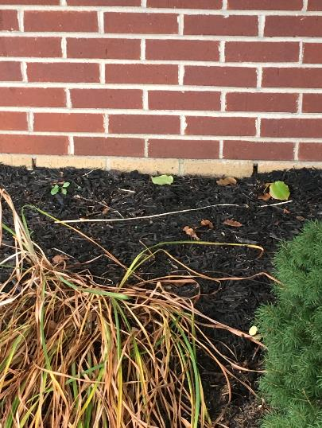
Mulch against exterior walls, burying weep holes
Picture 2
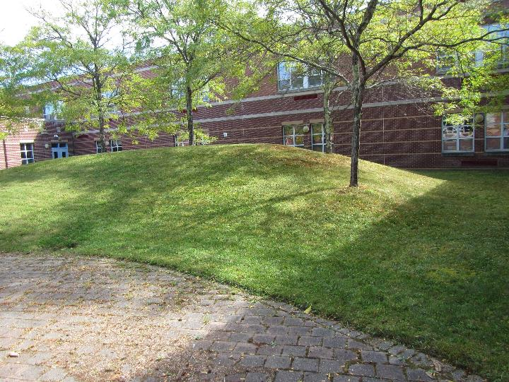
Hill topped by trees in courtyard
Picture 3
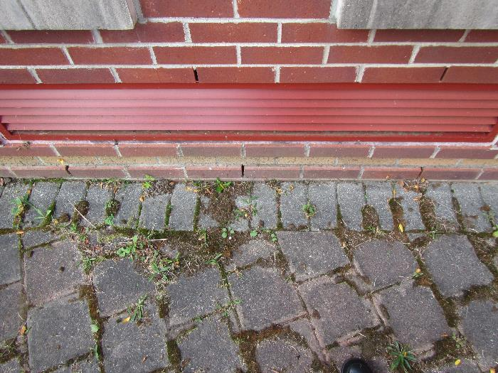
Moss growth indicates heavy and chronic dampening of brick and soil (Note univent fresh air intake above dampened area)
Picture 4
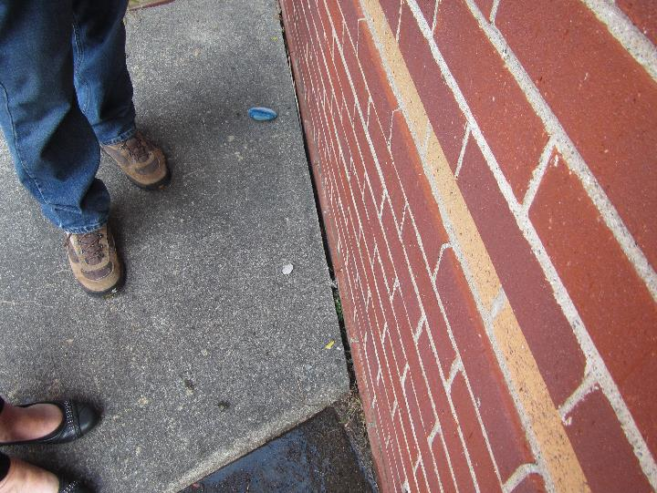
Seam missing sealant
Picture 5
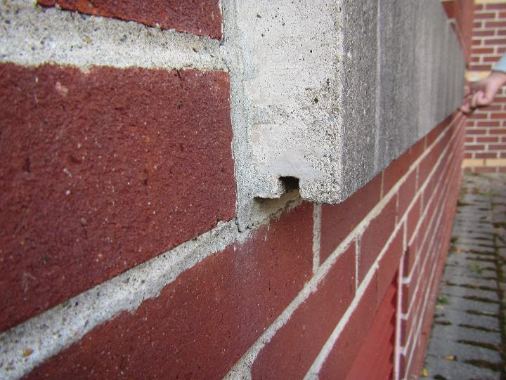
Windowsill drip groove
Picture 6
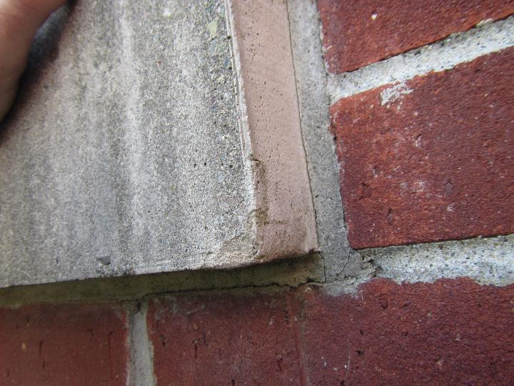
Sill with missing or filled-in window sill drip groove
Picture 7
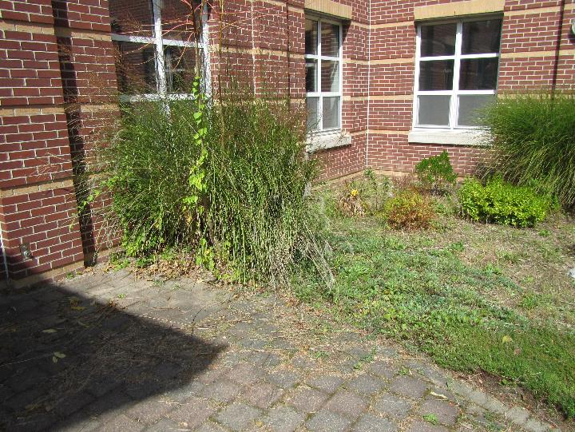
Plants in contact with exterior wall

Location | Carbon  Dioxide  (ppm) | Carbon Monoxide  (ppm) | Temp  (°F) | Relative  Humidity  (%) | PM2.5  (µg/m³) | Occupants  in Room | Windows  Openable | Ventilation |  | Remarks
 |  |  |  |  |  |  |  | Supply | Exhaust
Background | 384 | ND | 77 | 56 | 9
101 | 800 | ND | 70 | 63 | 8 | 20+ | Y | Y | Y | Odor
Planning | 502 | ND | 75 | 51 | 11 | 0 | Y | Y | Y
102 | 529 | ND | 73 | 54 | 6 | 0 | Y | Y | Y
103 | 515 | ND | 73 | 56 | 7 | 0 | Y | Y | Y | 2 WD CT – diffuser
104 | 509 | ND | 71 | 52 | 6 | 0 | Y | Y | Y | Odor
105 | 530 | ND | 70 | 60 | 9 | 0 | Y | Y | Y
106 | 549 | ND | 71 | 58 | 9 | 0 | Y | Y | Y | 4 WD CT
107 | 429 | ND | 71 | 58 | 7 | 0 | Y | Y | Y
Band room | 749 | ND | 71 | 62 | 6 | 30+ | Y | Y | Y | carpet
Library | 508 | ND | 72 | 59 | 5 | 2 | Y | Y | Y
108 | 476 | ND | 72 | 59 | 15 | 3 | Y | Y | Y
109 | 458 | ND | 72 | 60 | 10 | 0 | Y | Y | Y
111 | 717 | ND | 71 | 59 | 15 | 20 | Y | Y | Y
112 | 453 | ND | 71 | 61 | 8 | 16 | Y open | Y | Y
113 | 975 | ND | 71 | 66 | 6 | 25 | Y | Y | Y | 2 WD CT
115 | 520 | ND | 69 | 60 | 11 | 3 | Y | Y | Y | Strong odor
117 | 466 | ND | 69 | 65 | 9 | 0 | Y | Y | Y | Odor
118 | 509 | ND | 73 | 60 | 7 | 20 | Y | Y | Y
119 | 478 | ND | 69 | 63 | 8 | 0 | Y | Y | Y

