INDOOR AIR QUALITY ASSESSMENT

Sutton Elementary School
407 Boston Road
Sutton, Massachusetts

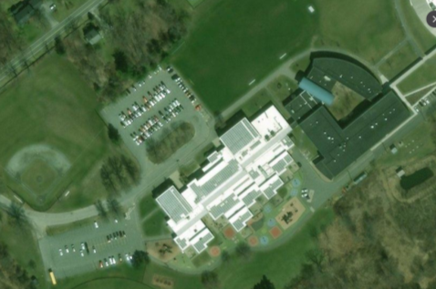

Prepared by:
Massachusetts Department of Public Health
Bureau of Environmental Health
Indoor Air Quality Program
November 2018

BACKGROUND
Building: | Sutton Elementary School (SES)
Address: | 407 Boston Road, Sutton, Massachusetts
Assessment Requested by: | Roger Raymond, Facility Manager, Sutton Public Schools
Reason for Request: | General indoor air quality (IAQ) concerns, with a focus on water damage/mold, mainly in rooms surrounding the courtyard.
Date of Assessment: | October 23, 2018
Massachusetts Department of Public Health/Bureau of Environmental Health (MDPH/BEH) Staff Conducting Assessment: | Cory Holmes, Environmental Analyst/Inspector IAQ Program
Date of Building Construction: | 1999
Building Description: | SES is a combination one and two-story, multi wing, red brick building. The school is built on a concrete slab and contains grades 3-5 with an enrollment of 313 and staff of approximately 60. Most areas have tile floors and suspended ceiling tile systems.
Windows: | Openable

METHODS
Please refer to the IAQ Manual and appendices for methods, sampling procedures, and interpretation of results (MDPH, 2015).

RESULTS and DISCUSSION
The following is a summary of indoor air testing results (Table 1).
- Carbon dioxide levels were above the MDPH recommended level of 800 parts per million (ppm) in about half the areas surveyed, which can indicate a lack of air exchange at the time of assessment. It is also important to note that several classrooms had low/no occupancy, which can reduce carbon dioxide levels.
- Temperature was within or very close to the MDPH recommended range of 70°F to 78°F in areas tested.
- Relative humidity was within or close to the MDPH recommended range of 40 to 60% in areas tested the day of assessment.
- Carbon monoxide levels were non-detectable (ND) in all areas tested.
- Particulate matter (PM2.5) concentrations measured were below the National Ambient Air Quality (NAAQS) level of 35 μg/m³ in all areas tested.
- Total volatile organic compounds (TVOCs) levels were non-detectable (ND) in all areas tested.

Ventilation
A heating, ventilating and air conditioning (HVAC) system has several functions. First it provides heating and, if equipped, cooling. Second, it is a source of fresh air. Finally, an HVAC system will dilute and remove normally-occurring indoor environmental pollutants by not only introducing fresh air, but by filtering the airstream and ejecting stale air to the outdoors via exhaust ventilation. Even if an HVAC system is operating as designed, point sources of respiratory irritation may exist and cause symptoms in sensitive individuals.
The HVAC system consists of unit ventilators (univents, Picture 1) controlled by a computerized system. Univents draw air from the outdoors through a fresh air intake located on the exterior wall of the building and return air through an air intake located at the base of the unit. Fresh and return air are mixed, filtered, heated or cooled and provided to rooms through an air diffuser located in the top of the unit (Figure 1). In some rooms items were on top or in front of univents, which can interfere with air circulation. In one area the univent was deactivated. Exhaust ventilation is provided by ceiling-mounted vents (Picture 2) ducted to rooftop motors. Some exhaust vents were not working at the time of the assessment (Table 1). Without proper supply and exhaust ventilation, common indoor air pollutants can build up (e.g., carbon dioxide) and lead to IAQ/comfort complaints.
The HVAC system controls include a carbon dioxide sensor system to control the amount of fresh air into the building. The system has reportedly been in use for approximately 2 years, and the controls are set for 800 ppm, which is the level recommended by MDPH. However, it is important to note that these systems need to be regularly maintained/calibrated in accordance with manufacturer’s instructions to ensure proper function. It was not known at the time of assessment, how often the carbon dioxide sensors need to be calibrated or replaced.

Microbial/Moisture Concerns
It is important to note that the Boston area experienced an unprecedented period of extended hot, humid weather. According to the Washington Post, “[d]ata…show[s]…cities in the Northeast have witnessed such humidity levels for record-challenging duration...[i]ncluding Albany, Boston, Burlington Portland and Providence” during the summer of 2018 (WP, 2018). “Boston and nearby locations… [saw]…historic numbers of those warm nights with low temperatures at or above 70 degrees…Providence and Blue Hill Observatory have already broken their annual records” (WP, 2018). If a building does not have either adequate exhaust ventilation and/or air chilling capacity to remove/reduce relative humidity from outside air, then hot, moist air can be introduced into a building and linger to increase occupant discomfort as well as possibly moisten materials that may lead to mold growth.
It was reported by Mr. Raymond that that over the summer of 2018, mold growth was visible on a number of classroom materials due to an extended period of elevated relative humidity. It was also reported that non-porous (hard/smooth) materials were cleaned. At the time of assessment, no visible mold growth was observed on classroom items or building materials in occupied areas. However, visible mold growth on paper covered pipe insulation above ceiling tiles was observed in several areas examined (Pictures 3 through 7). According to Mr. Raymond, school maintenance staff have been treating the surface of affected insulation with a product called Concrobium Mold Control. According to the manufacturer, the product kills mold and covers the surface with a protective barrier (Siamons International, 2018). Although this measure may be a short-term solution, moisture due to elevated humidity and condensation is likely to create similar conditions next summer, therefore long-term solutions should be examined.
Questions regarding mold growth/proper cleaning of classroom items were expressed. Although no visible mold growth was seen on classroom items, the following protocols should be conducted.
- Non-porous items-hard, solid, smooth, water-resistant items can be cleaned/wiped down with a damp cloth, mild detergent or anti-microbial agent.
- Porous-soft, paper/cloth/fiber-based materials (e.g., cardboard boxes, books, paper) should be discarded.
- Individual items should be examined upon packing for transport, and evaluated prior to moving to another location.
Also noted were cardboard boxes stored directly on the floor (Picture 7), which can become moistened during summer months due to condensation on cool surfaces.
Water-damaged ceiling tiles were seen in a number of classrooms (Pictures 4 and 8, Table 1). Water-damaged ceiling tiles should be replaced, after a leak is discovered/repaired. Some stained tiles were noted around exhaust vents, which would indicate leaks/breaches around the rooftop motors or through vents/louvers. Some tiles in the school are of an interlocking type that are difficult to replace.

Other Conditions
Exposure to low levels of total volatile organic compounds (TVOCs) may produce eye, nose, throat, and/or respiratory irritation in some sensitive individuals. Levels of TVOCs measured in the building were not detected (below the detection level of the instrument) at the time of the assessment. BEH/IAQ staff also examined rooms for products containing VOCs. BEH/IAQ staff noted hand sanitizers, cleaners and dry erase materials in use within the building (Table 1). These products have the potential to be irritants to the eyes, nose, throat, and respiratory system of sensitive individuals.
Other conditions that can affect IAQ were observed during the assessment. The MDPH recommend that air handlers/univents be outfitted with filters of a Minimum Efficiency Reporting Value (MERV) of 8, which are adequate in filtering out pollen and mold spores (ASHRAE, 2012). In addition, filters should be changed 2-4 times a year or in accordance with the manufacture’s recommendations. The filters observed at SES are MERV 7 and had reportedly been on a schedule to be changed once per year. Mr. Raymond reported that they are planning to increase filter changes to twice per year.
Most classrooms contain area carpets (Table 1). Carpets should be cleaned annually (or semi-annually in soiled/high traffic areas) in accordance with Institute of Inspection, Cleaning and Restoration Certification (IICRC) recommendations, (IICRC, 2012). Regular cleaning with a high efficiency particulate air (HEPA) filtered vacuum in combination with an annual cleaning will help to reduce accumulation and potential aerosolization of materials from carpeting. Area carpets too worn to be effectively cleaned should be replaced.
Accumulations of pencil shavings, dust and debris was noted in univent grills, as well as personal fans and exhaust vents. Dust can be irritating to the eyes, nose and respiratory tract. Dust on ventilation equipment and fans should be cleaned to prevent re-aerosolization when the system is activated. To prevent dust buildup and redistribution, flat surfaces should also be wiped and cleaned with a vacuum equipped with the HEPA filter on a regular basis.

RECOMMENDATIONS
The conditions within the SES require both short-term and long-term strategies. Short-term recommendations can be implemented as soon as practicable to improve IAQ. Long-term strategies may require planning and capital to prevent the reoccurrence of conditions conductive to HVAC leaks/condensation and mold growth. In view of the findings at the time of the visit, the following recommendations are made:

Short Term Recommendations
- Continue with plans to treat/seal pipe insulation where mold growth is found.
- Conduct these activities after hours.
- Clean areas where ceiling tiles are removed with a high efficiency particulate arrestance (HEPA) filter equipped vacuum cleaner in conjunction with wet wiping of surfaces.
- Ensure ceiling tile systems are complete to prevent debris from the plenum from entering occupied spaces.
- Clean/wipe down non-porous (e.g., solid/smooth, water-resistant) classroom items with a damp cloth, mild detergent or anti-microbial agent as necessary. Porous (e.g., soft, paper/cloth) materials (e.g., cardboard boxes, books, paper) that have been water-damaged/mold-colonized should be discarded.
- Refrain from storing cardboard boxes directly on floors or in other locations with chronic moisture to prevent moistening/mold growth.
- Make repairs to exhaust motors.
- Operate supply and exhaust ventilation continuously in all areas during occupied periods.
- Close classroom doors to improve air exchange.
- Upgrade univent filters to MERV 8 or higher and change them to 2-4 times per year.
- For buildings in New England, periods of low relative humidity during the winter are often unavoidable. Therefore, scrupulous cleaning practices should be adopted to minimize common indoor air contaminants whose irritant effects can be enhanced when the relative humidity is low. To control for dusts, a HEPA filter equipped vacuum cleaner in conjunction with wet wiping of all surfaces is recommended. Avoid the use of feather dusters. Drinking water during the day can help ease some symptoms associated with a dry environment (throat and sinus irritation).
- Replace water-damaged ceiling tiles after leaks are discovered and repaired. Investigate leaks from/around rooftop exhaust motors/ducts, make repairs as needed.
- During summer months closely monitor conditions of excess relative humidity (e.g., > 70% for extended periods of time) to prevent condensation/mold growth. Operate AC systems/dehumidifiers as needed.
- Ensure dehumidifiers are emptied/maintained on a regular basis to avoid scale/bacterial growth and associated odors.
- Clean supply, return/exhaust vents, univent grills/cabinets and personal fans periodically of accumulated dust.
- Clean area carpets annually or semi-annually in soiled high traffic areas as per the recommendations of the Institute of Inspection, Cleaning and Restoration Certification (IICRC, 2012). Replace those with excessive wear.
- Consider reducing the use of hand sanitizers, air deodorizers, and other scented materials in use within the office since these products have the potential to be irritants to the eyes, nose, throat, and respiratory system of sensitive individuals.
- Appendix A (attached) is the MDPH guidance document “Preventing Mold Growth in Massachusetts Schools During Hot, Humid Weather”.
- For more information on mold refer to the US EPA’s “Mold Remediation in Schools and Commercial Buildings” (US EPA, 2008). Available at: http://www.epa.gov/mold/mold-remediation-schools-and-commercial-buildings-guide.
- Refer to resource manual and other related indoor air quality documents located on the MDPH’s website for further building-wide evaluations and advice on maintaining public buildings. These documents are available at http://mass.gov/dph/iaq.

Long Term Recommendations
- Consult with an HVAC engineering firm/building/insulation specialist to examine long-term options for possible replacement of insulation materials and prevention of reoccurrence of conditions conducive to mold growth. This evaluation should also include a close examination of the building envelope to ensure that no uncontrolled air/moisture infiltration is occurring above the ceiling plenum.
- Contact the HVAC manufacturer to ensure a regular program/preventative maintenance system is instituted to ensure carbon dioxide sensor calibration/integrity and proper HVAC operation.
- The MDPH recommends adopting a balancing schedule of every 5 years for all mechanical ventilation systems, as recommended by ventilation industrial standards (SMACNA, 1994).

REFERENCES
ASHRAE. 2012. American Society of Heating, Refrigeration and Air Conditioning Engineers (ASHRAE) Standard 52.2-2012 -- Method of Testing General Ventilation Air-Cleaning Devices for Removal Efficiency by Particle Size (ANSI Approved). 2012.
IICRC. 2012. Institute of Inspection Cleaning and Restoration Certification. Institute of Inspection, Cleaning and Restoration Certification. Carpet Cleaning: FAQ.
MDPH. 2015. Massachusetts Department of Public Health. Indoor Air Quality Manual: Chapters I-III. Available at: http://www.mass.gov/eohhs/gov/departments/dph/programs/environmental-health/exposure-topics/iaq/iaq-manual/.
SMACNA. 1994. HVAC Systems Commissioning Manual. 1st ed. Sheet Metal and Air Conditioning Contractors’ National Association, Inc., Chantilly, VA.
Siamons International. 2018. Concrobium Mold Control. https://www.concrobium.com/products/mold-control-spray/
US EPA. 2008. Mold Remediation in Schools and Commercial Buildings. US Environmental Protection Agency, Office of Air and Radiation, Indoor Environments Division, Washington, D.C. EPA 402-K-01-001. http://www.epa.gov/mold/mold-remediation-schools-and-commercial-buildings-guide.
WP. 2018. ‘It’s been relentless’: Smothering summer humidity in the Northeast has crushed records. Washington Post, Washington, DC. https://www.washingtonpost.com/news/capital-weather-gang/wp/2018/08/30/its-been-relentless-smothering-summer-humidity-in-the-northeast-has-crushed-records/

Picture 1
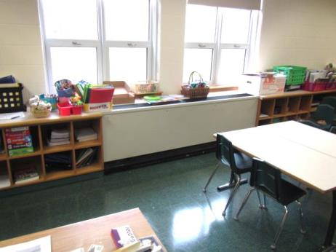
Classroom univent
Picture 2
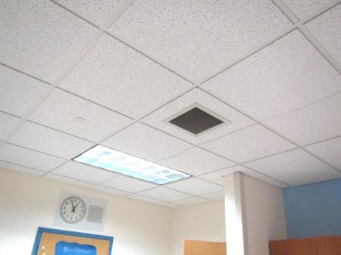
Classroom exhaust vent
Picture 3
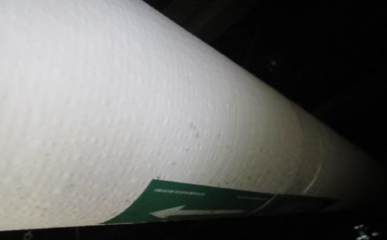
Light spotting indicating likely mold growth on paper covering pipe insulation above ceiling tiles
Picture 4
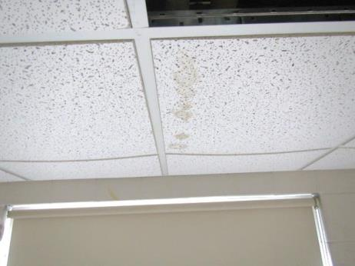
Water-damaged ceiling tiles below chilled water pipes
Picture 5
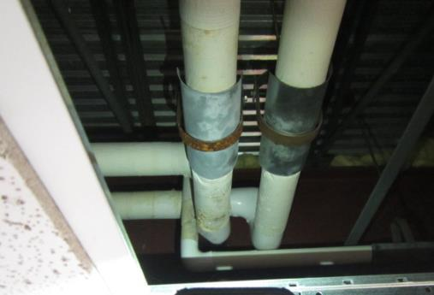
Chilled water pipes above water-damaged tiles in preceding picture
Picture 6
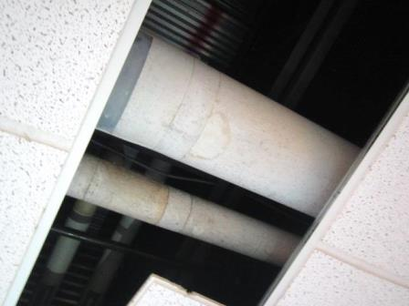
Light spotting indicating likely mold growth on paper covering pipe insulation above ceiling tiles
Picture 7
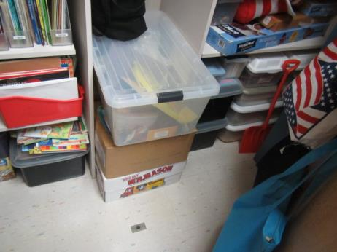
Cardboard boxes stored on floor
Picture 8
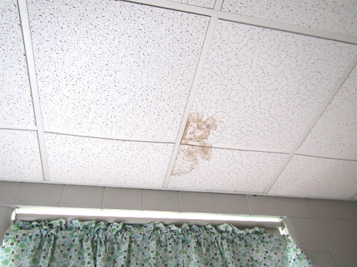
Water-damaged ceiling tiles below chilled water pipes
Location | Carbon  Dioxide  (ppm) | Carbon Monoxide  (ppm) | Temp  (°F) | Relative  Humidity  (%) | PM2.5  (µg/m³) | TVOCs  (ppm) | Occupants  in Room | Windows  Openable | Ventilation |  | Remarks
 |  |  |  |  |  |  |  |  | Supply | Exhaust
Background | 403 | ND | 63 | 54 | 16 | ND |  |  |  |  | Cloudy, rain expected later in day
16 | 659 | ND | 73 | 42 | 2 | ND | 0 | Y | Y | Y Off
17 | 738 | ND | 73 | 41 | 3 | ND | 0 | Y | Y | Y | MT, dusty exhaust vent, 16 occupants just left
101 | 763 | ND | 68 | 45 | 1 | ND | 0 | Y | Y | Y Off | HS, exhaust off-dusty, items in closet-organized, no visible mold on items examined, cardboard boxes on floor, UV filters dusty, visible mold/spotting on pipe insulation above CTs
102 | 874 | ND | 76 | 44 | 2 | ND | 26 | Y | Y | Y | Items on/front of UV, 4 WD CTs, area rug
104 | 805 | ND | 74 | 40 | 2 | ND | 24 | Y | Y | Y | Area rugs, pillows, 3 WD CT
105 | 648 | ND | 73 | 38 | 3 | ND | 0 | Y | Y | Y | 2 WD CTs, occupants at recess
106 | 624 | ND | 72 | 39 | 3 | ND | 0 | Y | Y | Y | 4 WD CTs, occupants at recess, 2 WD CTs above UV
107 | 545 | ND | 75 | 42 | 9 | ND | 4 | Y | Y | Y | 3 WD CT, chronic heat issues, room subdivided
109 | 1212 | ND | 75 | 45 | 12 | ND | 22 | Y | Y | Y Off | 4 WD CT, area rug
110 | 1389 | ND | 74 | 45 | 4 | ND | 23 | Y | Y | Y Off | Dust/debris UV
111 | 1238 | ND | 73 | 45 | 4 | ND | 20 | Y | Y | Y Off | Dust/debris/pencil shavings in UV grill, 3 WD CTs-near UV
112 | 1153 | ND | 73 | 47 | 5 | ND | 19 | Y | Y | Y Off | 7 WD CT, visible mold/spotting on paper insulation above ceiling tiles
113 | 1163 | ND | 74 | 44 | 2 | ND | 0 | Y | Y | Y Off | 5 WD CT
115 | 767 | ND | 72 | 40 | 3 | ND | 0 | Y | Y | Y Off | Visible mold/potting on paper/insulation above ceiling tiles, 2 WD CT
117 | 610 | ND | 71 | 42 | 3 | ND | 0 | Y | Y | Y Off | 3 WD CT, area rug
119 | 532 | ND | 71 | 42 | 6 | ND | 0 | Y | Y | Y
206 | 790 | ND | 75 | 40 | 5 | ND | 23 | Y | Y | Y
210 | 663 | ND | 73 | 43 | 5 | ND | 1 | Y | Y | Y Off | 2 WD CT-exhaust vent
Hallway outside 211-212 |  |  |  |  |  |  |  |  |  |  | 4 WD CTs
211 | 1544 | ND | 74 | 44 | 6 | ND | 1 | Y | Y Off | Y Off | 18 occupants gone ~20 mins, 5 WD CT, DO, UV reportedly cycling on/off w/thermostat
212 | 870 | ND | 74 | 39 | 3 | ND | 3 | Y | Y | Y | 5 WD CTs, exhaust duct-leak
213 | 1756 | ND | 75 | 49 | 3 | ND | 25 | Y | Y | Y Off

