Background

INDOOR AIR QUALITY ASSESSMENT

Swanson Road Intermediate School
10 Swanson Road
Auburn, MA

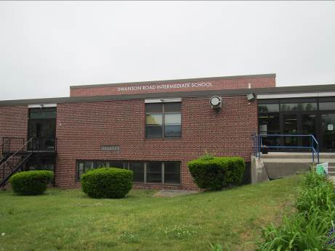

Prepared by:
Massachusetts Department of Public Health
Bureau of Environmental Health
Indoor Air Quality Program
July 2016
Building: | Swanson Road Intermediate School
Address: | 10 Swanson Road, Auburn, MA
Assessment Requested by: | Joe Fahey, Facilities Director, Auburn Public Schools
Reason for Request: | Health concerns and general indoor air quality (IAQ) concerns
Date of Assessment: | June 2, 2016
Massachusetts Department of Public Health/Bureau of Environmental Health (MDPH/BEH) Staff Conducting Assessment: | Ruth Alfasso, Environmental Engineer/Inspector and Cory Holmes, Environmental Analyst/Inspector, IAQ Program
Date of Building Construction: | 1959, with additions in 1972 and 1998 and a renovation in 2014
Building Description: | Originally the Swanson Road Intermediate School, starting in fall of 2015 it houses elementary school students. The building is two-story brick construction with flat roofs.
Building Population: | 550 students in grades 1 through 5 with a staff of approximately 60
Windows: | Mostly openable

METHODS
Please refer to the IAQ Manual for methods, sampling procedures, and interpretation of results (MDPH, 2015).

IAQ Testing Results
The following is a summary of indoor air testing results (Table 1).
- Carbon dioxide levels were above 800 parts per million (ppm) in 37 of 52 areas surveyed, indicating a lack of air exchange in two-thirds of the areas tested.
- Temperature was within the recommended range of 70°F to 78°F in all but one of the areas tested; one reading in an unoccupied modular classroom was 69°F.
- Relative humidity was within the recommended range of 40 to 60% in all but one of the areas tested.
- Carbon monoxide levels were non-detectable in all indoor areas tested.
- Fine particulate matter (PM2.5) concentrations measured were below the National Ambient Air Quality Standard (NAAQS) level of 35 μg/m³ in approximately 80 percent of areas tested. Note that outdoor levels were measured at 31, which is close to the NAAQS levels.

This sampling indicates that the ventilation system in the building could provide more fresh air and filtration in most classrooms.

Ventilation
A heating, ventilating and air conditioning (HVAC) system has several functions. First it provides heating and, if equipped, cooling. Second, it is a source of fresh air. Finally, an HVAC system will dilute and remove normally occurring indoor environmental pollutants by not only introducing fresh air, but by filtering the airstream and ejecting stale air to the outdoors via exhaust ventilation. Even if an HVAC system is operating as designed, point sources of respiratory irritation may exist and cause symptoms in sensitive individuals. The following analysis examines and identifies components of the HVAC system and likely sources of respiratory irritant/allergen exposure due to water damage, aerosolized dust and/or chemicals found in the indoor environment.
Fresh air is provided by a combination of unit ventilators (univents) located in individual classrooms along the outside wall (Picture 1) and air handling units (AHUs), which serve central areas. Unit ventilators draw fresh air through a vent on the exterior wall (Picture 2). Air is mixed with return air from the room, filtered, heated (if needed) and delivered back to the room. Air from the AHUs is filtered, heated/cooled and delivered to rooms via ducted supply vents (Picture 3). Most univents were off at the time of the visit, reducing the amount of fresh air being delivered to classrooms, and many were blocked on top or in front by items and furniture (Picture 4).
Note that the univents in each section of the building are original equipment, dating from 1959 and 1972, which makes them over 55 and over 40 years old respectively. Function of equipment of this age is difficult to maintain, since compatible replacement parts are often unavailable. According to the American Society of Heating, Refrigeration and Air-Conditioning Engineers (ASHRAE), the service life for a unit heater, hot water or steam is 20 years, assuming routine maintenance of the equipment (ASHRAE, 1991). Despite attempts to maintain the univents, the operational lifespan of the equipment has been exceeded. Maintaining the balance of fresh air to exhaust air will become more difficult as the equipment ages and as replacement parts become increasingly difficult to obtain. Note that univents installed during the 1998 renovation are also approaching 20 years old.
It is recommended that HVAC systems be re-balanced every five years to ensure adequate air systems function (SMACNA, 1994). It was reported that systems in this building were last balanced in March of 2016.
Exhaust vents are located on the walls or ceilings of classrooms and offices (Picture 5) and are ducted to fans on the roof. Additional exhaust vents are located in toilet rooms and other areas. While all classroom exhaust vents checked were operational, many were blocked by furniture and items (Picture 6), reducing the ability of the exhaust system to remove stale air. Some restroom exhaust vents were examined and weak or no draw from them was observed; motors, belts and power for these should be examined/repaired to ensure they are operational.
The AHU provides cooling as well as heating to areas it serves. Cooling in areas with univents is provided by ductless air conditioning units hung on walls (Picture 7). These units are connected to heat pumps using chilled refrigerant to provide cooling during the warmer months, and can also provide heating during the colder months.

Microbial/Moisture Concerns
Stained ceiling tiles were observed in a few areas (Table 1). Some of the observed stained tiles were from roof leaks that have reportedly been repaired. Leaks were reported from windows/window areas in a few classrooms. No water staining or damaged materials were observed in these areas at the time of the visit. Leaks should be reported promptly to building maintenance staff to ensure they can be repaired and materials can be dried. The US EPA and the American Conference of Governmental Industrial Hygienists (ACGIH) recommend that porous materials be dried with fans and heating within 24 to 48 hours of becoming wet (US EPA, 2008; ACGIH, 1989). If porous materials are not dried within this time frame, mold growth may occur. Once mold has colonized porous materials, they are difficult to clean and should be removed and discarded.
Ductless air conditioners have condensate drains. Most of these are directed outside and drain by gravity, but some had pumps. These units should be checked periodically to ensure drainage hoses are intact, not clogged, and that pumps are operational to prevent stagnant water and leaks. A classroom sink had a gap in the backsplash (Picture 8; Table 1), which can allow for moistening of the wood material and potential microbial growth.
In the basement area, former locker rooms had been converted to occupied space. There are unused toilets in this area that could create stagnant water conditions that may lead to odors or pests. Floor drains are also present that can allow sewer gases into occupied spaces if not periodically moistened.
Plants were observed in a few areas including on univents (Picture 9; Table 1). Plants can be a source of pollen and mold, which can be respiratory irritants to some individuals. Plants should be properly maintained and equipped with drip pans and should be located away from air diffusers to prevent the aerosolization of dirt, pollen and mold.
There were several refrigerators in the building, and one was found to have mold on the gasket (Picture 10). Refrigerators should be cleaned regularly to prevent microbial growth and odors.
The outside of the building was examined for conditions that may impact IAQ. A bush was noted along the outside of the building (Picture 11) and some trees/shrubs in the courtyard were close to the foundation and overhanging the roof (Picture 12). Plants close to the exterior can prevent walls from drying and lead to drainage problems/deterioration of the building envelope. When near air intakes, they can also be a source of odors, pollen and debris to the inside of the building.
Some downspouts were missing or damaged (Picture 13), which can allow water to accumulate against the foundation. The north (shady) side of the building had moss/mold staining (Picture 14) that should be cleaned. The courtyard has a small water feature. These can be difficult to maintain and lead to stagnant water, odors, and pests including mosquitoes.
The vinyl skirting of the modular classrooms was damaged in several areas (Pictures 15 and 16) that could allow harborage for pests. Some exterior doors were missing weather-stripping (Table 1), which can allow moisture, unconditioned air and pests into the building.

Other IAQ Evaluations

Particulate Matter
The US EPA has established NAAQS limits for exposure to particulate matter. Particulate matter includes airborne solids that can be irritating to the eyes, nose and throat. This PM2.5 standard requires outdoor air particle levels be maintained below 35 μg/m³ over a 24-hour average (US EPA, 2006). As mentioned, outdoor PM2.5 concentrations were measured at 31 μg/m³ (Table 1). PM2.5 levels indoors ranged from 5 to 66 μg/m³ (Table 1), which were above the NAAQS PM2.5 level of 35 μg/m³ in approximately 20% of the areas tested, most likely due to classroom activities, outside conditions and lack of ventilation/filtration. Carpeting in classrooms (Table 1) may contribute to elevated particulate levels in some areas. The usable life of carpeting is approximately 10-11 years (IICRC, 2002) and carpeting older than that may contribute particulates to the indoor environment due to wearing of fibers. Carpeting, including wall-to-wall and area rugs, also should be cleaned annually or semi-annually in soiled high traffic areas as per the recommendations of the Institute of Inspection, Cleaning and Restoration Certification (IICRC, 2012). Plush and upholstered items should also be cleaned regularly. Carpeting, area rugs and plush/upholstered items that are worn and/or have become hard to clean should be discarded.
Frequently, indoor air levels of particulates (including PM2.5) can be at higher levels than those measured outdoors. A number of activities that occur indoors and/or mechanical devices can generate particulate matter during normal operations. Sources of indoor airborne particulates may include but are not limited to particles generated during the operation of fan belts in the HVAC system, use of stoves and/or microwave ovens in kitchen areas; use of photocopiers, fax machines and computer printing devices; operation of an ordinary vacuum cleaner and heavy foot traffic indoors.

TVOCs
Exposure to low levels of total volatile organic compounds (TVOCs) may produce eye, nose, throat, and/or respiratory irritation in some sensitive individuals. To determine if VOCs were present, BEH/IAQ staff examined rooms for products containing VOCs. BEH/IAQ staff noted air fresheners, hand sanitizers, cleaners, and dry erase materials in use within the building (Table 1). All of these products have the potential to be irritants to the eyes, nose, throat, and respiratory system of sensitive individuals.
Laminators and copy machines were observed in several areas (Table 1). These can emit odors and VOCs, and copy machines can also emit ozone, which is a respiratory irritant. When possible, they should be placed in areas with direct-vented exhaust to remove the pollutants generated during operation.
A kiln in the art room had no exhaust ventilation and was located directly inside the classroom. Exhaust ventilation for kilns is necessary to remove heat and odors during operation. Consider installing a direct exhaust vent for the kiln and ensure it is used every time the kiln is in operation.
Additionally, no exhaust ventilation was observed in janitorial closets, which contain mops and cleaning chemicals, which can be sources of odors. Janitorial closets also had missing ceiling tiles (Picture 17) that can allow odors from the closets to traverse into occupied spaces. Missing/ajar tiles were also observed in occupied areas; tiles should be replaced flush with the ceilings to provide a barrier to dusts and odors between areas.
Filters were examined from a univent (Picture 18). It appeared recently changed/clean and well-fitted, but of a mesh type that provides minimal filtration. A pleated filter with a Minimum Efficiency Reporting Value (MERV) value of at least 9 is recommended. Because of the age of the univents, use of a higher-efficiency filter may reduce flow or cause mechanical stress, so univents should be evaluated to ensure higher-efficiency filters can be used. Filters should be changed 2 to 4 times a year. Having univents turned on and equipped with good filtration should help reduce levels of particulate matter in the building.
Some personal fans, supply and exhaust vents were observed to be dusty (Picture 19; Table 1). Univent cabinets had dust and debris in them as well (Table 1). In some areas, items were observed on the floor, windowsills, tabletops, counters, bookcases, and desks (e.g., Picture 3; Table 1). The numerous items/irregular surfaces make it difficult for custodial staff to clean.

Conclusions/Recommendations
Based on observations made at the time of the assessment, the following recommendations are made:
- Operate supply and exhaust ventilation in all areas during occupied periods. During temperate weather, use windows to supplement fresh air. Ensure all windows are closed at the end of the day and during the cooling season/AC operation.
- Work with building occupants to resolve comfort/noise concerns without reducing fresh air supply (e.g., repairing noisy univents, relocating desks away from vents).
- Remove blockages from the top and front of univents and from exhaust vents.
- Consider plans for overhaul or replacement of univents that are at/near the end of their useful life.
- Have the HVAC system balanced every 5 years in accordance with SMACNA recommendations.
- Install a direct-vented exhaust for the kiln and ensure it is used whenever the kiln is on and until the cycle has finished/kiln cooled down. Operate the kiln only when the classroom in which it is located is not occupied.
- Consider installing direct vented exhaust in other areas where odors and pollutants may be generated such as copy/lamination rooms and janitorial closets.
- Replace stained ceiling tiles. Monitor areas for leaks.
- Ensure that procedures are in place for occupants to report leaks, wet tiles, and other maintenance conditions so that they can be logged and repaired promptly.
- Monitor ductless air conditioning condensate drains to ensure they do not have clogs or standing water and that pumps are operational.
- Repair sink backsplashes to render them watertight. Refrain from storing porous or significant amounts of materials under sinks.
- Pour water down unused drain traps and flush unused toilets periodically to prevent stagnant water and dry drain traps. Consider removing unwanted fixtures and properly capping unused drains.
- Keep plants in good condition, avoid overwatering, and remove from the airstream of univents and other air sources.
- Ensure refrigerators are cleaned out regularly and that spills are cleaned promptly to prevent odors. Clean stained gaskets with an antimicrobial solution or, if they cannot be cleaned, replace.
- Remove plants to about five feet away from exterior walls/foundation, including in the courtyard.
- Clean moss from the south side of the building.
- Consider removing the water feature in the courtyard.
- Repair any breaks in the skirt/undercarriage of the modular classrooms to exclude pests.
- Repair/replace weather-stripping on exterior doors and monitor for light and drafts.
- Reduce the use of cleaning products, sanitizers, air fresheners, and other products containing VOCs. Use only school-issued products, ensure they are properly labeled, and keep material safety sheets on file for each product at the school.
- Ensure the ceiling tile system is intact with all tiles in place to prevent migration of dusts and odors to occupied areas.
- Change filters regularly in univents (2 to 4 times a year), and vacuum the cabinets of debris each time the filters are changed. Consider upgrading to a MERV 9 filter if current univents are capable of operating with the higher-efficiency filters.
- Clean supply and exhaust vents and personal fans regularly to prevent aerosolization of debris.
- Clean carpeting, area rugs and plush/upholstered items regularly in accordance with IICRC recommendations (IICRC 2012). If carpeting is too old and worn to be effectively cleaned, consider replacement.
- Consider reducing the amount of items stored in classrooms to make cleaning easier. Periodically move items to clean flat surfaces.
- Consider adopting the US EPA (2000) document, “Tools for Schools”, as an instrument for maintaining a good IAQ environment in the building. This document is available at: http://www.epa.gov/iaq/schools/index.html.
- Refer to resource manual and other related IAQ documents located on the MDPH’s website for further building-wide evaluations and advice on maintaining public buildings. These documents are available at: http://mass.gov/dph/iaq.

References
ACGIH. 1989. Guidelines for the Assessment of Bioaerosols in the Indoor Environment. American Conference of Governmental Industrial Hygienists, Cincinnati, OH.
ASHRAE. 1991. ASHRAE Applications Handbook, Chapter 33 “Owning and Operating Costs”. American Society of Heating, Refrigeration and Air Conditioning Engineers, Atlanta, GA.
IICRC. 2002. Institute of Inspection, Cleaning and Restoration Certification. Carpet Cleaning: A Life-cycle Cost Analysis for Floor Coverings in School Facilities. Retrieved from https://www.carpet-rug.org/Documents/Scientific_Resources/0203_IICRC_Life-Cycle-Cost-Analysis.aspx
IICRC. 2012. Institute of Inspection, Cleaning and Restoration Certification. Carpet Cleaning: FAQ. Retrieved from http://www.iicrc.org/consumers/care/carpet-cleaning/#faq.
MDPH. 2015. Massachusetts Department of Public Health. Indoor Air Quality Manual: Chapters I-III. Available at: http://www.mass.gov/eohhs/gov/departments/dph/programs/environmental-health/exposure-topics/iaq/iaq-manual/.
SMACNA. 1994. HVAC Systems Commissioning Manual. 1st ed. Sheet Metal and Air Conditioning Contractors’ National Association, Inc., Chantilly, VA.
US EPA. 2000. Tools for Schools. Office of Air and Radiation, Office of Radiation and Indoor Air, Indoor Environments Division (6609J). EPA 402-K-95-001, Second Edition. https://www.epa.gov/iaq-schools.
US EPA. 2008. “Mold Remediation in Schools and Commercial Buildings”. Office of Air and Radiation, Indoor Environments Division, Washington, DC. EPA 402-K-01-001. September 2008. Available at: http://www.epa.gov/mold/mold-remediation-schools-and-commercial-buildings-guide.
Picture

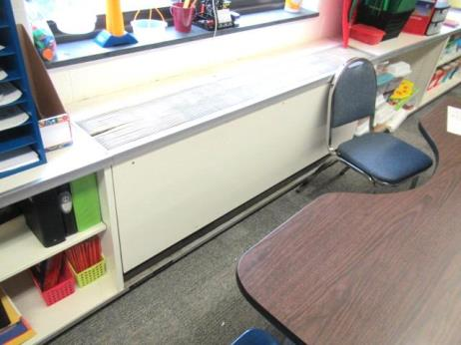

Unit ventilator (univent)

Picture 2

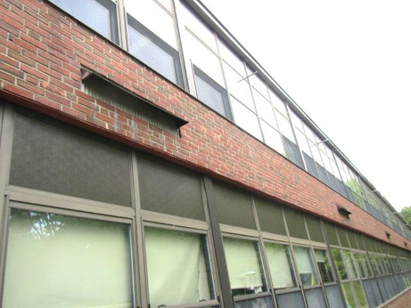

Univent fresh air intake
Picture 3

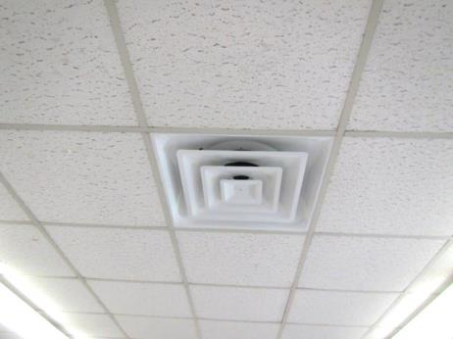

Typical supply vent

Picture 4

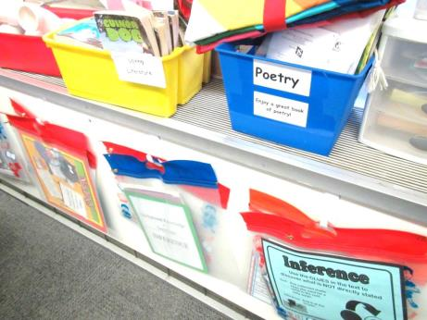
Top of univent blocked by items

Picture 5

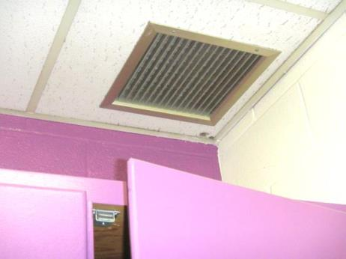

Ceiling-mounted exhaust vent in classroom

Picture 6

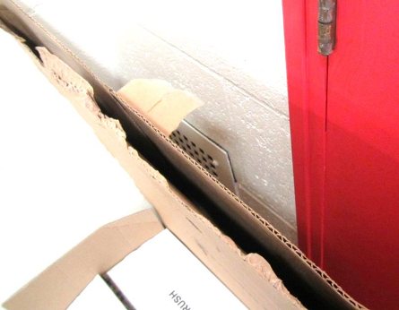

Wall-mounted exhaust vent (arrow) blocked by cardboard
Picture 7

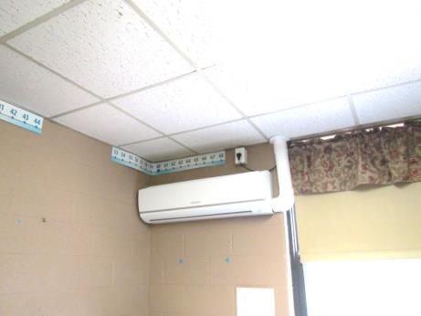

Wall-mounted ductless air conditioning unit

Picture 8

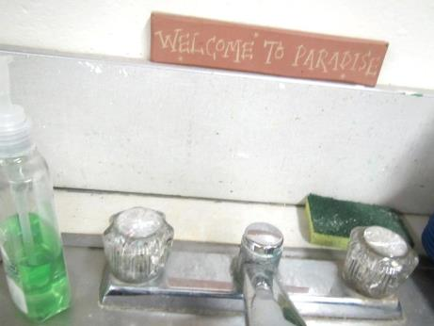

Damaged sink backsplash
Picture 9

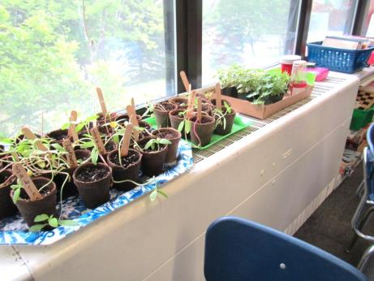

Plants on univent

Picture 10

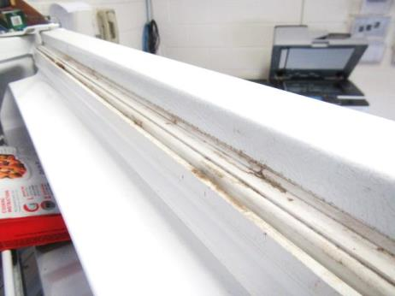

Stained refrigerator gasket
Picture 11

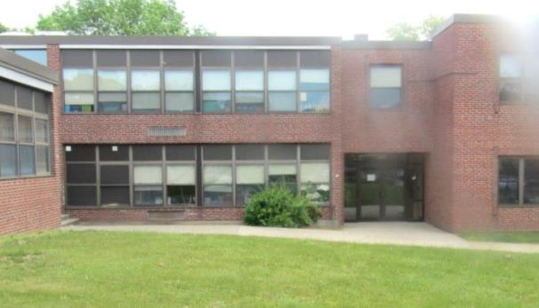

Shrub near side of building

Picture 12

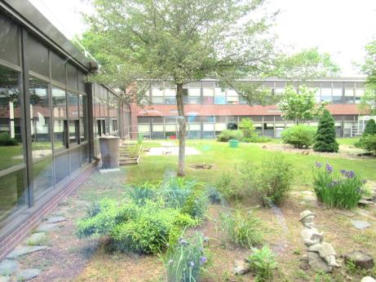

Plants and trees in the courtyard
Picture 13

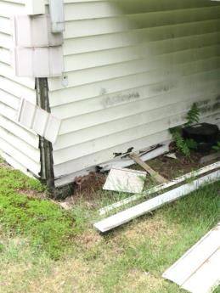

Broken downspouts and siding

Picture 14

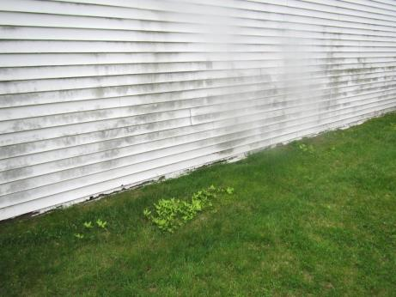

Moss/mold accumulations on north side of modular building
Picture 15

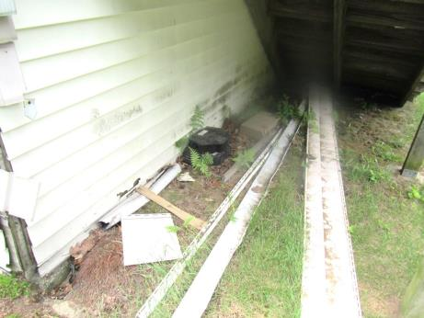

Deterioration at base of modular classroom

Picture 16

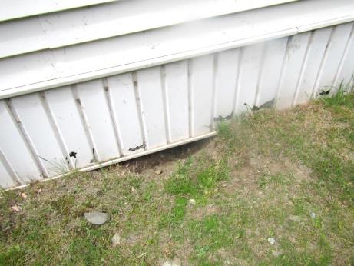

Hole/potential harborage under skirt of modular classroom
Picture 17

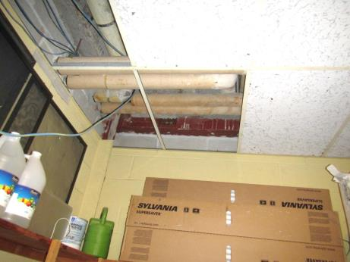

Missing tiles in janitorial closet

Picture 18

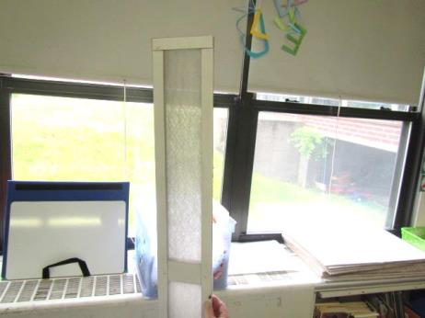

Mesh-type univent filter
Picture 19

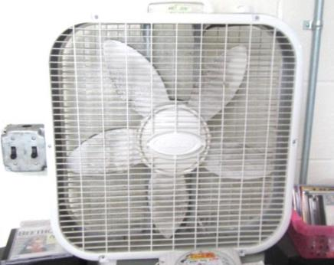

Dusty fan

Location | Carbon  Dioxide  (ppm) | Carbon Monoxide  (ppm) | Temp  (°F) | Relative  Humidity  (%) | PM2.5  (µg/m³) | Occupants  in Room | Windows  Openable | Ventilation |  | Remarks
 |  |  |  |  |  |  |  | Supply | Exhaust
Background | 421 | 0.6 | 65 | 56 | 31 |  |  |  |  | Cloudy/foggy and cool
B 108 | 524 | ND | 73 | 55 | 21 | 2 | N | Y | Y | Former locker room, abandoned shower drain
Main Office | 911 | ND | 73 | 54 | 16 | 0 | Y | Y | Y | PC, carpet, laminator
Principal’s Office | 703 | ND | 73 | 54 | 27 | 2 | Y | Y | Y | Carpet
Staff food and MDF area | 599 | ND | 73 | 53 | 15 | 0 | N | N | N | Fridge and toaster, MT, NC, AI
Custodial Closet |  |  |  |  |  |  |  |  |  | Mops, CP, MT/AT and holes in ceiling
Maintenance Office | 503 | ND | 75 | 52 | 21 | 1 | N | Y | Y | Toilets, fridge, NC, DEM
Nurse Suite | 890 | ND | 73 | 56 | 12 | 4 | Y | Y | Y
Faculty Lounge | 640 | ND | 72 | 57 | 16 | 7 | Y | N | N | Restroom exhaust off, laminator, PC-no local exhaust vent
Reception | 615 | ND | 74 | 53 | 19 | 1 | Y | Y | Y
Assistant Principal | 632 | ND | 73 | 53 | 16 | 0 | N | Y | Y | Carpet
Auditorium | 490 | ND | 73 | 51 | 13 | 0 | N | Y | Y | Carpet, PF on
Gym 1 | 599 | ND | 73 | 52 | 23 | 3 | N | Y | Y
Gym 2 | 610 | ND | 73 | 53 | 25 | 0 | n | Y | Y
Courtyard |  |  |  |  |  |  |  |  |  | Plants and trees near windows, water feature
Cafeteria | 683 | ND | 71 | 63 | 66 | ~200 | Y | Y | Y | NC
101 A Science Storage |  |  |  |  |  |  | N | N | N | PF, door blocked open by items
102 | 1509 | ND | 74 | 59 | 14 | 23 | Y | Y | Y | UV off
103 | 1539 | ND | 73 | 58 | 13 | 21 | Y | Y | Y | UV off, MT, WD CT
105 | 816 | ND | 73 | 57 | 14 | 7 | Y | Y | Y
108 Custodial Closet |  |  |  |  |  |  | N | N | N | No exhaust vent
109 Art | 1053 | ND | 73 | 58 | 15 | 21 | Y | Y | Y | UV off, kiln local exhaust not installed
110 | 915 | ND | 73 | 56 | 12 | 1 | Y | Y | Y | UV off, exhaust obstructed, 23 occupants gone 20 mins, DO
112 | 1495 | ND | 74 | 58 | 20 | 23 | Y | Y | Y | UV off
113 | 1079 | ND | 73 | 54 | 21 | 1 class just left | Y | Y | Y | 2 ductless AC, half carpeted, DEM, CP, sink backsplash open, plant
114 | 905 | ND | 72 | 53 | 28 | 1 class just left | Y | Y | Y | Ductless AC, DEM, carpet, AI
115 | 914 | ND | 71 | 55 | 17 | 1 | Y | Y | Y | Ductless AC, carpet, DEM
116 | 1088 | ND | 72 | 58 | 37 | 18 | Y | Y | Y | DEM, carpet, ductless AC
Reading Room | 910 | ND | 72 | 53 | 26 | 1 | Y | Y | Y | NC, DEM
118 | 1470 | ND | 73 | 58 | 31 | 18 | Y | Y | Y | NC, DEM
Copy Room | 870 | ND | 73 | 54 | 19 | 0 | N | N | N | DO, carpet, PC, ductless AC
121 | 1321 | ND | 73 | 58 | 44 | 21 | Y | Y | Y | Carpet, DEM, ductless AC
122 | 1178 | ND | 73 | 56 | 24 | 24 | Y | Y | Y | PF, ductless AC, area rug
203 | 960 | ND | 73 | 54 | 13 | 27 | Y | Y | Y | Spaces around exterior door, PF dusty
208 Modular | 625 | ND | 72 | 56 | 7 | 2 | Y | Y | Y | Dust/debris vents, WD CTs
209 Modular | 643 | ND | 69 | 51 | 5 | 0 | Y | Y | Y | Dust/debris vents, holes in CTs, WD CTs-painted
210 Modular | 588 | ND | 70 | 55 | 13 | 1 | Y | Y | Y | Dusty vents, carpet (new), DEM
211 Music Modular | 986 | ND | 70 | 50 | 11 | 0 | Y | Y | Y | Dusty vents, DEM, carpet (new)
214 | 989 | ND | 73 | 58 | 14 | 5 | Y | N | N | Window in inner office, DO
301 | 644 | ND | 72 | 53 | 44 | 22 | Y | Y | Y | Carpet, UV obstructed
302 | 960 | ND | 72 | 58 | 23 | 25 | Y | Y | Y | Carpet, DEM
305 | 1257 | ND | 73 | 57 | 18 | 0 | Y | Y | Y | UV-off
Math | 944 | ND | 72 | 55 | 42 | 2 | Y | Y | Y | Ductless AC, carpet, DO
OTPT | 945 | ND | 73 | 54 | 27 | 4 | Y | Y | Y | Ductless AC, wall-mount exhaust vent, carpet
312 | 1112 | ND | 72 | 54 | 13 | 0 | Y | N | N | Laminator, PC (2), no exhaust vent, refrigerator-moldy gasket
313 Storage | 1342 | ND | 74 | 50 | 21 | 0 | N | N | N | AT/MT, NC, flashing light, communication equipment
314 | 1538 | ND | 72 | 57 | 14 | 25 | Y | Y | Y | Exhaust vent obstructed by cabinet, UV-off
315 | 1822 | ND | 72 | 52 | 14 | 26 | Y | Y | Y | Exhaust vent obstructed, DO, AF
317 | 1351 | ND | 73 | 55 | 39 | 21 | Y | Y | Y | Ductless AC, carpet, DEM, plants, UV off
318 | 1714 | ND | 72 | 53 | 27 | 23 | Y | Y | Y | Obstructed exhaust, 2 ductless AC units, NC, DEM, HS
319 | 1768 | ND | 73 | 54 | 36 | 21 | Y | Y | Y | Obstructed exhaust, ductless AC, carpet, DEM
320 | 1358 | ND | 73 | 52 | 31 | 21 | Y | Y | Y | Ductless AC, carpet, DO, HS, obstructed exhaust
321 | 1675 | ND | 74 | 56 | 55 | 21 | Y | Y | Y | Ductless AC, plants on UV, carpet, concerns about allergies
322 | 1345 | ND | 74 | 54 | 71 | 20 | Y | Y | Y | Plants, carpet, DO
323 | 1467 | ND | 73 | 57 | 45 | 21 | Y | Y | Y | DEM, NC, DO, ductless AC
327 | 1120 | ND | 71 | 51 | 11 | 27 | Y | Y | Y | Exhaust vent partially obstructed, UV-off, WD CTs
328 | 965 | ND | 71 | 50 | 13 | 25 | Y | Y | Y | UV off, plug-in AF

The service life is the median time during which a particular system or component of …[an HVAC]… system remains in its original service application and then is replaced. Replacement may occur for any reason, including, but not limited to, failure, general obsolescence, reduced reliability, excessive maintenance cost, and changed system requirements due to such influences as building characteristics or energy prices (ASHRAE, 1991).

