White Paper


Symmetry® Episode Treatment Groups®

Measuring health care with meaningful episodes of care

Identifying clinical episodes of illness and the services involved in their diagnosis, management, and treatment have become a key business need of any health care organization. Purchasers, consumers, and patients seek greater transparency into the cost, quality, and service of health care delivery. Episodes of care provide a valuable unit of analysis to support transparency, measure health care, provide incentives for high performance, and plan subrogation.

Episode Treatment Groups® (ETG®) were introduced to the market in 1993 and rapidly became widely used for building episodes of care. Such measurements rely on accurate and valid definitions of a disease and the services related to a clinical condition. By combining related services into clinically homogenous units that describe complete episodes of care, ETG provides the basis of valid comparisons. Episodes are created by collecting all inpatient, outpatient, and ancillary services into mutually exclusive and exhaustive categories. The medical consistency within an ETG contributes to treatment decisions, as the groupings are meaningful to all care providers. At the patient level, ETG recognizes comorbidities, complications, and treatments that dramatically change the patient’s clinical profile, health care utilization, and costs. ETG enables powerful, accurate case mix adjustment. ETG covers the breadth of clinical medicine; both acute and chronic conditions can be measured and compared.

A number of features of the ETG methodology have contributed to its status as a market leader, including the clinical validity of the ETG approach and its ability to create resource-homogeneous episodes of care that can be compared across patients, providers, and populations. Symmetry® suite products are now licensed by more than 300 health care organizations in the United States, serving more than three-quarters of the insured population. When combined with other Symmetry products—Episode Risk Groups® (ERG®) and Pharmacy Risk Groups® (PRG®) to assess patient and population risk, EBM Connect®, Procedure Episode Groups® (PEG®), and PCQ Connect to measure quality of care—ETG supports a comprehensive suite of products, leveraging a single methodological platform to address a wide array of business needs.

This paper will provide an overview of how the ETG software supports:

- Valid measurement and comparison of providers based on cost of care

- Improved understanding of disease-specific risk to enhance care and case management

- Enhanced ability to track plan performance and trends around specific diseases and episodes

Organizations can use ETG for provider performance management, for case management by measuring demand, or for tracking financial performance and trends.

OptumInsight www.optuminsight.com Page 1

Symmetry ETG: Measuring health care with meaningful episodes of care

Episode treatment grouping

A number of factors differentiate ETG in the market:

- Strong clinical content, matching a patient’s diagnoses and procedures to appropriate episodes of care

- Inclusion of all relevant services into episodes of care, including ancillary, pharmaceutical, inpatient, and outpatient

- Use of both diagnostic and procedural information to more precisely assign individual services to episodes

- Methodology for creating dynamic clean periods around discrete episodes

- Recognition of the different complications, comorbidities, and treatment indicators that can influence an episode’s costs and utilization

- Severity assignment for an episode that factors comorbidities and complications, resulting in greatly enhanced classifications

- Flexible treatment of chronic episodes of care, recognizing the ongoing nature of these conditions

- Seamless integration with other Symmetry engines for consistent analysis

- Transparency—customers have access to the clinical rules and content behind ETG, supporting an understanding of grouped results¹
Each of these strengths continues to serve as the core of the ETG methodology. The resulting ETG provides medically meaningful, statistically stable units of analysis, representing a discrete underlying disease or condition.

Facilitates gaps in coverage

The ETG software first determines whether a member is eligible based on enrollment during the time frame, which can include gaps in coverage. Users determine how large a gap is acceptable. ETG then reviews each claim, building a complete treatment episode by identifying an anchor record and continuing to collect all clinically relevant

information until an absence of treatment—or clean period—is detected. This process is outlined in the following sections and described in detail in product documentation.

Building an episode

The key features of ETG are anchor records, clusters, and non-anchor (ancillary and pharmacy) records. Anchor records demonstrate that a clinician has evaluated a patient and determined the types of services required to further identify and treat his or her condition.

Prior to identifying claims records as anchor records, claims are assigned to one of five record types: management, surgery, facility, ancillary, and pharmacy. Certain revenue codes alone can be used to determine record type by identifying a facility’s room and board records, for instance. In the absence of a procedure or revenue code, the type of service—room and board, medical/surgical, or ancillary—can be used with the provider type or facility to determine that a record is associated with an inpatient confinement (a facility service).

Anchor records are then identified by a combination of the provider type and procedure codes, based on one of the following:

- A claim submitted by a clinician for services related to the evaluation of a member’s condition (management service)

- A claim submitted by a clinician for services for surgical or related procedures (surgical service)

- A claim submitted by a treatment facility for room and board services (facility service)
White Paper

OptumInsight www.optuminsight.com Page 2

Symmetry ETG: Measuring health care with meaningful episodes of care White Paper

• A claim submitted by a hospital for emergency room services |  | The first six digits define
 |  | The first six digits define | Figure 1.
(management service) |  | the base ETG, including
(management service) |  | the base ETG, including | ETG numbering system
 |  | information about the
The anchor record starts an episode. The grouper evaluates |  | information about the
 |  | part of the body affected.
every ancillary and pharmaceutical service (non-anchor records) |  | part of the body affected. | #### ## ¹/₀ ¹/₀ |  |  |  |  | #
 |  | The seventh and eighth
against all episodes to determine the best fit and groups claims |  | The seventh and eighth
into clusters, each with one anchor record. When a non-anchor |  | digits are set to 1 if | Condition Location
 |  | the base ETG has,
record such as lab test, x-ray, or pharmaceutical is eligible to join |  | the base ETG has,
 |  | the base ETG has, | class | on body
 |  | respectively, complications | class
more than one cluster, ETG will join it with the cluster that has an |  | respectively, complications
 |  | or comorbidities, and | Base ETG
anchor provider who is a clinician. If none is available, ETG joins |  | or comorbidities, and
 |  | to 0 if these factors are |  |  | Compli- |  |  | Treatment
the record to a cluster with a facility anchor provider. This logic |  | to 0 if these factors are
 |  | not present. Notably, |  |  | cation |  |  | indicator
provides a more meaningful tie-breaker rule: a physician’s cluster |  | not present. Notably,
 |  | comorbidities and
trumps a facility’s cluster. The result is clinically homogenous, |  | comorbidities and |  |  | Comorbidity
 |  | complications are base
statistically stable episodes. Each episode is assigned to a |  | complications are base |  |  | 1=present
 |  | ETG-specific, as a medical
base ETG, which classifies the medical condition. Base ETGs |  | ETG-specific, as a medical
 |  | ETG-specific, as a medical |  |  | 0=not present
 |  | condition will affect some
incorporate both the specificity of sub ETG and the grouping |  | condition will affect some
 |  | types of episodes but not others.
capacity of super ETG. Examples of base ETG include diabetes,
hypertension, and chronic obstructive pulmonary disease. |  | The ninth digit reflects the absence or presence of any treatment
Innovative ETG numbering system communicates |  | indicators, which categorize services such as defining surgeries
Innovative ETG numbering system communicates |  | and active management procedures (chemotherapy and
severity conditions
severity conditions |  | radiation therapy services). A value of 1 through 5 indicates
To achieve clinical homogeneity of the unit of analysis, the
 |  | specific groupings of similar procedures. The meaning of the
grouper reviews base ETGs for the presence of three factors that
 |  | code is specific to the base ETG, as seen in Table 1—allowing
could influence the amount of resources required to treat the
 |  | some continuity with prior versions of ETG. Most base ETGs use
episode: comorbidities, complications, or particular treatments,
 |  | only a 0 or 1, indicating without or with surgery, respectively. A
including major surgery or active management of neoplasms. Any
 |  | user would simply drop the final digit to perform analyses that
one of these factors would generate a separate classification of
 |  | don’t differentiate between episodes with treatment and those
the episode, characterized by a new nine-digit ETG numbering
 |  | without.
approach. |  | without.
approach. |  | As with prior versions, each base ETG is mapped to one major
Figure 1 demonstrates how the nine-digit ETG clearly and
 |  | practice category (MPC), which represents a body system or
immediately conveys the presence of any of these conditions.
 |  | physician specialty.
Table 1.
Treatment indicators and their meaning
Base ETG description | Treatment |  |  |  | Treatment indicator
Malignant neoplasm of large intestine | Without surgery, without active management |  |  | 0
 | With surgery, without active management |  |  | 1
 | Without surgery, with active management |  |  | 2
 | With surgery, with active management |  |  | 3
Ischemic heart disease | Without surgery |  |  | 0
 | With angioplasty |  |  | 1
 | With coronary artery bypass graft (CABG) |  |  | 3
 | With valve surgery |  |  | 4
 | With valve surgery and CABG |  |  | 5
Chest trauma, closed | Without surgery |  |  | 0
 | With surgery |  |  | 1



OptumInsight www.optuminsight.com Page 3

Symmetry ETG: Measuring health care with meaningful episodes of care White Paper

Assigning claims to episodes involves many intermediate decision points. For example, if a drug is eligible for two different conditions, a ranking is used to assist in determining assignment to a base ETG. Similarly, ETG is prepared for the unlikely event that a member has simultaneous episodes for multiple base ETGs for which a procedure is eligible. A ranking system would assign the procedure to the most appropriate base ETG. A third ranking system determines which base ETG should receive a signs and symptoms anchor record, which, reflecting vague conditions

like headache, is linked to a base ETG after all other claims have been linked.

It is critical that each claim’s dollars only be assigned to one episode so its associated costs are not double-counted. However, claims frequently have valid but unrelated diagnosis codes that should be considered. In these cases, ETG creates a phantom cluster and associates it with an existing or new episode, but does not attribute the costs to the episode. As additional claims are reviewed, they may be associated with this episode. If the episode based on a phantom anchor does not attract any other claims, it remains a phantom episode at zero cost. Users can include phantom episodes in the summary file.

The grouping process loops back through the data and intelligently shifts results based on intermediate determinations so that claims are assigned appropriately and accurately.

Some claims cannot be grouped to an episode. For example, screenings and immunizations incidental to other services could be indicative of preventive medicine or health promotion. They do not create an anchor record, but instead are assigned to

a specific base ETG and included in the output file. Similarly, prescriptions for ongoing conditions that were not associated with an office visit are assigned to a specific base ETG.

Pharmaceutical records are coded using a proprietary framework for drug coding that includes the National Drug Code system (NDC), a hierarchical drug coding system compatible with ETG methodology, and major practice categories, as well as current medical and drug information literature. The framework is updated to reflect treatment evolution and new drug entities.

Drug claim records that cannot be legitimately grouped are assigned as base ETG orphan drug record.

Dynamic clean periods

Episodes often occur in a discrete time frame. To build a complete episode, a unique time frame must be defined.

As ETG reviews the claims, it considers the length of time since a relevant claim was identified, called the clean period. To be clinically meaningful, the clean period is specific to each base ETG. For example, the clean period for brain trauma is 90 days, while the clean period for migraine headache is 60 days. Most acute conditions have a clean period less than 180 days. The shortest is acute alcohol intoxication, with a clean period of only seven days.

Episodes also have base ETG-specific drug clean periods within which pharmaceutical claims must fall to be associated with the episode.

Each episode is framed by a start date, defined by the earliest anchor record in the episode, and an end date. The end date is defined as the latest anchor record in the episode.² If both the start and end dates are known, the episode is complete.

Episodes with an unknown start date, an unknown end date, or both, can be considered complete if they include a full year of data. The value of the variable episode type identifies the type of complete episode—e.g., clean start, unknown finish (full year of data)—enabling users to easily select the appropriate episodes. Episode type also identifies the reason an episode is incomplete. It is essential to compare only complete episodes with complete episodes.

Handling chronic conditions

To validly compare treatment of ongoing chronic conditions, ETG partitions episodes into year-long, separate episodes. ETG
supports five different methods for users to define the year. Users who know or suspect their data are more complete at certain points, or who have long run-out periods, or whose members turn over frequently, may choose different options.

As medical conditions progress, the episode may shift. Once data are parsed into years, the patient may, for example, have a base ETG of non-malignant neoplasm of prostate in one year

and malignant neoplasm of prostate in the next. These situations can be easily identified using the chronic ID field in the summary file and analyzed using the output file that shows all prior ETG assignments. (See Figure 2 for a demonstration of one patient’s changing clinical profile over three years.)

ETG also offers an unlimited episode length option that allows episodes to be longer than one year for clients who are interested in analyzing chronic conditions such as diabetes or hyperlipidemia.

Severity measurement method

ETG severity measurement involves two important concepts: episode severity score and episode severity level. To model severity, the complications and comorbidities important to each base ETG were first noted. Multiple linear regression models were then run on a nationally representative sample of 66 million episodes to determine the impact of these factors on the overall costs for an episode. Separate models were estimated for each base ETG where severity adjustment was indicated. In addition to complications and comorbidities, the models accounted

for patient demographics, selected interactions between complications, and selected interactions between comorbidities. For some conditions, separate severity models were calculated for elderly (ages 65 and older) and non-elderly populations to accurately reflect different disease progression and subsequent trends in costs.

OptumInsight www.optuminsight.com Page 4

Symmetry ETG: Measuring health care with meaningful episodes of care White Paper

Following the completion of a severity model for each relevant base ETG, the results are used to generate a severity score for each episode. The severity score is derived from two components:

(1) the observed complications, comorbidities, and patient demographics and the severity weights determined from the regression models; and (2) experience from the large sample of episodes used for development. The severity weight for each complication, comorbidity, or demographic factor in a model represents its expected incremental contribution to the cost for the episode. Summing the weights for all of the observed factors for an episode produces the severity score.

Table 2 shows three episodes of congestive heart failure from one patient, with each episode representing one year’s experience.

As the patient’s clinical profile becomes more complex, his severity scores and severity levels increase. He stays in the same

age group (45–64) so each episode has the same demographic severity weight (0.2733). Each identified condition and comorbidity is listed, along with its weight. For example, in the first year (episode 2423), the patient has comorbid diabetes (weight=0.1513), another hematologic disease (0.1217), and ischemic heart disease (0.0660).

When there are multiple comorbidities of a similar clinical nature within the same MPC, a clinical hierarchy indicates that only the more severe disease is assigned a severity weight. In year two (episode 2424), the patient developed cardiomyopathy, which is more severe than ischemic heart disease and is thus assigned the severity weight for the last two episodes.

Acute renal failure is more severe than chronic renal failure, chronic renal inflammation, and nephrotic syndrome, and thus is assigned a severity weight for the last episode. (Note that

Table 2.

Severity weights
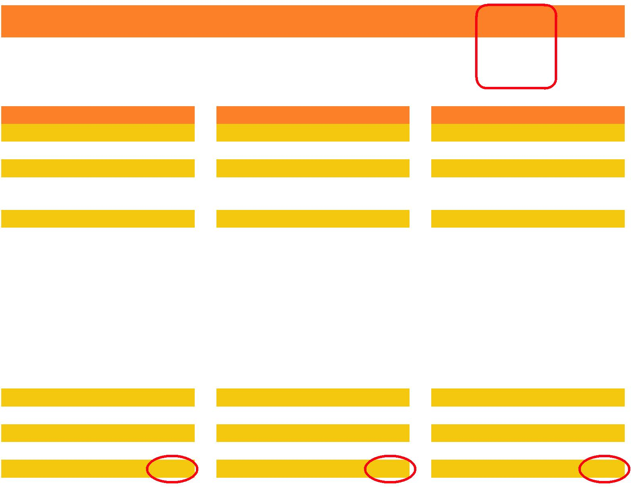
 |  |  |  | Severity
ETG | ETG description | Episode | Severity score | level
386800010 | Congestive heart failure, w/o complication, with comorbidity, w/o surgery | 2423 | 00000.6123 | 2
386500010 | Congestive heart failure, w/o complication, with comorbidity, w/o surgery | 2424 | 00001.9423 | 3
386500011 | Congestive heart failure, w/o complication, with comorbidity, with angioplasty | 2425 | 00003.0827 | 4

Episode 2423 |  |  |  | Episode 2424 |  |  |  | Episode 2425
Demographics |  | Weight |  | Demographics |  | Weight |  | Demographics |  | Weight
Male | 45 | 0.2733 |  | Male | 46 | 0.2733 |  | Male | 47 | 0.2733
Condition status |  |  |  | Condition status |  |  |  | Condition status
None |  |  |  | None |  |  |  | 70086 | Congestive heart failure | 1.1404
 |  |  |  |  |  |  |  |  | with diastolic heart failure
Comorbidities |  |  |  | Comorbidities |  |  |  | Comorbidities
80018 | Diabetes | 0.1513 |  | 80018 | Diabetes | 0.1513 |  | 80018 | Diabetes | 0.1513
80045 | Other hematologic | 0.1217 |  | 80045 | Other hematologic | 0.1217 |  | 80045 | Other hematologic | 0.1217
 | diseases |  |  |  | diseases |  |  |  | diseases
80171 | Ischemic heart disease | 0.0660 |  | 80171 | Ischemic heart disease | 0.0000 |  | 80171 | Ischemic heart disease | 0.0000
 |  |  |  | 80173 | Cardiomyopathy | 0.7395 |  | 80173 | Cardiomyopathy | 0.7395
 |  |  |  | 80375 | Acute renal failure | 0.0289 |  | 80375 | Acute renal failure | 0.0289
 |  |  |  |  |  |  |  | 80377 | Chronic renal failure | 0.0000
 |  |  |  |  |  |  |  | 80381 | Chronic renal | 0.0000
 |  |  |  |  |  |  |  |  | inflammation
 |  |  |  |  |  |  |  | 80383 | Nephrotic syndrome | 0.0000
Interactions |  |  |  | Interactions |  |  |  | Interactions
None |  |  |  | 80173 and 80375 |  | 0.6276 |  | 80173 and 80375 |  | 0.6276
Multiple counts |  |  |  | Multiple counts |  |  |  | Multiple counts
None |  |  |  | None |  |  |  | None
Total score |  | 0.6123 |  | Total score |  | 1.9423 |  | Total score |  | 3.0827

OptumInsight www.optuminsight.com Page 5

Symmetry ETG: Measuring health care with meaningful episodes of care White Paper

the weights assigned to each comorbidity and complication are shown here for demonstration purposes, but are not included in the output tables.)

The unweighted comorbidity is included in output tables for a complete view of the patient’s medical condition.

Severity scores are normalized to each base ETG. A severity score of 1.0 means that the episode has average expected resource costs, compared with other episodes of the same base ETG. Severity scores are relative: a severity score of 0.5 means that the episode has half, while a severity score of 2.0 means the episode has double the expected resource costs.

In addition to a severity score, each episode is assigned to a severity level. The severity level is determined by the episode’s severity score and also predetermined ranges for each level for a base ETG. As an example, diabetes employs four severity levels. Episodes with a severity score of:

- Less than 1.0 are assigned to Level 1

- 1.01 through 1.4 are assigned to Level 2

- 1.41 through 1.7 are assigned to Level 3

- 1.71 and above are assigned to Level 4

When the relative severity is plotted against the cost, the resulting chart clearly shows the pattern of costs increasing with episode complexity and severity. In most cases, there is a clear demarcation between severity levels.

Figure 2 shows how severity scores are fairly level for 60 percent of episodes of anxiety disorder or phobias. The severity scores then jump and again remain fairly level until they increase by about a third for the most severe 2 percent of episodes. The base ETG anxiety disorder or phobia therefore has three severity levels.

Figure 2.

Disease episodes vary in severity: anxiety disorder or phobias

 | 5
 | 4.5
 | 4
severity | 3.5
severity | 3
severity | 2.5
Relative | 2.5 |  |  |  |  | Level 3
Relative | 2 |  |  |  |  | Level 3
Relative | 1.5 |  |  |  |  | Level 2
 | 1
 | 0.5 |  |  |  |  |  |  | Level 1
 | 0
 | 0 | 10 | 20 | 30 | 40 | 50 | 60 | 70 | 80 | 90 | 100
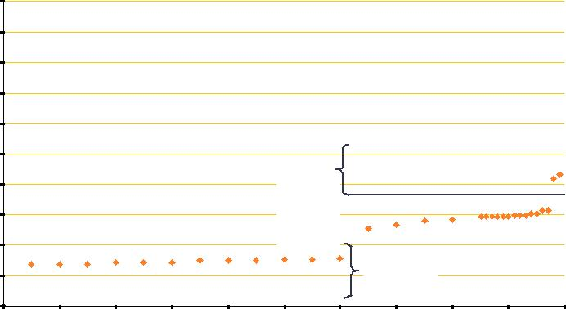
Percentile of costs incurred

Figure 3.

Disease episodes vary in severity: lymphoma

5
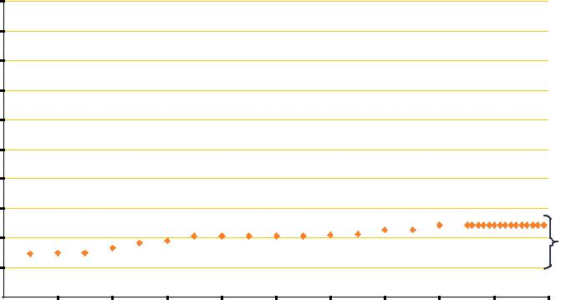
4.5

4

3.5 severity 3 2.5
Relative 2 1.5
1 | Level 1

0.5

0

0 10 20 30 40 50 60 70 80 90 100

Percentile of costs incurred

Episodes of anxiety disorder or phobia will be assigned a severity level of 1 if they are in the lowest risk category, 2 if they are in the middle risk category, and 3 if they are in the highest risk category.

In contrast, there is very little variation in severity of episodes of lymphoma, as seen in Figure 3. All episodes of lymphoma will be assigned a severity level of 1. No further severity assessment was indicated for episodes in this ETG beyond the base condition.

Each base ETG was assigned as many as four severity levels, determined by the base ETG’s unique pattern of increased severity. Therefore, the severity levels are closely correlated with actual data, which would not be the case if episodes were divided according to an arbitrary measure such as quartiles.

Clinical accuracy can be inferred from the statistical homogeneity of the cost within a severity grouping.

Outliers

Each combination of base ETG, severity level, and treatment indicator is assigned trim points that frame the normal range of costs for the combination. Episode costs outside the range are flagged as outliers. (Since complications and comorbidities are factored into the severity, as described in the previous section, they are not considered again in calculating outliers.) Outliers can be the result of inappropriate treatment; rare, extremely complicated cases; or simple coding error.

Trim points can be customized to create customer-specific outlier ranges.

Using complete non-outlier episodes, users can calculate a risk-adjusted value for cost or utilization measures that the provider’s immediate peers would be expected to generate if treating the same set of episodes within a base ETG, with the same case mix as measured by episode severity. Using this measure, a provider’s utilization decisions and costs can be validly compared with his or her peers.

OptumInsight www.optuminsight.com Page 6

Symmetry ETG: Measuring health care with meaningful episodes of care White Paper

Confinements

ETG builds individual confinements based on all claims associated with an inpatient stay, determined by the admit date and discharge date. The software then reviews all other claims, such as specialty inpatient consults, that occur within that time frame and assigns them to the confinement. As a default, each facility record would trigger a discrete confinement. Users can select the link facility records option to include facility records within the days allowed between confinements, with the same provider ID, and with the same bed type value, to join the confinement. The only exception is facility records that would extend the confinement beyond a year, unless the unlimited episode length option is activated.

Outputs

ETG produces a variety of output files. Users can confine their analyses to the main summary file or link the files to analyze the data for a wide range of purposes.

The primary output file is the summary file, used to analyze data by defining episodes of care as the medically meaningful unit of analysis. The precise configuration of the summary file is determined by whether various options were selected. For

example, the summarize complete episodes only option excludes episodes that have unknown start or end dates. These episodes may not have accrued all the relevant costs, so they could be misleading for comparative purposes.

The ETG numbering system clearly demonstrates whether or not the episode has a clinically relevant condition (including complications), comorbidity, or treatment. Each of these has its own output file that includes the specific data comprising a condition, comorbidity, or treatment. This information is critical to analyzing provider performance, as it provides the specific

factors that may have affected the management of the patient’s condition. Additionally, the information may be useful for the physicians who are managing those cases.

ETG also produces a patient comorbidity file of all comorbidities for each member. This file can be used as an input for future runs, to make sure a patient’s underlying health status is factored into disease severity.

The episode ETG file presents all the episodes that shifted base ETG during the grouping process. Analyses will demonstrate the disease progression and utilization pattern of the underlying condition.

The annual file includes the base ETG orphan record and orphan episodes. Therefore, it allows for analysis of members’ complete ETG costs, including those that do not, for example, fall within the clean period of a specific episode.

The phantom file presents the phantom clusters and phantom episodes, based on claims that were relevant to two or more episodes but whose costs could only be grouped to one episode

to avoid double-counting costs. These data can be linked to summary file episodes that contain only ancillary or pharmacy records to assess care and utilization for the entire episode.

Confinements can include episodes from many ETG. Therefore, the confinement file enables users to analyze all costs associated with the inpatient stay, whether or not the confinement is related to an episode.

Finally, users may want to determine whether a claim service record was included in an episode, a confinement, or both. An ETGINFO set of fields provides a link between the claims data and all output files. This function also allows the user to investigate the grouping results in detail.

All output files are described in detail in product documentation, along with business applications.

Summary

ETG takes analyzing and comparing health care utilization to a new level while retaining the signature integration with other Symmetry engines for consistent analysis.

The ETG numbering system streamlines analysis of episodes and directly presents factors that contribute to case mix. These factors are easily linked to the summative data. Similar, concurrent conditions are now grouped into one episode.

The severity scores provide unprecedented ability to distinguish between episodes, based on the patient’s underlying condition, episode-specific comorbidities, and demographics. The severity levels reflect the clinical reality of each base ETG—some have little variation while others demonstrate a wide range of utilization requirements.

Similarly, each ETG has a calibrated “normal” range of costs, outside of which episodes are deemed outliers.

ETG retains the Symmetry suite’s commitment to flexibility. Users have many options to select or override particular features

according to their business or analytic needs. Users can define the analysis year, as five options accommodate different types of data strength or weakness.

About Optum

Optum is an information and technology-enabled health services business platform serving the broad health marketplace, including care providers, plan sponsors, life sciences companies, and consumers. Its business units—OptumHealth™, OptumInsight, and OptumRx™—employ more than 30,000 people worldwide who are committed to enabling Sustainable Health Communities. For more information, visit www.optuminsight.com.

OptumInsight www.optuminsight.com Page 7

Symmetry ETG: Measuring health care with meaningful episodes of care White Paper

References

- Consistent with Symmetry’s signature transparency, the ETG Clinical Knowledgebase that describes the relationship of diagnosis and procedure codes to Base ETG and of Base ETG to Major Practice Categories (MPC) is now available with a click.

- Signs & Symptoms Anchor Records are one exception. These records are processed in reverse chronological order, allowing multiple pre-episodic claims to link together, re-setting the Start Date of an episode.

To learn more about Symmetry Episode Treatment Groups, please contact us at
800.765.6807 or empower@optum. com.

The views and opinions expressed herein are not necessarily those of Optum, its employees, or others. Optum provides this white paper for informational purposes only. It is not intended as advice for a particular situation, nor is it intended to be legal or professional advice. Consult with an appropriate professional for your situation.

The information in this document is subject to change without notice. This documentation contains proprietary
information, which is protected by U.S. and international copyright. Ingenix is now OptumInsight™,

part of Optum™—a leading health services business.

No part of this document may be reproduced or transmitted in any form or by any means, electronic or mechanical, include photocopying and recording, without the express written permission of Optum.


www.optum.com

13625 Technology Drive, Eden Prairie, MN 55344

Optum and its respective marks are trademarks of Optum, Inc. All other brand or product names are trademarks or registered marks of their respective owners. Because we are continuously improving our products and services, Optum reserves the right to change specifications without prior notice. Optum is an equal opportunity employer.

The views and opinions expressed herein are not necessarily those of Optum, its employees, or others. Optum provides this white paper for informational purposes only. It is not intended as advice for a particular situation, nor is it intended to be legal or professional advice. Consult with an appropriate professional for your situation.

12-28349 04/12 © 2012 Optum. All Rights Reserved.

Page 8

