 | Commonwealth of Massachusetts  City/Town of  System Pumping Record  Form 4  DEP has provided this form for use by local Boards of Health. Other forms may be used, but the information must be substantially the same as that provided here. Before using this form, check with your local Board of Health to determine the form they use. The System Pumping Record must be submitted to the local Board of Health or other approving authority within 14 days from the pumping date in accordance with 310 CMR 15.351.
 | A. Facility Information
Important: When filling out forms on the computer, use only the tab key to move your cursor - do not use the return key.  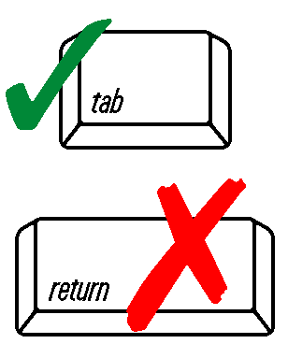 | 1. System Location:
 | Address
 | City/Town |  |  |  | State | Zip Code
 | 2. System Owner:
 | Name
Address (if different from location)

State

 | City/Town |  |  |  | State | Zip Code
 |  |  |  |  | Telephone Number
 | B. Pumping Record
 | 1. Date of Pumping | Date |  | 2. Quantity Pumped: |  | Gallons
 | 3. Component: Cesspool(s) Septic Tank Tight Tank Grease Trap
 | Other (describe):
 | 4. Effluent Tee Filter present? Yes No If yes, was it cleaned? Yes No
 | 5. Observed condition of component pumped:
 | 6. System Pumped By:
 | Name |  |  |  | Vehicle License Number
 | Company
 | 7. Location where contents were disposed:
 | Signature of Hauler |  |  |  | Date
 | Signature of Receiving Facility (or attach facility receipt) |  |  |  | Date

