Location | Carbon  Dioxide  (ppm) | Carbon Monoxide  (ppm) | Temp  (°F) | Relative  Humidity  (%) | PM2.5  (µg/m³) | Occupants  in Room | TVOCs (ppm) | Windows  Openable | Ventilation |  | Remarks
 |  |  |  |  |  |  |  |  | Supply | Exhaust
Background (outdoors) | 370 | ND | 57 | 23 | 10-15 |  | ND |  |  |  | Mostly Cloudy, cool
5th Floor
501 Mechanical Room | 554 | ND | 76 | 23 | 3 | 0 | ND | N
Electrical Room | 582 | ND | 73 | 23 | 3 | 0 | ND
4th Floor
423 | 518 | ND | 74 | 19 | 5 | 2 | ND | N | Y | N | DO
420 | 518 | ND | 74 | 19 | 1 | 0 | ND | N | Y | N | Fan coil unit, DO
416A | 549 | ND | 74 | 19 | 2 | 1 | ND | N | Y | Y | DO
Reg of Deeds (ROD) Receptionist | 498 | ND | 73 | 19 | 2 | 2 | ND | N | Y | Y | DO
ROD 407 | 470 | ND | 73 | 20 | 2 | 0 | ND | N | Y | Y | Dust/debris on vents, AP-filter light on
ROD 3018-3066 | 440 | ND | 73 | 21 | 1 | 1 | ND | N | Y | Y
ROD 6332-6478 | 448 | ND | 73 | 20 | 1 | 0 | ND | N | Y | Y
Administration | 485 | ND | 73 | 22 | 2 | 2 | ND | N | Y | Y
HR | 462 | ND | 72 | 23 | 1 | 0 | ND | N | N | N | Old/soiled carpet, PF, CF
401 | 455 | ND | 72 | 24 | 3 | 0 | ND | N | Y | Y | Interior window open, AP
402 | 448 | ND | 72 | 24 | 1 | 0 | ND | N | Y | Y
403 | 448 | ND | 73 | 22 | 2 | 0 | ND | N | Y | Y | WD CT, CF
403A | 529 | ND | 74 | 23 | 2 | 0 | ND | N | Y | Y | Computer equipment
403B | 449 | ND | 71 | 21 | 2 | 2 | ND | N | Y | Y | Wall mounted ACs
Publication Research Area | 490 | ND | 72 | 21 | 2 | 2 | ND | N | Y | Y
412 | 471 | ND | 72 | 20 | 7 | 1 | ND | N | Y | Y
Land Court | 482 | ND | 73 | 20 | 2 | 2 | ND | N | Y | Y
Archive Area | 424 | ND | 73 | 18 | 2 | 0 | ND | N | Y | Y | Dehumidifier
415 | 465 | ND | 72 | 21 | 7 | 0 | ND | N | Y  Blocked | Y
413 | 507 | ND | 72 | 22 | 2 | 0 | ND | N | Y | Y | AT-wiring, dehumidifier (full)
412 | 462 | ND | 74 | 19 | 5 | 0 | ND | N | Y | Y | Large printer-heat, portable AC-ducted, PF, CF
411 | 456 | ND | 72 | 20 | 3 | 1 | ND | N | Y | Y | PC, CF, discolored CTs, poor temperature control reported, shield on vent/louvers
409-410 | 479 | ND | 72 | 19 | 3 | 1 | ND | N | Y | Y | Dust/debris-vents, PF, CF, PC, AP
408 | 525 | ND | 72 | 19 | 2 | 1 | ND | N | Y | Y | CF, carpeting
408A | 513 | ND | 74 | 19 | 2 | 1 | ND | N | y | Y | PF, CF, carpeting
Front Desk Area | 490 | ND | 74 | 20 | 2 | 4 | ND | N | Y | Y | Carpeting
417 Kitchen | 580 | ND | 72 | 21 | 2 | 0 | ND | N | Y | Y | Refrigerator gasket-stained/mold
Probate Courtroom 1 | 534 | ND | 72 | 22 | 10 | 0 | ND | N | y | Y | Carpeting
Probate Courtroom 3 | 527 | ND | 71 | 22 | 2 | 0 | ND | N | Y | Y | Carpeting, dust/debris-vents/wall near ceiling
Conference Room A | 447 | ND | 71 | 23 | 2 | 0 | ND | N | Y | Y | Dust/debris-vents
Conference Room B | 566 | ND | 71 | 23 | 2 | 0 | ND | N | Y | Y | Dust/debris-vents
427 Employee Lounge | 630 | ND | 72 | 24 | 3 | 4 | ND | N | Y | Y | Dust/debris-vents, DO
426 | 584 | ND | 72 | 22 | 2 | 1 | ND | N | Y | Y | Dust/debris-vents, DO, CF
Probate Court Room 2 | 531 | ND | 72 | 23 | 2 | 0 | ND | N | Y | Y | PF, carpeting
Probate Court Room 4 | 529 | ND | 72 | 23 | 1 | 0 | ND | N | Y | Y
Conference Room B | 516 | ND | 72 | 22 | 3 | 0 | ND | N | Y | Y | 8 WD CT, MT
Conference Room A | 504 | ND | 71 | 22 | 3 | 0 | ND | N | Y | Y
428 | 583 | ND | 72 | 23 | 2 | 1 | ND | N | Y | Y | Carpet squares
428A | 532 | ND | 72 | 22 | 3 | 0 | ND | N | Y | Y | 3 WD CT
428B | 546 | ND | 73 | 21 | 2 | 0 | ND | N | Y | Y
Jury Pool | 471 | ND | 71 | 18 | 3 | 2 | ND | N | Y | Y | Dust/debris-vents, PF, carpet, plants
Jury Pool Rear | 470 | ND | 71 | 18 | 3 | 0 | ND | N | Y | Y | WD CTs, plants-leaking on countertop, dust/debris-vents
Registry of Probate (ROP) | 664 | ND | 71 | 22 | 3 | 8 | ND | N | Y | Y | AI, 6 WD CTs
Probate Work Area | 479 | ND | 72 | 20 | 2 | 9 | ND | N | Y | Y | Dust/debris-vents/CTs, PF, PC, 15+ WD CTs
Vault | 447 | ND | 70 | 25 | 3 | 2 | ND | N | Y | Y | Missing vents, dust/debris-vents, 10+ WD CTs
435 | 425 | ND | 69 | 21 | 3 | 0 | ND | N | Y | Y
434 | 420 | ND | 69 | 20 | 3 | 0 | ND | N | Y | Y | PF, dust/debris-vents
432 | 441 | ND | 70 | 20 | 3 | 0 | ND | N | Y | Y | Plants, dust/debris-vents, carpet
431 | 475 | ND | 71 | 22 | 2 | 1 | ND | N | Y | Y | Dust/debris-vents, carpeting, plants
431A | 452 | ND | 71 | 19 | 2 | 0 | ND | N | Y | Y | Dust/debris-vents
422 | 523 | ND | 73 | 18 | 3 | 0 | ND | N | Y | Y | Carpet tile
421 | 480 | ND | 72 | 17 | 3 | 0 | ND | N | Y | Y
419 | 514 | ND | 72 | 19 | 4 | 0 | ND | N | Y | Y | Plants
Reception-judges lobbies | 536 | ND | 72 | 19 | 3 | 2 | ND | N | Y | Y | Plants, AF
416B | 607 | ND | 72 | 19 | 4 | O | ND | N | Y | Y | Plants
3rd Floor
320A | 601 | ND | 73 | 23 | 2 | 0 | ND | N | Y | Y | Plants, WD CTs x 2
320 reception | 599 | ND | 74 | 21 | 2 | 0 | ND | N | Y | Y
320B | 604 | ND | 74 | 21 | 1 | 0 | ND | N | Y | Y | WD CT
317 | 597 | ND | 74 | 22 | 2 | 1 | ND | N | Y | Y
317B | 620 | ND | 74 | 21 | 3 | 1 | ND | N | Y | Y | Plants
317A | 553 | ND | 73 | 20 | 3 | 0 | ND | N | Y | Y | Renovations
315 | 550 | ND | 74 | 19 | 4 | 0 | ND | N | Y | Y | Personal heaters
Jury Room B | 639 | ND | 72 | 22 | 3 | 0 | ND | N | Y | Y
Jury Room A | 549 | ND | 72 | 21 | 1 | 0 | ND | N | Y | Y | WD CT
313A | 594 | ND | 71 | 25 | 4 | 2 | ND | N | Y | Y
Court Room 3 | 604 | ND | 71 | 23 | 4 | 0 | ND | N | Y | Y
Law Library-front | 606 | ND | 73 | 25 | 3 | 3 | ND | N | Y | Y
Training Room | 569 | ND | 73 | 20 | 3 | 0 | ND | N | Y | Y | Newly renovated
309 | 638 | ND | 75 | 26 | 3 | 0 | ND | N | Y | Y | Dust/debris on supply vent and ceiling
Library-rear | 582 | ND | 76 | 24 | 4 | 3 | ND | N | Y | Y | Broken window gaskets, missing ceiling tiles
Clerks- front | 596 | ND | 75 | 20 | 3 | 12 | ND | N | Y | Y | Carpet tile, DEM
Clerks- middle | 710 | ND | 75 | 22 | 4 | 12 | ND | N | Y | Y | HS, AF
304 | 650 | ND | 74 | 22 | 3 | 1 | ND | N | Y | Y | Personal heater, plants
302 | 643 | ND | 74 | 22 | 3 | 2 | ND | N | Y | Y | HS, AF, plants
303 | 618 | ND | 73 | 22 | 3 | 1 | ND | N | Y | Y | AI, blocked fan coil vent
Superior-Clerks | 612 | ND | 73 | 21 | 5 | 5 | ND | N | Y | Y | Dusty vents/soot
Superior-Probation | 629 | ND | 73 | 22 | 4 | 7 | ND | N | Y | Y | Dusty vents
338 | 665 | ND | 74 | 22 | 5 | 2 | ND | N | Y | Y | CPs
339 | 725 | ND | 74 | 22 | 4 | 2 | ND | N | Y | Y | CPs
343 | 655 | ND | 73 | 23 | 3 | 0 | ND | N | Y | Y | DEM
344 | 677 | ND | 72 | 23 | 4 | 0 | ND | N | Y | Y
341 | 677 | ND | 72 | 23 | 3 | 1 | ND | N | Y | Y
346 | 719 | ND | 72 | 27 | 3 | 2 | ND | N | Y | Y | NC
337 | 784 | ND | 73 | 26 | 4 | 2 | ND | N | Y | Y
340 | 661 | ND | 72 | 24 | 4 | 1 | ND | N | Y | Y | PF
342 | 656 | ND | 72 | 23 | 3 | 0 | ND | N | Y | Y | HS
Courtroom 6 | 541 | ND | 72 | 21 | 2 | 0 | ND | N | Y | Y
Courtroom 5 | 524 | ND | 72 | 21 | 1 | 0 | ND | N | Y | Y
Jury Room | 549 | ND | 73 | 20 | 2 | 1 | ND | N | Y | Y
Courtroom 2 | 539 | ND | 73 | 20 | 2 | 12 | ND | N | Y | Y
Courtroom 1 | 511 | ND | 72 | 20 | 1 | 0 | ND | N | Y | Y
347A | 559 | ND | 73 | 20 | 2 | 1 | ND | N | Y | Y
347 | 759 | ND | 74 | 20 | 2 | 0 | ND | N | Y | Y
Jury C | 492 | ND | 74 | 18 | 3 | 0 | ND | N | Y | Y
Jury D | 504 | ND | 73 | 18 | 4 | 0 | ND | N | Y | Y
DA- front | 570 | ND | 73 | 20 | 4 | 4 | ND | N | Y | Y
350 | 529 | ND | 74 | 20 | 2 | 0 | ND | N | Y | Y | AI
351 | 544 | ND | 74 | 20 | 1 | 0 | ND | N | Y | Y | DEM, HS, carpet
352 | 547 | ND | 73 | 20 | 2 | 0 | ND | N | Y | Y
358 | 581 | ND | 73 | 19 | 3 | 0 | ND | N | Y | Y | MT, dusty vents
359 | 542 | ND | 73 | 20 | 1 | 0 | ND | N | Y | Y | AI
353 | 557 | ND | 73 | 20 | 3 | 0 | ND | N | Y | Y | HS
360 | 530 | ND | 73 | 20 | 1 | 0 | ND | N | Y | Y | Holes/pathways
354 | 519 | ND | 72 | 19 | 2 | 0 | ND | N | Y | Y | HS
Break | 614 | ND | 73 | 20 | 3 | 4 | ND | N | Y | Y
361 | 505 | ND | 73 | 21 | 3 | 0 | ND | N | Y | Y
366 main | 510 | ND | 73 | 19 | 1 | 0 | ND | N | Y | Y
369 | 500 | ND | 72 | 20 | 1 | 0 | ND | N | Y | Y
368 | 509 | ND | 72 | 19 | 2 | 0 | ND | N | Y | Y | Carpet
367 | 516 | ND | 73 | 20 | 2 | 0 | ND | N | Y | Y | AI, HS, plants
Rear corner | 510 | ND | 73 | 19 | 3 | 0 | ND | N | Y | Y
2nd Floor
242 | 474 | ND | 70 | 22 | 3 | 0 | ND | N | Y | Y | Dust/debris-vents/CT, WD CTs
244 | 523 | ND | 70 | 22 | 3 | 0 | ND | N | Y | Y | Dust/debris-vents/CT, plants
241 | 496 | ND | 69 | 22 | 2 | 0 | ND | N | Y | Y | Dust/debris-vents
241A | 494 | ND | 69 | 23 | 3 | 0 | ND | N | Y | Y
District Courtroom 10 | 458 | ND | 71 | 21 | 2 | 0 | ND | N | Y | Y
District Courtroom 9 | 452 | ND | 72 | 20 | 2 | 2 | ND | N | Y | Y
G48 | 440 | ND | 70 | 24 | 2 | 0 | ND | N | Y | Y | Dust/debris-vents
Superior Courtroom 8 | 451 | ND | 72 | 20 | 2 | 0 | ND | N | Y | Y
Superior Courtroom 7 | 506 | ND | 72 | 20 | 2 | 0 | ND | N | Y | Y
District Courtroom 3 | 444 | ND | 72 | 20 | 2 | 0 | ND | N | Y | Y
District Courtroom 5 | 441 | ND | 72 | 20 | 3 | 0 | ND | N | Y | Y
District Courtroom 6 | 444 | ND | 72 | 20 | 2 | 0 | ND | N | Y | Y
228 Lounge | 533 | ND | 73 | 21 | 2 | 3 | ND | N | Y | Y
210A | 515 | ND | 74 | 19 | 2 | 1 | ND | N | Y | Y
210 | 501 | ND | 74 | 18 | 2 | 1 | ND | N | Y | Y | HS, plants
209 | 486 | ND | 74 | 18 | 2 | 0 | ND | N | Y | Y | Plants, WD CT
208 | 468 | ND | 73 | 19 | 3 | 0 | ND | N | Y | Y | Dusty vent
207 main | 482 | ND | 72 | 20 | 1 | 0 | ND | N | Y | Y | HS
Lobby B | 494 | ND | 73 | 21 | 1 | 0 | ND | N | Y | Y | Carpet, WD CT near window
Lobby A | 543 | ND | 73 | 22 | 2 | 1 | ND | N | Y | Y | Plants
206 | 523 | ND | 73 | 20 | 3 | 0 | ND | N | Y | Y
205 | 525 | ND | 72 | 20 | 4 | 1 | ND | N | Y | Y
204 | 514 | ND | 72 | 21 | 3 | 0 | ND | N | Y | Y | Plants, HS
Lobby B | 527 | ND | 72 | 21 | 1 | 0 | ND | N | Y | Y | Plants
Lobby A | 529 | ND | 72 | 22 | 2 | 1 | ND | N | Y | Y | WD CTs
246C | 501 | ND | 70 | 21 | 2 | 0 | ND | N | Y | Y | Plant
246 | 519 | ND | 69 | 21 | 2 | 0 | ND | N | Y | Y | Soiled carpet
246E | 545 | ND | 70 | 22 | 3 | 1 | ND | N | Y | Y | Missing ceiling tile
Jury | 499 | ND | 72 | 19 | 4 | 0 | ND | N | Y | Y | WD (buckets near window)
249A | 510 | ND | 73 | 19 | 3 | 1 | ND | N | Y | Y | Missing CT, carpet stained
249 | 505 | ND | 72 | 19 | 7 | 1 | ND | N | Y | Y | Old, soiled/torn carpet
Lobby B | 516 | ND | 72 | 19 | 10 | 1 | ND | N | Y | Y | WD CT (painted over)
250 | 554 | ND | 72 | 20 | 4 | 0 | ND | N | Y | Y | Vacant
Director security | 509 | ND | 73 | 19 | 3 | 1 | ND | N | Y | Y | AI
Chief court officer | 543 | ND | 72 | 19 | 3 | 1 | ND | N | Y | Y | WD CT
230 | 476 | ND | 71 | 19 | 3 | 0 | ND | N | Y | Y | Old lockup now storage
Small claims | 495 | ND | 72 | 20 | 3 | 9 | ND | N | Y | Y | Photocopier, HS
214 | 511 | ND | 72 | 19 | 3 | 0 | ND | N | Y | N
215 | 531 | ND | 72 | 20 | 3 | 0 | ND | N | Y | Y
213 | 533 | ND | 73 | 19 | 3 | 0 | ND | N | Y | Y
211 | 626 | ND | 73 | 21 | 2 | 2 | ND | N | Y | Y
1st Floor
121 | 480 | ND | 71 | 21 | 2 | 0 | ND | N | Y | Y | Carpeting
121A | 484 | ND | 72 | 22 | 2 | 0 | ND | N | Y | Y | 4 WD CT, Dust/debris-vents/CTs
121B | 488 | ND | 72 | 21 | 2 | 0 | ND | N | Y | Y | Dust/debris-vents/CTs, plants, 2 WD CTs
Police Room | 530 | ND | 71 | 21 | 3 | 3 | ND | N | Y | Y | Dust/debris-vents/CTs
109 | 522 | ND | 72 | 22 | 2 | 0 | ND | N | Y | Y | PC
DC Clerk Criminal | 508 | ND | 73 | 23 | 4 | 9 | ND | N | Y | Y | PC
104 | 515 | ND | 73 | 22 | 2 | 0 | ND | N | Y | Y
103 | 529 | ND | 72 | 22 | 3 | 0 | ND | N | Y | Y
102 | 601 | ND | 74 | 24 | 2 | 0 | ND | N | Y | Y | Plug-in AF
Cash Office | 663 | ND | 75 | 22 | 2 | 4 | ND | N | Y | Y | Carpeting, plants
108 | 503 | ND | 74 | 19 | 3 | 0 | ND | N | Y | Y | Dust/debris-vents/CTs
Prosecutor Main Work Area | 675 | ND | 72 | 22 | 2 | 3 | ND | N | Y | Y | CF
115 | 530 | ND | 72 | 21 | 8 | 0 | ND | N | Y | Y | Dust/debris-vents/CTs
116 | 509 | ND | 72 | 21 | 2 | 0 | ND | N | Y | Y | Dust/debris-vents/CTs, carpeting
117 | 491 | ND | 72 | 20 | 5 | 0 | ND | N | Y | Y | Dust/debris-vents/CTs, carpeting
119 | 496 | ND | 72 | 21 | 5 | 0 | ND | N | Y | Y | Dust/debris-vents/CTs
120 | 493 | ND | 72 | 21 | 2 | 3 | ND | N | Y | Y | Dust/debris-vents/CTs, carpeting
114 | 582 | ND | 72 | 21 | 2 | 3 | ND | N | Y | Y | Dust/debris-vents
138 | 577 | ND | 72 | 22 | 2 | 0 | ND | N | Y | Y | CF
Bar Association Lounge | 590 | ND | 72 | 23 | 4 | 5 | ND | N | Y | Y | Dust/debris-vents/CTs
137 | 600 | ND | 73 | 23 | 1 | 3 | ND | N | Y | Y | Dust/debris-vents/CTs
138 | 540 | ND | 72 | 22 | 2 | 0 | ND | N | Y | Y | Dust/debris-vents, carpet, WD CT
135 | 536 | ND | 72 | 21 | 2 | 1 | ND | N | Y | Y | Dust/debris-vents, WD CTs, carpet
167 | 519 | ND | 73 | 21 | 3 | 7 | ND | N | Y | Y | Dust/debris-vents, carpet squares
145 | 479 | ND | 73 | 20 | 2 | 0 | ND | N | Y | Y
146 | 525 | ND | 75 | 21 | 3 | 1 | ND | N | Y | Y
147 | 563 | ND | 74 | 22 | 20 | 1 | ND | N | Y | Y | 3 WD CTs, AF odors
148 | 537 | ND | 74 | 19 | 3 | 0 | ND | N | Y | Y | Plants
149 | 470 | ND | 73 | 19 | 3 | 0 | ND | N | Y | Y | Plants, dust/debris-vents/CTs
150 | 562 | ND | 73 | 20 | 3 | 2 | ND
151 | 537 | ND | 74 | 19 | 2 | 1 | ND | N | Y | Y | Plants
152 | 508 | ND | 74 | 20 | 4 | 0 | ND | N | Y | Y
153 | 528 | ND | 75 | 18 | 3 | 1 | ND | N | Y | Y | Loose vent
143 | 577 | ND | 75 | 19 | 3 | 3 | ND | N | Y | Y | Dust/debris-vents
155 | 511 | ND | 75 | 19 | 6 | 0 | ND | N | Y | Y | WD CT
156 | 514 | ND | 74 | 18 | 5 | 0 | ND | N | Y | Y
Break Area | 523 | ND | 75 | 19 | 4 | 1 | ND | N | Y | Y
160 | 495 | ND | 76 | 17 | 4 | 0 | ND | N | Y | Y
159 | 545 | ND | 75 | 19 | 4 | 1 | ND | N | Y | Y | Dust/debris-vents
158 | 443 | ND | 75 | 17 | 3 | 0 | ND | N | Y | Y | Dust/debris-vents/cobwebs
157 | 550 | ND | 75 | 20 | 4 | 1 | ND | N | Y | Y
142 | 487 | ND | 75 | 18 | 3 | 2 | ND | N | Y | Y | Dust/debris-vents
141 | 450 | ND | 75 | 17 | 3 | 0 | ND | N | Y | Y
161 | 507 | ND | 75 | 18 | 3 | 2 | ND | N | Y | Y
164 | 536 | ND | 75 | 17 | 3 | 0 | ND | N | Y | Y
163 | 661 | ND | 75 | 17 | 7 | 0 | ND | N | Y | Y | Dust/debris-vents/CT
166 | 470 | ND | 75 | 17 | 4 | 0 | ND | N | Y | Y | Dust/debris-vents/CT
165 | 525 | ND | 75 | 18 | 3 | 1 | ND | N | Y | Y | Dust/debris-vents
140 | 569 | ND | 75 | 18 | 5 | 2 | ND | N | Y | Y | Dust/debris-vents
138 | 463 | ND | 75 | 17 | 3 | 1 | ND | N | Y | Y | Dust/debris-vents, WD CT
131 | 527 | ND | 74 | 19 | 2 | 1 | ND | N | Y | Y
District Courtroom 2 | 462 | ND | 74 | 18 | 3 | 2 | ND | N | Y | Y
Main Lobby | 478 | ND | 71 | 19 | 4 | 15 | ND | N | Y | Y

Location | Carbon  Dioxide  (ppm) | Carbon Monoxide  (ppm) | Temp  (°F) | Relative  Humidity  (%) | PM2.5  (µg/m³) | Occupants  in Room | TVOCs (ppm) | Windows  Openable | Ventilation |  | Remarks
 |  |  |  |  |  |  |  |  | Supply | Exhaust
Background (outdoors) | 470 | ND | 54 | 78 | 44 | - | ND | - | - | -
District Courtroom 1 | 520 | ND | 73 | 45 | 3 | 0 | ND | N | Y | Y | Dust/debris-vents
District Courtroom 4 | 514 | ND | 72 | 46 | 3 | 0 | ND | N | Y | Y
Conference Room A | 533 | ND | 73 | 45 | 5 | 0 | ND | N | Y | Y | Dust/debris-vents
Conference Room B | 504 | ND | 72 | 46 | 3 | 6 | ND | N | Y | Y
Wood Shop | 672 | ND | 67 | 51 | 19 | 4 | ND | N | Y | N | DIY large particulate wood dust filter (recirculates only)

Location | Mercury Level  (µg/m³)
Background (outdoors) | 0.019
4th Floor
422 | 0.007
421 | 0.010
420 | 0.010
419 | 0.011
4th floor elevator lobby | 0.012
428 | 0.011
428 R | 0.012
428 L | 0.010
430 | 0.011
Jury Pool | 0.013-0.015
Probate Court 4 | 0.014
Probate reception | 0.016
Probate vault | 0.002-0.009
439 | 0.003
437 | 0.004
435 | 0.005
431 A | 0.009
434 | 0.013
433 | 0.013
432 | 0.013
431 | 0.012
Main lobby | 0.010-0.014
Deed reception | 0.013
407 | 0.013
Deeds stacks | 0.009-0.012
Deeds front desk | 0.009-0.011
Deeds printer | 0.010
Deeds corner office | 0.010
403 | 0.009
404 | 0.008
408A | 0.010
406 | 0.011
409 | 0.009
411 | 0.012
Deeds recorder | 0.009
412 | 0.009
413 | 0.009
Deeds archives | 0.009
402 | 0.007
401 | 0.006
Deeds breakroom | 0.010
3rd Floor
331 | 0.010
347B | 0.010
347 | 0.010
347A | 0.011
348 | 0.009
320 A | 0.010
320 B | 0.010
320 | 0.009
3rd floor elevator lobby | 0.010
3rd floor lock up | 0.009
330 | 0.007
334 | 0.008
DA reception | 0.011
DA office | 0.008
DA assistant | 0.008
366 | 0.008
DA office | 0.010
361 | 0.011
368 | 0.009
369 | 0.010
361 | 0.009
363 | 0.008
362 | 0.007
364 | 0.007
367 | 0.009
365 | 0.010
373 | 0.009
372 | 0.007
371 | 0.002
DA break room | 0.006
360 | 0.008
354 | 0.008
353 | 0.010
359 | 0.009
358 | 0.008
352 | 0.009
351 | 0.009
356 | 0.007
350 | 0.008
350 A | 0.009
336 | 0.007
337 | 0.008
346 | 0.004
342 | 0.007
341 | 0.008
305 | 0.007
302 | 0.009
310 | 0.008
309 | 0.007
Probation reception | 0.010
Probation main desk | 0.009
342 | 0.005
345 | 0.007
344 | 0.005
343 | 0.006
339 | 0.006
340 | 0.006
302 | 0.008
303 | 0.007
304 | 0.005
Superior Clerk Civil | 0.009
Superior Clerk Criminal | 0.009
Library | 0.007
320 A | 0.009
320 B | 0.009
320 | 0.009
317 B | 0.010
317 A | 0.009
317 | 0.008
315 | 0.007
3rd floor jury room B | 0.009
2nd Floor
District Clerk of Court reception | 0.010
District Clerk of Court main office | 0.009
211 | 0.009
District Clerk of Court | 0.010
228 | 0.009
213 | 0.010
212 | 0.011
215 | 0.011
District Clerk of Court vault | 0.008
District Clerk of Court conference room | 0.008
218 | 0.010
219 | 0.009
214 | 0.007
230 | 0.009
Court office | 0.010
Director of Security  HCBA | 0.010
246 C | 0.010
246 | 0.010
249 A | 0.010
249 B | 0.011
210A | 0.002
210 | 0.002
209 | 0.003
208 | 0.002
204 A | 0.005
204 | 0.002
204 B | 0.004
205 | 0.003
207 A | 0.002
207 | 0.002
207 B | 0.003
1st Floor
Main lobby | 0.008
District Court cash office | 0.010
105 | 0.010
107 | 0.008
102 | 0.007
103 | 0.006
104 | 0.007
111 | 0.006
District Court criminal clerk | 0.006
108 | 0.007
109 | 0.007
Break room | 0.007
Clerk of Court office | 0.009
101 | 0.006
198 A | 0.009
Court service | 0.010
124 | 0.009
140 | 0.010
140 A | 0.011
121 B | 0.010
121 | 0.009
121 A | 0.008
District Court Probation | 0.011
Probation Main Office | 0.009
143 | 0.008
145 | 0.007
146 | 0.007
147 | 0.008
148 | 0.007
149 | 0.009
150 | 0.009
151 | 0.009
152 | 0.010
153 | 0.010
157 | 0.009
154 | 0.008
158 | 0.009
155 | 0.008
159 | 0.008
156 | 0.007
160 | 0.007
Lounge | 0.008
164 | 0.009
163 | 0.007
166 | 0.009
162 | 0.005
Attorney lounge | 0.002
107 | 0.002
DA office | 0.002
DA office | 0.002
108A | 0.003
161 | 0.005
165 | 0.004
162 | 0.006
DA Conference room | 0.002
DA Main office | 0.002
DA office | 0.002
DA office | 0.002
DA break room | 0.002
115 | 0.002
120 | 0.002
119 | 0.002
117 | 0.002
116 | 0.002
Main Lobby security | 0.002
Main Lobby Information desk | 0.003
Court Sessions
DC court 4 | 0.003
DC court 3 | 0.005
DC court 5 | 0.005
DC court 6 | 0.004
DC court 1 | 0.004
DC court 2 | 0.005
DC court 7 | 0.004
DC court 8 | 0.003
DC court 9 | 0.003
DC court 11 | 0.002
SC court 2 | 0.005
SC court 1 | 0.004
SC court 4 | 0.004
SC court 3 | 0.004
SC court 5 | 0.003
SC court 6 | 0.003
Ground floor
G Snack Bar | 0.006
G38 | 0.008

HVAC component | Expected Service Life Defined by ASHRAE, | Current Age of equipment beyond ASHRAE service life (date of construction = 1973) | Percentage of Exceedance of Actual Service Life compared to ASHRAE service life
Fan coil unit | 20 | 45 | 225 %
Ductwork | 30 | 45 | 150 %
Dampers | 20 | 45 | 225 %
Insulation, molded | 20 | 45 | 225 %
Insulation blankets | 24 | 45 | 180 %
Controls electric | 16 | 45 | 280 %
Controls electronic | 15 | 45 | 300 %
Air terminals-diffusers, grilles and registers | 27 | 45 | 167 %

Picture 1
View of Roderick Ireland Courthouse (RIC) from I-91
Picture 2

RIC

HJC
RIC and Housing-Juvenile Court (HJC)
Picture 3
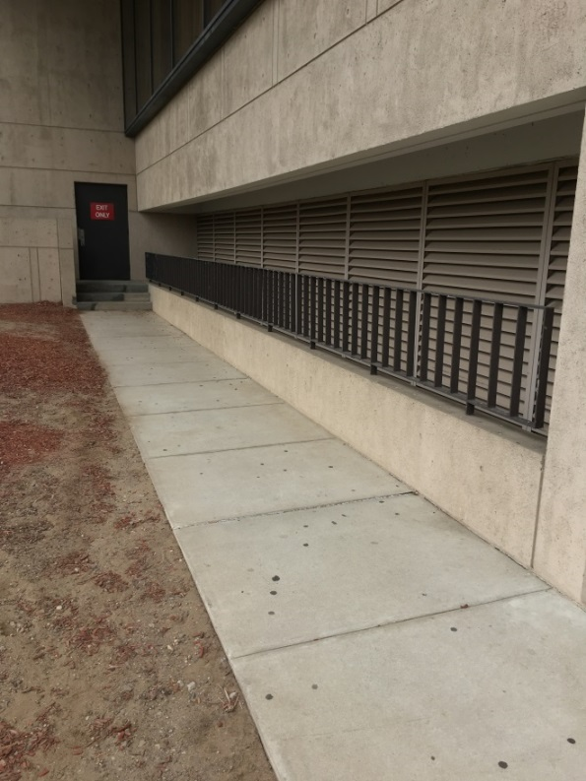
Ground level HVAC system fresh air intake
Picture 4
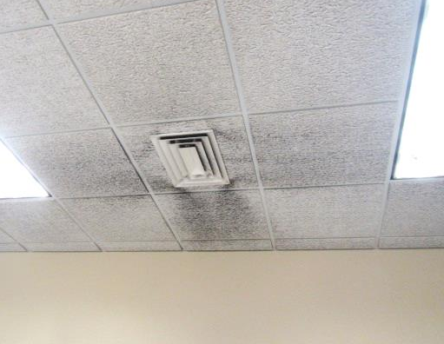
Fresh air diffuser (Note discoloration on ceiling tiles)
Picture 5
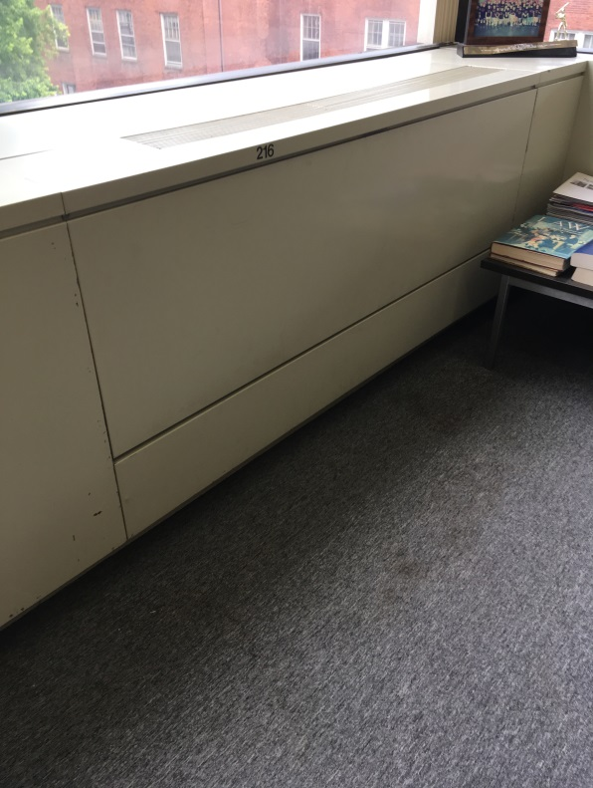
Fan coil unit (FCU)
Picture 6
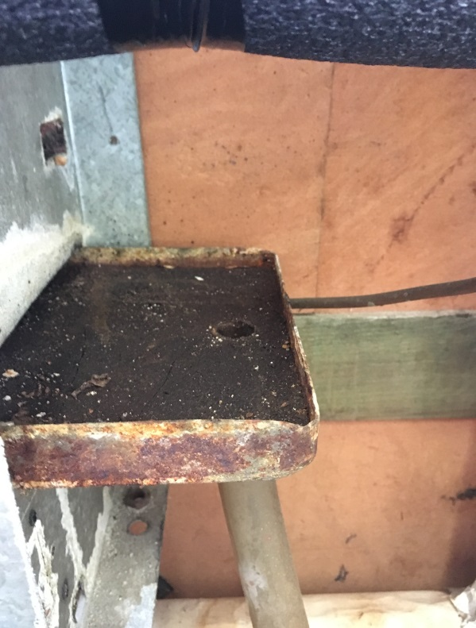
Condensation collector coated with scale
Picture 7
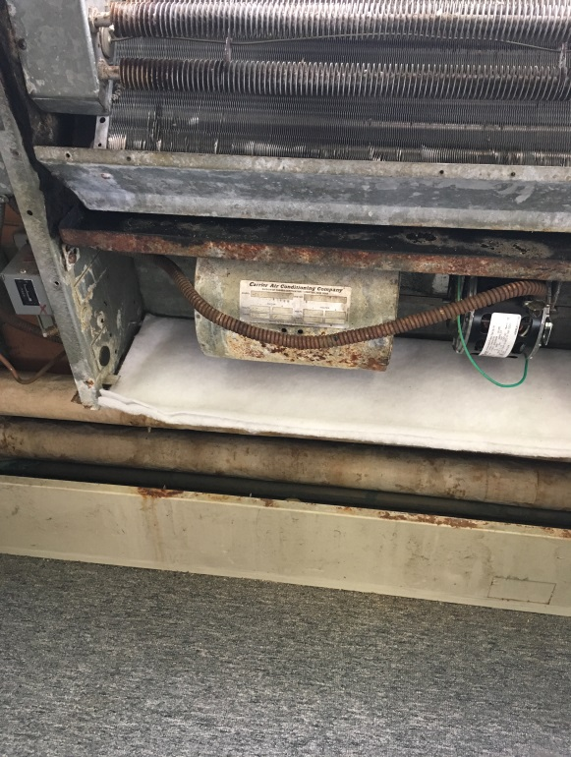
Corrosion on FCU motor cover, flexible steel electric conduit, and the underside of the drip pan
Picture 8
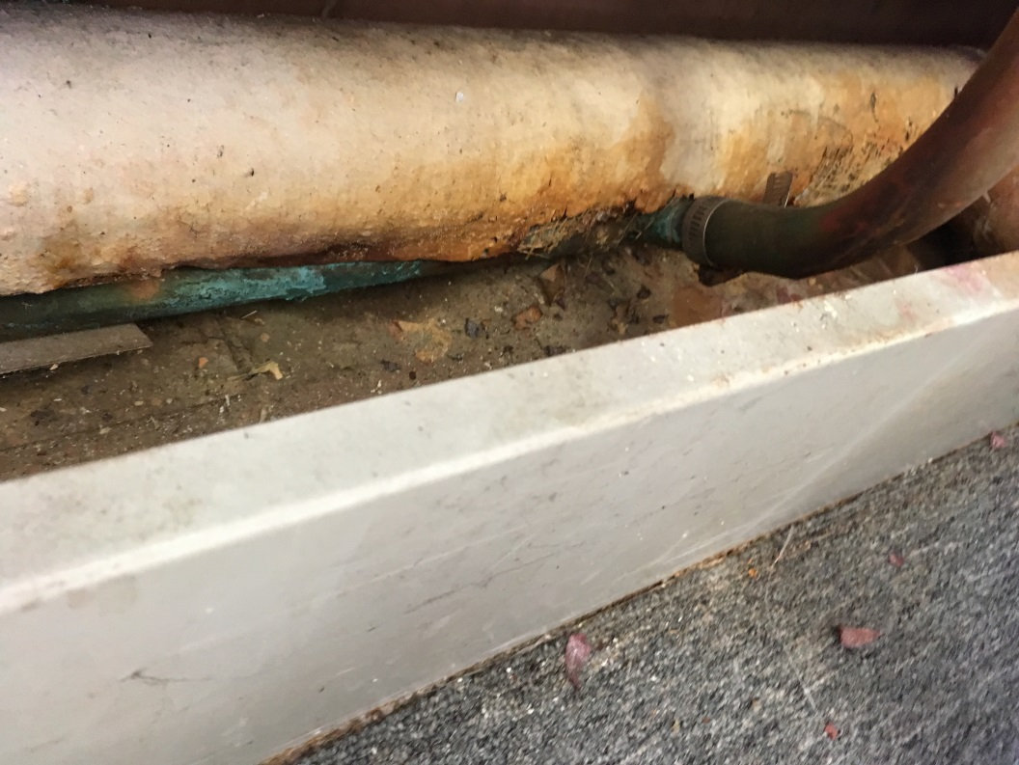
An uninsulated copper pipe beneath water-damaged fiberglass insulation
Picture 9
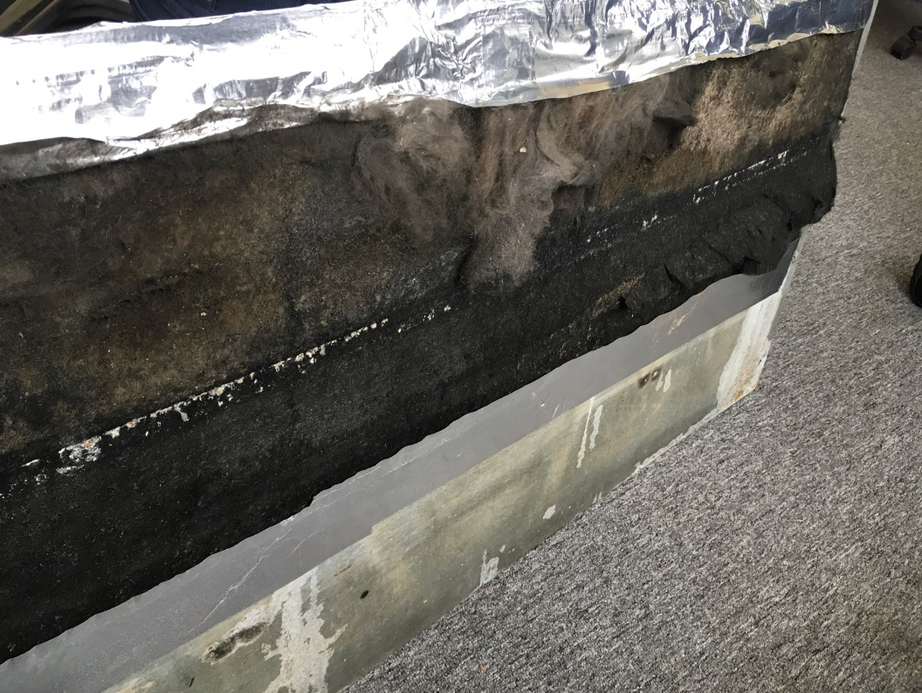
Frayed insulation on FCU cover
Picture 10
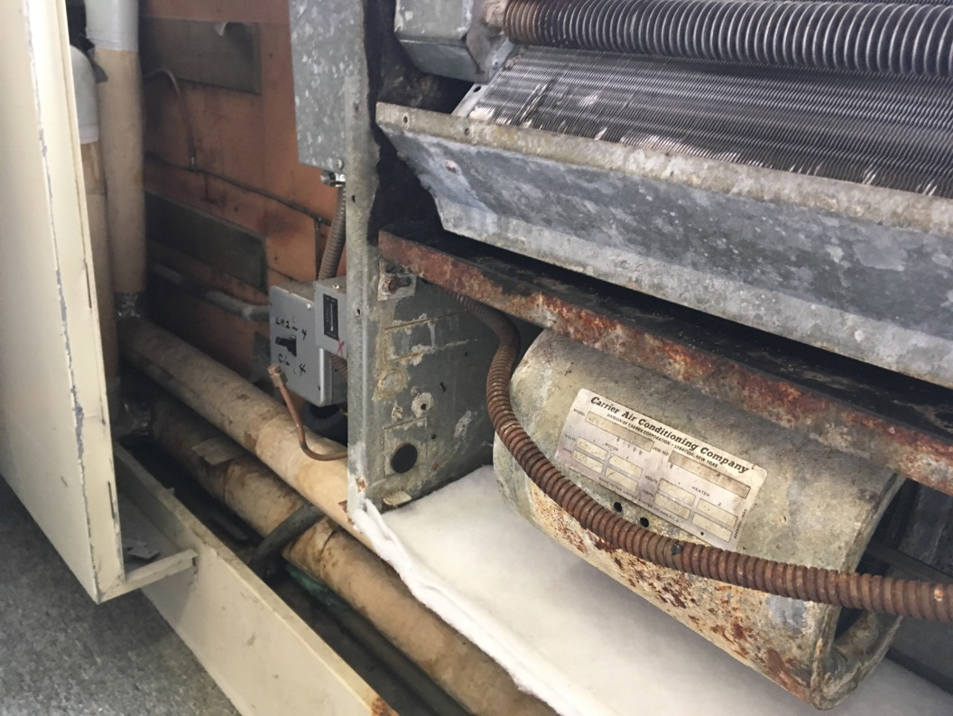
FCU filter medium that needs to be physically cut to size
Picture 11
Dust/debris/staining on vents and surrounding ceiling tiles
Picture 12
Dust/debris/staining on vents and surrounding ceiling tiles
Picture 13
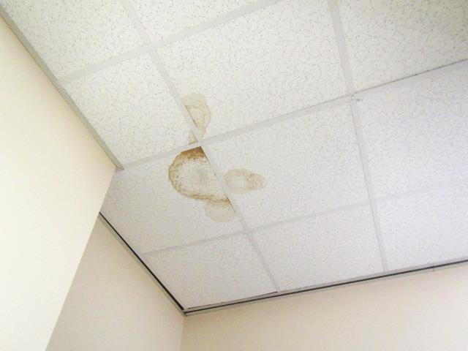
Water-damaged ceiling tiles
Picture 14
Water-damaged ceiling tiles
Picture 15
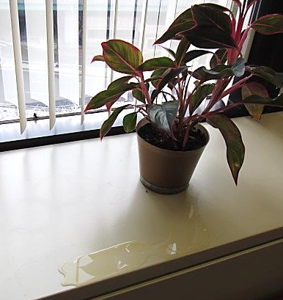
Plant with leaking water on countertop

Expected service life with routine maintenance. Service life can be reduced if equipment was not routinely maintained.
ASHRAE 1991 Applications Handbook, Table 3, page 33.3

