Location | Carbon  Dioxide  (ppm) | Carbon Monoxide  (ppm) | Temp  (°F) | Relative  Humidity  (%) | PM2.5  (µg/m³) | Occupants  in Room | TVOCs (ppm) | Windows  Openable | Ventilation |  | Remarks
 |  |  |  |  |  |  |  |  | Supply | Exhaust
Background (outdoors) | 470 | ND | 54 | 78 | 44 | - | ND | - | - | - | Light rain
Basement
B9 Utility | 756 | ND | 75 | 45 | 27 | 1 | ND | N | Y | Y | Dust/debris-vents
B10 | 773 | ND | 71 | 41 | 12 | 0 | ND | N | Y | Y | Dust/debris-vents
B11 | 852 | ND | 72 | 38 | 7 | 5 | ND | N | Y | Y | Dust/debris-vents/CTs, ATs
B14 | 613 | ND | 72 | 43 | 4 | 0 | ND | N | Y | Y | Air purifier
Utility/Records Storage | 737 | ND | 70 | 43 | 12 | 0 | ND | N | Y | Y
B17 | 770 | ND | 74 | 37 | 11 | 0 | ND | N | Y | Y | Air handling unit-moldy box/panel space
B21 | 780 | ND | 74 | 41 | 8 | 0 | ND | N | Y | Y | Soiled carpet/wrinkled
B22 | 773 | ND | 73 | 42 | 4 | 0 | ND | N | Y | N
B23 | 820 | ND | 71 | 44 | 4 | 0 | ND | N | Y | Y | Peeling paint, efflorescence wall, dust/debris-vents
B26 | 799 | ND | 72 | 44 | 4 | 0 | ND | N | Y | Y | Dust/debris-vents
B28 | 773 | ND | 74 | 43 | 5 | 1 | ND | N | Y | Y | Dust/debris-vents, carpet squares
B30 Conf Rm | 775 | ND | 72 | 43 | 5 | 0 | ND | N | Y | Y | Carpeting
B33 | 837 | ND | 73 | 43 | 4 | 1 | ND | N | Y | Y
B34 | 800 | ND | 72 | 44 | 4 | 0 | ND | N | Y | Y | Dust/debris-vents, carpeting
B35 | 767 | ND | 71 | 43 | 5 | 0 | ND | N | Y | Y | DO, carpeting
B36 | 780 | ND | 72 | 44 | 5 | 0 | ND | N | Y | Y | Carpeting
B37 | 870 | ND | 72 | 45 | 4 | 2 | ND | N | Y | Y | Carpeting, DO
B39 | 718 | ND | 69 | 32 | 3 | 0 | ND | N | Y | Y
B48 Hallway | 765 | ND | 71 | 33 | 4 | 0 | ND | N | Y | Y | Peeling paint, efflorescence wall
B58 | 777 | ND | 69 | 44 | 4 | 0 | ND | N | Y | Y | Chronic clogs reported-sewer line (odors), records storage, boxes on floor, AF
B61 | 742 | ND | 70 | 32 | 4 | 2 | ND | N | Y | Y
1st Floor
Public Waiting area (1st floor) | 1304 | ND | 68 | 50 | 15 | 7 | ND | N | Y | Y
151 | 1589 | ND | 70 | 46 | 16 | 3 | ND | N | Y | Y | Carpet
Conference B | 1505 | ND | 72 | 42 | 19 | 2 | ND | N | Y | N
132 | 1137 | ND | 73 | 43 | 16 | 12 | ND | Y | Y | Y | Carpet, CPs, HS
144 | 1061 | ND | 73 | 43 | 15 | 2 | ND | N | Y | Y | AI
138 | 1053 | ND | 72 | 44 | 17 | 1 | ND | Y | Y | Y | Carpet
137 | 1018 | ND | 72 | 44 | 15 | 0 | ND | Y | Y | Y | Heat pumps
130 | 1006 | ND | 72 | 44 | 17 | 0 | ND | Y | Y | Y
135 | 1166 | ND | 73 | 57 | 88* | 2 | 35-40* | Y | Y | Y | *Floor cleaning in progress
126 | 924 | ND | 73 | 42 | 15 | 0 | ND | Y | Y | Y | Carpet
102-Clerks | 1013 | ND | 74 | 44 | 15 | 11 | ND | Y | Y | Y | Carpet
116 | 981 | ND | 75 | 43 | 14 | 0 | ND | Y | Y | Y | Plants
101 | 1002 | ND | 75 | 43 | 15 | 2 | ND | Y | Y | Y | Carpet tile
115 | 849 | ND | 76 | 41 | 14 | 1 | ND | Y | Y | Y | Carpet
Hall near 110 | 987 | ND | 76 | 41 | 14 | 1 | ND | Y | Y | Y
Courtroom 2 | 1151 | ND | 75 | 34 | 11 | 5 | ND | N | Y | Y
120 | 1069 | ND | 75 | 35 | 8 | 0 | ND | Y | Y | Y | Carpet
Conference A | 1273 | ND | 72 | 37 | 9 | 0 | ND | N | Y | Y
151 Hall | 1314 | ND | 72 | 37 | 7 | 0 | ND | N | Y | Y
Juvenile Foyer 150 Hall | 1218 | ND | 72 | 39 | 9 | 3 | ND | N | N | N
123 Hall | 1223 | ND | 73 | 41 | 8 | 4 | ND | N | N | N | WD plaster ceiling
106 Foyer | 1138 | ND | 74 | 37 | 10 | 5 | ND | N | N | N
152 (Court) | 1591 | ND | 68 | 45 | 16 | session ended 5 min ago | ND | Y | Y | Y | Old, soiled carpet
2nd Floor
Housing Court Lobby | 978 | ND | 73 | 45 | 8 | 3 | ND | N | Y | Y
Court Room 2 | 826 | ND | 72 | 41 | 8 | 0 | ND | N | Y | Y | Carpeting
202 Judge’s Lobby | 897 | ND | 76 | 39 | 7 | 1 | ND | N | Y | N | Restroom-no exhaust
208 | 910 | ND | 70 | 47 | 6 | 0 | ND | N | Y | Y | Peeling wallpaper, WD CT
215 | 871 | ND | 68 | 47 | 6 | 0 | ND | N | Y | Y
216 | 969 | ND | 76 | 38 | 5 | 1 | ND | N | Y | N
220 | 869 | ND | 71 | 46 | 8 | 0 | ND | N | Y | Y
235 | 690 | ND | 71 | 43 | 2 | 0 | ND | N | Y | Y | Carpeting
243 | 1065 | ND | 73 | 39 | 8 | 0 | ND | N | Y | Y | HS
242 | 930 | ND | 73 | 39 | 9 | 0 | ND | N | Y | Y | Non-ducted return
241 | 1224 | ND | 73 | 40 | 7 | 0 | ND | Y | Y | Y | Plants
249 | 1048 | ND | 72 | 42 | 6 | 1 | ND | Y | Y | Y | HS, AF
250 | 894 | ND | 72 | 40 | 7 | 0 | ND | Y | Y | Y | Carpet
251 | 1068 | ND | 71 | 44 | 9 | 1 | ND | Y | Y | Y | WD from units/roof
252 | 1095 | ND | 71 | 43 | 10 | 1 | ND | Y | Y | Y | HS
254 | 1052 | ND | 70 | 43 | 10 | 1 | ND | Y | Y | N | Plants, CP
253 | 1144 | ND | 70 | 44 | 8 | 1 | ND | Y | Y | N | HS
247 | 1101 | ND | 70 | 43 | 9 | 0 | ND | N | Y | N
246 | 1044 | ND | 70 | 44 | 9 | 0 | ND | N | Y | N | Missing CT
245 | 990 | ND | 71 | 42 | 8 | ND | ND | Y | Y | Y | Dusty vents
Hall outside 245 | - | - | - | - | - | - | - | - | - | - | WD CTs
226 | 980 | ND | 72 | 41 | 7 | 0 | ND | N | Y | Y | HS
223 | 922 | ND | 72 | 41 | 6 | 0 | ND | Y | Y | Y | Musty odor
240 | 1119 | ND | 73 | 42 | 8 | 2 | ND | Y | Y | Y | HS
227 | 1069 | ND | 73 | 41 | 8 | 1 | ND | N | Y | Y | HS, AI
239 | - | - | - | - | - | - | - | - | - | - | Small unoccupied room w/fridge and old janitor sink, WD plaster, efflorescence
232 | 993 | ND | 74 | 39 | 7 | 1 | ND | N | Y | Y | Old carpet, debris in vent
222 (Courtroom 1) | 952 | ND | 72 | 45 | 12 | 1 | ND | N | Y | Y | WD ceilings
3rd Floor
328 | 1152 | ND | 74 | 38 | 7 | 4 | ND | N | Y | Y | Carpet
323 | 1146 | ND | 73 | 37 | 6 | 2 | ND | Y | Y | Y
324 | 1196 | ND | 73 | 39 | 7 | 0 | ND | N | Y | Y | WD CT, HS
325 | 1147 | ND | 73 | 38 | 6 | 1 | ND | N | Y | Y | HS, personal heater
326 | 1158 | ND | 74 | 38 | 7 | 0 | ND | Y | Y | Y | WD CT near return vent
338 | 1098 | ND | 74 | 36 | 6 | 7 | ND | Y | Y | Y | Carpet
344 Storage | - | - | - | - | - | - | - | - | - | - | WD
339 File storage | - | - | - | - | - | - | - | - | - | - | Dusty vent
346 | 1098 | ND | 73 | 37 | 7 | 1 | ND | Y | Y | Y | AF (reeds), WD CT
347 | 991 | ND | 70 | 36 | 6 | 0 | ND | Y | Y | Y | WD CT
342 | 968 | ND | 68 | 39 | 5 | 0 | ND | Y | Y dusty | Y | Electric baseboard
341 | 1004 | ND | 67 | 40 | 5 | 0 | ND | Y | Y | Y | HS
336 | 1036 | ND | 68 | 45 | 6 | 0 | ND | Y | Y | Y
300 Conf Room | 741 | ND | 71 | 44 | 3 | 0 | ND | N | Y | Y | Carpeting
301 | 873 | ND | 71 | 43 | 4 | 1 | ND | N | Y | Y | 4 WD CT, carpeting
305 | 861 | ND | 71 | 44 | 2 | 0 | ND | N | Y | Y | Carpeting, plants
307 Break Room | 854 | ND | 72 | 44 | 58* | 3 | ND | N | Y | Y | *Elevated PM2.5 from burnt food/toaster
321 | 792 | ND | 71 | 43 | 3 | 0 | ND | N | Y | Y | Carpeting
322 | 824 | ND | 71 | 44 | 9 | 1 | ND | N | Y | Y | Dust/debris-vents, DO, carpeting

Location | Mercury Level  (µg/m³)
Background (outside) | 0.016 -0.019
337 | 0.118
336 | 0.100
348 | 0.081
340 | 0.121
342 | 0.122
343 | 0.125
341 | 0.112
330 | 0.121
334 | 0.122
347 | 0.120
338 | 0.124
328 | 0.131
323 | 0.130
324 | 0.127
325 | 0.125
326 | 0.119
252 | 0.108
245 | 0.102
254 | 0.108
247 | 0.109
253 | 0.106
251 | 0.102
244 | 0.108
250 | 0.105
242 | 0.103
240 | 0.122
227 | 0.117
239 | 0.118
249 | 0.101
155 | 0.261
151 | 0.213
151C | 0.322
151B | 0.341
151A | 0.336
124 | 0.188
132 | 0.080
144 | 0.074
142 | 0.073
138 | 0.077
137 | 0.076
130 | 0.076
136 | 0.078
135 | 0.080
126 | 0.069
Juvenile Court Foyer | 0.155
Housing Court Foyer | 0.069
116 | 0.054
Housing Clerk | 0.056
101 | 0.053
115 | 0.024
119 | 0.151
215 | 0.059
220 | 0.053
235 | 0.052
227 | 0.077
226 | 0.088
B47 | 0.422
B57 | 0.426
B46 | 0.228
B39 | 2.755
B39 B1 cell | 3.220
B39 B2 cell | 1.350
B39 B3 cell | 1.700
B39 B4 cell | 1.510
B39 interior room | 1.185
B15 | 0.065
B04 | 0.062
B04 interior room | 0.066
B15 | 0.067

Location | Mercury Level  (µg/m³)
Background (Outdoors) | 0.007
Garage | 0.002
B13 | 0.193
B16 | 0.183
B48 Hallway | 1.505
B39 Cell Control | 2.137
B39 B1 Cell | 6.378
B39 B2 Cell | 2.078
B39 B3 Cell | 0.658
B39 B4 Cell | 0.948
B39 Toilet | 0.922
B46 Mechanical Room | 0.375
B46 inside vent duct | 0.550
B17 Mechanical Room | 0.112
B17 inside vent duct | 0.115
B47 | 0.444
B61 | 0.526
B61 A10 | 0.515
B61 A09 | 0.560
B61 A08 | 0.507
B61 A07 | 0.527
B61 A06 | 0.529
B61 A05 | 0.505
B61 A04 | 0.518
B61 A03 | 0.527
B61 A02 | 0.427
B61 A01 | 0.541
B51 elevator mechanical room | 1.568
151c | 0.411
151b | 0.453
151c | 0.403
155 | 0.310
124 | 0.224
Elevator on 3rd floor | 0.500
3rd floor elevator foyer | 0.131
Elevator on 2nd floor | 0.331
2nd floor elevator foyer | 0.122
Elevator on 1st floor | 0.386
1st floor elevator foyer | 0.317
Elevator on basement level | 0.376
Basement elevator foyer | 1.505

Picture 1
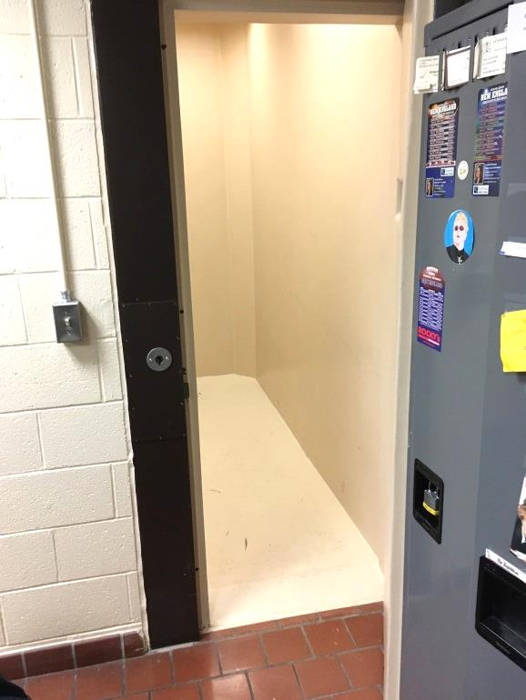
Padding in B39 cell B1
Picture 2
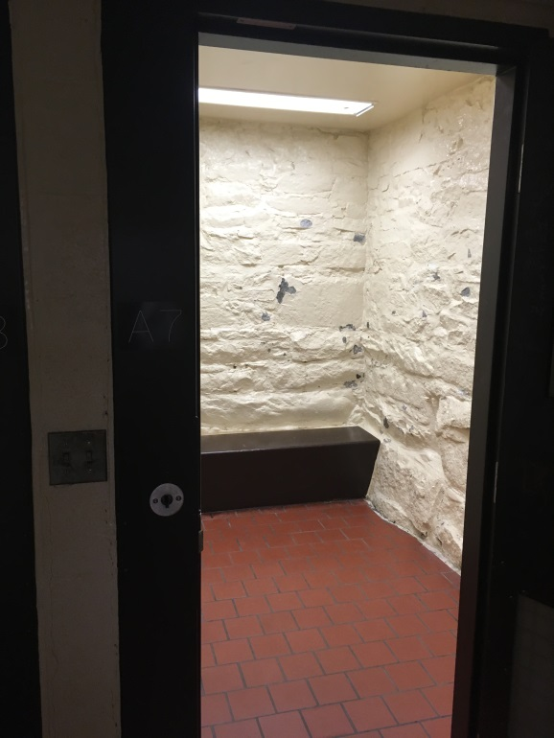
Typical cell without padding
Picture 3
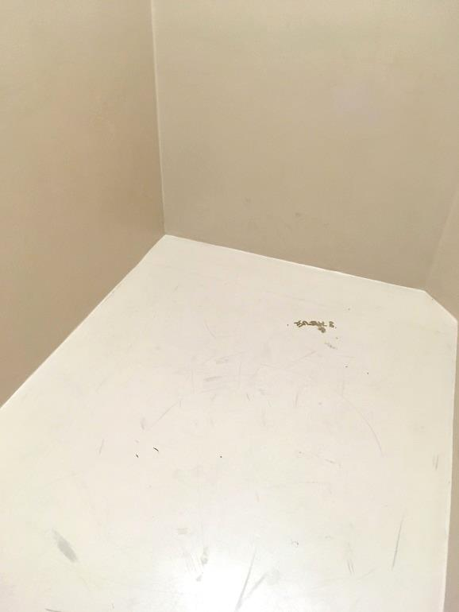
Close up of padding on floor of B39 cell B1
Picture 4
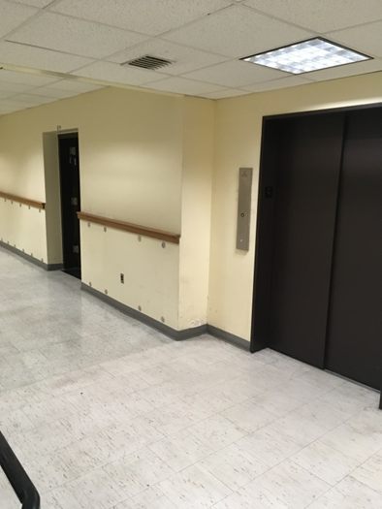
Elevator next to door to B39 (left)
Picture 5
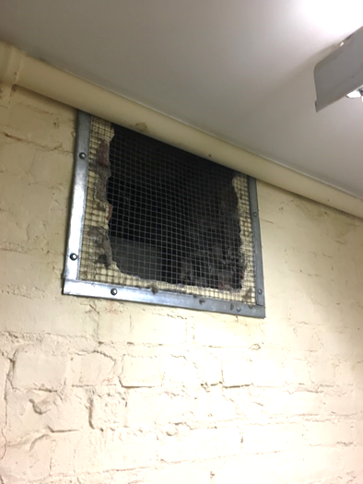
Elevator pressure equalization vent in B50
Picture 6
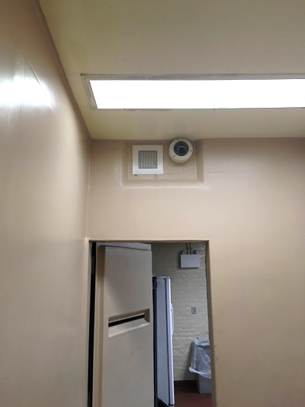
Fresh air supply vent (arrow) in B39 B1
Picture 7
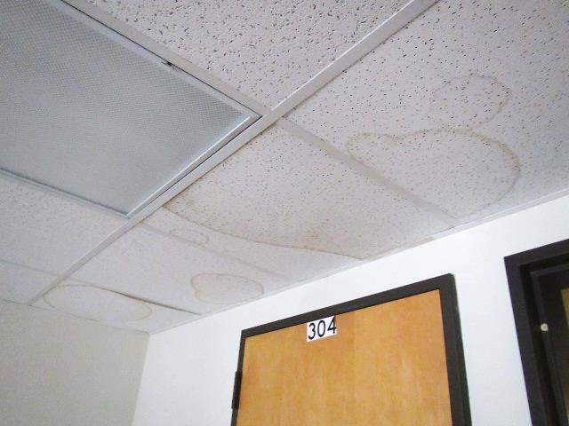
Water-damaged ceiling tiles
Picture 8
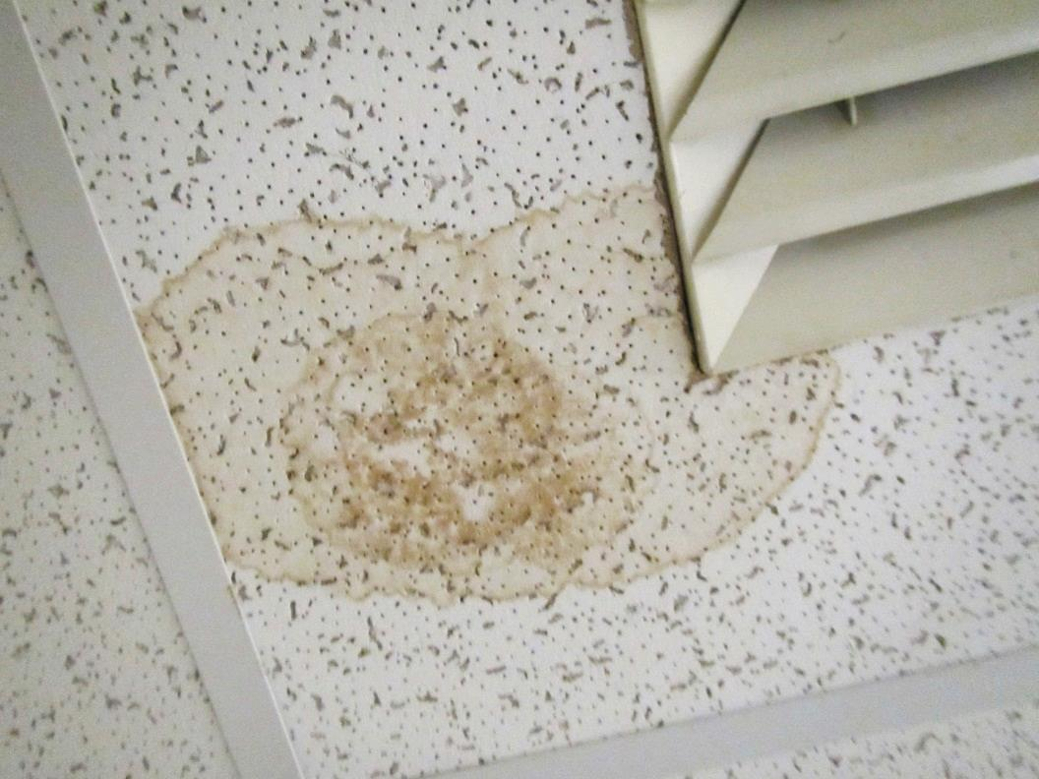
Water-damaged ceiling tile
Picture 9
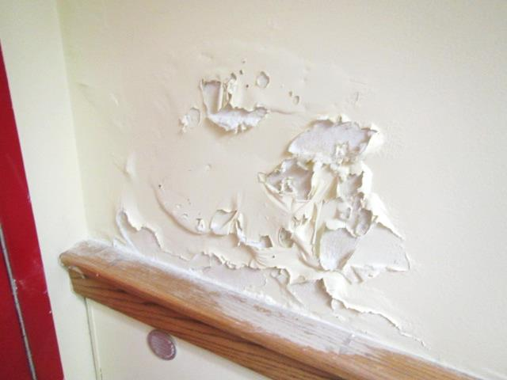
Peeling paint and efflorescence on wall plaster
Picture 10
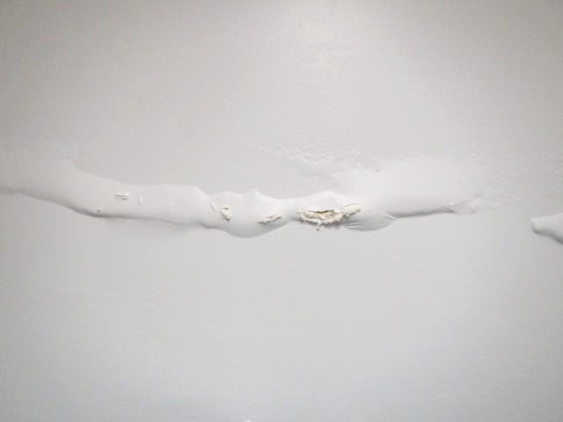
Peeling paint and efflorescence on wall plaster
Picture 11
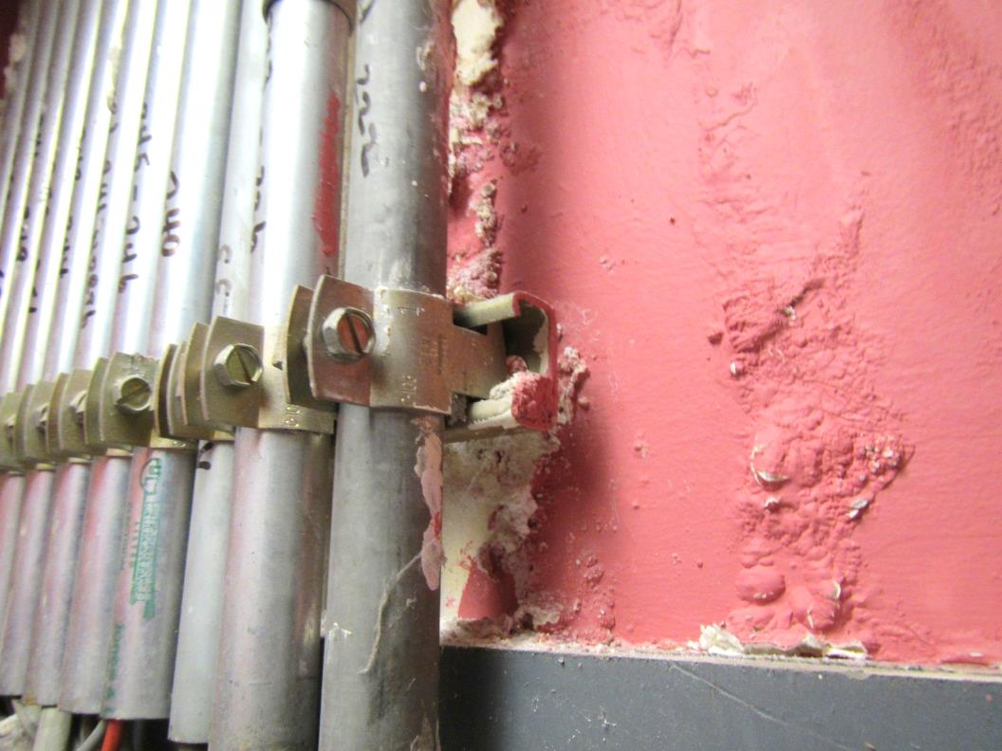
Peeling paint and efflorescence on wall plaster
Picture 12
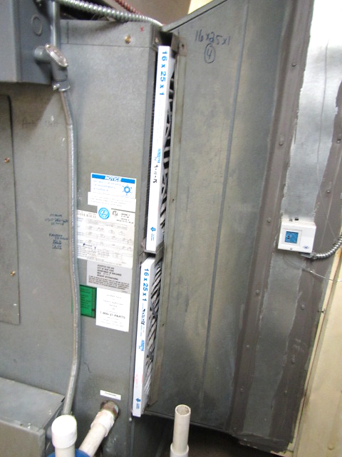
AHU missing its filter panel
Picture 13
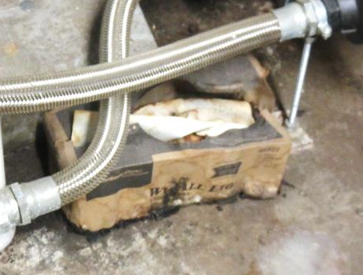
Moldy/water-damaged box near AHU in Picture 12
Picture 14
Dust/debris accumulation on supply vent and surrounding ceiling tiles
Picture 15
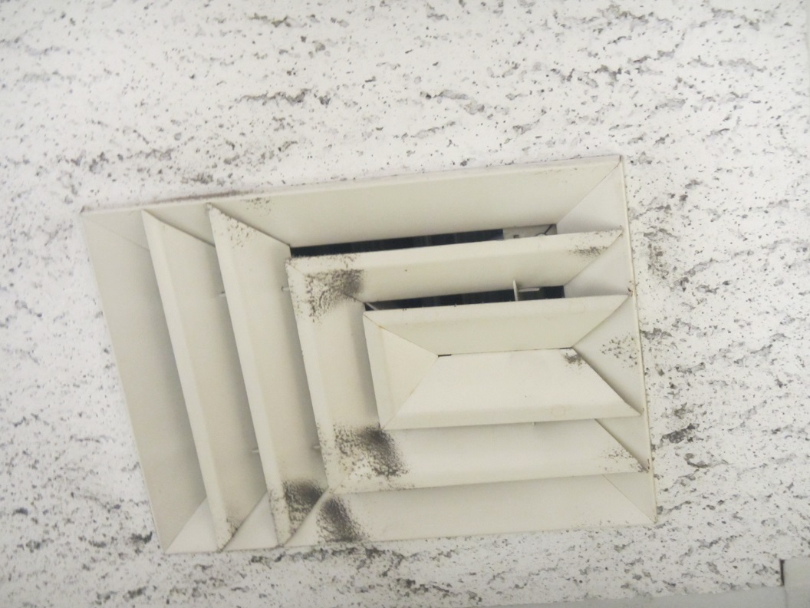
Dust/debris accumulation on supply vent
Picture 16
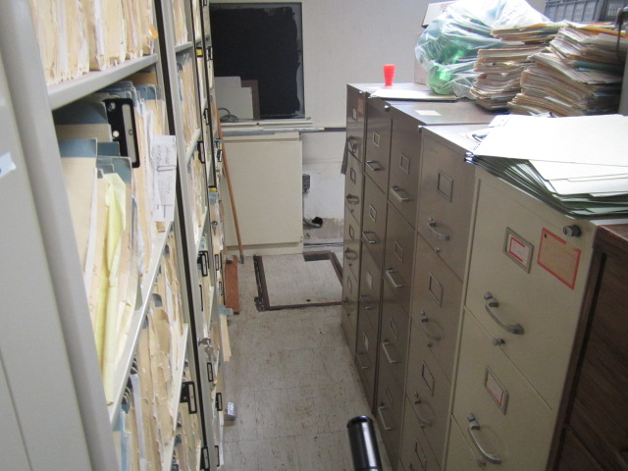
Area in basement where sewer backups reportedly occur

