Background/Introduction

INDOOR AIR QUALITY ASSESSMENT

Earl D. Taft Elementary School
16 Granite Street
Uxbridge, Massachusetts

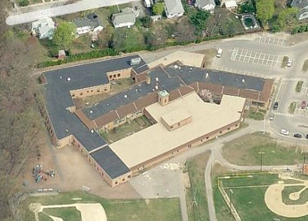

Prepared by:
Massachusetts Department of Public Health
Bureau of Environmental Health
Indoor Air Quality Program
January 2014
At the request of Michael Legendre, Facilities Director for Uxbridge Public Schools, the Massachusetts Department of Public Health (MDPH), Bureau of Environmental Health (BEH) provided assistance and consultation regarding indoor air quality (IAQ) at the Taft Elementary School (TES) located at 16 Granite Street, Uxbridge, Massachusetts. On November 7, 2013, Cory Holmes, Environmental Analyst/Regional Inspector in BEH’s IAQ Program visited the school to perform an assessment.
The TES is a one-story brick-on slab-building constructed in the early 1950s. Additions were made to the building in 1989 and 1998. The building is structured around two courtyards and consists of general classrooms, music room, library, art room, computer lab, kitchen, cafeteria, gymnasium and office space. Windows are openable throughout the building.

Methods
Air tests for carbon monoxide, carbon dioxide, temperature and relative humidity were conducted with the TSI, Q-Trak, IAQ Monitor, Model 7565. Air tests for airborne particle matter with a diameter less than 2.5 micrometers were taken with the TSI, DUSTTRAK™ Aerosol Monitor Model 8520. BEH/IAQ staff also performed visual inspection of building materials for water damage and/or microbial growth.

Results
The school houses approximately 650 students in grades 1 through 4 with a staff of approximately 100. Tests were taken during normal operations at the school. Results appear in Table 1.

Discussion

Ventilation
It can be seen from Table 1 that carbon dioxide levels were below 800 parts per million (ppm) in 46 out of 48 areas, indicating adequate air exchange in all but two areas examined. Fresh air in the majority of classrooms is supplied by unit ventilators (univents) (Picture 1). A univent is designed to draw air from outdoors through a fresh air intake located on the exterior wall of the building. Return air is drawn through an air intake located at the base of each unit where fresh and return air are mixed, filtered, heated or cooled and provided to classrooms through an air diffuser located in the top of the unit (Figure 1). Univents were found deactivated or obstructed with classroom items in a number of areas (Table 1). In order for univents to provide fresh air as designed, intakes/returns must remain free of obstructions. Importantly, these units must remain on and be allowed to operate while rooms are occupied.
Note that the univents are original equipment, over 60 years old in the original wing (Picture 1), over 24 years old for the 1989 wing. Function of equipment of this age is difficult to maintain, since compatible replacement parts are often unavailable. According to the American Society of Heating, Refrigeration and Air-Conditioning Engineers (ASHRAE), the service life for a unit heater, hot water or steam is 20 years, assuming routine maintenance of the equipment (ASHRAE, 1991). Despite attempts to maintain the univents, the operational lifespan of the equipment has been exceeded. Maintaining the balance of fresh air to exhaust air will become more difficult as the equipment ages and as replacement parts become increasingly difficult to obtain.
Some classrooms, offices and common areas are ventilated by air handling units (AHUs) located above the ceiling tile system. Room 144, the Student Support suite, had no openable window or mechanical means of ventilation.
Exhaust ventilation in most classrooms is provided by wall-mounted vents. In some classrooms, exhaust vents are located in cubby holes or in coat closets. Exhaust vents were also found obstructed in some areas (Table 1).
To maximize air exchange, the MDPH recommends that both supply and exhaust ventilation operate continuously during periods of occupancy. In order to have proper ventilation with a mechanical supply and exhaust system, the systems must be balanced to provide an adequate amount of fresh air to the interior of a room while removing stale air from the room. It is recommended that heating, ventilating and air conditioning (HVAC) systems be re-balanced every five years to ensure adequate air systems function (SMACNA, 1994). The date of the last balancing of these systems was not available at the time of assessment.
Minimum design ventilation rates are mandated by the Massachusetts State Building Code (MSBC). Until 2011, the minimum ventilation rate in Massachusetts was higher for both occupied office spaces and general classrooms, with similar requirements for other occupied spaces (BOCA, 1993). The current version of the MSBC, promulgated in 2011 by the State Board of Building Regulations and Standards (SBBRS), adopted the 2009 International Mechanical Code (IMC) to set minimum ventilation rates. Please note that the MSBC is a minimum standard that is not health-based. At lower rates of cubic feet per minute (cfm) per occupant of fresh air, carbon dioxide levels would be expected to rise significantly. A ventilation rate of 20 cfm per occupant of fresh air provides optimal air exchange resulting in carbon dioxide levels at or below 800 ppm in the indoor environment in each area measured. MDPH recommends that carbon dioxide levels be maintained at 800 ppm or below. This is because most environmental and occupational health scientists involved with research on IAQ and health effects have documented significant increases in indoor air quality complaints and/or health effects when carbon dioxide levels rise above the MDPH guidelines of 800 ppm for schools, office buildings and other occupied spaces (Sundell et al., 2011). The ventilation must be on at all times that the room is occupied. Providing adequate fresh air ventilation with open windows and maintaining the temperature in the comfort range during the cold weather season is impractical. Mechanical ventilation is usually required to provide adequate fresh air ventilation.
Carbon dioxide is not a problem in and of itself. It is used as an indicator of the adequacy of the fresh air ventilation. As carbon dioxide levels rise, it indicates that the ventilating system is malfunctioning or the design occupancy of the room is being exceeded. When this happens, a buildup of common indoor air pollutants can occur, leading to discomfort or health complaints. The Occupational Safety and Health Administration (OSHA) standard for carbon dioxide is 5,000 parts per million parts of air (ppm). Workers may be exposed to this level for 40 hours/week, based on a time-weighted average (OSHA, 1997).
The MDPH uses a guideline of 800 ppm for publicly occupied buildings. A guideline of 600 ppm or less is preferred in schools due to the fact that the majority of occupants are young and considered to be a more sensitive population in the evaluation of environmental health status. Inadequate ventilation and/or elevated temperatures are major causes of complaints such as respiratory, eye, nose and throat irritation, lethargy and headaches. For more information concerning carbon dioxide, consult Appendix A.
Indoor temperature measurements ranged from 70 °F to 76 °F (Table 1), which were within the MDPH recommended comfort range on the day of assessment. The MDPH recommends that indoor air temperatures be maintained in a range of 70 °F to 78 °F in order to provide for the comfort of building occupants. In many cases concerning indoor air quality, fluctuations of temperature in occupied spaces are typically experienced, even in a building with an adequate fresh air supply. In addition, it is difficult to control temperature and maintain comfort without operating the ventilation equipment as designed (e.g., univents/exhaust vents deactivated/obstructed). Draft/odor complaints were expressed concerning the corner of music room 229. BEH/IAQ staff detected a noticeable draft from a space in the corner where the two walls meet. BEH/IAQ staff recommends using an appropriate sealant in this space and monitoring the area for drafts.
The relative humidity measured in areas surveyed in the building ranged from 49 to 62 percent, all within or slightly above the MDPH recommended comfort range (Table 1). The MDPH recommends a comfort range of 40 to 60 percent for indoor air relative humidity. Relative humidity levels in the building would be expected to drop during the winter months due to heating. The sensation of dryness and irritation is common in a low relative humidity environment. Low relative humidity is a very common problem during the heating season in the northeast part of the United States.

Microbial/Moisture Concerns
Water-damaged ceiling tiles were observed in several areas (Table 1; Picture 2); these can indicate active/historic leaks from either the roof/building envelope or plumbing system. A tile in the corner of room 265 appeared to have possible mold growth (Picture 3). Water-damaged ceiling tiles can provide a source of mold and should be replaced after a water leak is discovered and repaired.
Moderate water damage to plaster around windows, and efflorescence were observed in room 140. Water damage is most likely the result of water penetration around window frames and poor drainage from the gutter/drainage system outside this area. Efflorescence is a characteristic sign of water penetration, but it is not mold growth. As moisture penetrates and works its way through mortar, brick or plaster, water-soluble compounds dissolve, creating a solution. As the solution moves to the surface of these materials, the water evaporates, leaving behind white, powdery mineral deposits.
Open seams between the sink countertop and backsplash were observed in several rooms (Table 1; Picture 4). If seams are not watertight, water can penetrate the seam, causing water damage. Water penetration and chronic exposure of porous and wood-based materials can cause these materials to swell, show signs of water damage and lead to potential mold growth. Sink caulking in room 265 appeared to be visibly mold-colonized (Picture 5).
The US Environmental Protection Agency (US EPA) and the American Conference of Governmental Industrial Hygienists (ACGIH) recommend that porous materials (e.g., carpeting, gypsum wallboard) be dried with fans and heating within 24 to 48 hours of becoming wet (US EPA, 2001; ACGIH, 1989). If not dried within this time frame, mold growth may occur. Once mold has colonized porous materials, they are difficult to clean and should be removed/discarded.
Visible mold growth was observed in the refrigerator in the teacher’s lunchroom as well as several refrigerators located in classrooms. Upon opening refrigerators used by staff for food storage, BEH/IAQ staff found both refrigerator and freezer door gaskets to be colonized with mold (Table 1; Pictures 6 through 8). Some of the refrigerators had noticeable odors and/or had spillage of unknown origin. In addition, the drip pan beneath the refrigerator in the teacher’s lunchroom had a large amount of mold/debris (Picture 9); it appeared not to have been cleaned for some time.
Plants were noted in some classrooms (Table 1). Plants can be a source of pollen and mold which can be respiratory irritants to some individuals. Plants should be properly maintained and equipped with drip pans and should be located away from univents to prevent the aerosolization of dirt, pollen and mold.
Aquariums and terrariums were observed in a few classrooms (Table 1). Aquariums should be properly maintained to prevent microbial/algal growth, which can emit unpleasant odors. Similarly, terrariums should be properly maintained to ensure soil does not become a source for mold growth/odors.

Other IAQ Evaluations
Indoor air quality can be negatively influenced by the presence of respiratory irritants, such as products of combustion. The process of combustion produces a number of pollutants. Common combustion emissions include carbon monoxide, carbon dioxide, water vapor and smoke (fine airborne particle material). Of these materials, exposure to carbon monoxide and particulate matter with a diameter of 2.5 micrometers (μm) or less (PM2.5) can produce immediate, acute health effects upon exposure. To determine whether combustion products were present in the indoor environment, BEH/IAQ staff obtained measurements for carbon monoxide and PM2.5.

Carbon Monoxide
Carbon monoxide is a by-product of incomplete combustion of organic matter (e.g., gasoline, wood and tobacco). Exposure to carbon monoxide can produce immediate and acute health effects. Several air quality standards have been established to address carbon monoxide and prevent symptoms from exposure to these substances. The MDPH established a corrective action level concerning carbon monoxide in ice skating rinks that use fossil-fueled ice resurfacing equipment. If an operator of an indoor ice rink measures a carbon monoxide level over 30 ppm, taken 20 minutes after resurfacing within a rink, that operator must take actions to reduce carbon monoxide levels (MDPH, 1997).
The American Society of Heating Refrigeration and Air-Conditioning Engineers (ASHRAE) has adopted the National Ambient Air Quality Standards (NAAQS) as one set of criteria for assessing indoor air quality and monitoring of fresh air introduced by HVAC systems (ASHRAE, 1989). The NAAQS are standards established by the US EPA to protect the public health from six criteria pollutants, including carbon monoxide and particulate matter (US EPA, 2006). As recommended by ASHRAE, pollutant levels of fresh air introduced to a building should not exceed the NAAQS levels (ASHRAE, 1989). The NAAQS were adopted by reference in the Building Officials & Code Administrators (BOCA) National Mechanical Code of 1993 (BOCA, 1993), which is now an HVAC standard included in the Massachusetts State Building Code (SBBRS, 2011). According to the NAAQS, carbon monoxide levels in outdoor air should not exceed 9 ppm in an eight-hour average (US EPA, 2006).
Carbon monoxide should not be present in a typical, indoor environment. If it is present, indoor carbon monoxide levels should be less than or equal to outdoor levels. On the day of assessment, outdoor carbon monoxide concentrations were non-detect (ND) (Table 1). No measurable levels of carbon monoxide were detected inside the building (Table 1).

Particulate Matter
The US EPA has established NAAQS limits for exposure to particulate matter. Particulate matter includes airborne solids that can be irritating to the eyes, nose and throat. The NAAQS originally established exposure limits to PM with a diameter of 10 μm or less (PM10). In 1997, US EPA established a more protective standard for fine airborne particulate matter with a diameter of 2.5 μm or less (PM2.5). This more stringent PM2.5 standard requires outdoor air particle levels be maintained below 35 μg/m³ over a 24-hour average (US EPA, 2006). Although both the ASHRAE standard and BOCA Code adopted the PM10 standard for evaluating air quality, MDPH uses the more protective PM2.5 standard for evaluating airborne PM concentrations in the indoor environment.
Outdoor PM2.5 concentrations were measured at 3 μg/m³ (Table 1). PM2.5 levels measured in the school were between 1 to 23 μg/m³ (Table 1), which were below the NAAQS PM2.5 level of 35 μg/m³. Frequently, indoor air levels of particulates (including PM2.5) can be at higher levels than those measured outdoors. A number of activities that occur indoors and/or mechanical devices can generate particulate during normal operations. Sources of indoor airborne particulates may include but are not limited to particles generated during the operation of fan belts in the HVAC system, use of stoves and/or microwave ovens in kitchen areas; use of photocopiers, fax machines and computer printing devices; operation of an ordinary vacuum cleaner and heavy foot traffic indoors.

Volatile Organic Compounds
Indoor air concentrations can be greatly impacted by the use of products containing volatile organic compounds (VOCs). VOCs are carbon-containing substances that have the ability to evaporate at room temperature. Frequently, exposure to low levels of total VOCs (TVOCs) may produce eye, nose, throat and/or respiratory irritation in some sensitive individuals. For example, chemicals evaporating from a paint can stored at room temperature would most likely contain VOCs. In an effort to identify materials that can potentially increase indoor VOC concentrations, BEH/IAQ staff examined rooms for products containing these respiratory irritants.
Classrooms contained dry erase boards and related materials. Materials such as dry erase markers and dry erase board cleaners may contain VOCs, such as methyl isobutyl ketone, n-butyl acetate and butyl-cellusolve (Sanford, 1999), which can be irritating to the eyes, nose and throat.
Cleaning, sanitizing and paint products were observed on/under sinks in some rooms (Table 1; Pictures 10 and 11). These products contain chemicals that can be irritating to the eyes, nose and throat of sensitive individuals. Cleaning products should be properly labeled and stored in an area inaccessible to children. In addition, a Material Safety Data Sheets (MSDS) should be available at a central location for each product in the event of an emergency. Consideration should be given to providing teaching staff with school issued cleaning products and supplies to prevent any potential for adverse chemical interactions between residues left from cleaners used by the facilities staff and those left by cleaners brought in by others. In one case, metal spray containers were rusted/corroded (Picture 12), which can lead to an unwanted release of product. At the time of the assessment, Mr. Legendre removed these containers from the classroom.
Plug-in air deodorizers (Picture 13), air fresheners and scented oils were found in several areas (Table 1). Air deodorizers contain chemicals that can be irritating to the eyes, nose and throat of sensitive individuals. Many air deodorizers contain 1,4-dichlorobenzene, a VOC which may cause reductions in lung function (NIH, 2006). Further, air deodorizers do not remove materials causing odors, but rather, mask odors which may be present in the area.

Other Conditions
Other conditions that can affect IAQ were observed during the assessment. In many classrooms, a large number of items were on floors, windowsills, tabletops, counters, bookcases and desks, which provide a source for dusts to accumulate. These items (e.g., papers, folders, boxes) make it difficult for custodial staff to clean. Items should be relocated and/or be cleaned periodically to avoid excessive dust build up. In addition, dust and debris can accumulate on flat surfaces (e.g., desktops, shelving and carpets) in occupied areas and subsequently be re-aerosolized causing further irritation.
Many classrooms carpets were found soiled and deteriorated, in some cases loose/wrinkled, which could be a tripping hazard (Pictures 14 and 15). The Institute of Inspection, Cleaning and Restoration Certification (IICRC), recommends that carpeting be cleaned annually (or semi-annually in soiled high traffic areas) (IICRC, 2005). Since the average service time of carpeting in a school environment is approximately eleven years (Bishop, 2002), consideration should be given to planning for the replacement of carpeting with new flooring.
A number of air diffusers, exhaust/return vents and personal fans were found to have accumulated dust/debris (Table 1; Picture 16 and 17). If exhaust vents are not functioning, backdrafting can occur, which can re-aerosolize accumulated dust particles. Re-activated supply, exhaust/return vents and fans can also aerosolize dust accumulated on vents/fan blades.
Upholstered furniture, pillows/cushions and large stuffed animals were seen in several classrooms (Picture 18). Upholstered furniture, pillows and cushions are covered with fabric that comes in contact with human skin. This type of contact can leave oils, perspiration, hair and skin cells. Dust mites feed upon human skin cells and excrete waste products that contain allergens. In addition, if relative humidity levels increase above 60 percent, dust mites tend to proliferate (US EPA, 1992). In order to remove dust mites and other pollutants, frequent vacuuming of upholstered furniture is recommended (Berry, M.A., 1994). It is also recommended that upholstered furniture (if present in schools), be professionally cleaned on an annual basis. If outdoor conditions or indoor activities (e.g., renovations) create an excessively dusty environment, cleaning frequency should be increased (every six months) (IICRC, 2000).
An inactive insect nest and other items were noted suspended from the ceiling system in classroom 248 (Picture 19). Nests can contain bacteria and may be a source of allergenic material. Nests should be placed in resealable bags to prevent aerosolization of allergenic material. In a number of other classrooms, items were seen hanging from the suspended ceiling tile system (Table 1; Picture 20). Items should not be suspended from ceiling tile systems; movement of ceiling tiles may aerosolize dust above ceiling tiles. Moreover, the accumulated weight of items may damage the ceiling tile frames.

Conclusions/Recommendations
In view of the findings at the time of the visit, the following recommendations are made:
- Operate all ventilation systems throughout the building (e.g., gym, cafeteria, classrooms) continuously during periods of occupancy to maximize air exchange. If increased airflow is desired, operate univents in fan “high” mode.
- While carbon dioxide levels measured during this assessment suggested adequate provision of fresh air supply, maintaining the balance of fresh air to exhaust air will become more difficult as the equipment ages (i.e., classroom univents, exhaust vents and AHUs in common areas) and as replacement parts become increasingly difficult to obtain. Based on the age, physical deterioration and availability of parts, the BEH recommends that an HVAC engineering firm evaluate options to determine feasibility of repairing/replacing the equipment.
- Relocate occupant of room 144 Student Support, to an area with natural (windows) or mechanical ventilation. Examine the feasibility of providing mechanical supply ventilation to this area.
- Remove blockages/items from the surface of univent air diffusers and return vents (along front/bottom).
- Remove blockages/items from wall, cubby and coat closet exhausts to ensure adequate airflow.
- Ensure classroom doors are closed for proper operation of mechanical ventilation system/air exchange.
- Continue to change filters for air handling equipment (univents and AHUs) 2-4 times a year.
- Consider adopting a balancing schedule of every 5 years for all mechanical ventilation systems, as recommended by ventilation industrial standards (SMACNA, 1994).
- Use openable windows in conjunction with classroom exhaust vents to facilitate air exchange. Care should be taken to ensure windows are properly closed at night and weekends to avoid the freezing of pipes and potential flooding.
- For buildings in New England, periods of low relative humidity during the winter are often unavoidable. Therefore, scrupulous cleaning practices should be adopted to minimize common indoor air contaminants whose irritant effects can be enhanced when the relative humidity is low. To control dusts, a high efficiency particulate arrestance (HEPA) filter equipped vacuum cleaner in conjunction with wet wiping of all surfaces is recommended. Avoid the use of feather dusters. Drinking water during the day can help ease some symptoms associated with a dry environment (throat and sinus irritations).
- Ensure roof/plumbing leaks are repaired and replace any remaining water-damaged ceiling tiles (e.g., room 265). Examine the area above these tiles for mold growth. Disinfect areas of water leaks with an appropriate antimicrobial, as needed.
- Inspect and make repairs as needed to gutter/drainage system in courtyard outside of classroom 140. Once completed, clean/scrape efflorescence from window plaster repair/refinish water-damaged areas as needed.
- Clean and disinfect interior of refrigerators and freezers with mild detergent or antimicrobial agent. Consider replacing mold-contaminated gaskets. Clean spilled food promptly, and clean out the refrigerator of expired items on a regular schedule.
- Consider replacing older model refrigerator in Teacher’s Lunchroom with a modern, energy-efficient model.
- Seal breaches, seams, and spaces between sink countertops and backsplashes to prevent water damage. Remove/replace moldy caulking in room 265. Consider eventual replacement with a one-piece molded countertop.
- Refrain from storing porous materials (e.g., paper, cardboard) under sinks.
- Ensure indoor plants are equipped with drip pans. Examine drip pans periodically for mold growth and disinfect with an appropriate antimicrobial, as needed. Move plants away from the air stream of mechanical ventilation equipment.
- Clean and maintain aquariums and terrariums to prevent bacterial/microbial growth and associated odors.
- Store nests in resealable bags, away from ventilation sources.
- Refrain from hanging objects from ceiling tile systems.
- Relocate or consider reducing the amount of materials stored in classrooms to allow for more thorough cleaning of classrooms. Clean items regularly with a wet cloth or sponge to prevent excessive dust build-up.
- Refrain from using air fresheners and deodorizers to prevent exposure to VOCs.
- Store cleaning products properly and out of reach of students. Ensure spray bottles are properly labeled. All cleaning products used at the facility should be approved by the school department with MSDS’ available at a central location.
- Seal the space in the corner of music room 229 between where the two walls meet to mitigate drafts/odor complaints from wall cavity.
- Continue to clean carpeting annually or semi-annually in soiled high traffic areas as per the recommendations of the Institute of Inspection, Cleaning and Restoration Certification (IICRC). Copies of the IICRC fact sheet can be downloaded at: http://www.cleancareseminars.com/carpet_cleaning_faq4.htm (IICRC, 2005)
- Consider a long-term plan to replace old/soiled/damaged carpeting in the building as funds become available. Consider replacing carpeting with a non-porous surface such as vinyl tile.
- Clean personal fans, air diffusers and return vents periodically of accumulated dust.
- Clean upholstered furniture, cloth curtains, stuffed animals, pillows and curtains on a regular schedule. If not possible/practical, consider removing from classrooms.
- Consider adopting the US EPA (2000) document, “Tools for Schools”, as an instrument for maintaining a good indoor air quality environment in the building. This document is available at: http://www.epa.gov/iaq/schools/index.html.
- Refer to resource manual and other related indoor air quality documents located on the MDPH’s website for further building-wide evaluations and advice on maintaining public buildings. These documents are available at: http://mass.gov/dph/iaq.

References
ACGIH. 1989. Guidelines for the Assessment of Bioaerosols in the Indoor Environment. American Conference of Governmental Industrial Hygienists, Cincinnati, OH.
ASHRAE. 1989. Ventilation for Acceptable Indoor Air Quality. American Society of Heating, Refrigeration and Air Conditioning Engineers. ANSI/ASHRAE 62-1989.
ASHRAE. 1991. ASHRAE Applications Handbook, Chapter 33 “Owning and Operating Costs”. American Society of Heating, Refrigeration and Air Conditioning Engineers, Atlanta, GA.
Berry, M.A. 1994. Protecting the Built Environment: Cleaning for Health, Michael A. Berry, Chapel Hill, NC.
Bishop, J. & Institute of Inspection, Cleaning and Restoration Certification. 2002. A Life Cycle Cost Analysis for Floor Coverings in School Facilities.
BOCA. 1993. The BOCA National Mechanical Code/1993. 8th ed. Building Officials and Code Administrators International, Inc., Country Club Hill, IL.
IICRC. 2000. IICRC S001 Reference Guideline for Professional On-Location Cleaning of Textile Floor Covering Materials Institute of Inspection, Cleaning and Restoration Certification. Institute of Inspection Cleaning and Restoration, Vancouver, WA.
IICRC. 2005. Carpet Cleaning FAQ 4 Institute of Inspection, Cleaning and Restoration Certification. Institute of Inspection Cleaning and Restoration, Vancouver, WA.
MDPH. 1997. Requirements to Maintain Air Quality in Indoor Skating Rinks (State Sanitary Code, Chapter XI). 105 CMR 675.000. Massachusetts Department of Public Health, Boston, MA.
NIH. 2006. Chemical in Many Air Fresheners May Reduce Lung Function. NIH News. National Institute of Health. July 27, 2006. http://www.nih.gov/news/pr/jul2006/niehs-27.htm.
OSHA. 1997. Limits for Air Contaminants. Occupational Safety and Health Administration. Code of Federal Regulations. 29 C.F.R 1910.1000 Table Z-1-A.
Sanford. 1999. Material Safety Data Sheet (MSDS No: 198-17). Expo® Dry Erase Markers Bullet, Chisel, and Ultra Fine Tip. Sanford Corporation. Bellwood, IL.
SBBRS. 2011. Mechanical Ventilation. State Board of Building Regulations and Standards. Code of Massachusetts Regulations, 8th edition. 780 CMR 1209.0
SMACNA. 1994. HVAC Systems Commissioning Manual. 1st ed. Sheet Metal and Air Conditioning Contractors’ National Association, Inc., Chantilly, VA.
Sundell. 2011. Sundell, J., H. Levin, W. W. Nazaroff, W. S. Cain, W. J. Fisk, D. T. Grimsrud, F. Gyntelberg, Y. Li, A. K. Persily, A. C. Pickering, J. M. Samet, J. D. Spengler, S. T. Taylor, and C. J. Weschler. 2011. Ventilation rates and health: multidisciplinary review of the scientific literature. Indoor Air, Volume 21: pp 191–204.
US EPA. 1992. Indoor Biological Pollutants. US Environmental Protection Agency, Environmental Criteria and Assessment Office, Office of Health and Environmental Assessment, research Triangle Park, NC. EPA 600/8-91/202. January 1992.
US EPA. 2000. Tools for Schools. Office of Air and Radiation, Office of Radiation and Indoor Air, Indoor Environments Division (6609J). EPA 402-K-95-001, Second Edition. http://www.epa.gov/iaq/schools/actionkit.html.
US EPA. 2001. Mold Remediation in Schools and Commercial Buildings. US Environmental Protection Agency, Office of Air and Radiation, Indoor Environments Division, Washington, D.C. EPA 402-K-01-001. March 2001.
US EPA. 2006. National Ambient Air Quality Standards (NAAQS). US Environmental Protection Agency, Office of Air Quality Planning and Standards, Washington, DC. http://www.epa.gov/air/criteria.html.
Picture 1
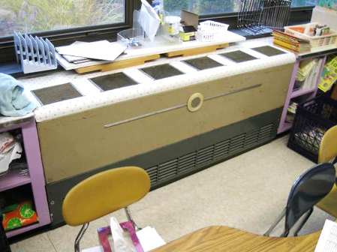
Classroom univent 1950s vintage

Picture 2
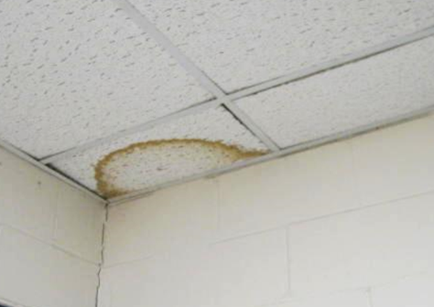
Water-damaged ceiling tile
Picture 3
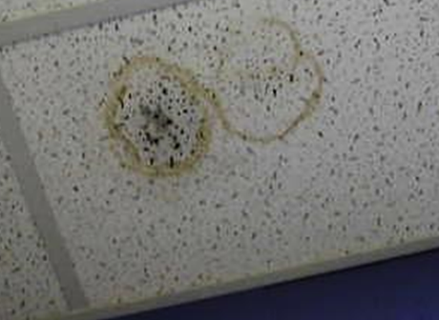
Water-damaged ceiling tile with possible mold in room 265

Picture 4
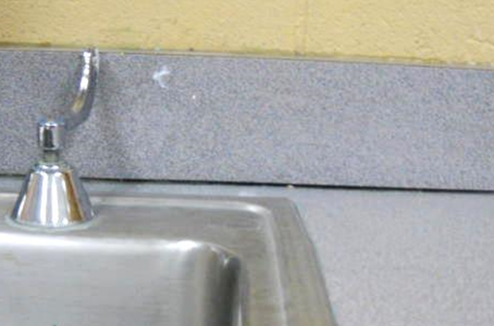
Space between sink backsplash and countertop in classroom
Picture 5
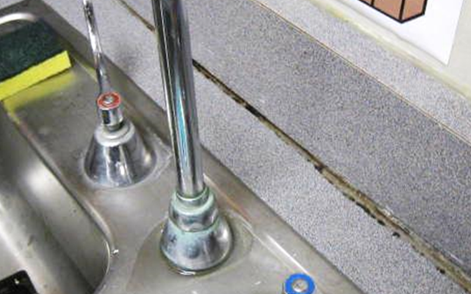
Visible mold on sink caulking in classroom 265

Picture 6
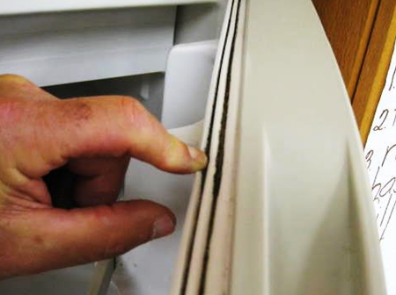
Visible mold (dark staining) in gasket of portable refrigerator in classroom
Picture 7
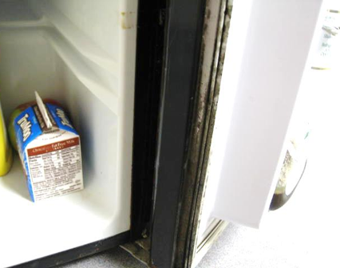
Mold growth (dark staining) on gasket of portable refrigerator in classroom

Picture 8
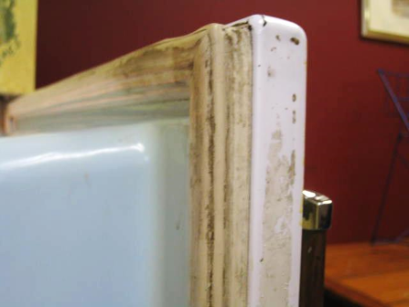
Visible mold (dark staining) on gasket of refrigerator in teachers’ lunchroom
Picture 9
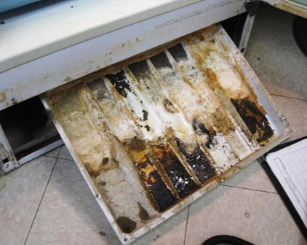
Visible mold/debris (dark staining) in drip pan of refrigerator in teachers’ lunchroom

Picture 10
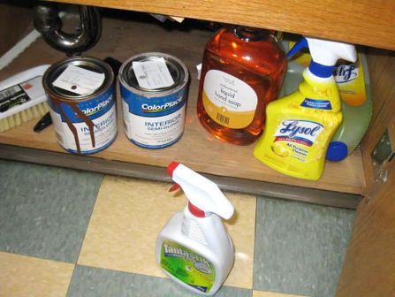
Spray cleaners and paints under sink in classroom
Picture 11
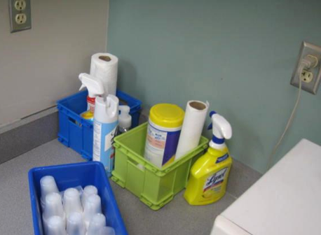
Spray cleaners on countertop in classroom

Picture 12
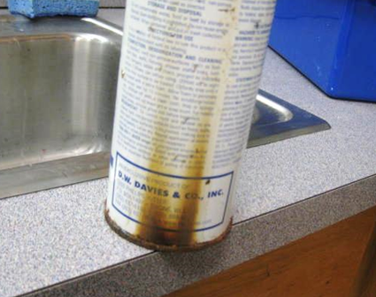
Severely rusted/corroded (dark staining) metal spray container
Picture 13
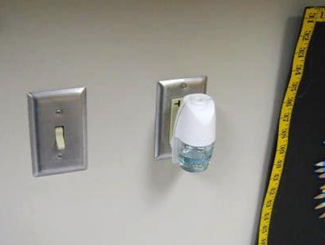
Plug-in air freshener in classroom

Picture 14
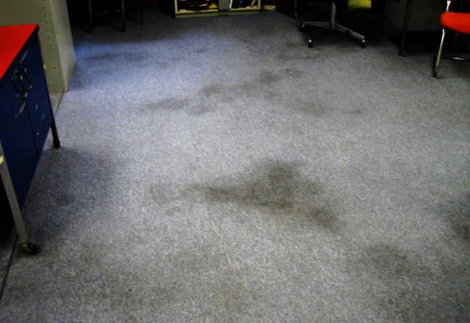
Stained/soiled carpeting
Picture 15
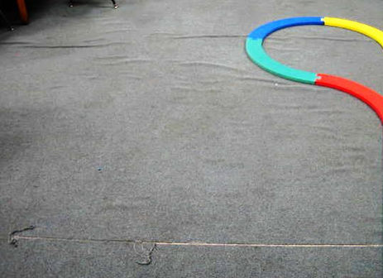
Wrinkled/damaged carpeting

Picture 16
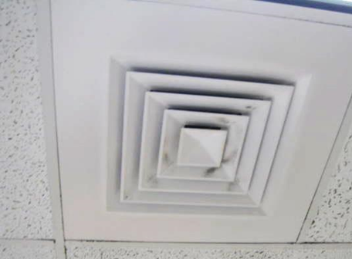
Dust/debris on supply louvers
Picture 17
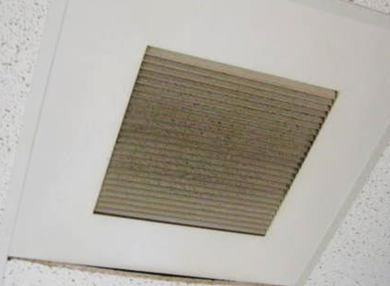
Dust/debris accumulation on exhaust vent

Picture 18
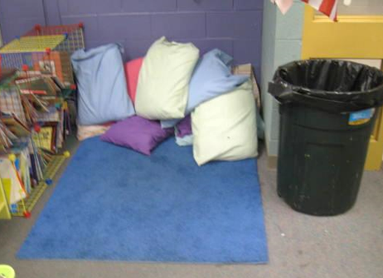
Pillows on floor of classroom
Picture 19
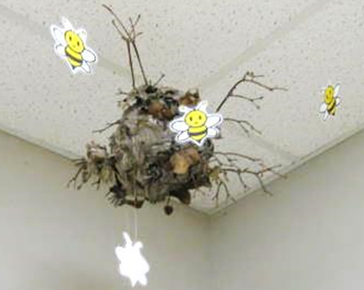
Wasp’s nest hanging from classroom ceiling

Picture 20
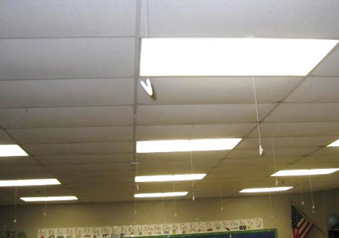
Multiple clips/strings hanging from suspended ceiling tile system
Location | Carbon  Dioxide  (*ppm) | Carbon Monoxide  (ppm) | Temp  (°F) | Relative  Humidity  (%) | PM2.5  (ug/m³) | Occupants  in Room | Windows  Openable | Ventilation |  | Remarks
 |  |  |  |  |  |  |  | Intake | Exhaust
Background | 368 | ND | 69 | 62 | 3 |  |  |  |  | Cloudy, moderate to heavy rain, winds WSW 7-16 mph, gusts up to 24 mph
124 Staff Dining Room | 654 | ND | 74 | 60 | 2 | 2 | Y | Y | Y | Broken window, dust/debris on vents, vintage refrigerator-mold gaskets/drip pan
126 | 666 | ND | 75 | 56 | 20 | 24 | Y | Y | Y | No active leaks, PF-dusty
129 | 675 | ND | 75 | 55 | 6 | 19 | Y | Y | Y | Old soiled carpet, dust/debris-vents, historic WD ceiling plaster
130 | 740 | ND | 74 | 58 | 3 | 20 | Y | Y | Y | PF-dusty, old/soiled carpeting
138 | 523 | ND | 73 | 58 | 5 | 8 | Y | Y | Y | Plants, AC-windows
140 | 510 | ND | 74 | 58 | 2 | 1 | Y | Y | Y | Old/soiled carpeting, efflorescence-windows-corner (possible gutter/drainage issues on exterior/courtyard)
143 | 494 | ND | 75 | 53 | 3 | 1 | Y | Y | N | UV deactivated, PF-Dusty, air freshener
144 Student Support | 608 | ND | 76 | 49 | 3 | 1 | N | N | Y | Exhaust in restroom, no means for supply air
153 | 792 | ND | 73 | 60 | 7 | 19 | Y | Y | Y | DO, cubby hole exhaust, occupants report sewer gas odors from behind cabinets
154 | 551 | ND | 73 | 59 | 4 | 22 | Y | Y | Y | UV off, DO, cubby hole exhaust
155 | 503 | ND | 73 | 58 | 2 | 20 | Y | Y | Y | DO, cubby hole exhaust
156 | 503 | ND | 70 | 62 | 4 | 3 | Y | Y | Y | Window open, 18 occupants gone~2 mins, cubby hole exhaust, PF
158 | 409 | ND | 73 | 62 | 1 | 0 | Y | Y | Y | Window AC, plants
159 | 461 | ND | 74 | 56 | 3 | 1 | Y | Y | Y | PF
165 Guidance Office | 470 | ND | 74 | 57 | 3 | 0 | N | Y | Y
166 Office | 460 | ND | 73 | 56 | 1 | 1 | N | Y | Y
184 Library | 621 | ND | 74 | 56 | 7 | 25 | Y | Y | Y | Wall to wall carpet, 1980’s vintage, dust/debris accumulation on vents, DO
192 | 499 | ND | 73 | 56 | 2 | 7 | Y | Y | Y | Window open, DO
193 | 517 | ND | 71 | 58 | 2 | 2 | Y | Y | Y | 12 occupants gone ~3 mins, 1 WD CT
194 | 489 | ND | 73 | 56 | 4 | 4 | Y | Y | Y | Window open, DO, old carpeting-soiled, 1 WD CT
195 OT/PT | 545 | ND | 74 | 55 | 2 | 4 | Y | Y | Y | Window open, old carpeting-damaged, wrinkled, soiled, PF-dusty
198 | 500 | ND | 75 | 54 | 1 | 0 | Y | Y | Y | Window AC unit-dirty, plants
199 | 556 | ND | 73 | 58 | 1 | 12 | Y | Y | Y | Window open, DO, 1 WD CT (corner)
201 | 457 | ND | 73 | 56 | 2 | 0 | Y | Y | Y
202 | 515 | ND | 73 | 58 | 1 | 12 | Y | Y | Y | DO
204 | 463 | ND | 71 | 57 | 1 | 12 | Y | Y | Y | Window open, aquarium, DO
205 | 609 | ND | 74 | 57 | 4 | 20 | Y | Y | Y | PF
222 | 576 | ND | 72 | 58 | 5 | 24 | Y | Y | Y | Window open, UV-deactivated, DO, old carpet-soiled
223 | 473 | ND | 73 | 57 | 2 | 0 | Y | Y | Y | Window open, UV-obstructed, class at lunch, old carpet-soiled
224 | 571 | ND | 74 | 54 | 1 | 1 | Y | Y | Y | DO, 21 occupants gone ~10 mins, accumulated items, old carpet-soiled, 3 WD CT, WD sink countertop
225 | 510 | ND | 73 | 56 | 6 | 1 | Y | Y | Y | DO, accumulated items, PF fan
226 Storage | 406 | ND | 75 | 53 | 3 | 0 | Y | Y | Y | Space between sink and countertop
229 Music | 807 | ND | 74 | 56 | 19 | 1 | Y | Y | Y | 18 occupants gone~10 mins, space between sink and countertop, windows open earlier, occupant deactivated UV (heat complaint), air freshener/oil/reeds, drafts/odors reported from corner-rec sealing space in corner/walls
235 | 497 | ND | 75 | 54 | 1 | 0 | Y | Y | Y | DO, refrigerator-mold/gaskets, space between sink and countertop
237 | 590 | ND | 73 | 59 | 18 | 5 | Y | Y | Y | Window open, DO, plants, WD CT, space between sink and countertop
238 | 665 | ND | 74 | 58 | 7 | 19 | Y | Y | Y | Window open, plants, space between sink and countertop
245 | 580 | ND | 74 | 55 | 9 | 3 | Y | Y | Y | UV deactivated
248 | 677 | ND | 73 | 58 | 16 | 19 | Y | Y | Y | DO, wasp nest hanging from ceiling, old carpet-soiled, space between sink and countertop, visible mold on mini-fridge gasket, microwave, CP/paint under sink
256 | 700 | ND | 74 | 59 | 9 | 17 | Y | Y | Y | Pillows on floor, old carpet-soiled, items hanging from ceiling, plug-in air freshener, space between sink and countertop, DO, microwave, items obstructing UV, CP countertop
257 | 739 | ND | 72 | 61 | 10 | 19 | Y | Y | Y | Window open, UV deactivated, CP sink countertop, DO, plug-in air freshener, metal spray cans under sink-severely corroded, space between sink and countertop
265 | 485 | ND | 73 | 60 | 5 | 2 | Y | Y | Y | WD CT/possible mold growth-corner, old/soiled carpeting, space between sink and countertop, moldy caulking-sink
271 | 933 | ND | 74 | 57 | 11 | 18 | Y | Y | Y | UV deactivated, plants, pillows, strong cinnamon odor (plug-in air freshener)
278 | 780 | ND | 74 | 56 | 10 | 19 | Y | Y | Y | Items obstructing UV return vent, DO, items hanging from ceiling
Cafeteria | 789 | ND | 75 | 60 | 12 | ~100 | N | Y | Y | 5-10 WD CTs, dust/debris on vents
Gym | 660 | ND | 73 | 59 | 23 | 25 | N | Y | Y | Historic WD ceiling plaster
Nurse | 602 | ND | 73 | 57 | 4 | 4 | Y | Y | Y | DO, dust/debris-vents
Main Office | 535 | ND | 74 | 56 | 1 | 1 | Y | Y | Y | Sewer ejector pump in closet
Principal’s Office | 555 | ND | 73 | 56 | 1 | 1 | Y | Y | Y | Dust/debris-vents

The service life is the median time during which a particular system or component of …[an HVAC]… system remains in its original service application and then is replaced. Replacement may occur for any reason, including, but not limited to, failure, general obsolescence, reduced reliability, excessive maintenance cost, and changed system requirements due to such influences as building characteristics or energy prices (ASHRAE, 1991).

