Overhead #1

John’s Story
Job: Fast food worker
Injury: Slipped on greasy floor
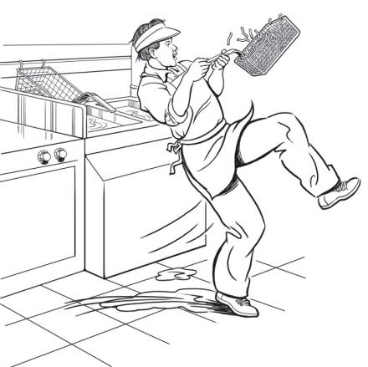

Overhead #2

Antonio’s Story
Job: Construction helper
Injury: Fell from roof
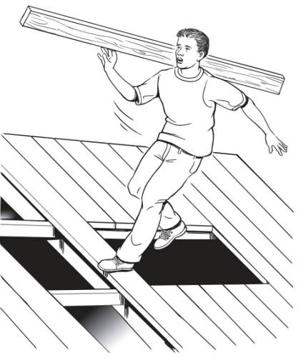

Overhead #3

Keisha’s Story
Job: Computer data entry
Injury: Repetitive stress injury

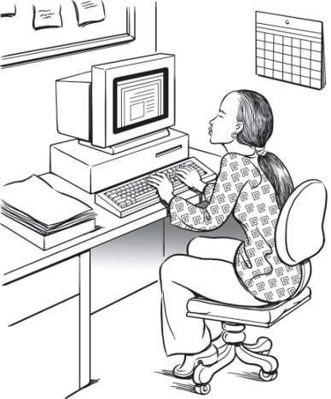

Overhead #4

Francisco’s Story
Job: Landscaping worker
Injury: Death

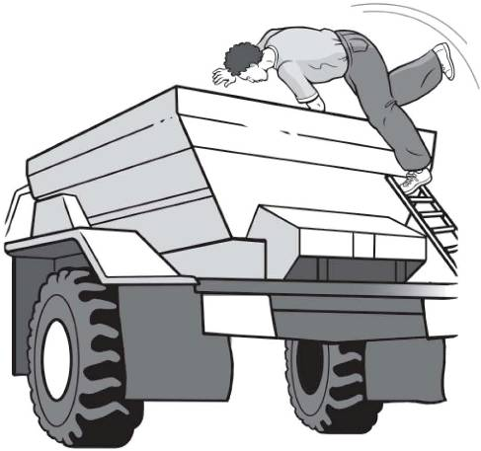

Overhead #5

Where are Teens Injured?
Other
15%
Retail
54%
Agriculture
7%
Manufacturing
4%
Service
20%
Where Teens Work:
Other
11%
Retail
54%
Agriculture 5%
Manufacturing 5%
Service
25%

Overhead #6

Where do Massachusetts Teens Work?

Employed 15- to 17-Year-Olds, by Industry, Massachusetts, 2006:

Where are Massachusetts Teens Injured?

Work-related injuries to Teens under Age 18, by Industry, Massachusetts, 2002-2006:

Overhead #7

How are Massachusetts Teens working in Food Services being Injured?

Note: Of the 349 “food service workers” injuries identified, there were 42 cases for which injury type was missing; of the 2,021 “all other occupations” injuries identified, there were 238 missing injury type. These cases were not included in the calculations.

Overhead #8

Where are Massachusetts Teens Working in Food Services Getting Injured?

Note: Of the 349 “food service workers” injuries identified, there were 10 cases for which industry type was missing; of the 2,021 “all other occupations” injuries identified, there were 241 missing industry type. These cases were not included in the calculations.

Overhead #9

Your Safety IQ Quiz

The law says your employer must give you training about health and safety hazards on the job.
___True ___ False

The law sets limits on how late you can work on a school night if you are under 16.
___True ___ False

If you are 16 years old you are allowed to drive a car on public streets as part of your job.
___True ___ False

If you are injured on the job, your employer must pay for your medical care.
___ True ___ False

How many teens get injured on the job every year in the U.S.?
___ One per day ___ One per hour
___ One every 7 minutes

Overhead #10

Key Points of This Training

You will learn more about:

Identifying and reducing hazards on the job.

Identifying and reducing hazards in healthcare jobs.

Laws that protect teens from working too late or too long.

Laws that protect teens from doing dangerous work.

How to solve health and safety problems at work.

What agencies enforce health and safety laws and child labor laws.

What to do in an emergency.

Overhead #11

Job Hazards

A job hazard is anything at work than can hurt you, either physically or mentally.

Safety hazards can cause immediate accidents and injuries.
Examples: hot surfaces or slippery floors.

Chemical hazards are gases, vapors, liquids, or dusts that can harm your body.
Examples: cleaning products or pesticides.

Biological hazards are living things that can cause sickness or disease.
Examples: bacteria, viruses, or insects.

Other health hazards are harmful things, not in the other categories, that can injure you or make you sick. These hazards are sometimes less obvious because they may not cause health problems right away.
Examples: noise, repetitive movements, heavy lifting, stress.

Overhead #12

Find the Hazards: Fast Food

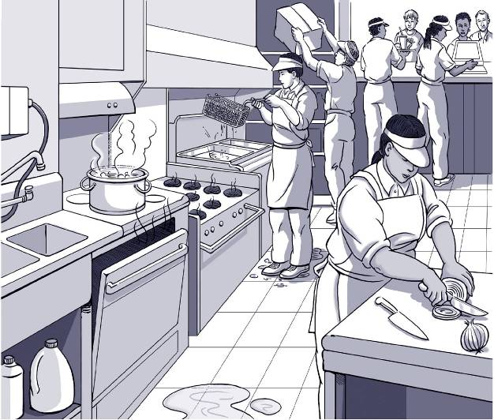
Overhead #13

Find the Hazards: Grocery Store

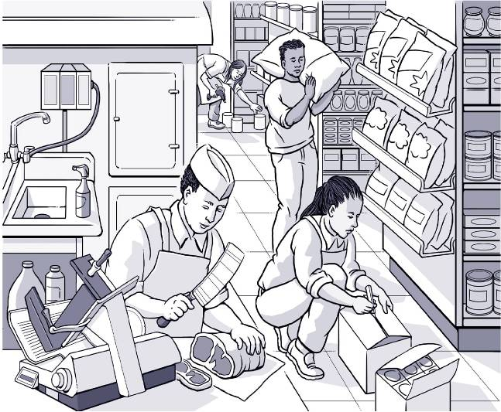

Overhead #14

Find the Hazards: Office

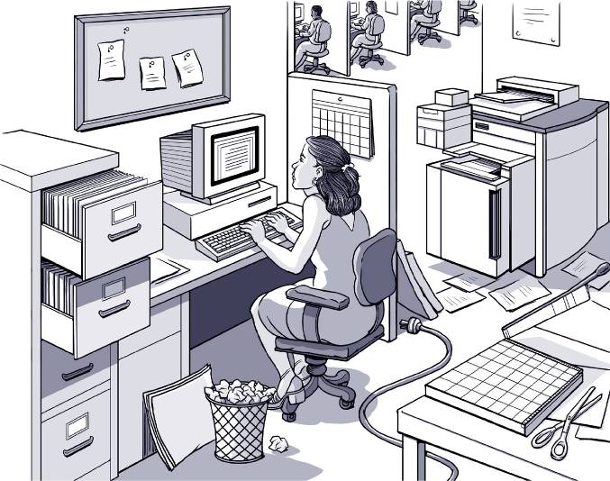

Overhead #15

Find the Hazards: Gas Station
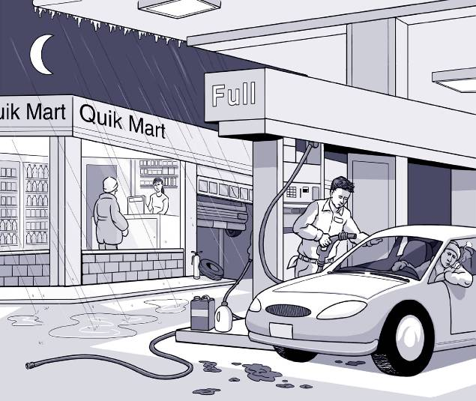

Overhead #16

Sample Hazard Map

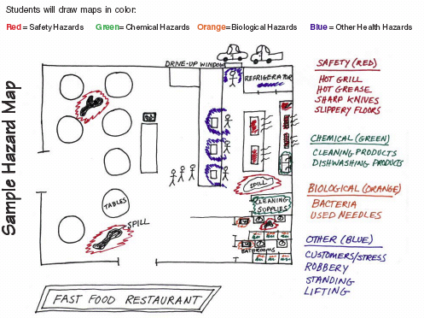

Overhead #17

Key Points: Finding Hazards

- Every job has health and safety hazards
- You should always be aware of these hazards
- Find out about chemicals at work by checking labels, readings MSDSs, and getting training.

Overhead #18

Controlling Hazards

First choice: Remove the Hazard
(e.g., use safer chemicals, put guards around hot surfaces)

Second choice: Work Policies and Procedures
(e.g., give workers safety training, assign enough people to do the job)

Third choice: Personal Protective Equipment
(e.g., wear gloves, use a respirator)

Overhead #19

Jamie’s Story
Job: Hospital Dishwasher
Injury: Dishwashing chemical splashed in eye

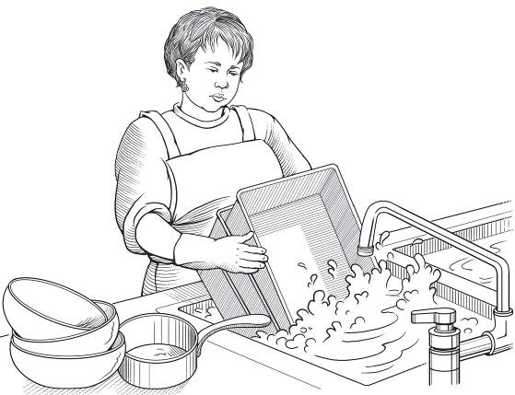

Overhead #20

Billy’s Story
Job: Fast food worker
Injury: Burned hand on grill

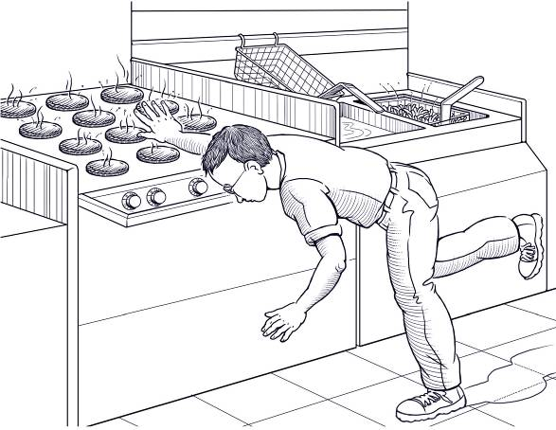

Overhead #21

Stephen’s Story
Job: Grocery store clerk
Injury: Hurt back while loading boxes

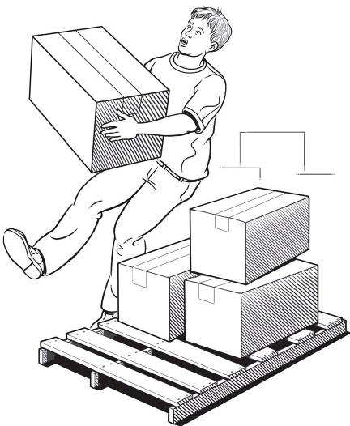

Overhead #22

Terry’s Story
Job: Grocery store deli clerk
Injury: Cut finger on meat slicer

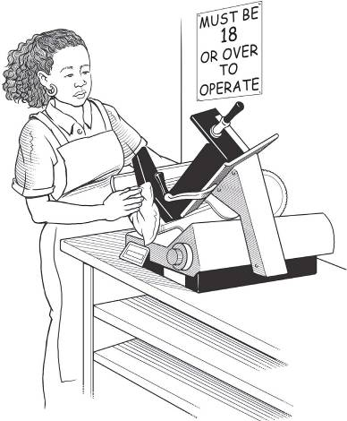

Overhead #23

James’ Story
Job: Pizza shop employee
Injury: Repetitive motion injury

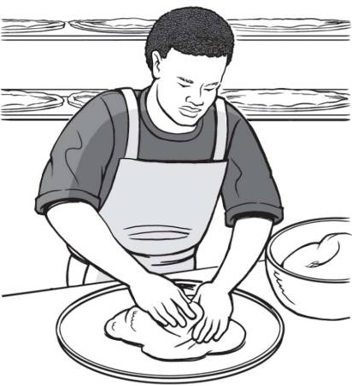

Overhead #24

Jose’s Story
Job: Dietary aide
Injury: Back injury and concussion

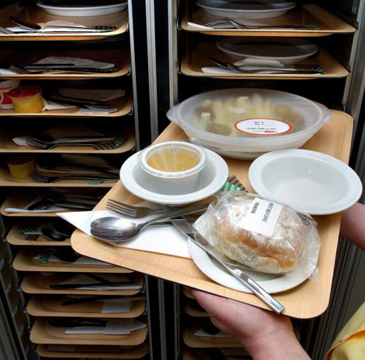

Overhead #25

Chris’ Story
Job: City public works employee
Injury: Fainted due to heat

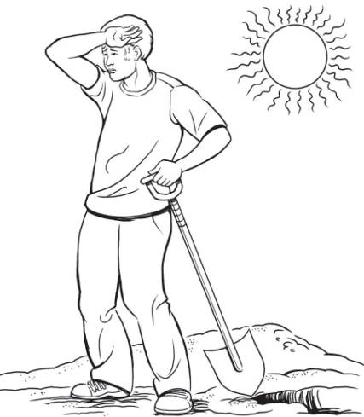

Overhead #26

Maria’s Story
Job: Farmworker
Injury: Pesticide poisoning

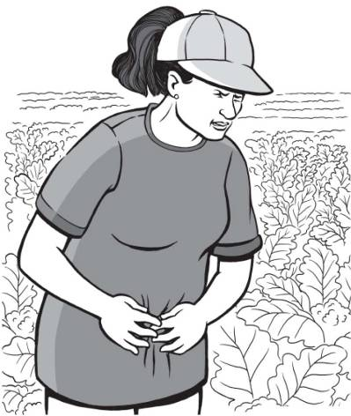

Overhead #27

Brent’s Story
Job: Pallet making
Injury: Amputated arm

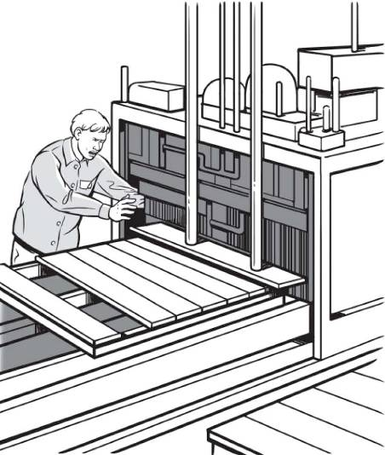

Overhead #28

Sara’s Story
Job: Nursing Aide
Injury: Back, neck, and shoulder pain

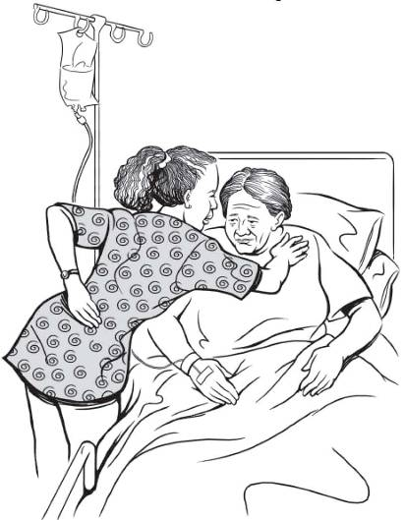

Overhead #29

Key Points: Making the Job Safer

- OSHA requires employers to provide a safe workplace.
- It’s best to get rid of a hazard completely, if possible.
- If your employer can’t get rid of the hazard, there are usually many ways to protect you from it.

Overhead #30

Key Points: Emergencies at Work

- Every workplace should have an emergency action plan
- The plan should cover:
  - What to do in different emergencies
  - Where shelters and meeting places are
  - Evacuation routes
  - Emergency equipment and alert systems
  - Who’s in charge
  - Procedures to follow when someone is injured
- The workplace should have practice drills
- Workers should be trained on everything in the plan.

Overhead #31

Game Board

Jeopardy Game
Rights on the Job | Dangerous Work and Work Permits | Hours for Teens and Working Safely | Job Injuries and Getting Help
$100 | $100 | $100 | $100
$200 | $200 | $200 | $200
$300 | $300 | $300 | $300
$400 | $400 | $400 | $400
$500 | $500 | $500 | $500

Overhead #32

Key Points: Know Your Rights

- Federal and state labor laws:
  - Set minimum age for some tasks
  - Protect teens from working too long, too late or too early
- OSHA says every employer must provide:
  - A safe workplace
  - Safety training on certain hazards
  - Safety equipment
- By law, your employer is not allowed to fire or punish you for reporting a safety problem.

Overhead #33

Handling Workplace Safety Problems

- Define the problem
- Get advice
- Choose your goals
- Know your rights
- Decide the best way to talk to the supervisor
- If necessary, contact an outside agency for help.

Overhead #34

Round 1

Restaurant Safety Jeopardy Game
Preventing Burns | Preventing Cuts & Lacerations | Preventing Sprains & Strains | Preventing Slips & Falls
$100 | $100 | $100 | $100
$200 | $200 | $200 | $200
$300 | $300 | $300 | $300
$400 | $400 | $400 | $400
$500 | $500 | $500 | $500

Overhead #35

Round 2

Restaurant Safety Jeopardy Game
Preventing Chemical Exposures & Burns | Fire Prevention | Labor Laws & Worker Rights | Resources
$200 | $200 | $200 | $200
$400 | $400 | $400 | $400
$600 | $600 | $600 | $600
$800 | $800 | $800 | $800
$1000 | $1000 | $1000 | $1000

Overhead #36

Summing Up

- Know your rights. The factsheet is an important resource. Show it to your friends and parents.

- Know your responsibilities. It’s your responsibility to follow safety rules and report any problems you see.

- Know your employer’s responsibilities. Your employer must keep the workplace safe and give you safety training.

- Know how to solve problems. Resources include co-workers, friends, parents, teachers, and government agencies like OSHA, EPA, and federal and state labor law enforcement agencies.

