Overhead #1

John’s Story
Job: Fast food worker
Injury: Slipped on greasy floor
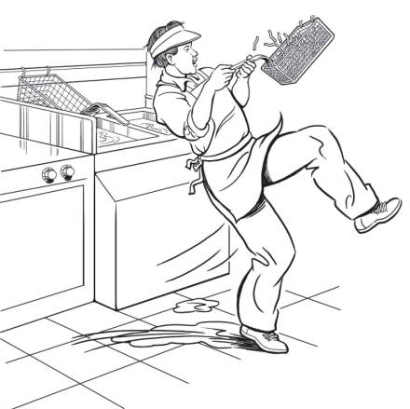

Overhead #2

Antonio’s Story
Job: Construction helper
Injury: Fell from roof
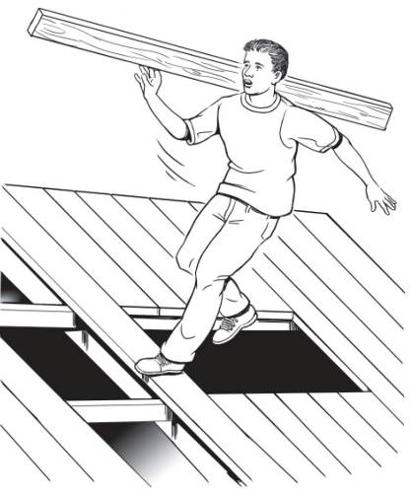

Overhead #3

Keisha’s Story
Job: Computer data entry
Injury: Repetitive stress injury

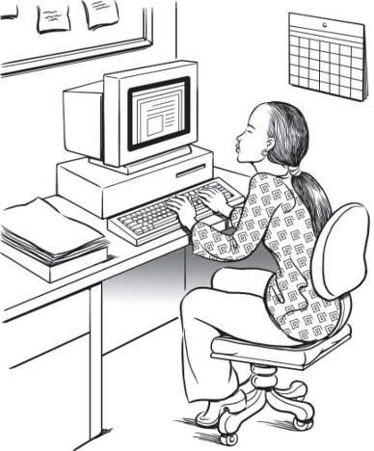

Overhead #4

Francisco’s Story
Job: Landscaping worker
Injury: Death

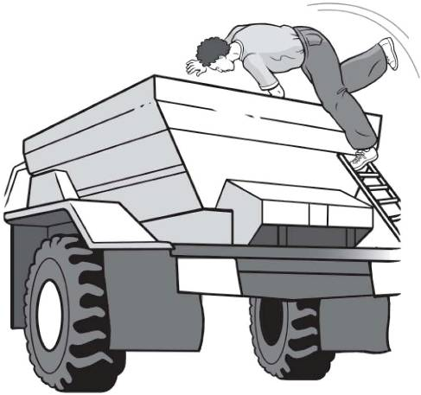

Overhead #5

Where are Teens Injured?
Other
15%
Retail
54%
Agriculture
7%
Manufacturing
4%
Service
20%
Where Teens Work:
Other
11%
Retail
54%
Agriculture 5%
Manufacturing 5%
Service
25%

Overhead #6

Where do Massachusetts Teens Work?

Employed 15- to 17-Year-Olds, by Industry, Massachusetts, 2006:

Where are Massachusetts Teens Injured?

Work-related injuries to Teens under Age 18, by Industry, Massachusetts, 2002-2006:

Overhead #7

Your Safety IQ Quiz

The law says your employer must give you training about health and safety hazards on the job.
___True ___ False

The law sets limits on how late you can work on a school night if you are under 16.
___True ___ False

If you are 16 years old you are allowed to drive a car on public streets as part of your job.
___True ___ False

If you are injured on the job, your employer must pay for your medical care.
___ True ___ False

How many teens get injured on the job every year in the U.S.?
___ One per day ___ One per hour
___ One every 7 minutes

Overhead #8

Key Points of This Training
You will learn more about:

Identifying and reducing hazards on the job

Identifying and reducing hazards in healthcare jobs

Laws that protect teens from working too late or too long

Laws that protect teens from doing dangerous work

How to solve health and safety problems at work

What agencies enforce health and safety laws and child labor laws

What to do in an emergency.

Overhead #9

Job Hazards
A job hazard is anything at work than can hurt you, either physically or mentally.

Safety hazards can cause immediate accidents and injuries.
Examples: hot surfaces or slippery floors.

Chemical hazards are gases, vapors, liquids, or dusts that can harm your body.
Examples: cleaning products or pesticides.

Biological hazards are living things that can cause sickness or disease.
Examples: bacteria, viruses, or insects.

Other health hazards are harmful things, not in the other categories, that can injure you or make you sick. These hazards are sometimes less obvious because they may not cause health problems right away.
Examples: noise, repetitive movements, heavy lifting, stress.

Overhead #10

Find the Hazards: Fast Food
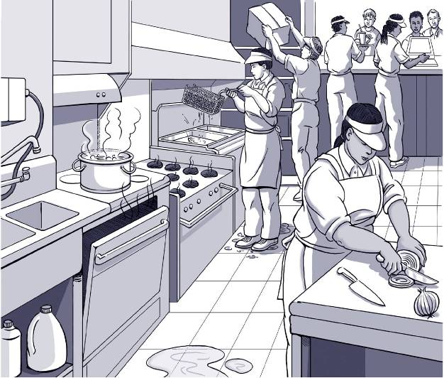

Overhead #11

Find the Hazards: Grocery Store

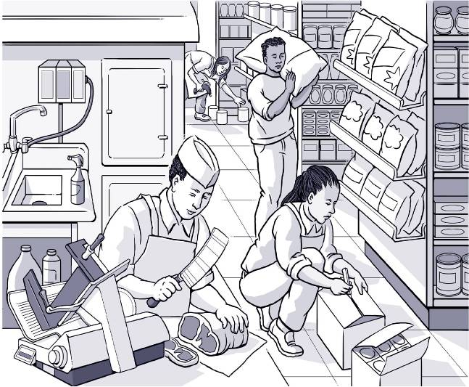

Overhead #12

Find the Hazards: Office
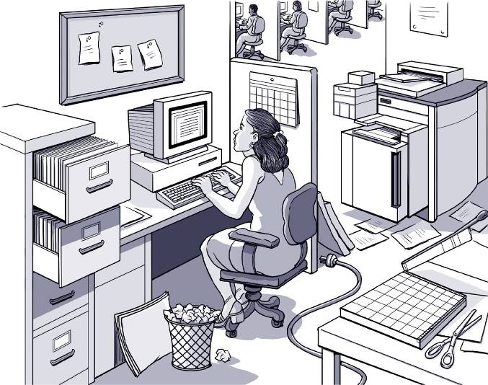

Overhead #13

Find the Hazards: Gas Station

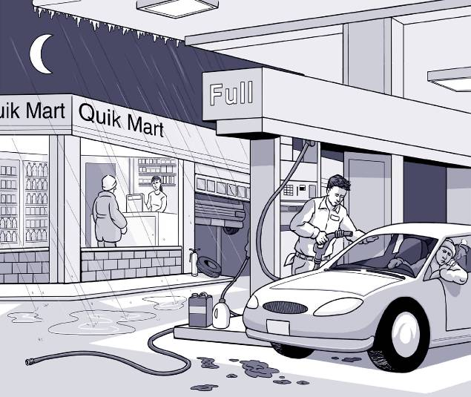

Overhead #14

Find the Hazards: Nursing Home

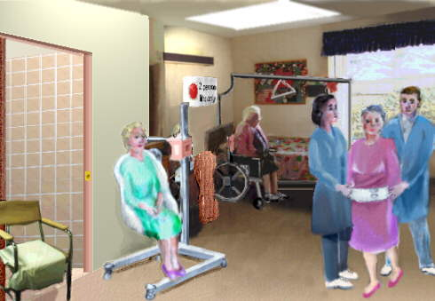

Nursing home picture from: http://www.osha.gov/SLTC/etools/hospital/hazards/ergo/ergo.html

Overhead #15

Find the Hazards: ICU

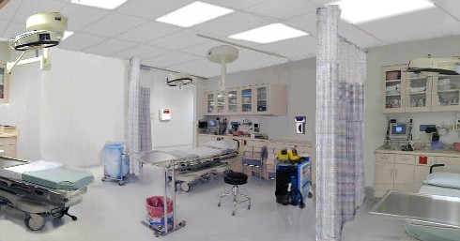

ICU picture from: http://www.osha.gov/SLTC/etools/hospital/icu/icu.html

Overhead #16

Sample Hazard Map
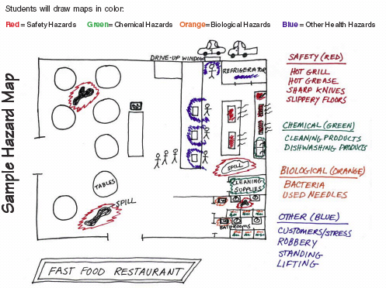

Overhead #17

Key Points: Finding Hazards

- Every job has health and safety hazards
- You should always be aware of these hazards
- Find out about chemicals at work by checking labels, readings MSDSs, and getting training.

Overhead #18

Controlling Hazards

First choice: Remove the Hazard
(e.g., use safer chemicals, put guards around hot surfaces)

Second choice: Work Policies and Procedures
(e.g., give workers safety training, assign enough people to do the job)

Third choice: Personal Protective Equipment
(e.g., wear gloves, use a respirator)

Overhead #19

Jamie’s Story
Job: Hospital Dishwasher
Injury: Dishwashing chemical splashed in eye

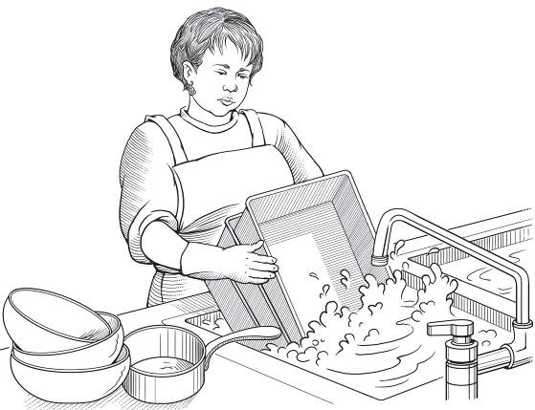

Overhead #20

Billy’s Story
Job: Fast food worker
Injury: Burned hand on grill

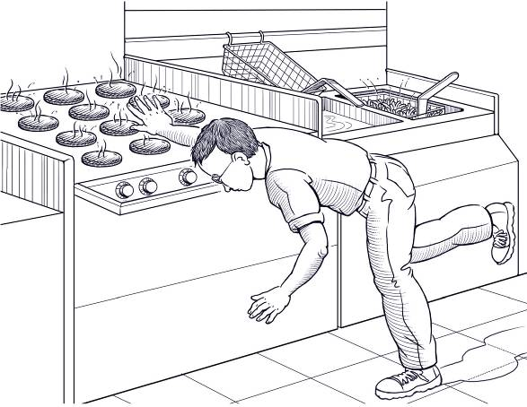

Overhead #21

Stephen’s Story
Job: Grocery store clerk
Injury: Hurt back while loading boxes

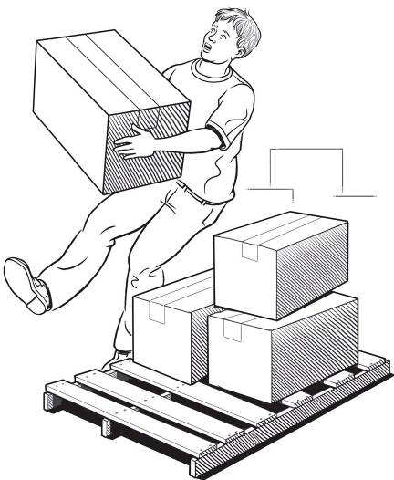

Overhead #22

Terry’s Story
Job: Grocery store deli clerk
Injury: Cut finger on meat slicer

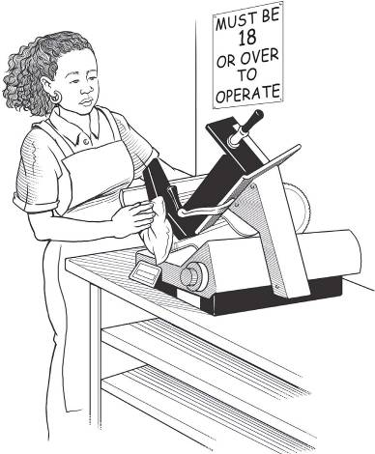

Overhead #23

Chris’ Story
Job: City public works employee
Injury: Fainted due to heat

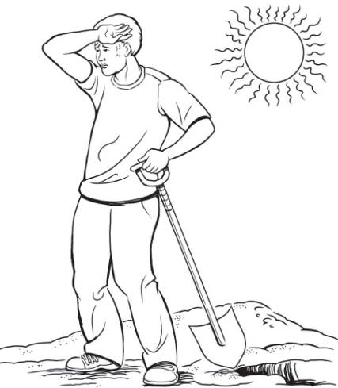

Overhead #24

James’ Story
Job: Pizza shop employee
Injury: Repetitive motion injury

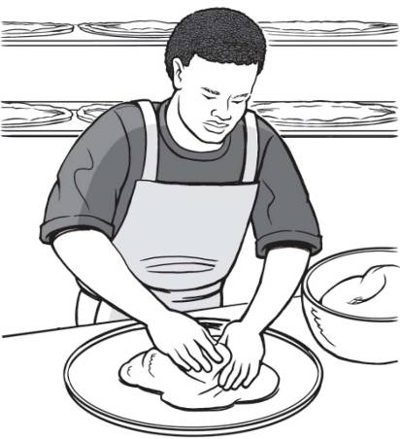

Overhead #25

Maria’s Story
Job: Farmworker
Injury: Pesticide poisoning

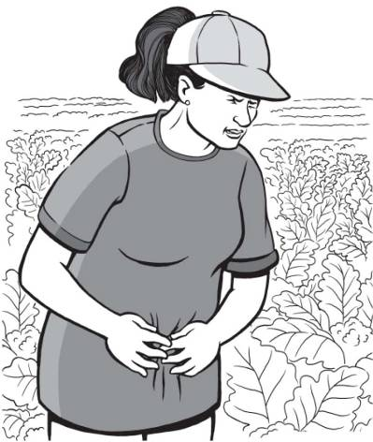

Overhead #26

Brent’s Story
Job: Pallet making
Injury: Amputated arm

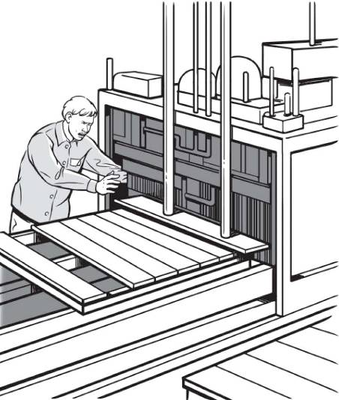

Overhead #27

Sara’s Story
Job: Nursing Aide
Injury: Back, neck, and shoulder pain

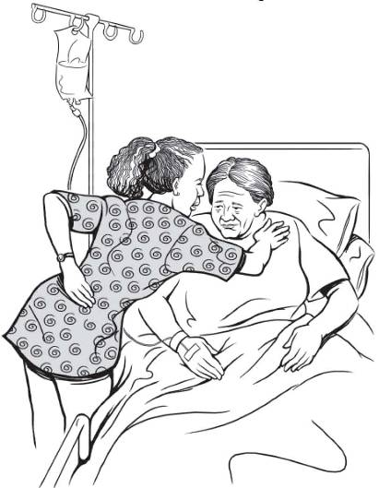

Overhead #28

Julie’s Story
Job: Dental assistant
Injury: Needlestick

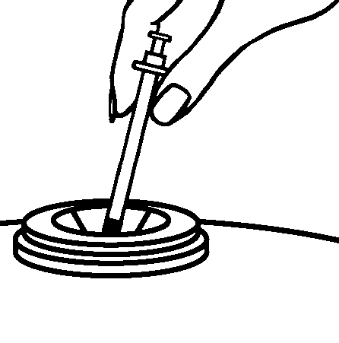

Overhead #29

Michael’s Story
Job: Health assistant
Injury: Chemical burns to eyes
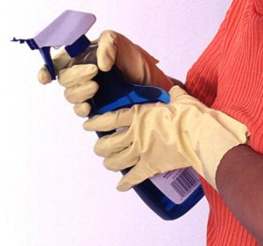

Overhead #30

Vanessa’s Story
Job: Nursing aide
Injury: Sprained back and cracked rib

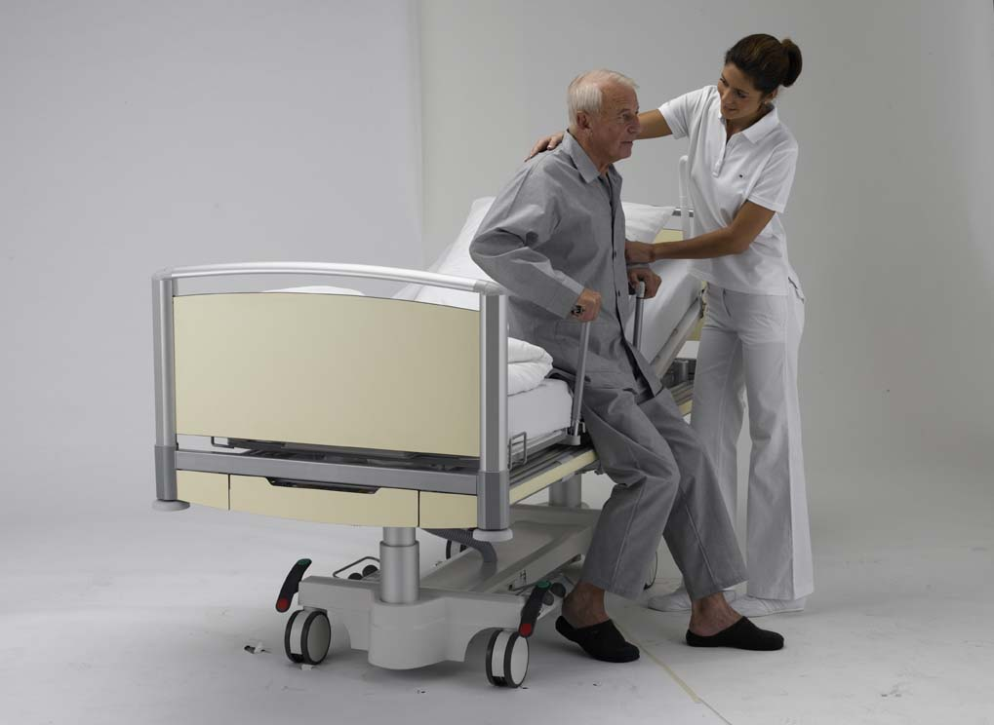

Overhead #31

Jose’s Story
Job: Dietary aide
Injury: Back injury and concussion

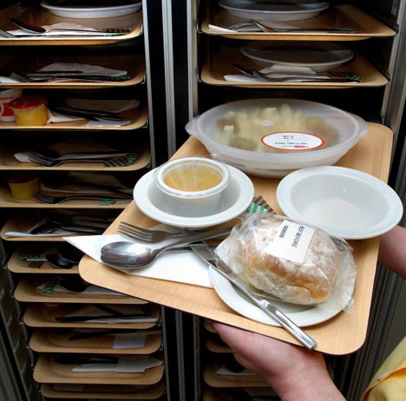

Overhead #32

Key Points: Making the Job Safer

- OSHA requires employers to provide a safe workplace.
- It’s best to get rid of a hazard completely, if possible.
- If your employer can’t get rid of the hazard, there are usually many ways to protect you from it.

Overhead #33

Sharps Devices with Safety Features

Self Re-sheathing Needle
Initially, the sleeve is located over the barrel of the syringe with the needle exposed for use. After the device is used, the user slides the sleeve forward over the needle where it locks in place and provides a guard around the used needle.
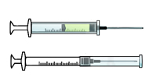

Syringe with Retractable Needle
After the needle is used, an extra push on the plunger retracts the needle into the syringe, removing the hazard of needle exposure.
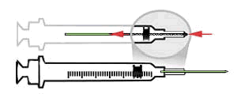

Blunt-Tipped Blood Drawing Needles
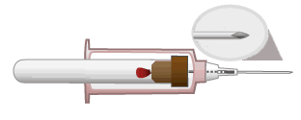
After blood is drawn, a push on the collection tube moves the blunt tip needle forward through the needle and past the sharp needle point. The blunt point tip of this needle can be activated before it is removed from the vein or artery.

Winged Steel Needles
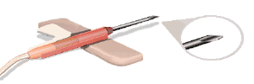
After placement, the third wing is rotated to flat position which blunts the needle point before it is removed from the patient.

"Add on" Safety Feature
Hinged or sliding shields attached to phlebotomy needles, winged steel needles, and blood gas needles.
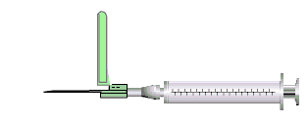

Pictures from: http://www.osha.gov/SLTC/etools/hospital/hazards/sharps/sharps.html

Overhead #34

Who Wants to Win a Million Dollars?

Question | Dollar Value
1 | $100
2 | $250
3 | $500
4 | $1,000
5 | $2,000
6 | $4,000
7 | $8,000
8 | $16,000
9 | $32,000
10 | $64,000
11 | $125,000
12 | $250,000
13 | $500,000
14 | $1,000,000

Overhead #35

Who Wants to Win a Million Dollars?

Round One Questions

$100: Which of the following can be considered a bloodborne pathogen?
A. Cancer
B. HIV
C. Hepatitis B
D. B & C

$250: A soiled laundry bag is overflowing. To make it easier to close, you should:
A. Push down on the top of the linens with your hands.
B. Push down on the top of the linens with your feet.
C. Gently shake down the laundry by holding the bag’s top.
D. Pull some of the dirty linens out and put them on the floor.

$500: Which of the following can be considered a “sharp” instrument?
A. Broken glass.
B. Latex gloves.
C. Exposed ends of dental wires.
D. A & C

$1,000: If you are in a rushed situation, how should you handle contaminated sharps?
A. By temporarily disposing of the contaminated sharps in a regular trash receptacle.
B. By carefully disposing of them in the proper sharps disposal containers.
C. By leaving them out on a counter for housekeeping to clean-up.
D. By wrapping them in soiled linens.

Overhead #36

Who Wants to Win a Million Dollars?

Round One Questions

$2,000: Mary slips and falls as she is rushing down the hallway of the hospital while carrying several large boxes that she can barely see over. Which of the following might have helped prevent her fall?
A. Wearing slip-resistant shoes.
B. Running as fast as she could down the hallway so she could put the boxes down.
C. Carrying only one box at a time so she could see over it.
D. A & C

$4,000: Which of the following is the symbol for a biohazard?

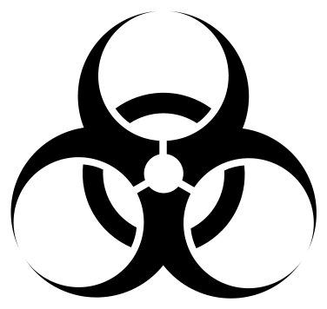
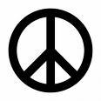
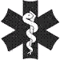

A.
B.
D.
C.

$8,000: James is a nursing assistant working long hours in the ICU, and lately he’s been feeling depressed, having difficulty sleeping, and has started smoking. Which of the following could be causing his symptoms?
A. Drinking too much coffee.
B. Eating too much sugar.
C. Going to the gym regularly.
D. Excessive job-related stress.

Overhead #37

Who Wants to Win a Million Dollars?

Round One Questions

$16,000: If you observe a suspicious individual or circumstance at work, you should:
A. Ask a co-worker to speak to the individual.
B. Alert security or law enforcement immediately.
C. Try to apprehend the individual yourself.
D. Find something to use as a weapon and then speak to the individual.

$32,000: Which of the following is NOT a safe handling technique for sharps?
A. Always bend a contaminated sharp before disposing of it.
B. Always direct the sharps’ point away from yourself and others.
C. Make sure you are wearing gloves that fit properly.
D. Disposing of contaminated sharps immediately after use in specified containers.

$64,000: Which agency says that workers have the right to get information about chemicals used in their workplace?
A. Environmental Protection Agency (EPA)
B. Centers for Disease Control and Prevention (CDC)
C. Occupational Safety and Health Administration (OSHA)
D. Food and Drug Administration (FDA)

Overhead #38

Who Wants to Win a Million Dollars?

Round One Questions

$125,000: Which of the following is something an employer could do to reduce the risk of workplace violence in a healthcare setting?
A. Not letting a potentially violent person stand between you and the door.
B. Provide security escorts to the parking lot at night.
C. Making sure staff always work alone.
D. Learn signals that may be associated with impending violence.

$250,000: Anything at work that can hurt you, either physically or mentally, is a:
A. Bloodborne pathogen.
B. Universal precaution.
C. Workplace hazard.
D. Needlestick injury.

$500,000: Which of the following statements is false?
A. Exposure to some chemicals can cause breathing problems.
B. All chemicals should be stored in closed containers and clearly labeled.
C. Exposure to latex can cause allergic reactions in some people.
D. Employees do not have to have access to Material Safety Data Sheets (MSDS) unless there is an injury.

Overhead #39

Who Wants to Win a Million Dollars?

Round One Questions

$1,000,000: Which of the following exposures pose a risk for bloodborne pathogen
infection?
A. A nurse sustains a needlestick while drawing-up insulin to administer to a patient with diabetes.
B. A lab worker is splashed on the arm with urine from a patient with HIV.
C. An operating room technician with a cut on her hand notices blood under her gloves after assisting in a surgery on a patient with hepatitis C infection.
D. While cleaning the bathroom, a housekeeper’s intact skin has contact with feces.

Overhead #40

Who Wants to Win a Million Dollars?

Round Two Questions

$100: To protect yourself against bloodborne pathogens, you should avoid direct contact with which of the following?
A. Blood
B. Hair
C. Saliva
D. A & C

$250: Which of the following are reasons healthcare work can be very stressful?
A. Having patients thank you for taking such good care of them.
B. Dealing with life-threatening emergencies.
C. Dealing with demanding and dependent patients.
D. B & C

$500: How should you carry trash bags or bags full of dirty linens?
A. On your back.
B. By the top, away from your body.
C. Close to your body.
D. None of the above.

$1,000: Which of the following could be a slip, trip, or fall hazard in the workplace?
A. Wearing slip-resistant shoes.
B. A drawer left open.
C. Items left on both sides of a hallway.
D. B & C

Overhead #41

Who Wants to Win a Million Dollars?

Round Two Questions

$2,000: For which of the following is there a vaccine to help protect you against infection?
A. Hepatitis B
B. Hepatitis C
C. Cooties
D. HIV

$4,000: Which of the following could be a signal that may be associated with impending violence?
A. A patient thanking you for how well you’ve cared for them.
B. A family member of a patient bringing you flowers.
C. A patient verbally expressing anger and frustration.
D. None of the above.

$8,000: What is the first thing you should do if you are stuck with a contaminated needle or sharp instrument?
A. Clean the wound with soap and water.
B. Clean the wound with bleach.
C. Put a band-aid on the wound.
D. All of the above.

$16,000: If an employee is the victim of violence or witnesses violence in the workplace, the best thing for an employer to do is:
A. Pretend it never happened.
B. Provide a program of support and services to help the employee.
C. Force the employee back to their job immediately to get over being scared.
D. Only help the victim and not the witnesses.

Overhead #42

Who Wants to Win a Million Dollars?

Round Two Questions

$64,000: Which of the following information can be found on a Material Safety Data Sheet (MSDS)?
A. Chemical name.
B. Where to purchase the product.
C. Price.
D. Taste.

$125,000: Viruses, bacteria, molds and used, bloody needles are considered what kind of workplace hazard?
A. Safety.
B. Chemical.
C. Biological.
D. All of the above.

$250,000: What is the definition of Universal Precautions?
A. Wearing slip-resistant shoes to protect yourself from a fall.
B. Treating all blood and other potentially infectious body fluids as if they are infected.
C. Wearing gloves while using certain chemicals.
D. Treating all blood and body fluids as if they are safe.

$500,000: Your supervisor asks you to clean up dried blood on the floor. You should:
A. Tell him or her you don’t feel like cleaning it up.
B. Clean it up, but follow universal precautions because some bloodborne pathogens can survive in dried blood.
C. Clean it up, but not worry about putting on gloves – if the blood is dry there’s no risk.
D. None of the above.

Overhead #43

Who Wants to Win a Million Dollars?

Round Two Questions

$1,000,000: Which of the following is the definition of ergonomics?
A. The science of detecting bloodborne pathogens.
B. The science of fitting the job to the worker.
C. Lifting as much weight as you can without hurting your back.
D. Using sharp instruments with safety features.

Overhead #44

Key Points: Emergencies at Work

- Every workplace should have an emergency action plan
- The plan should cover:
  - What to do in different emergencies
  - Where shelters and meeting places are
  - Evacuation routes
  - Emergency equipment and alert systems
  - Who’s in charge
  - Procedures to follow when someone is injured
- The workplace should have practice drills
- Workers should be trained on everything in the plan.

Overhead #45

Game Board

Jeopardy Game
Rights on the Job | Dangerous Work and Work Permits | Hours for Teens and Working Safely | Job Injuries and Getting Help
$100 | $100 | $100 | $100
$200 | $200 | $200 | $200
$300 | $300 | $300 | $300
$400 | $400 | $400 | $400
$500 | $500 | $500 | $500

Overhead #46

Key Points: Know Your Rights

- Federal and state labor laws:
  - Set minimum age for some tasks
  - Protect teens from working too long, too late or too early
- OSHA says every employer must provide:
  - A safe workplace
  - Safety training on certain hazards
  - Safety equipment
- By law, your employer is not allowed to fire or punish you for reporting a safety problem.

Overhead #47

Handling Workplace Safety Problems

- Define the problem.
- Get advice from a parent, teacher, or co-worker.
- Choose your goals. Decide which solution is best.
- Know your rights.
- Decide the best way to talk to the supervisor.
- If necessary, contact an outside agency for help.

Overhead #48

Summing Up

- Know your rights. The factsheet is an important resource. Show it to your friends and parents.

- Know your responsibilities. It’s your responsibility to follow safety rules and report any problems you see.

- Know your employer’s responsibilities. Your employer must keep the workplace safe and give you safety training.

- Know how to solve problems. Resources include co-workers, friends, parents, teachers, and government agencies like OSHA, EPA, and federal and state labor law enforcement agencies.

