Slide #1

Youth @ Work: Talking Safety
Health Services Safety Edition
Teaching Young Workers About Job Safety and Health

National Institute for Occupational Safety and Health
Centers for Disease Control and Prevention
National Young Worker Safety Resource Centers
Labor Occupational Health Program, U.C. Berkeley
Education Development Center, Inc., Newton, MA

Massachusetts Department of Public Health
Occupational Health Surveillance Program
Teens at Work: Injury Surveillance and Prevention Project

Slide #2

Youth @ Work: Talking Safety

You will learn about:
- Some of the ways people (both youth and adults) can get hurt on the job.
- What to do if you see something at work that could hurt you or make you sick.
- What legal rights all workers have to make sure their jobs are safe.
- What extra protections young workers have under child labor laws.

Slide #3

What is Your Experience with Work?

- Have you ever had a job?
- Where did you work?
- What did you do?
- Have you ever been hurt at work, or do you know someone who was?

Slide #4

Lesson One

- Young Worker Injuries

Slide #5

Examples of Teen Work Injuries/The Impact of Work Injuries

John’s Story
Job: Fast food worker
Injury: Slipped on greasy floor

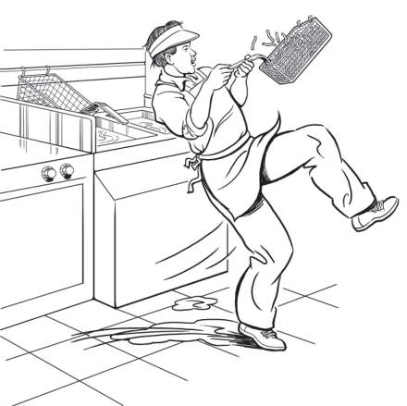

Why do you think this happened?
What could have prevented John from getting hurt?

Slide #6

Examples of Teen Work Injuries/The Impact of Work Injuries

Antonio’s Story
Job: Construction helper
Injury: Fell from roof
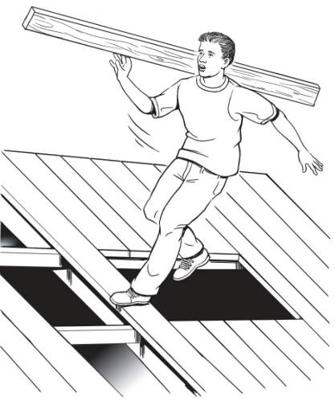

Why do you think this happened?
What could have prevented Antonio from being killed?

Slide #7

Examples of Teen Work Injuries/The Impact of Work Injuries

Keisha’s Story
Job: Computer data entry
Injury: Repetitive stress injury

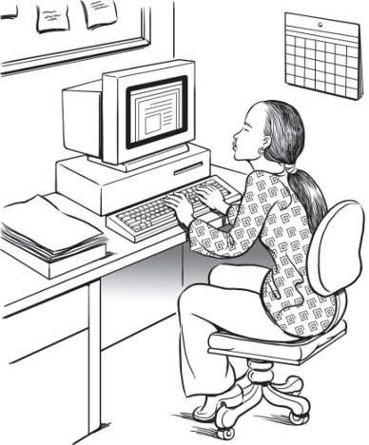

Why do you think this happened?
What could have prevented Keisha from getting hurt?

Slide #8

Examples of Teen Work Injuries/The Impact of Work Injuries

Francisco’s Story
Job: Landscaping worker
Injury: Death

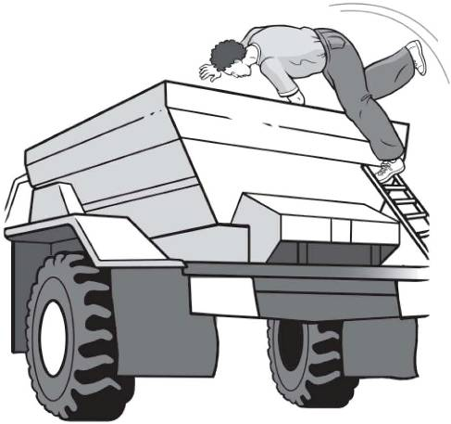

Why do you think this happened?
What could have prevented Francisco from being killed?

Slide #9

Teen Work Injury Statistics

- Many youth are injured on the job:
  - 250,000 <18-year-olds injured/year in the US
  - 84,000 <18-year-olds to the ER for work injuries
  - 70 <18-year-olds die each year
  - 90 18-19 year-olds die each year
- Young workers are injured at a higher rate than adult workers.

Slide #10

Where are Teens Injured?/Teen Work Injury Statistics

Where Teens are Injured:
Other
15%
Retail
54%
Agriculture
7%
Manufacturing
4%
Service
20%
Where Teens Work:
Other
11%
Retail
54%
Agriculture 5%
Manufacturing 5%
Service
25%

Slide #11

Where are Massachusetts Teens Injured?/Teen Work Injury Statistics

Where are Massachusetts Teens Injured?

Work-related injuries to Teens under Age 18, by Industry, Massachusetts, 2002-2006:

Where do Massachusetts Teens Work?

Employed 15- to 17-Year-Olds, by Industry, Massachusetts, 2006:

Slide #12

Your Safety IQ Quiz

The law says your employer must give you training about health and safety hazards on the job.
___True ___ False

The law sets limits on how late you can work on a school night if you are under 16.
___True ___ False

If you are 16 years old you are allowed to drive a car on public streets as part of your job.
___True ___ False

Slide #13

Your Safety IQ Quiz, continued

If you are injured on the job, your employer must pay for your medical care.
___ True ___ False

How many teens get injured on the job every year in the U.S.?
___ One per day ___ One per hour
___ One every 7 minutes

Slide #14

Why are Young Workers Injured at High Rates?

Teens: The Hazards We Face in the Workplace
Video and Discussion

Slide #15

Key Points of this Training

You will learn more about:
- Identifying and reducing hazards on the job
- Laws that protect teens from working too late or too long
- Laws that protect teens from doing dangerous work
- How to solve health and safety problems at work
- What agencies enforce health and safety laws and child labor laws
- What to do in an emergency.

Slide #16

Lesson Two

- Finding Hazards

Slide #17

Job Hazards

A job hazard is anything at work that can hurt you either physically or mentally.
- Safety hazards: knives, hot grease, etc.
- Chemical hazards: dusts, gases, vapors
- Biological hazards: living organisms
- Other health hazards: noise, radiation,repetitive movements, heat, cold, stress

Slide #18

Illustrated Workplaces/Find the Hazards: Fast Food

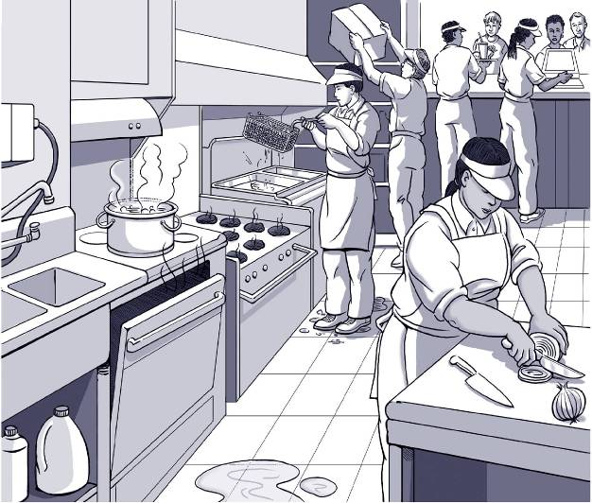

Slide #19

Illustrated Workplaces/Find the Hazards: Grocery Store

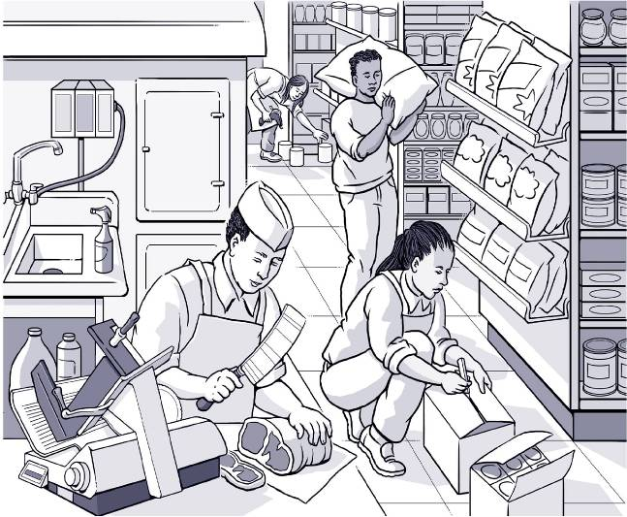

Slide #20

Illustrated Workplaces/Find the Hazards: Office

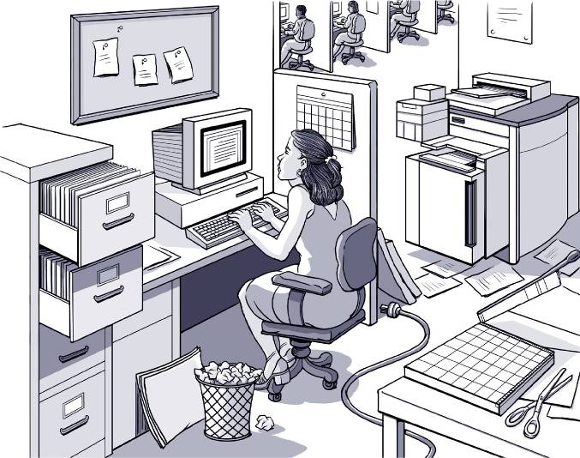

Slide #21

Illustrated Workplaces/Find the Hazards: Gas Station

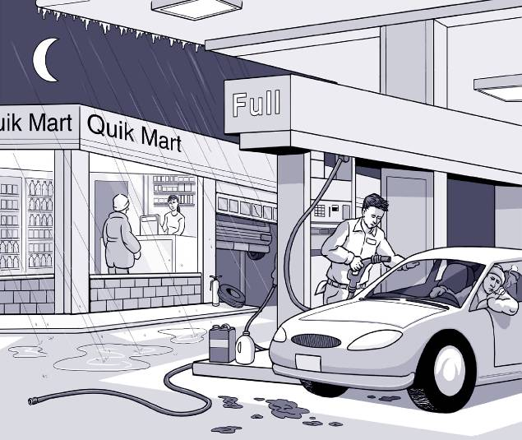

Slide #22

Illustrated Workplaces/Find the Hazards: Nursing Home

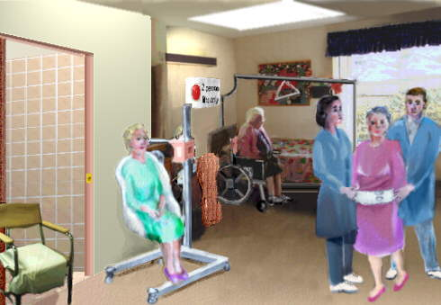

Slide #23

Illustrated Workplaces/Find the Hazards: ICU

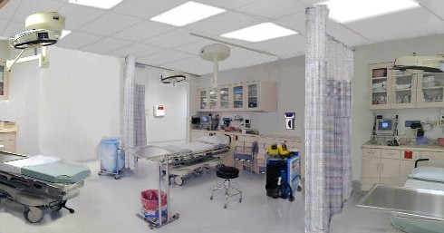

Slide #24

Hazard Mapping Activity
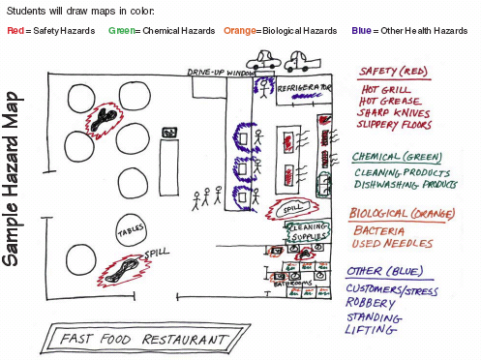

Slide #25

Finding Hazards: Key Points

- Every job has health and safety hazards
- You should always be aware of these hazards
- Find out about chemicals at work by checking labels, readings MSDSs, and getting training.

Slide #26

Lesson Three

- Finding Ways to Make the Job Safer

Slide #27

Controlling Hazards

Remove
the Hazard
(e.g., use safer
chemicals)

Work Policies and
Procedures
(e.g., assign enough people
to do the job)

Personal Protective Equipment
(e.g., wear gloves, use a respirator)

Slide #28

$25,000 Safety Pyramid Game

Eliminating or Reducing Hazards: Jamie’s Story

Job: Hospital Dishwasher
Injury: Dishwashing chemical splashed in eye

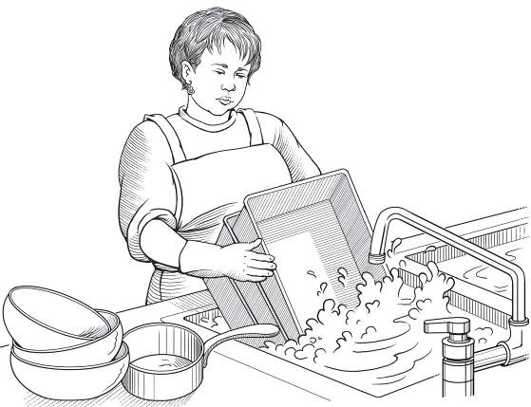

Jamie is a 17-year-old dishwasher in a hospital kitchen. To clean cooking pans, she soaks them in a powerful chemical solution. She uses gloves to protect her hands and arms. One day, as Jamie was lifting three large pans out of the sink at once, they slipped out of her hands and back into the sink. The cleaning solution splashed all over the side of her face and got into her right eye. She was blinded in that eye for two weeks.

Slide #29

$25,000 Safety Pyramid Game

Eliminating or Reducing Hazards: Billy’s Story

Job: Fast food worker
Injury: Burned hand on grill

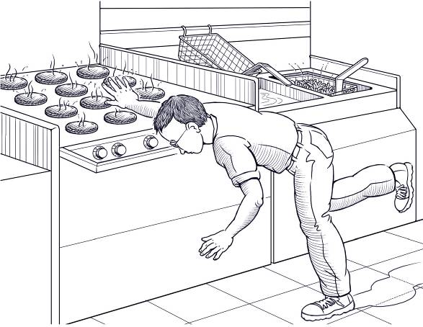

Billy is a 16-year-old who works in a fast food restaurant. One day Billy slipped on the greasy floor. To catch his fall, he tried to grab a bar near the grill. He missed it and his hand touched the hot grill instead. He suffered second degree burns on the palm of his hand.

Slide #30

$25,000 Safety Pyramid Game

Eliminating or Reducing Hazards: Stephen’s Story

Job: Grocery store clerk
Injury: Hurt back while loading boxes

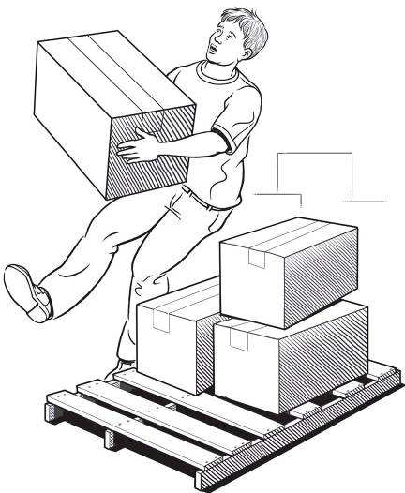

Stephen is a 17-year-old who works in a grocery store. One day while unloading a heavy box from a truck onto a wooden pallet, he slipped and fell. He felt a sharp pain in his lower back. He was embarrassed, so he got up and tried to keep working. It kept bothering him, so he finally went o the doctor. He had to stay out of work for a week to recover. His back still hurts sometimes.

Slide #31

$25,000 Safety Pyramid Game

Eliminating or Reducing Hazards: Terry’s Story

Job: Grocery store deli clerk
Injury: Cut finger on meat slicer

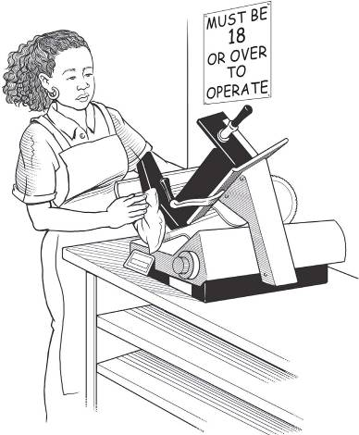

Terry is a 16-year-old who works in the deli department at a grocery store. Her supervisor asked her to clean the meat slicer, although she had never done this before and had never been trained to do it. She thought the meat slicer was turned off before she began cleaning it. Just as she started to clean the blades, the machine started up. The blade cut a finger on Terry’s left hand all the way to the bone.

Slide #32

$25,000 Safety Pyramid Game

Eliminating or Reducing Hazards: Chris’ Story

Job: City public works employee
Injury: Fainted due to heat
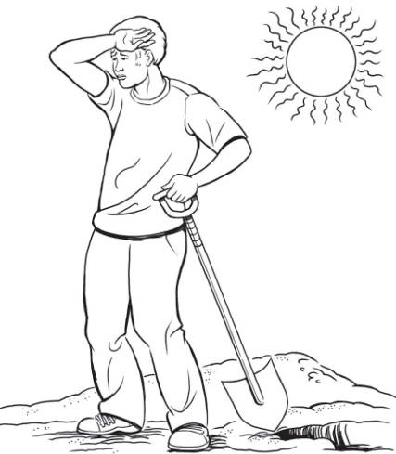

Chris works for a city public works department. One hot afternoon the temperature outside reached 92 degrees. While Chris was shoveling dirt in a vacant lot, he started to feel dizzy and disoriented. He fainted due to the heat.

Slide #33

$25,000 Safety Pyramid Game

Eliminating or Reducing Hazards: James’ Story

Job: Pizza shop employee
Injury: Repetitive motion injury

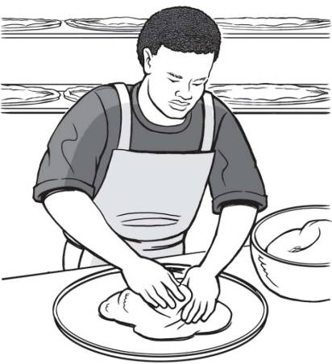

James is a 16-year-old who works in a busy pizza shop. His job is to pat pizza dough into pans. He prepares several pans per minute. Lately he has noticed that his hands, shoulders, and back are hurting from the repetitive motion and standing for long periods of time.

Slide #34

$25,000 Safety Pyramid Game

Eliminating or Reducing Hazards: Maria’s Story

Job: Farmworker
Injury: Pesticide poisoning
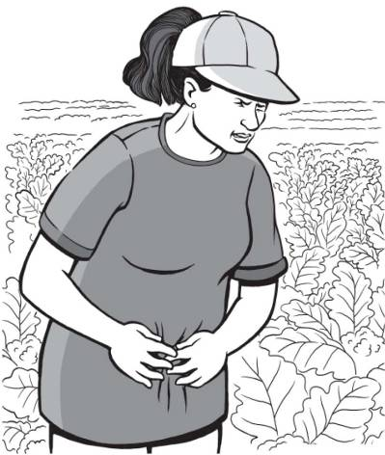

Maria works tying up cauliflower leaves on a 16-acre farm. One day she was sent into the field too soon after it had been sprayed. No one told her that the moisture on the plants was a highly toxic pesticide. Soon after she began to work, Maria’s arms and legs started shaking. When she stood up, she got dizzy and stumbled. She was taken by other farmworkers to a nearby clinic. Three weeks later she continues to have headaches, cramps, and trouble breathing.

Slide #35

$25,000 Safety Pyramid Game

Eliminating or Reducing Hazards: Brent’s Story

Job: Pallet making
Injury: Amputated arm

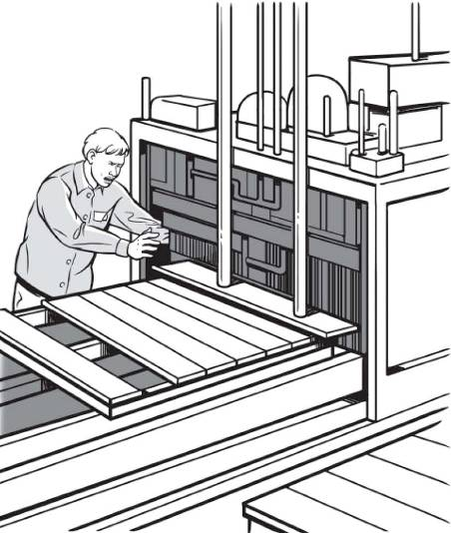

Seventeen-year-old Brent worked after school in his father’s pallet making business. One day Brent was working on a machine that helps take old pallets apart by cutting through wood and nails. The machine sorts out the old nails into a bin and then cuts the remaining wood into small pieces that can be ground into shavings. Brent’s sleeve got caught in the mechanism of the saw. Before he realized what was happening, his arm was cut off. He was rushed to the hospital, but the arm could not be saved.

Slide #36

$25,000 Safety Pyramid Game

Eliminating or Reducing Hazards: Sara’s Story

Job: Nursing Aide
Injury: Back, neck, and shoulder pain

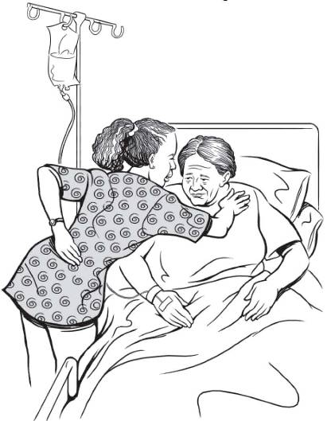

Sara works as a nursing aide at a local hospital. She is expected to clean bedpans and sometimes change sheets, which requires lifting patients. Lately she has been feeling twinges in her back when bending over or lifting. She knows she is supposed to get help when lifting a patient, but everyone in the unit is so busy that she is reluctant to ask. At home, as she is going to sleep, she often feels shooting pains in her back, neck and shoulders. The se pains seem to be getting worse every day.

Slide #37

$25,000 Safety Pyramid Game

Eliminating or Reducing Hazards: Julie’s Story

Job: Dental assistant
Injury: Needlestick
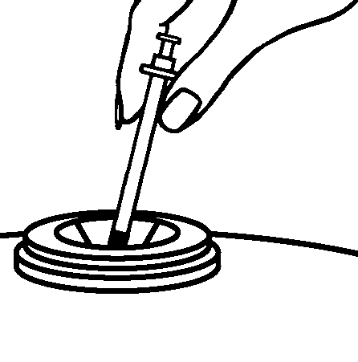

Julie is in school studying toe be a dental assistant, and works part-time for a local dentist. One day at work she was trying to dispose of a needle by putting it in the sharps disposal container, when the loose cap fell off and the needle scratched the tip of her finger. The dentist had bent the needle top and the cap didn’t fit on all the way.

Slide #38

$25,000 Safety Pyramid Game

Eliminating or Reducing Hazards: Michael’s Story

Job: Health assistant
Injury: Chemical burns to eyes

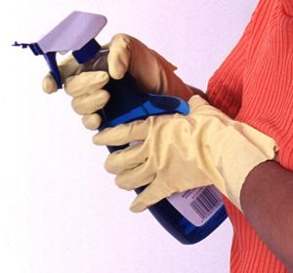

Michael is 17-years-old and works as a health assistant in a nursing home. He is often asked to help out with routine cleaning tasks, such as cleaning the wheelchairs used to transport patients. He was simply told to use the cleaner called “spitfire” to clean the wheelchairs. One day while spraying a chair with spitfire, some of the chemical splashed in his face and got into his eyes. Even though he rinsed his eyes out with water, they still burned so he was taken to the emergency room where he was told he had chemical burns on his eyes.

Slide #39

$25,000 Safety Pyramid Game

Eliminating or Reducing Hazards: Vanessa’s Story

Job: Nursing aide
Injury: Sprained back and cracked rib

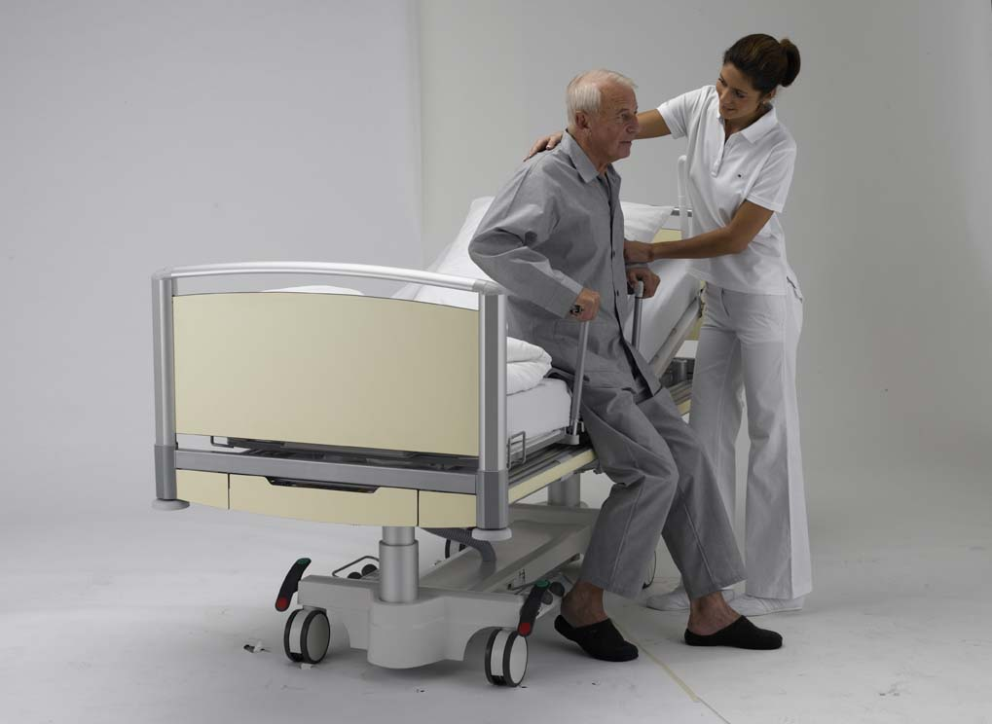

Vanessa is a nursing aide at a long-term care facility where one of her regular duties is to bathe and clean patients. Because the facility is so short-staffed, most of the aides work by themselves. One day she was cleaning a bedridden patient with dementia by herself, when the patient started yelling at her. She tried to verbally redirect him but it wasn’t working, and she didn’t want to leave the patient alone. The yelling became worse, the patient started thrashing around, and eventually the patient punched her in the back and side. She ended up with a sprained back and cracked rib.

Slide #40

$25,000 Safety Pyramid Game

Eliminating or Reducing Hazards: Jose’s Story

Job: Dietary aide
Injury: Back injury and concussion

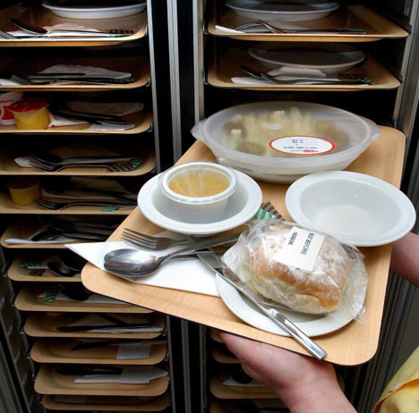

Jose works as a dietary aide in a nursing home. One day while getting ready to serve dinner, he went into the kitchen to pick-up trays of food. Another co-worker had spilled some food on the kitchen floor, and someone wiped it up, but the floor was still wet and greasy. He didn’t notice the wet floor, and he slipped and fell, landing on his back and hitting his head and wrist on the counter as he fell. He suffered a concussion, fractured his wrist, and still has back pain weeks later.

Slide #41

Making the Job Safer: Key Points

- OSHA requires employers to provide a safe workplace.
- It’s best to get rid of a hazard completely, if possible.
- If your employer can’t get rid of the hazard, there are usually many ways to protect you from it.

Slide #42

Lesson Four

- Hazards in Healthcare Settings

Slide #43

Sharps Devices with Safety Features

Self Re-sheathing Needle
Initially, the sleeve is located over the barrel of the syringe with the needle exposed for use. After the device is used, the user slides the sleeve forward over the needle where it locks in place and provides a guard around the used needle.
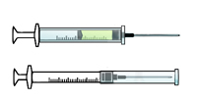

Syringe with Retractable Needle
After the needle is used, an extra push on the plunger retracts the needle into the syringe, removing the hazard of needle exposure.
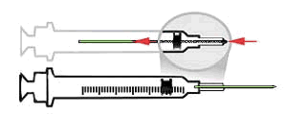

Blunt-Tipped Blood Drawing Needles
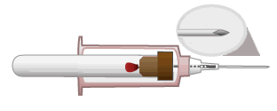
After blood is drawn, a push on the collection tube moves the blunt tip needle forward through the needle and past the sharp needle point. The blunt point tip of this needle can be activated before it is removed from the vein or artery.

Slide #44

Sharps Devices with Safety Features (continued)

Winged Steel Needles
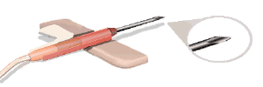
After placement, the third wing is rotated to flat position which blunts the needle point before it is removed from the patient.

"Add on" Safety Feature
Hinged or sliding shields attached to phlebotomy needles, winged steel needles, and blood gas needles.
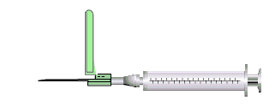

Pictures from: http://www.osha.gov/SLTC/etools/hospital/hazards/sharps/sharps.html

Slide #45

Who Wants to Win a Million Dollars?

Question | Dollar Value
1 | $100
2 | $250
3 | $500
4 | $1,000
5 | $2,000
6 | $4,000
7 | $8,000
8 | $16,000
9 | $32,000
10 | $64,000
11 | $125,000
12 | $250,000
13 | $500,000
14 | $1,000,000

Slide #46

Healthcare Hazards: Key Points

- Healthcare workers face a wide range of hazards on the job, including:
  - Exposure to bloodborne pathogens
  - Needlestick and sharps injuries
  - Exposure to hazardous chemicals
  - Slips, trips, and falls
  - Stress and violence
- It is important to work with your employer to make sure you are protected from these and other hazards.

Slide #47

Lesson Five

- Emergencies at Work

Slide #48

Emergencies at Work

What is an emergency at work?
An unplanned event that harms or threatens employees, customers, or the public; that shuts down business operations; or that causes physical or environmental damage.

Slide #49

Emergencies at Work

- Disaster Blaster Game
- Emergencies in the News activity

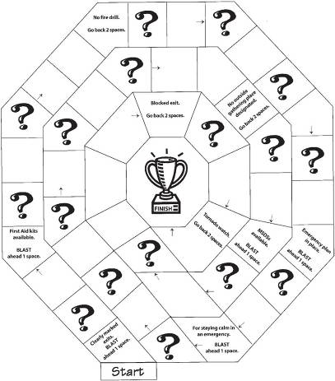

Slide #50

Emergencies at Work: Key Points

- Every workplace should have an emergency action plan
- The plan should cover:
  - What to do in different emergencies
  - Where shelters and meeting places are
  - Evacuation routes
  - Emergency equipment and alert systems
  - Who’s in charge
  - Procedures to follow when someone is injured
- The workplace should have practice drills
- Workers should be trained on everything in the plan.

Slide #51

Lesson Six

- Know Your Rights

Slide #52

Are You a Working Teen?

Slide #53

Know Your Rights

Jeopardy Game
Rights on the Job | Dangerous Work and Work Permits | Hours for Teens and Working Safely | Job Injuries and Getting Help
$100 | $100 | $100 | $100
$200 | $200 | $200 | $200
$300 | $300 | $300 | $300
$400 | $400 | $400 | $400
$500 | $500 | $500 | $500

Slide #54

Know Your Rights
Labor Law BINGO Game

Board #1

$8.00 an hour
10 or 10:15 PM

Slide #55

Know Your Rights: Key Points

- Federal and state labor laws:
  - Set minimum age for some tasks
  - Protect teens from working too long, too late or too early
- OSHA says every employer must provide:
  - A safe workplace
  - Safety training on certain hazards
  - Safety equipment
- By law, your employer is not allowed to fire or punish you for reporting a safety problem.

Slide #56

Lesson Seven

- Taking Action

Slide #57

Handling Workplace Safety Problems

Steps in Problem Solving
- Define the problem.
- Get advice.
- Choose your goals.
- Know your rights.
- Decide the best way to talk to the supervisor.
- If necessary, contact an outside agency for help.

Slide #58

Summing Up

- Know your rights
- Know your responsibilities
- Know your employer’s responsibilities
- Know how to solve problems

Slide #59

Resources for More Information

Websites:
www.youthrules.dol.gov
www.osha.gov/SLTC/teenworkers
www.youngworkers.org

Slide #60

Resources for More Information

National Institute for Occupational Safety and Health
www.cdc.gov/niosh
1-800-232-4636

National Young Worker Resource Center Offices
Labor Occupational Health Program
University of California Berkeley
2223 Fulton Street, 4th floor, Berkeley, CA 94720-5120
tel: 510-642-5507; fax: 510-643-5698
dbush@berkeley.edu
rdewey@berkeley.edu

Education Development Center, Inc.
55 Chapel Street, Newton, MA 02458
tel: 617-618-2238
cmiara@edc.org

www.youngworkers.org

Massachusetts Department of Public Health
Teens at Work: Injury Surveillance and Prevention Project
tel: 617-624-5632
teens.atwork@state.ma.us
www.mass.gov/dph/teensatwork

