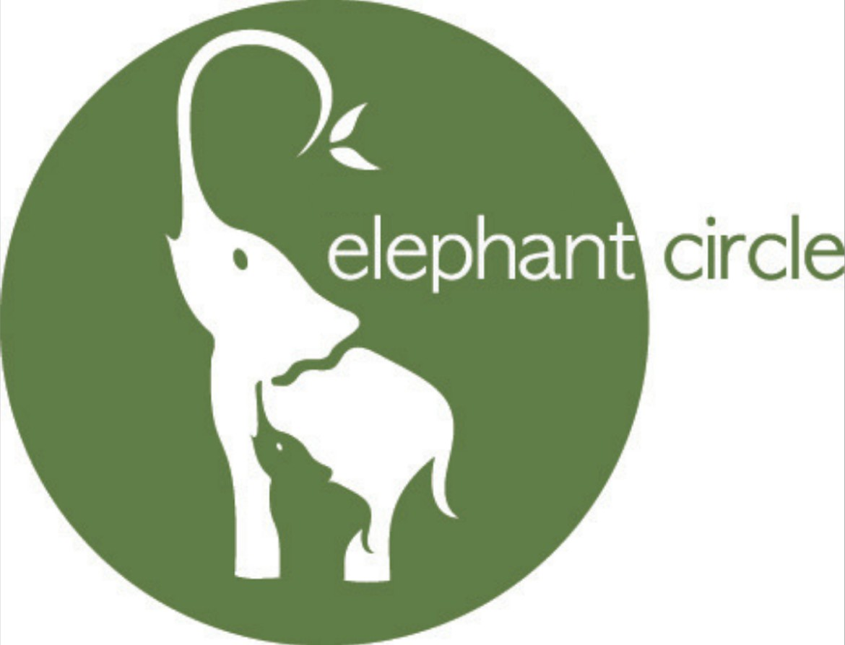

April 22, 2026
Department of Public Health
250 Washington Street
Boston, MA 02108
RE: Testimony in Support of 274 CMR 3.00: Licensed Certiﬁed Professional Midwife
Licensure Requirements
My name is Tamara Matheson-Holmgren. I am a Massachusetts resident and a legal fellow at
Elephant Circle. I am submitting this testimony on behalf of the organization. Inspired by Elephants who give birth in a circle of support and protection in the wild, Elephant Circle is a Colorado-based birth justice organization with pockets of work and community across the country. We envision a world where every birthing person has a circle of support and protection throughout their entire perinatal journey and we are submitting this testimony in support of the new regulation.
We support regulation that centers the midwifery model of care, both in its design and its
implementation. We support regulation that allows midwives to practice at the top of their license recognizing their expertise and commitment to physiologic birth. We recognize the power, training, and rootedness in community birth that CPMs hold and we support regulation that enables their ability to serve their families in a supportive, integrated, and thriving regulatory landscape.
Through Elephant Circle’s experience advocating for midwifery legislation in Colorado and across
the country, we understand that accessible midwifery care is integral to a thriving maternal health system. We know without a doubt that midwifery saves lives, supports bodily autonomy, and supports better health outcomes for birthing people and their families. This new regulation is a foundation for true integration of midwifery care in the state of Massachusetts and is one step toward increasing access to community birth for MassHealth members and families who have private insurance. We urge the Department to promulgate regulation that truly enacts the goals of H.4999 and recognizes that midwifery is the movement.
Sincerely,
Tamara Matheson-Holmgren
If/When/How Reproductive Justice Fellow, Elephant Circle
Elephant Circle, 3548 G Rd, Palisade, CO 81526-9788

