INDOOR AIR QUALITY ASSESSMENT

**Taunton State Hospital**

**Gifford Building**

Taunton, MA

**June 2024**

Taunton State Hospital
Gifford Building
Taunton, MA


Prepared by:

Massachusetts Department of Public Health

Bureau of Climate and Environmental Health

Indoor Air Quality Program

Contents

EXECUTIVE SUMMARY 3

BACKGROUND 5

RESULTS AND DISCUSSION 5

Ventilation 6

Water Damage and Moisture Concerns 7

Water Damage Issues 8

Sources of Respiratory Irritants/Possible Asthma Triggers 9

CONCLUSIONS AND RECOMMENDATIONS 11

REFERENCES 14

PICTURES 15

Table 1 24

Table 2A 27

Table 2B 28

Table 2C 29

Table 3 30

Table 4 32

# R an EXECUTIVE SUMMARY

The Massachusetts Department of Public Health’s Indoor Air Quality Program (MDPH IAQ) conducted an IAQ assessment of the first and second floors of the Gifford Building located on the campus of Taunton State Hospital on May 14, 2024. This assessment was requested by Department of Mental Health (DMH) administration for the purpose of investigating mold concerns and general IAQ complaints reported by staff.

It is important to note that the building was constructed in the early 1900s and has been placed on the historical register, requiring special permission to work on/make improvements and repairs to the building. It is also important to note that the building originally constructed with no mechanical ventilation components in work areas occupied by DMH and was dependent on natural cross-ventilation fresh air supply by operable windows and passive door vents. A number of these components were disabled by sealing of passive vents and installing window-mounted air conditioners (ACs) that make some windows inoperable. These conditions make it difficult to control outside airflow, temperature, and relative humidity, particularly during hot, humid, summer conditions.

In addition, a number of building envelope issues/leaks have led to water damage as evidenced by peeling paint and efflorescence (i.e., mineral deposits) on ceiling and wall plaster. As climate change and global warming intensifies, the urgent need for modern, energy-efficient solutions becomes clear, without significant repair of the building envelope and repair/upgrade of interior components, building conditions and indoor air quality will continue to degrade.

The assessment was conducted by evaluating several key elements within the building; a visual inspection of the heating, cooling, and ventilating (HVAC) systems, water/microbial damage, cleanliness, point sources of respiratory irritants such as chemicals. Air measurements of carbon dioxide (CO2), carbon monoxide (CO), temperature, relative humidity (RH), and small particulate matter (PM2.5) were taken using Q-trak XP monitor. Data is collected in this manner to identify potential asthma triggers, allergens, and other environmental factors that can cause indoor air quality symptoms. Please refer to the [Indoor Air Quality Manual](https://www.mass.gov/lists/indoor-air-quality-manual-and-appendices#indoor-air-quality-manual-) on the MDPH website for methods, sampling procedures, and interpretation of results.

As a result of this assessment, there are several findings: conditions in this building are typical of buildings of this age and type, active leaks, musty odors, and water-damaged building materials were present in the 1st floor conference room. Other evidence such as peeling paint and efflorescence were observed in several areas throughout the building, and there are occupant-induced issues such as clutter and use of personal devices/materials that can affect air quality. (Results and Discussion)

Upon review of these findings, the musty odors and water damage are likely due to water infiltration through the building envelope, which are being addressed by ongoing repointing and identification of leaks throughout the building. (Conclusions)

Based on the results of the assessment, the following primary recommendations are made:

* Continue with plans for repointing and weather-proofing the building.
* Particular attention should be made to fixing the leak(s) creating chronic water damage in the 1st floor conference room.
* Until the entire carpet can be removed in the 1st floor conference room, remove sections of carpeting around radiators and in the corner where active leaks are present. Determine if carpeting is adhered to asbestos-containing floor tile prior to any carpet removal. If asbestos present in flooring, comply with all state and federal asbestos handling and disposal laws and regulations.
* Use openable windows to supplement fresh air during temperate weather. Ensure all windows are tightly closed at the end of the day or during periods of elevated relative humidity to avoid condensation/mold issues.
* Use “Fan Only” function on window mounted ACs to create air circulation when windows are closed or when cooling is not needed.
* Continue to make available portable air purifiers equipped with high efficiency particulate arrestance (HEPA) filters for occupants who request them.
* Clean/scrape and refinish areas of peeling paint and efflorescence and monitor for further damage. Determine if paint contains lead. If paint contains lead, use best practices for lead paint removal to prevent cross-contamination.
* To control for dusts, a HEPA filter equipped vacuum cleaner in conjunction with wet wiping of all surfaces is recommended. Particular attention should be made around radiators, windows, and ACs in office areas to remove accumulated cobwebs, dust and debris.

(Conclusions and Recommendations)

# R an BACKGROUND

|  |  |
| --- | --- |
| Building: | Gifford Building |
| Address: | Taunton State Hospital Campus  Taunton, Massachusetts |
| Assessment Requested by: | Sharon Moody, Assistant Director Department of Mental Health (DMH), Office of Engineering and Facilities Management |
| Reason for Request: | Mold concerns and general indoor air quality (IAQ) |
| Date of Assessment: | May 14, 2024 |
| Massachusetts Department of Public Health/Bureau of Climate and Environmental Health (MDPH/BCEH) Staff Conducting Assessment: | Cory Holmes, Assistant Director, IAQ Program  Tom Murphy, Inspector, IAQ Program |
| Building Description: | The DMH is located on the 1st and 2nd floors of the Gifford Building, which is a red brick building with slate roof that was originally constructed in the early 1900s as dorm rooms for Taunton State Hospital nursing staff. The space consists of private offices, common areas and conference rooms. The building has no means of mechanical ventilation. |
| Windows: | Windows are openable throughout the building; however, several could not be opened due to the installation of portable air conditioners (ACs). However, in many cases modifications have been made to install small, openable windows that can be opened adjacent to ACs. |

# R an RESULTS AND DISCUSSION

The following is a summary of indoor air testing results (Table 1)

|  |  |  |
| --- | --- | --- |
| * ***Carbon dioxide (CO2)*** | *a measure of the adequacy of ventilation* | Levels were below the MDPH guideline of 800 parts per million (ppm) in most of the areas surveyed. A few areas had levels above 800 ppm, typically smaller rooms with higher occupancy and or windows shut. |
| * ***Temperature*** | *a measure of comfort* | Was within or close to the MDPH recommended range of 70°F to 78°F in occupied areas. |
| * ***Relative humidity*** | *a measure of comfort and, when in excess for an extended period, a way to reflect the potential for mold and fungal growth* | Was within the MDPH recommended range of 40 to 60% in all areas tested. |
| * ***Carbon monoxide***   ***(CO)*** | *a product of combustion that can result in acute and long term cardiovascular, respiratory, and neurological symptoms* | Levels were non-detectible in all areas assessed. |
| * ***Particulate matter (PM2.5)*** | *a way to measure inhalable particle distribution in the air* | Concentrations were below the National Ambient Air Quality Standard (NAAQS) of 35 micrograms per cubic meter (μg/m3) in all areas tested, with one exception-room 136 (100 μg/m3), which had a desktop humidifier operating that was vaporizing water droplets. |

## Ventilation

Ventilation refers to both the supply of fresh air and the removal of stale air from a room. The introduction of fresh air into an occupied space will dilute normally occurring pollutants that are generated by occupancy and other activities. In addition, a heating, ventilation, and air conditioning (HVAC) system will remove pollutants from a building if operating appropriately. As previously mentioned, the occupied areas of the DMH space have no means of mechanical ventilation.

As mentioned, the Gifford Building was configured in a manner to use *cross-ventilation* to provide comfort for building occupants. The building is equipped with windows on opposing exterior walls. In addition, passive vents (called transfer air vents) are installed in hallway doors (Picture 1). These passive vents enable the occupants to keep hallway doors secured while maintaining a pathway for airflow. This design allows for airflow to enter an open window (windward side), pass through a room, pass through the passive door vent, enter the hallway, pass through the opposing open room door vent, into the opposing room and exit the building on the leeward side (opposite the windward side). With all windows and passive vents open, airflow can be maintained in a building regardless of the direction of the wind. This system fails if the windows or vents are closed or disabled. It was reported that these passive vents were sealed for privacy purposes. In addition, the installation of window-mounted ACs has limited the ability of cross-ventilation.

The various types of ventilation components *as well as devices that can move/redirect airflow* are listed in Table 2A, Table 2B and Table 2C.

**Additional HVAC Conditions:**

* In some cases, openable windows were disabled by the installation of window-mounted ACs. However, in a number of areas modifications have been made to install small, openable windows to allow for introduction of fresh air (Picture 2).
* These can be used for additional fresh air during temperate weather. Windows should be kept closed during wet weather, when air conditioning is operating in the room, and at the end of the workday.
* Most window-style air conditioners can supply some amount of fresh air while operating in “Fan Only” or similar mode (Picture 3).
* They are also equipped with filters that need to be cleaned periodically.

## Water Damage and Moisture Concerns

Please note that the IAQ Program does not recommend conducting mold testing in a typical water damage remediation. For details, please consult [Guidance Regarding Testing for Mold in Water-Damaged Public Buildings](https://www.mass.gov/info-details/guidance-regarding-testing-for-mold-in-water-damaged-public-buildings) | Mass.gov

The application of a mildewcide to moldy porous materials is not recommended.

Molds are found naturally in our environment both indoors and outdoors. Inside, mold growth may occur when items, particularly porous products such as paper or gypsum wallboard, are exposed to moisture. Typical water sources include leaks, floods, and condensation. To avoid mold growth, dry all water-damaged items and affected areas within 24-48 hours and reduce indoor humidity. Some people with chronic respiratory conditions, such as asthma, are more likely to experience health symptoms associated with molds, including allergic reactions and respiratory irritation. Controlling moisture is the key to preventing mold growth and potential health symptoms.

Hot humid summers are becoming more frequent due to climate change. Massachusetts has experienced hot, humid, and rainy summers in 2018, 2021, and 2023. July of 2021 was the wettest ever recorded in Massachusetts, and the three-month period from June through August, known as the meteorological summer, was the fourth wettest on record, according to the National Oceanic and Atmospheric Administration’s (NOAA) Centers for Environmental Information (NOAA, 2021). The summer of 2023 was also hot, and wet, being measured as the second rainiest on record (WBUR, 2023). These conditions are challenging for buildings, particularly those without central air conditioning.

During these hot and wet summers, extended periods of outdoor relative humidity above 70% occurred. Under these weather periods, public buildings experienced extended periods of water vapor exposure from high relative humidity. When exposed to these conditions, porous materials such as gypsum wallboard, cardboard, and other materials may become prone to developing mold colonization, particularly if located in areas that are prone to developing condensation on floors and walls (e.g., below grade space).

### Water Damage Issues

(see Water Damage and Moisture Concern Pictures)

* Active leaks were reported above the window in room 125 and more prominently in the 1st floor conference room. Building facilities staff reported that repointing around the building and weather-proofing is an ongoing effort. Occupants should ensure they report active leaks to building management for investigation and repairs.
* Water infiltration and leaks around radiators was evident in the form of missing ceiling tiles, stained carpeting, peeling paint, and water-damaged wall and ceiling plaster as noted by efflorescence in a number of areas including the 1st floor conference room (Table 1, Pictures 4 through 7). Efflorescence results when rainwater penetrates into brick and mortar. A suspension of water and salts forms in the brick and mortar, which then travels to the wall surface. As the water evaporates, a white, powdery material is formed (efflorescence). While efflorescence is a sign of water exposure to brick, and water intrusion, it is not mold growth.
* Also noted was cloth material stuffed around window ACs (Picture 8). Cloth is a porous material that can grow mold if wetted repeatedly.
* A water cooler was noted directly on carpeting in the 1st floor conference room (Picture 9). Water coolers and full containers should be placed on waterproof mats or surfaces to prevent chronic moisture that can lead to mold growth.
* Plants were noted in several areas (Table 1). Plants can be a source of pollen or mold especially if overwatered or not well maintained. In addition, plants were noted on top of paper plates in some cases, which can delaminate and be a source of mold growth (Picture 10).

Several other conditions on the outside of the building were identified that can contribute to water infiltration issues, which are specified in Table 3 and are listed below.

**Mold Growth**

Porous materials (e.g., gypsum wallboard, ceiling tiles and carpeting) can be dried with fans and heating within 24 to 48 hours of becoming wet (US EPA, 2008).

If porous materials are not dried within this time frame, mold growth may occur.

* Broken windows were noted on the top floor (Picture 11), which can allow drafts, moisture, and pest entry into the building.
* Delaminating paint was noted along the roof eaves, which can accelerate water damage and wood rot (Picture 12).
* Trees were in close proximity to the building (Pictures 13 and 14). The presence of large trees is likely enhancing water retention, preventing drying of the exterior, and affecting drainage as well as overhanging the roof. These trees pose several hazards:
  + Leaves and other debris accumulate around gutters, and if present - roof drains, which inhibits rainwater drainage. Clogged gutters and/or ineffective drains can lead to water running off the roof to moisten exterior walls.
  + Trees prevent sunlight from drying walls and soil.
  + The trees are a possible danger due to the distance from exterior walls:

The recommended safe distance that any tree should be planted is the minimum of the expected maximum growth height of the species from the exterior of a building (BI, 2015).

* + Soil subsidence may also be caused by tree roots, which can undermine the structure of a building to cause wall and floor cracking and related damage. To prevent subsidence, a sufficient distance appropriate for the tree species is recommended (Williams, 2006).
  + Severe weather may result in the tree falling onto the building or the tree roots damaging the foundation. Due to the height of the trees, each is likely located closer than recommended distances.
  + In general, a tree root system will spread out in all directions from its trunk. In some cases, tree roots can extend for over 100 feet from its trunk. Any structure disrupting the root structure may make the tree unstable if subjected to high winds from a certain direction. Based on the location, the foundation walls likely disrupt the roots of several trees.
  + The Federal Emergency Management Agency (FEMA) provides several recommendations in order to prepare for severe thunderstorms. Of note FEMA recommends “Cut down or trim trees that may be in danger of falling on your [building]” (FEMA, 2018). Given the proximity to exterior walls, removal of trees from the courtyard should be strongly considered.

## 

## Sources of Respiratory Irritants/Possible Asthma Triggers

Asthma is a lung disease that can make breathing difficult. Without careful management of asthma, some people can have symptoms, like a tight feeling in the chest, shortness of breath, coughing, or wheezing. Although there is no cure for asthma, people with asthma can live healthy, active lives. A safe and healthy environment helps to reduce asthma symptoms.

Possible asthma triggers and/or airborne pollutants exist in the building. These are listed below as well as in (Table 4).

(see Sources of Respiratory Irritant Pictures)

* Accumulated cobwebs, dust and debris were noted in a number of areas, particularly around radiators, windows and ACs (Table 1). Flaking paint was also noted on radiators in a number of areas. Although janitorial and maintenance staff perform routine cleaning, they may not be able to clean as effectively if personal items are not picked up or surfaces are cluttered.
* Although efflorescence is not mold growth, the white, powdery mineral deposits can become airborne if disturbed and be a source of eye and respiratory irritation (Picture 15).
* Dust, a common respiratory and eye irritant, can collect on surfaces and items. Although janitorial and maintenance staff perform routine cleaning, they may not be able to clean as effectively if items are not picked up or surfaces are cluttered. Even with a properly functioning ventilation system, it is necessary to either eliminate or reduce the use of materials that can be a source of respiratory irritants to prevent symptoms in individuals who have sensitivity to such pollutants.

* Several areas had area rugs (Table 1). These need to be cleaned regularly to remove dust, debris, and odors.
* Some areas had carpeting that was beyond its service life of approximately 10-11 years (IICRC, 2002). Carpeting that is beyond its service life becomes increasingly difficult to clean and may release fibers which can be irritating if airborne. Carpets should be vacuumed regularly with a high efficiency particulate arrestance (HEPA) filter equipped vacuum cleaner and cleaned annually (or semi-annually in soiled/high traffic areas) in accordance with Institute of Inspection, Cleaning and Restoration Certification (IICRC) recommendations (IICRC, 2012).
* Scent diffusers including wax melters were observed in use in the building, (Table 1), with strong odors detected in the main hallway. These products have the potential to be irritants to the eyes, nose, throat, and respiratory system of sensitive individuals. Consult “[Clean Air Is Odor Free](https://www.mass.gov/doc/clean-air-is-odor-free-removing-fragrances-to-improve-indoor-air-quality-in-schools-and-offices-0/download)” for more information on fragrances in schools and *other buildings*.
* Holes and breaches in floors around utilities/radiators were observed in some areas (Table 1, Picture 16). These breaches can provide a pathway for drafts, odors, and particulates from the ceiling plenum and wall cavities into occupied areas.
* Some areas had personal fans with accumulated dust and debris (Picture 17). This dust/debris can be re-aerosolized when fans are activated and be a source of eye and respiratory irritation.
* Finally, air purifiers were noted in some areas (Picture 18). DMH administrators reported that these units can be made available upon request by staff. HEPA-filtered units are good choices for use in occupied areas. Air purifiers that may produce ozone should not be used (EPA, 2003) All air purifiers should be cleaned and maintained in accordance with manufacturer’s instructions.

# R an CONCLUSIONS AND RECOMMENDATIONS

|  |  |  |
| --- | --- | --- |
| **Short-term Recommendations** | | |
| **HVAC System** | | |
|  |  | **Helpful links** |
|  | Facilities staff should work with occupants to identify areas where AC units have been installed that prevent the opening of windows and make modifications to install openings. |  |
|  | For air circulation (and limited fresh air introduction) window-mounted ACs can be operated in the “Fan Only” mode. |  |
|  | Reopen passive door vents to allow for air circulation. |  |
|  | Clean filters in AC units prior to and as needed during the cooling season. Keep windows closed in rooms *while air conditioners are operating* to avoid condensation that can lead to mold growth. |  |
|  | During filter cleaning examine cooling fins for dust/debris and clean/vacuum as needed to ensure efficient operation and to prevent mold growth and associated odors. |  |
|  | Use openable windows for additional fresh air during temperate weather. Close windows tightly during wet weather and at the end of each day |  |
| **Water Damage Sources** | | |
|  | Continue to conduct repointing efforts and building envelope evaluation to eliminate leaks. Building occupants should ensure they report active leaks to building management for investigation and repairs. | US EPA. 2008. “Mold Remediation in Schools and Commercial Buildings”. EPA 402-K-01-001. United States Environmental Protection Agency, Office of Air and Radiation, Indoor Environments Division, Washington, DC. September 2008. <http://www.epa.gov/mold/mold-remediation-schools-and-commercial-buildings-guide> |
|  | Once leaks are repaired, clean/scrape efflorescence and peeling paint from water-damaged plaster ceilings and walls using a HEPA-filtered vacuum cleaner. Cover items to prevent dust accumulation and conduct thorough cleaning after using HEPA vacuum and wet-wiping techniques. Monitor for further leaks/damage. |  |
|  | Remove carpeting around radiator units. |  |
|  | Until the full carpet in the 1st floor conference room can be replaced, remove carpeting in the corner where chronic leaks are identified. Water-damaged wooden baseboard in this area can be sanded down and refinished. Have the materials examined by a Massachusetts-licensed asbestos inspector. If carpeting is adhered to asbestos-containing materials, follow all federal and state asbestos handling and disposal laws and regulations. |  |
|  | Remove trees and plants from away from exterior walls to allow for better drying of building materials and prevent pollen and odors from being drawn into the building. |  |
|  | Place water coolers on waterproof mats or relocate to area with non-porous flooring material. |  |
|  | Keep all indoor plants in good condition with non-porous drip pans and do not overwater. Properly maintain plants to avoid mold and odors. |  |
|  | Seal around window and wall-mounted air conditioners tightly with a material that will not support mold growth. |  |
|  | Refinish/repaint delaminated wooden roof eaves to prevent water damage and wood rot. |  |
|  | Seal/repair broken windows on top floor to prevent drafts, moisture, and pest entry. |  |
|  | Do not store cardboard boxes (or porous/paper items) directly on floor, to prevent water damage/mold growth from condensation; elevate or store on shelves. |  |
| **Respiratory Irritants/Possible Asthma Triggers** | | |
|  | Reduce clutter. Periodically remove unwanted items. Store remaining items neatly and off the floor. Where rooms have a history of moisture issues, consider storing items in waterproof totes. |  |
|  | To control for dusts, a high efficiency particulate arrestance (HEPA) filter equipped vacuum cleaner in conjunction with wet wiping of all surfaces is recommended. Particular attention should be made around radiators, windows, and ACs in office areas to remove accumulated cobwebs, dust and debris. Avoid the use of feather dusters. |  |
|  | Clean area rugs frequently using a HEPA-equipped vacuum cleaner. |  |
|  | Until carpet can be replaced, clean in accordance with IICRC recommendations (IICRC, 2012); annually (or semi-annually in soiled/high traffic areas). |  |
|  | Scrape/clean flaking paint from radiators. |  |
|  | Reduce use of products and equipment that create irritating volatile organic compounds (VOCs) and only use in well-ventilated areas. Minimize the use of air fresheners (e.g., plug-ins), deodorizers and scented products. | Consult “[Clean Air Is Odor Free](https://www.mass.gov/doc/clean-air-is-odor-free-removing-fragrances-to-improve-indoor-air-quality-in-schools-and-offices-0/download)” for more information on fragrances in schools and *other buildings*. |
|  | Clean/change filters and maintain portable air purifiers/HEPA units in accordance with manufacturers’ recommendations. Avoid the use of air purifiers that may product ozone. | <https://www.epa.gov/indoor-air-quality-iaq/ozone-generators-are-sold-air-cleaners> |
|  | Seal breaches in walls and space around utilities with a fire-rated insulation or foam. |  |
|  | Clean portable fans regularly to remove accumulated dust/debris. |  |
| **Other Recommendations to Improve Air Quality Conditions** | | |
|  | Seal breaches/openings around utilities (e.g., radiator pipes) exterior doors, and the building envelope to keep out drafts, moisture and pests. Report any pest/rodent sightings to building management. | |
| **Long-term Recommendations** | | |
|  | Replace carpeting beyond its service life. | |
|  | Remove trees from close proximity to the building. | |
|  | Replace broken windows. | |

# REFERENCES

BI. 2015. A List of Trees and the Recommended Safe Distance from Buildings. Bickers Insurance, Littlehampton, West Sussex, UK. <https://www.bickersinsurance.co.uk/about-us/latest-news/property-owners-news/a-list-of-trees-and-the-recommended-safe-distance-from-buildings/>

FEMA. 2018. How to Stay Safe When a Thunderstorm Threatens. Federal Emergency Management Agency, Washington, DC. FEMA V-1009/May 2018.

IICRC. 2002. Institute of Inspection, Cleaning and Restoration Certification. A Life-Cycle Cost Analysis for Floor Coverings in School Facilities.

IICRC. 2012. Institute of Inspection, Cleaning and Restoration Certification. Carpet Cleaning: FAQ.

MDPH. 2015. Massachusetts Department of Public Health. Indoor Air Quality Manual: Chapters I-III. Available at: [Indoor Air Quality Manual](https://www.mass.gov/lists/indoor-air-quality-manual-and-appendices#indoor-air-quality-manual-).

NOAA. 2021. Summer 2021 neck and neck with Dust Bowl summer for hottest on record. National Oceanic and Atmospheric Administration, 1401 Constitution Avenue NW, Room 5128, Washington, DC 20230 <https://www.noaa.gov/news/summer-2021-neck-and-neck-with-dust-bowl-summer-for-hottest-on-record>

US EPA. 2003. “Ozone Generators that are Sold as Air Cleaners: An Assessment of Effectiveness and Health Consequences”. United States Environmental Protection Agency, Office of Air and Radiation, Indoor Environments Division, Washington, DC. Last updated September, 2018. <https://www.epa.gov/indoor-air-quality-iaq/ozone-generators-are-sold-air-cleaners>.

US EPA. 2008. Mold Remediation in Schools and Commercial Buildings. US Environmental Protection Agency, Office of Air and Radiation, Indoor Environments Division, Washington, D.C. EPA 402-K-01-001. <http://www.epa.gov/mold/mold-remediation-schools-and-commercial-buildings-guide>.

WBUR. 2023. “It's been a summer of rain and flooding misery in Mass.” WBUR local news. September 12, 2023. <https://www.wbur.org/news/2023/09/12/summer-flooding-rain-massachusetts>.

Williams. 2006. The Distance at Which Trees Can Affect a Building is Quite Significant. The Architects’ Journal. <https://www.architectsjournal.co.uk/home/the-distance-at-which-trees-can-affect-a-building-is-quite-significant/130858.article>

# 

# R an PICTURES

(Click to link back to report)

HVAC pictures

**Picture 1**

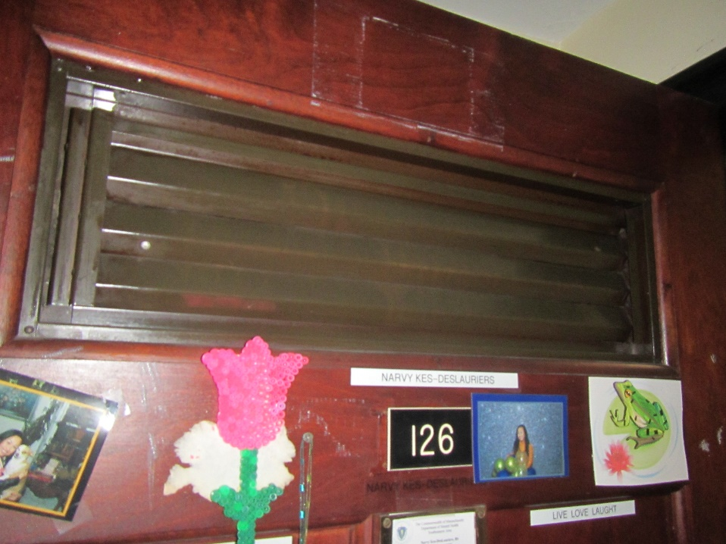

**Passive vent in door**

**Picture 2**

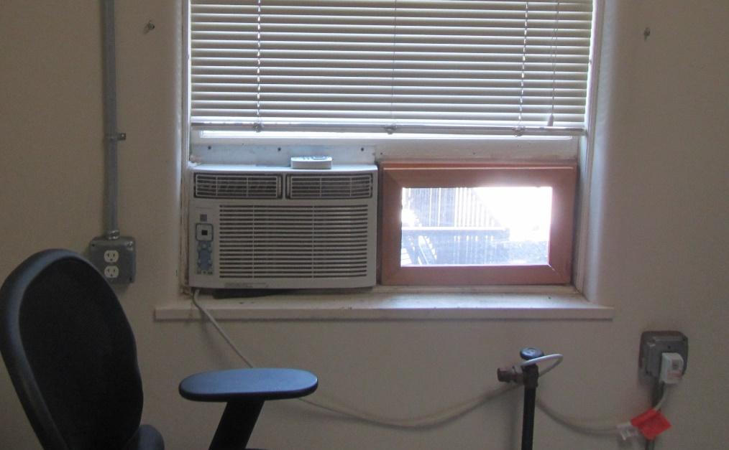

**AC and window modification (openable) on right**

**Picture 3**

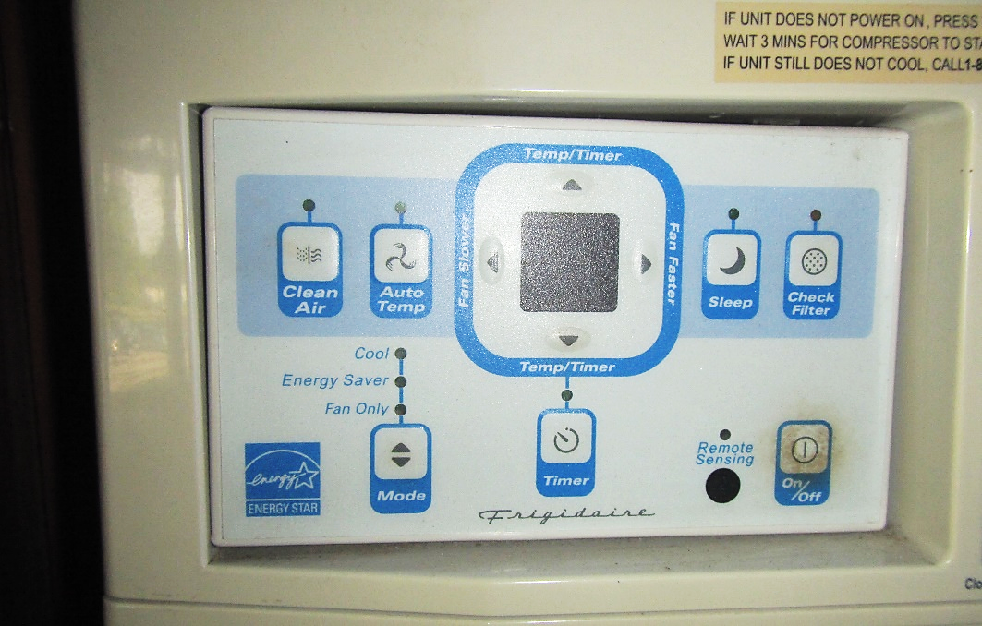

**AC control panel, Note “Fan Only” mode (arrow)**

**Water Damage and Moisture Concern Pictures**

**(click to link back to report)**

**Picture 4**

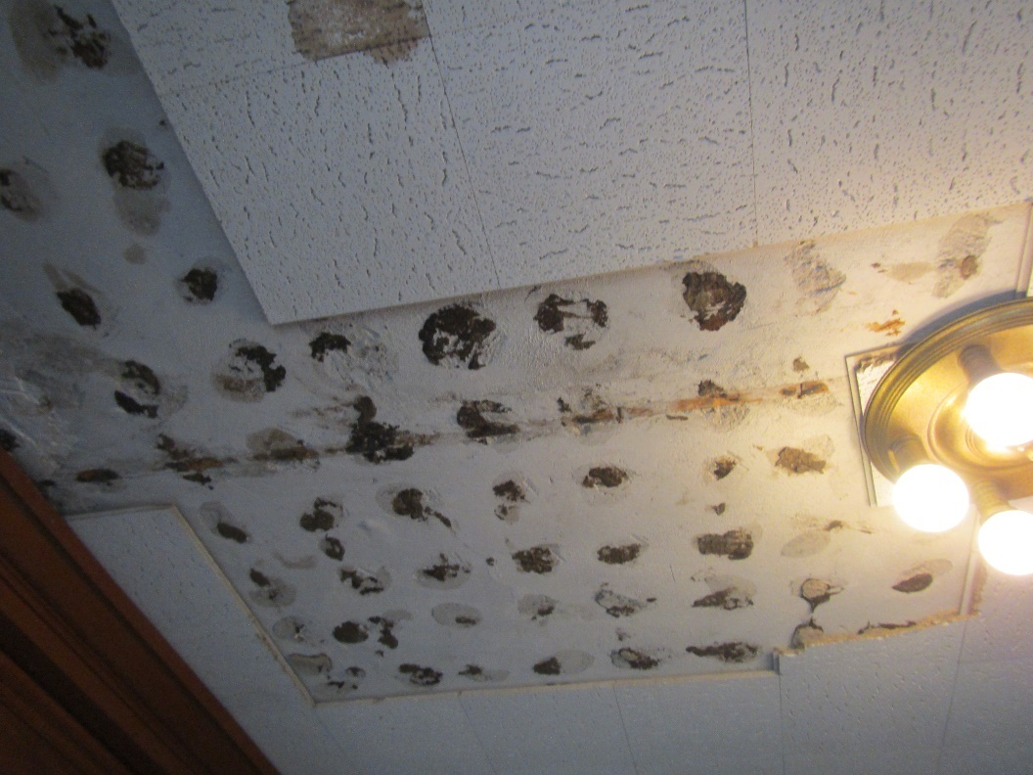

**Missing/water-damaged ceiling tiles in 1st floor conference room**

**Picture 5**

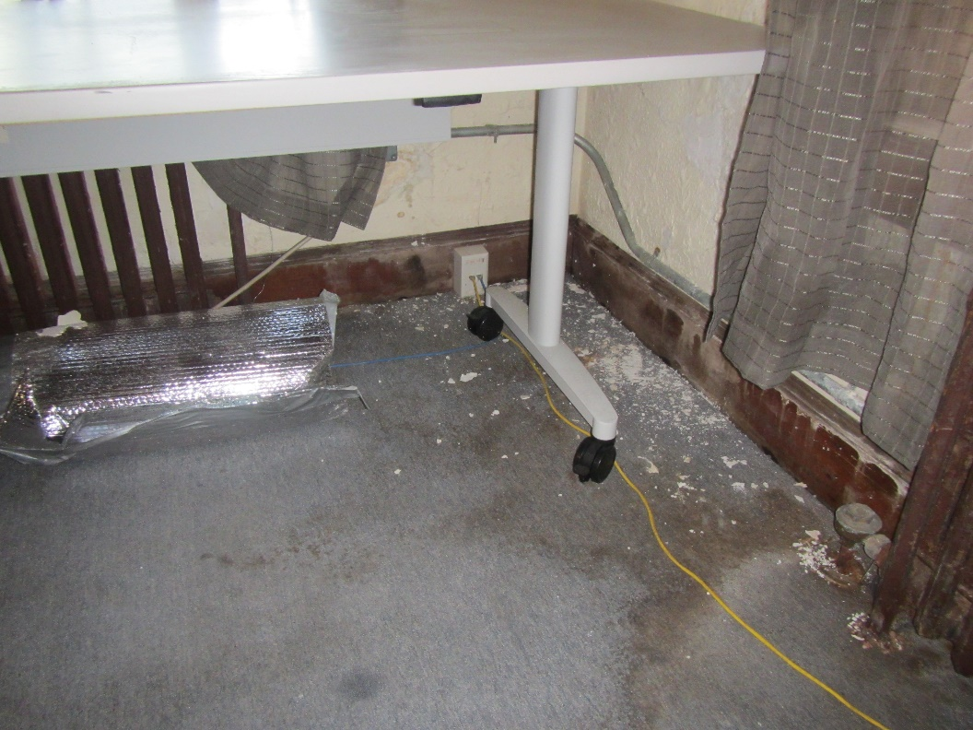

**Water-damaged carpet, wooden baseboard and wall plaster in 1st floor conference room**

**Picture 6**

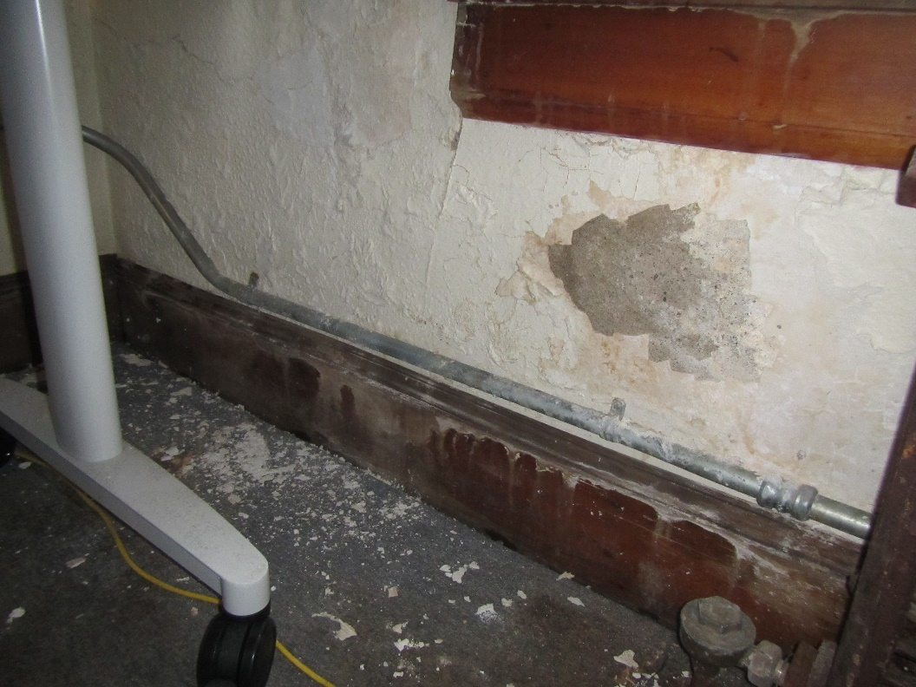

**Water-damaged carpet, wooden baseboard, and wall plaster (efflorescence) in 1st floor conference room**

**Picture 7**

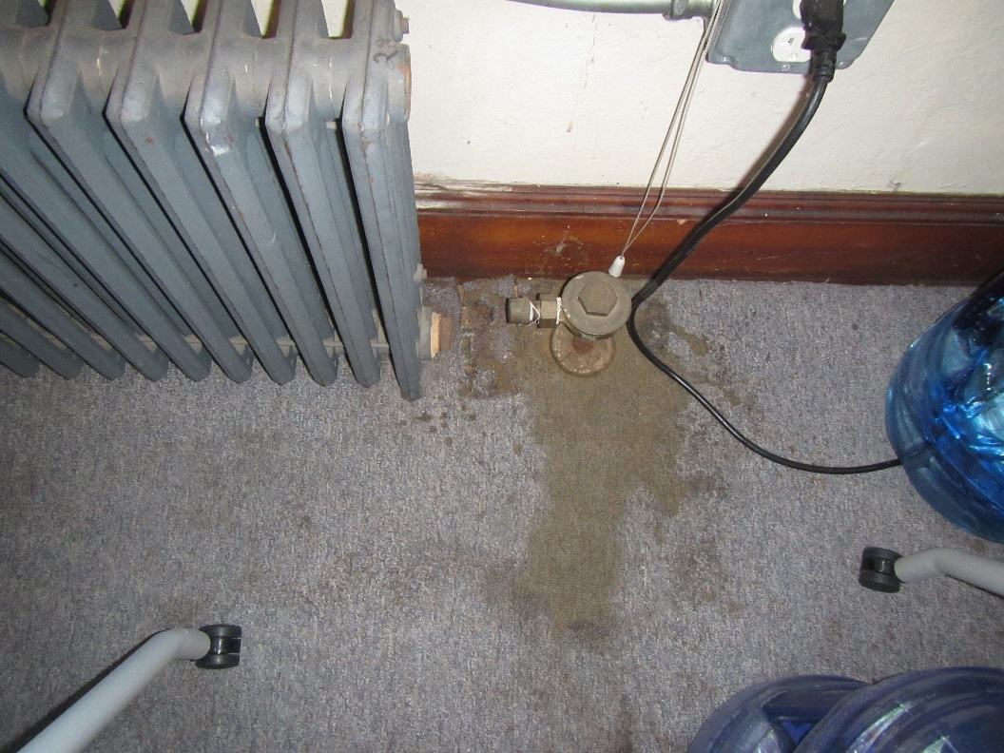

**Stained carpeting around radiator**

**Picture 8**

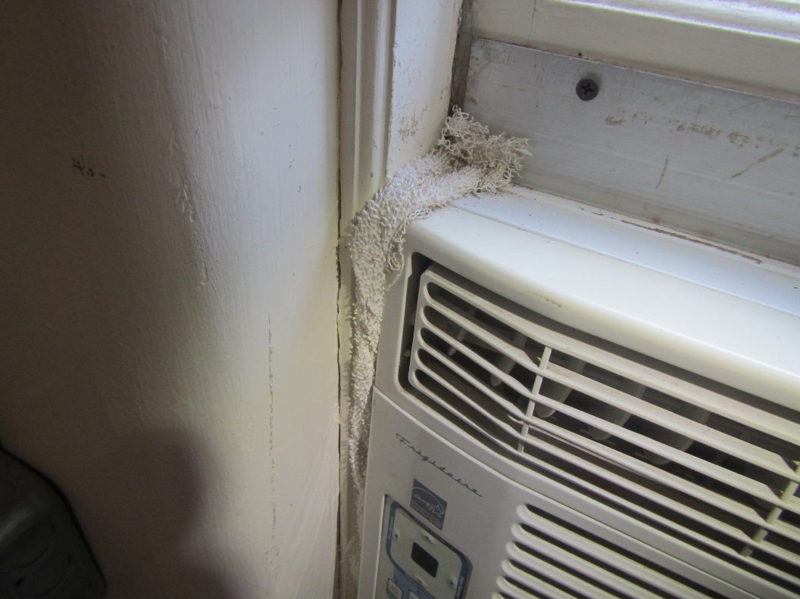

**Cloth stuffed around AC in office**

**Picture 9**

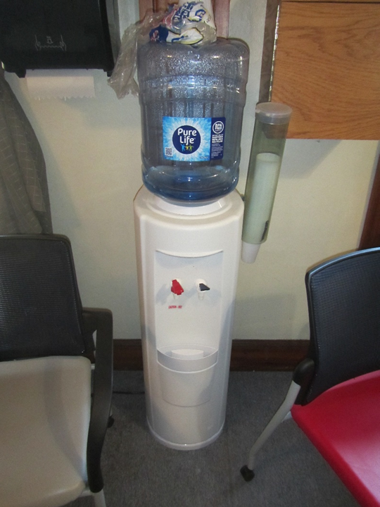

**Water cooler on carpet**

**Picture 10**

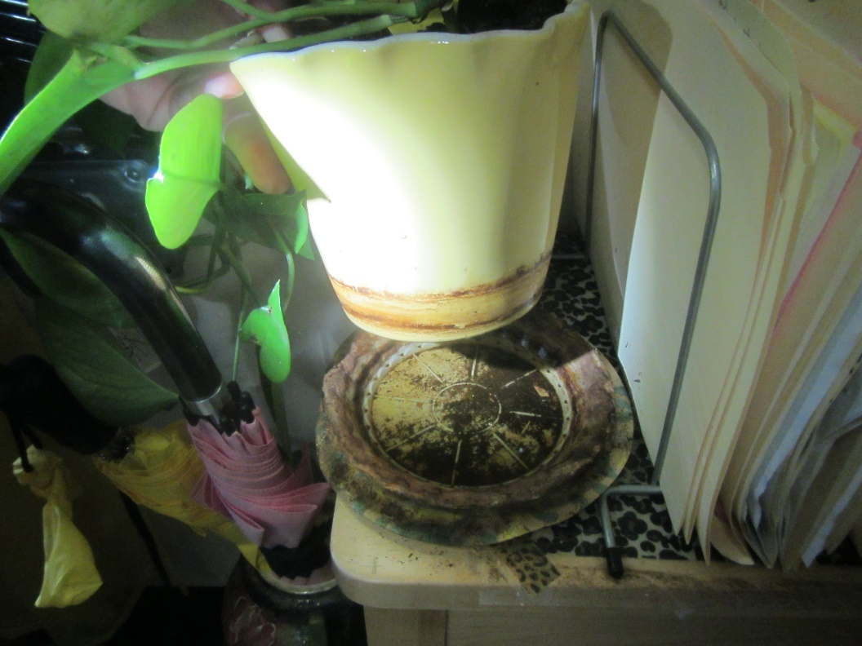

**Plant with drip pan on paper plate in office**

**Picture 11**

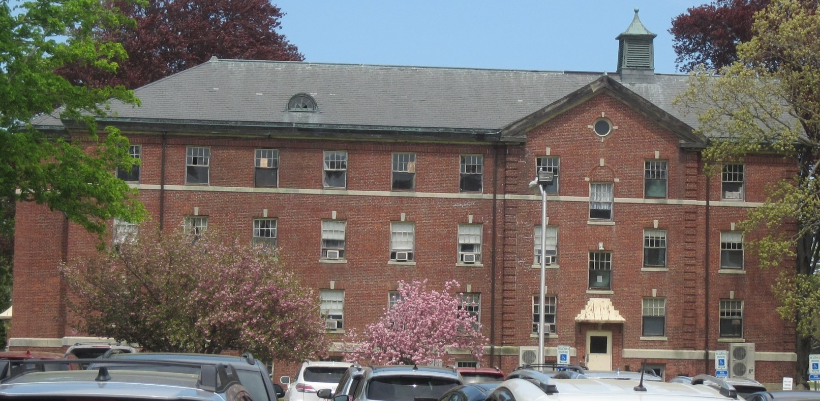

**Broken windows on top floor (arrows)**

**Picture 12**

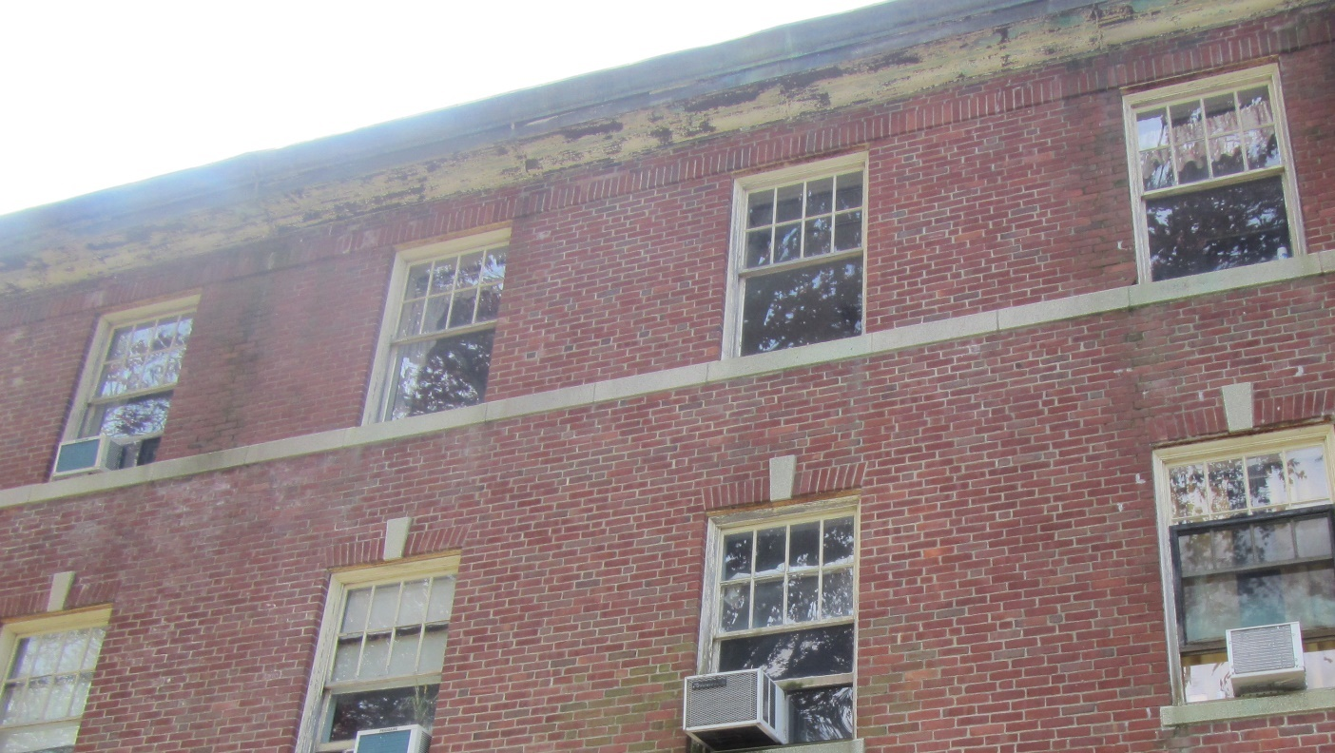

**Delamination of paint exposing wood along roof eaves**

**Picture 13**

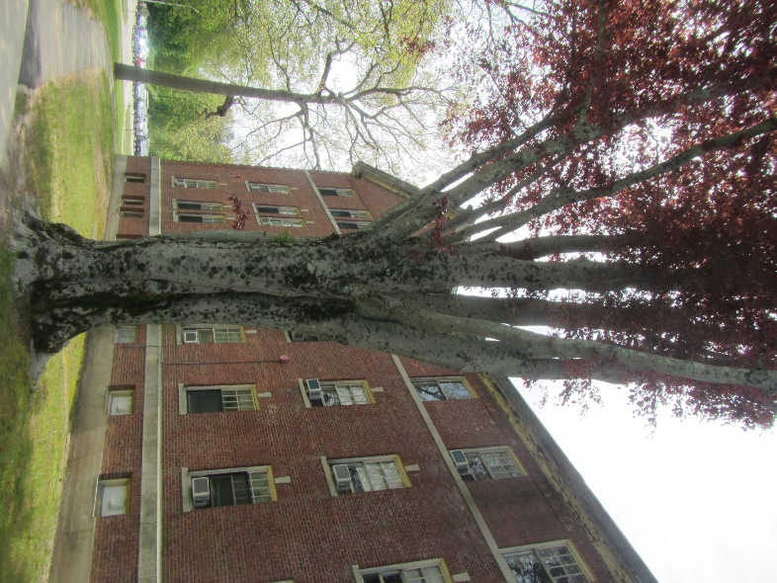

**Trees in close proximity to the building**

**Picture 14**



**Trees in close proximity to the building**

Sources of Respiratory Irritant Pictures

(Click to link back to report)

**Picture 15**

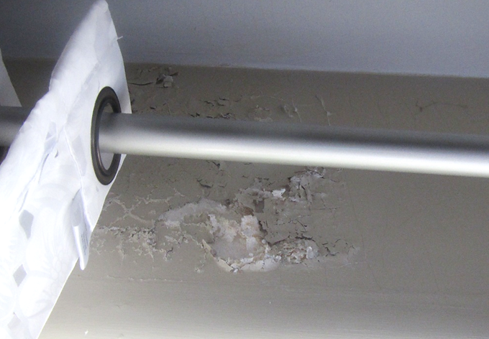

**Efflorescence and peeling paint on office wall**

**Picture 16**

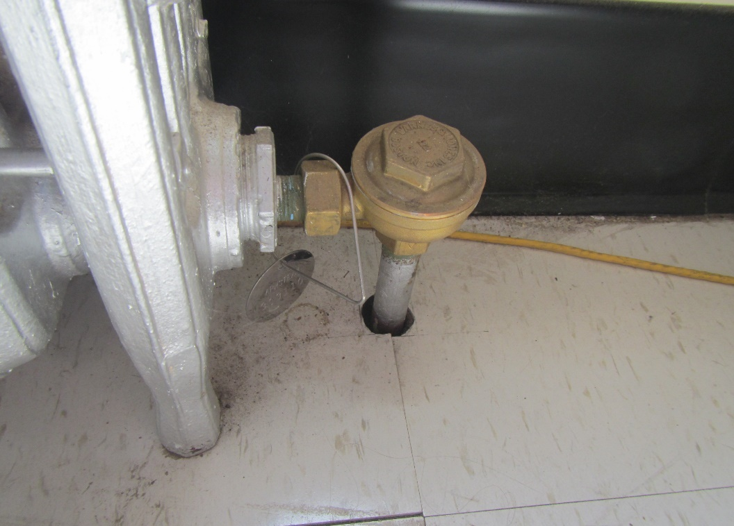

**Hole in floor around radiator pipe**

**Picture 17**

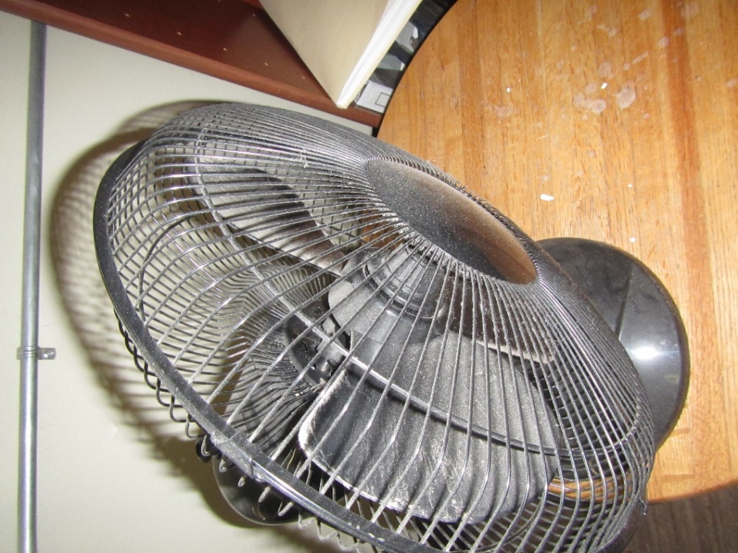

**Personal fan with accumulated dust/debris**

**Picture 18**

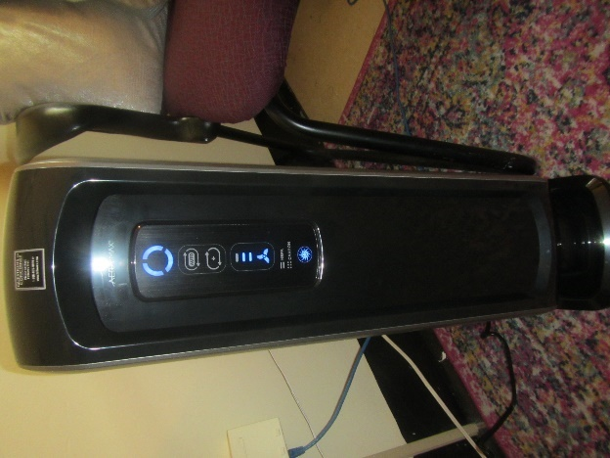

**Air purifier**



| Table 1 **Location** | **Carbon**  **Dioxide**  **(ppm)** | **Carbon Monoxide**  **(ppm)** | **Temp**  **(°F)** | **Relative**  **Humidity**  **(%)** | **PM2.5**  **(µg/m3)** | **Occupants**  **in Room** | **Windows**  **Openable** | **Ventilation** | | **Remarks** |
| --- | --- | --- | --- | --- | --- | --- | --- | --- | --- | --- |
| **Supply** | **Exhaust** |
| Background (outside) | 440 | ND | 68 | 56 | 2 |  |  |  |  | Sunny, dry |
| 109 | 592 | ND | 72 | 49 | 4 | 1 | N | N | N | Carpeted room, wax melter -odors in hallway, plants |
| 1st floor Conference Room | 651 | ND | 68 | 56 | 1 | 5 | Y | N | N | Water-damaged carpet (corner-active leak), efflorescence on plaster walls, water-damaged wooden baseboard, carpet over 11 years old, carpet around radiators, water cooler on carpet |
| 117 | 690 | ND | 73 | 49 | 6 | 0 | Y | N | N | Area carpet |
| 125 | 618 | ND | 70 | 51 | 2 |  |  |  |  | Plants, flaking paint – radiator, peeling paint ceiling, leak reported above window, efflorescence – wall plaster |
| 126 | 888* | ND | 69 | 55 | 2 | 0* | Y | N | N | * 4 staff in inspection party in space |
| Central Hallway | 620 | ND | 70 | 53 | 2 |  |  |  |  |  |
| Central South Hallway 1st Floor | 670 | ND | 71 | 52 | 6 | 0 | N | N | N |  |
| 132 | 560 | ND | 71 | 50 | 5 | 0 | Y | N | N | No radiator – removed, stuffed cloth next to AC unit in window |
| 136 | 590 | ND | 73 | 51 | 100* | 0 | Y | N | N | Plants, humidifier* (vaporized water droplets) |
| Center North Hallway | 630 | ND | 72 | 50 | 7 | 0 | Y | N | N |  |
| North Hallway | 610 | ND | 72 | 50 | 2 | 0 | N | N | N |  |
| 142 | 1029 | ND | 72 | 51 | 1 | 1 | Y | N | N | Connected restroom, cardboard boxes on floor, plants |
| 154 | 612 | ND | 72 | 51 | 1 | 1 | Y | N | N | Plants, occasional mice sightings |
|  |  |  |  |  |  |  |  |  |  |  |
| 2nd Floor Central South Hallway | 580 | ND | 71 | 51 | 1 | 0 | Y | N | N |  |
| 201 | 596 | ND | 73 | 49 | 1 | 0 | Y | N | N | Peeling paint, personal fan-dusty, area carpet, cobwebs around radiator |
| 223 | 548 | ND | 71 | 51 | 1 | 1 | Y | N | N | Plants |
| 2nd Floor South Hallway | 665 | ND | 74 | 54 | 1 | 0 | N | N | N |  |
| Central North Hallway | 615 | ND | 71 | 51 | 2 | 0 | Y | N | N |  |
| 238 | 640 | ND | 71 | 51 | 1 | 1 | Y | N | N | Damaged floor – uneven/tripping hazard |
| North Hallway | 570 | ND | 71 | 51 | 1 | 0 | N | N | N |  |
| 251 | 564 | ND | 72 | 52 | 2 | 1 | N | N | N | Gap in floor near radiator |

(Click to link back to report)

# Table 2A

|  |  |  |  |  |  |
| --- | --- | --- | --- | --- | --- |
| **Equipment Present in Building**  **(X = Yes)** | **Type of Heating/Cooling Ventilation**  **Equipment** | **Fresh**  **Air**  **Supply**  **(X = Yes)** | **Type of Location(s)** | **Air Filters Installed**  **MERV Rating**  **(1-15, U*)**  **(X = Yes)** | **Comments** |
|  | Univents |  |  |  |  |
|  | Rooftop Air Handling Units |  |  |  |  |
|  | Outdoor, Ground-Installed Air Handling Units |  |  |  |  |
|  | Attic/Crawlspace Air Handling Units |  |  |  |  |
|  | Ceiling-Mounted Air Handling Units (including inside plenum) |  |  |  |  |
|  | Basement/Crawlspace-Installed Air Handling Units |  |  |  |  |
|  | Mechanical Room-installed Air Handling Units |  |  |  |  |
|  | Fan Coil Units |  |  |  |  |
| X | Window-Mounted Air Conditioners | X | Various |  |  |
|  | Wall Louver-Controlled Gravity Air Supply |  |  |  |  |
| X | Windows |  | Various |  |  |
|  | Fan in window (blowing in) |  |  |  |  |
|  | Built in wall fan (switched) |  |  |  |  |
|  | Heat recovery ventilator unit |  |  |  |  |
|  | Energy recovery ventilator unit |  |  |  |  |
|  | Chilled Beam |  |  |  |  |
|  | Passive combustion supply vent in basement/boiler room |  |  |  |  |

*U = Filter Rating underdetermined due to inaccessibility during building visit

(Click to link back to report)

# Table 2B

|  |  |  |  |  |
| --- | --- | --- | --- | --- |
| **Equipment Present in Building**  **(X = Yes)** | **Type of Exhaust Ventilation**  **Equipment** | **Ducted**  **To Outdoors**  **(X = Yes)** | **Type of Location(s)** | **Comments** |
|  | Rooftop Motors/Fans |  |  |  |
|  | Unit Exhaust |  |  |  |
|  | Ceiling Return Vent |  |  |  |
|  | Ceiling Return Vent, Plenum |  |  |  |
|  | Wall Return Vent |  |  |  |
|  | Kitchen Stove Hood |  |  |  |
| X | Restroom Exhaust Vent |  |  |  |
|  | Photocopier Exhaust Vent |  |  |  |
|  | Garage |  |  |  |
|  | Chemical Hood(s) |  |  |  |
|  | Locker Rooms |  |  |  |
|  | Showers |  |  |  |
|  | Lock up Cells |  |  |  |
|  | Clothes Dryers |  |  |  |
|  | Gas Water Heaters |  |  |  |
|  | Furnace-Flue to Chimney |  |  |  |
|  | Furnace/Boiler direct vent or power vent (no combustion air supply) |  |  |  |
|  | Kiln, Pottery |  |  |  |
|  | Dark Room |  |  |  |
|  | Generator Room |  |  |  |
|  | Wood Shop Dust Collector |  |  |  |
|  | Spray Paint Booths |  |  |  |
|  | Fan in window (blowing out) |  |  |  |

# Table 2C

|  |  |  |  |
| --- | --- | --- | --- |
| **Equipment Present in Building**  **(X = Yes)** | **Type of Equipment** | **Type of Location(s)** | **Comments** |
|  | Floor Fans, pedestal |  |  |
| X | Portable fans | Various |  |
| X | Air Purifier (HEPA, other) | Various |  |
|  | Floor heaters, portable |  |  |
|  | Refrigerators, Cold Beverage Vending Machines |  |  |
| X | Radiator, wall-mounted | Various |  |
|  | Radiator, floor-mounted |  |  |
| X | Passive vents (Wall/Door) | Various |  |

(Click to link back to report)

# Table 3

| **Found in Building**  **X = Yes** | **Water-Damaged Materials, Building Components or Stored Materials** | **Location** | **Visible Microbial Growth?**  **X = Yes** | **Musty odor detected?**  **X = Yes** | **Comments** |
| --- | --- | --- | --- | --- | --- |
|  | Books-other bound materials |  |  |  |  |
| X | Brick walls – broken, missing mortar | Exterior |  |  |  |
|  | Brick walls – blocked weep holes |  |  |  |  |
| X | Cardboard boxes |  |  |  |  |
|  | Carpet tiles |  |  |  |  |
|  | Carpet - Area rugs |  |  |  |  |
| X | Carpet wall-to-wall | 1st fl conf room |  | X |  |
| X | Ceiling tiles - affixed directly to ceiling surface | 1st fl conf room |  |  |  |
|  | Ceiling tiles - bowing-in suspended ceiling |  |  |  |  |
|  | Ceiling tiles - water-stained in splined ceiling |  |  |  |  |
|  | Ceiling tiles - water-stained in suspended ceiling |  |  |  |  |
|  | Chairs - laminated |  |  |  |  |
|  | Cloth |  |  |  |  |
|  | Countertops (around sinks) |  |  |  |  |
|  | Curtains |  |  |  |  |
|  | Dust/debris within AHU, uninvent, HVAC, chilled beam units, etc. (WD through condensation, humidity, or leaks) |  |  |  |  |
| X | Efflorescence (i.e., mineral deposits) | Various |  |  |  |
|  | Engineered woods - particleboard, plywood, Masonite |  |  |  |  |
|  | Flooring – loosened tiles |  |  |  |  |
|  | Flooring - wooden |  |  |  |  |
|  | Furniture - laminated |  |  |  |  |
|  | Furniture - upholstered |  |  |  |  |
|  | Gypsum wallboard - ceiling |  |  |  |  |
|  | Gypsum wallboard - restroom wall |  |  |  |  |
|  | Gypsum wallboard - interior wall |  |  |  |  |
|  | Gypsum wallboard – located on exterior wall |  |  |  |  |
|  | HVAC drain pan – lack of draining |  |  |  |  |
|  | HVAC filters |  |  |  |  |
|  | Insulation- attic (paper-backed) |  |  |  |  |
|  | Insulation - inside air handling unit |  |  |  |  |
|  | Insulation - on pipe(s) fiberglass |  |  |  |  |
|  | Insulation - on pipe(s) other/plaster-like material |  |  |  |  |
|  | Insulation - wall cavity |  |  |  |  |
|  | Insulation – ceiling plenum |  |  |  |  |
|  | Modular furniture – walls/cloth partitions |  |  |  |  |
|  | Musical instrument cases |  |  |  |  |
| X | Plaster ceilings | Various |  |  |  |
| X | Plaster walls | Various |  |  |  |
|  | Records/files |  |  |  |  |
|  | Refrigerator - door gasket |  |  |  |  |
|  | Refrigerator - drip pan |  |  |  |  |
|  | Refrigerator - Interior surfaces |  |  |  |  |
|  | Room divider - ceiling-mounted, sliding |  |  |  |  |
|  | Sink backsplash |  |  |  |  |
|  | Tables – laminated |  |  |  |  |
|  | Wallpaper |  |  |  |  |
|  | Wood - attic/roof materials |  |  |  |  |
|  | Wood - floor joists in basement ceiling |  |  |  |  |
|  | Wood - wall framing |  |  |  |  |
|  | Wood - window sills |  |  |  |  |
|  | Wood - window-mounted air conditioner framing |  |  |  |  |
| X | OTHER: Wooden baseboard |  |  |  |  |

WHAT ARE ENVIRONMENTAL ASTHMA TRIGGERS?

Asthma triggers are any chemical, pollutant, or allergen that can make your asthma worse. Asthma triggers can also be strong chemical smells, dust, or pets. Your asthma triggers may be different from those of other people. Not all asthma triggers affect people the same way. Environmental asthma triggers are found both indoors and outdoors. DPH link: [Asthma and Your Environment (mass.gov)](https://www.mass.gov/doc/asthma-and-your-environment-english/download)

(click to link back to report)

# Table 4

| **Condition Present**  **X = Yes** | **Possible asthma symptom-inducing environmental pollutant** | **Recommendation to reduce or eliminate the pollutant** |
| --- | --- | --- |
| X | Water Damage and/or Mold  (allergen) | Identify water source and repair to eliminate.  Clean non-porous materials.  Remove and replace porous materials susceptible to mold growth.  Perform regular water damage assessments as a tool to ensure timely mitigation as needed.  Use NIOSH water damage assessment protocol as a guide: [NIOSH water damage assessment guideline](https://www.cdc.gov/niosh/docs/2019-115/pdfs/2019-115.pdf?id=10.26616/NIOSHPUB2019115&inf_contact_key=241b5c2ed98c27d94b530dedc36f1623f651f238aa2edbb9c8b7cff03e0b16a0). |
|  | Moistening of building components during hot, humid weather (>2 days in length) (mold, allergen) | Remove materials not dried in <2 days in a manner consistent with [US EPA Mold Removal in Commercial Buildings guideline](https://www.epa.gov/mold/pdf-version-checklist-mold-remediation-mold-remediation-schools-and-commercial-buildings).  Use dehumidification in occupied basement areas and other areas with chronic dampness. |
|  | Vegetation against exterior of building (water damage-mold) | Remove all vegetation preventing building exterior drying.  Remove all vegetation capable of falling onto a building or depositing debris onto the roof. |
| X | Personal humidifiers (lack of proper maintenance)  (pollutant and allergen) | Clean and maintain properly.  Use distilled water to eliminate metal and water treatment odors.  Maintain hydration by increasing water consumption. |
|  | Drains: Floor drains, Sink drains (abandoned use)  Water bubblers (abandoned use) | If in use, pour water into drain at least twice a week.  If not in use, seal the drain with an appropriate material in accordance with Massachusetts Plumbing Code (248 CMR 10.00). |
|  | Live Animals (turtles, gerbils, birds, rabbits, etc.) | Ensure cleanliness or remove animals from the location. |
|  | Improperly maintained aquariums and terrariums (allergen) | Maintain such equipment properly to eliminate odor.  Discontinue use. |
| X | Plants and flowers  (allergen and mold) | Keep indoor plants well maintained and not overwatered. Monitor for signs of mold and pests.  Ensure water for cut flowers does not become stagnant.  Ensure dried plant material is free of odors, mold, and pests and handled carefully  If asthma risks are high, eliminate plants and flowers. |
|  | HVAC system moisture issues  (mold, allergen) | Consult ASHRAE’s minimum standards for HVAC maintenance and inspection of commercial HVAC systems (<https://www.ashrae.org/technical-resources/bookstore/standards-180-and-211>). |
|  | HVAC system contaminant issues (allergen) | Consult ASHRAE’s minimum standards for HVAC maintenance and inspection of commercial HVAC systems (<https://www.ashrae.org/technical-resources/bookstore/standards-180-and-211>). |
|  | Indoor swimming pool odors outside of swimming pool (mold, chemical) | Maintain and operate pool HVAC systems to vent odors from building.  Ensure locker room exhaust vents are operating during building hours.  All doors leading to pool should be rendered airtight and be closed. |
| X | Pollen (allergen) | Recommend installation of MERV 8 or better filters if HVAC engineer confirms HVAC system can be so equipped without adversely affecting function.  Cut grass after hours.  Cut grass in a pattern to direct clippings away from exterior wall.  Remove trees and shrubs from in front of windows and air intakes. |
|  | Dry air | Maintain hydration.  Avoid overheating of air. |
| X | Dust mites  (allergen) | Recommendation to remove non-official upholstered furniture, area rugs, pillows, cushions, etc.  Cleaning with use of HEPA-filtered vacuum cleaner.  Eliminating clutter, storing items in dust and moisture-proof containers, and regularly removing dust through wet wiping. |
| X | Pests, including rodents and cockroaches  (allergen) | Use of integrated pest management guidelines, including:   * Proper disposal of food containers * Proper storage of food products in airtight containers * Elimination of use of food as art projects * Remove pest harborages/clutter * Regular monitoring for pests   [EPA IPM guideline link](https://www.epa.gov/ipm/introduction-integrated-pest-management) |
|  | Latex-containing materials | Remove tennis balls from furniture legs. |
|  | Fragrances  (chemical) | Eliminate point sources, such as:   * Plug-in air fresheners * Aroma/oil reed diffusers * Scented sprays * Discontinue use of other scented materials * Consult DPH fragrance guideline: [*Clean air is odor-free*](https://www.mass.gov/doc/clean-air-is-odor-free-removing-fragrances-to-improve-indoor-air-quality-in-schools-and-0/download) |
|  | Strong smells from /use of Chemicals (such as cleaning products)  (chemical) | Use building-issued cleaning products.  Use products in accordance with manufacturer’s instructions including dilution, application, and ventilation.  Avoid using products that are stronger than needed for the situation. |
|  | Strong odors from new building materials (carpeting/furniture)  (chemical) | Use low VOC-emitting materials.  Air out materials (outside or in unoccupied area) prior to installation. |
|  | Tobacco smoke  Secondhand Smoke  (pollutant) | Eliminate tobacco smoking.  Seal all shared wall penetrations. |
| X | Products with a strong odor such as paint, perfume, hairspray, air fresheners, bug-spray, laminators, candles, wax melters, dry erase markers and other VOC-containing products  (chemical) | If essential:   * Provide proper exhaust ventilation to eject aerosolized product directly outdoors. * Avoid/reduce use during occupied hours.   If not necessary, remove and eliminate. |
|  | Vehicle exhaust  (pollutant) | Enforce anti-idling regulations and post signs to give notice.  Relocate vehicles away from fresh air intakes.  Require cars to park face-in at building walls.  [MA anti-idling law FAQs](https://www.mass.gov/files/documents/2018/02/20/idling-faq.pdf#:~:text=The%20Massachusetts%20Anti-Idling%20Law%20The%20goal%20of%20the,sometime%20wonder%20when%20idling%20might%20be%20considered%20necessary.) |
|  | Vapors and or fumes from gas, oil, or kerosene stoves  (pollutant) | Operate stove hood when stove in use.  Install stove hood if not present.  Ensure equipment is in good working order. |
|  | Ozone (pollutant) | Eliminate use of ozone generating equipment. |
| X | Window Air Conditioners (if not properly maintained) (allergen) | Equip with proper filter and clean periodically.  Clean drip pans.  Install in window with weathertight, non-mold-growth sustaining material. |
|  | Pottery (pollutant) | Do not operate kiln during occupied hours.  Operate kiln with exhaust system activated.  Seal all seams and holes in kiln vent.  Ensure kiln exhaust discharge terminates outdoors. |
| X | Carpeting (allergen) | Clean carpeting in a manner consistent with IICRC standards, including regular vacuuming with a high efficiency particulate air (HEPA) filtered vacuum in combination with annual cleaning or semi-annual cleaning in soiled high traffic areas. |
|  | Sweeping/dusting vs HEPA vacuuming/wet wiping  (allergen or pollutant) | Refrain from using feather dusters or brooms.  Utilize HEPA vacuums and wet wiping to minimize aerosolizing particulate matter. |
|  | Lack of adequate air exchange/mechanical ventilation | Make repairs as necessary and ensure all HVAC system components are operating continuously when building is occupied. |
|  | Lack of local exhaust at source of pollution (vocational shop activities, kitchen exhaust hood) (all) | Recommend installation of exhaust ventilation to direct pollutants directly outdoors. |
|  | Renovating buildings while occupied  (chemical) | Use all SMACNA guidelines for Renovation While Buildings Are Occupied. For information, visit <https://www.mass.gov/service-details/construction-and-renovation-generated-pollutants-in-occupied-buildings>. |
|  | Chemistry program chemical storage  (chemical) | Repair (if needed) and operate chemical storeroom vents appropriately.  Reduce or eliminate unneeded or overstocked chemicals.  Store all chemicals in a manner to separate incompatible chemicals.  Keep chemical storerooms clean. |
| X | Photocopiers/duplicating machines | All machines should have dedicated exhaust vents or be used in a well-ventilated area. |