

Berkshires+ Valley DSAC Team

Regional Assistance Director
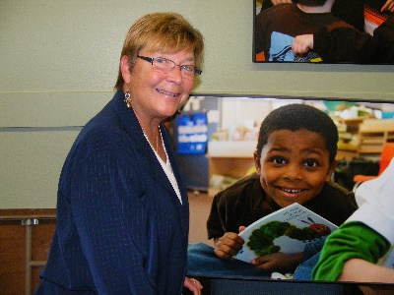
Donna Harlan donna.harlan@dsacma.org
Donna L. Harlan, Ed.D., has been in education since 1969. She began her teaching career in a junior high school in San Antonio, Texas, since then has taught grades PK - 12, in community colleges, in 4-year universities and at the graduate level in Master's and Doctoral programs. She has served as a principal, a guidance counselor, associate superintendent and superintendent, and has educated students, parents, and teachers in Texas, Vermont, Connecticut, and Massachusetts. Donna retired from serving as a superintendent in western Massachusetts in June of 2009. She began serving as the Regional Assistance Director for the Berkshire DSAC in July of 2009.
Donna holds a BS degree in history, geography and secondary education from the University of Texas in Austin; a Master's degree in diagnostics and education psychology from Trinity University in San Antonio; an Ed.D. from the University of Massachusetts in Amherst; and a Master of Arts in Applied Theology from the Elms College in Chicopee.
Support Facilitators
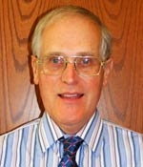
Bob Vaughan bob.vaughan@dsacma.org
Bob Vaughan has spent 44 years in education, teaching grades 2-8 in Hanover, MA (4th), Wentworth, NH (5-8), and Sidi-bel-Abbes, Algeria (2-5 for GTE International), and serving as an Elementary Principal in Wentworth, NH, Wales, MA, Lenox, MA, and Cornwall, CT. During a retirement year in 2008-09 he taught two courses in the AIC Master’s Program, consulted in Berkshire County, worked for the U.S. Census, and volunteered with Habitat for Humanity.
He holds a BA in Sociology from Wesleyan University, a Master of Arts in Teaching in Reading from the Harvard Graduate School of Education, and a Master’s in Educational Administration from Plymouth State College. He joined the Berkshire DSAC as a Support Facilitator in July, 2011.

Eileen Jachym eileen.jachym@dsacma.org
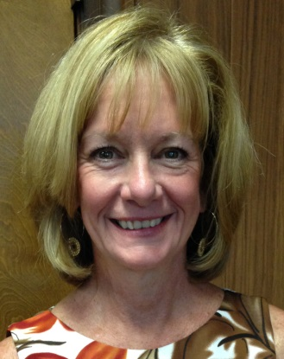
Eileen Jachym recently joined the Berkshire/Pioneer Valley DSAC team as a Support Facilitator after retiring from serving in public education for thirty-four years. During her career, she was a special education teacher grades K-12, an educational plan developer/ diagnostician, special education supervisor, assistant principal and principal of a middle school in Westfield, Massachusetts. For the last two years of her career, Eileen was the Director of 21st Century Learning, focusing on curriculum, instruction and professional development for the district. She holds a BS in Elementary as well as Special Education and a Master’s in Educational Administration.

CVTE – Support Facilitator
Dean Scranton dean.scranton@dsacma.org

Dean is a Career and Vocational/Technical Education Support Facilitator for DSAC, serving both Pioneer Valley and Berkshire districts. He has extensive experience in the building trades, having worked in all aspects of the timber-frame industry, and metal fabrication, as a welder and artist-blacksmith. More recently, Dean has pursued a career in education. He taught English and Theater at Franklin County Technical School for twenty years and co-taught a course for Franklin County high school seniors, “The College Connection,” at Greenfield Community College, for five years.
Dean received his BA and MEd from the University of Massachusetts. He lives in the house he and his wife built, in Conway, MA.

Data Specialist
Joseph Wyman joseph.wyman@dsacma.org
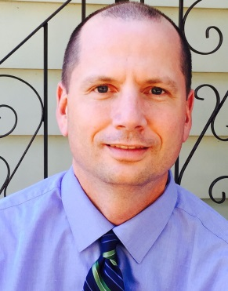
Joseph Wyman worked as a Data Analyst and the Manager of Strategic Data with the Springfield Public Schools for three and a half years. He began his tenure in Springfield as a fellow with the Strategic Data Project. Before working in Springfield, Joe worked as an Evaluation Manager for the University of Massachusetts Donahue Institute for five years. Joe has both a Bachelors in History and a Masters in Public Policy and Administration from the University of Massachusetts Amherst.

Math Specialist

Ian Stith istith@doe.mass.edu
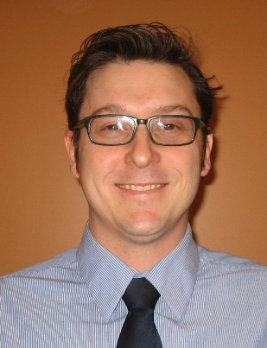
Ian Stith has worked in math and science education for the last 12 years. After graduating with a Bachelor’s degree in Mechanical Engineering, Ian transitioned to the field of education. First, he earned his Master’s degree in secondary math and Science education at the University of Pennsylvania. He stayed in Philadelphia to teacher secondary math, science, and technology at two city high schools. While teaching, Ian continued to stay connected with researchers from UPenn and participated in educational research studies. One outcome of this work was a book he coauthored with Beth Wassell, Becoming an Urban Physics and Math Teacher: Infinite Potential. These research experiences led him to purse his PhD in education. His dissertation focused on engaging students as active participants in their own learning. This work was published as the book,Students in Action: Cogenerative Dialogues from Secondary to Elementary Schools. Following earning his degree, Ian transitioned to Math Coaching at the elementary level in Ludlow and Amherst, MA. Most recently, Ian has worked as the K-12 Math/Science Coordinator and STEM Coordinator for the Amherst Public Schools in Massachusetts.

Literacy Specialist
The Berkshire+ DSAC is currently seeking a highly qualified individual to fill this position.

Targeted Assistance Resource Coordinator

Cheryl Holmes cheryl.holmes@dsacma.org


Cheryl Holmes, has over 25 years experience in office administration, managing and supporting events and workshops, database design and analysis, and information technology projects. Most recently, she managed the virtual office and assisted at events for Wine & Canvas in western Massachusetts. She also volunteers as a chef and workshop program assistant at the Kripalu Center for Yoga and Health.

