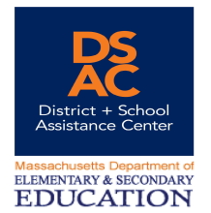

Pioneer Valley DSAC Team

Regional Assistance Director

Ken Rocke kenneth.rocke@dsacma.org


Kenneth Rocke has worked in a variety of educational roles over the past twenty-five years. Most recently, he was Interim Superintendent at Gill-Montague Regional School District (2007 – 2009). Prior to that he served as Superintendent-Director of Blue Hills Regional Technical School (2001 – 2006) and Director of the Southwest Vermont Career Development Center (1998 – 2001) in Bennington, Vermont. His teaching career included thirteen years at Franklin County Technical School as a Mill and House Carpentry Instructor. In addition to his DSAC role, he also works as a consultant to the Massachusetts Association of Regional Schools, specializing in regionalization issues. He was educated at Shimer College, Beloit College (BA in Sociology), and Westfield State College (Masters in Secondary Education).

Support Facilitators
Leslie Edinson les.edinson@dsacma.org
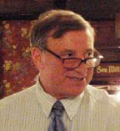
Les is a Support Facilitator at SchoolWorks. He previously served as an upper elementary and middle grade teacher, staff developer and project manager in Suffolk County, N.Y., the U.S. Virgin Islands and Cambridge, Massachusetts before assuming principalships in Hubbardston, Shutesbury, Holyoke and Springfield, Massachusetts. Les then spent three years as the founding principal of the Fitchburg Arts Academy, a publicly-funded Pilot School formed in partnership with the Fitchburg Art Museum. He has led state and federally funded magnet schools and collaborated with the Center for Collaborative Education, the Institute for Learning, the Northeast Foundation for Children and Expeditionary Learning Schools. Les is an instructor in the administrative licensure program of the Collaborative for Educational Services and has led monitoring site visit and school review teams in association with SchoolWorks. Les received his B.A. in Education from Antioch College and his M.Ed. in Educational Administration from Salem State College.

Support Facilitator & Data Specialist

Christine Shea cshea@lpvec.org
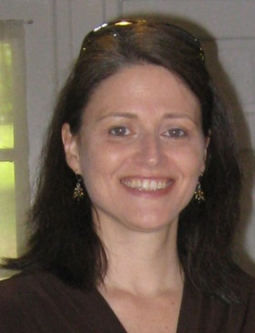
Christine has been with the DSAC as data specialist and support facilitator since 2010. Prior to that, she worked in schools as a teacher, assistant principal and principal, along with being an educational researcher and program evaluator. In addition to DSAC, she is a school improvement specialist at the Lower Pioneer Valley Educational Collaborative and an instructor for the licensure program at the Collaborative for Educational Services. Christine's undergraduate degree is from Mount Holyoke College. She also received a Masters from the Harvard Graduate School of Education and a Doctorate in Research, Evaluation and Measurement from the University of Massachusetts at Amherst.

CVTE Support Facilitator
Dean Scranton dscranton@doe.mass.edu

Dean is a Career and Vocational/Technical Education Support Facilitator for DSAC, serving both Pioneer Valley and Berkshire districts. He has extensive experience in the building trades, having worked in all aspects of the timber-frame industry, and metal fabrication, as a welder and artist-blacksmith. More recently, Dean has pursued a career in education. He taught English and Theater at Franklin County Technical School for twenty years and co-taught a course for Franklin County high school seniors, “The College Connection,” at Greenfield Community College, for five years.
Dean received his BA and MEd from the University of Massachusetts. He lives in the house he and his wife built, in Conway, MA.

Data Specialist

Zach Smith zsmith@lpvec.org
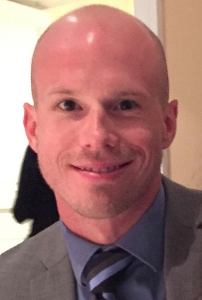
Zach joined the Pioneer Valley DSAC team as a Data Specialist while continuing his role as a School Improvement Specialist for the Lower Pioneer Valley Educational Collaborative. He works with principals, teachers, and district administration to understand and use data most effectively for school improvement. Prior to joining the team, he coordinated and taught online courses, trained teachers on technology integration through Westfield State University with the ITECC Course and MA New Literacies Institute, and researched and developed assessments at the Connecticut State Department of Education. Zach holds a B.S. in Psychology, a M.Ed. in Educational Policy, Research, and Administration, and a C.A.G.S. in Psychometrics, Statistics, and Research Methods, all from the University of Massachusetts Amherst.

Literacy Specialist

Susan Kazeroid skazeroid@doe.mass.edu

Susan Kazeroid has been a literacy specialist with the MA Elementary and Secondary Education Department for the past 11 years. Susan has worked with principals, reading specialists, teachers, leadership teams, and paraprofessionals to identify and implement best practices in literacy instruction. Susan has also worked on the Tier Instruction Workgroup at the department helping to create guiding documents for tiered instruction. In addition she worked to create a Literacy Coaching Module for the state. Prior to being a literacy specialist, she worked as a literacy coach, reading specialist, title 1 teacher and classroom teacher.

Math Specialist
Marria Carrington mcarrington@doe.mass.edu

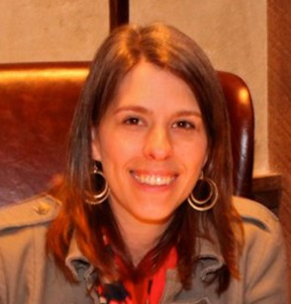
Marria Carrington worked for 7 years as a math coach. Six of those years were in Holyoke at a K-8 school and one year was in Amherst as a K-6 math coach. She has also worked as an adjunct professor for Lesley University teaching the courses Numbers and Operations and Formative and Summative Assessment in Mathematics. Prior to being a math coach, Marria taught 3rd and 4th grade and high school mathematics. She graduated from Mouth Holyoke College and received Master’s degrees from both Smith College and Lesley University. She also completed courses with the U.S. Math Recovery Council and is a trainer for their Add+Vantage Math Recovery Course 1 and 2.

Targeted Assistance Resource Coordinator

Cheryl Holmes cheryl.holmes@dsacma.org


Cheryl Holmes has over 25 years experience in office administration, managing and supporting events and workshops, database design and analysis, and information technology projects. Most recently, she managed the virtual office and assisted at events for Wine & Canvas in western Massachusetts. She also volunteers as a chef and workshop program assistant at the Kripalu Center for Yoga and Health.

