March 2010

Teens at Work
Work-Related Injuries to Teens in Massachusetts, 2003-2007

Teens at Work: Injury Surveillance and Prevention Project
Occupational Health Surveillance Program, Massachusetts Department of Public Health

Preventing Injuries to Working Teens

Why Teens?
Working is part of life for many teenagers. Many of us remember a first teen job—bussing tables, bagging groceries—and today’s U.S. teens are no different, with about 80% of them holding a job at some point during high school.¹ In 2008, 25% of 15- to 17-year-olds in Massachusetts were employed at any given point in time.²

Employment can provide many benefits to youth in addition to income: opportunities to take on new responsibilities, learn job skills, explore future careers and, in some cases, improve academic skills. But just like adults, teens are at risk of getting injured at work. In 2006 in the U.S., 52,600 teens less than age 18 visited hospital emergency departments for work-related injuries.³ Three times that many teen work injuries are thought to occur every year,⁴ and in 2008, 34 U.S. teenagers were fatally injured at work.⁵ In fact, young people have a higher rate of non-fatal occupational injury per hour worked than older workers.⁶ Inexperience is a risk factor. Also teens tend to work in jobs that have higher than average injury rates for workers of all ages. In addition, we know that many working teens receive no health and safety training either in school or on the job.

Even in today’s tough economy, with fewer teens working than in past years,⁷ we still rely on youth in many industries. We need to do all we can to ensure jobs in which teens are employed are safe. We also need to provide teens with basic health and safety skills that will help protect them now and in the future.

What We Do
Having information about where and how young workers are injured on the job is essential to prevent future injuries and to promote safer work opportunities for youth. So, for over 16 years, the Teens at Work: Injury Surveillance and Prevention Project at the Massachusetts Department of Public Health (MDPH) has been tracking work-related injuries to Massachusetts teens under age 18.

Teens at Work collects data from hospital emergency departments (ED), and workers’ compensation (WC) lost wage claims, to identify work-related injuries to teens and conducts follow-up interviews with injured youth. WC claims are for injuries resulting in five or more days of missed work, while ED injuries can range in severity. Informed by these data, Teens at Work collaborates with other agencies and community partners on initiatives to prevent injuries to working teens in Massachusetts.

This annual Teens at Work update provides information about work-related injuries to teens in Massachusetts from 2003 through 2007. Thank you for reading.

In This Issue:
Teen Injuries at a Glance
What Injured Teens Have to Say
Injuries to Teens in Nursing Homes
Youth@Work: Talking Safety
Sexual Harassment and Teen Workers
Resources
Teen Injuries at a Glance⁸
In Massachusetts, from 2003 through 2007:
- Five teenagers under age 18 were fatally injured while working. At least two of these teens were doing tasks prohibited by the child labor laws at the time of injury.
  - Age 16: Boy killed while driving a forklift on uneven ground when it tipped over and crushed him.
  - Age 17: Boy died while working on a scalloping vessel that sank.
  - Age 17: Boy killed working at his father’s auto repair shop, when the truck he was working on fell off of the lift striking him in the head.
  - Age 17: Boy killed when he and his father were dismantling scaffold and the pole he was holding came in contact with an energized overhead power line.
  - Age 17: Boy killed when he fell 23 feet while carrying roofing shingles up a ladder to the building’s roof.
- There were 4,285 emergency department (ED) visits for work-related injuries to teens under age 18; the average annual rate of ED visits for injuries to 15- to 17-year-olds was 3.1 per 100 full-time workers.
- There were 1,039 workers’ compensation (WC) lost wage claims filed by teens under age 18 for injuries resulting in five or more lost workdays; the average annual rate of lost wage claims for injuries to 15- to 17-year-olds was 0.8 injuries per 100 full-time workers.
- The majority of teen work injuries were to 16- and 17-year-olds. Males had higher rates of injuries than females, based on both ED visits and WC claims (Figures 1 and 2).
- Open wounds were the most common injuries to working teens, accounting for close to half of the injuries seen in EDs. Sprains were the most common injuries for which WC lost time claims were filed (Figure 3).
- The largest numbers of nonfatal injuries to workers under age 18 occurred in restaurants (26%), part of the Accommodation & Food Service sector, followed by grocery stores (16%) in the Retail Trade sector, and nursing homes (7%) in the Health Services & Social Assistance sector (Figure 4). Information about the industry in which injured teens were employed was available in the WC claim records but not the ED data set.

What Injured Teens Have to Say
Teens at Work staff completed interviews with 208 young workers injured on the job from 2003 through 2007. While the information from these interviews does not necessarily represent all young workers who have been injured, it does provide some important information for targeting prevention efforts.

“A bagel got stuck in the toaster and I asked my manager if [they] had tongs or hot gloves and [they] said no, just stick your hand in. I did and I burned my arm.” — 17-year-old cashier at a doughnut shop

- More than half (52%) said they had received no on-the-job training about how to work safely and avoid injury. This finding is consistent with other studies.
- 22% reported they had no work permits for their jobs at the time they were injured. NOTE: Massachusetts child labor laws require teens to have work permits, which may be obtained through the school district where the teen resides or attends school.
- 39% missed over five days of work as a result of their injury.
- 20% of injured teens reported one or more of the following anticipated permanent effects from their injuries: limited movement, feeling, or pain
- 62% believed their injuries could have been prevented.
- 15% reported that no supervisor or person responsible for supervising them was on the premises at the time of injury.

Figure 1. Distribution of reported work-related injuries to teens under age 18, by age, gender* and data source —Massachusetts, 2003-2007
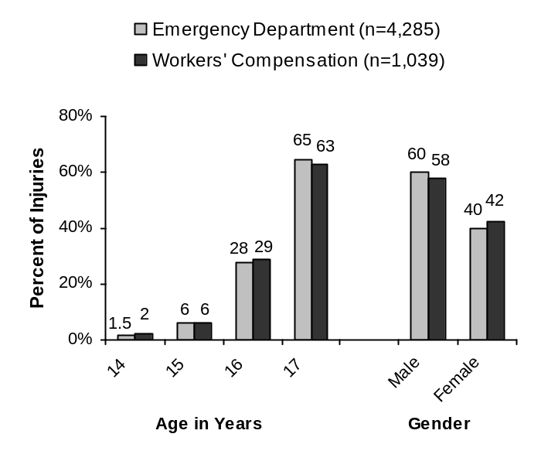
* Gender information was missing for 12 cases in the WC data.
Source: Teens at Work Injury Surveillance System, MDPH.

Figure 2. Average annual rates of work-related injuries among 15– to 17-year-olds, by gender and data source — Massachusetts, 2003-2007
Figure 2. Average annual rates of work-related injuries among 15– to 17-year-olds, by gender and data source — Massachusetts, 2003-2007

Source: Teens at Work Injury Surveillance System, MDPH; Current Population Survey, Bureau of Labor Statistics.

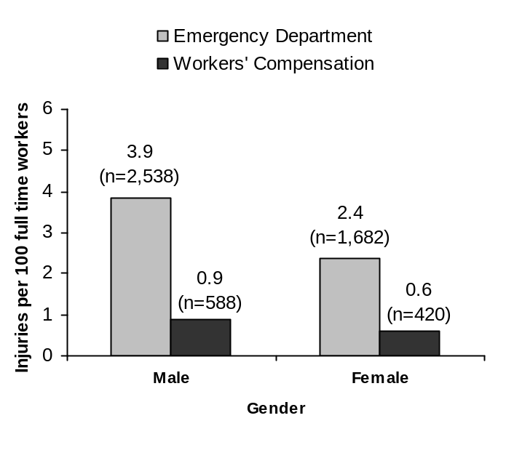

Source: Teens at Work Injury Surveillance System, MDPH; Current Population Survey, Bureau of Labor Statistics.

Figure 3. Distribution of work-related injuries to teens under age 18 by injury type and data source —Massachusetts, 2003-2007

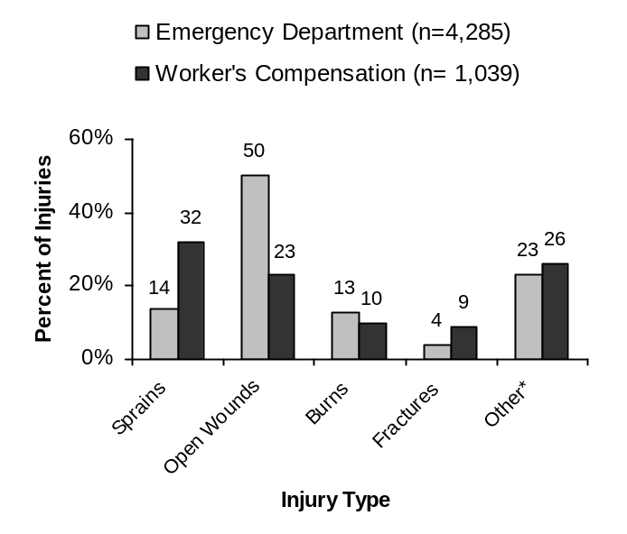

* Other includes some injuries with missing injury type.
Source: Teens at Work Injury Surveillance System, MDPH.

Figure 4. Distribution of work-related injuries to teens under age 18 by industry sector*, based on workers’ compensation claims — Massachusetts, 2003-2007
(n = 1,039)

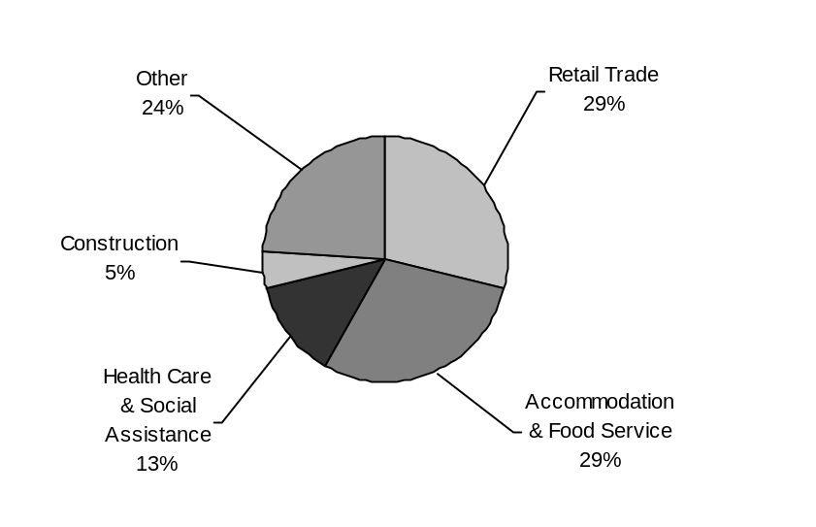

* NAICS 97
Source: Teens at Work Injury Surveillance System, MDPH.

Injuries to Teens Working in Nursing Homes
While only about of 2% of working teens in Massachusetts were employed in nursing homes during 2003-2007, these teens accounted for 7% of all injuries and had the highest rate of work-related injuries based on workers’ compensation (WC) claims—2 injuries per 100 full time workers. This is not surprising as nursing homes, which require many physically demanding tasks, have high rates of injuries for workers of all ages.

State employment data show that close to half of teens working in nursing homes were employed in food service jobs (such as food preparation workers and dietary aides), followed by jobs as medical assistants and nursing assistants (Figure 5). To help target prevention efforts, TAW used WC data to take a closer look at the 77 injuries among teens in nursing homes from 2003 through 2007, that resulted in 5 or more days away from work.

- Unlike findings for other industries, in nursing homes most of the injuries were to girls (85%).
- Information about occupation was available for only about half (42%) of the injured teens. The largest number of injuries occurred among those in food service jobs (23%) followed by nursing assistants (16%).
- Whereas strains and sprains accounted for about a third of the injuries to working teens in all industries identified through WC claims, they accounted for nearly 60% of the injuries to teens in nursing homes (Figure 6). Half of these were strains and sprains of the back.
- The two leading causes of injuries reported were slips and falls (often on wet floors), and lifting—mostly patients—underscoring that safe patient handling is important for both adult and teens workers alike.

TAW has recently develop new resources for training teens working in health services (see next page). Federal guides for safe patient handling in nursing homes are also important resources to know about:

Safe Lifting and Movement of Nursing Home Residents. Go to: www.cdc.niosh.gov

Ergonomics for the Prevention of Musculoskeletal Disorders:Guidelines for Nursing Homes. Go to: www.osha..gov

Figure 5. Distribution of the types of jobs held by teens under 18 working in nursing homes, Massachusetts, 2003-2007

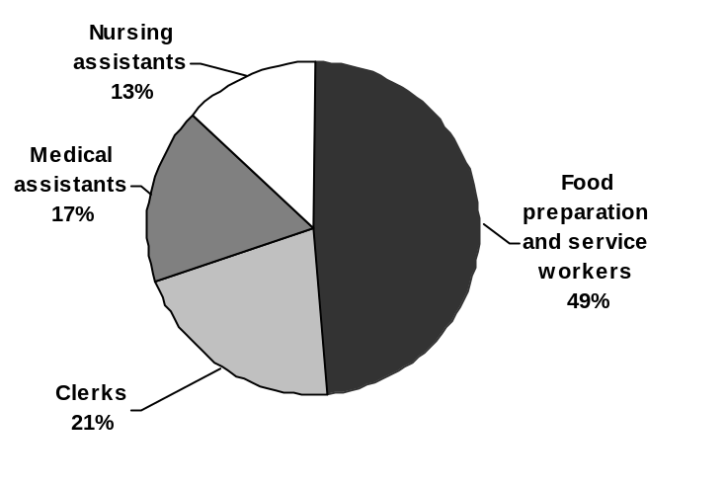
Source: Current Population Survey, Bureau of Labor Statistics.

Figure 6. Distribution of type of injuries obtained in nursing homes, based on reported work-related injuries to teens under age 18, Massachusetts, 2003-2007

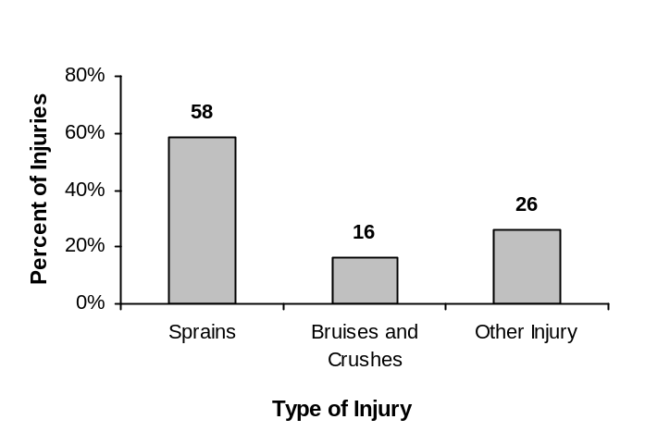
Source: Teens at Work Injury Surveillance System, MDPH.

Youth @ Work: Talking Safety, A curriculum for training teens
With growing recognition that many teens are entering the workforce with little no orientation to job safety, more and more schools and community organizations that serve youth around the country are taking action. Many are using Youth @ Work: Talking Safety, a free, interactive curriculum to help teens build a foundation of health and safety skills.
This 3-5 hour curriculum with six modules provides teens with information about recognizing and reducing hazards, their rights and responsibilities as young workers, dealing with emergencies, and how to speak up effectively about safety concerns. It engages youth through hands-on activities such as hazard mapping, labor law bingo, and role playing. Specialized activities for youth with cognitive and learning disabilities are included.
Modules of Talking Safety can also be used to teach some of the required components of the longer OSHA ten-hour course for general industry, now being taught to students in a number of Vocational and Technical Education programs.

The entire Talking Safety curriculum includes a step-by-step guide for presenting the materials. In addition to serving as a teaching tool, it helps teachers and others who work with youth to become familiar with workplace safety guidelines and laws designed to protect young workers. To download a free copy go to: http://www.cdc.gov/niosh/talkingsafety/

In Massachusetts, the Massachusetts Coalition for Occupational Safety and Health and Teens at Work provide train-the-trainer workshops for those interested in using the curriculum. Teens at Work also tailored the curriculum to help meet the needs of those who train youth for employment in specific industry sectors in the state. Last year we released a food services safety edition, and this year we are excited to announce that a safety edition for training youth in health services jobs is now available at the Teens at Work website. Go to: http://www.mass.gov/dph/teensatwork

What’s next? We have ideas about which industries to adapt Talking Safety for next, including landscaping and summer jobs. But we would like to hear more from educators and others who work with teens about what is needed. Please e-mail us: teens.atwork@state.ma.us

Training Matters

Here is what some injured teens had to say when asked about preventing their injuries.

What happened? “I was using a brush machine to clean under the buffet trays. Then I was washing out my rag in a bucket. The liquid splattered and chemicals got in my eyes. I ended up with a scratch on my cornea.”

Was it preventable? “With goggles. [I] should have been informed about the cleaner (thought it was soap).”
— 17-year-old dietary aide

What happened? “I was operating a ‘compactor’ which presses the ground firm before laying gravel. It has a moving handle which goes part way around to direct what gets flattened. The whole thing was vibrating and I somehow stepped backward into the hot motor and burned my calf.”

Was it preventable? “I now know that I wasn’t even supposed to operate that thing. I shouldn’t have been doing it at all.”
—14-year-old landscaping gardener
What happened? “I was using a brush machine to clean under the buffet trays. Then I was washing out my rag in a bucket. The liquid splattered and chemicals got in my eyes. I ended up with a scratch on my cornea.”
Was it preventable? “With goggles. [I] should have been informed about the cleaner (thought it was soap).”
— 17-year-old dietary aide
What happened? “I was operating a ‘compactor’ which presses the ground firm before laying gravel. It has a moving handle which goes part way around to direct what gets flattened. The whole thing was vibrating and I somehow stepped backward into the hot motor and burned my calf.”
Was it preventable? “I now know that I wasn’t even supposed to operate that thing. I shouldn’t have been doing it at all.”
—14-year-old landscaping gardener
General health and safety training can provide teens with important knowledge and skills. In addition, employers are responsible for providing workers with job-specific training about how to do their jobs safely. Neither of these teens received either general or job-specific health and safety training, like over half of injured teens interviewed by Teens at Work. Training may have provided the knowledge to recognize and ask about the hazards prior to engaging in the tasks.

Sexual Harassment and Teen Workers

“It’s always like we were reassured: ‘That’s just his behavior; that’s just the way he acts; it was just a joke.’ I was like, I don’t think that’s the way it’s supposed to go, but I didn’t know enough about the way it worked,
so I was just like…OK.”
—Teen who was sexually harassed at work
(“Is Your Daughter Safe at Work?”)

Sexual harassment isn’t usually thought of as an occupational safety or health risk, since it differs from issues typically thought of as workplace hazards—unsafe equipment, toxic chemicals. Yet, in some cases sexual harassment in the workplace leads to sexual assault or physical violence. More often it can result in stress which can lead to other physical and mental health problems and poor employment outcomes, in addition to increasing the risk of injury on the job.⁹

Little of the existing research on sexual harassment has included young workers, but that is changing. One recent survey of girls from a suburban high school who worked—mostly in restaurants and retail sales—found that more than half had experienced some form of sexual harassment in the past year at their jobs.¹⁰ The Schuster Institute for Investigative Journalism at Brandeis University tracks teen worker sexual harassment law suits across the country. In Massachusetts, there have been at least six successful-outcome lawsuits for teens who were sexually harassed at work. While these cases send an important message to employers, the harassment should never have occurred at all.

The issue has also been spotlighted on television twice in the past year: first on NOW, PBS’s public affairs show, in a special called “Is Your Daughter Safe at Work?” (February 2009); and more recently in a 20/20 full report (January 2010) sparked by the growing number of teens coming forward about their experiences with sexual harassment in the workplace.

Because of the risks it poses, the Massachusetts Coalition for Occupational Safety and Health (MassCOSH) has developed a curriculum for training teens on workplace sexual harassment, and began piloting the training this past January. After the pilot, MassCOSH plans to finalize the materials and make them available to use as a stand alone training or as a supplement to the Talking Safety curriculum.

Nancy Luc of MassCOSH has been a leading force in bringing sexual harassment awareness to Massachusetts teens through Teens Lead at Work (TL@W), a MassCOSH youth-led program that involves teens in educating their peers about workplace health and safety and engaging young people in advocating for safe working conditions. We asked her to share some of her thoughts on working with TL@W’s Peer Leaders and others to develop this needed training.

Why is it important to include sexual harassment as a topic for occupational health and safety training?
From local and national news reports, we found that sexual harassment is on the rise among teenage girls. We reached out to different partners and found that there were no educational resources on what was going on. The teens saw the need and opportunity to help educate teens and parents on sexual harassment in the workplace and develop a curriculum to do that. The fundamental reason the TL@W Peer Leaders felt sexual harassment falls under health and safety is because teens have the right to feel safe at the workplace. No one has the right to hurt you, make you feel uncomfortable, or violated in the workplace.

How did you go about developing training pieces specifically for sexual harassment in the workplace? It seems like a topic of a more sensitive nature.
During summer programming of 2009 TL@W Peer Leaders researched, interviewed, and partnered with individuals and organizations across the country doing work around domestic violence and sexual harassment for adults. They collected any information people were willing to share, and found the Massachusetts Laws and policies and made them youth friendly (which was not an easy task). They brainstormed what they should focus on and then developed, trainings, tip sheets, and activities for each major focus.

From your experience in working with teens, is this something they seem to want? That is, training on how to recognize/prevent/respond to sexual harassment in the workplace.
We have had an overwhelming number of teens ask for our new sexual harassment curriculum even in its pilot form. Both teens and teen programs see a need for the training and education of both teens and adults on sexual harassment.

To learn more about trainings available through MassCOSH, visit: http://masscosh.org or call 617-825-SAFE.

Resources
We encourage you to take advantage of the resources below; they are here to help answer questions you have about young worker safety.

Massachusetts Young Worker Contacts and Resources

Child Labor Laws & Wages
Massachusetts Attorney General’s Office
Fair Labor Division
(617) 727-3465
www.mass.gov/ago

US Department of Labor
Wage and Hour Division
(617) 624-6700
www.dol.gov/whd

Work Permits
Massachusetts Department of Labor
Division of Occupational Safety
(617) 626-6952
www.mass.gov/dos

Workers’ Compensation
Massachusetts Department of Labor
Department of Industrial Accidents
(800) 323-3249 ext. 470
www.mass.gov/dia

Health & Safety
US Department of Labor Occupational Safety and Health Administration (OSHA)
Andover—(978) 837-4460
Braintree—(617) 565-6924
Springfield—(413) 785-0123
www.osha.gov

Massachusetts Department of Labor
Division of Occupational Safety
Workplace Safety and Health Program
(617) 969-7177
www.mass.gov/dos

Massachusetts Department of Public Health
Teens at Work: Injury Surveillance and Prevention Project
(617) 624-5632
www.mass.gov/dph/teensatwork

Massachusetts Commission Against Discrimination
(617) 727-3990
www.mass.gov/mcad

US Equal Employment Opportunity Commission
Boston Area Office
(800) 669-4000
www.eeoc.gov/field/boston

National Young Worker Resources

Health & Safety
National Institute for Occupational Safety and
Health (NIOSH)
Young Worker Safety and Health Website:
www.cdc.gov/niosh/topics/youth/

US Department of Labor Occupational Safety and Health Administration (OSHA)
Safety and Health Topics Page:
www.osha.gov/SLTC
Teen Workers Website:
www.osha.gov/SLTC/teenworkers

National Young Worker Safety Resource Center
Young Workers’ Health and Safety Website:
www.youngworkers.org/nation

US Equal Employment Opportunity Commission, Youth@Work Website
http://youth.eeoc.gov

Laws & Wages
US Department of Labor, Wage and Hour Division
Fact Sheet Index Website:
www.dol.gov/whd/fact-sheets-index.htm
YouthRules! Website:
www.youthrules.dol.gov

International Young Worker Health & Safety Resources

The Workers’ Compensation Board of British Columbia (Canada)
WorkSafeBC Website:
www.worksafebc.com

WorkSafeBC Young Workers Website:
www2.worksafebc.com/Topics/YoungWorker/Home.asp

This website offers resources for everyone, including young workers, employers, unions, educators, parents, and youth community groups.

Ontario Ministry of Labour (Canada)
Protecting Our Future Website:
www.labour.gov.on.ca/english/atwork/youngworkers.php

This site provides health and safety information for young workers, tips for employers and parents, and links to online publications.

European Agency for Safety and Health at Work (European Union)
EU-OSHA Website:
http://osha.europa.eu/

Young People Webpage:
http://osha.europa.eu/en/priority_groups/young_people

This page discusses the risks young people face in the workplace, and gives tips on what everyone can do broken down by group (young workers, employers, educators, parents, and health and safety professionals). It also provides links to dozens of Agency publications on young worker safety and hazards in the workplace.

References
1) National Research Council. Institute of Medicine. 1998. Protecting youth at work: Health, safety and development of working children and adolescents in the United States. Washington, DC: National Academy Press.
2) U.S. Census Bureau. 2008. Current Population Survey.
3) National Institute for Occupational Safety and Health, Division of Safety Research. Data overview of young worker deaths and injuries, United States (figure 5). December 29, 2009, http://www.cdc.gov/niosh/topics/youth/chartpackage.html
4) National Institute for Occupational Safety and Health. Young worker safety and health. December 29, 2009, http://www.cdc.gov/niosh/topics/youth/
5) Bureau of Labor Statistics. 2008 Census of Fatal Occupational Injuries (preliminary data). December 29, 2009, http://ww.bls.gov/iif/oshcfoi1.htm#2008
6) MMWR Morbidity Mortality Weekly Report. 2004. 56(16):393-397.
7) Bureau of Labor Statistics. Quarterly Household Data: Seasonally adjusted data. “D-6. Characteristics of the Employed.” December 29, 2009, http://www.bls.gov/cps/tables.htm#charemp_q
8) Teens at Work Injury Surveillance System.
9) NIOSH Program Portfolio: Work organization and stress-related disorders. 2007. March 2, 2010, http://www.cdc.gov/niosh/blog/nsb120307_stress.html
10) Fineran S and Gruber JE. 2009. Youth at work: Adolescent employment and sexual harassment. Child Abuse and Neglect. 33:550-559.
Acknowledgements
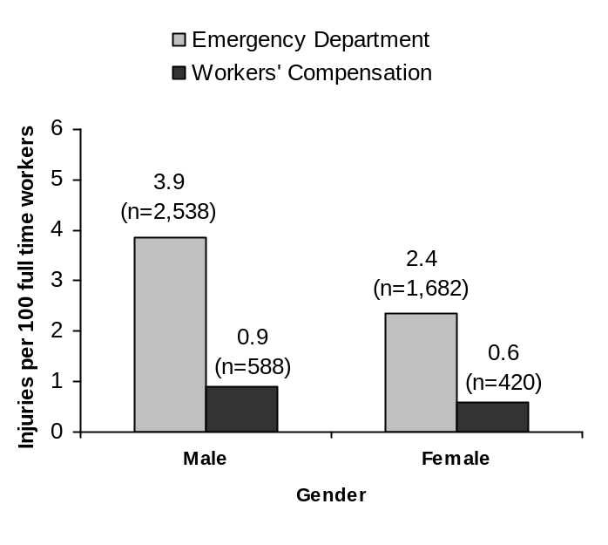
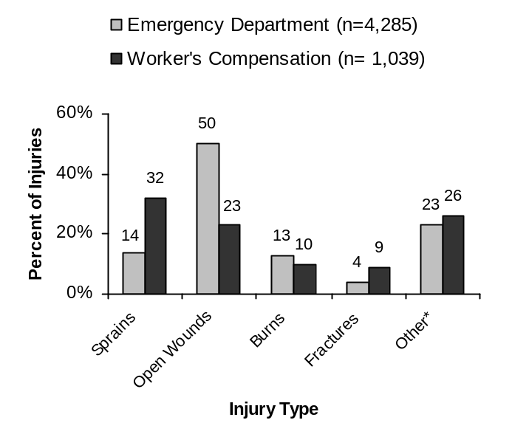
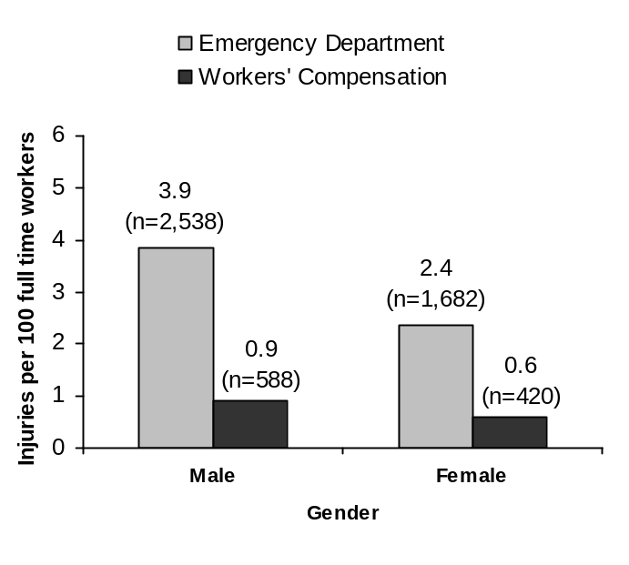This Injury Surveillance Update was prepared by the Massachusetts Department of Public Health’s Teens at Work Injury Surveillance and Prevention Project with funding from the National Institute for Occupational Safety and Health. Cooperative Agreement #0 U60 OH008490.
Figure 2. Average annual rates of work-related injuries among 15– to 17-year-olds, by gender and data source — Massachusetts, 2003-2007

Source: Teens at Work Injury Surveillance System, MDPH; Current Population Survey, Bureau of Labor Statistics.

Figure 2. Average annual rates of work-related injuries among 15– to 17-year-olds, by gender and data source — Massachusetts, 2003-2007

Source: Teens at Work Injury Surveillance System, MDPH; Current Population Survey, Bureau of Labor Statistics.

Figure 2. Average annual rates of work-related injuries among 15– to 17-year-olds, by gender and data source — Massachusetts, 2003-2007

Source: Teens at Work Injury Surveillance System, MDPH; Current Population Survey, Bureau of Labor Statistics.

Figure 2. Average annual rates of work-related injuries among 15– to 17-year-olds, by gender and data source — Massachusetts, 2003-2007

Source: Teens at Work Injury Surveillance System, MDPH; Current Population Survey, Bureau of Labor Statistics.

Figure 2. Average annual rates of work-related injuries among 15– to 17-year-olds, by gender and data source — Massachusetts, 2003-2007

Source: Teens at Work Injury Surveillance System, MDPH; Current Population Survey, Bureau of Labor Statistics.

Figure 3. Distribution of work-related injuries to teens under age 18 by injury type and data source —Massachusetts, 2003-2007

* Other includes some injuries with missing injury type.
Source: Teens at Work Injury Surveillance System, MDPH.
Figure 2. Average annual rates of work-related injuries among 15– to 17-year-olds, by gender and data source — Massachusetts, 2003-2007

Source: Teens at Work Injury Surveillance System, MDPH; Current Population Survey, Bureau of Labor Statistics.

Figure 2. Average annual rates of work-related injuries among 15– to 17-year-olds, by gender and data source — Massachusetts, 2003-2007

Source: Teens at Work Injury Surveillance System, MDPH; Current Population Survey, Bureau of Labor Statistics.

Figure 2. Average annual rates of work-related injuries among 15– to 17-year-olds, by gender and data source — Massachusetts, 2003-2007

Source: Teens at Work Injury Surveillance System, MDPH; Current Population Survey, Bureau of Labor Statistics.

Figure 2. Average annual rates of work-related injuries among 15– to 17-year-olds, by gender and data source — Massachusetts, 2003-2007

Source: Teens at Work Injury Surveillance System, MDPH; Current Population Survey, Bureau of Labor Statistics.

Figure 2. Average annual rates of work-related injuries among 15– to 17-year-olds, by gender and data source — Massachusetts, 2003-2007

Source: Teens at Work Injury Surveillance System, MDPH; Current Population Survey, Bureau of Labor Statistics.

Figure 2. Average annual rates of work-related injuries among 15– to 17-year-olds, by gender and data source — Massachusetts, 2003-2007

Source: Teens at Work Injury Surveillance System, MDPH; Current Population Survey, Bureau of Labor Statistics.

