Young Workers Project: Work-Related Injuries to Teens in Massachusetts, 2009-2013

Massachusetts Department of Public Health, June 2016

Preventing Injuries to Working Teens

In 2013, 15% of 15- to 17-year-olds in Massachusetts were employed at any given point in time.1 While work can provide teens with important benefits, it can also pose health and safety risks. Nationally, teen workers have about twice the risk of nonfatal on-the-job injuries per hour worked than older workers.2 This is partly explained by the fact that teens tend to work in industries that are high risk for workers of all ages, such as restaurants and healthcare; inexperience and lack of health and safety training are also factors.3

Information about where and how teens are injured at work is essential to prevent future injuries and promote safer work opportunities for youth. For over 20 years, the *Young Workers: Injury Surveillance and Prevention Project* at the Massachusetts Department of Public Health has tracked work-related injuries to teens under age 18. Over the years, the *Young Workers Project* has collaborated with partners on a variety of initiatives to prevent injuries to working teens.

Continued efforts are needed to ensure jobs in which teens are employed are safe. And as we engage teens in the workplace—whether as employers, schools, jobs programs, or parents with family businesses—we need to provide them with basic health and safety skills that will help protect them now and in the future.

In This Issue:

Teen Injuries at a Glance….2-5

What Injured Teens Have to Say….5

Largest Growing MA Occupations….6-7

Resources….7

Massachusetts Health Promotion Clearinghouse

Need educational materials? We’ve got you covered. Our most popular products, including the *Guide for Working Teens* and *Child Labor Laws in Massachusetts*, have been moved to the Massachusetts Health Promotion Clearinghouse where you can order materials on workplace health and safety, plus many other topics, for FREE.

Getting started is easy:

1. **Go to** www.mass.gov/MAClearinghouse

2. **Create** a login account for ease and speed on future orders.

3. **Click on** ‘Workplace Health & Safety’ under the left-hand Topic Areas column to add materials to your cart.

We look forward to your orders. Thank you for using and sharing our materials!

Teen Injuries at a Glance, 2009 - 2013

The *Young Workers Project* collects data from hospital emergency departments (ED) and workers’ compensation (WC) lost wage claims to identify work-related injuries to youth. WC claims are for injuries resulting in five or more days of missed work, while ED injuries can range in severity.

From 2009-2013, there were **1,629 ED visits** and **524 WC lost wage claims** filed for work-related injuries to youth under age 18. A more detailed account of these injuries follows.

Age & Gender

**Figure 1.** Distribution of work-related injuries to youth under age 18, by age, gender, and data source, Massachusetts, 2009-2013

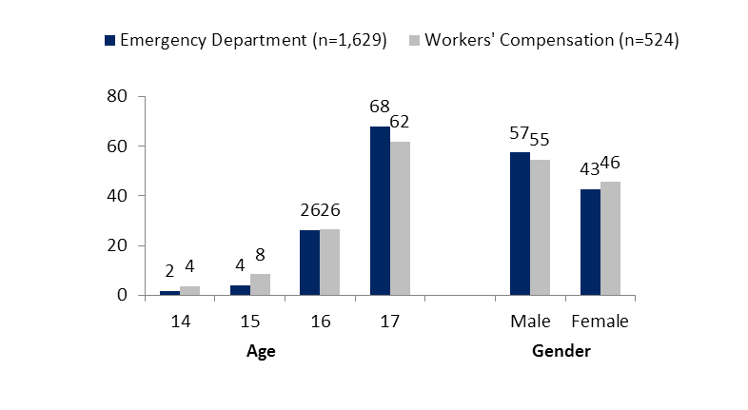

**Percent of** Injuries

Note: Cases for which age or gender was missing were not included in the calculations.

Note: Numbers may not add up to 100 because of rounding.

Source: Young Workers Injury Surveillance System, MDPH.

**Figure 2.** Average annual rates of ED visits among workers, by age group, Massachusetts, 2009-2013

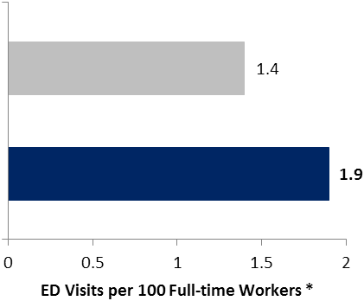

* Two half-time workers count as one full-time worker

25-64 years

**15-17 years**

**Age Group**

Source: Young Workers Injury Surveillance System, MDPH.

*I was getting a customer's order and as I was walking to the drive-thru window there was a fry box on the ground and I slipped on it. I have had x-rays, MRIs, and physical therapy. Also I am seeing an orthopedist. —17-year-old fast food cashier*

* The majority of work-related injuries to teens were among 17-year-olds. This was true in both the ED and WC data sets. (Figure 1)
* Fourteen- and 15-year-olds accounted for a small proportion of injuries. (Figure 1)

*Special laws limit the types of tasks that teens of different ages may perform at work. View the “Child Labor Laws in Massachusetts” poster online to learn more:*

www.mass.gov/dph/teensatwork > Educational Materials > Working Teen Pamphlets

* There were nearly 2 ED visits by teens for every 100 full-time teen workers, 35% higher than the rate for adults ages 25+. (Figure 2)
* Male teens had higher numbers of injury (Figure 1) as well as higher rates than females — 2.2 ED visits and 0.6 WC claims per every 100 full-time workers vs. 1.5 ED visits and 0.5 WC claims for females (not shown).

Fatal Injuries to Teens

There were no reported deaths among teens under age 18 resulting from work-related injuries, from 2009-2013 in Massachusetts.

Race & Ethnicity

**Figure 3.** Average annual rates of work-related ED visits among 15- to 17-year-olds, by race and ethnicity, Massachusetts, 2009-2013 (n=1,599)

Injuries per 100 Full-time Workers:
White non-Hispanic - 1.9
Black non-Hispanic - 1.7
Asian non-Hispanic - 0.6
Hispanic - 1.8

**Injuries per 100 Full-time Workers**

Note: “Other” race/ethnicity category not shown in figure.

Source: Young Workers Injury Surveillance System, MDPH.

* The rates of work-related ED visits for Black non-Hispanic, Hispanic, and White non-Hispanic teens were similar, ranging from 1.7 to 1.9 injuries per 100 full-time workers. (Figure 3)
* The rate of work-related ED visits for Asian non-Hispanic teens (0.6) was significantly lower than that of the other racial/ethnic groups. (Figure 3)

Nature of Injury

No single data set shows the full picture of injuries to teen workers. This is particularly true for the nature of injury (see below). This is why the *Young Workers Project* uses both ED and WC data sets to look at reported injuries.

**Figure 4.** Distribution of work-related injuries among teens under age 18, by injury type and data source, Massachusetts, 2009-2013

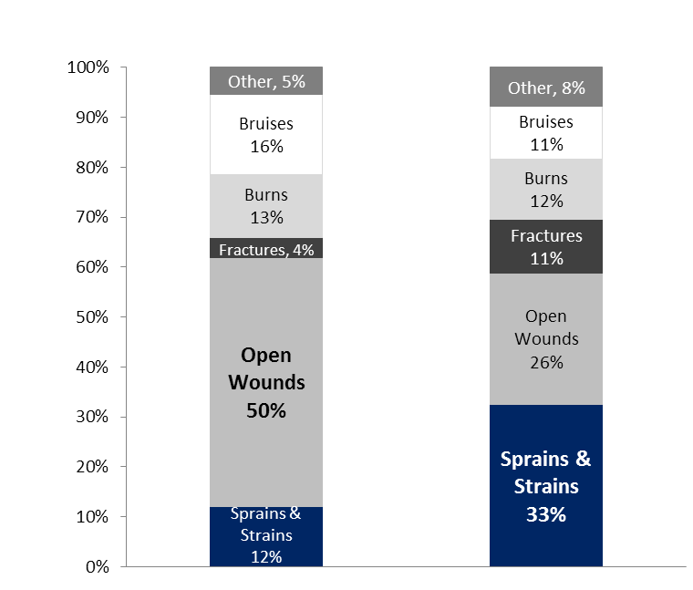

**Emergency Department** (n=1,629) **Workers’ Compensation** (n=524)

**Percent of Injuries**

 Note: Cases for which injury type was missing were not included in the calculations.

Source: Young Workers Injury Surveillance System, MDPH.

* While **open wounds**, including cuts, made up half (50%) of all work-related injuries seen in EDs, **sprains and strains** were the most common injury (33%) for which WC lost wage claims were filed. (Figure 4)

*Of 54 interviewed Massachusetts teens with a work-related sprain or strain, half (50%) expected some kind of permanent effect from the injury.*

* Among sprain injuries, 37% (54) of WC claims and 25% (46) of ED visits were back injuries, putting the injured teens at risk for future back pain.4

Industry Type

**Figure 5.** Distribution of WC lost wage claims for teens under age 18, by industry sector*, Massachusetts, 2009-2013 (n=524)

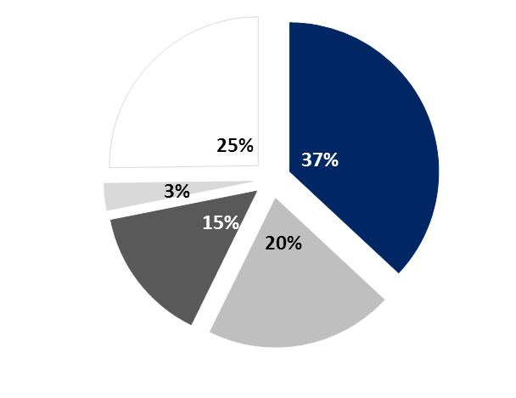

Accommodation & Food Service

Retail Trade

Health Care & Social Assistance

Construction

Other



*NAICS 1997

Note: Cases for which industry was missing were not included in the calculations.

Source: Young Workers Injury Surveillance System, MDPH.

* The four industries in Figure 5 accounted for nearly 75% of work-related injuries to teens.

*I was taking out the trash in the kitchen. When I lifted the bottom of the bag with my hand, broken glass punctured through the plastic and cut my palm. I got three stitches. —15-year-old restaurant dishwasher*

* Accommodation & Food Service, including fast food and full-service restaurants, made up the largest proportion of WC claims (n=189), followed by Retail Trade (n=104), which includes grocery stores. (Figure 5)

What Injured Teens Have to Say

*Young Workers Project* staff completed 185 interviews with young workers who were injured on the job from 2009 through 2013. While the information from these interviews does not necessarily represent the experience of all young injured workers, it provides important information for targeting prevention efforts.

**Figure 6.** Responses of select questions from interviews with teens injured at work, Massachusetts, 2009-2013 (n=185)

“At the time of my injury, there was no supervisor on site.” – 14%

“I expect some kind of permanent effect from my injury.” – 24%

“I had no work permit at the time of my injury.”* - 25%

“I received no health and safety training from my employer.” – 50%

“I believe my injury was preventable.” – 53%

*\* MA child labor laws require teens to have work permits.*

Source: Young Workers Injury Surveillance System, MDPH.

The Largest Growing MA Occupations — Common Hazards

A recent report, *Meeting the Commonwealth’s Workforce Needs*5, highlights the federal forecast that the two largest growing occupational groups in Massachusetts are food-related preparation and service jobs, and healthcare-related practitioner and technical jobs. Common job titles in these groups are within the same industries in which we see many injuries to teen workers (page 4). Below are some job hazards that these workers can face every day.

Food Preparation & Service Workers

**Most likely to work in restaurants and eating places, but can also work in healthcare settings, grocery stores and schools:**

* Bartenders
* Chefs & Cooks
* Host/Hostesses
* Wait Staff
* Food Preparation Workers
* Dishwashers

**Common Hazards:**

* Knives
* Hot ovens
* Heavy lifting
* Slippery floors
* Fast-paced environment
* Standing long hours
* Demanding customers

Healthcare Practitioner & Technical Workers

**Likely to work in various settings such as hospitals, medical practices, ambulance services, schools, healthcare facilities and pharmacies:**

* Medical Records & Health Information Technicians
* Chiropractors
* Dentists & Dental Hygienists
* Pharmacists
* Nurses
* EMTs & Paramedics
* Physicians & Physician Assistants

**Common Hazards**

* Lifting/moving patients
* Exposure to bodily fluids
* Workplace violence
* Standing long hours
* Needles/scalpels
* Stressful emergency situations

**Making the Job Safer**

*Examples for Employers*

* **Slippery kitchen area floors?** Provide and place slip-resistant mats on floors and train workers in procedures to clean spills promptly.
* **Lifting or moving patients?** Provide transfer equipment and train staff in safe patient handling procedures, and be aware of prohibited tasks for minors.6
* **Standing long hours?** Enforce a policy and schedule enough staff to provide workers with adequate breaks.
* **Exposure to needles and other sharps?** Provide devices with sharps injury prevention features, and ensure staff are trained in their use and proper disposal procedures for all sharps.

Want more information on workplace hazards, injuries, and ways to make jobs safer?

Read our industry fact sheets to learn more about the nature of injuries to teens within the following industries:

* **Food Service**
* **Health Care Service**
* Retail Trade (not including grocery stores)
* Grocery Stores
* Construction

www.mass.gov/dph/teensatwork > Educational Materials > Working Teen Pamphlets

Use our *Youth @ Work: Talking Safety* curricula for **Food Service** and **Health Services**.

www.mass.gov/dph/teensatwork > Educational Materials > Youth @ Work: Talking Safety

Massachusetts and National Young Worker Resources

Please take advantage of the resources below covering a range of topics on young worker health and safety.

Child Labor Laws & Wages

Massachusetts Office of the Attorney General

Fair Labor Division

(617) 727-3465

www.mass.gov/ago

U.S. Department of Labor

Wage & Hour Division

(617) 624-6700

www.dol.gov/whd

www.youthrules.dol.gov

Workers’ Compensation

Massachusetts Department of Industrial Accidents

(800) 323-3249

www.mass.gov/dia

Discrimination at Work

Massachusetts Commission Against Discrimination

(617) 727-3990

www.mass.gov/mcad

U.S. Equal Employment Opportunity Commission

Boston Area Office—(617) 669-4000

www.eeoc.gov/youthHealth & Safety and Work Permits

Massachusetts Department of Labor Standards

Work Permits—(617) 626-6952

Workplace Safety & Health Program—(508) 616-0461

www.mass.gov/dols/youth

Massachusetts Department of Public Health

Young Workers: Injury Surveillance & Prevention Project

(617) 624-5632

www.mass.gov/dph/teensatwork

U.S. Department of Labor

Occupational Safety & Health Administration (OSHA)

North Boston Area Office—(978) 837-4460

South Boston Area Office—(617) 565-6924

Springfield Area Office—(413) 785-0123

www.osha.gov/SLTC/teenworkers

National Institute for Occupational Safety & Health (NIOSH)

Workplace Safety & Health Topics

www.cdc.gov/niosh/topics/youth

Youth @ Work: Talking Safety (Curriculum)

http://www.cdc.gov/niosh/talkingsafety/

Data Sources

Young Workers: Injury Surveillance System. Massachusetts Department of Public Health. www.mass.gov/dph/teensatwork.

Emergency department data were obtained through the Massachusetts Center for Health Information and Analysis, www.mass.gov/chia. Workers’ compensation claims were obtained through the Massachusetts Department of Industrial Accidents, www.mass.gov/dia.

References

1 US Bureau of Labor Statistics, Current Population Survey. Washington, DC: US Bureau of Labor Statistics. 2012.

2 MMWR Morbidity Mortality Weekly Report. Occupational Injuries and Deaths Among Younger Workers—United States, 1998-2007.

2010. 59(15):449-455. www.cdc.gov/mmwr/pdf/wk/mm5915.pdf. Accessed June 3, 2016.

3 Centers for Disease Control and Prevention, National Institute for Occupational Safety & Health. “Young Worker Safety and Health.”

August 15, 2015. www.cdc.gov/niosh/topics/youth. Accessed June 3, 2016.

4 Hestbaek L, Leboeuf-Yde C, Manniche C. Low back pain: what is the long-term course? A review of studies of general patient

populations. European Spine Journal. April 2003, Volume 12, Issue 2, pp 149-165. www.ncbi.nlm.nih.gov/pmc/articles/PMC3784852/

pdf/586_2003_Article_508.pdf. Accessed June 3, 2016.

5 Clayton-Matthews A, Bluestone B, Lee N. Meeting the Commonwealth’s Workforce Needs: Occupational Projections and Vocational Education. Dukakis Center for Urban and Regional Policy. October 2015. www.northeastern.edu/dukakiscenter/wp-content/uploads/2015/11/FINAL-PRINTED-REPORT.101915.pdf. Accessed February 2, 2016.

6 US Department of Labor, Wage and Hour Division. Field Assistance Bulletin No. 2011-3. July 2011. www.dol.gov/whd/FieldBulletins/fab2011_3.htm. Accessed February 25, 2016.

Acknowledgements

This Injury Surveillance Update was prepared by the Massachusetts Department of Public Health’s Young Workers: Injury Surveillance and Prevention Project and supported by cooperative agreement # 2U60OH008490-06 from CDC-NIOSH. Its contents are solely the responsibility of the authors and do not necessarily represent the official views of CDC-NIOSH.

*Young Workers: Injury Surveillance and Prevention Project*

[www.mass.gov/dph/teensatwor](http://www.mass.gov/dph/teensatwor)

teens.atwork@state.ma.us