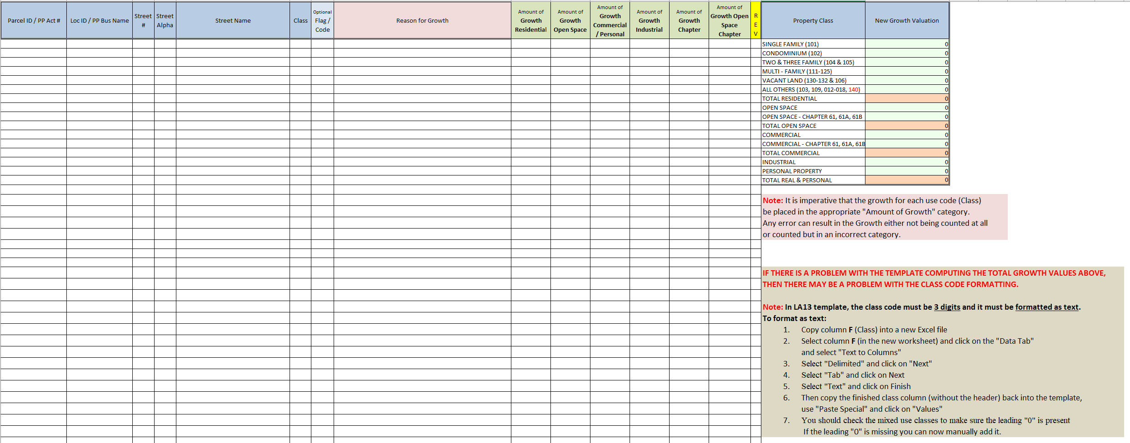
This is the New Growth Verification Template

This is the simple Excel template to upload growth

The New Growth Verification Template can be used to capture and record new growth and allows you to see the tallies in each category. It is a “BEST PRACTICE” to use the Verification Template to record the growth as it is collected. This will give the assessors an opportunity to see the level of growth as it is collected. Additionally, the format is the same in both the Verification and Simple templates so that copying the data from the Verification Template to the Simple Template for uploading into Gateway can be done with ease.
The simple Excel template will be used to upload the data into Gateway, in the LA-13 Upload section of the Taxrate tab. See the directions “LA-13 Upload”
Completing the Template
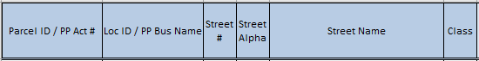
The “Parcel ID”, “Loc ID”, “Street #”, “Street Alpha”, “Street Name”, and “Class” should have the same formats as used on the LA-3. It is important to NOTE that the Use Code or “Class” must be in the required format for the LA-3 state class code. The Class must be three digits only. Additionally, the field must be TEXT (See page 4). Note: For Personal property accounts, you can substitute the Personal Property account number in the first column and Business name in the Loc ID Column.

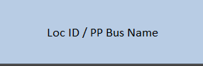This section can contain the Loc ID or in the case of Personal Property accounts it will contain the Business Name. DO NOT EXCEED 32 CHARACTERS INCLUDING SPACES AND DO NOT USE SPECIAL CHARACTERS other than the customary formatting of the LOC ID – ONLY USE NUMBERS OR LETTERS.

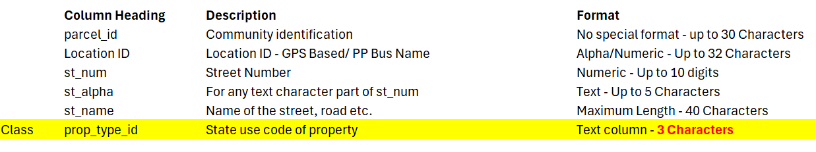

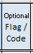
This space may be used for Flags or Codes, particular to individual CAMA systems, to identify growth items.


Reasons for Growth should not be abbreviations or general categories (DO NOT USE: Permits, field review, cyclical review, code 1…) but specific verbiage identifying exactly what new item or items were added to justify adding growth (USE: From Exempt to taxable, New Home, New Condo, Addition, New Garage, Added Bath). Personal Property Growth can be identified as “Accounts taxed for the first time” or “Items new for the current Fiscal Year”. Normal upkeep or maintenance such as painting, minor repairs …., which corrected or replaced portions of items previously taxed and have not increased overall value should not be counted as growth (Do not simply use the permit value – there may not be a reciprocal property value change}. NOTE: Keep the reason short, do not exceed 32 characters including spaces.
While having a detailed description of the completed work can be helpful to the assessor, it should be reserved for the growth template saved for the assessors office and not uploaded into Gateway.
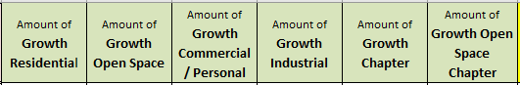Growth for each line in the Template must be listed within the appropriate Major Class/Major Classes. NOTE: Exempt properties are not taxed and therefore do not have growth. Mixed Use classes may have growth in one or two categories
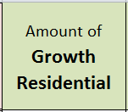Residential Growth should be allocated to the “Growth Residential” 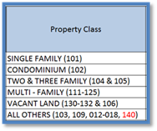
column. All residential Growth should be accounted for under the “Growth Residential” column.
This column should also include the Residential portion of growth in any Mixed-Use properties.

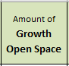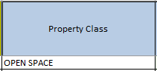
Open Space Growth should be allocated to the “Growth Open Space” column. This column should also include the Open Space portion of growth in any Mixed-Use properties.

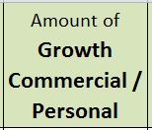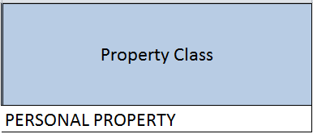
Commercial Growth and Personal Property Growth should be allocated to the “Growth Commercial / Personal” column.
This column should also include the Commercial portion of growth in any Mixed-Use properties.

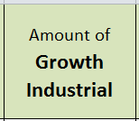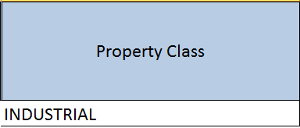
Industrial Growth should be allocated to the “Growth Industrial” column.
This column should also include the Industrial portion of growth in any Mixed-Use properties.

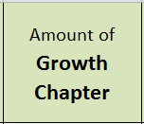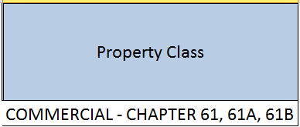
Chapter Growth should be allocated to the “Growth Chapter” column. Note: Growth in Chapter is rare as property transferred to Chapter has been taxed previously and the change to chapter rarely causes an increase in value. A transfer from Exempt to Chapter would be considered growth. This column should also include the Chapter portion of growth in any Mixed-Use properties.

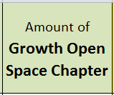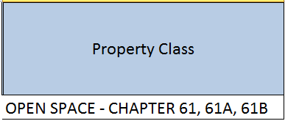
Open Space Chapter Growth should be allocated to the “Growth Open Space Chapter” column. Note: Growth in Chapter is rare as property transferred to Chapter has been taxed previously and the change to chapter rarely causes an increase in value. A transfer from Exempt to Chapter would be considered growth. This column should also include the Open Space Chapter portion of growth in any Mixed-Use properties.

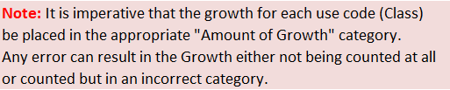

If you are using the verification template and having trouble with the values calculation properly, you can use the instructions below the calculator to re-format the use code column.
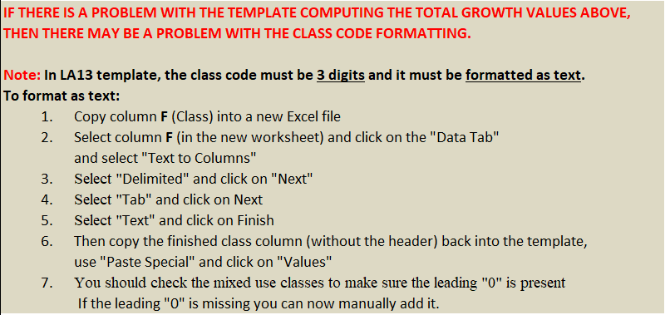

Summary: LA13 New Growth Valuation by Property Class Calculator at the top right of the Verification Template

This section of the worksheet will automatically summarize the new growth entered by class to be reported and mimics the New Growth Valuation Column on the LA13 in Gateway.

Verification Template Calculator:
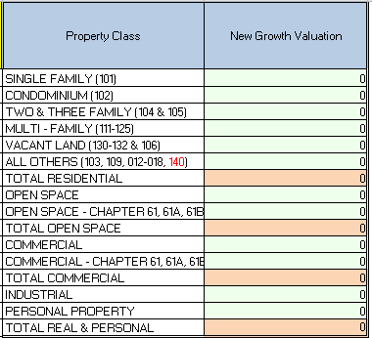
This grid appears on the right side of the Verification Template. It is “self-filled” from the combination of the use class and the appropriate Growth column.

NOTE: If you have copied comments into the “Reason for Growth”: DO NOT EXCEED 32 CHARACTERS INCLUDING SPACES AND DO NOT USE SPECIAL CHARACTERS – ONLY USE NUMBERS OR LETTERS.
