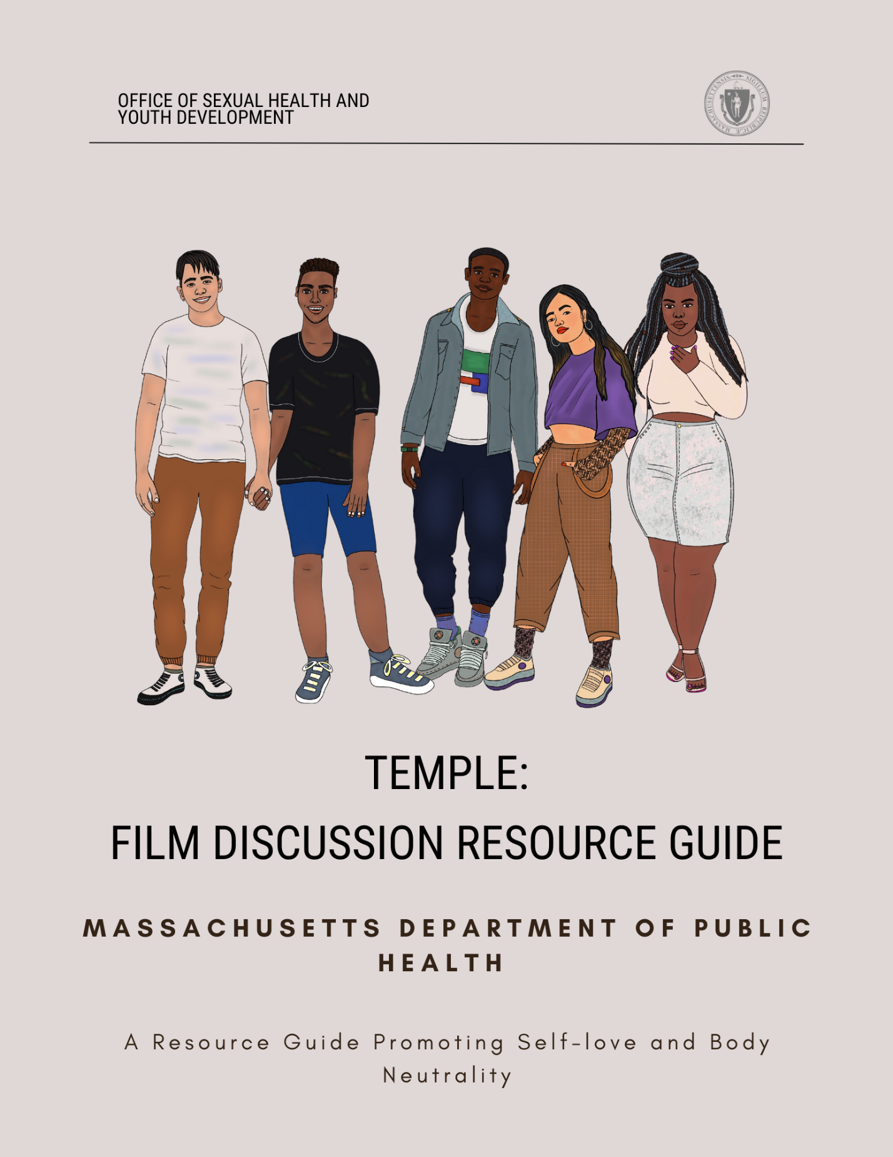

Table of Contents

This Resource Guide 3
Thank You 4
Definitions 5
Resources for Youth 7
988 Suicide and Crisis Lifeline 7
Health Steps 7
MCSP: Greater Boston Regional Suicide 7
The Body Positive 7
National Alliance on Mental Illness (NAMI) 7
The Body Project 7
Greater Boston Wellness Collaborative 8
Speaking of Hope 8
Young Adult Access Centers 8
Video Summary 9
Guiding Discussion Questions 9
Facilitator Tips 11
Mandated Reporting & Managing Disclosure 11
Creating Brave Spaces 11
How To Promote Body Neutrality 12
References 13

This Resource Guide

As a branch of the Massachusetts Department of Public Health, the Office of Sexual Health and Youth Development (OSHYD) is proud to offer this Film Discussion & Resource Guide to trusted caregivers and educators.

OSHYD is comprised of several programs that work synergistically to increase access to comprehensive sexuality education, decrease unintended teen pregnancy, decrease the incidence of sexually transmitted infections (STIs), increase the sustainability of delivery networks serving youth and other vulnerable populations, and increase protective factors for young people using a positive youth development lens¹.

“Body image isn’t about how your body looks; it’s about how you think and feel about your body”². Youth experience barriers that influence health and wellness, such as stressors like bullying, social pressures to look and feel a certain way, and disordered eating. Social media culture deeply impacts how young people can think and feel about their bodies, and it paints an unrealistic picture of bodies by upholding specific beauty standards. These beauty standards can include looking thin or curvy and dictating which skin tones, hair textures, sizes or facial features are deemed “beautiful”³. These messages are upheld by experiences like bullying, racism, sexism, weight-loss praise, body shaming, or how loved ones talk about their own bodies⁴.

Social media usage has significantly increased in the past ten years. In 2021, 72% of US adults reported using at least one social media site, an increase from about 60% in 2014. This pattern was drastically affected by the COVID-19 pandemic during which social media use increased, particularly among young adults⁵. In 2022, a generalizable survey showed about 95% of US teens have YouTube accounts and about 67% of teens have TikTok accounts⁶. Data shows that there is an association between disordered eating and poor body image with smartphone usage^{7,8} and can negatively influence youths’ relationships with their bodies.

Trustworthy and empowering adults play a crucial role as lifelines and safeguards for adolescents. Young people’s overall well-being can be improved by having an accepting community, adult, or caregiver; for instance, a dependable adult can direct young people to resources or services that might be useful. Trusted adults create and maintain a safe and brave space for youth to deconstruct personal perceptions of the ideal body image and work towards gaining a sense of body neutrality or decentering the appearance of bodies and, instead, prioritize the functionality of bodies^{9,10}.

This discussion guide can be used in conjunction with the film, Temple, on how to ask questions or have potentially challenging conversations with youth. Included are resources that provide accurate and trauma-informed information that addresses social determinants of health for youth’s mental well-being as it relates to body image. This discussion guide is meant to be a starter kit for facilitators, schools, community organizations, parents, and trustworthy adults on what support systems are available and how to navigate what may feel like uncharted territory.

Thank You

The Massachusetts Department of Public Health, the Office of Sexual Health and Youth Development (OSHYD) would like to thank the following organizations and individuals for their input and contribution to this resource guide:

Cecelia Werner, 2023 Fellow at the Boston University Maternal and Child Health Center for Excellence, Master of Public Health candidate

A special thanks go to the cast and crew of Temple

Girls Inc. of The Valley¹¹

Thato Mwosa¹², Film Producer, Writer, and Director for Tuli Media

Dara Oloyede (DPH), Adolescent Health Coordinator at the Office of Sexual Health and Youth Development

Lissette Gil-Sanchez (DPH), Director of the Office of Sexual Health and Youth Development

Definitions

These definitions are based on what is currently appropriate as of November 2023, and please note that these definitions are not exhaustive.

Body Image¹³ | The idea that someone has of what their own body looks like.
Body Neutrality^{9, 10} | Decentering the appearance of bodies, and instead, focusing on and prioritizing the functionality of bodies. It is honoring the body as it is.
Brave Space¹⁴ | An environment that acknowledges the challenges that both students and faculty have when discussing difficult and/or sensitive topics such as race, power, privilege and the various forms of oppression for the purpose of learning.
Bullying¹⁵ | The behavior of a person who hurts or frightens someone smaller or less powerful, often forcing that person to do something they do not want to do.
Cyberbullying¹⁶ | Bullying that takes place over digital devices like cell phones, computers, and tablets. Cyberbullying can occur through SMS, text, and apps, or online in social media, forums, or gaming where people can view, participate in, or share content. Cyberbullying includes sending, posting, or sharing negative, harmful, false, or mean content about someone else.
Disordered Eating¹⁷ | A term used to describe a range of irregular eating behaviors that may or may not warrant a diagnosis of a specific eating disorder.
Eating Disorder¹⁸ | Behavioral conditions that are characterized by severe and persistent disturbance in eating behaviors and associated distressing thoughts and emotions. They can be very serious conditions affecting physical, psychological, and social function.
Normative Discontent¹⁹ | The general idea that it’s normal to be perpetually dissatisfied with one’s weight/shape/size.
Social Media²⁰ | Websites and computer programs that allow people to communicate and share information (thoughts, ideas, photos, etc.) on the internet using a computer or cell phone.
Trusted Adult²¹ | A trusted adult is chosen by the young person as a safe figure who listens without judgment, agenda or expectation but with the sole purpose of supporting and encouraging positivity within a young person’s life.

Resources for Youth

988 Suicide and Crisis Lifeline

988 is a direct three-digit number to trained Suicide and Crisis Lifeline specialists. 988 is free and available 24/7, 365 days a year via phone call, text or chat²².

Health Steps

211HELPSteps is the online platform of Mass211. From any desktop or mobile device, individuals can search and then connect to local health and human service resources across the Commonwealth. Programs that are included support basic needs such as food security, housing, childcare, transportation, and mental and emotional health resources²³.

MCSP: Greater Boston Regional Suicide

The Greater Boston Regional Suicide Prevention Coalition (GBRSPC) is one of ten regional coalitions that operate under the umbrella of the Massachusetts Coalition for Suicide Prevention (MCSP). Massachusetts Coalition for Suicide Prevention (MCSP) is an inclusive alliance of suicide prevention advocates, including public and private agency representatives, policymakers, suicide loss, and attempt survivors, impacted family and friends, mental health and public health consumers and providers, and concerned citizens who are dedicated to working together to reduce the incidence of suicide and self-harm across the Commonwealth. Services include mental health crisis hotlines, emergency mental health services, statewide resources, RIAC community services, and youth mental health resources²⁴.

The Body Positive

The Body Positive is a nonprofit organization that teaches people to listen to their bodies, learn and thrive. Their goal is to end the harmful consequences of negative body image: eating disorders, depression, anxiety, cutting, suicide, substance abuse, and relationship violence. They are especially concerned about poor body image in teens and young adults. Services include training educators and student leaders²⁵.

National Alliance on Mental Illness (NAMI)

This is a mini collection of resources for people who are dealing with food-related or eating-related mental health symptoms, put together by people who have had such experiences. Services include the Compass Helpline, peer support, family support, health insurance, etc²⁶.

The Body Project

The Body Project is a group-based intervention that provides a forum for high school girls and college-aged women to confront unrealistic appearance ideals and develop healthy body image and self-esteem. It has repeatedly been shown to effectively reduce body dissatisfaction, negative mood, unhealthy dieting, and disordered eating. Services include high school facilitator training, college facilitator training, The Body Project Experience workshop, etc.²⁷.

Greater Boston Wellness Collaborative

Our mission is to provide exceptional multi-disciplinary care to individuals and families experiencing eating disorders, disordered eating, body image challenges, and related issues. Services include nutrition counseling, psychopharmacology, psychotherapy, meal coaching, etc. ²⁸.

Speaking of Hope

Speaking of Hope is a web and social media platform that supports mental wellness for young adults in Massachusetts and offers key resources such as employment and training services, mental health support, and substance use recovery support for young adults²⁹.

Young Adult Access Centers

Young Adult Access Centers provide timely and effective services for young adults facing mental health concerns. These centers focus on outreach to those dealing with challenges such as mental illness, substance misuse, economic insecurity, and homelessness. Services are free and available in Massachusetts. Find a center at https://www.speakingofhope.org/access-centers/ or contact Heidi Holland, Director of Young Adult Transitional Services, at Heidi.holland@mass.gov. Centers are affirming and inclusive spaces that promote an environment that specifically and effectively engages Black, Indigenous, People of Color (BIPOC) and Lesbian, Gay, Bisexual Queer/Questioning (LGBTQIA+) young people³⁰.

Video Summary: Temple

This short film follows Valerie (“Val”), a teen who is struggling with her body image. Val is dealing with bullying and unrealistic body standards both on and offline, which are magnified by unattainable body ideals. With the love and support of her sister, Val finds a newfound value in loving herself just the way she is.

Content Warning:

This film delves into sensitive topics related to body image, including instances of self-harm, negative self-talk, and bullying. It is important to note that this film and the subsequent discussion may bring up strong emotions or reactions. Facilitators leading discussions should be mindful of the potential emotional impact on youth.

We encourage facilitators to review the available resources in the designated section. Additionally, please be aware of the mental health resources and referral partners within your organization. If youth express a need for additional services or resources, it is crucial to have these options readily available.

Guiding Discussion Questions

Below are a series of questions that can be used after watching the video, Temple, to guide a discussion about body neutrality, healthy friendships, and the role of caregivers in supporting positive body image in young people’s lives.

- Key Themes
- Bullying
- Social Media
- Trusted Adult
- Positive Body Image

- Reflection Questions for Facilitators
- Do you know what body neutrality is? How do you speak about your own body?
- How do you, as a trusted adult, speak about bodies in a neutral manner?
- How can you model brave space, respect towards others, and calling in any harm that has been done?
- How can you respond to a young person’s criticism about their own bodies or others in a way that is body neutral?
- How can cultural expectations or norms be a protective factor for youth?
- How would you approach a youth whom you notice has been more withdrawn from programming?
- What mental health resources or referral partners can your program provide for youth? Is there any protocol around follow-up?
- What is your agency’s policy around disclosure and mandatory reporting? See Facilitator Tips.

- Discussion Questions for Youth
- How did the appearance-related comments on Val’s pictures make her feel?
    - What role does Val’s sister play in the film?
- What are ways to compliment others that are not based on physical appearance?
- How does social media and other media affect your body image?
    - Do you agree or disagree with these stories?
- How does your culture or community affect your body image?
- What are healthy strategies that can help you or your friends cope with these pressures?
- What student support resources exist at your school? Who can you talk to if you experience challenges with body image?

Facilitator Tips

Below are recommendations and factors to consider while leading this or any other conversation about body image in a group or 1-on-1.

Mandated Reporting & Managing Disclosure

Under Massachusetts law, the Department of Children and Families (DCF) is the state agency that receives all reports of suspected abuse and/or neglect of children under the age of 18. Professionals who have regular contact with children are mandated by state law to inform the Department of Children and Families (DCF) if they have suspicions of child abuse or neglect³¹. If you work in childcare, you may find it necessary to submit a report to DCF regarding suspected child abuse or neglect³². To learn more about the process of reporting alleged child abuse or neglect under section 51A, please click here for additional information.

Below is a list of positions that are mandated reporters³¹:

- Physicians, dentists, nurses, medical interns, hospital personnel, and all medical staff.
- Public or private school teachers, educational administrators, guidance, or family counselors.
- Early education, preschool, childcare, or after-school program staff, including any person paid to care for or work with a child in any public or private facility funded or licensed by the Commonwealth.
- Voucher management agencies, family childcare, and childcare food programs.
- Childcare licensors, such as staff from the Department of Early Education and Care.

Being well-informed about your agency's policies regarding mandated reporting and managing disclosures is crucial. Setting up a pre-planned strategy with your agency for managing disclosures and locating post-disclosure support is essential for effectively dealing with such challenging situations. It is vital to maintain transparency and honesty when interacting with children or students under the age of 18 and disclose that you are a mandated reporter. This disclosure is essential, as it can provide children or students with support or guide them to other resources to feel comfortable and safe.

Creating Brave Spaces

Establishing a brave space for youth is difficult but doable. As a facilitator, it is important to set and communicate discussion boundaries immediately to help maintain a healthy and safe environment. One effective approach is to involve the youth in collectively setting ground rules for your time together. Some examples of such rules could include: (1) focusing on challenging ideas, not individuals, (2) respecting confidentiality - what's discussed here, stays here, (3) listening with the intent to learn rather than simply responding. Another approach is using the “Comfort Circle”. To follow this suggestion, check out page 32 of the Valuing Our Insights for Civic Engagement (VOICES) curriculum³³. This curriculum was developed by the Office of Sexual Health and Youth Development in collaboration with the Posse Foundation. Write down these rules somewhere where everyone can see them and seek consensus that everyone in the space will commit to following the ground rules. At the start of each day of programming, refer youth back to the ground rules.

It is important to understand that some of these suggestions and conversations can be challenging and uncomfortable. Many young individuals in this context may be actively seeking and in need of resources. It's important to remember that your role as a facilitator is not to offer counseling but to serve as a trustworthy adult and direct the young person to the appropriate resources. Always seek permission before sharing resources, such as connecting them with a therapist or school staff member. Follow up with the students to see how they are doing and ensure they are mentally and physically safe.

Additionally, safeguarding your own mental health is critical. Engaging empathetically with youth who have experienced trauma can lead to vicarious trauma. Be watchful for signs of emotional exhaustion, reduced personal accomplishment, and dissociation. Establish a plan with your leadership team and seek mental health support for yourself ³⁴.

How To Promote Body Neutrality

Young people have compounding identities, such as cultural identity, skin tone, hair texture, height, stigma, or the systems that our young people navigate that may affect how they view their bodies. Trusted adults in young people’s communities play a significant and important role in maintaining a brave space that is focused on body neutrality and acceptance. Below is a list of possible suggestions on how to practice and promote body neutrality³:

- Write a letter of gratitude to your body and list what you’re thankful for.
- Accept body image distress as normal.
- Focus on other values.
- Get support.

When facilitating a conversation about body neutrality, the conversation has the potential to shift too far in the direction of physical ability/functionality. It will be important to help the group recognize that there is natural diversity in what our bodies can do and that all bodies have inherent worth, no matter where they fall on that spectrum.

As a facilitator, you also have the power to model body positivity or neutrality. It is important to make sure to model body positivity even when you are not talking directly to youth. Youth may overhear these conversations and normalize these discussions as the norm. Let’s make body neutrality or positivity the norm!

References
- Office of Sexual Health and Youth Development. Mass.gov. Accessed February 10,
2023. https://www.mass.gov/orgs/office-of-sexual-health-and-youth-development.
- “Body Image and Self-Esteem.” Teens Health. 2023. Accessed August 12, 2023.
https://kidshealth.org/en/teens/body-image.html.
- “Body Image and Ethnic Background.” Mental Health Foundation. Accessed August 11,
2023. www.mentalhealth.org.uk/our-work/research/body-image-how-we-think-and-feel-about-our-bodies/body-image-and-ethnic-background.
- “Tips for a Healthy Body Image: Jed.” The Jed Foundation. August, 11,
2023. https://jedfoundation.org/resource/tips-for-body-positivity-ways-to-feel-better-about-our-bodies/.
- Sanzari, C., Gorrell, S., Anderson, L., Reilly, E., et., al. “The impact of social media use
on body image and disordered eating behaviors: Content matters more than duration of exposure.” Eating Behaviors, Volume 49, 2023. Assessed on August 12, 2023. https://doi.org/10.1016/j.eatbeh.2023.101722.
- Dixon, Stacy Jo. “U.S. Teens on Social Media Ever Used by Platform 2022.” Accessed
August 11, 2023. www.statista.com/statistics/1327653/us-teens-social-media-platforms-sites-apps-used/#:~:text=Instagram%20was%20used%20by%2062,95%20percent%20of%20U.S.%20teens.
- Zhang, J., Wang, Y., Li, Q., & Wu, C. (2021). The relationship between SNS usage and
disordered eating behaviors: a meta-analysis. Frontiers in Psychology, 12, 641919.
- Holland, G., & Tiggemann, M. (2016). A systematic review of the impact of the use of
social networking sites on body image and disordered eating outcomes. Body image, 17, 100-110.
- “5 Steps to Body Neutrality.” National Eating Disorders Association. Accessed
August 11, 2023. www.nationaleatingdisorders.org/blog/5-steps-body-neutrality#:~:text=Body%20neutrality%20is%20a%20shift,support%20your%20body%20hatred%20anymore.
- Sharp, Gemma. Bilal, Maria. Nileshni Fernando, Anne. De Boer, Kathleen. “Examining
health professional perspectives on social media body image movements: A qualitative exploration, Body Image.” Volume 46, 2023, Pages 230-237. Accessed August 13, 2023. https://doi.org/10.1016/j.bodyim.2023.06.004.
- “We Are Girls Inc. of the Valley.” Girls Inc. of the Valley. Accessed 17 Aug. 2023.
www.girlsincvalley.org/.
- Thato R. Mwosa, October 6, 2023. https://thatomwosa.com/.
- Cambridge Dictionary. Definition of “Body Image.” Accessed November 22, 2023.
https://dictionary.cambridge.org/us/dictionary/english/body-image.
- The 6 Pillars of a Brave Space. University of Maryland. Accessed November 10, 2023.
https://www.ssw.umaryland.edu/media/ssw/field-education/2---The-6-Pillars-of-Brave-Space.pdf.
- Cambridge Dictionary. Definition of “Bullying.” Accessed November 22, 2023.
https://dictionary.cambridge.org/us/dictionary/english/bullying.
- “What is Cyberbullying.” Stopbullying.gov. 2023. Accessed on October 15, 2023.
https://www.stopbullying.gov/cyberbullying/what-is-it.
- “What is Disordered Eating.” Eatright.org. 2023. Accessed on October 15, 2023.
https://www.eatright.org/health/health-conditions/eating-disorders/what-is-disordered-eating.
- “What are Eating Disorders.” American Psychiatric Association. 2023. Accessed on
October 15, 2023. https://www.psychiatry.org/patients-families/eating-disorders/what-are-eating-disorders.
- Body image Health Task Force. Ohio State University. 2023. Accessed on October 15,
2023. https://u.osu.edu/bihtf/body-image-issues/eating-disorder-glossary/#:~:text=Perceptual%20%E2%80%93%20the%20way%20you%20see,to%20the%20way%20you%20look.
- Cambridge Dictionary. Definition of “Social Media.” Accessed November 22, 2023.
https://dictionary.cambridge.org/us/dictionary/english/social-media?q=Social+Me
dia.
- YoungMinds. Definitions. Accessed. November 15, 2023.
https://www.youngminds.org.uk/professional/community-support/someone-to-turn-to/defining-a-trusted-adult/#:~:text=What%20is%20a%20trusted%20adult,within%20a%20young%20person's%20life.
- 988 Suicide and Crisis Lifeline. Mass.gov. Accessed October 6, 2023.
https://www.mass.gov/info-details/about-the-988-suicide-and-crisis-lifeline.
- 211HELPSteps. Accessed May 10, 2023.
https://www.helpsteps.com/#/services/286302-lgbtq.
- Suicide prevention program. Mass.gov. Accessed May 10, 2023.
https://www.mass.gov/suicide-prevention-program.
- The Body Positive. Accessed on October 15, 2023. https://thebodypositive.org/.
- NAMI. National Alliance on Mental Illness. 2023. Accessed on October 15, 2023.
https://www.nami.org/Home.
- The Body Project. National Eating Disorders Association. 2023. Accessed on October 15,
2023. https://www.nationaleatingdisorders.org/get-involved/the-body-project.
- Greater Boston Wellness Collaborative. Accessed October 15, 2023.
https://www.gbwellness.com/.
- Speaking of Hope. Accessed October 6, 2023. https://www.speakingofhope.org/
- Access Centers. Speaking of Hope. Accessed October 6, 2023.
https://www.speakingofhope.org/access-centers/
- Massachusetts Department of Children & Families. Mass.gov. Accessed May 10, 2023.
https://www.mass.gov/orgs/massachusetts-department-of-children-families.
- Reporting alleged child abuse or neglect (filing a 51A report). Mass.gov. Accessed
October 6, 2023. https://www.mass.gov/info-details/reporting-alleged-child-abuse-or-neglect-filing-a-51a-report.
- Office of Sexual Health & Youth Development & The Posse Foundation. (2016). Valuing Our Insights for Civic Engagement (VOICES) (2nd Ed.). Boston, MA.
- Bell, H., Kulkarni, S., Dalton, L. Organizational Prevention of Vicarious Trauma.
Families in Society, 84(4), 463-470. 2003. https://doi.org/10.1606/1044-3894.131

