INDOOR AIR QUALITY ASSESSMENT

Templeton Center School
17 South Road
Templeton, MA

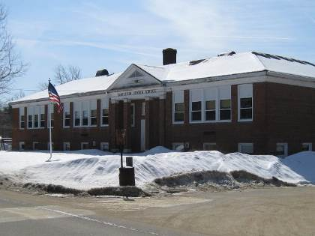

Prepared by:
The Massachusetts Department of Public Health
Bureau of Environmental Health
Indoor Air Quality Program
May 2011

Background/Introduction
At the request of Joyce Crouse, Health Director, Templeton Board of Health, the Massachusetts Department of Public Health (MDPH) Bureau of Environmental Health’s (BEH) Indoor Air Quality (IAQ) Program conducted an assessment at the Templeton Center School (TCS) located at 17 South Road, Templeton, Massachusetts. On March 4, 2011, the building was visited by Michael Feeney, Director of BEH’s IAQ Program. During the assessment, Mr. Feeney was accompanied by Angelo Garofalo, Principal, TCS. This visit was a follow-up to a February 2011 visit that assessed ceiling tile failure due to roof leakage in classroom 107 and was the subject of a separate report (Appendix A).
The TCS is a one story brick building with wooden roof and occupied basement constructed in 1941, according to the Templeton School Department. An addition was constructed sometime before 1970. The roof is flat with peaked sides (Picture 1). Windows are openable throughout the building. It was reported to BEH staff by Superintendent Roseli S. Weiss that the school district is attempting to seek funds for either renovations or replacement of the TCS within the next several years.

Methods
Air tests for carbon monoxide, carbon dioxide, temperature and relative humidity were conducted with the TSI, Q-Trak, IAQ Monitor, Model 7565. Air tests for airborne particle matter with a diameter less than 2.5 micrometers were taken with the TSI, DUSTTRAK™ Aerosol Monitor Model 8520. BEH staff also performed visual inspection of building materials for water damage and/or microbial growth.

Results
This school houses approximately 112 students and a staff of approximately 15. Tests were taken under normal operating conditions. Test results appear in Table 1.

Discussion

Ventilation
It can be seen from Table 1 that carbon dioxide levels were above 800 parts per million (ppm) in all but one area surveyed. Carbon dioxide levels in classroom 105 exceeded 2,000 ppm. The elevated carbon dioxide levels measured in most areas of the school indicate poor air exchange throughout the building, particularly in classrooms that were fully occupied. These levels are due to deactivated/non-functioning/poorly functioning ventilation equipment. It is also important to note that some areas were empty/sparsely populated, which can greatly reduce carbon dioxide levels. Carbon dioxide levels would be expected to increase with higher room occupancy.
Fresh air in classrooms throughout the school is supplied by unit ventilator (univent) systems. A univent draws air from the outdoors through a fresh air intake located on the exterior wall of the building and returns air through an air intake located at the base of the unit. Fresh and return air are mixed, filtered, heated and provided to classrooms through an air diffuser located in the top of the unit (Picture 1). Univents were found deactivated during the assessment, therefore no means of mechanical introduction of fresh air was being provided. Univents were also obstructed by items such as chairs, tables, desks, and books (Pictures 2 and 3). In order to function as designed, univents must be activated and allowed to operate free of obstructions. Mechanical ventilation for large/common areas such as the cafeteria and other basement level rooms is provided by ceiling-mounted univents (Picture 4).
Univents at the TCS were reportedly installed when the school was built in 1941 and for the new addition, prior to 1970. According to the American Society of Heating, Refrigeration and Air-Conditioning Engineers (ASHRAE), the service life for a unit heater, hot water or steam is 20 years, assuming routine maintenance of the equipment (ASHRAE, 1991). The operational lifespan of this equipment has long passed. Given its age, continuing to maintain the balance of fresh air to exhaust air will be difficult at best.
Exhaust ventilation in classrooms is provided by hearth-like structures at the base of walls (Picture 5) that are connected to exhaust vents in the attic that direct air through vents located on the flat section of the roof (Pictures 1 and 6). At the time of the assessment, the exhaust system was found deactivated. In addition, several classrooms had exhaust vents that were either shut or obstructed by papers, posters, bookcases and furniture. As with the univents, exhaust vents need to be free from obstruction to function as designed. Without adequate exhaust ventilation, excess heat and environmental pollutants can build up and lead to indoor air/comfort complaints.
To maximize air exchange, the MDPH recommends that both supply and exhaust ventilation operate continuously during periods of building occupancy. In order to have proper ventilation with a mechanical supply and exhaust system, the systems must be balanced to provide an adequate amount of fresh air to the interior of a room while removing stale air from the room. It is recommended that HVAC systems be re-balanced every five years to ensure adequate air systems function (SMACNA, 1994). The date of the last balancing of the HVAC system was not available at the time of the assessment.
The Massachusetts Building Code requires that each room have a minimum ventilation rate of 15 cubic feet per minute (cfm) per occupant of fresh outside air or openable windows (SBBRS, 1997; BOCA, 1993). The ventilation must be on at all times that the room is occupied. Providing adequate fresh air ventilation with open windows and maintaining the temperature in the comfort range during the cold weather season is impractical. Mechanical ventilation is usually required to provide adequate fresh air ventilation.
Carbon dioxide is not a problem in and of itself. It is used as an indicator of the adequacy of the fresh air ventilation. As carbon dioxide levels rise, it indicates that the ventilating system is malfunctioning or the design occupancy of the room is being exceeded. When this happens, a buildup of common indoor air pollutants can occur, leading to discomfort or health complaints. The Occupational Safety and Health Administration (OSHA) standard for carbon dioxide is 5,000 parts per million parts of air (ppm). Workers may be exposed to this level for 40 hours/week, based on a time-weighted average (OSHA, 1997).
The MDPH uses a guideline of 800 ppm for publicly occupied buildings. A guideline of 600 ppm or less is preferred in schools due to the fact that the majority of occupants are young and considered to be a more sensitive population in the evaluation of environmental health status. Inadequate ventilation and/or elevated temperatures are major causes of complaints such as respiratory, eye, nose and throat irritation, lethargy and headaches. For more information concerning carbon dioxide, consult Appendix B.
Temperature measurements ranged from 70°F to 73°F, which were within the MDPH recommended comfort range in all areas (Table 1). The MDPH recommends that indoor air temperatures be maintained in a range of 70º F to 78º F in order to provide for the comfort of building occupants. In many cases concerning indoor air quality, fluctuations of temperature in occupied spaces are typically experienced, even in a building with an adequate fresh air supply. Given the age, condition and operating status of ventilation equipment, temperature control would be expected to be difficult.
The relative humidity measured in the building ranged from 8 to 23 percent which was below the MDPH recommended comfort range (Table 1). The MDPH recommends a comfort range of 40 to 60 percent for indoor air relative humidity. Relative humidity levels in the building would be expected to drop during the winter months due to heating. The sensation of dryness and irritation is common in a low relative humidity environment. Low relative humidity is a very common problem during the heating season in the northeast part of the United States.

Microbial/Moisture Concerns
In addition to the issue in room 107 discussed in the previous MDPH report (Appendix A), water-damaged ceiling tiles and/or plaster were observed in other locations in the building (Table 1). The TCS appears to have a number of water penetration issues related to the building envelope (roof, windows and exterior walls). It was reported by school officials that attempts to patch the roof have been made. Ceiling tiles should be replaced after a water leak is discovered and repaired.
The US Environmental Protection Agency (US EPA) and the American Conference of Governmental Industrial Hygienists (ACGIH) recommend that porous materials be dried with fans and heating within 24 to 48 hours of becoming wet (US EPA, 2001; ACGIH, 1989). If not dried within this time frame, mold growth may occur. Once mold has colonized porous materials, they are difficult to clean and should be removed and discarded.

Other Indoor Air Evaluations
Indoor air quality can be negatively influenced by the presence of respiratory irritants, such as products of combustion. The process of combustion produces a number of pollutants. Common combustion emissions include carbon monoxide, carbon dioxide, water vapor, and smoke (fine airborne particle material). Of these materials, exposure to carbon monoxide and particulate matter with a diameter of 2.5 micrometers (μm) or less (PM2.5) can produce immediate, acute health effects upon exposure. To determine whether combustion products were present in the indoor environment, BEH staff obtained measurements for carbon monoxide and PM2.5.

Carbon Monoxide
Carbon monoxide is a by-product of incomplete combustion of organic matter (e.g., gasoline, wood and tobacco). Exposure to carbon monoxide can produce immediate and acute health affects. Several air quality standards have been established to address carbon monoxide and prevent symptoms from exposure to these substances. The MDPH established a corrective action level concerning carbon monoxide in ice skating rinks that use fossil-fueled ice resurfacing equipment. If an operator of an indoor ice rink measures a carbon monoxide level over 30 ppm, taken 20 minutes after resurfacing within a rink, that operator must take actions to reduce carbon monoxide levels (MDPH, 1997).
The American Society of Heating Refrigeration and Air-Conditioning Engineers (ASHRAE) has adopted the National Ambient Air Quality Standards (NAAQS) as one set of criteria for assessing indoor air quality and monitoring of fresh air introduced by HVAC systems (ASHRAE, 1989). The NAAQS are standards established by the US EPA to protect the public health from six criteria pollutants, including carbon monoxide and particulate matter (US EPA, 2006). As recommended by ASHRAE, pollutant levels of fresh air introduced to a building should not exceed the NAAQS levels (ASHRAE, 1989). The NAAQS were adopted by reference in the Building Officials & Code Administrators (BOCA) National Mechanical Code of 1993 (BOCA, 1993), which is now an HVAC standard included in the Massachusetts State Building Code (SBBRS, 1997). According to the NAAQS, carbon monoxide levels in outdoor air should not exceed 9 ppm in an eight-hour average (US EPA, 2006).
Carbon monoxide should not be present in a typical, indoor environment. If it is present, indoor carbon monoxide levels should be less than or equal to outdoor levels. Outdoor carbon monoxide concentrations were non-detect (ND) at the time of the assessment (Table 1). No measurable levels of carbon monoxide were detected inside the building during the assessment (Table 1).

Particulate Matter
The US EPA has established NAAQS limits for exposure to particulate matter. Particulate matter is airborne solids that can be irritating to the eyes, nose and throat. The NAAQS originally established exposure limits to particulate matter with a diameter of 10 μm or less (PM10). According to the NAAQS, PM10 levels should not exceed 150 micrograms per cubic meter (μg/m³) in a 24-hour average (US EPA, 2006). These standards were adopted by both ASHRAE and BOCA. Since the issuance of the ASHRAE standard and BOCA Code, US EPA established a more protective standard for fine airborne particles. This more stringent PM2.5 standard requires outdoor air particle levels be maintained below 35 μg/m³ over a 24-hour average (US EPA, 2006). Although both the ASHRAE standard and BOCA Code adopted the PM10 standard for evaluating air quality, MDPH uses the more protective PM2.5 standard for evaluating airborne particulate matter concentrations in the indoor environment.
Outdoor PM2.5 was measured at 32 μg/m³ (Table 1). PM2.5 levels measured indoors ranged from 5 to 10 μg/m³ (Table 1), which were below the NAAQS PM2.5 level of 35 μg/m³. Frequently, indoor air levels of particulates (including PM2.5) can be at higher levels than those measured outdoors. A number of mechanical devices and/or activities that occur indoors can generate particulate during normal operations. Sources of indoor airborne particulates may include but are not limited to particles generated during the operation of fan belts in the HVAC system, use of stoves and/or microwave ovens in kitchen areas; use of photocopiers, fax machines and computer printing devices; operation of an ordinary vacuum cleaner and heavy foot traffic indoors.
While no elevated levels of airborne particulate were measured, soot deposition was observed in the library around light fixtures (Picture 7). This soot may be attributed to furnace generated pollutants in the mechanical room next door to the library. A number of holes in the wall of the mechanical room were noted (Pictures 8 and 9). These holes should be sealed to prevent the migration of combustion products into occupied areas.

Other Conditions
Other conditions that can affect indoor air quality were observed during the assessment. BEH staff observed tennis balls which had been sliced open and placed on chair and/or table legs presumably to reduce noise (Picture 10). Tennis balls are made of a number of materials that are a source of respiratory irritants. Constant wearing of tennis balls can produce fibers and cause volatile organic compounds (VOCs) to off-gas. Tennis balls are made with a natural rubber latex bladder, which becomes abraded when used as a chair leg pad. Use of tennis balls in this manner may introduce latex dust into the school environment. Some individuals are highly allergic to latex (e.g., spina bifida patients) (SBAA, 2001). It is recommended that the use of materials containing latex be limited in buildings to reduce the likelihood of symptoms in sensitive individuals (NIOSH, 1997).
Finally, of note, was the amount of materials stored inside classrooms. In several classrooms, items were observed on the floor, windowsills, tabletops, counters, bookcases and desks. The large number of items stored in classrooms provides a source for dusts to accumulate. These items (e.g., papers, folders, boxes) make it difficult for custodial staff to clean. Items should be relocated and/or cleaned periodically to avoid excessive dust build up.

Conclusions/Recommendations
The capacity of mechanical ventilation equipment to provide adequate fresh air and exhaust to classrooms is limited, as evidenced by air testing (i.e., carbon dioxide levels above 800 ppm). As mentioned previously, it is our understanding that a proposal to replace (or renovate) the building is in the planning stages. To remedy building problems, two sets of recommendations are made: short-term measures that may be implemented as soon as practicable to help get the building through to its proposed replacement and long-term measures that will require planning and resources to address the overall indoor air quality concerns if the building is retained for renovations. In view of the findings at the time of the visit, the following recommendations are provided:

Short Term Recommendations
- Implement recommendations made in the previous MDPH report (Appendix A).
- Repair leaks (roof, windows and exterior walls) and replace any remaining water-damaged ceiling tiles. Examine the area above these tiles for mold growth. Disinfect areas of water leaks with an appropriate antimicrobial, as needed.
- Operate all functional ventilation systems throughout the building (e.g., cafeteria, classrooms) continuously during periods of occupancy. An increase in the percentage of fresh air supply and/or increased exhaust capabilities is recommended.
- Remove all blockages from univents and exhaust vents to ensure adequate airflow.
- Use openable windows in conjunction with classroom univents and exhaust vents to facilitate air exchange until repairs that are more permanent can be made. Care should be taken to ensure windows are properly closed at night and weekends to avoid the freezing of pipes and potential flooding.
- For buildings in New England, periods of low relative humidity during the winter are often unavoidable. Therefore, scrupulous cleaning practices should be adopted to minimize common indoor air contaminants whose irritant effects can be enhanced when the relative humidity is low. To control dusts, a high efficiency particulate arrestance (HEPA) filter equipped vacuum cleaner in conjunction with wet wiping of all surfaces is recommended. Drinking water during the day can help ease some symptoms associated with a dry environment (throat and sinus irritations).
- Seal holes in mechanical room/library wall with a fire-rated sealant; clean soot deposition from ceiling.
- Relocate or consider reducing the amount of materials stored in classrooms to allow for more thorough cleaning of classrooms. Clean items regularly with a wet cloth or sponge to prevent excessive dust build-up.
- Consider replacing tennis balls with latex-free tennis balls or glides.
- Consider adopting the US EPA (2000) document, “Tools for Schools”, as an instrument for maintaining a good indoor air quality environment in the building. This document is available at: http://www.epa.gov/iaq/schools/index.html.
- Refer to resource manual and other related indoor air quality documents located on the MDPH’s website for further building-wide evaluations and advice on maintaining public buildings. These documents are available at: http://mass.gov/dph/iaq.

Long Term Recommendations
- Contact an HVAC engineering firm for a building-wide ventilation systems assessment. Based on historical issues with air exchange/indoor air quality complaints, age, physical deterioration and availability of parts for ventilation components, such an evaluation is necessary to determine the operability and feasibility of replacing the equipment.
- Strong consideration should be given to replacing univents in classrooms. Consideration should also be given to replacing exhaust units.
- Consideration should be given for full roof replacement.
- To alleviate ice dams, removal of the passive vents mentioned in our previous report (Appendix A) should be considered. Installation of a ridge-like vent should be considered.
- If roof alterations are planned, the addition of a peak the flat roof would decrease snow accumulation of the flat surface and therefore decrease the snow load on the roof.
- If a peak is added to the roof, consideration should be given to redesigning the exhaust vent system so it directs air from existing vents at the front and rear of the building.
- Consideration should also be given to window replacement to reduce/eliminate water penetration.

References
ACGIH. 1989. Guidelines for the Assessment of Bioaerosols in the Indoor Environment. American Conference of Governmental Industrial Hygienists, Cincinnati, OH.
ASHRAE. 1989. Ventilation for Acceptable Indoor Air Quality. American Society of Heating, Refrigeration and Air Conditioning Engineers. ANSI/ASHRAE 62-1989.
ASHRAE. 1991. ASHRAE Applications Handbook, Chapter 33 “Owning and Operating Costs”. American Society of Heating, Refrigeration and Air Conditioning Engineers, Atlanta, GA.
BOCA. 1993. The BOCA National Mechanical Code/1993. 8th ed. Building Officials and Code Administrators International, Inc., Country Club Hill, IL.
MDPH. 1997. Requirements to Maintain Air Quality in Indoor Skating Rinks (State Sanitary Code, Chapter XI). 105 CMR 675.000. Massachusetts Department of Public Health, Boston, MA.
NIOSH. 1997. NIOSH Alert: Preventing Allergic Reactions to Natural Rubber Latex in the Workplace. National Institute for Occupational Safety and Health, Atlanta, GA.
OSHA. 1997. Limits for Air Contaminants. Occupational Safety and Health Administration. Code of Federal Regulations. 29 C.F.R 1910.1000 Table Z-1-A.
SBAA. 2001. Latex In the Home And Community Updated Spring 2001. Spina Bifida Association of America, Washington, DC.
SBBRS. 1997. Mechanical Ventilation. State Board of Building Regulations and Standards. Code of Massachusetts Regulations. 780 CMR 1209.0
SMACNA. 1994. HVAC Systems Commissioning Manual. 1st ed. Sheet Metal and Air Conditioning Contractors’ National Association, Inc., Chantilly, VA.
US EPA. 1992. Indoor Biological Pollutants. US Environmental Protection Agency, Environmental Criteria and Assessment Office, Office of Health and Environmental Assessment, research Triangle Park, NC. EPA 600/8-91/202 January 1992.
US EPA. 2000. Tools for Schools. Office of Air and Radiation, Office of Radiation and Indoor Air, Indoor Environments Division (6609J). EPA 402-K-95-001, Second Edition.
http://www.epa.gov/iaq/schools/tools4s2.html
US EPA. 2001. “Mold Remediation in Schools and Commercial Buildings”. Office of Air and Radiation, Indoor Environments Division, Washington, DC. EPA 402-K-01-001. March 2001. Available at: http://www.epa.gov/iaq/molds/mold_remediation.html
US EPA. 2006. National Ambient Air Quality Standards (NAAQS). US Environmental Protection Agency, Office of Air Quality Planning and Standards, Washington, DC. http://www.epa.gov/air/criteria.html.
Picture 1

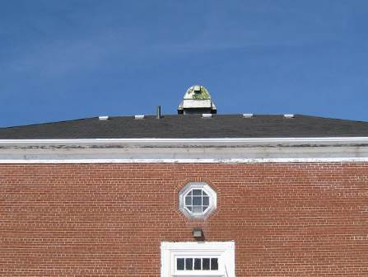

A Hip Roof Without a Peak

Picture 2

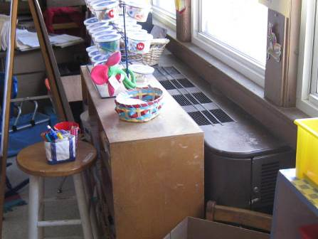

Univent Blocked by Shelf Unit

Picture 3

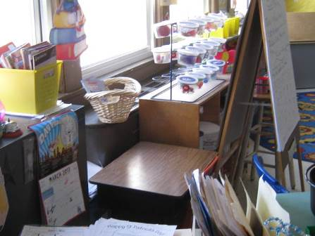

Univent Obstructed by Various Classroom Materials

Picture 4

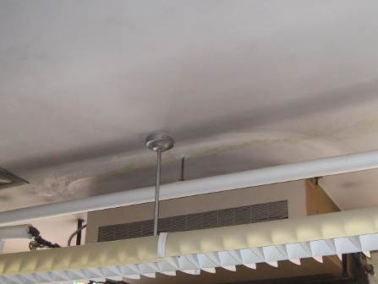

Example of a Ceiling-Mounted Univent in Basement

Picture 5

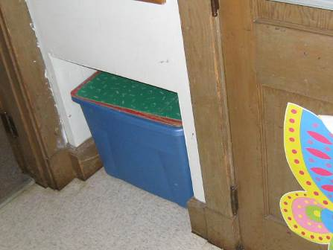

Exhaust Ventilation/Hearth-Like Structure in Classrooms

Picture 6

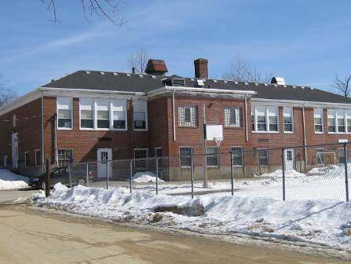

Exhaust Vents on Roof

Picture 7

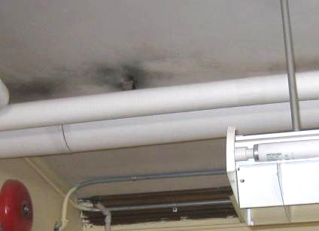

Soot Deposition around Light Fixtures in Library

Picture 8

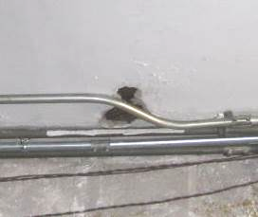

Hole in Furnace Room Wall

Picture 9

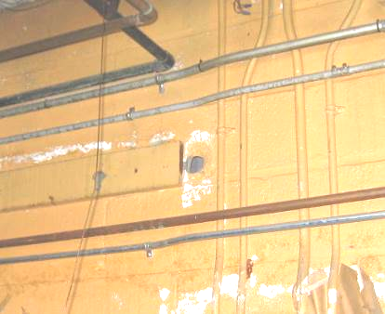

Hole in Furnace Room Wall

Picture 10

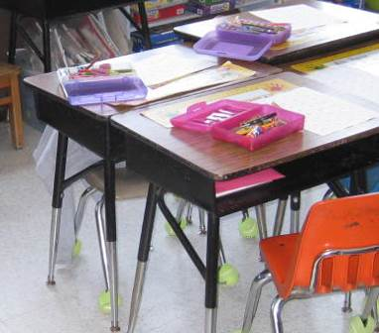

Tennis Balls on Chairs Legs
Location/ Room | Occupants  in Room | Temp  (°F) | Relative  Humidity  (%) | Carbon  Dioxide  (ppm) | Carbon Monoxide  (ppm) | PM2.5  (µg/m3) | Windows  Openable | Ventilation |  | Remarks
 |  |  |  |  |  |  |  | Supply | Exhaust | Remarks
Background (outdoors) |  | 33 | 35 | 389 | ND | 32
B5 | 19 | 70 | 13 | 1341 | ND | 7 | Y | Y | Y | Supply off  Exhaust off  Water damaged ceiling tiles
B6 | 0 | 71 | 8 | 763 | ND | 5 | Y | Y | Y | Supply off  Exhaust off  Water damaged plaster
Cafeteria | 2 | 72 | 11 | 833 | ND | 9 | Y | Y | Y | Supply off  Exhaust off
Reading specialist | 0 | 71 | 13 | 959 | ND | 10 | Y | Y | Y | Supply off  Exhaust off
Staff room | 0 | 72 | 14 | 969 | ND | 7 | Y | Y | Y | Supply off  Exhaust off  Water damaged ceiling tiles
102 | 0 | 71 | 15 | 1389 | ND | 6 | Y | Y | Y | Supply off, blocked  Exhaust off  Water damaged ceiling tiles
103 | 20 | 72 | 15 | 1747 | ND | 7 | Y | Y | Y | Supply off  Exhaust off
104 | 19 | 73 | 14 | 1403 | ND | 8 | Y | Y | Y | Supply off  Exhaust off  Tennis balls
105 | 16 | 73 | 19 | 2104 | ND | 9 | Y | Y | Y | Supply off, blocked  Exhaust off
106 | 0 | 70 | 18 | 1478 | ND | 5 | Y | Y | Y | Supply off  Exhaust off  Water damaged plaster  Tennis balls
107 | 0 | 70 | 23 | 1627 | ND | 5 | Y | Y | Y | Supply off  Exhaust off  Water damaged ceiling tiles

The service life is the median time during which a particular system or component of … [an HVAC]… system remains in its original service application and then is replaced. Replacement may occur for any reason, including, but not limited to, failure, general obsolescence, reduced reliability, excessive maintenance cost, and changed system requirements due to such influences as building characteristics or energy prices (ASHRAE, 1991).

