Mold/Water Damage Investigation

Templeton Center School
17 South Road
Templeton, Massachusetts

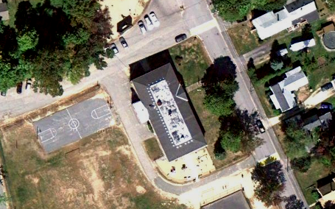

Prepared by:
Massachusetts Department of Public Health
Bureau of Environmental Health
Indoor Air Quality Program
March 2011

Background/Introduction
At the request of Ms. Joyce Crouse, Health Director, Templeton Board of Health (BOH), the Massachusetts Department of Public Health (MDPH) Bureau of Environmental Health’s (BEH) Indoor Air Quality (IAQ) Program conducted an assessment at the Templeton Center School (TCS) located at 17 South Road, Templeton, Massachusetts. On February 25, 2011, the building was visited by Michael Feeney, Director of BEH’s IAQ Program. During the assessment, Mr. Feeney was accompanied by Ms. Crouse and Mr. William Claybaugh, Head of Maintenance, Narragansett Regional School District (NRSD). The request was prompted due to concerns related to a ceiling tile failure due to roof leakage in classroom 107 during school hours.
The TCS is a brick building with wooden roof constructed in 1941. At the time of the visit, repairs to the roof and classroom ceiling were in progress. The NRSD retained the firm of Klienfelder/SEA Consultants to evaluate the roof and make recommendations to repair the ceiling area/framing of classroom 107 (Klienfelder/SEA Consultants, 2011). A number or recommendations were made regarding the repair of the suspended ceiling in room 107 (Appendix A).

Methods and Results
BEH staff performed a visual inspection of building materials for water damage and/or microbial growth in classroom 107 and the attic above this area.

Discussion

Microbial Concerns
Both classroom 107 and the attic above did not appear to have mold colonization at the time of the IAQ Program’s evaluation. Classroom 107 did, however, have some water-damaged ceiling tiles remaining (Picture 1). Water-damaged ceiling tiles can indicate sources of water penetration and provide a source of mold growth. Ceiling tiles should be replaced after a water leak is discovered and repaired. The US Environmental Protection Agency (US EPA) and the American Conference of Governmental Industrial Hygienists (ACGIH) recommends that porous materials (carpeting, ceiling tiles, etc.) be dried with fans and heating within 24 to 48 hours of becoming wet (US EPA, 2001; ACGIH, 1989). If porous materials are not dried within this time frame, mold growth may occur. Water-damaged porous materials cannot be adequately cleaned to remove mold growth. The application of a mildewcide to moldy porous materials is not recommended.
BEH staff examined the ceiling of classroom 107 as well as the attic area above the leak. The school has a hip roof without a peak/ridge, meaning the center of the roof is flat with sloped sides. The area where the roof leak occurred is near a roof valley, in a location that roughly faces northeast (Picture 2). The part of the roof would be highly prone to lingering snow accumulation during nor’easters. The orientation of the building also keeps this location shaded from direct sunlight, which inhibits melting. Therefore, it is highly likely the support structure of the roof would be subjected to prolonged snow loads, resulting in ice dams, chronic moisture, and exposure to roofing materials, all of which can result in roof leaks.
A series of passive air vents that allow warm air to pass into the attic were installed near the center of each sloped roof plane in an effort to prevent ice dams and prevent heated air from accumulating in the roof peaks. A roof venting system is typically designed to have a vent draw air into the attic at the roof’s edge and expel air through a vent in the peak of the roof (e.g., a ridge vent). In its current configuration, heat accumulates in the attic because no ridge vent (or an equivalent) exists in the flat roof. Therefore no means exist for heat to exit the roof, which likely results in ice dam formation on the roof.
The area of the attic beneath the water leak was examined. Of note is the diagonal brace system, which appears to support the roof at the junction where the roof transfers from a flat to sloped plane. Each of these braces are notched and inserted beneath the roof rafter at the flat/slope roof junction (Picture 3). BEH staff observed that the diagonal brace beneath the area of the roof leak is split down the middle (Picture 4) and has shifted out of position where it connects to the floor joist (Picture 5). In this condition, the damaged diagonal beam likely cannot bear the same load as intact beams, which likely allowed the roof to sag under snow load, resulting in leaks.
Another sign of roof movement beneath the leak location is the rotation of a brace connecting the diagonal roof rafters beneath the water leak. One end has rotated to split the end of the brace at its fastener (Picture 6). The condition of each of these braces appears to indicate that load was depressing the roof in this location, which can lead to roof damage and subsequent water leaks.

Conclusions/Recommendations
No visible mold growth was observed in classroom 107 and the attic during the assessment. The following are several recommendations to prevent possible potential/future water penetration.
- Repair roof braces to prevent further damage and roof leaks. Either replacement of the braces or repair by “sistering” the braces should be examined.
- Replace all water-damaged ceiling tiles and wet insulation material.
- The base of the diagonal brace in Picture 6 needs to be re-footed.
- Continue to implement recommendations made in the Klienfelder/SEA Consultants report.

References
ACGIH. 1989. Guidelines for the Assessment of Bioaerosols in the Indoor Environment. American Conference of Governmental Industrial Hygienists, Cincinnati, OH.
Klienfelder/SEA Consultants, 2011. Letter to Massachusetts Interlocal Insurance Association from Wade Brown, Principal Structural Engineer, Klienfelder/SEA Consultants, 2011, Regarding Templeton Center School 17 South Road, Templeton, MA. Recommendations Regarding Ceiling Tile Damage, dated February 15, 2011. Klienfelder/SEA Consultants, Cambridge, MA.
US EPA. 2001. “Mold Remediation in Schools and Commercial Buildings”. Office of Air and Radiation, Indoor Environments Division, Washington, DC. EPA 402-K-01-001. March 2001. Available at: http://www.epa.gov/iaq/molds/mold_remediation.html
Picture 1

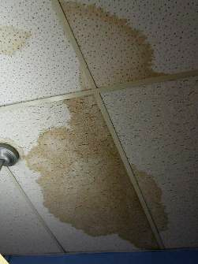

Remaining Water-Damaged Ceiling Tiles in Classroom 107

Picture 2

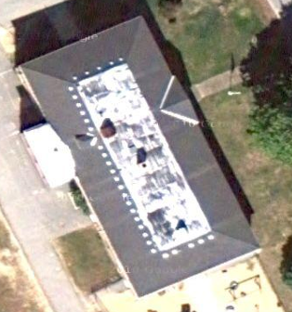

Location of Roof Leak (Arrow)
Picture 3

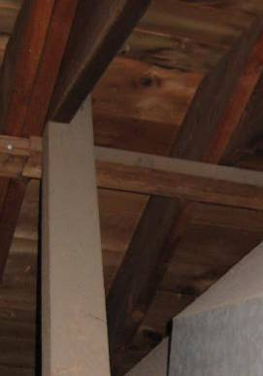

Diagonal Brace, Not Notch at End of Beam (Arrow)

Picture 4

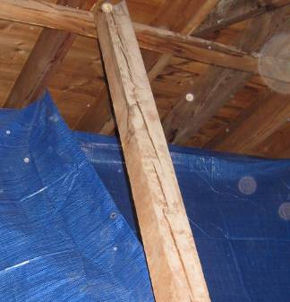

Diagonal Brace Is Split Down the Middle

Picture 5

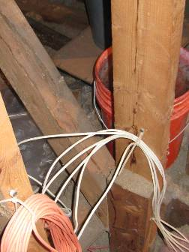

Brace Holding the Base of the Diagonal Brace in Place was Kicked Outward (Arrow)

Picture 6

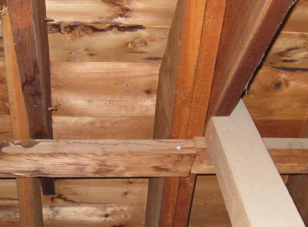

Rotation of a Brace Connecting the Diagonal Roof Rafters beneath the Water Leak (Note Split at the Nail and that the Brace Junction Where the Brace Ends are no Longer Flush. Also Note Water Stains on the Braces and Adjacent Rafter on Left Side of Picture)
