Occupational Health Surveillance Program Massachusetts Department of Public Health
January 1995
No. 1

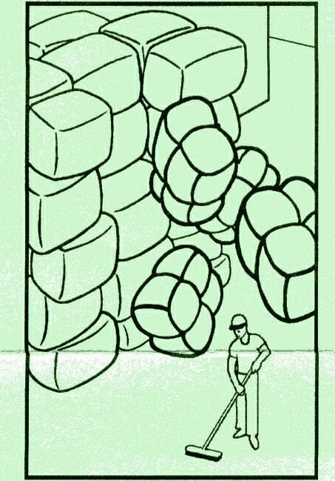
Temporary Worker Fatally Crushed
Paper Bales Topple at Recycling Plant
Background
The victim, an 18-year-old Hispanic male,
and co-worker were hired as temporary' laborers by a cleaning service and assigned to a paper recycling plant.
The company recycled and packaged paper. It had been in business for over four years. Waste paper was collected, separated, bound, and stacked in bales on site. The company had eight to ten regular employees, and routinely contracted the cleaning service to provide a crew of three or four laborers. The company did not employ a designated safety person or have written safety policies or procedures. Neither the company nor the cleaning service provided safety training for the temporary employees.
The Incident
The incident occurred 90 minutes into the victim's first day at the plant. He and two co-workers were alone in the main facility, sweeping in the vicinity of the plant waste-paper conveyor and stacked paper bales. The paper bales were stacked 25 feet deep and 18 feet (seven bales) high along the side of the building.. Without warning, four of the bales of wire-bound waste paper fell 18 feet onto the victim and one of his co-workers. The bales weighed approximately 1,300 pounds and measured approximately four feet by two and a half feet by five feet each.
The victim suffered massive crushing injuries to the upper body and head and was pronounced dead at the scene. The co-worker was airlifted to a regional hospital where he survived the acute trauma.
Caused by Improper Stacking
The bale columns were top-heavy and stacked too high. In addition, they were not interlocked and one side of the columns was not adequately supported.
» Because the forklift could not fully reach the highest row, the top bale of each column overhung the next lower bale by a foot or more.
• Due in part to their irregular size and shape, many of the bales were not stacked in a square or firmly seated position on top of one another.
Recommendations
Employers must adhere to OSHA Standard 29 CFR 1910.176 (b), which requires bundles and other materials stored in tiers to be •stacked, blocked, interlocked, and limited in height so that they
are stable and secure against sliding or collapse.
Employers should further:
• ensure that forklift operators are properly trained in stacking and securing materials to prevent slippage or collapse;
• consider using stanchions with chains to brace stacked materials;
• ensure that contracted cleaning company personnel are fully informed of potential job-site safety hazards.
In addition, temporary agencies and contracting employers¹ should specify in their contracts who is responsible for providing temporary employees with both general and job-specific health and safety training.

