Water Damage Investigation

Tewksbury Hospital
Saunders Building
A-2 Quality Management Department
365 East Street Tewksbury, MA

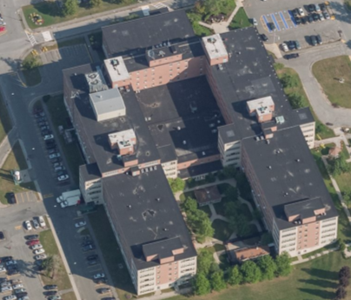

Prepared by:
Massachusetts Department of Public Health
Bureau of Environmental Health
Indoor Air Quality Program
December 2018

Background
Building: | Tewksbury Hospital, Saunders Building- A2 Quality Management Department
Address: | 365 East Street, Tewksbury, MA
Assessment Requested by: | Scott J. Consaul, J.D., CPHQ, CHSP, CSL  Director of Facilities Management
Reason for Request: | General Indoor Air Quality (IAQ) and health concerns following water damage events
Date of Assessment: | November 27, 2018
Massachusetts Department of Public Health/Bureau of Environmental Health (MDPH/BEH) Staff Conducting Assessment: | Jason Dustin, Environmental Analyst, indoor air quality (IAQ) Program
Building Description: | The offices examined are on the 1st floor of a U-shaped, five-story building with a flat rubber membrane roof. It was originally built in the 1960s with additional wings added in the early 1970s.
Windows: | Not openable

Methods
Please refer to the IAQ Manual for methods, sampling procedures, and interpretation of results (MDPH, 2015).

IAQ Testing Results
The following is a summary of indoor air testing results (Table 1).
- Carbon dioxide levels were below the MDPH 800 parts per million (ppm) in all areas surveyed, indicating adequate air exchange.
- Temperature was within the MDPH recommended range of 70°F to 78°F in all areas tested.
- Relative humidity was below the MDPH recommended range of 40 to 60% in the areas tested which is typical during the heating season.
- Carbon monoxide levels were non-detectable (ND) in all areas tested.
- Fine particulate matter (PM2.5) concentrations measured were below the National Ambient Air Quality (NAAQS) limit of 35 μg/m³ in all areas tested.
- Total Volatile Organic Compound (TVOC) levels were ND in all areas surveyed.

Ventilation
A heating, ventilating and air conditioning (HVAC) system has several functions. First it provides heating and, if equipped, cooling. Second, it is a source of fresh air. Finally, an HVAC system will dilute and remove normally-occurring indoor environmental pollutants by not only introducing fresh air, but by filtering the airstream and ejecting stale air to the outdoors via exhaust ventilation. Even if an HVAC system is operating as designed, point sources of respiratory irritation may exist and cause symptoms in sensitive individuals.
Fresh air is supplied by air handling units (AHU) and delivered to supply vents located in the ceilings of rooms. The building uses 100% fresh air so that no air is returned to the AHUs. Stale air is drawn through grates and ejected out of the building through roof-mounted exhaust units.
The MDPH typically recommends that HVAC systems be re-balanced every five years to ensure adequate air systems function (SMACNA, 1994). It is not known when the last time these systems were balanced. Balancing should also occur when the space is significantly rearranged.

Microbial/Moisture Concerns

Facilities personnel reported that there had recently been a sewage backup in this office suite. The sewage reportedly flowed from an area off of room # 253B which appeared to be an old bathroom with abandoned plumbing connections (Picture 1). Internal Environmental Services staff initially responded by extracting the water and maintenance crews removed the carpets from the affected offices (Picture 2). Service Master was later called in to sanitize the entire area. It was reported that Service Master disinfected the remaining common area carpet just outside the affected offices (Picture 3) which was also impacted by the sewage backup. Further cleaning/deodorizing was later performed by Environmental Services. Some occupants expressed concerns regarding the passage of time that occurred since the sewage backup and the sanitizing of the common area carpet, especially under a large file cabinet which was left in place during the initial response (Picture 4).
In general, nonporous surfaces (e.g., concrete, tile) may be effectively cleaned/sanitized. However, porous materials (e.g., gypsum wallboard, carpet, cardboard) that have been in contact with blackwater (sewage) cannot be effectively cleaned/sanitized or dried and must be disposed of properly. Therefore, any areas of carpeting or other porous materials that were impacted by the blackwater should be discarded.
The impacted offices (C253B, C252, & C253) were noted to have a vinyl baseboard/coving (Picture 5). The vinyl coving should be inspected to ensure that it does not have a paper backing which would be porous and susceptible to microbial colonization, and removed/discarded if necessary. It should be noted that BEH staff did not observe any visible signs of microbial colonization nor detect any musty odors at the time of this assessment.

Other IAQ Evaluations

Exposure to low levels of total volatile organic compounds (TVOCs) may produce eye, nose, throat, and/or respiratory irritation in some sensitive individuals. To determine if VOCs were present, BEH/IAQ staff examined rooms for products containing VOCs. BEH/IAQ staff noted cleaners, hand sanitizers, air fresheners and other products in use within the areas. All of these products have the potential to be irritants to the eyes, nose, throat, and respiratory system of sensitive individuals.
The relative humidity readings were below the MDPH recommended comfort range the day of the assessment. The MDPH recommends a comfort range of 40 to 60 percent for indoor air relative humidity. Relative humidity in the building would be expected to drop during the winter months due to heating. The sensation of dryness and irritation is common in a low relative humidity environment. “Extremely low (below 20%) relative humidity may be associated with eye irritation [and]…may affect the mucous membranes of individuals with bronchial constriction, rhinitis, or cold and influenza related symptoms” (Arundel et al., 1986). Low relative humidity is a common problem during the heating season in the northeast part of the United States.
In some areas, stored materials and accumulated items make it more difficult for custodial staff to clean (Picture 6). Items should be stored neatly and moved periodically to allow for wet-wiping and vacuuming of surfaces.

Conclusions/Recommendations
Based on observations at the time of assessment, the following is recommended:

- Continue to follow EPA and industry guidelines concerning methods used to remediate buildings that are impacted by sewage (i.e., blackwater). Some of these guideline links include: https://www.epa.gov/sites/production/files/2015-09/documents/floods.pdf and ANSI/IICRC S500 - Standard and Reference Guide for Professional Water Damage Restoration.
- Remove any water-damaged porous items that were impacted by the blackwater. This would include the carpeting just outside of the impacted offices and under the large file cabinet.
- Inspect vinyl coving to ensure that it does not contain a paper adhesive backing material. If so, remove the coving in all impacted areas and disinfect before replacing with new coping.
- Eliminate/reduce the use of hand sanitizers, air fresheners, harsh or scented cleaning products and dry erase materials in the office since all of these products have the potential to be irritants to the eyes, nose, throat, and respiratory system of sensitive individuals.
- For buildings in New England, periods of low relative humidity during the winter are often unavoidable. Therefore, scrupulous cleaning practices should be adopted to minimize common indoor air contaminants whose irritant effects can be enhanced when the relative humidity is low. To control for dusts, a high efficiency particulate arrestance (HEPA) filter equipped vacuum cleaner in conjunction with wet wiping of all surfaces is recommended. Avoid the use of feather dusters. Drinking water during the day can help ease some symptoms associated with a dry environment (throat and sinus irritations).
- Reduce the amount of items stored on flat surfaces to allow regular cleaning.
- Have the HVAC system balanced every 5 years in accordance with SMACNA recommendations (SMACNA, 1994). Consider a rebalancing when the building layout is changed.
- Refer to resource manual and other related IAQ documents located on the MDPH’s website for further building-wide evaluations and advice on maintaining public buildings. These documents are available at: http://mass.gov/dph/iaq.

References
Arundel et al. 1986. Indirect Health Effects of Relative Humidity on Indoor Environments. Env. Health Perspectives 65:351-361.
MDPH. 2015. Massachusetts Department of Public Health. Indoor Air Quality Manual: Chapters I-III. Available at: http://www.mass.gov/eohhs/gov/departments/dph/programs/environmental-health/exposure-topics/iaq/iaq-manual/.
SMACNA. 1994. HVAC Systems Commissioning Manual. 1st ed. Sheet Metal and Air Conditioning Contractors’ National Association, Inc., Chantilly, VA.

Picture 1
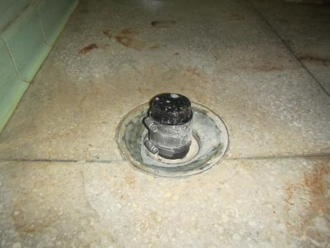
Area of sewage backup origination (off of room #253 B)
Picture 2
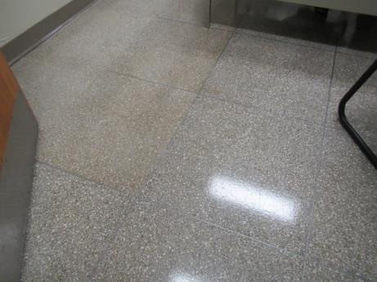
Office area showing carpeting removed and sanitized nonporous tile
Picture 3
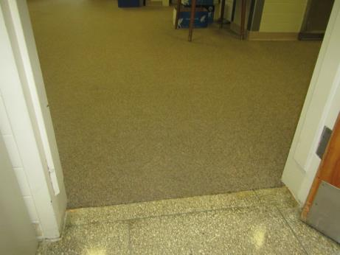
Area of water-damaged carpet outside of impacted offices
Picture 4
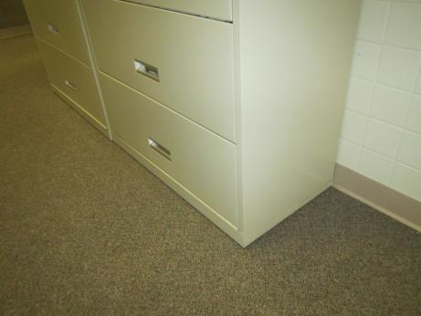
Large file cabinet(s) initially left in place but later disinfected beneath
Picture 5
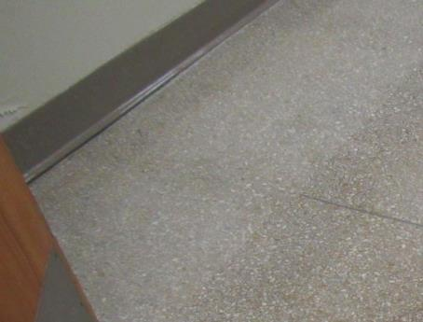
Vinyl coving in impacted office
Picture 6
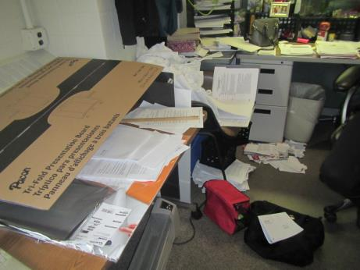
Accumulated items in office area
Location | Carbon  Dioxide  (ppm) | Carbon Monoxide  (ppm) | Temp  (°F) | Relative  Humidity  (%) | PM2.5  (µg/m³) | TVOC  (ppm) | Occupants  in Room | Windows  Openable | Ventilation |  | Remarks
 |  |  |  |  |  |  |  |  | Supply | Exhaust
Background | 391 | ND | 41 | 71 | 9 | ND | - | - | - | -
C253B | 506 | ND | 75 | 30 | 1 | ND | 2 | N | Y | Y | Leak originated off of this room, carpet removed, room sanitized, vinyl coving left in place
C252 | 457 | ND | 76 | 29 | 1 | ND | 0 | N | Y | Y | Carpet removed, room sanitized, vinyl coving left in place
C253 | 542 | ND | 75 | 29 | 3 | ND | 2 | N | Y | N | Carpet removed, room sanitized, vinyl coving left in place
Main office | 497 | ND | 75 | 30 | 2 | ND | 5 | N | Y | Y | Carpet in main area impacted near offices and was cleaned/sanitized
Joanne’s area | 547 | ND | 76 | 29 | 1 | ND | 1 | N | Y | Y | No musty odors or visible mold
UM area | 501 | ND | 77 | 29 | 3 | ND | 3 | N | Y | Y | AF odor, carpet, DEM, AI

