INDOOR AIR QUALITY ASSESSMENT

Centerpoint Program
Tewksbury Hospital
365 East Street
Tewksbury, MA

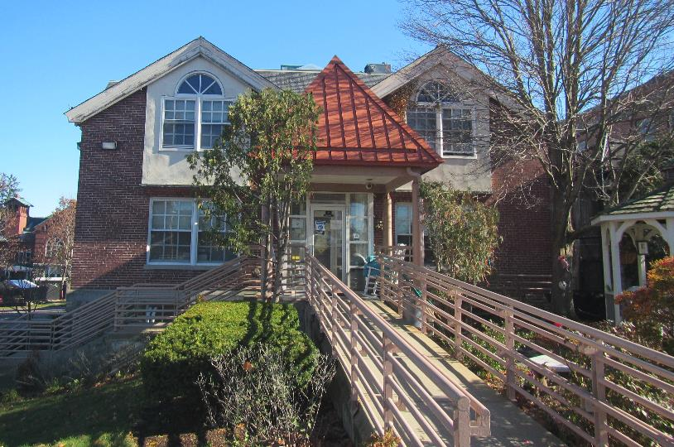

Prepared by:
Massachusetts Department of Public Health
Bureau of Environmental Health
Indoor Air Quality Program
November 2022

BACKGROUND
Building: | Centerpoint Program (CP) at Tewksbury Hospital
Address: | 365 East Street, Tewksbury, MA
Assessment Requested by: | Candy Ingalls, Program Director,  CP
Reason for Request: | Water damage assessment in multiple rooms on the lower level
Date of Assessment: | November 7, 2022
Massachusetts Department of Public Health/Bureau of Environmental Health (MDPH/BEH) Staff Conducting Assessment: | Ruth Alfasso Environmental  Engineer/Inspector, Indoor Air Quality  (IAQ) Program
Building Description: | The CP is located in a three-story fieldstone and brick building located on the campus of Tewksbury Hospital. It was originally constructed in the early 1900s.
Windows: | Openable

METHODS
Please refer to the IAQ Manual for methods, sampling procedures, and interpretation of results (MDPH, 2015). Note that the area examined was previously assessed in September of 2021; that report is available on request.

RESULTS AND DISCUSSION
The following is a summary of indoor air testing results (Table 1):
- Carbon dioxide levels were below the MDPH recommended level of 800 parts per million (ppm) in all areas surveyed.
- Temperature was within the MDPH recommended range of 70°F to 78°F in areas tested.
- Relative humidity was slightly above the MDPH recommended range of 40 to 60% in all areas. This is discussed further below.
- Carbon monoxide levels were non-detectable (ND) in all areas tested.
- Particulate matter (PM2.5) concentrations measured were below the National Ambient Air Quality (NAAQS) level of 35 μg/m³ in all areas tested.

Ventilation
A heating, ventilating, and air conditioning (HVAC) system has several functions. First it provides heating and, if equipped, cooling. Second, it is a source of fresh air. Finally, an HVAC system will dilute and remove normally occurring indoor environmental pollutants by not only introducing fresh air, but by filtering the airstream and ejecting stale air to the outdoors via exhaust ventilation. Even if an HVAC system is operating as designed, point sources of respiratory irritation may exist and cause symptoms in sensitive individuals.
Supply vents are present in the ceiling of most rooms. These are reportedly served by rooftop air handling units (AHU) that supply fresh air and heating/cooling. Ceiling-mounted return or exhaust vents are also present in most of the rooms examined. Exhaust vents in restrooms were checked and there was no flow of air, indicating that they were either shut off or not functioning. Exhaust ventilation is particularly necessary in restrooms to remove odors and moisture; restroom exhaust vents should preferably operate continuously during occupied periods rather than being activated by a switch.
To maximize air exchange, the MDPH recommends that both supply and exhaust ventilation operate continuously during periods of occupancy. In order to have proper ventilation with a mechanical supply and exhaust system, the systems must be balanced to provide an adequate amount of fresh air to the interior of a room while removing stale air from the room. It is recommended that HVAC systems be re-balanced every five years to ensure adequate air systems function (SMACNA, 1994).

Microbial Concerns
The previous visit to the CP was prompted by flooding that occurs through a door from the outside into the main or “multipurpose” room (Picture 1). During heavy rain events, water accumulated at the end of the accessibility ramp to this door. A small drain at the end of this ramp (Picture 2) frequently became clogged or overwhelmed by excessive rain, allowing water to flow under the door and into the room. A small trench drain is present on the interior side of the door, but this reportedly also became overwhelmed by excessive water.
Since the previous visit in 2021, several repairs were made to attempt to mitigate the inflow of water down the access ramp and into the building through the door. These included cleaning the drain at the foot of the ramp and directing some of the water away from the ramp. However, some flooding was reported recently through this door. Note that the flooring near the door is water resistant/non-porous. So long as cleanup is prompt (e.g., with a wet vac or mop) when flooding occurs, no lasting damage should take place to the non-porous flooring near the door. However, it is important to keep porous materials (e.g., cardboard boxes) off the floor/away from this door to prevent water damage. It is recommended that porous material be dried with fans and heating within 24 to 48 hours of becoming wet (US EPA, 2008, ACGIH, 1989).
One of the items recommended during the previous assessment was to assess the sump pump located in the women’s staff restroom and determine if it functioned or could be returned to function. This item is reportedly on a list of work orders to be completed. If this sump pump works, it can help remove water that infiltrates into the building before extensive flooding occurs.
Cleaning, including mopping, occurred in the room during the assessment. This is likely the reason for the high relative humidity in the room. Note that a dehumidifier was operating in the main/multipurpose room. Use of such equipment can help reduce the chances of condensation and help any potentially flood impacted materials to dry. Dehumidifiers need to be emptied and cleaned regularly to avoid odors associated with stagnant water. During the heating season, relative humidity would be expected to drop, and the use of dehumidifiers should be discontinued.
There were numerous missing ceiling tiles in the hallway next to the restrooms, along with a water-damaged ceiling tile (Picture 3). Reportedly, these were moistened by a leak from the plumbing system that has since been repaired, and a work order has been put in to replace the tiles. Additional water-damaged tiles were noted in the adjacent restrooms. Missing ceiling tiles were also noted in closet GC6.
Water was observed dripping from the roof edge near the access ramp (Picture 4). Facility staff reported that there are plans to add an awning, which would direct rainwater away from the ramp. Repair of gutters, or other rainwater roof collection systems, would also assist with this.

Other Conditions
As noted on the previous visit, there are several 3-D printers in this facility. 3-D printers may produce a variety of emissions, depending on brand and use. These may include both volatile organic compounds (VOCs), and fine and ultrafine particles with a variety of chemical compositions. Levels of pollutants produced may exceed health-based limits under some conditions. 3-D printers should be used in areas away from occupants and with good ventilation (UL, 2020).

CONCLUSIONS AND RECOMMENDATIONS
In view of the findings at the time of the visit, the following recommendations are made:

Ventilation Recommendations
- Operate the HVAC system to provide for continuous ventilation during occupied hours.
- Ensure all exhaust vents are drawing air during occupied periods to remove stale air, odors, moisture, and irritants.
- Use openable windows to supplement fresh air during temperate weather where possible. Ensure all windows are closed tightly at the end of each day.
- Ensure filters are replaced on HVAC units at least twice a year. If feasible, use filters with a minimum efficiency rating value (MERV) of 8 or higher to the greatest extent that the equipment can handle.
- Consider adopting a balancing schedule of every 5 years for all mechanical ventilation systems, as recommended by ventilation industrial standards (SMACNA, 1994).

Water Damage Recommendations
- Continue to use dehumidifiers in below-grade areas during high humidity periods and while cleaning up from flooding.
- Empty, clean and maintain all dehumidifiers to reduce stagnant water and the potential for odors.
- All water-damaged material should be removed in a manner consistent with recommendations listed in the US EPA’s “Mold Remediation in Schools and Commercial Buildings” (US EPA, 2008). This work should be performed when the building is unoccupied.
- Continue with methods to avoid flooding via the wheelchair ramp and door to the multipurpose room including:
  - Ensure the outside drain at the base of the ramp is kept free from debris,
  - Assess whether water from elsewhere in the storm system is backing up to this drain during heavy rains, and increase drainage capacity where possible,
  - Ensure that the door sweep on the multipurpose room door is well-fitted and in good condition to discourage water infiltration. Good door sweeps also deter pests.
- Check the condition of the small trench drain in front of the multipurpose room door, and ensure it is functioning.
- If the sump and pump in the women’s restroom is functional, ensure it is working when needed. Clean the sump of debris periodically and keep the lid tightly closed to prevent odors.
- Repair gutters and downspouts to protect the exterior of the building.
- Clean any water penetration promptly.
- Avoid storing any porous items near the door.
- Replace water-damaged ceiling tiles once leaks have been repaired.

Other Recommendations
- Use the 3-D printer during periods when the room is unoccupied to prevent exposure to VOCs and fine particles from operation.
- Reduce clutter in classrooms and offices and ensure items are stored off the floor, and in waterproof containers.
- Clean supply/exhaust vents and personal fans regularly to remove accumulated dust/debris. Replace surrounding ceiling tiles that cannot be adequately cleaned.
- Refer to the resource manual and other related indoor air quality documents located on the MDPH’s website for further building-wide evaluations and advice on maintaining public buildings. These documents are available at http://mass.gov/dph/iaq.

REFERENCES
ACGIH. 1989. Guidelines for the Assessment of Bioaerosols in the Indoor Environment. American Conference of Governmental Industrial Hygienists, Cincinnati, OH.
MDPH. 2015. Massachusetts Department of Public Health. Indoor Air Quality Manual: Chapters I-III. Available at: https://www.mass.gov/lists/indoor-air-quality-manual-and-appendices#indoor-air-quality-manual-
SMACNA. 1994. HVAC Systems Commissioning Manual. 1st ed. Sheet Metal and Air Conditioning Contractors’ National Association, Inc., Chantilly, VA.
UL. 2020. Phase 1 Research on Chemical and Particle Emissions from 3D Printing. Underwriter’s Limited Chemical Insights Program. Marietta, Georgia.
https://chemicalinsights.org//wp-content/uploads/2019/09/3DPrinting_BasicFacts.pdf

US EPA. 2008. “Mold Remediation in Schools and Commercial Buildings”. Office of Air and Radiation, Indoor Environments Division, Washington, DC. EPA 402-K-01-001. September 2008. Available at: http://www.epa.gov/mold/mold-remediation-schools-and-commercial-buildings-guide

Picture 1
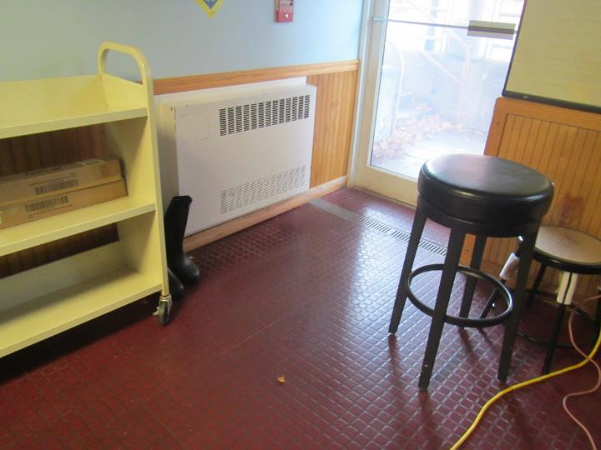
Multipurpose room with door to access ramp and drain
Picture 2
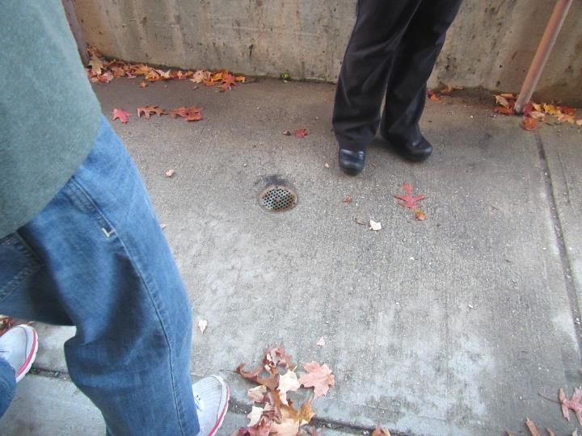
Drain outside door in Picture 1
Picture 3
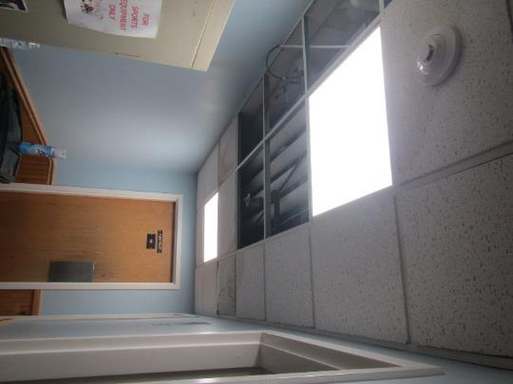
Missing and water-damaged ceiling tiles
Picture 4
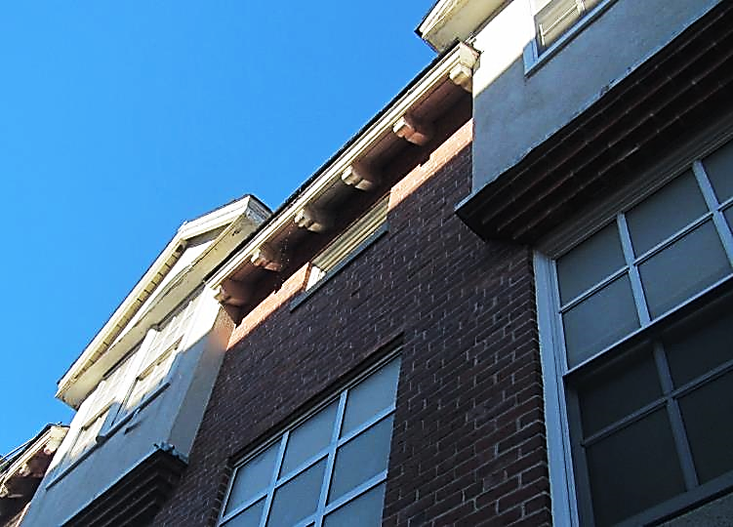
Water dripping from the roof
Location | Carbon Dioxide  (ppm) | Carbon Monoxide (ppm) | Temp  (°F) | Relative  Humidity  (%) | PM2.5  (µg/m³) | Occupants | Window  Openable | Ventilation |  | Remarks
 |  |  |  |  |  |  |  | Supply | Exhaust
Women’s restroom |  |  |  |  |  |  | N | N | Y | Contains sump pump, unknown if operational. Exhaust fan is not on
Men’s Restroom |  |  |  |  |  |  | N | N | Y | Exhaust fan not on, WD CT
Men’s staff restroom |  |  |  |  |  |  | N | N | Y | Exhaust fan not on, gap around cable in wall
Restroom hallway |  |  |  |  |  |  | N | N | N | Many ceiling tiles missing and one WD CT
Main room | 488 | ND | 75 | 61 | 2 | 3 | Y | Y | Y | NC – water resistant flooring. Cleaning taking place, dehumidifier - on
Grass-floor room | 462 | ND | 75 | 62 | 1 | 2 | Y | Y | Y | Artificial grass carpeting
Classroom | 460 | ND | 74 | 63 | 2 | 0 | Y | Y | Y | Wood floor, DEM
Classroom | 454 | ND | 73 | 64 | ND | 0 | Y | Y | Y | Wood floor, DEM
Closet GC6 |  |  |  |  |  |  |  |  |  | Missing CT, stored items
Classroom/  workshop | 444 | ND | 73 | 65 | ND | 1 | Y | Y | Y | 3D printers, DEM, wood floor
Classroom | 438 | ND | 73 | 64 | 2 | 0 | Y | Y | Y | Wood floor

