WATER DAMAGE ASSESSMENT

Centerpoint Program
Tewksbury Hospital
365 East Street
Tewksbury, MA

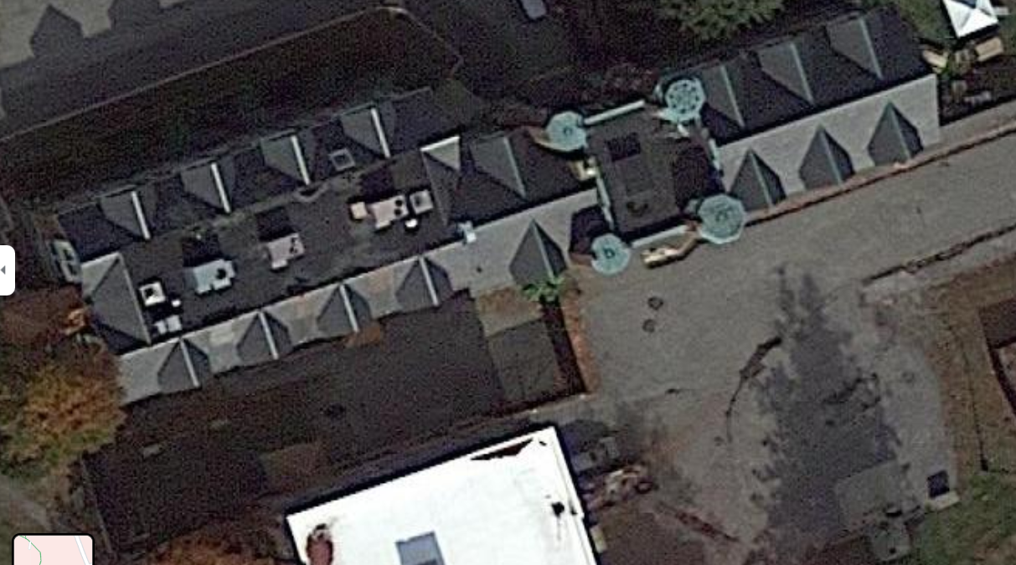

Prepared by:
Massachusetts Department of Public Health
Bureau of Environmental Health
Indoor Air Quality Program
September 2021

BACKGROUND
Building: | Centerpoint Program at Tewksbury Hospital (CP)
Address: | 365 East Street, Tewksbury, MA
Assessment Requested by: | Candy Ingalls, Program Director  Centerpoint Program
Reason for Request: | Water damage assessment in multiple rooms on the lower level
Date of Assessment: | September 16, 2021
Massachusetts Department of Public Health/Bureau of Environmental Health (MDPH/BEH) Staff Conducting Assessment: | Ruth Alfasso Environmental Engineer/Inspector, Indoor Air Quality Program
Building Description: | The CP is located in a three-story fieldstone and brick building located on the campus of Tewksbury Hospital. It was originally constructed in the early 1900s.
Windows: | Openable

METHODS
DPH staff conducted testing for carbon dioxide, carbon monoxide, temperature, and relative humidity with a TSI, Q-Trak, IAQ Monitor 7565. Surface temperature was measured using a laser thermometer. Moisture testing of flooring and other materials was determined using a moisture meter, and a visual assessment of water-damaged materials was also conducted. Air tests for airborne particle matter with a diameter less than 2.5 micrometers were taken with the TSI, DUSTTRAK™ Aerosol Monitor Model 8520. Please refer to the IAQ Manual for methods, sampling procedures, and interpretation of results (MDPH, 2015).

RESULTS AND DISCUSSION
Only a limited area in the lower level was examined during this visit. The following is a summary of indoor air testing results (Table 1):
- Carbon dioxide levels were below the MDPH recommended level of 800 parts per million (ppm) in all areas surveyed.
- Temperature was within the MDPH recommended range of 70°F to 78°F in areas tested.
- Relative humidity was slightly above the MDPH recommended range of 40 to 60% in all areas.
- Floor temperatures were in a range of 71°F to 74°F, less than 5°F colder than the corresponding air temperature.
- Carbon monoxide levels were non-detectable (ND) in all areas tested.
- Particulate matter (PM2.5) concentrations measured were below the National Ambient Air Quality (NAAQS) level of 35 μg/m³ in all areas tested

Ventilation
A heating, ventilating and air conditioning (HVAC) system has several functions. First it provides heating and, if equipped, cooling. Second, it is a source of fresh air. Finally, an HVAC system will dilute and remove normally occurring indoor environmental pollutants by not only introducing fresh air, but by filtering the airstream and ejecting stale air to the outdoors via exhaust ventilation. Even if an HVAC system is operating as designed, point sources of respiratory irritation may exist and cause symptoms in sensitive individuals.
Supply vents are present in the ceiling of most rooms (Picture 1). It was not known at the time of the visit whether these are connected to a fresh air supply system, or if they only supply conditioned, recirculated air. Ceiling-mounted return or exhaust vents are also present in most of the rooms examined.
To maximize air exchange, the MDPH recommends that both supply and exhaust ventilation operate continuously during periods of occupancy. In order to have proper ventilation with a mechanical supply and exhaust system, the systems must be balanced to provide an adequate amount of fresh air to the interior of a room while removing stale air from the room. It is recommended that HVAC systems be re-balanced every five years to ensure adequate air systems function (SMACNA, 1994).

Microbial Concerns
The reason for this visit to the CP was concerns regarding flooding and water damage that occurs periodically in one area of the building. Flooding has been reported through a door from the outside into the “multipurpose” room (Picture 2). During heavy rain events, water accumulates at the end of the accessibility ramp to this door. A small drain at the end of this ramp (Picture 3) frequently becomes clogged or overwhelmed by excessive rain, allowing water to flow under the door and into the room. A small trench drain is present on the interior side of the door, but this reportedly also becomes overwhelmed by excessive water at times. Water up to a few inches deep was reported to occur in the multipurpose room and in the interior offices that abut the other side of the room. Reportedly, when flooding occurs, the water is removed with a shop-vac and the floor is cleaned. No standing water or infiltration was observed at the time of the visit. No visible mold or moldy odors were observed in materials examined.
There is a sump and pump located in the women’s staff restroom which is next to the door to the multipurpose room (Picture 4). This pump should be assessed to determine if it is functional, that it turns on whenever it is needed, and that it pumps water away from the building.
The wall between the multipurpose room and the offices is covered with a layer of wood paneling (Picture 5). While the surface of the wood paneling was measured to be dry, the interior of the wall behind the paneling could not be accessed for examination or testing.
Although most of the flooring in the areas examined is non-porous, one section adjacent to areas impacted by flooding has a turf-like floor covering that appears to be outdoor carpeting. This material is likely to be resistant to microbial growth, but the texture may make it more difficult to clean up after a flooding incident if water reaches this area. Other materials were found on floors in and adjacent to affected areas such as pillows, books, papers, and an area rug (Table 1). Where conditions exist for water infiltration or condensation (including any below-grade room), porous items should be kept off the floor to the greatest extent possible. It is recommended that porous material be dried with fans and heating within 24 to 48 hours of becoming wet (US EPA, 2008, ACGIH, 1989).
The potential also exists for moistening of building materials due to condensation. The key to managing condensation is understanding dew point. When warm, moist air passes over a cooler surface, condensation can form. Condensation is the collection of moisture on a surface at or below the dew point. The dew point is the temperature that air must reach for saturation to occur. If a building material/component has a temperature below the dew point, condensation will accumulate on that material. If this material is porous, such as carpeting, it may become colonized by mold. Measurements of floor temperatures were conducted in many areas and floors were up to 5ºF cooler than the air. This temperature differential likely exists because the floor is uninsulated and in contact with the ground. With significantly higher humidity, condensation could occur on the floor. When air and floor (or other building materials) temperatures differ significantly (>5ºF), condensation may form during humid weather (>70%).
A dehumidifier was operating in the multipurpose room. Use of such equipment can help reduce the chances of condensation and help any potentially flood impacted materials to dry. Dehumidifiers need to be emptied and cleaned regularly to avoid odors associated with stagnant water.
Water-damaged ceiling tiles were observed in one room (Picture 6). These indicate a leak from the plumbing system or building envelope. The conditions leading to the tiles becoming stained should be repaired, and the stained tiles should be removed and replaced.
The exterior of the building was examined outside the areas assessed. Water was observed dripping from a gap in the gutter (Picture 7). Gutters should be repaired so rainwater is directed away from the building. Some plants were also very close to the building where they can prevent drying. These should be removed to at least 5 feet away.

Other Conditions
A 3-D printer was operating in the multi-purpose room at the time of the visit. 3-D printers may produce a variety of emissions, depending on brand and use. These may include both volatile organic compounds (VOCs), and fine and ultrafine particles with a variety of chemical compositions. Levels of pollutants produced may exceed health-based limits under some conditions. 3-D printers should be used in areas away from occupants and with good ventilation (UL, 2020).
Air purifiers were noted in several classrooms. These units need to be maintained in accordance with manufacturer’s instructions, including cleaning and filter changes. Note that these units will be more effective if the filtered airstream is in the breathing zone of the occupants rather than on the floor. No air purifiers that create ozone should be used in occupied spaces as ozone is a respiratory irritant (US EPA, 2003).
Supply and exhaust/return vents were dusty in most of the areas assessed (Picture 1). Dust on vents can become re-aerosolized and lead to irritation. In addition, dust on vents can become moistened due to condensation and be a source of mold growth.

CONCLUSIONS AND RECOMMENDATIONS
In view of the findings at the time of the visit, the following recommendations are made:

Ventilation Recommendations
- Assess whether the HVAC system brings in fresh air. If it does not, consider if future upgrades can be made to supply fresh air through the HVAC system.
- Operate the HVAC system to provide for continuous ventilation during occupied hours.
- Ensure all exhaust vents are drawing air during occupied periods to remove stale air, odors, moisture, and irritants.
- Use openable windows to supplement fresh air during temperate weather where possible. Ensure all windows are closed tightly at the end of each day.
- Change filters in HVAC units at least twice a year. Use MERV 8 or higher filters to the greatest extent that the equipment can handle.
- Consider adopting a balancing schedule of every 5 years for all mechanical ventilation systems, as recommended by ventilation industrial standards (SMACNA, 1994).

Water Damage Recommendations:
- Continue to use dehumidifiers in below-grade areas.
- Empty, clean and maintain all dehumidifiers to reduce stagnant water and the potential for odors.
- If possible, remove wood paneling from the walls of the multipurpose room and check behind for water damage and microbial growth. Remove any wallboard that shows water damage, stains, or musty odors and replace.
- All water-damaged material should be removed in a manner consistent with recommendations listed in the US EPA’s “Mold Remediation in Schools and Commercial Buildings” (US EPA, 2008). This work should be performed when the building is unoccupied.
- Consider methods to avoid flooding via the wheelchair ramp and door to the multipurpose room including:
  - Ensure the drain is free-flowing and not blocked internally by roots or other material,
  - Assess whether water from elsewhere in the storm system is backing up to this drain during heavy rains, and increase drainage capacity where possible,
  - Assess whether drainage can be improved in the area above the ramp, including potentially grading adjacent land away from the building, or installation of another drain,
  - Ensure that the door sweep on the multipurpose room door is well-fitted and in good condition to discourage water infiltration. Good door sweeps also deter pests.
- Check the condition of the small trench drain in front of the multipurpose room door, and ensure it is functioning.
- If the sump and pump in the women’s restroom is functional, ensure it is working when needed. Clean the sump of debris periodically and keep the lid tightly closed to prevent odors.
- Repair gutters and downspouts to protect the exterior of the building.
- Trim any plants within 5 feet of the building exterior, including overhanging trees.
- Replace water-damaged ceiling tiles once leaks have been repaired.

Other Recommendations
- Use the 3-D printer during periods when the room is unoccupied to prevent exposure to VOCs and fine particles from operation.
- Reduce clutter in classrooms and offices and ensure items are stored off the floor, and in waterproof containers.
- Clean supply/exhaust vents and personal fans regularly to remove accumulated dust/debris. Replace surrounding ceiling tiles that cannot be adequately cleaned.
- Refer to the resource manual and other related indoor air quality documents located on the MDPH’s website for further building-wide evaluations and advice on maintaining public buildings. These documents are available at http://mass.gov/dph/iaq.

REFERENCES
ACGIH. 1989. Guidelines for the Assessment of Bioaerosols in the Indoor Environment. American Conference of Governmental Industrial Hygienists, Cincinnati, OH.
MDPH. 2015. Massachusetts Department of Public Health. Indoor Air Quality Manual: Chapters I-III. Available at: https://www.mass.gov/lists/indoor-air-quality-manual-and-appendices#indoor-air-quality-manual-
SMACNA. 1994. HVAC Systems Commissioning Manual. 1st ed. Sheet Metal and Air Conditioning Contractors’ National Association, Inc., Chantilly, VA.
UL. 2020. Phase 1 Research on Chemical and Particle Emissions from 3D Printing. Underwriter’s Limited Chemical Insights Program. Marietta, Georgia.
https://chemicalinsights.org//wp-content/uploads/2019/09/3DPrinting_BasicFacts.pdf

US EPA. 2003. “Ozone Generators that are Sold as Air Cleaners: An Assessment of Effectiveness and Health Consequences”. US Environmental Protection Agency, Office of Air and Radiation, Indoor Environments Division, Washington, D.C. https://www.epa.gov/indoor-air-quality-iaq/ozone-generators-are-sold-air-cleaners
US EPA. 2008. “Mold Remediation in Schools and Commercial Buildings”. Office of Air and Radiation, Indoor Environments Division, Washington, DC. EPA 402-K-01-001. September 2008. Available at: http://www.epa.gov/mold/mold-remediation-schools-and-commercial-buildings-guide

Picture 1

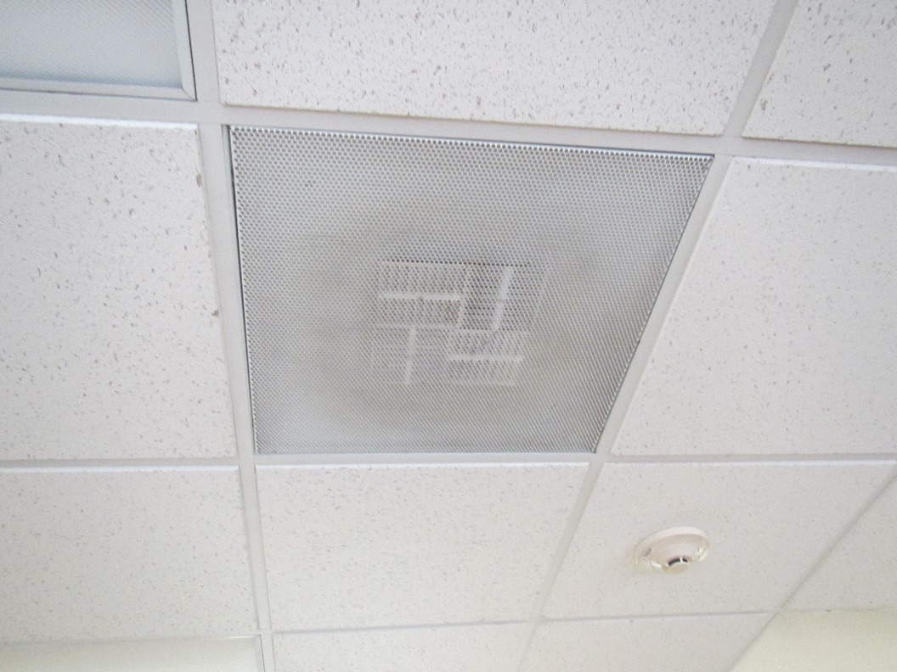

Supply vent in the ceiling, note dust on grill and louvers

Picture 2

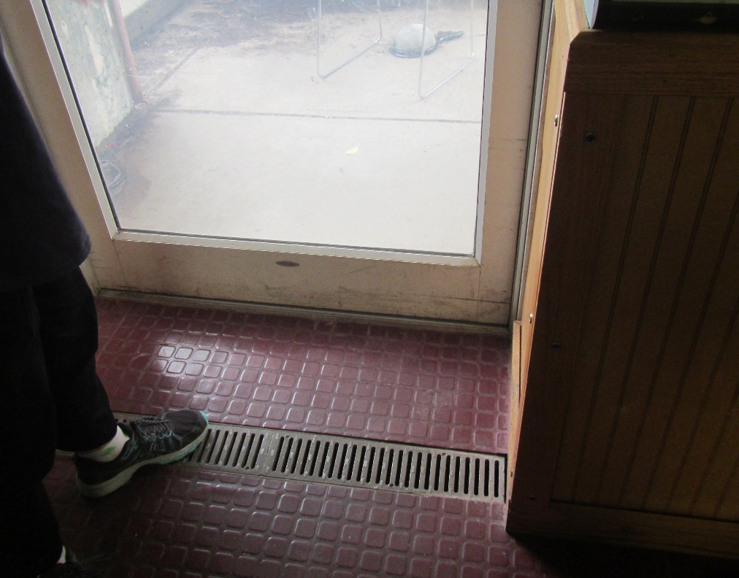

Door to wheelchair ramp from multipurpose room; note trench drain inside
Picture 3

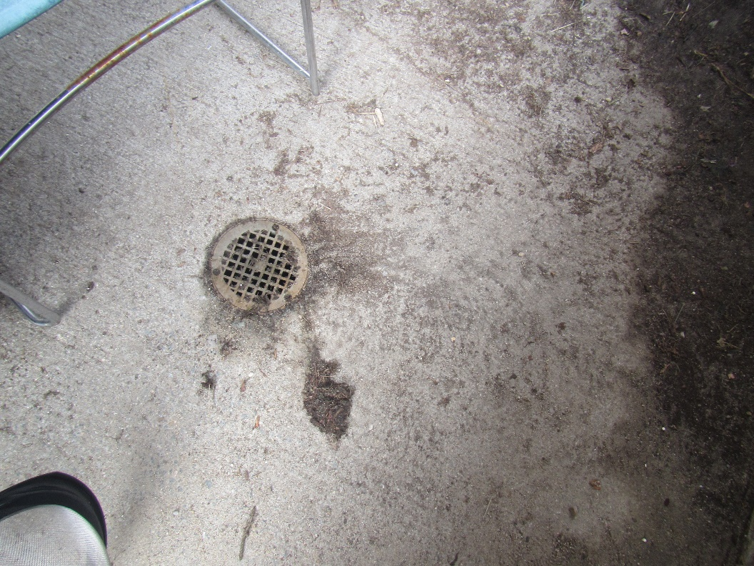

Storm drain at the bottom of the wheelchair ramp outside the multipurpose room

Picture 4

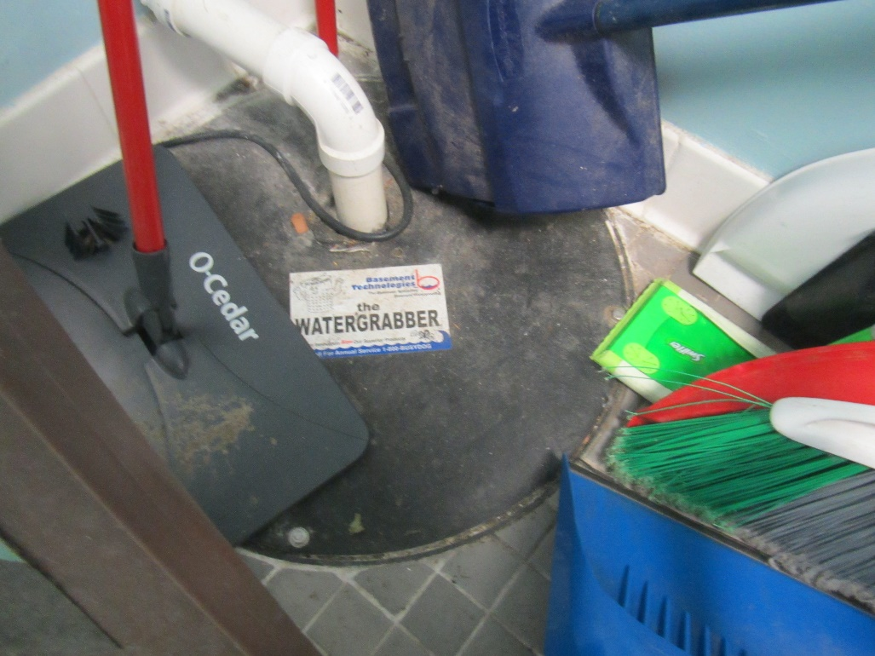

Sump and pump in the women’s staff restroom

Picture 5

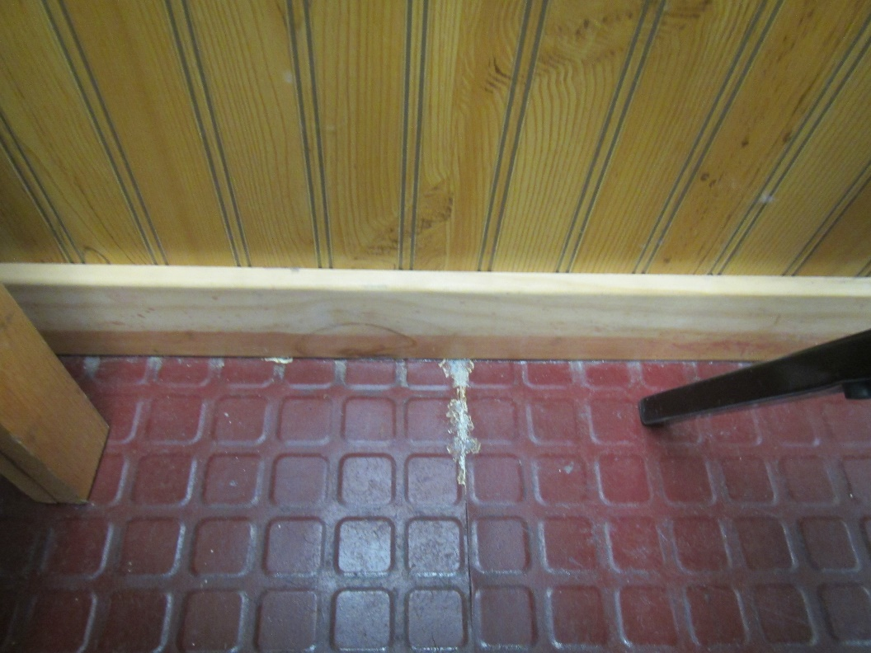

Wood paneling on multipurpose room wall and non-porous flooring

Picture 6
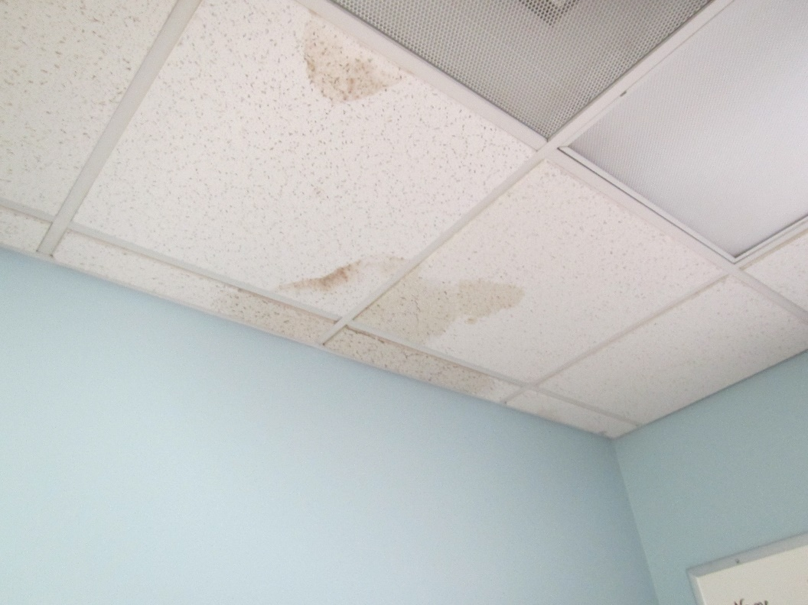

Water-damaged ceiling tiles
Picture 7

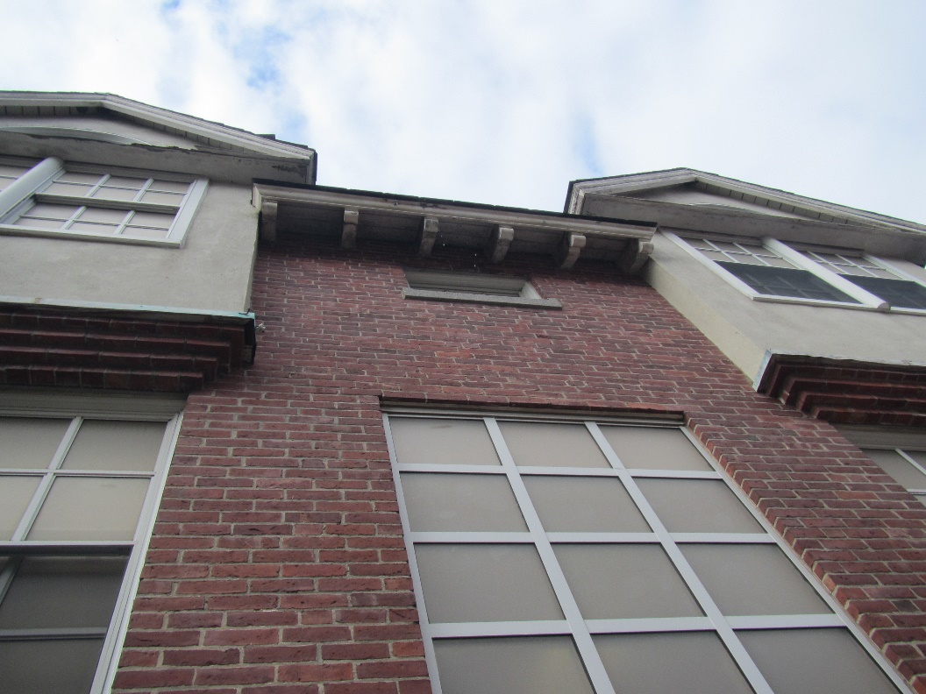

Water dripping from damaged gutter
Location | Carbon Dioxide  (ppm) | Carbon Monoxide (ppm) | Temp  (°F) | Relative  Humidity  (%) | Floor Temp  (°F) | PM2.5  (µg/m³) | Occupants | Window  Openable | Ventilation |  | Remarks
 |  |  |  |  |  |  |  |  | Supply | Exhaust
Background (outside) | 365 | ND | 70 | 71 |  | 7 |  |  |  |  | Overcast with occasional showers
Multipurpose room | 669 | ND | 76 | 63 | 71-72 | 8 | 0 | Y | Y | Y | 3-D printer operating, dehumidifier operating, NC, door with history of leaks, interceptor drain in front of door, wood paneling along interior wall – measured as not wet, defunct fridge and other items
GC4 (office) | 695 | ND | 76 | 64 |  | 9 | 1 | N | Y | Y | NC, pillow on floor
G20 classroom | 698 | ND | 76 | 64 | 73-74 | 9 | 4 | Y 1 open | Y | Y | DEM
GC5 (office) | 691 | ND | 76 | 63 | 73 | 8 | 1 | N | Y | Y | Stored items, area rug on floor in reported area of leak, NC under area rug
GC6 (office) | 723 | ND | 76 | 64 | 73 | 6 | 0 | N | Y | Y | PF, papers/books on floor, DEM
G18 classroom | 680 | ND | 76 | 63 | 71-72 | 7 | 0 | Y | Y | Y | NC
G16 classroom | 615 | ND | 75 | 64 | 73 | 7 | 0 | Y 1 open | Y | Y | DEM, AP
G13 | 617 | ND | 75 | 63 |  | 7 | 0 | Covered in plastic | Y | Y | Water-damaged ceiling tiles, DEM
G12 classroom | 641 | ND | 75 | 63 | 73 | 7 | 0 | Y | Y | Y | DEM, artificial turf flooring (outdoor carpet), plant
Artificial Turf room | 610 | ND | 75 | 63 | 73 | 8 | 1 | Covered in plastic | Y | Y
Female staff restroom |  |  |  |  |  |  |  | N | N | Y on | Sump and pump in corner
Male staff restroom |  |  |  |  |  |  |  | N | N | Y on

