INDOOR AIR QUALITY ASSESSMENT

**Tewksbury Hospital Campus**

**Department of Mental Health**

**Northeast Area Office**

Tewksbury, MA

**July 2024**

Prepared by:

Massachusetts Department of Public Health

Bureau of Climate and Environmental Health

Indoor Air Quality Program

Contents

EXECUTIVE SUMMARY [3](https://massgov-my.sharepoint.com/personal/ruth_alfasso_mass_gov/Documents/Desktop/work%202020/reports%20since%20lockdown/tewksbury-hospital-dmh-admin-july-2024.docx#_Toc172024573)

BACKGROUND 4

RESULTS AND DISCUSSION 5

Ventilation 5

Water Damage and Moisture Concerns 6

Sources of Respiratory Irritants/Possible Asthma Triggers 8

[CONCLUSIONS AND RECOMMENDATIONS 9](https://massgov-my.sharepoint.com/personal/ruth_alfasso_mass_gov/Documents/Desktop/work%202020/reports%20since%20lockdown/tewksbury-hospital-dmh-admin-july-2024.docx#_Toc172024580)

REFERENCES 14

[PICTURES 15](https://massgov-my.sharepoint.com/personal/ruth_alfasso_mass_gov/Documents/Desktop/work%202020/reports%20since%20lockdown/tewksbury-hospital-dmh-admin-july-2024.docx#_Toc172024583)

Table 1 22

Table 2A 24

Table 2B 25

Table 2C 26

Table 3 27

Table 4 29

# EXECUTIVE SUMMARY

The Massachusetts Department of Public Health’s Indoor Air Quality Program (MDPH IAQ) conducted an IAQ assessment of the Department of Mental Health Northeast Area Office located on the Tewksbury Hospital campus on July 10, 2024. This assessment was requested through The Department of Labor Standards (DLS) for a joint inspection with the IAQ Program. Complaints to DLS included mold, water infiltration, poor ventilation, and pests.

The Northeast Area office is located in a building referred to as the “Old Administration Building” on the Tewksbury Hospital Campus. The building was originally constructed in the mid-1800s. It is a red brick building with a slate roof in a complex shape, including a clock tower in a cupola. DMH occupies the second and third floors and the Public Health Museum is on the first floor. Since the third floor was the subject of the DLS complaint, only that floor was visited during this inspection.

This building was originally constructed with no mechanical ventilation components and is dependent on natural cross-ventilation fresh air supply by operable windows. Window air conditioners (WAC) have been installed in most occupied rooms. In addition, most rooms are equipped with operable ceiling fans. The lack of mechanical ventilation makes it difficult to control outside airflow, temperature, and relative humidity, particularly during hot, humid, summer conditions.

The assessment was conducted by evaluating several key elements within the building; a visual inspection of the heating, cooling, and ventilating (HVAC) systems, water/microbial damage, cleanliness, point sources of respiratory irritants such as chemicals. Air measurements of carbon dioxide (CO2), carbon monoxide (CO), temperature, relative humidity (RH), and small particulate matter (PM2.5) were taken using Q-trak XP monitor. Data is collected in this manner to identify potential asthma triggers, allergens, and other environmental factors that can cause indoor air quality symptoms. Please refer to the [Indoor Air Quality Manual](https://www.mass.gov/lists/indoor-air-quality-manual-and-appendices#indoor-air-quality-manual-) on the MDPH website for methods, sampling procedures, and interpretation of results.

As a result of this assessment, there are several findings: without mechanical ventilation, conditions in this building are typical of this age and type. Water damage had occurred in several rooms damaging wallpaper, wall plaster, and other building materials, some of which may be colonized by mold, but no current leaks were found. Other evidence such as peeling paint and efflorescence were observed in several areas throughout the 3rd floor. (Results and Discussion)

(Conclusions)

Based on the results of the assessment, the following primary recommendations are made:

* Use windows and window air conditioners to provide fresh air, using caution to avoid bringing in hot, humid air, or air with elevated particulates.
* Address water-damaged materials, including wallpaper and carpeting by removing and cleaning/replacing the underlying plaster.

(Conclusions and Recommendations)

# BACKGROUND

|  |  |
| --- | --- |
| Building: | Department of Mental Health Northeast Area Office |
| Address: | Tewksbury Hospital Campus, Old Administration Building, 3rd floor, Tewksbury, Massachusetts |
| Assessment Requested by: | Department of Labor Standards |
| Reason for Request: | Various complaints, including mold and general indoor air quality (IAQ) |
| Date of Assessment: | July 10, 2024 |
| Massachusetts Department of Public Health/Bureau of Climate and Environmental Health (MDPH/BCEH) Staff Conducting Assessment: | Ruth Alfasso, Inspector, IAQ Program, accompanied by Len Evers, Inspector, Workplace Safety & Health Program, MA Department of Labor Standards |
| Building Description: | The Old Administration Building is a red brick building with stone foundation and a slate roof in a complex shape including a cupola with bell tower. It was built in the 1800s. |
| Windows: | Windows are openable throughout the building. While some room’s sole window had a WAC installed in it, windows appear to be able to be opened at least a small amount from the top of the frame. |

The following is a summary of indoor air testing results (Table 1)

# RESULTS AND DISCUSSION

|  |  |  |
| --- | --- | --- |
| * ***Carbon dioxide (CO2)*** | *a measure of the adequacy of ventilation* | Levels were below the MDPH guideline of 800 parts per million (ppm) in all of the areas surveyed. |
| * ***Temperature*** | *a measure of comfort* | Was within or close to the MDPH recommended range of 70°F to 78°F in occupied areas. |
| * ***Relative humidity*** | *a measure of comfort and, when in excess for an extended period, a way to reflect the potential for mold and fungal growth* | Was within or slightly above the MDPH recommended range of 40 to 60% in areas tested. This is reflective of outdoor conditions. |
| * ***Carbon monoxide***   ***(CO)*** | *a product of combustion that can result in acute and long term cardiovascular, respiratory, and neurological symptoms* | Levels were non-detectible in all areas assessed. |
| * ***Particulate matter (PM2.5)*** | *a way to measure inhalable particle distribution in the air* | Concentrations were close to and slightly above the National Ambient Air Quality Standard (NAAQS) of 35 micrograms per cubic meter (μg/m3) in all areas tested. All readings were lower than levels outside, which were 43 μg/m3 |

## Ventilation

Ventilation refers to both the supply of fresh air and the removal of stale air from a room. The introduction of fresh air into an occupied space will dilute normally occurring pollutants that are generated by occupancy and other activities. In addition, a heating, ventilation, and air conditioning (HVAC) system will remove pollutants from a building if operating appropriately. As previously mentioned, the occupied areas of the third floor of the Old Administration Building have no means of mechanical ventilation.

The Old Administration Building was originally configured to use *cross-ventilation* to provide comfort for building occupants. The building is equipped with windows on opposing exterior walls. This design allows for airflow to enter an open window (windward side), pass through a room, enter the hallway, pass into the opposing room and exit the building on the leeward side (opposite the windward side). With all windows open, airflow can be maintained in a building regardless of the direction of the wind. This system fails if the windows are closed or disabled, or if doors between rooms and the hallways are closed and lack transfer air vents. In addition, the installation of WACs has limited the ability of cross-ventilation.

The various types of ventilation components *as well as devices that can move/redirect airflow* are listed in Table 2A, Table 2B and Table 2C.

**Additional HVAC Conditions:**

* **Most window-style ACs can supply some amount of fresh air while operating in “Fan Only” or similar mode.**
* **The WACs in the Old Administration Building are of varying ages and conditions. Some units (Picture 1) have a style that suggests they are decades old.** Older units may be less energy efficient, or less effective at cooling air.
* **Window air conditioners have a filter that needs to be cleaned periodically.**
* **Most rooms on the third floor have operable ceiling fans (Table 1).** Ceiling fans are good at mixing air to create a more even temperature and can make occupants feel cooler. However, the drafts they create may become uncomfortable during cooler weather.
* **The building is heated via steam radiators; the steam is generated elsewhere on the Tewksbury Hospital campus.** Occupants had complaints about excess heat in the winter, and difficulty controlling inside temperatures.
* **Radiators in a few rooms had been removed, possibly due to malfunction or leaks.** Rooms without radiators would not have a source of heat in the winter.
* **The restroom on the third floor has a window that opens into the stairwell rather than outside.** A small exhaust fan has been placed in this window that is activated when the light switch is turned on (Pictures 2 and 3). This fan exhausts odors and moisture from the restroom but ejects them into the stairwell.

## Water Damage and Moisture Concerns

Please note that the IAQ Program does not recommend conducting mold testing in a typical water damage remediation. For details, please consult [Guidance Regarding Testing for Mold in Water-Damaged Public Buildings](https://www.mass.gov/info-details/guidance-regarding-testing-for-mold-in-water-damaged-public-buildings) | Mass.gov

The application of a mildewcide to moldy porous materials is not recommended.

Molds are found naturally in our environment both indoors and outdoors. Inside, mold growth may occur when items, particularly porous products such as paper or gypsum wallboard, are exposed to moisture. Typical water sources include leaks, floods, and condensation. To avoid mold growth, dry all water-damaged items and affected areas within 24-48 hours and reduce indoor humidity. Some people with chronic respiratory conditions, such as asthma, are more likely to experience health symptoms associated with molds, including allergic reactions and respiratory irritation. Controlling moisture is the key to preventing mold growth and potential health symptoms.

Hot humid summers are becoming more frequent due to climate change. Massachusetts has experienced hot, humid, and rainy summers in 2018, 2021, and 2023. July of 2021 was the wettest ever recorded in Massachusetts, and the three-month period from June through August, known as the meteorological summer, was the fourth wettest on record, according to the National Oceanic and Atmospheric Administration’s (NOAA) Centers for Environmental Information (NOAA, 2021). The summer of 2023 was also hot, and wet, being measured as the second rainiest on record (WBUR, 2023). These conditions are challenging for buildings, particularly those without central air conditioning.

During these hot and wet summers, extended periods of outdoor relative humidity above 70% occurred. Under these weather periods, public buildings experienced extended periods of water vapor exposure from high relative humidity. When exposed to these conditions, porous materials such as gypsum wallboard, cardboard, and other materials may become prone to mold colonization.

### Water Damage Issues

(see Water Damage and Moisture Concern Pictures)

* **Water-damaged wallpaper and walls were noted in several offices (Pictures 4 through 6; Table 1).** Occupants reported that they did not know when the water infiltration occurred to moisten wallpaper and believed it may have happened while the office was unoccupied during the COVID lockdowns. Some of this wallpaper appears to be colonized with mold.
* **Other building materials also appear to have been moistened, including pipe wrap (Picture 7) and carpeting (Table 1).** None of these water-damaged items were wet at the time of the visit.
* **A water cooler was noted directly on carpeting (Picture 8).** Water coolers and full containers should be placed on waterproof mats or surfaces to prevent chronic moisture that can lead to mold growth.
* **Plants were noted in several areas (Table 1).** Plants can be a source of pollen or mold especially if overwatered or not well maintained.
* **Humidity control in a building without central air conditioning is difficult during hot, humid summer weather.** Use of window air conditioning can provide dehumidification, but care should be taken to avoid introducing too much hot, humid air into rooms where the air conditioning may be cooling surfaces, as this may lead to condensation and water damage. Windows should be closed in rooms with air conditioning operating, and room doors should be closed when some rooms have air conditioning operating and others are using open windows.

Several other conditions on the outside of the building were identified that can contribute to water infiltration issues, which are specified in Table 3 and are listed below.

**Mold Growth**

Porous materials (e.g., gypsum wallboard, ceiling tiles and carpeting) can be dried with fans and heating within 24 to 48 hours of becoming wet (US EPA, 2008).

If porous materials are not dried within this time frame, mold growth may occur.

* **Gutters were noted to discharge close to the building (Picture 9).** This can allow water to impact the foundation and potentially infiltrate the building.
* **Ivy was climbing in some areas on the building (Picture 10), and other plants were close to the exterior (Pictures 9 and 10).** Plants and ivy can hold moisture against the building, climbing plants can damage brick and mortar, and plants next to the building can provide transportation and harborage for pests.
* **The complex shape of the building can catch water from heavy rain, especially at roof segment joins, or lips such as those beneath many of the building’s windows.** Areas of efflorescence were observed (Picture 11) which indicate places where water chronically infiltrates, dissolves part of brick and mortar, and then evaporates.

## 

## Sources of Respiratory Irritants/Possible Asthma Triggers

Asthma is a lung disease that can make breathing difficult. Without careful management of asthma, some people can have symptoms, like a tight feeling in the chest, shortness of breath, coughing, or wheezing. Although there is no cure for asthma, people with asthma can live healthy, active lives. A safe and healthy environment helps to reduce asthma symptoms.

Possible asthma triggers and/or airborne pollutants exist in the building. These are listed below as well as in (Table 4).

(see Sources of Respiratory Irritant Pictures)

* **Particulate matter or respirable dust, as measured by PM2.5, was elevated outdoors on the day of the assessment as shown by the background level (Table 1).** Outdoor PM can originate from local sources, such as traffic and the use of gas-powered construction or landscaping equipment. PM can also be elevated due to more widespread outdoor air trends. Without mechanical ventilation and the filtration it can provide, outdoor PM can be brought inside. When high PM is in the forecast, occupants can take steps to improve IAQ which may include closing windows, turning WACs to the *recirculate* mode if available, and using high-efficiency particulate air (HEPA) filters to remove respirable dusts from the air.
* **An air purifier was noted in a hallway (Picture 12).** HEPA-filtered units are good choices for use in occupied areas. Air purifiers that may produce ozone should not be used (EPA, 2003). This unit appears to use UV light along with a HEPA filter. It was also found to be listed on the California Air Resources Board’s (CARB) website on air cleaners, which lists those which meet CARB’s certification criteria for safety (CARB, 2024). All air purifiers should be cleaned and maintained in accordance with manufacturer’s instructions. The unit shown was unplugged at the time of the visit.
* **Indoor dust is another common respiratory and eye irritant**. It can collect on surfaces and items. Although janitorial staff perform routine cleaning, they may not be able to clean as effectively if items are not picked up or surfaces are cluttered.
* **Occupants reported issues with mice on the third floor, and a pest trap was noted in one office (Table 1, Picture 13).** Mouse wastes can cause allergic reactions in sensitive individuals and they can lead to sensitization where people become allergic after repeated exposures. Facility staff should use the principles of Integrated Pest Management (IPM) to exclude and remove rodents from the building. However, mice are difficult to exclude from older buildings surrounded by grass. Any sources of food, or harborage should be eliminated inside to the greatest extent possible.
* **Most areas on the third floor are carpeted.** Carpets should be vacuumed regularly with a high efficiency particulate arrestance (HEPA) filter equipped vacuum cleaner and cleaned annually (or semi-annually in soiled/high traffic areas) in accordance with Institute of Inspection, Cleaning and Restoration Certification (IICRC) recommendations (IICRC, 2012).
* **Ceiling fans, stand fans, and personal fans can accumulate dust that can be aerosolized when they are used.** and be a source of eye and respiratory irritation.

# CONCLUSIONS AND RECOMMENDATIONS

|  |  |  |
| --- | --- | --- |
| **Short-term Recommendations** | | |
| **HVAC System** | | |
|  |  | **Helpful links** |
|  | For air circulation (and limited fresh air introduction) window-mounted ACs can be operated in the “Fan Only” mode. |  |
|  | Clean filters in AC units prior to and as needed during the cooling season. |  |
|  | During filter cleaning examine cooling fins for dust/debris and clean/vacuum as needed to ensure efficient operation and to prevent mold growth and associated odors. |  |
|  | Window air conditioners have a limited lifespan, depending on how well they are made and how they are maintained and stored. Replace WACs that no longer sufficiently cool the room with units that are properly sized for the location. |  |
|  | Use openable windows for additional fresh air during temperate weather. Close windows tightly during wet weather and at the end of each day |  |
|  | Use these guidelines to control moisture and increase comfort without central air conditioning especially during heatwaves. | • Mold Growth Prevention During Hot, Humid Weather <https://www.mass.gov/service-details/preventing-mold-growth-in-massachusetts-schools-during-hot-humid-weather>  • Remediation and Prevention of Mold Growth and Water Damage in Public Schools <https://www.mass.gov/service-details/remediation-and-prevention-of-mold-growth-and-water-damage-in-public-schools-and>  • Methods for Increasing Comfort in Non-air-conditioned Schools <https://www.mass.gov/doc/methods-for-increasing-comfort-in-non-air-conditioned-schools/download> |
|  | Use ceiling fans and other fans as needed to mix room air and provide a breeze. Ensure they are kept clean so they do not recirculate dust. |  |
|  | Where some offices are using air conditioning, and some using open windows, ensure office doors are closed to keep hot, humid air away from surfaces chilled by air conditioning, as this can lead to condensation. |  |
|  | Ensure steam radiators are repaired as needed to prevent leaks and lack of heating. If rooms without radiators are too cold to be used, consider replacing the radiators. |  |
|  | Because radiators do not provide fine control of heat, open windows may be used during the winter to avoid overheating. |  |
|  | Consider replacing the exhaust fan in the restroom with one that is ducted to the outside; ensure fan capacity is large enough to overcome resistance in the length of duct to be used. Restroom exhaust fans work better when they are on continuously rather than switch-operated. |  |
| **Water Damage Sources** | | |
|  | Remove water-damaged wallpaper and clean/repair any underlying wall material. Use the US EPA guidelines Mold Remediation in Schools and Commercial Buildings to remove potentially moldy materials safely. | <https://www.epa.gov/mold/mold-remediation-schools-and-commercial-buildings-guide-chapter-1> |
|  | Remove or clean other water-damaged materials including pipe wrap and carpeting. Porous materials that may be moldy will not be able to be cleaned and need to be removed. |  |
|  | Consider removing carpeting around radiators and replace with non-porous flooring to prevent leaks from leading to odors and mold growth. |  |
|  | Place water coolers on waterproof mats or relocate to area with non-porous flooring material. |  |
|  | Keep all indoor plants in good condition with non-porous drip pans and do not overwater. Properly maintain plants to avoid mold and odors. |  |
|  | Seal around window and wall-mounted air conditioners tightly with a material that will not support mold growth. |  |
|  | Ensure gutters can drain water away from the building. |  |
|  | Remove trees and plants from away from exterior walls to allow for better drying of building materials and prevent pollen and odors from being drawn into the building. |  |
|  | Ensure that any joints in the roof or building envelope are intact, including appropriate flashing to drain water from the building. |  |
| **Respiratory Irritants/Possible Asthma Triggers** | | |
|  | Use available outdoor air quality data and forecasting to determine when to take measures to minimize indoor particulate matter. When PM is or is forecasted to be elevated, steps can include closing windows, turning WACs to recirculate if available, and using HEPA-equipped air filters. The same measures can be taken when local activities such as construction or landscaping are operating nearby. | <https://www.airnow.gov/> |
|  | Report any pest/rodent sightings to building management. Ensure all food is kept in tightly sealed pest-proof containers and that crumbs and spills in and around cooking equipment are cleaned promptly. | <https://www.mass.gov/doc/integrated-pest-management-ipm-toolkit/download>  <https://massnrc.org/ipm/docs/ipmkitforbuildingmanagers.pdf> |
|  | To control for dusts, a high efficiency particulate arrestance (HEPA) filter equipped vacuum cleaner in conjunction with wet wiping of all surfaces is recommended. Particular attention should be made around radiators, windows, and ACs in office areas to remove accumulated cobwebs, dust and debris. Avoid the use of feather dusters. |  |
|  | Clean/change filters and maintain portable air purifiers/HEPA units in accordance with manufacturers’ recommendations. Avoid the use of air purifiers that may product ozone. | <https://www.epa.gov/indoor-air-quality-iaq/ozone-generators-are-sold-air-cleaners>  <https://ww2.arb.ca.gov/list-carb-certified-air-cleaning-devices> |
|  | Clean ceiling fans and portable fans regularly to remove accumulated dust/debris. |  |
| **Other Recommendations to Improve Air Quality Conditions** | | |
|  | Refer to the resource manual and other related indoor air quality documents located on the MDPH’s website for further building-wide evaluations and advice on maintaining public buildings. | <http://mass.gov/dph/iaq> |
|  | Since this evaluation only focused on the third floor where the DLS complaints were made, the IAQ program would be happy to assess the rest of the building on request. |  |
| **Long-term Recommendations** | | |
|  | Consider having an HVAC engineering assessment of the building to determine the feasibility of adding mechanical ventilation and cooling. | |

# REFERENCES

CARB. 2024. California Air Resources Board List of CARB-Certified Air Cleaning Devices. <https://ww2.arb.ca.gov/list-carb-certified-air-cleaning-devices>

IICRC. 2012. Institute of Inspection, Cleaning and Restoration Certification. Carpet Cleaning: FAQ.

MDPH. 2015. Massachusetts Department of Public Health. Indoor Air Quality Manual: Chapters I-III. Available at: [Indoor Air Quality Manual](https://www.mass.gov/lists/indoor-air-quality-manual-and-appendices#indoor-air-quality-manual-).

NOAA. 2021. Summer 2021 neck and neck with Dust Bowl summer for hottest on record. National Oceanic and Atmospheric Administration, 1401 Constitution Avenue NW, Room 5128, Washington, DC 20230 <https://www.noaa.gov/news/summer-2021-neck-and-neck-with-dust-bowl-summer-for-hottest-on-record>

US EPA. 2003. “Ozone Generators that are Sold as Air Cleaners: An Assessment of Effectiveness and Health Consequences”. United States Environmental Protection Agency, Office of Air and Radiation, Indoor Environments Division, Washington, DC. Last updated September, 2018. <https://www.epa.gov/indoor-air-quality-iaq/ozone-generators-are-sold-air-cleaners>.

US EPA. 2008. Mold Remediation in Schools and Commercial Buildings. US Environmental Protection Agency, Office of Air and Radiation, Indoor Environments Division, Washington, D.C. EPA 402-K-01-001. <http://www.epa.gov/mold/mold-remediation-schools-and-commercial-buildings-guide>.

WBUR. 2023. “It's been a summer of rain and flooding misery in Mass.” WBUR local news. September 12, 2023. <https://www.wbur.org/news/2023/09/12/summer-flooding-rain-massachusetts>.

# 

# PICTURES

(Click to link back to report)

HVAC pictures

**Picture 1**

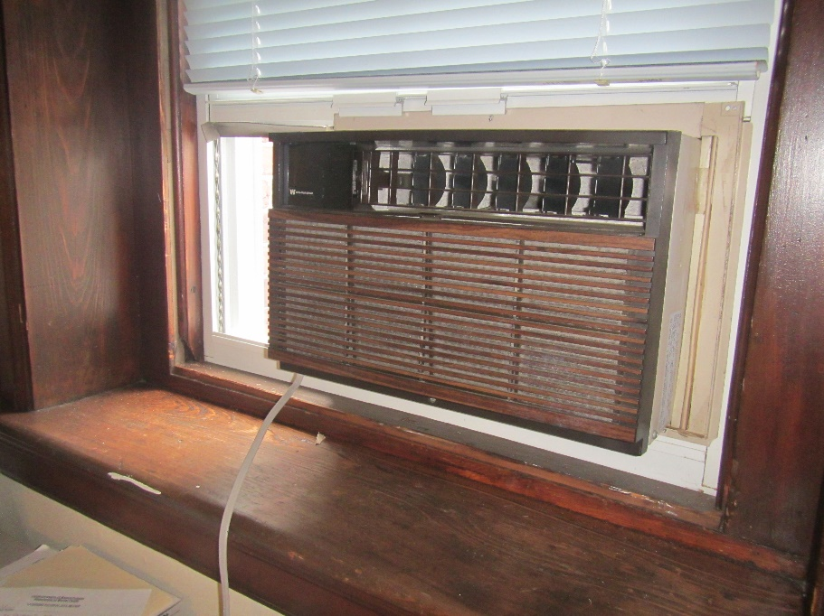

**Window air conditioner; the design of this unit suggests it is decades old**

**Picture 2**

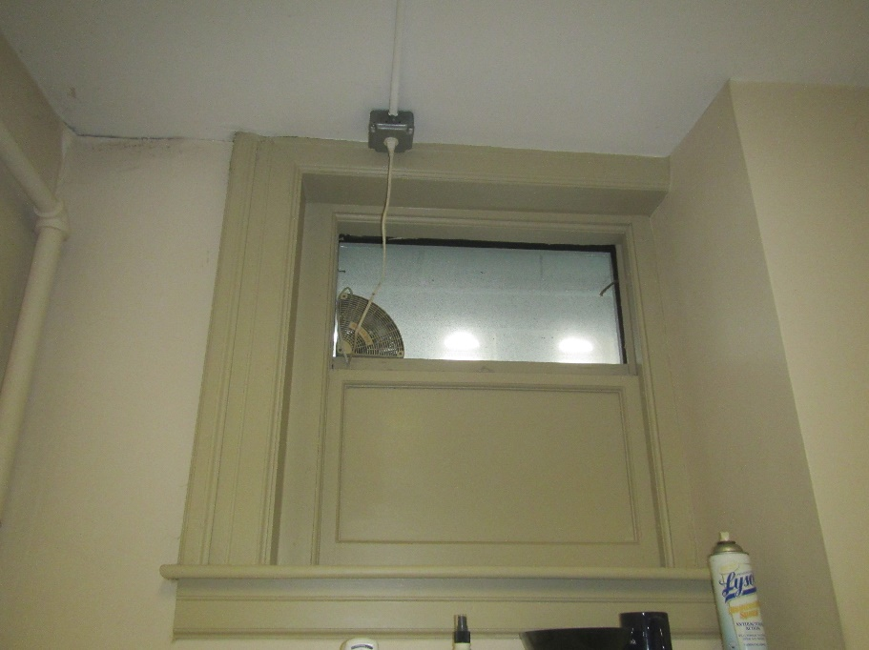

**Small exhaust vent in restroom window which overlooks the stairwell**

**Picture 3**

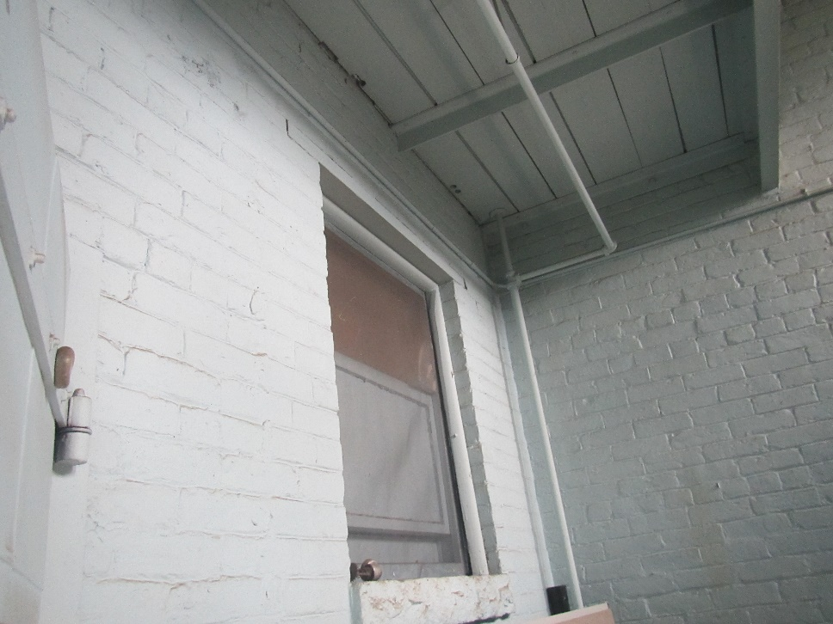

**Stairwell side of restroom window, arrow is vent shown in Picture 2**

Water Damage and Moisture Concern Pictures

**(click to link back to report)**

**Picture 4**

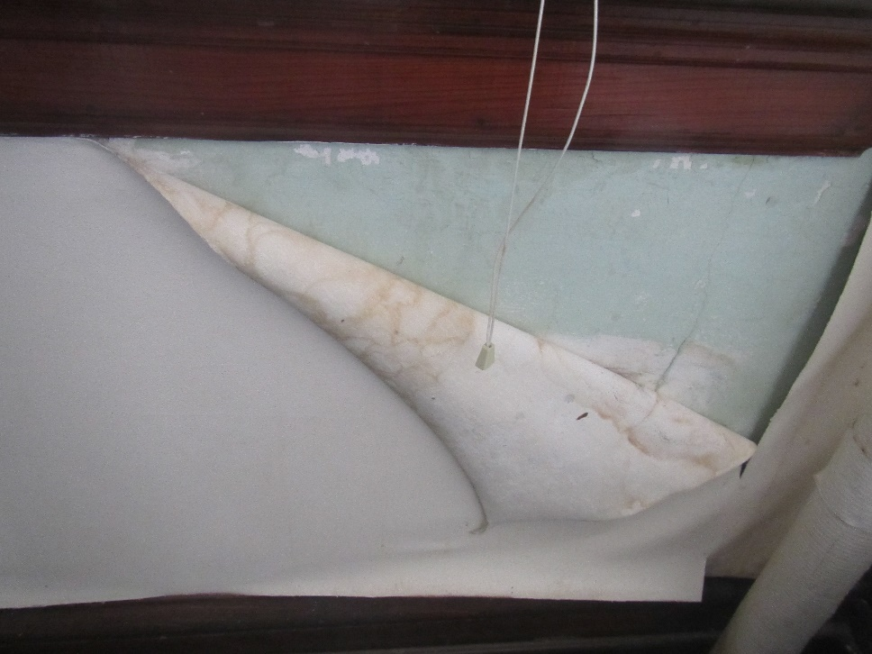

**Water-damaged, peeling wallpaper**

**Picture 5**

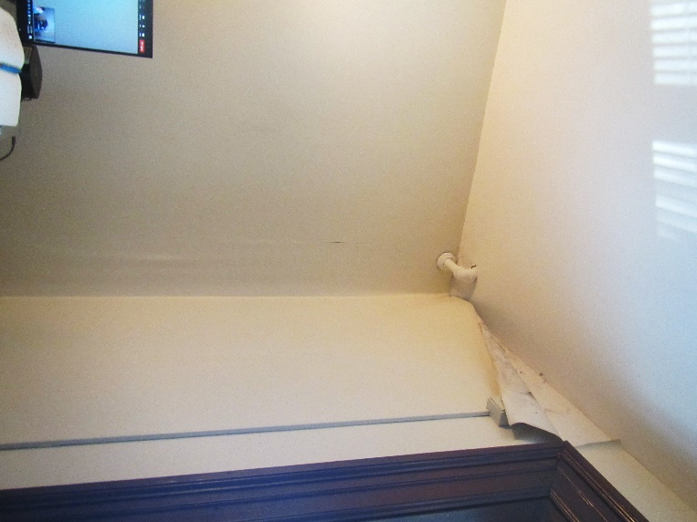

**Water damage to walls and peeling wallpaper; dark staining may be mold growth**

**Picture 6**

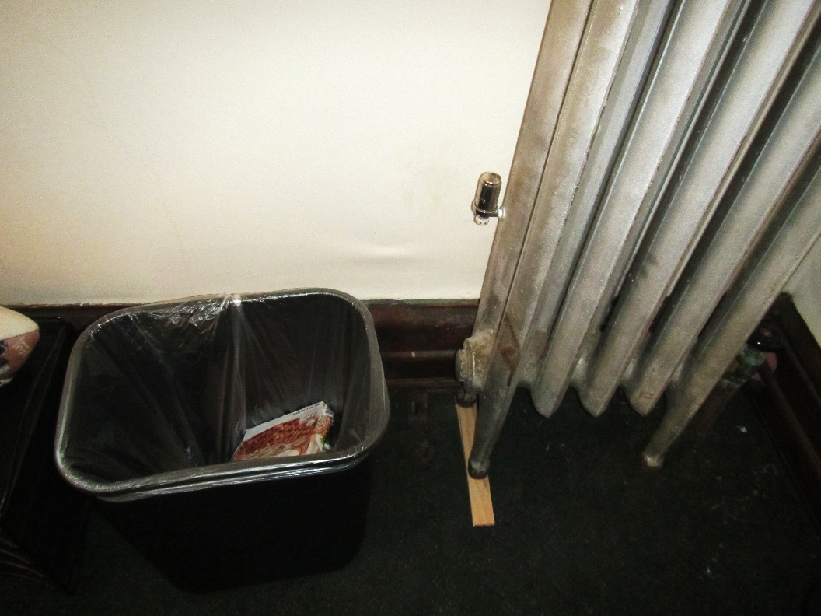

**Water-damaged wall next to radiator**

**Picture 7**

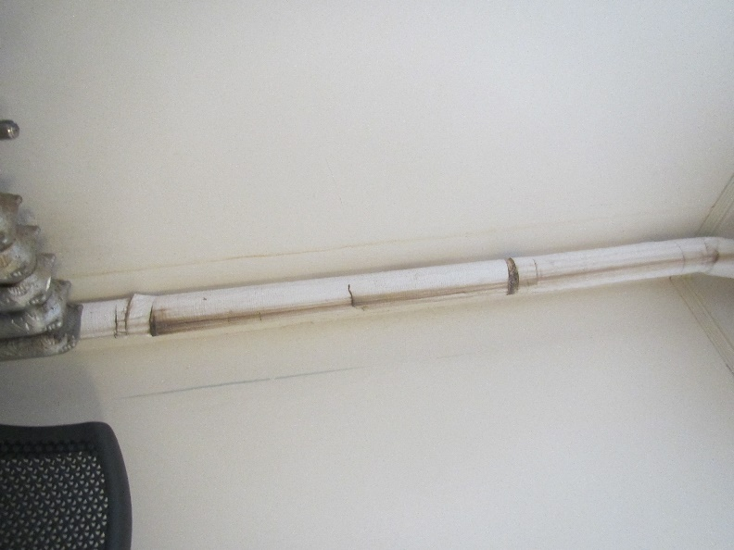

**Water-damaged pipe wrap and walls**

**Picture 8**

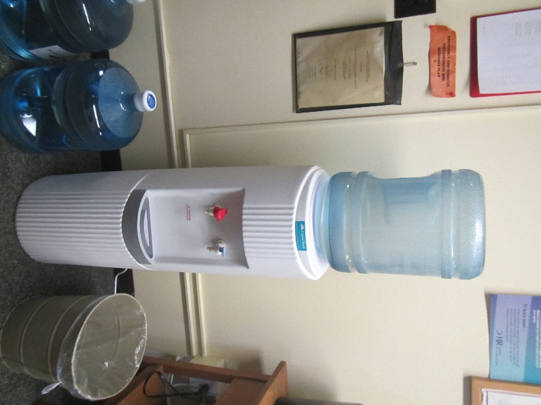

**Water cooler and bottles on carpeting**

**Picture 9**

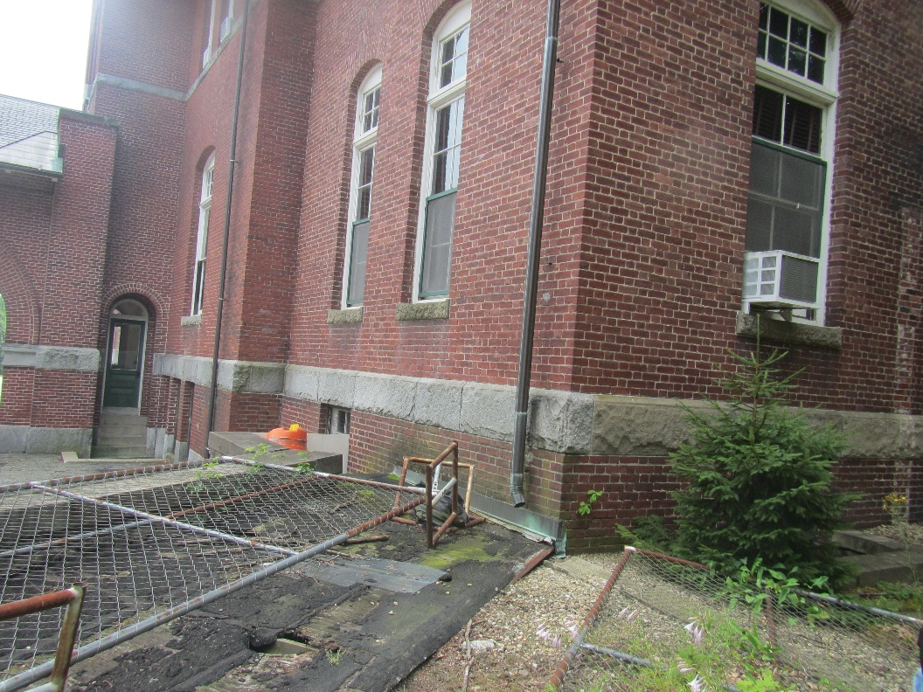

**Gutter ending just above ground next to the building and plants adjacent to foundation**

**Picture 10**

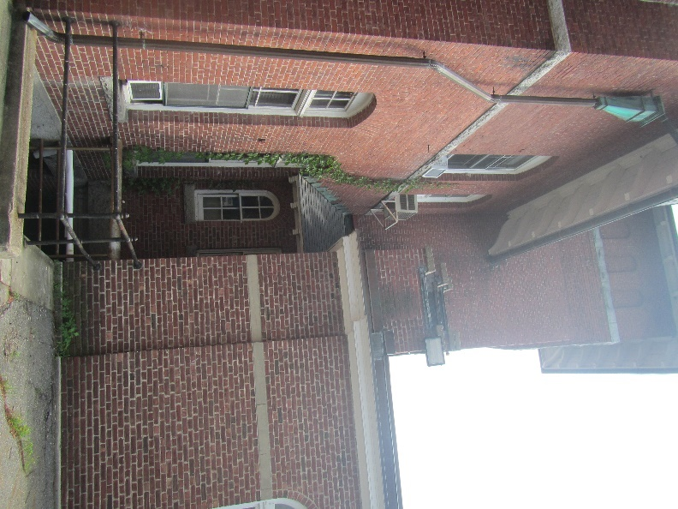

**Ivy hanging on building; note complex building shape with many joints**

**Picture 11**

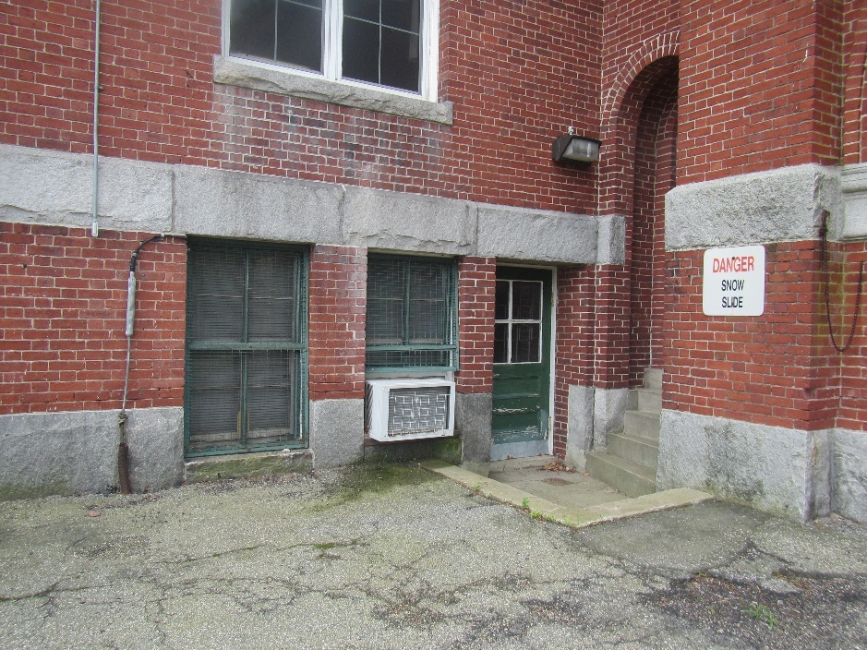

**White powdery deposits under window (efflorescence)**

Sources of Respiratory Irritant Pictures

(Click to link back to report)

Picture 12

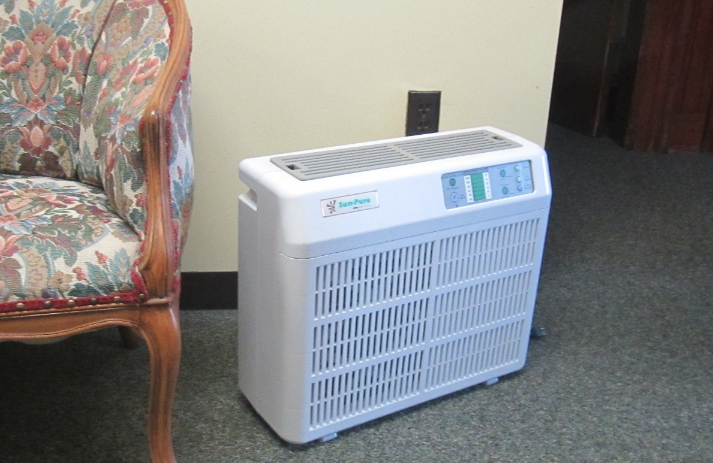

**Air purifier in the hallway**

**Picture 13**

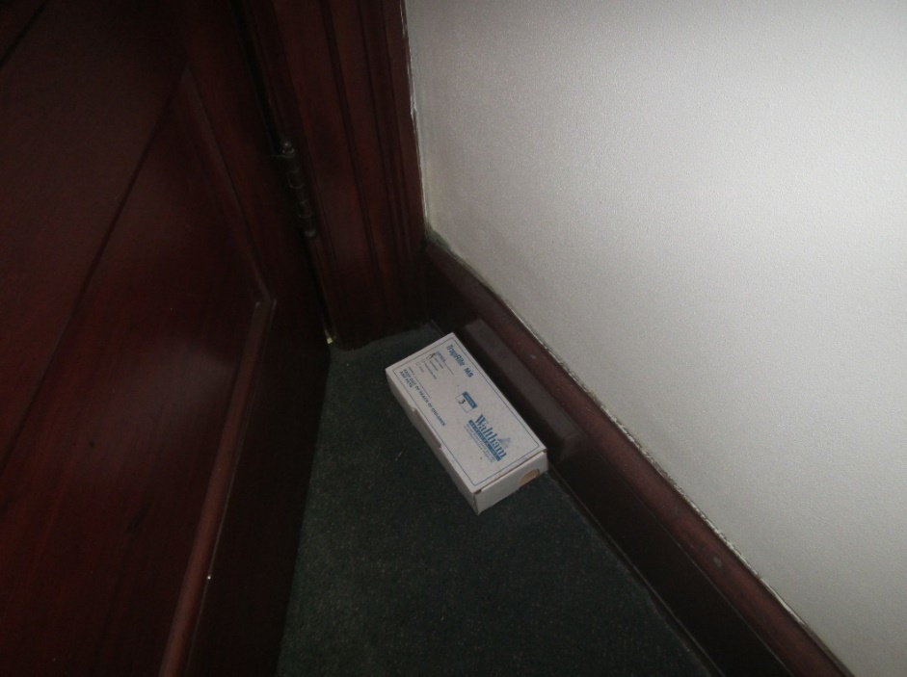

**Pest trap in an office**



| **Location** | **Carbon**  **Dioxide**  **(ppm)** | **Carbon Monoxide**  **(ppm)** | **Temp**  **(°F)** | **Relative**  **Humidity**  **(%)** | **PM2.5**  **(µg/m3)** | **Occupants**  **in Room** | **Windows**  **Openable** | **Ventilation** | | **Remarks** |
| --- | --- | --- | --- | --- | --- | --- | --- | --- | --- | --- |
| **Supply** | **Exhaust** |
| Background (outside) | 372 | ND | 90 | 67 | 43 |  |  |  |  | Hot and humid, high PM2.5 outdoors |
| 304 | 663 | ND | 79 | 59 | 41 | 1 | Y | N | N | WAC in only window, CF on, carpeted |
| 305 | 688 | ND | 79 | 61 | 40 | 0 | Y | N | N | WAC, carpeted, CF |
| Copy/fridge | 620 | ND | 79 | 55 | 36 | 0 | Y | N | N | no air conditioner, NC, PC and fridge (Clean) |
| 323 (restroom) | 576 | ND | 77 | 54 | 36 | 0 | Y | N | N | Household-style exhaust vent in window, which opens to stairwell and not outside, air freshener |
| 302 |  |  |  |  |  |  |  |  |  | Door to stairwell |
| 321 | 591 | ND | 79 | 51 | 30 | 2 | Y | N | N | WAC on, food, DEM, CF |
| 322 | 592 | ND | 78 | 57 | 33 | 1 | Y | N | N | WAC, CF, candle, wrinkled carpet (previous water damage), peeling wallpaper with stains – possible mold |
| 317 | 557 | ND | 74 | 60 | 36 | 0 | Y | N | N | Peeling wallpaper, CF, carpet looks newer |
| 315 | 544 | ND | 75 | 63 | 34 | 0 | Y | N | N | WAC, CF on, carpet looks newer |
| 313 | 555 | ND | 74 | 60 | 36 | 1 | Y | N | N | WAC on, CF |
| 311 | 595 | ND | 75 | 56 | 36 | 2 | Y | N | N | Older style WAC on, CF, carpet, |
| 309 | 479 | ND | 76 | 65 | 31 | 0 | Y | N | N | no WAC, carpet and plush furniture, radiator removed |

(Click to link back to report)

# Table 2A

|  |  |  |  |  |  |
| --- | --- | --- | --- | --- | --- |
| **Equipment Present in Building**  **(X = Yes)** | **Type of Heating/Cooling Ventilation**  **Equipment** | **Fresh**  **Air**  **Supply**  **(X = Yes)** | **Type of Location(s)** | **Air Filters Installed**  **MERV Rating**  **(1-15, U*)**  **(X = Yes)** | **Comments** |
|  | Univents |  |  |  |  |
|  | Rooftop Air Handling Units |  |  |  |  |
|  | Outdoor, Ground-Installed Air Handling Units |  |  |  |  |
|  | Attic/Crawlspace Air Handling Units |  |  |  |  |
|  | Ceiling-Mounted Air Handling Units (including inside plenum) |  |  |  |  |
|  | Basement/Crawlspace-Installed Air Handling Units |  |  |  |  |
|  | Mechanical Room-installed Air Handling Units |  |  |  |  |
|  | Fan Coil Units |  |  |  |  |
| X | Window-Mounted Air Conditioners | X | Exterior rooms |  |  |
|  | Wall Louver-Controlled Gravity Air Supply |  |  |  |  |
| X | Windows | X | Exterior rooms |  |  |
|  | Fan in window (blowing in) |  |  |  |  |
|  | Built in wall fan (switched) |  |  |  |  |
|  | Heat recovery ventilator unit |  |  |  |  |
|  | Energy recovery ventilator unit |  |  |  |  |
|  | Chilled Beam |  |  |  |  |
|  | Passive combustion supply vent in basement/boiler room |  |  |  |  |

*U = Filter Rating underdetermined due to inaccessibility during building visit

(Click to link back to report)

# Table 2B

|  |  |  |  |  |
| --- | --- | --- | --- | --- |
| **Equipment Present in Building**  **(X = Yes)** | **Type of Exhaust Ventilation**  **Equipment** | **Ducted**  **To Outdoors**  **(X = Yes)** | **Type of Location(s)** | **Comments** |
|  | Rooftop Motors/Fans |  |  |  |
|  | Unit Exhaust |  |  |  |
|  | Ceiling Return Vent |  |  |  |
|  | Ceiling Return Vent, Plenum |  |  |  |
|  | Wall Return Vent |  |  |  |
|  | Kitchen Stove Hood |  |  |  |
| X | Restroom Exhaust Vent | no |  |  |
|  | Photocopier Exhaust Vent |  |  |  |
|  | Garage |  |  |  |
|  | Chemical Hood(s) |  |  |  |
|  | Locker Rooms |  |  |  |
|  | Showers |  |  |  |
|  | Lock up Cells |  |  |  |
|  | Clothes Dryers |  |  |  |
|  | Gas Water Heaters |  |  |  |
|  | Furnace-Flue to Chimney |  |  |  |
|  | Furnace/Boiler direct vent or power vent (no combustion air supply) |  |  |  |
|  | Kiln, Pottery |  |  |  |
|  | Dark Room |  |  |  |
|  | Generator Room |  |  |  |
|  | Wood Shop Dust Collector |  |  |  |
|  | Spray Paint Booths |  |  |  |
|  | Fan in window (blowing out) |  |  |  |

# Table 2C

|  |  |  |  |
| --- | --- | --- | --- |
| **Equipment Present in Building**  **(X = Yes)** | **Type of Equipment** | **Type of Location(s)** | **Comments** |
|  | Floor Fans, pedestal |  |  |
| X | Ceiling fans | Most rooms |  |
| X | Portable fans | Various |  |
| X | Air Purifier (HEPA, other) | Hallway |  |
|  | Floor heaters, portable |  |  |
|  | Refrigerators, Cold Beverage Vending Machines |  |  |
|  | Radiator, wall-mounted |  |  |
| X | Radiator, floor-mounted | Most rooms | Some radiators missing |
|  | Passive vents (Wall/Door) |  |  |

(Click to link back to report)

# Table 3

| **Found in Building**  **X = Yes** | **Water-Damaged Materials, Building Components or Stored Materials** | **Location** | **Visible Microbial Growth?**  **X = Yes** | **Musty odor detected?**  **X = Yes** | **Comments** |
| --- | --- | --- | --- | --- | --- |
|  | Books-other bound materials |  |  |  |  |
| X | Brick walls – broken, missing mortar | Exterior |  |  |  |
|  | Brick walls – blocked weep holes |  |  |  |  |
|  | Cardboard boxes |  |  |  |  |
|  | Carpet tiles |  |  |  |  |
|  | Carpet - Area rugs |  |  |  |  |
| X | Carpet wall-to-wall | Room 322 |  |  |  |
|  | Ceiling tiles - affixed directly to ceiling surface |  |  |  |  |
|  | Ceiling tiles - bowing-in suspended ceiling |  |  |  |  |
|  | Ceiling tiles - water-stained in splined ceiling |  |  |  |  |
|  | Ceiling tiles - water-stained in suspended ceiling |  |  |  |  |
|  | Chairs - laminated |  |  |  |  |
|  | Cloth |  |  |  |  |
|  | Countertops (around sinks) |  |  |  |  |
|  | Curtains |  |  |  |  |
|  | Dust/debris within AHU, uninvent, HVAC, chilled beam units, etc. (WD through condensation, humidity, or leaks) |  |  |  |  |
| X | Efflorescence (i.e., mineral deposits) | Exterior |  |  |  |
|  | Engineered woods - particleboard, plywood, Masonite |  |  |  |  |
|  | Flooring – loosened tiles |  |  |  |  |
|  | Flooring - wooden |  |  |  |  |
|  | Furniture - laminated |  |  |  |  |
|  | Furniture - upholstered |  |  |  |  |
|  | Gypsum wallboard - ceiling |  |  |  |  |
|  | Gypsum wallboard - restroom wall |  |  |  |  |
|  | Gypsum wallboard - interior wall |  |  |  |  |
|  | Gypsum wallboard – located on exterior wall |  |  |  |  |
|  | HVAC drain pan – lack of draining |  |  |  |  |
|  | HVAC filters |  |  |  |  |
|  | Insulation- attic (paper-backed) |  |  |  |  |
|  | Insulation - inside air handling unit |  |  |  |  |
|  | Insulation - on pipe(s) fiberglass |  |  |  |  |
| X | Insulation - on pipe(s) other/plaster-like material |  |  |  |  |
|  | Insulation - wall cavity |  |  |  |  |
|  | Insulation – ceiling plenum |  |  |  |  |
|  | Modular furniture – walls/cloth partitions |  |  |  |  |
|  | Musical instrument cases |  |  |  |  |
|  | Plaster ceilings |  |  |  |  |
|  | Plaster walls |  |  |  |  |
|  | Records/files |  |  |  |  |
|  | Refrigerator - door gasket |  |  |  |  |
|  | Refrigerator - drip pan |  |  |  |  |
|  | Refrigerator - Interior surfaces |  |  |  |  |
|  | Room divider - ceiling-mounted, sliding |  |  |  |  |
|  | Sink backsplash |  |  |  |  |
|  | Tables – laminated |  |  |  |  |
| X | Wallpaper | Several exterior offices | X |  |  |
|  | Wood - attic/roof materials |  |  |  |  |
|  | Wood - floor joists in basement ceiling |  |  |  |  |
|  | Wood - wall framing |  |  |  |  |
|  | Wood - window sills |  |  |  |  |
|  | Wood - window-mounted air conditioner framing |  |  |  |  |
|  | OTHER: Wooden baseboard |  |  |  |  |

WHAT ARE ENVIRONMENTAL ASTHMA TRIGGERS?

Asthma triggers are any chemical, pollutant, or allergen that can make your asthma worse. Asthma triggers can also be strong chemical smells, dust, or pets. Your asthma triggers may be different from those of other people. Not all asthma triggers affect people the same way. Environmental asthma triggers are found both indoors and outdoors. DPH link: [Asthma and Your Environment (mass.gov)](https://www.mass.gov/doc/asthma-and-your-environment-english/download)

(click to link back to report)

# Table 4

| **Condition Present**  **X = Yes** | **Possible asthma symptom-inducing environmental pollutant** | **Recommendation to reduce or eliminate the pollutant** |
| --- | --- | --- |
| X | Water Damage and/or Mold  (allergen) | Identify water source and repair to eliminate.  Clean non-porous materials.  Remove and replace porous materials susceptible to mold growth.  Perform regular water damage assessments as a tool to ensure timely mitigation as needed.  Use NIOSH water damage assessment protocol as a guide: [NIOSH water damage assessment guideline](https://www.cdc.gov/niosh/docs/2019-115/pdfs/2019-115.pdf?id=10.26616/NIOSHPUB2019115&inf_contact_key=241b5c2ed98c27d94b530dedc36f1623f651f238aa2edbb9c8b7cff03e0b16a0). |
|  | Moistening of building components during hot, humid weather (>2 days in length) (mold, allergen) | Remove materials not dried in <2 days in a manner consistent with [US EPA Mold Removal in Commercial Buildings guideline](https://www.epa.gov/mold/pdf-version-checklist-mold-remediation-mold-remediation-schools-and-commercial-buildings).  Use dehumidification in occupied basement areas and other areas with chronic dampness. |
| X | Vegetation against exterior of building (water damage-mold) | Remove all vegetation preventing building exterior drying.  Remove all vegetation capable of falling onto a building or depositing debris onto the roof. |
|  | Personal humidifiers (lack of proper maintenance)  (pollutant and allergen) | Clean and maintain properly.  Use distilled water to eliminate metal and water treatment odors.  Maintain hydration by increasing water consumption. |
|  | Drains: Floor drains, Sink drains (abandoned use)  Water bubblers (abandoned use) | If in use, pour water into drain at least twice a week.  If not in use, seal the drain with an appropriate material in accordance with Massachusetts Plumbing Code (248 CMR 10.00). |
|  | Live Animals (turtles, gerbils, birds, rabbits, etc.) | Ensure cleanliness or remove animals from the location. |
|  | Improperly maintained aquariums and terrariums (allergen) | Maintain such equipment properly to eliminate odor.  Discontinue use. |
| X | Plants and flowers  (allergen and mold) | Keep indoor plants well maintained and not overwatered. Monitor for signs of mold and pests.  Ensure water for cut flowers does not become stagnant.  Ensure dried plant material is free of odors, mold, and pests and handled carefully  If asthma risks are high, eliminate plants and flowers. |
|  | HVAC system moisture issues  (mold, allergen) | Consult ASHRAE’s minimum standards for HVAC maintenance and inspection of commercial HVAC systems (<https://www.ashrae.org/technical-resources/bookstore/standards-180-and-211>). |
|  | HVAC system contaminant issues (allergen) | Consult ASHRAE’s minimum standards for HVAC maintenance and inspection of commercial HVAC systems (<https://www.ashrae.org/technical-resources/bookstore/standards-180-and-211>). |
|  | Indoor swimming pool odors outside of swimming pool (mold, chemical) | Maintain and operate pool HVAC systems to vent odors from building.  Ensure locker room exhaust vents are operating during building hours.  All doors leading to pool should be rendered airtight and be closed. |
| X | Pollen (allergen) | Recommend installation of MERV 8 or better filters if HVAC engineer confirms HVAC system can be so equipped without adversely affecting function.  Cut grass after hours.  Cut grass in a pattern to direct clippings away from exterior wall.  Remove trees and shrubs from in front of windows and air intakes. |
|  | Dry air | Maintain hydration.  Avoid overheating of air. |
| X | Dust mites  (allergen) | Recommendation to remove non-official upholstered furniture, area rugs, pillows, cushions, etc.  Cleaning with use of HEPA-filtered vacuum cleaner.  Eliminating clutter, storing items in dust and moisture-proof containers, and regularly removing dust through wet wiping. |
| X | Pests, including rodents and cockroaches  (allergen) | Use of integrated pest management guidelines, including:   * Proper disposal of food containers * Proper storage of food products in airtight containers * Elimination of use of food as art projects * Remove pest harborages/clutter * Regular monitoring for pests   [EPA IPM guideline link](https://www.epa.gov/ipm/introduction-integrated-pest-management) |
|  | Latex-containing materials | Remove tennis balls from furniture legs. |
|  | Fragrances  (chemical) | Eliminate point sources, such as:   * Plug-in air fresheners * Aroma/oil reed diffusers * Scented sprays * Discontinue use of other scented materials * Consult DPH fragrance guideline: [*Clean air is odor-free*](https://www.mass.gov/doc/clean-air-is-odor-free-removing-fragrances-to-improve-indoor-air-quality-in-schools-and-0/download) |
|  | Strong smells from /use of Chemicals (such as cleaning products)  (chemical) | Use building-issued cleaning products.  Use products in accordance with manufacturer’s instructions including dilution, application, and ventilation.  Avoid using products that are stronger than needed for the situation. |
|  | Strong odors from new building materials (carpeting/furniture)  (chemical) | Use low VOC-emitting materials.  Air out materials (outside or in unoccupied area) prior to installation. |
|  | Tobacco smoke  Secondhand Smoke  (pollutant) | Eliminate tobacco smoking.  Seal all shared wall penetrations. |
|  | Products with a strong odor such as paint, perfume, hairspray, air fresheners, bug-spray, laminators, candles, wax melters, dry erase markers and other VOC-containing products  (chemical) | If essential:   * Provide proper exhaust ventilation to eject aerosolized product directly outdoors. * Avoid/reduce use during occupied hours.   If not necessary, remove and eliminate. |
|  | Vehicle exhaust  (pollutant) | Enforce anti-idling regulations and post signs to give notice.  Relocate vehicles away from fresh air intakes.  Require cars to park face-in at building walls.  [MA anti-idling law FAQs](https://www.mass.gov/files/documents/2018/02/20/idling-faq.pdf#:~:text=The%20Massachusetts%20Anti-Idling%20Law%20The%20goal%20of%20the,sometime%20wonder%20when%20idling%20might%20be%20considered%20necessary.) |
|  | Vapors and or fumes from gas, oil, or kerosene stoves  (pollutant) | Operate stove hood when stove in use.  Install stove hood if not present.  Ensure equipment is in good working order. |
|  | Ozone (pollutant) | Eliminate use of ozone generating equipment. |
| X | Window Air Conditioners (if not properly maintained) (allergen) | Equip with proper filter and clean periodically.  Clean drip pans.  Install in window with weathertight, non-mold-growth sustaining material. |
|  | Pottery (pollutant) | Do not operate kiln during occupied hours.  Operate kiln with exhaust system activated.  Seal all seams and holes in kiln vent.  Ensure kiln exhaust discharge terminates outdoors. |
| X | Carpeting (allergen) | Clean carpeting in a manner consistent with IICRC standards, including regular vacuuming with a high efficiency particulate air (HEPA) filtered vacuum in combination with annual cleaning or semi-annual cleaning in soiled high traffic areas. |
|  | Sweeping/dusting vs HEPA vacuuming/wet wiping  (allergen or pollutant) | Refrain from using feather dusters or brooms.  Utilize HEPA vacuums and wet wiping to minimize aerosolizing particulate matter. |
|  | Lack of adequate air exchange/mechanical ventilation | Make repairs as necessary and ensure all HVAC system components are operating continuously when building is occupied. |
|  | Lack of local exhaust at source of pollution (vocational shop activities, kitchen exhaust hood) (all) | Recommend installation of exhaust ventilation to direct pollutants directly outdoors. |
|  | Renovating buildings while occupied  (chemical) | Use all SMACNA guidelines for Renovation While Buildings Are Occupied. For information, visit <https://www.mass.gov/service-details/construction-and-renovation-generated-pollutants-in-occupied-buildings>. |
|  | Chemistry program chemical storage  (chemical) | Repair (if needed) and operate chemical storeroom vents appropriately.  Reduce or eliminate unneeded or overstocked chemicals.  Store all chemicals in a manner to separate incompatible chemicals.  Keep chemical storerooms clean. |
| X | Photocopiers/duplicating machines | All machines should have dedicated exhaust vents or be used in a well-ventilated area. |