Water Damage Investigation

Tewksbury Hospital
Saunders Building
EB12 Occupational Therapy
365 East Street Tewksbury, MA

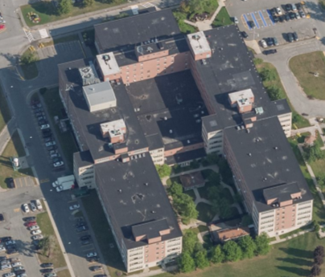

Prepared by:
Massachusetts Department of Public Health
Bureau of Environmental Health
Indoor Air Quality Program
December 2018

Background
Building: | Tewksbury Hospital, Saunders Building- EB12 Occupational Therapy
Address: | 365 East Street, Tewksbury, MA
Assessment Requested by: | Scott J. Consaul, J.D., CPHQ, CHSP, CSL  Director of Facilities Management
Reason for Request: | General Indoor Air Quality (IAQ) and health concerns following water damage events
Date of Assessment: | November 27, 2018
Massachusetts Department of Public Health/Bureau of Environmental Health (MDPH/BEH) Staff Conducting Assessment: | Jason Dustin, Environmental Analyst, indoor air quality (IAQ) Program
Building Description: | The offices examined are on the basement level of a U-shaped, five-story building with a flat rubber membrane roof. It was originally built in the 1960s with additional wings added in the early 1970s.
Windows: | Some openable

Methods
Please refer to the IAQ Manual for methods, sampling procedures, and interpretation of results (MDPH, 2015).

IAQ Testing Results
The following is a summary of indoor air testing results (Table 1).
- Carbon dioxide levels were below the MDPH 800 parts per million (ppm) in all areas surveyed, indicating adequate air exchange.
- Temperature was within the MDPH recommended range of 70°F to 78°F in all areas tested.
- Relative humidity was below the MDPH recommended range of 40 to 60% in the areas tested which is typical during the heating season.
- Carbon monoxide levels were non-detectable (ND) in all areas tested.
- Fine particulate matter (PM2.5) concentrations measured were below the National Ambient Air Quality (NAAQS) limit of 35 μg/m³ in all areas tested.
- Total Volatile Organic Compound (TVOC) levels were ND in all areas surveyed.

Ventilation
A heating, ventilating and air conditioning (HVAC) system has several functions. First it provides heating and, if equipped, cooling. Second, it is a source of fresh air. Finally, an HVAC system will dilute and remove normally-occurring indoor environmental pollutants by not only introducing fresh air, but by filtering the airstream and ejecting stale air to the outdoors via exhaust ventilation. Even if an HVAC system is operating as designed, point sources of respiratory irritation may exist and cause symptoms in sensitive individuals.
Fresh air is supplied by air handling units (AHU) and delivered to supply vents located in the ceilings of rooms and hallways. The Saunders building uses 100% fresh air so that no air is returned to the AHUs. Stale air is drawn through grates and ejected out of the building through roof-mounted exhaust units. The EB12 office suite appears to have been subdivided from a larger room after the original construction of the building. As a result, the space does not appear to have supply or exhaust vents located directly in the office. Instead, EB12 relies on fresh air supply and direct exhaust from the common hallways by leaving the door to the office suite open. The MDPH IAQ program typically recommends supply/exhaust ventilation in each office area to more effectively dilute/remove commonly found indoor air pollutants.
The MDPH typically recommends that HVAC systems be re-balanced every five years to ensure adequate air systems function (SMACNA, 1994). It is not known when the last time these systems were balanced. Balancing should also occur when the space is significantly rearranged.

Microbial/Moisture Concerns
Facilities personnel reported that there had recently been a drain leak which impacted the EB12D office within this suite. While maintenance personnel were working on a drain pipe, another worker removed a bag used to block a sink and poured water down the drain where maintenance was being performed. In addition, this same drain was later broke. As a result, the carpet tiles in room EB12D were water-damaged (Picture 1). Internal Environmental Services staff immediately responded by extracting the water, using fans to dry the area, and other mitigation techniques. Some occupants reported experiencing health effects since the leak occurred. Symptoms reported include respiratory issues (coughing, congestion) and burning/itching eyes.
Although the source of the leak was water coming from a sink, it is highly likely that the sink shares a drain pipe that is used for toilets. In this case, the water leaked would be considered blackwater (contaminated with sewage) if the water was part of a sewage back-up. In general, nonporous surfaces (e.g., concrete, tile) may be effectively cleaned/sanitized. However, porous materials (e.g., gypsum wallboard, carpet, cardboard) that have been in contact with blackwater cannot be effectively cleaned/sanitized or dried and must be disposed of properly. Therefore, any areas of carpeting or other porous materials (e.g., gypsum wallboard, boxes) that were impacted by the blackwater should be discarded.
The EB12 suite has carpet tiles throughout the office areas. In general, carpeting should be vacuumed daily using a high efficiency particulate arrestance (HEPA) equipped filter and cleaned at least annually in accordance with IICRC recommendations (IICRC, 2012).
Carpeting in areas that may be subject to chronic moistening (e.g. basement areas) should be removed and replaced with non-porous flooring where possible.
This is especially pertinent following the extreme relative humidity and elevated dew points that occurred for an extended period of time during the summer of 2018. The New England area experienced an unprecedented period of extended hot, humid weather. According to the Washington Post, “[d]ata…show[s]…cities in the Northeast have witnessed such humidity levels for record-challenging duration...[i]ncluding Albany, Boston, Burlington, Portland and Providence” during the summer of 2018 (WP, 2018). “Boston and nearby locations… [saw]…historic numbers of those warm nights with low temperatures at or above 70 degrees…Providence and Blue Hill Observatory have already broken their annual records” (WP, 2018). If a building does not have either adequate exhaust ventilation and/or air chilling capacity to remove/reduce relative humidity from outside air, then hot, moist air can be introduced into a building and linger to lead to possible moistening of building floor and other components and/or contents that may lead to mold growth. This type of weather condition has led to mold growth incidents in public buildings throughout Massachusetts over the summer of 2018.
During this time, carpet tiles in some EB offices were observed by BEH staff to have elevated moisture levels for weeks. Although most modern commercial carpet tiles are manufactured to be somewhat “mold-resistant”, it is typically the dust/debris found within the synthetic carpet fibers that is responsible for microbial colonization as the dust/debris is predominantly organic in composition. It should be noted that BEH staff did not observe any visible signs of microbial colonization nor detect any musty odors at the time of this assessment.
BEH staff observed a small refrigerator on top of a plastic tray which appeared to have residue/liquid which had leaked from the refrigerator (Picture 2). This tray should be cleaned regularly to avoid microbial colonization within the residue/tray.

Other IAQ Evaluations
Exposure to low levels of total volatile organic compounds (TVOCs) may produce eye, nose, throat, and/or respiratory irritation in some sensitive individuals. To determine if VOCs were present, BEH/IAQ staff examined rooms for products containing VOCs. BEH/IAQ staff noted cleaners, hand sanitizers, air fresheners and other products in use within the areas. All of these products have the potential to be irritants to the eyes, nose, throat, and respiratory system of sensitive individuals.
The relative humidity readings were below the MDPH recommended comfort range the day of the assessment. The MDPH recommends a comfort range of 40 to 60 percent for indoor air relative humidity. Relative humidity in the building would be expected to drop during the winter months due to heating. The sensation of dryness and irritation is common in a low relative humidity environment. “Extremely low (below 20%) relative humidity may be associated with eye irritation [and]…may affect the mucous membranes of individuals with bronchial constriction, rhinitis, or cold and influenza related symptoms” (Arundel et al., 1986). Low relative humidity is a common problem during the heating season in the northeast part of the United States.
In some areas, stored materials and accumulated items make it more difficult for custodial staff to clean. Items should be stored neatly and moved periodically to allow for wet-wiping and vacuuming of surfaces.
BEH staff noted one office which had an air purifier/filter (Picture 3). These appliances should be cleaned/maintained regularly including filter changes. Avoid the use of “ionizing” air cleaners which may produce ozone, a lung irritant, as a byproduct.

Conclusions/Recommendations
Based on observations at the time of assessment, the following is recommended:
- Continue to follow EPA and industry guidelines concerning methods used to remediate buildings that are impacted by sewage (i.e., blackwater). Some of these guideline links include: https://www.epa.gov/sites/production/files/2015-09/documents/floods.pdf and ANSI/IICRC S500 - Standard and Reference Guide for Professional Water Damage Restoration.
- Remove any water-damaged porous items that were impacted by the blackwater. This would include any carpet tiles, gypsum wallboard, or boxes/papers impacted by the blackwater event.
- Consider adding fresh air supply and exhaust ventilation to the office areas lacking them. In the meanwhile, use the windows to as needed to supplement fresh air and leave the door to the common hallway open during occupied hours.
- Refrain from opening windows while air conditioning is operating to avoid condensation.
- Consider replacing carpet tiles with nonporous flooring options for areas prone to condensation (e.g., basement areas).
- Ensure that a program of daily HEPA vacuuming and annual carpet cleaning in accordance with IICRC recommendations (IICRC, 2012) is maintained.
- Eliminate/reduce the use of hand sanitizers, air fresheners, harsh or scented cleaning products and dry erase materials in the office since all of these products have the potential to be irritants to the eyes, nose, throat, and respiratory system of sensitive individuals.
- For buildings in New England, periods of low relative humidity during the winter are often unavoidable. Therefore, scrupulous cleaning practices should be adopted to minimize common indoor air contaminants whose irritant effects can be enhanced when the relative humidity is low. To control for dusts, a high efficiency particulate arrestance (HEPA) filter equipped vacuum cleaner in conjunction with wet wiping of all surfaces is recommended. Avoid the use of feather dusters. Drinking water during the day can help ease some symptoms associated with a dry environment (throat and sinus irritations).
- Reduce the amount of items stored on flat surfaces to allow regular cleaning.
- Clean refrigerator tray regularly to avoid microbial colonization of residue.
- Regularly clean/maintain any air filters including filter changes. Avoid the use of “ionizing” air cleaners which may produce ozone, a lung irritant, as a byproduct.
- Have the HVAC system balanced every 5 years in accordance with SMACNA recommendations (SMACNA, 1994). Consider a rebalancing when the building layout is changed.
- Refer to resource manual and other related IAQ documents located on the MDPH’s website for further building-wide evaluations and advice on maintaining public buildings. These documents are available at: http://mass.gov/dph/iaq.

References
Arundel et al. 1986. Indirect Health Effects of Relative Humidity on Indoor Environments. Env. Health Perspectives 65:351-361.
IICRC. 2012. Institute of Inspection, Cleaning and Restoration Certification. Carpet Cleaning: FAQ.
MDPH. 2015. Massachusetts Department of Public Health. Indoor Air Quality Manual: Chapters I-III. Available at: http://www.mass.gov/eohhs/gov/departments/dph/programs/environmental-health/exposure-topics/iaq/iaq-manual/.
SMACNA. 1994. HVAC Systems Commissioning Manual. 1st ed. Sheet Metal and Air Conditioning Contractors’ National Association, Inc., Chantilly, VA.
WP. 2018. ‘It’s been relentless’: Smothering summer humidity in the Northeast has crushed records. Washington Post, Washington, DC. https://www.washingtonpost.com/news/capital-weather-gang/wp/2018/08/30/its-been-relentless-smothering-summer-humidity-in-the-northeast-has-crushed-records/
Picture 1
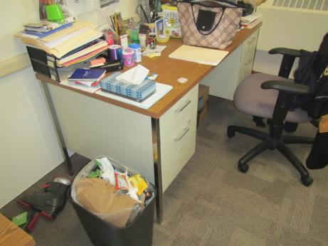
Area of water-damaged carpet tiles
Picture 2
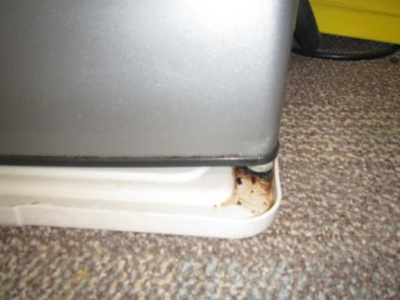
Residue buildup in plastic tray beneath refrigerator
Picture 3
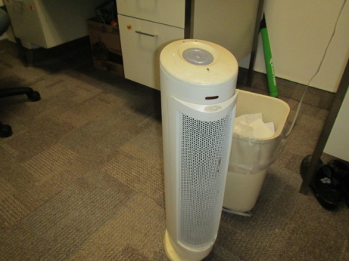
Air filter in office

Location | Carbon  Dioxide  (ppm) | Carbon Monoxide  (ppm) | Temp  (°F) | Relative  Humidity  (%) | PM2.5  (µg/m³) | TVOC  (ppm) | Occupants  in Room | Windows  Openable | Ventilation |  | Remarks
 |  |  |  |  |  |  |  |  | Supply | Exhaust
Background | 391 | ND | 41 | 71 | 9 | ND | - | - | - | -
EB12 Main- left side | 554 | ND | 74 | 30 | 1 | ND | 4 | N | N | N | Carpet tiles, door open, CPs, no musty odors or visible mold observed
EB12D | 546 | ND | 74 | 29 | 2 | ND | 0 | Y | N | N | Site of reported WD carpet tiles, AI, no musty odors or visible mold observed
EB12C | 553 | ND | 74 | 30 | 2 | ND | 0 | Y | N | N | Air filter, carpet tile, no musty odors or visible mold observed
EB12-right corner | 606 | ND | 74 | 31 | 2 | ND | 2 | Y | N | N | No musty odors or visible mold observed

