INDOOR AIR QUALITY ASSESSMENT

Mass Health Enrollment Center
Tewksbury Hospital Campus, Halls 1 and 2
367 East Street
Tewksbury, Massachusetts

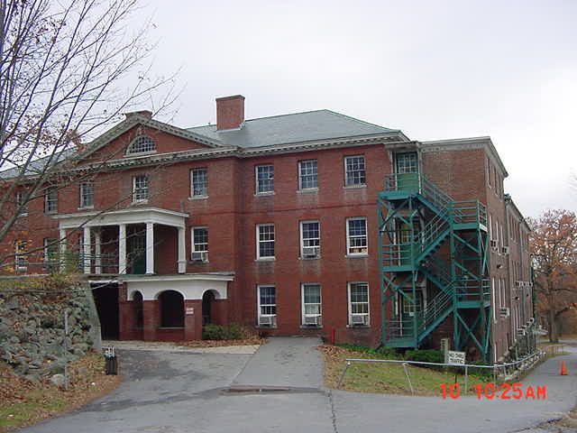

Prepared by:
Massachusetts Department of Public Health
Bureau of Environmental Health
Indoor Air Quality Program
October 2013

Background/Introduction
In response to a request from the Executive Office of Health and Human Services (EOHHS), the Massachusetts Department of Public Health (MDPH), Bureau of Environmental Health (BEH) provided assistance and consultation regarding indoor air quality (IAQ) concerns at the Mass Health Enrollment Center (MHEC) located in Halls 1 and 2 on the Tewksbury Hospital campus located at 367 East Street, Tewksbury, Massachusetts. The request was prompted by concerns relating to general air quality, specifically the impact of printers on the indoor environment and potential health impacts. A visit to conduct an assessment of the MHEC was made on July 23, 2013 by Ruth Alfasso, an Environmental Engineer/Inspector in BEH’s IAQ Program.
Halls 1 and 2 are red brick buildings with cobblestone foundations that were believed to be constructed in the early 1900s. The two buildings are connected by accessory hallways; because the two buildings are not at the same level, the hallways contain stairs. The halls were originally built as dorm facilities for Tewksbury Hospital nursing staff. The MHEC has occupied the halls since 1996 and utilizes the first and second floors for office space, while the third floor is unoccupied.
The basement of Hall 2 was formerly used for storage of records. A visit was made to the facility in 2005 by the BEH/IAQ program; this assessment included both general IAQ and a specific focus on mold and moisture related to the storage of records in the basement. The report from that visit was issued in December of 2005 and is available on request. Appendix A describes actions that were taken in response to the recommendations from that report.

Methods
Air tests for carbon monoxide, carbon dioxide, temperature and relative humidity were conducted with the TSI, Q-Trak, IAQ Monitor, Model 7565. Air tests for airborne particle matter with a diameter less than 2.5 micrometers were taken with the TSI, DUSTTRAK™ Aerosol Monitor Model 8520. Sampling for total volatile organic compounds (TVOCs) was performed using a Mini-RAE 2000 photoionization detector. BEH/IAQ staff also performed a visual inspection of building materials for water damage and/or microbial growth.

Results
The MHEC has an employee population of approximately 50 and can be visited by up to 50 individuals daily. The tests were taken during normal operations and results appear in Table 1.

Discussion

Ventilation
It can be seen from Table 1 that carbon dioxide levels were above 800 parts per million (ppm) in 19 out of 47 areas tested, indicating a lack of air exchange in more than a third of the areas tested at the time of assessment. It is important to note that a number of areas were sparsely populated or unoccupied at the time measurements were taken, which may result in reduced carbon dioxide levels. Carbon dioxide levels would be expected to be higher with full occupancy.
The MHEC offices have no mechanical ventilation systems and use windows to introduce fresh air. Window air conditioners (ACs) were installed in most offices and were operating on the day of assessment (Picture 1; Table 1). When cooling is not called for, window AC units can be operated to provide limited outside air through the “fan only” setting. In some locations, the window AC units were not activated in either cooling or “fan only” settings (Table 1) and windows were closed, therefore no means of providing fresh air was occurring at the time of assessment.
Note that most of the office spaces have been reconfigured from dormitory rooms and many of them have had their hallway doors removed. This configuration has the potential to allow for cross ventilation of rooms when the windows are open (Figure 1), which may be used to provide air exchange during periods of temperate weather.
At least one restroom (second floor ladies) had no source of outside air or exhaust (Table 1). Without an operable window or exhaust fan, odors and moisture produced in restrooms can be distributed to adjacent areas. It was reported that the installation of exhaust ventilation for this restroom is planned.
Minimum design ventilation rates are mandated by the Massachusetts State Building Code (MSBC). Until 2011, the minimum ventilation rate in Massachusetts was higher for both occupied office spaces and general classrooms, with similar requirements for other occupied spaces (BOCA, 1993). The current version of the MSBC, promulgated in 2011 by the State Board of Building Regulations and Standards (SBBRS), adopted the 2009 International Mechanical Code (IMC) to set minimum ventilation rates. Please note that the MSBC is a minimum standard that is not health-based. At lower rates of cubic feet per minute (cfm) per occupant of fresh air, carbon dioxide levels would be expected to rise significantly. A ventilation rate of 20 cfm per occupant of fresh air provides optimal air exchange resulting in carbon dioxide levels at or below 800 ppm in the indoor environment in each area measured. MDPH recommends that carbon dioxide levels be maintained at 800 ppm or below. This is because most environmental and occupational health scientists involved with research on IAQ and health effects have documented significant increases in indoor air quality complaints and/or health effects when carbon dioxide levels rise above the MDPH guidelines of 800 ppm for schools, office buildings and other occupied spaces (Sundell et al., 2011). The ventilation must be on at all times that the room is occupied. Providing adequate fresh air ventilation with open windows and maintaining the temperature in the comfort range during the cold weather season is impractical. Mechanical ventilation is usually required to provide adequate fresh air ventilation.
Carbon dioxide is not a problem in and of itself. It is used as an indicator of the adequacy of the fresh air ventilation. As carbon dioxide levels rise, it indicates that the ventilating system is malfunctioning or the design occupancy of the room is being exceeded. When this happens, a buildup of common indoor air pollutants can occur, leading to discomfort or health complaints. The Occupational Safety and Health Administration (OSHA) standard for carbon dioxide is 5,000 parts per million parts of air (ppm). Workers may be exposed to this level for 40 hours/week, based on a time-weighted average (OSHA, 1997).
The MDPH uses a guideline of 800 ppm for publicly occupied buildings. A guideline of 600 ppm or less is preferred in schools due to the fact that the majority of occupants are young and considered to be a more sensitive population in the evaluation of environmental health status. Inadequate ventilation and/or elevated temperatures are major causes of complaints such as respiratory, eye, nose and throat irritation, lethargy and headaches. For more information concerning carbon dioxide, please see Appendix B.
Temperature readings ranged from 68ºF to 79ºF during the assessment, which were within or close to the MDPH recommended comfort guidelines (Table 1). The MDPH recommends that indoor air temperatures be maintained in a range of 70ºF to 78ºF in order to provide for the comfort of building occupants. In many cases concerning indoor air quality, fluctuations of temperature in occupied spaces are typically experienced, even in a building with an adequate fresh air supply.
The relative humidity measured during the assessment ranged from 40 to 68 percent (Table 1); all but three of the readings were within the MDPH recommended comfort range. The MDPH recommends a comfort range of 40 to 60 percent for indoor air relative humidity. Note that the outdoor relative humidity was measured at 85 percent with heavy showers. The moderate levels measured indoors indicate that the window AC units are performing adequately to remove excess moisture from the air, increasing occupant comfort. Moisture removal is important since higher humidity at a given temperature reduces the ability of the body to cool itself by perspiration; “heat index” is a measurement that takes into account the impact of a combination of heat and humidity on how hot it feels. At a given indoor temperature, the addition of humid air increases occupant discomfort and may generate heat complaints. If moisture levels are decreased, the comfort of the individuals increases.
Relative humidity levels in the building would be expected to drop during the winter months due to heating. The sensation of dryness and irritation is common in a low relative humidity environment. Low relative humidity is a very common problem during the heating season in the northeast part of the United States.

Microbial/Moisture Concerns
A few areas had water-stained ceiling tiles (Table 1), which are evidence of historic roof or plumbing leaks. Water-damaged ceiling tiles can provide a source of microbial growth and should be replaced after a water leak is discovered and repaired. In the ladies room, coving appeared to be peeling next to the sink, possibly from water damage due to overflow or chronic high humidity (Picture 2).
In a few locations, strips of foam used to seal around the window ACs were found to be moist from the driving rain and high humidity conditions outside (Picture 1). If these porous materials remain wet, microbial growth can occur. Adjacent wood and wall materials can also become moist due to contact with the foam material, which wicks the moisture from outside. The US Environmental Protection Agency (US EPA) and the American Conference of Governmental Industrial Hygienists (ACGIH) recommend that porous materials be dried with fans and heating within 24 to 48 hours of becoming wet (US EPA, 2001; ACGIH, 1989). If not dried within this time frame, mold growth may occur. Once mold has colonized porous materials, they are difficult to clean and should be removed/discarded.
Plants and cut flowers were observed in some areas (Table 1; Picture 3). Plants should be properly maintained and equipped with drip pans. Cut flower vases should be cleaned and the water changed regularly to prevent microbial growth and odors from stagnant water. Plants and vases should also not be placed on porous materials, since water damage to porous materials may lead to microbial growth.

Other IAQ Evaluations
Indoor air quality can be negatively influenced by the presence of respiratory irritants, such as products of combustion. The process of combustion produces a number of pollutants. Common combustion emissions include carbon monoxide, carbon dioxide, water vapor, and smoke (fine airborne particle material). Of these materials, exposure to carbon monoxide and particulate matter with a diameter of 2.5 micrometers (μm) or less (PM2.5) can produce immediate, acute health effects upon exposure. To determine whether combustion products were present in the indoor environment, BEH/IAQ staff obtained measurements for carbon monoxide and PM2.5.

Carbon Monoxide
Carbon monoxide is a by-product of incomplete combustion of organic matter (e.g., gasoline, wood and tobacco). Exposure to carbon monoxide can produce immediate and acute health effects. Several air quality standards have been established to address carbon monoxide and prevent symptoms from exposure to these substances. The MDPH established a corrective action level concerning carbon monoxide in ice skating rinks that use fossil-fueled ice resurfacing equipment. If an operator of an indoor ice rink measures a carbon monoxide level over 30 ppm, taken 20 minutes after resurfacing within a rink, that operator must take actions to reduce carbon monoxide levels (MDPH, 1997).
The American Society of Heating Refrigeration and Air-Conditioning Engineers (ASHRAE) has adopted the National Ambient Air Quality Standards (NAAQS) as one set of criteria for assessing indoor air quality and monitoring of fresh air introduced by HVAC systems (ASHRAE, 1989). The NAAQS are standards established by the US EPA to protect the public health from six criteria pollutants, including carbon monoxide and particulate matter (US EPA, 2006). As recommended by ASHRAE, pollutant levels of fresh air introduced to a building should not exceed the NAAQS levels (ASHRAE, 1989). The NAAQS were adopted by reference in the Building Officials & Code Administrators (BOCA) National Mechanical Code of 1993 (BOCA, 1993), which is now an HVAC standard included in the Massachusetts State Building Code (SBBRS, 2011). According to the NAAQS, carbon monoxide levels in outdoor air should not exceed 9 ppm in an eight-hour average (US EPA, 2006).
Carbon monoxide should not be present in a typical, indoor environment. If it is present, indoor carbon monoxide levels should be less than or equal to outdoor levels. On the day of assessment, outdoor carbon monoxide concentrations were non-detect (ND) (Table 1). No measureable levels of carbon monoxide were detected in the building during the assessment (Table 1).

Particulate Matter
The US EPA has established NAAQS limits for exposure to particulate matter. Particulate matter includes airborne solids that can be irritating to the eyes, nose and throat. The NAAQS originally established exposure limits to PM with a diameter of 10 μm or less (PM10). In 1997, US EPA established a more protective standard for fine airborne particulate matter with a diameter of 2.5 μm or less (PM2.5). This more stringent PM2.5 standard requires outdoor air particle levels be maintained below 35 μg/m³ over a 24-hour average (US EPA, 2006). Although both the ASHRAE standard and BOCA Code adopted the PM10 standard for evaluating air quality, MDPH uses the more protective PM2.5 standard for evaluating airborne PM concentrations in the indoor environment.
Outdoor PM2.5 concentration was measured at 15 μg/m³ (Table 1). PM2.5 levels measured indoors ranged from 4 to 18 μg/m³ (Table 1), which were below the NAAQS PM2.5 level of 35 μg/m³. Frequently, indoor air levels of particulates (including PM2.5) can be at higher levels than those measured outdoors. A number of mechanical devices and/or activities that occur indoors can generate particulate during normal operations. Sources of indoor airborne particulates may include but are not limited to particles generated during the operation of fan belts in the HVAC system, use of stoves and/or microwave ovens in kitchen areas; use of photocopiers, fax machines and computer printing devices; operation of an ordinary vacuum cleaner and heavy foot traffic indoors.
Of particular interest to the occupants of the MHEC were particulates produced from the operation of small printers in the office. A study conducted by the International Laboratory for Air Quality and Health, Queensland University of Technology and the Queensland Department of Public Works, in Brisbane Australia showed that office printers contributed to airborne particle concentrations in the work environment (Congrong, et al, 2007).
A study was performed by the BEH/IAQ program at the Salem Department of Revenue (DOR) Office in 2007 on similar printers in an office environment involving detailed measurements during various printing scenarios. The conclusion of that report was that a small increase in particulates (PM 2.5) could be measured during heavy printing operations, but that no readings were found above the NAAQS limits of 35 ppm (MDPH, 2007). A copy of that report can be accessed on the MDPH website at http://www.mass.gov/eohhs/docs/dph/environmental/iaq/2007/salem-dor-oct2007.doc.
The impact of printing on airborne particulate levels in the MHEC was assessed at two of the printers during printing of a 10 page document; no increase in particulates was measured. In addition, no total volatile organic compounds (TVOCs) were measured in the MHEC space, including at the printers while printing was occurring. TVOCs are discussed further in the following section of this report.
It was reported that printing in the MHEC is less common than it once was due to the increased adoption of paperless office procedures and that the small printers located in offices near occupants are not regularly used for large document printing. Note that any particulates produced by printers can be mitigated through: (1) increased ventilation to dilute/remove airborne particulates as discussed in the previous Ventilation section, (2) locating printers away from occupants when possible, and (3) use of heavy-duty copiers/printers located in hallway areas for large jobs. If it has not already occurred, networking of these heavy-duty machines will allow many jobs to be printed in areas away from occupants.

Volatile Organic Compounds
Indoor air can be greatly impacted by the use of products containing volatile organic compounds (VOCs). VOCs are carbon-containing substances that have the ability to evaporate at room temperature. Frequently, exposure to low levels of total VOCs (TVOCs) may produce eye, nose, throat and/or respiratory irritation in some sensitive individuals. For example, chemicals evaporating from a paint can stored at room temperature would most likely contain VOCs. In an effort to determine whether VOCs were present in the building, air monitoring for TVOCs was conducted. Outdoor air samples were taken for comparison. Outdoor TVOC concentrations were ND. Indoor measurements of TVOCs were also ND including measurements specifically conducted during the operation of printers assessed for particulates.
Cleaning products were found in a number of rooms throughout the building (Table 1). Cleaning products contain chemicals that can be irritating to the eyes, nose and throat of sensitive individuals. These products should be properly labeled. In addition, Material Safety Data Sheets (MSDS) should be available at a central location for each product in the event of an emergency. Consideration should be given to working with building management to provide staff with office-issued cleaning products and supplies to prevent any potential for adverse chemical interactions. Air fresheners, deodorizing materials and other scented products were observed in some areas (Table 1). Air deodorizers contain chemicals that can be irritating to the eyes, nose and throat of sensitive individuals. Many air fresheners contain 1,4-dichlorobenzene, a VOC which may cause reductions in lung function (NIH, 2006). Furthermore, deodorizing agents do not remove materials causing odors, but rather mask odors that may be present in the area.

Other Conditions
Other conditions that can affect indoor air quality were observed during the assessment. AC units are equipped with washable filters. These filters should be cleaned periodically as per manufacturer’s instructions to avoid the build-up and re-aerosolization of dirt, dust and particulate matter. A number of personal fans were observed to have accumulated dust/debris (Table 1). Re-activated fans can aerosolize dust accumulated on fan blades/housing. High efficiency particulate arrestance (HEPA) room filter units were also observed in offices and restrooms (Table 1; Picture 4). These units should be cleaned and maintained in accordance with manufacturer’s instructions. Note that a HEPA filter is very effective at removing particulates, but will not remove non-particulate odors or moisture.
Food-preparation equipment including microwaves, toaster ovens, coffee makers, and refrigerators were observed in many offices (Table 1; Picture 5). The use of this equipment can provide a source of particulates and odors, particularly if the equipment is not kept clean. Food/debris remaining on heating elements can burn the next time the items are used, producing smoke and odors. In addition, crumbs remaining on food-preparation equipment can be attractive to pests. Refrigerators in particular can be a source of moisture and, if not cleaned out and washed inside regularly, can be a source of mold and unpleasant odors.
An odor was reported in room 108, which is the same location an odor was of concern in the 2005 report. Occupants reported following many of the suggestions for investigating the odor and cleaning the area following the receipt of the 2005 report (Appendix A) and that the odor continues to reoccur. No significant odor was detected during the assessment, but occupants reported that the odor comes and goes, being more significant during warm dry weather. The odor was described as “eggs” which suggests hydrogen sulfide and other products of anaerobic (without oxygen) decomposition, which can enter buildings through dry drains or abandoned pipes. Additional investigation should be conducted for any drains or broken pipes in the walls, which may lead to sanitary or storm sewer systems or an area of composting organic materials. Walls may need to be opened and/or a metal detector may need to be used to locate any pipes/drains/entry points. The room is currently only used on an occasional basis and should remain so as long as the odor continues to occur.
A fluorescent light fixture was observed to have numerous flies under the cover (Picture 6). Light fixtures should be cleaned regularly to remove debris that can become aerosolized. The presence of so many dead flies in this area suggests that window screens are missing/damaged or the edges around air conditioners may not be properly sealed.
In some offices, items (papers, books, personal items) were found on desks and the floor (Pictures 4 and 7). These items make it difficult for custodial staff to clean. Items should be reduced, relocated and/or be cleaned periodically to avoid excessive dust build up. In addition, these materials can accumulate on flat surfaces (e.g., desktops, shelving and carpets) in occupied areas and subsequently be re-aerosolized causing further irritation. It was reported that significant reductions in files and storage of materials has been conducted in this office.

Conclusions/Recommendations
In view of the findings at the time of the visit, the following recommendations are made:
- Operate window AC units for cooling/fresh air when they are installed and use operable windows to provide air exchange. Keep windows closed in rooms where ACs are operating in cooling mode. Ensure that windows are closed tightly at the end of each workday to prevent security issues and the freezing of pipes during cold weather.
- Continue with plans to add exhaust ventilation to restrooms without any exhaust. If a powered exhaust vent is installed, ensure that supply/make-up air to the restroom is provided via an undercut or a passive vent in the restroom door.
- Seal around air conditioners with water-resistant materials. If materials used to seal around air conditioners become moist due to rain infiltration, ensure they can dry thoroughly or replace.
- Replace water-damaged ceiling tiles.
- For buildings in New England, periods of low relative humidity during the winter are often unavoidable. Therefore, scrupulous cleaning practices should be adopted to minimize common indoor air contaminants whose irritant effects can be enhanced when the relative humidity is low. To control for dusts, a high efficiency particulate arrestance (HEPA) filter equipped vacuum cleaner in conjunction with wet wiping of all surfaces is recommended. Avoid the use of feather dusters. Drinking water during the day can help ease some symptoms associated with a dry environment (throat and sinus irritations).
- Ensure plants and cut flowers are well maintained to prevent spills/leaks, stagnant odors and the aerosolization of pollen, dirt and mold.
- Continue with paperless office procedures to the greatest extent possible to reduce the need for printing. Use the higher-capacity printers/copiers located outside of offices for large jobs as often as possible. Locate printers away from occupants to the greatest extent possible. Maintain printers in accordance with manufacturer’s instructions.
- Store cleaning products properly. All cleaning products used at the facility should be approved by the facilities staff with MSDS’ available at a central location.
- Avoid the use of scented products including air fresheners.
- Clean window AC filters on a regular basis in accordance to the manufacturer’s instruction, including prior to first use during the cooling season and before storage at the end of the summer. Ensure window AC units are stored in an area free from mold, dust and other contaminants when not in use.
- Clean and maintain HEPA filters in accordance with manufacturer’s instructions.
- Clean personal fans of dust/debris on a regular basis.
- Ensure all food-preparation equipment is kept clean and well-maintained to prevent the production of smoke/odors and the attracting of pests. Regularly clean refrigerators.
- Consider removing food-preparation equipment from occupied areas and use in central location (e.g., kitchen/breakroom).
- Refer to the recommendations from the 2005 report (Appendix A) for further investigation and cleaning to determine and remediate the source of odors in room 108 concentrating on drains/pipes in walls. Continue to use the room infrequently or not at all until the source can be determined.
- Clean fluorescent light fixture shown in Picture 6. Examine nearby areas for missing/damaged window screens, and/or other penetrations/sources of flies.
- Relocate or consider reducing the amount of materials stored in offices and common areas to allow for more thorough cleaning.
- Refer to resource manuals and other related indoor air quality documents for further building-wide evaluations and advice on maintaining public buildings. Copies of these materials are located on the MDPH’s website: http://mass.gov/dph/iaq.
References
ACGIH. 1989. Guidelines for the Assessment of Bioaerosols in the Indoor Environment. American Conference of Governmental Industrial Hygienists, Cincinnati, OH.
ASHRAE. 1989. Ventilation for Acceptable Indoor Air Quality. American Society of Heating, Refrigeration and Air Conditioning Engineers. ANSI/ASHRAE 62-1989.
BOCA. 1993. The BOCA National Mechanical Code/1993. 8th ed. Building Officials & Code Administrators International, Inc., Country Club Hills, IL.
Congrong, et al, 2007. Particle Emission Characteristics of Office Printers. He, C., Morawska, L., and Taplin, L. Environ. Sci. Technol., 41, 17, 6039 - 6045, 2007, 10.1021/es063049z
Lstiburek, J. & Brennan, T. 2001. Read This Before You Design, Build or Renovate. Building Science Corporation, Westford, MA. U.S. Department of Housing and Urban Development, Region I, Boston, MA.
MDPH. 1997. Requirements to Maintain Air Quality in Indoor Skating Rinks (State Sanitary Code, Chapter XI). 105 CMR 675.000. Massachusetts Department of Public Health, Boston, MA.
MDPH. 2007. Indoor Air Quality Assessment, Particulate Testing of Laser Jet Printers, Department of Revenue, 35 Congress Street, Shetland Park Office Park, Salem, MA. Massachusetts Department of Public Health, Bureau of Environmental Health Assessment, Boston, MA. October, 2007. Available at: http://www.mass.gov/eohhs/docs/dph/environmental/iaq/2007/salem-dor-oct2007.doc.
NIH. 2006. Chemical in Many Air Fresheners May Reduce Lung Function. NIH News. National Institute of Health. July 27, 2006. http://www.nih.gov/news/pr/jul2006/niehs-27.htm.
OSHA. 1997. Limits for Air Contaminants. Occupational Safety and Health Administration. Code of Federal Regulations. 29 C.F.R 1910.1000 Table Z-1-A.
SBBRS. 2011. Mechanical Ventilation. State Board of Building Regulations and Standards. Code of Massachusetts Regulations, 8th edition. 780 CMR 1209.0.
Sundell. 2011. Sundell, J., H. Levin, W. W. Nazaroff, W. S. Cain, W. J. Fisk, D. T. Grimsrud, F. Gyntelberg, Y. Li, A. K. Persily, A. C. Pickering, J. M. Samet, J. D. Spengler, S. T. Taylor, and C. J. Weschler. Ventilation rates and health: multidisciplinary review of the scientific literature. Indoor Air, Volume 21: pp 191–204.
US EPA. 2001. “Mold Remediation in Schools and Commercial Buildings”. Office of Air and Radiation, Indoor Environments Division, Washington, DC. EPA 402-K-01-001. March 2001. Available at: http://www.epa.gov/iaq/molds/mold_remediation.html.
US EPA. 2006. National Ambient Air Quality Standards (NAAQS). US Environmental Protection Agency, Office of Air Quality Planning and Standards, Washington, DC. http://www.epa.gov/air/criteria.html.

Figure 1

Cross Ventilation in a Building Using Open Windows and Doors/Transoms

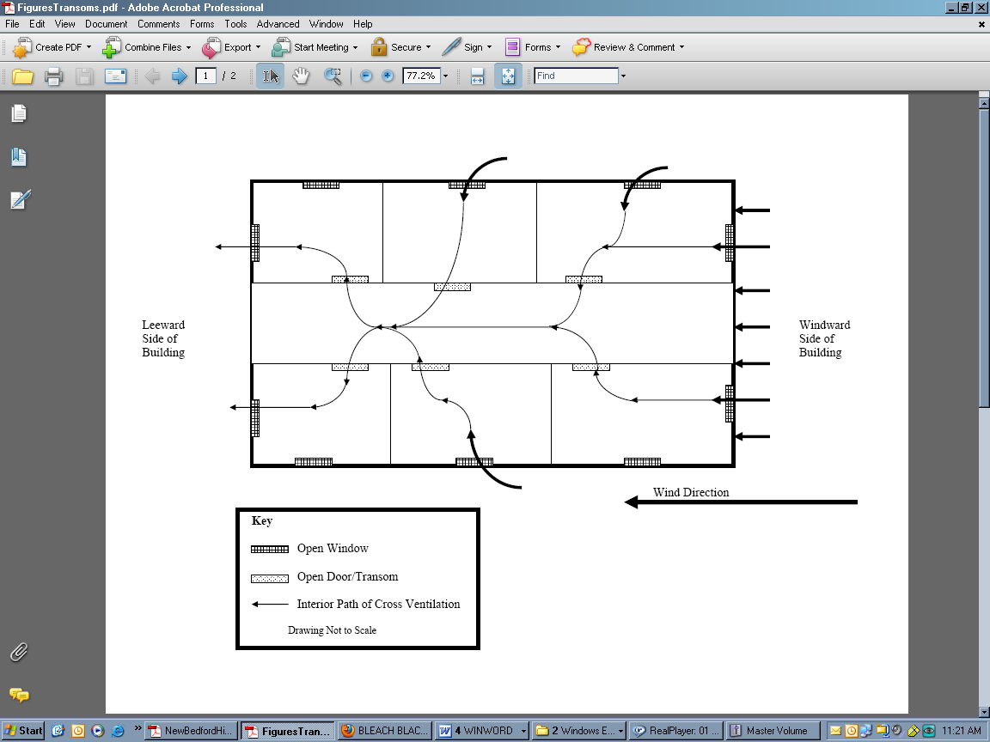

Picture 1

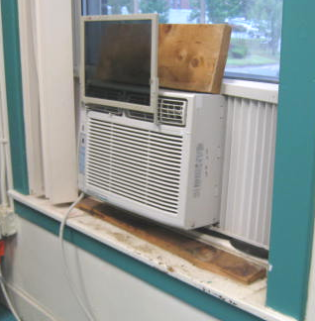

Window air conditioner; note stained wood, and foam (foam was moist)

Picture 2

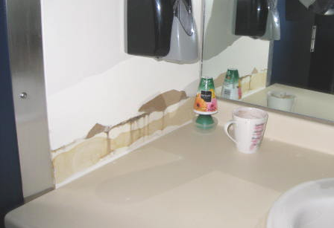

Missing coving in ladies room sink area; note also pop-up air freshener

Picture 3

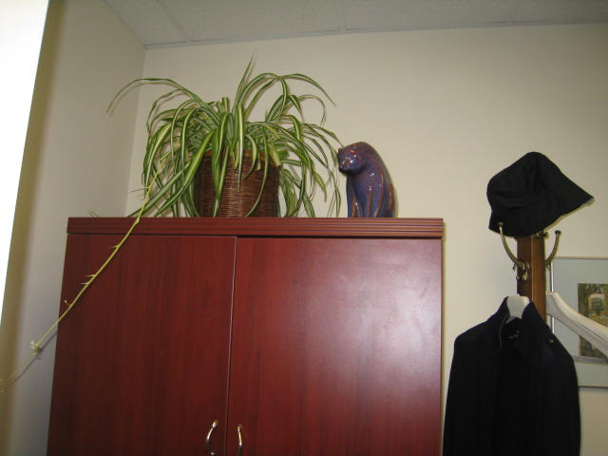

Plant in an office

Picture 4

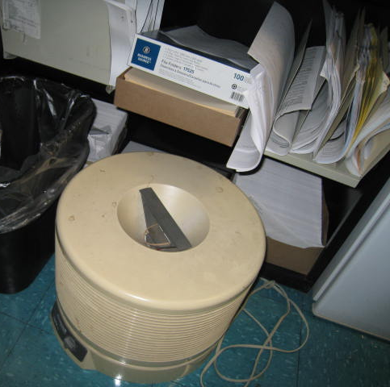

HEPA filter unit, note also papers/boxes on table and floor

Picture 5

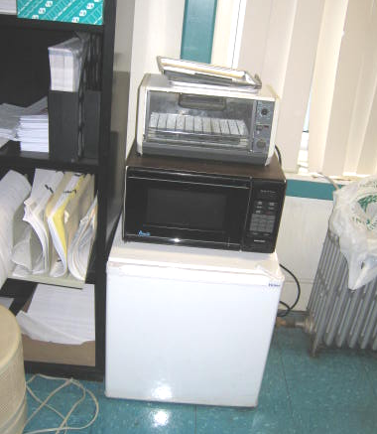

Refrigerator, microwave and toaster oven in office

Picture 6

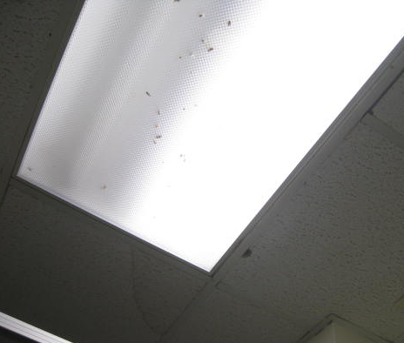

Flies under fluorescent light cover

Picture 7

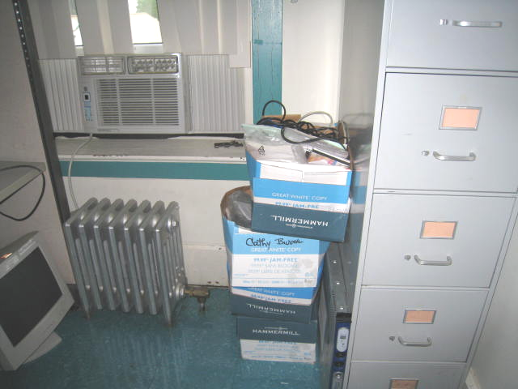

Boxes/items on floor
Location | Carbon  Dioxide  (ppm) | Carbon Monoxide  (ppm) | Temp  (°F) | Relative  Humidity  (%) | TVOCs  (ppm) | PM2.5  (ug/m³) | Occupants  in Room | Windows  Openable | Ventilation |  |  | Remarks
 |  |  |  |  |  |  |  |  | Intake | Exhaust |  | Remarks
Background | 537 | ND | 77 | 85 | ND | 15 |  |  |  |  |  | Intermittent heavy showers, car idling nearby in parking lot
100 | 536 | ND | 75 | 60 | ND | 6 | 0 | Y | N |  | N | WAC off
101 nurse space | 760 | ND | 75 | 43 | ND | 6 | 0 | Y | N |  | N | WAC, microwave
102 | 643 | ND | 74 | 53 | ND | 5 | 0 | Y | N |  | N | WAC
103 reception | 684 | ND | 76 | 50 | ND | 6 | 1 | Y | N |  | N | WAC on, foam around WAC may be damp, printer
105 waiting room | 685 | ND | 73 | 45 | ND | 5 | 0 | Y | N |  | N | WAC
106 | 648 | ND | 72 | 47 | ND | 5 | 0 | Y | N |  | N | WAC on high
107 | 689 | ND | 73 | 51 | ND | 5 | 1 | Y | N |  | N | WAC
108 | 800 | ND | 75 | 57 | ND | 6 | 1 | Y | N |  | N | WAC off, HEPA filter, PF
109 | 730 | ND | 71 | 42 | ND | 5 | 0 | Y | N |  | N | WAC, heavy rain through foam on WAC
110 | 905 | ND | 76 | 52 | ND | 5 | 1-2 | Y | N |  | N | WAC off, plants
111 | 835 | ND | 70 | 49 | ND | 6 | 1 | Y | N |  | N | WAC high
116 | 709 | ND | 73 | 57 | ND | 5 | 2 | Y | N |  | N | WAC on, toaster, microwave, DEM, printer, plants
117 | 749 | ND | 74 | 56 | ND | 5 | 0 | Y | N |  | N | WAC off, plants, coffeemaker, toaster
118 right | 759 | ND | 74 | 48 | ND | 6 | 0 | Y | N |  | N | WAC on, items, rubber cement
118 left | 761 | ND | 73 | 49 | ND | 4 | 1 | Y | N |  | N | WAC off, next to big copier, coffeemaker
119 | 707 | ND | 74 | 60 | ND | 5 | 0 | Y | N |  | N | WD CT, WAC off, coffeemaker, plants
120 | 725 | ND | 73 | 62 | ND | 5 | 1 | Y | N |  | N | WAC off, flowers, toaster
121 right | 923-1200 | ND | 75 | 54 | ND | 5 | 2 | Y | N |  | N | WAC off, Cleaners (Clorox and PineSol), printers
122 left | 921 | ND | 75 | 51 | ND | 5 | 3 | Y | N |  | N | WAC off, items
122 right | 986 | ND | 74 | 52 | ND | 6 | 3 | Y | N |  | N | WAC
124 | 872 | ND | 73 | 40 | ND | 5 | 0 | Y | N |  | N | WAC on, DO, plants, fireplace
125 | 1080 | ND | 71 | 45 | ND | 4 | 3 | Y | N |  | N | WAC on, printers, PF
126 left | 1042 | ND | 71 | 47 | ND | 5 | 2 | Y | N |  | N | WAC off, items, papers
126 right | 942 | ND | 72 | 43 | ND | 4 | 0 | Y | N |  | N | WAC on, toaster, microwave, coffeemaker, plants, papers
128 | 940 | ND | 68 | 46 | ND | 5 | 0 | Y | N |  | N | WAC on high, plants, fridge, DO
1st floor lunchroom | 604 | ND | 72 | 53 | ND | 5 | 0 | Y | N |  | N | Large fridge, microwave, vending machine, toaster
200 | 434 | ND | 75 | 56 | ND | 5 | 0 | Y | N |  | N | WAC off, chimney/fireplace
201 | 534 | ND | 75 | 50 | ND | 6 | 0 | Y | N |  | N | computer training, WAC on
205 conference | 481 | ND | 75 | 52 | ND | 6 | 0 | Y | N |  | N | WAC off
207 | 547 | ND | 75 | 52 | ND | 6 | 0 | Y | N |  | N | WAC off
208 training | 542 | ND | 74 | 51 | ND | 6 | 0 | Y | N |  | N | WAC off
218 | 649 | ND | 77 | 47 | ND | 11 | 2 | Y | N |  | N | WAC off, PF, sanitizer
219 | 670 | ND | 75 | 45 | ND | 10 | 1 | Y | N |  | N | WAC off, printer, coffeemaker, toaster
220 | 735 | ND | 77 | 42 | ND | 6 | 0 | Y | N |  | N | Printer, coffeemaker, WAC on
221 | 864 | ND | 78 | 50 | ND | 5 | 3 | Y | N |  | N | 2 PF on, printer, coffee maker, WAC on
222 left | 843 | ND | 78 | 48 | ND | 6 | 1 | Y | N |  | N | PF, WAC on
222 right | 793 | ND | 78 | 48 | ND | 5 | 2 | Y | N |  | N | PF, WAC on
224 | 838 | ND | 78 | 46 | ND | 5 | 1 | Y | N |  | N | WAC, plants, printer
225 | 848 | ND | 75 | 55 | ND | 5 | 2 | Y | N |  | N | plants, microwave, printer
226 left | 931 | ND | 75 | 55 | ND | 6 | 1 | Y | N |  | N | No doors, WAC on
226 right | 916 | ND | 76 | 53 | ND | 5 | 3 | Y | N |  | N | No doors, plants, WAC off
227 | 819 | ND | 75 | 68 | ND | 5 | 1 | Y | N |  | N | WAC on
228 | 814 | ND | 75 | 66 | ND | 5 | 1 | Y | N |  | N | WAC on, DO, printer, coffeemaker
2nd floor ladies room | 478 | ND | 77 | 52 | ND | 6 | 0 | Y | N |  | N | Vent/AC
2nd floor lunch | 515 | ND | 75 | 49 | ND | 18 | 0 | Y | N |  | N | WAC
2nd floor mailroom |  |  |  |  |  |  |  | Y | N |  | N | Large stamping machine
2nd floor Meeting room | 521 | ND | 75 | 42 | ND | 12 | 0 | Y | N |  | N | WAC
2nd floor Women’s restroom | 1029 | ND | 79 | 52 | ND | 9 | 0 | N | N |  | N | Plants, HEPA filter, 1 WD-CT

