# 

INDOOR AIR QUALITY ASSESSMENT

**Tewksbury Hospital Campus, Halls 1 and 2**

**MassHealth Enrollment Center**

Tewksbury, MA

**August 2024**

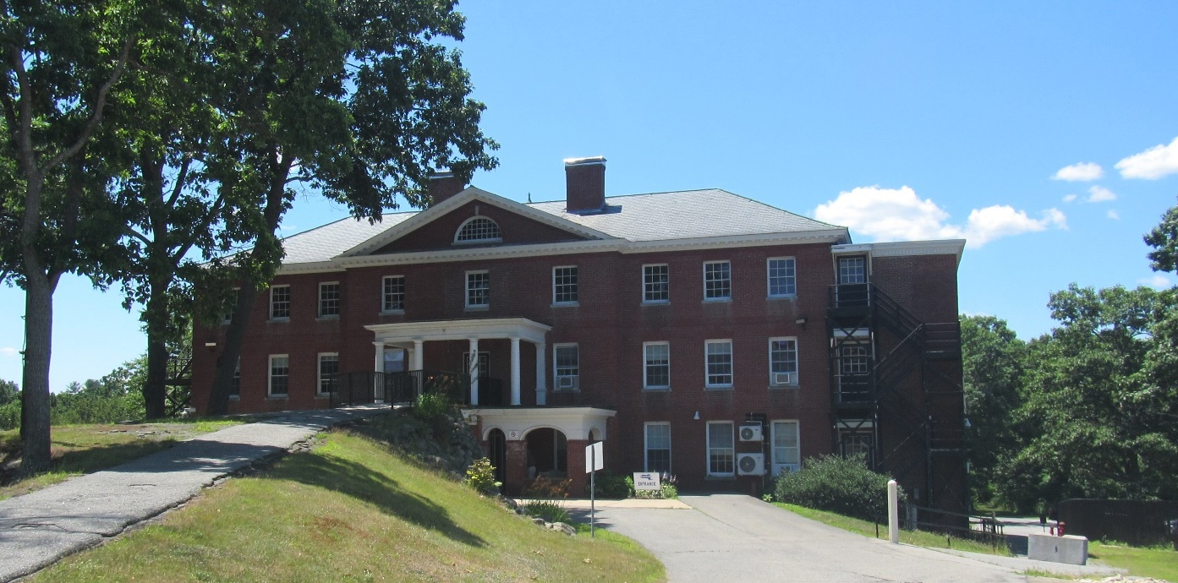

Prepared by:

Massachusetts Department of Public Health

Bureau of Climate and Environmental Health

Indoor Air Quality Program

Contents

EXECUTIVE SUMMARY 3

BACKGROUND 4

RESULTS AND DISCUSSION 5

Ventilation 6

Water Damage and Moisture Concerns 7

Water Damage Issues 7

Sources of Respiratory Irritants/Possible Asthma Triggers 9

CONCLUSIONS AND RECOMMENDATIONS 11

REFERENCES 16

PICTURES 18

Table 1 27

Table 2A 31

Table 2B 32

Table 2C 33

Table 3 34

Table 4 36

# R an EXECUTIVE SUMMARY

The Massachusetts Department of Public Health’s Indoor Air Quality Program (MDPH IAQ) conducted an IAQ assessment of the MassHealth Enrollment Offices located in Halls 1 and 2 located on the Tewksbury Hospital campus on July 2, 2024. This assessment was requested by Joel Posner, Labor Relations Director, Executive Office of Health and Human Services for the purpose of investigating staff concerns about indoor air quality in the MassHealth offices.

It is important to note that the building was constructed in the early 1900s and has been placed on the historic register, requiring special permission to work on/make improvements and repairs to the building. It is also important to note that the building was originally constructed with no mechanical ventilation components and is dependent on natural cross-ventilation fresh air supply by operable windows. Because window-mounted air conditioners (WAC) have been installed in most occupied rooms, some windows are now blocked and unable to be opened for ventilation. These conditions make it difficult to control outside airflow, temperature, and relative humidity, particularly during hot, humid, summer conditions.

As a result of this assessment, there are several findings: conditions in this building are typical of buildings of this age and type. Without mechanical ventilation, the building relies on openable windows which requires a balancing act – while opening windows can bring in fresh air, it can also allow in outdoor pollutants, such as vehicle exhaust, pollen, mold spores, wildfire smoke, pests, and noise into the building. Excess water vapor during hot, humid weather and/or heavy rain may also enter the building causing damage to building materials. It was also noted that the currently unused third floor has disused plumbing that may be a source of leaks and sewer gas as well as allow for pest/water entry. (Results and Discussion)

(Conclusions)

Based on the results of the assessment, the following primary recommendations are made:

* Use openable windows to supplement fresh air during temperate weather. Ensure all windows are tightly closed at the end of the day or during periods of elevated relative humidity to avoid condensation/mold issues.
* Use “Fan Only” function on window mounted ACs to create air circulation when windows are closed or when cooling is not needed.
* Maintain the third-floor plumbing and building envelope to reduce sources of moisture into the building.

(Conclusions and Recommendations)

# BACKGROUND

|  |  |
| --- | --- |
| Building: | MassHealth Enrollment Center |
| Address: | Tewksbury Hospital Campus, Halls 1 and 2  367 East Street, Tewksbury, Massachusetts |
| Assessment Requested by: | Joel Posner, Labor Relations Director,  EOHHS - HR |
| Reason for Request: | Mold concerns and general indoor air quality (IAQ) |
| Date of Assessment: | July 2, 2024 |
| Massachusetts Department of Public Health/Bureau of Climate and Environmental Health (MDPH/BCEH) Staff Conducting Assessment: | Ruth Alfasso and Thomas Murphy, Inspectors, IAQ Program |
| Building Description: | Halls 1 and 2 are red brick buildings with cobblestone foundations that were believed to be constructed in the early 1900s. The two buildings are connected by accessory hallways; because the two buildings are not at the same level, the hallways contain stairs. The halls were originally built as dorm facilities for Tewksbury Hospital nursing staff. MassHealth has occupied the halls since 1996 and uses the first and second floors for office space. The third floor has been unoccupied for at least ten years and is also used for storage. |
| Windows: | Windows are openable throughout the building. While some room’s sole window had a WAC installed in it, windows appear to be able to be opened at least a small amount from the top of the frame. |

# METHODS

The assessment was conducted by evaluating several key elements within the building; a visual inspection of the heating, cooling, and ventilating (HVAC) systems, water/microbial damage, cleanliness, point sources of respiratory irritants such as chemicals. Air measurements of carbon dioxide (CO2), carbon monoxide (CO), temperature, relative humidity (RH), and small particulate matter (PM2.5) were taken using a Q-trak XP monitor. Data is collected in this manner to identify potential asthma triggers, allergens, and other environmental factors that can cause indoor air quality symptoms. Please refer to the [Indoor Air Quality Manual](https://www.mass.gov/lists/indoor-air-quality-manual-and-appendices#indoor-air-quality-manual-) on the MDPH website for methods, sampling procedures, and interpretation of results. Also note that this building has been visited by the IAQ program previously, and the report from that visit can be found at: <https://www.mass.gov/info-details/indoor-air-quality-reports-cities-and-towns-t#tewksbury->.

# RESULTS AND DISCUSSION

The following is a summary of indoor air testing results (Table 1)

|  |  |  |
| --- | --- | --- |
| * ***Carbon dioxide (CO2)*** | *a measure of the adequacy of ventilation* | Levels were below the MDPH guideline of 800 parts per million (ppm) in most of the areas surveyed. A few areas had levels above 800 ppm, mostly the areas in and around the public waiting area. |
| * ***Temperature*** | *a measure of comfort* | Was within or close to the MDPH recommended range of 70°F to 78°F in occupied areas. |
| * ***Relative humidity*** | *a measure of comfort and, when in excess for an extended period, a way to reflect the potential for mold and fungal growth* | Was within the MDPH recommended range of 40 to 60% in all areas tested. |
| * ***Carbon monoxide***   ***(CO)*** | *a product of combustion that can result in acute and long term cardiovascular, respiratory, and neurological symptoms* | Levels were non-detectible in most areas. Towards the end of the assessment, levels between 1 and 5 ppm were detected in occupied areas, and higher levels up to 7 ppm were detected outside adjacent to the building. |
| * ***Particulate matter (PM2.5)*** | *a way to measure inhalable particle distribution in the air* | Concentrations were below the National Ambient Air Quality Standard (NAAQS) of 35 micrograms per cubic meter (μg/m3) in all areas tested. |

## Ventilation

Ventilation refers to both the supply of fresh air and the removal of stale air from a room. The introduction of fresh air into an occupied space will dilute normally occurring pollutants that are generated by occupancy and other activities. In addition, a heating, ventilation, and air conditioning (HVAC) system will remove pollutants from a building if operating appropriately. As previously mentioned, the occupied areas of the MassHealth space have no means of mechanical ventilation.

As mentioned, Halls 1 and 2 were originally configured to use *cross-ventilation* to provide comfort for building occupants. The building is equipped with windows on opposing exterior walls. This design allows for airflow to enter an open window (windward side), pass through a room, enter the hallway, pass into the opposing room, and exit the building on the leeward side (opposite the windward side). With all windows open, airflow can be maintained in a building regardless of the direction of the wind. This system fails if the windows are closed or disabled, or if doors between rooms and the hallways are closed and lack transfer air vents. In addition, the installation of window-mounted air conditioning units (ACs) has limited the ability of cross-ventilation.

The various types of ventilation components *as well as devices that can move/redirect airflow* are listed in Table 2A, Table 2B and Table 2C.

**Additional HVAC Conditions:**

* **Most window-style air conditioners can supply some amount of fresh air** while operating in “Fan Only” or similar mode (Picture 1).
* **They are also equipped with filters that need to be cleaned periodically.**
* **Portable air conditioners were also noted (Picture 2; Table 1).**
* **Areas in and near the public waiting and interview rooms on the first floor are equipped with wall-mounted ductless air conditioners**. These systems are effective at cooling, but do not provide any air exchange. Nor are there operable windows in some of these spaces. Between the lack of air exchange and the higher occupancy of the public-side areas, levels of carbon dioxide were correspondingly higher in these rooms (Table 1).

## Water Damage and Moisture Concerns

Please note that the IAQ Program does not recommend conducting mold testing in a typical water damage remediation. For details, please consult [Guidance Regarding Testing for Mold in Water-Damaged Public Buildings](https://www.mass.gov/info-details/guidance-regarding-testing-for-mold-in-water-damaged-public-buildings) | Mass.gov

The application of a mildewcide to moldy porous materials is not recommended.

Molds are found naturally in our environment both indoors and outdoors. Inside, mold growth may occur when items, particularly porous products such as paper or gypsum wallboard, are exposed to moisture. Typical water sources include leaks, floods, and condensation. To avoid mold growth, dry all water-damaged items and affected areas within 24-48 hours and reduce indoor humidity. Some people with chronic respiratory conditions, such as asthma, are more likely to experience health symptoms associated with molds, including allergic reactions and respiratory irritation. Controlling moisture is the key to preventing mold growth and potential health symptoms.

Hot humid summers are becoming more frequent due to climate change. Massachusetts has experienced hot, humid, and rainy summers in 2018, 2021, and 2023. July of 2021 was the wettest ever recorded in Massachusetts, and the three-month period from June through August, known as the meteorological summer, was the fourth wettest on record, according to the National Oceanic and Atmospheric Administration’s (NOAA) Centers for Environmental Information (NOAA, 2021). The summer of 2023 was also hot, and wet, being measured as the second rainiest on record (WBUR, 2023). These conditions are challenging for buildings, particularly those without central air conditioning.

During these hot and wet summers, extended periods of outdoor relative humidity above 70% occurred. Under these weather periods, public buildings experienced extended periods of water vapor exposure from high relative humidity. When exposed to these conditions, porous materials such as gypsum wallboard, cardboard, and other materials may become prone to developing mold colonization, In addition, high relative humidity will cause paper to absorb moisture, which in turn cause paper jams in photocopiers and computer printers (Fisher, N., 2024)

### Water Damage Issues

(see Water Damage and Moisture Concern Pictures)

* **A water-stained ceiling tile was observed in an office (Picture 3; Table 1**), which is evidence of historic roof or plumbing leaks. Water-damaged ceiling tiles can provide a source of microbial growth and should be replaced after a water leak is discovered and repaired.
* **Signs of water damage were noted on windowsills around some air conditioners (Picture 4).** Damage to the windowsills may be the result of condensation due to operation of the air conditioner or may have resulted from moisture infiltration through the window under and around the air conditioner.
* **A water cooler was noted directly on carpeting in the 1st floor accessory hallway (Picture 5).** Water coolers and full containers should be placed on waterproof mats or surfaces to prevent chronic moisture that can lead to mold growth.
* **Plants were noted in several areas (Table 1; Pictures 6 and 7).** Plants can be a source of pollen or mold especially if overwatered or not well maintained. They should be properly maintained and equipped with waterproof drip pans. Plants and vases should also not be placed on porous materials, since water damage to porous materials may lead to microbial growth.
* **Food storage items such as refrigerators were found in the building.** Refrigerators can be a source of moisture and, if not cleaned out and washed inside regularly, can be a source of mold and unpleasant odors.
* **Note that the third floor of this building is not currently occupied and is used for storage.** There are old disused restrooms on the third floor (Pictures 8 and 9). The plumbing in these restrooms has reportedly not been removed or capped off. This can lead to two separate water damage issues:
  + Old plumbing can leak, leading to water damage on the floors below. Because the third floor is not frequently visited, even a small leak over time could lead to significant damage.
  + When fixture drains are not used frequently or wetted periodically, the traps can dry out which will allow sewer gases into the third-floor space which can then infiltrate into occupied spaces.
* **The third floor has multiple rooms with ceilings and walls in disrepair (Picture 10).** Failure to repair the damaged ceilings and walls can lead to water and moisture infiltration.

Several other conditions on the outside of the building were identified that can contribute to water infiltration issues, which are specified in Table 3 and are listed below.

**Mold Growth**

Porous materials (e.g., gypsum wallboard, ceiling tiles and carpeting) can be dried with fans and heating within 24 to 48 hours of becoming wet (US EPA, 2008).

If porous materials are not dried within this time frame, mold growth may occur.

* **Efflorescence was observed on the exterior of the building envelope (Picture 11).** Efflorescence results when rainwater penetrates into brick and mortar. A suspension of water and salts forms in the brick and mortar, which then travels to the wall surface. As the water evaporates, a white, powdery material is formed (efflorescence). While efflorescence is a sign of water exposure to brick, and water intrusion, it is not mold growth.
* **Trees were in close proximity to the building (Picture 12).** The presence of large trees is likely enhancing water retention, preventing drying of the exterior, and affecting drainage as well as overhanging the roof. These trees pose several hazards:
  + Leaves and other debris accumulate around gutters, which inhibits rainwater drainage. Clogged gutters and/or ineffective drains can lead to water moistening exterior walls.
  + Trees prevent sunlight from drying walls and soil.
  + The trees are a possible danger due to the distance from exterior walls:

The recommended safe distance that any tree should be planted is the minimum of the expected maximum growth height of the species from the exterior of a building (BI, 2015).

* + Soil subsidence may also be caused by tree roots, which can undermine the structure of a building to cause wall and floor cracking and related damage. To prevent subsidence, a sufficient distance appropriate for the tree species is recommended (Williams, 2006).
  + Severe weather may result in the tree falling onto the building or the tree roots damaging the foundation. Due to the height of the trees, each is likely located closer than recommended distances.
  + In general, a tree root system will spread out in all directions from its trunk. In some cases, tree roots can extend for over 100 feet from its trunk. Any structure disrupting the root structure may make the tree unstable if subjected to high winds from a certain direction. Based on the location, the foundation walls likely disrupt the roots of several trees.
  + The Federal Emergency Management Agency (FEMA) provides several recommendations in order to prepare for severe thunderstorms. Of note FEMA recommends “Cut down or trim trees that may be in danger of falling on your [building]” (FEMA, 2018).

## 

## Sources of Respiratory Irritants/Possible Asthma Triggers

Asthma is a lung disease that can make breathing difficult. Without careful management of asthma, some people can have symptoms, like a tight feeling in the chest, shortness of breath, coughing, or wheezing. Although there is no cure for asthma, people with asthma can live healthy, active lives. A safe and healthy environment helps to reduce asthma symptoms.

Possible asthma triggers and/or airborne pollutants exist in the building. These are listed below as well as in (Table 4).

(see Sources of Respiratory Irritant Pictures)

* **As noted in the results section, carbon monoxide (CO) levels indoors were mostly non-detectable (ND) during this assessment.** Prior to conducting indoor testing, outdoor CO levels were ND. During the later part of the assessment, CO levels were detectable indoors (Table 1). Outdoor CO testing which was done after indoor testing was completed, ranged up to 7 ppm. These measurements show that outdoor CO levels increased during this assessment. It is important to note that CO measurements indoors were lower than the outdoor measurements, indicating the likely CO sources was outside the building. CO is produced when heating fuel oil, diesel or gasoline are combusted during operation of heating systems or operating motor vehicles. Of note is that easterly winds of a speed of 10 mph were experienced in the greater Tewksbury area of the day of this assessment (WU, 2024). A number of possible outdoor sources of CO exist singly or in combinations that are in the vicinity of the building:
  + Operation of construction/landscaping equipment (front end loaders),
  + Vehicle traffic from parking lots,
  + Heavy traffic on I-93 during the 4th of July holiday traffic,
  + Heavy traffic as well as a food warehouse distribution center which would have significant diesel truck traffic.

Air quality standards have been established to limit exposure to carbon monoxide and prevent symptoms. The MDPH established a corrective action level for carbon monoxide in ice skating rinks that use fossil-fueled ice resurfacing equipment. If an operator of an indoor ice rink measures a carbon monoxide level over 30 ppm, taken 20 minutes after resurfacing within a rink, that operator must take actions to reduce the carbon monoxide level (MDPH, 1997).

The American Society of Heating, Refrigerating and Air-Conditioning Engineers (ASHRAE) has adopted the National Ambient Air Quality Standards (NAAQS) as one set of criteria for assessing IAQ and monitoring of fresh air introduced by HVAC systems (ASHRAE, 2022). The NAAQS are standards established by the US EPA to protect the public’s health from six criteria pollutants, including carbon monoxide and particulate matter (US EPA, 2006). As recommended by ASHRAE, pollutant levels in fresh air introduced into a building should not exceed the NAAQS levels (ASHRAE, 2022). According to the NAAQS, carbon monoxide levels in outdoor air should not exceed 9 ppm in an eight-hour average (US EPA, 2024) and this threshold cannot be exceeded more than once a year, or an area would be violating the standard. According to the US EPA Region 1 “in New England, fuel combustion in residential housing, businesses, industry and utilities accounts for 10 to 20 percent of the total CO emissions, while mobile sources (cars, trucks, buses and off-road equipment such as marine engines and construction equipment) account for 80 to 90 percent” (US EPA, 2024).

Carbon monoxide should not be present in a typical, indoor environment. If it is present, indoor CO levels should be less than or equal to outdoor levels. During this assessment, CO levels were below US EPA NAAQS and outdoor ambient levels.

* **When activities occur nearby that may lead to elevated CO, occupants can take steps to improve IAQ** which may include temporarily closing windows and turning WACs to the recirculate mode if available. This will also reduce impacts from noise, particulate matter, and odors.
* **In some offices, items (papers, books, personal items) were found on desks and the floor (Picture 13)**. These items make it difficult for custodial staff to clean. Items should be reduced, relocated and/or be cleaned periodically to avoid excessive dust build up.
* **Damaged ceiling tiles and open areas in the ceiling were observed around piping (Picture 14; Table 1).** Damaged ceiling tiles and openings in the ceiling can allow for dust and debris to fall into occupied areas.
* **Food-preparation equipment including microwaves and coffee makers were observed (Picture 15).** The use of this equipment can provide a source of particulates and odors, particularly if the equipment is not kept clean. Food/debris remaining on heating elements can burn the next time the items are used, producing smoke and odors. In addition, crumbs remaining on food-preparation equipment can be attractive to pests.
* **Some personal fans had accumulated dust and debris (Picture 16).** This dust/debris can be re-aerosolized when fans are activated and be a source of eye and respiratory irritation.
* **Air purifiers were noted in some areas including in the hallways and offices (Picture 17).** HEPA-filtered units are good choices for use in occupied areas. Air purifiers that may produce ozone should not be used (EPA, 2003) All air purifiers should be cleaned and maintained in accordance with manufacturer’s instructions.
* **As a result of the ceilings and walls being in disrepair on the third floor, drafts can enter through these open spaces**. Pests can also use these areas as access points. Some of the dust and debris has been swept into piles which if not properly picked up, can become aerosolized while storing items in the vacant rooms (Picture 18).
* **Some areas had carpeting**. Carpets should be vacuumed regularly with a high efficiency particulate arrestance (HEPA) filter equipped vacuum cleaner and cleaned annually (or semi-annually in soiled/high traffic areas) in accordance with Institute of Inspection, Cleaning and Restoration Certification (IICRC) recommendations (IICRC, 2012).

# R an CONCLUSIONS AND RECOMMENDATIONS

|  |  |  |
| --- | --- | --- |
| **Short-term Recommendations** | | |
| **HVAC System** | | |
|  |  | **Helpful links** |
|  | Operate window AC units for cooling/fresh air when they are installed. |  |
|  | For air circulation (and limited fresh air introduction) window mounted ACs can be operated in the “Fan Only” mode. |  |
|  | Use openable windows for additional fresh air during temperate weather. Close windows tightly during wet weather and at the end of each day. |  |
|  | Where some offices are using air conditioning, and some using open windows, ensure office doors are closed to keep hot, humid air away from surfaces chilled by air conditioning, as this can lead to condensation. Since some areas are no longer equipped with office doors, occupants should consider coordinating use of WACs and open windows. |  |
|  | Clean filters in AC units prior to and as needed during the cooling season. |  |
|  | During filter cleaning, examine cooling fins for dust/debris and clean/vacuum as needed to ensure efficient operation and to prevent mold growth and associated odors. |  |
|  | Use these guidelines to control moisture and increase comfort without central air conditioning especially during heatwaves. | • Mold Growth Prevention During Hot, Humid Weather <https://www.mass.gov/service-details/preventing-mold-growth-in-massachusetts-schools-during-hot-humid-weather>  • Remediation and Prevention of Mold Growth and Water Damage in Public Schools <https://www.mass.gov/service-details/remediation-and-prevention-of-mold-growth-and-water-damage-in-public-schools-and>  • Methods for Increasing comfort in Non-air-conditioned Schools <https://www.mass.gov/doc/methods-for-increasing-comfort-in-non-air-conditioned-schools/download> |
|  | Use what openable windows and doors exist in the public areas where carbon dioxide levels were higher. |  |
| **Water Damage Sources** | | |
|  | Replace all water-damaged ceiling tiles. Identify the source of the water damage and repair/replace as necessary. |  |
|  | Remove trees and plants from away from exterior walls to allow for better drying of building materials and prevent pollen and odors from being drawn into the building. |  |
|  | Place water coolers on waterproof mats or relocate to area with non-porous flooring material. |  |
|  | Keep all indoor plants in good condition with non-porous drip pans and do not overwater. Properly maintain plants to avoid mold and odors. |  |
|  | Seal around window and wall-mounted air conditioners tightly with a material that will not support mold growth. |  |
|  | Repair/repaint damaged windowsills to prevent water damage and wood rot. |  |
|  | Keep refrigerators and other food preparation equipment clean. Store all food in pest-proof containers. |  |
|  | Properly cap off any unneeded plumbing on the third floor. Maintain any remaining plumbing by periodic checking for leaks and wetting of the drain traps. |  |
|  | Repair broken walls and ceilings on 3rd floor to prevent drafts, moisture, and pest entry. |  |
| **Respiratory Irritants/Possible Asthma Triggers** | | |
|  | If vehicle or construction exhaust odors are detected, contact building management. Consider installing a carbon monoxide detector on the lower level of the building if not already present. |  |
|  | Reduce clutter. Periodically remove unwanted items. Store remaining items neatly and off the floor. Where rooms have a history of moisture issues, consider storing items in waterproof totes. |  |
|  | To control for dusts, a high efficiency particulate arrestance (HEPA) filter equipped vacuum cleaner in conjunction with wet wiping of all surfaces is recommended. Particular attention should be made to the dust/debris piles on the 3rd floor as well as around radiators, windows, and ACs in office areas to remove accumulated cobwebs, dust and debris. Avoid the use of feather dusters. |  |
|  | Clean area rugs frequently using a HEPA-equipped vacuum cleaner. |  |
|  | Until carpet can be replaced, clean in accordance with IICRC recommendations (IICRC, 2012); annually (or semi-annually in soiled/high traffic areas). |  |
|  | Repair/replace any damaged ceiling tiles and open areas in the ceiling around pipes to prevent any dust/debris from falling into the room. |  |
|  | Reduce use of products and equipment that create irritating volatile organic compounds (VOCs) and only use in well-ventilated areas. Minimize the use of air fresheners (e.g., plug-ins), deodorizers and scented products. | Consult “[Clean Air Is Odor Free](https://www.mass.gov/doc/clean-air-is-odor-free-removing-fragrances-to-improve-indoor-air-quality-in-schools-and-offices-0/download)” for more information on fragrances in schools and *other buildings*. |
|  | Clean/change filters and maintain portable air purifiers/HEPA units in accordance with manufacturers’ recommendations. Avoid the use of air purifiers that may product ozone. | <https://www.epa.gov/indoor-air-quality-iaq/ozone-generators-are-sold-air-cleaners> |
|  | Clean portable fans regularly to remove accumulated dust/debris. |  |
| **Other Recommendations to Improve Air Quality Conditions** | | |
|  | Communicate with the rest of Tewksbury Hospital to gain information on landscaping and construction activities that may occur near the building and take steps to reduce the impact on IAQ including strategic closing of windows. |  |
|  | Seal breaches/openings around utilities (e.g., radiator pipes) exterior doors, and the building envelope to keep out drafts, moisture and pests. Report any pest/rodent sightings to building management. |  |
| **Long-term Recommendations** | | |
|  | Replace carpeting beyond its service life. | |
|  | Remove trees from close proximity to the building. | |
|  | Consider having an HVAC engineering assessment of the building to determine the feasibility of adding mechanical ventilation and cooling. | |

# REFERENCES

ASHRAE, 2022. American Society of Heating, Refrigeration and Air Conditioning Engineers (ASHRAE) Ventilation for Acceptable Indoor Air Quality. ANSI/ASHRAE Standard 62.1-2022. Atlanta, GA.

BI. 2015. A List of Trees and the Recommended Safe Distance from Buildings. Bickers Insurance, Littlehampton, West Sussex, UK. <https://www.bickersinsurance.co.uk/about-us/latest-news/property-owners-news/a-list-of-trees-and-the-recommended-safe-distance-from-buildings/>

FEMA. 2018. How to Stay Safe When a Thunderstorm Threatens. Federal Emergency Management Agency, Washington, DC. FEMA V-1009/May 2018.

Fisher, N. 2024. How Humidity Affects Your Copier And Paper Quality. Cobb Technologies, Richmond, VA. <https://www.cobbtechnologies.com/blog/how-humidity-affects-your-copier-and-paper-quality>.

IICRC. 2002. Institute of Inspection, Cleaning and Restoration Certification. A Life-Cycle Cost Analysis for Floor Coverings in School Facilities.

IICRC. 2012. Institute of Inspection, Cleaning and Restoration Certification. Carpet Cleaning: FAQ.

MDPH. 2015. Massachusetts Department of Public Health. Indoor Air Quality Manual: Chapters I-III. Available at: [Indoor Air Quality Manual](https://www.mass.gov/lists/indoor-air-quality-manual-and-appendices#indoor-air-quality-manual-).

MDPH. 1997. Requirements to Maintain Air Quality in Indoor Skating Rinks (State Sanitary Code, Chapter XI). 105 CMR 675.000. Massachusetts Department of Public Health, Boston, MA.

NOAA. 2021. Summer 2021 neck and neck with Dust Bowl summer for hottest on record. National Oceanic and Atmospheric Administration, 1401 Constitution Avenue NW, Room 5128, Washington, DC 20230 <https://www.noaa.gov/news/summer-2021-neck-and-neck-with-dust-bowl-summer-for-hottest-on-record>

US EPA. 2003. “Ozone Generators that are Sold as Air Cleaners: An Assessment of Effectiveness and Health Consequences”. United States Environmental Protection Agency, Office of Air and Radiation, Indoor Environments Division, Washington, DC. Last updated September, 2018. <https://www.epa.gov/indoor-air-quality-iaq/ozone-generators-are-sold-air-cleaners>.

US EPA. 2006. National Ambient Air Quality Standards (NAAQS). United States Environmental Protection Agency, Office of Air Quality Planning and Standards, Washington, DC. <https://www.epa.gov/criteria-air-pollutants/naaqs-table>.

US EPA. 2008. Mold Remediation in Schools and Commercial Buildings. US Environmental Protection Agency, Office of Air and Radiation, Indoor Environments Division, Washington, D.C. EPA 402-K-01-001. <http://www.epa.gov/mold/mold-remediation-schools-and-commercial-buildings-guide>.

US EPA. 2024. Carbon Monoxide: Carbon Monoxide Maintenance Areas In New England. USEPA Region 1. Last Updated March 14, 2024. <https://www3.epa.gov/region1/airquality/co.html>

US EPA. 2024. National Ambient Air Quality Standards (NAAQS). US Environmental Protection Agency, Office of Air Quality Planning and Standards, Washington, DC. <https://www.epa.gov/criteria-air-pollutants/naaqs-table>

WBUR. 2023. “It's been a summer of rain and flooding misery in Mass.” WBUR local news. September 12, 2023. <https://www.wbur.org/news/2023/09/12/summer-flooding-rain-massachusetts>.

WU. 2024. Weather Underground Tewksbury, MA July 2, 2024. <https://www.wunderground.com/history/daily/us/ma/east-boston/KBOS/date/2024-7-2>

Williams. 2006. The Distance at Which Trees Can Affect a Building is Quite Significant. The Architects’ Journal. <https://www.architectsjournal.co.uk/home/the-distance-at-which-trees-can-affect-a-building-is-quite-significant/130858.article>.

# 

# R an PICTURES

(Click to link back to report)

HVAC pictures

**Picture 1**

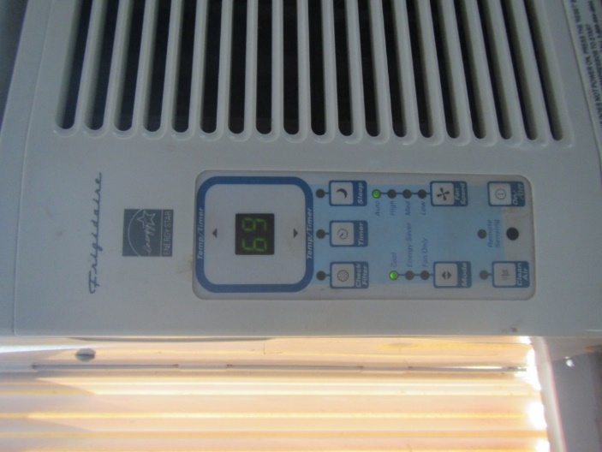

**Window air conditioner control panel**

**Picture 2**

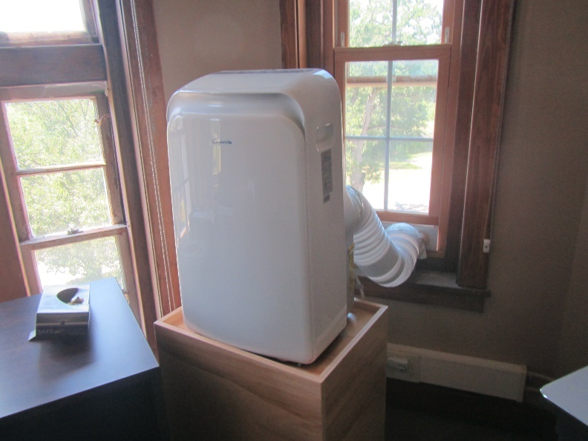

**Portable air conditioner**

Water Damage and Moisture Concern Pictures

**(click to link back to report)**

**Picture 3**

**Water-damaged ceiling tile 
**

**Water-damaged ceiling tile**

**Picture 4**

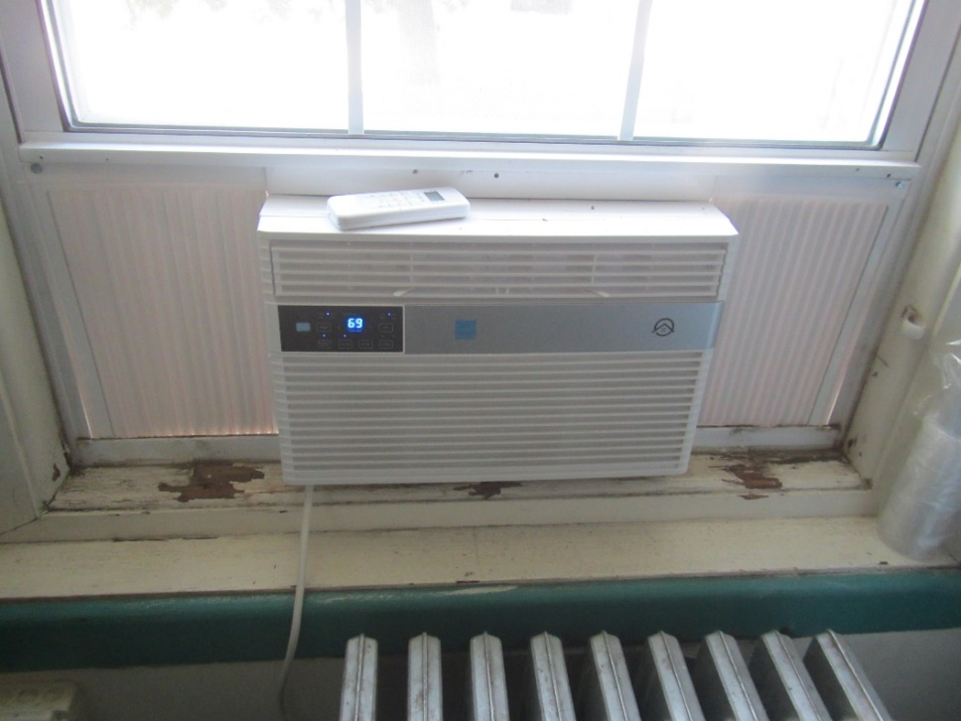

**Window air conditioner and windowsill in disrepair**

**Picture 5**

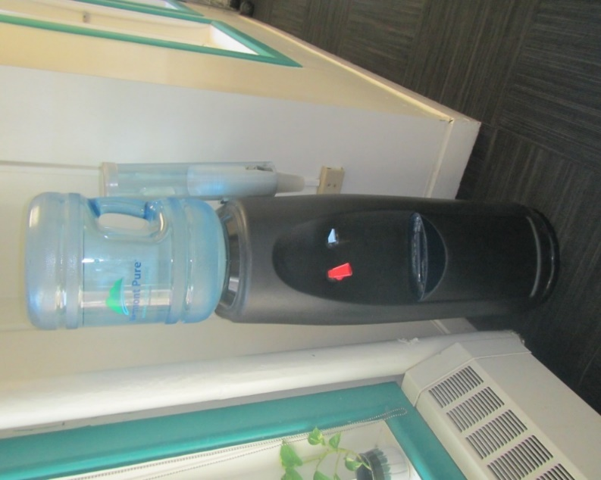

**Water cooler on carpet**

**Picture 6**

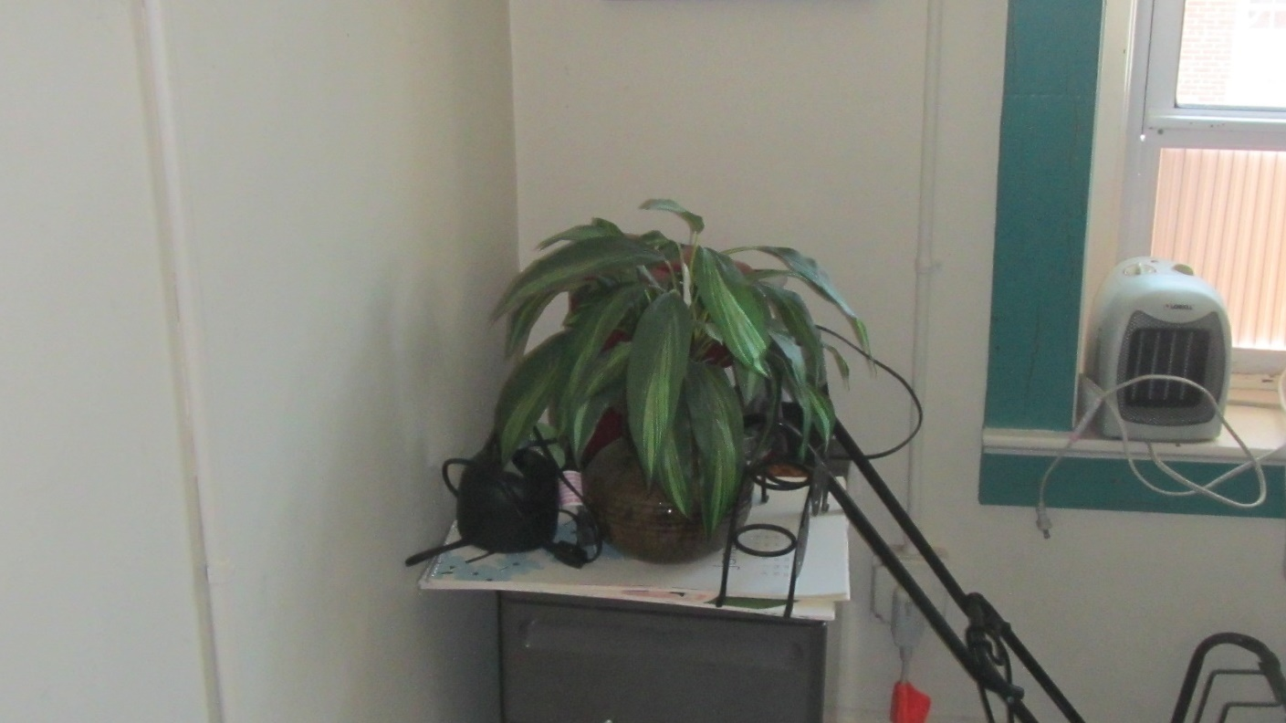

**Plant in an office**

**Picture 7**

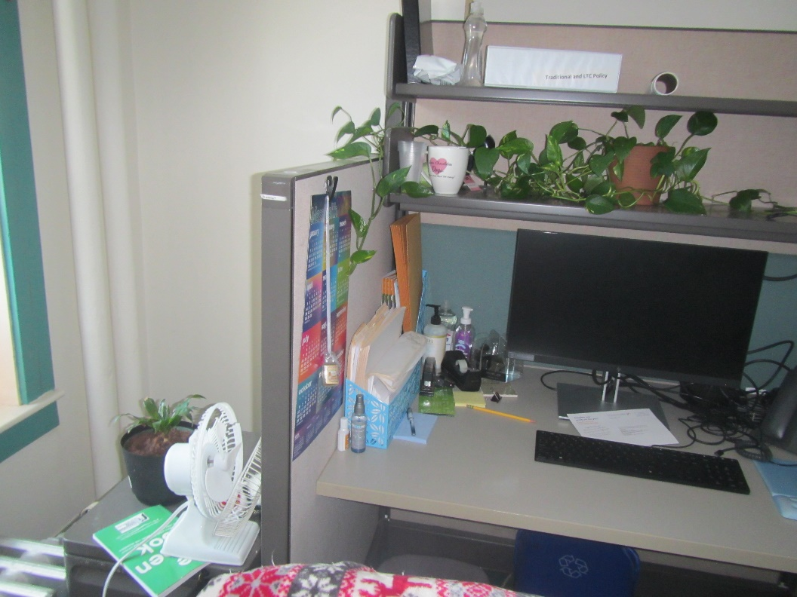

**Plants on a desk**

**Picture 8**

**Disused toilet on the third floor
**

**Disused toilet on the third floor**

**Picture 9**

**Disused sinks on the third floor 
**

**Disused sinks on the third floor**

**Picture 10**

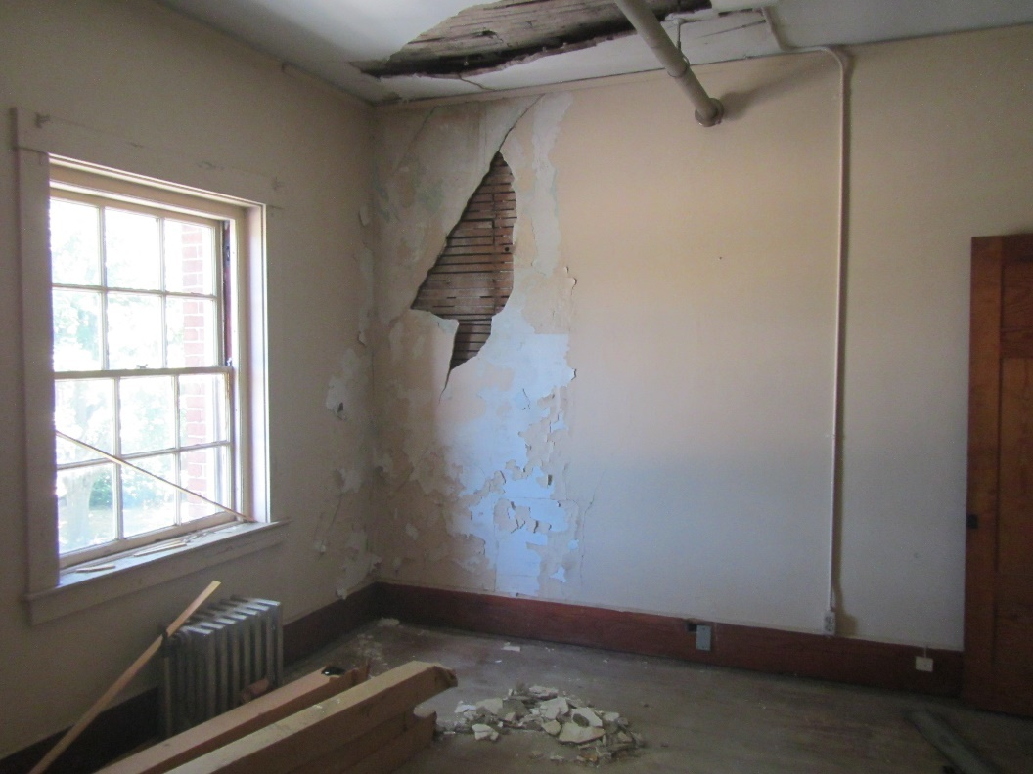

**Walls and ceiling in disrepair on third floor**

**Picture 11**

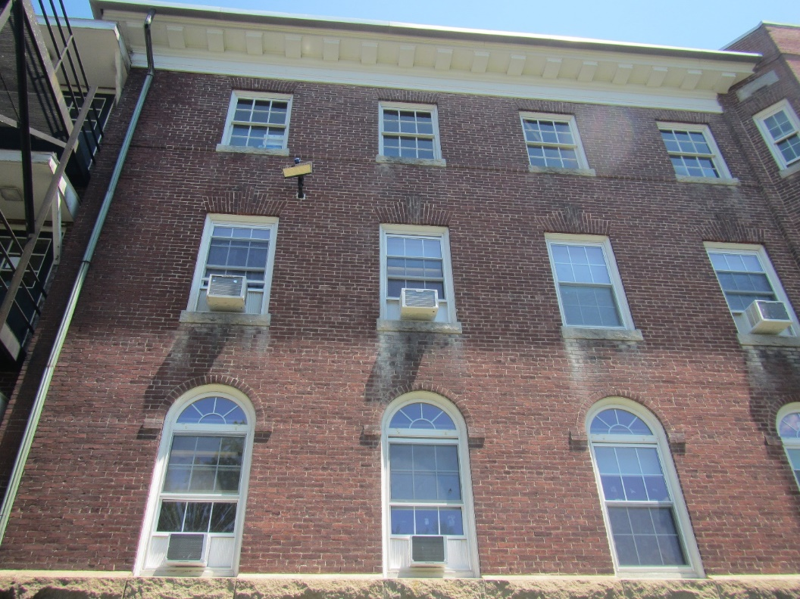

**Efflorescence underneath windows on the exterior of the building**

**Picture 12**

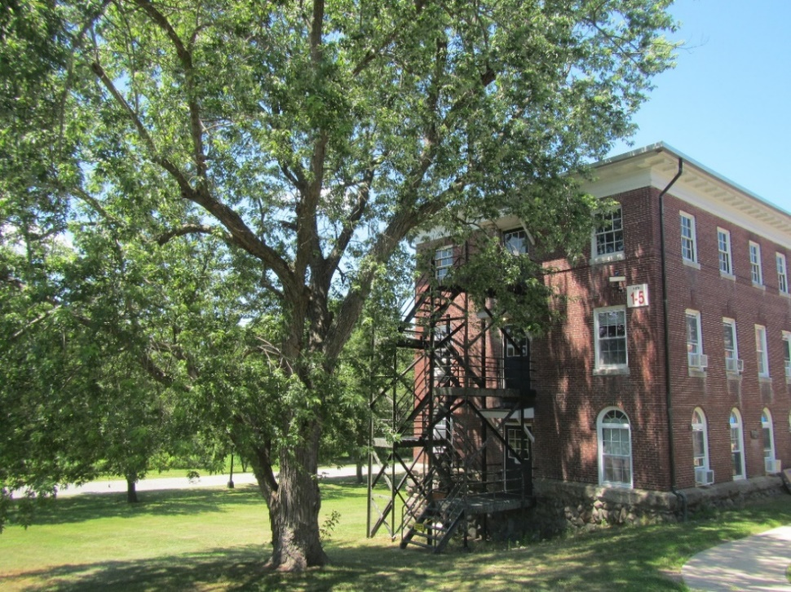

**Trees next to the building**

Sources of Respiratory Irritant Pictures

(Click to link back to report)

**Picture 13**

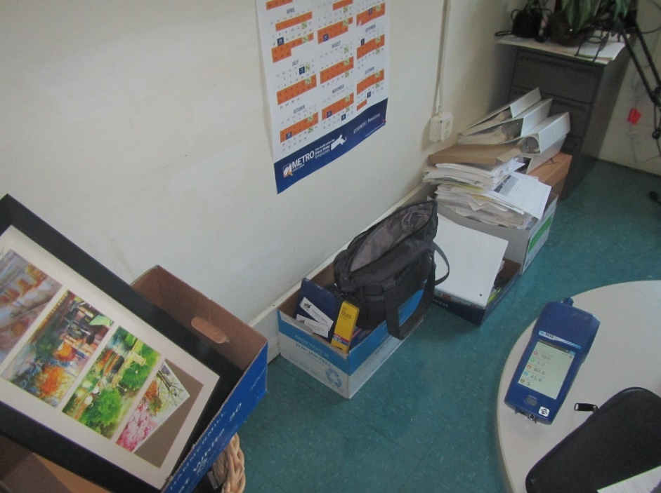

**Cardboard boxes and other items stored on office floor**

**Picture 14**

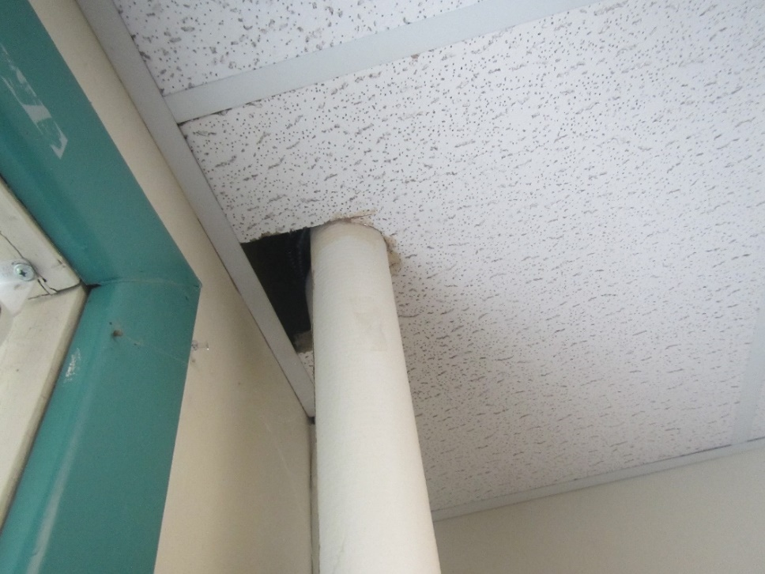

**Gap in ceiling tile around pipe**

**Picture 15**

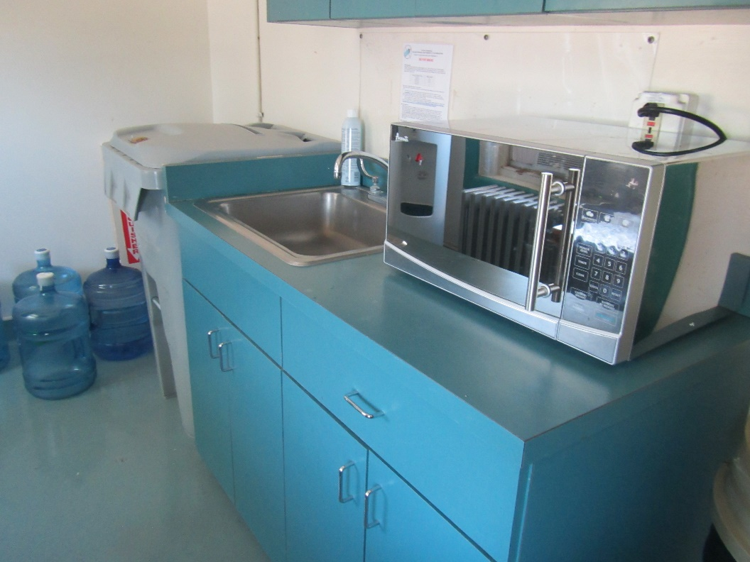

**Microwave next to kitchen sink and trash container**

**Picture 16**

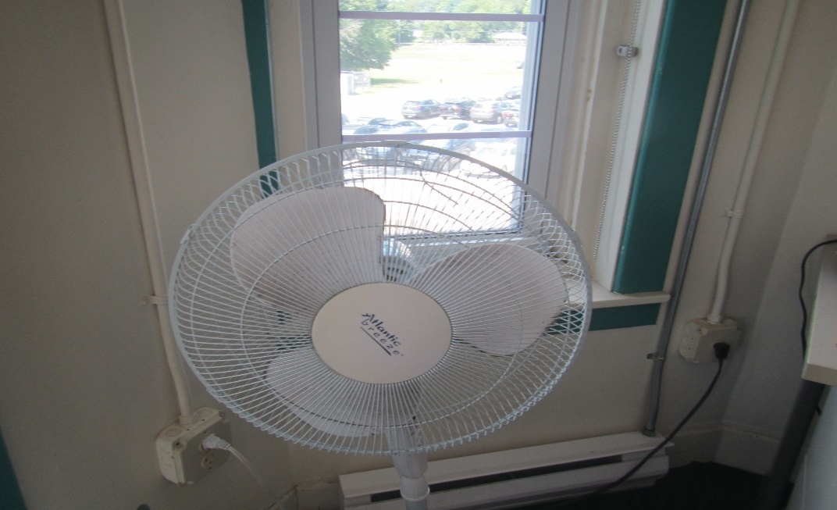

**Personal fan with accumulated dust/debris**

**Picture 17**

Portable air purifier on a desk


**Portable air purifier on a desk**

**Picture 18**

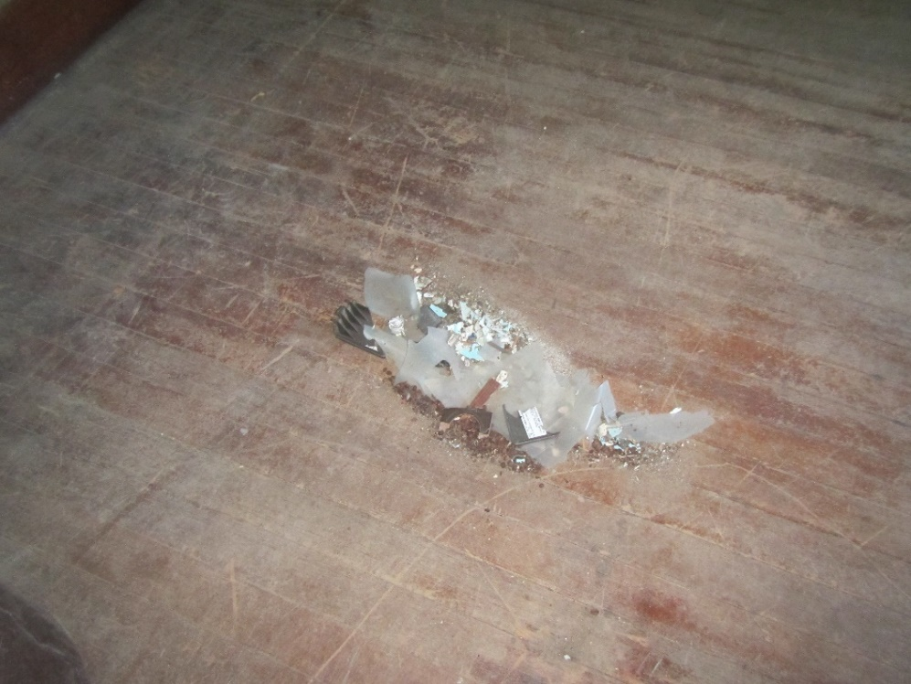

**Pile of dust and debris on third floor**

| **Location** | **Carbon**  **Dioxide**  **(ppm)** | **Carbon Monoxide**  **(ppm)** | **Temp**  **(°F)** | **Relative**  **Humidity**  **(%)** | **PM2.5**  **(µg/m3)** | **Occupants**  **in Room** | **Windows**  **Openable** | **Ventilation** | | **Remarks** |
| --- | --- | --- | --- | --- | --- | --- | --- | --- | --- | --- |
| **Supply** | **Exhaust** |
| Background (outside) | 373 | ND - 7 | 83 | 42 | 5 |  |  |  |  | Sunny. Note no carbon monoxide measured before assessment outside, levels up to 7 ppm measured outside after assessment |
| Second Floor | | | | | | | | | | |
| 200 | 854 | 1.2 | 80 | 49 | 4 | 1 | Y | N | N | Plant, NC, WAC |
| 203 | 631 | ND | 77 | 53 | 7 | 1 | Y | N | N | NC, maintenance equipment |
| 207 |  |  |  |  |  |  |  | N | N | Hole in ceiling tile |
| 208 | 652 | 1.1 | 78 | 47 | 17 | 0 | Y | N | N | NC, plants, personal fan, WAC |
| 210 | 680 | 1.1 | 76 | 47 | 8 | 0 | Y | N | N | Personal fan, office equipment machine, WAC |
| 218 | 475 | ND | 76 | 48 | 9 | 0 | Y | N | N | Carpet |
| 219 | 510 | ND | 76 | 49 | 9 | 0 | Y | N | N | Carpet, plants, coffee, small heater |
| 220 | 578 | 1 | 76 | 47 | 8 | 0 | Y | N | N | Scanner, mini-fridge, carpet, WAC |
| 221 | 521 | ND | 76 | 50 | 8 | 0 | Y | N | N |  |
| 222 | 657 | 1 | 76 | 49 | 15 | 1 | Y | N | N | Damaged ceiling tile, openings around pipes in ceiling, WAC |
| 224 | 545 | ND | 75 | 48 | 9 | 0 | Y | N | N | Carpet, plants, dusty fan |
| 262 AB | 683 | ND | 80 | 50 | 10 | 2 | Y | N | N | NC |
| Conference/IT | 606 | ND | 78 | 51 | 7 | 1 | Y | N | N | Fireplace, NC, door open to hallway |
| Kitchen/break | 521 | ND | 75 | 50 | 10 | 0 | Y | N | N | NC, elevator in back of room |
| Training room | 556 | ND | 81 | 46 | 9 | 0 | Y | N | N | no AC (portable used as needed) |
| Women’s restroom near 224 |  |  |  |  |  |  | N | N | Y | no window, air freshener |
| Women’s restroom near training room | 571 | ND | 79 | 54 | 10 | 0 | Y | N | N | NC, WAC on |
| First Floor | | | | | | | | | | |
| 103 | 1452 | 4.5 | 70 | 47 | 1 | 1 | Y | N | N | WAC, carpet |
| 105 | 1917 | 3.3 | 68 | 56 | 1 | 3 | Y | N | N | WAC, carpet |
| 106 | 1693 | 2.6 | 68 | 51 | 1 | 0 | Y | N | N | WAC, carpet |
| 107 | 1727 | 1.9 | 67 | 53 | 3 | 0 | Y | N | N | WAC, carpet |
| 108 | 1856 | 1.5 | 73 | 51 | 5 | 2 | Y | N | N | WAC, carpet |
| 113 | 800 | ND | 74 | 44 | 5 | 0 | Y | N | N | WAC, Microwave |
| 116 | 905 | 1.4 | 70 | 47 | 5 | 1 | Y | N | N | WAC, carpet |
| 117 | 750 | ND | 73 | 48 | 2 | 1 | Y | N | N | Carpet, refrigerator on carpet, WAC in only window |
| 118 | 721 | ND | 75 | 47 | 7 | 0 | Y | N | N | WAC in only window |
| 118A | 728 | ND | 75 | 47 | 5 | 0 | Y | N | N | Carpet, WAC in only window |
| 119 | 789 | ND | 76 | 47 | 6 | 0 | Y | N | N | Carpet, coffee, WAC in only window |
| 120 | 900 | 1.4 | 75 | 47 | 8 | 1 | Y | N | N | Boxes on floor, plant, carpet, WAC |
| 121 | 767 | ND | 76 | 48 | 5 | 3 | Y | N | N | Carpet |
| 122 | 1053 | 1.4 | 76 | 49 | 4 | 4 | Y | N | N | Water-damaged ceiling tile, plants, carpet, WAC |
| 124 | 626 | ND | 77 | 52 | 6 | 0 | Y | N | N | Plants, carpet, fireplace, fridge and microwave, WAC |
| 125 | 758 | ND | 76 | 52 | 4 | 2 | Y | N | N | Occupants report odors from restroom, plants, carpet, refrigerator, WAC on |
| 126 | 821 | 1.3 | 76 | 48 | 5 | 1 | Y | N | N | Personal fan, plants, air purifier, WAC |
| 127 | 712 | ND | 76 | 51 | 5 | 0 | Y | N | N | Plant, WAC in only window |
| 128 | 845 | 1.2 | 76 | 50 | 5 | 0 | Y | N | N | Plants, carpet WAC, |
| Public Side of First Floor | | | | | | | | | | |
| 100 | 1197 | 2.3 | 72 | 48 | 1 | 1 | Y | N | N | Carpet, WAC in only window |
| 101 | 1238 | 2.4 | 72 | 46 | 2 | 0 | Y | N | N | Carpet. WAC |
| 102 | 1265 | 2.1 | 71 | 47 | 2 | 0 | Y | N | N | Carpet, WAC in only window |
| 110 | 1415 | ND | 72 | 48 | 1 | 1 | Y | N | N | Ductless AC, carpet |
| Public side women’s restroom |  |  |  |  |  |  |  | N | N | AC on, plus window, |
| Public waiting | 1463 | ND | 72 | 52 | 3 | 6 | Y | N | N | Ductless AC, carpet |

(Click to link back to report)

# Table 2A

|  |  |  |  |  |  |
| --- | --- | --- | --- | --- | --- |
| **Equipment Present in Building**  **(X = Yes)** | **Type of Heating/Cooling Ventilation**  **Equipment** | **Fresh**  **Air**  **Supply**  **(X = Yes)** | **Type of Location(s)** | **Air Filters Installed**  **MERV Rating**  **(1-15, U*)**  **(X = Yes)** | **Comments** |
|  | Univents |  |  |  |  |
|  | Rooftop Air Handling Units |  |  |  |  |
|  | Outdoor, Ground-Installed Air Handling Units |  |  |  |  |
|  | Attic/Crawlspace Air Handling Units |  |  |  |  |
|  | Ceiling-Mounted Air Handling Units (including inside plenum) |  |  |  |  |
|  | Basement/Crawlspace-Installed Air Handling Units |  |  |  |  |
|  | Mechanical Room-installed Air Handling Units |  |  |  |  |
|  | Fan Coil Units |  |  |  |  |
| X | Window-Mounted Air Conditioners | X | Various |  |  |
|  | Wall Louver-Controlled Gravity Air Supply |  |  |  |  |
| X | Windows | X | Various |  |  |
|  | Fan in window (blowing in) |  |  |  |  |
|  | Built in wall fan (switched) |  |  |  |  |
|  | Heat recovery ventilator unit |  |  |  |  |
|  | Energy recovery ventilator unit |  |  |  |  |
|  | Chilled Beam |  |  |  |  |
|  | Passive combustion supply vent in basement/boiler room |  |  |  |  |

*U = Filter Rating underdetermined due to inaccessibility during building visit

(Click to link back to report)

# Table 2B

|  |  |  |  |  |
| --- | --- | --- | --- | --- |
| **Equipment Present in Building**  **(X = Yes)** | **Type of Exhaust Ventilation**  **Equipment** | **Ducted**  **To Outdoors**  **(X = Yes)** | **Type of Location(s)** | **Comments** |
|  | Rooftop Motors/Fans |  |  |  |
|  | Unit Exhaust |  |  |  |
|  | Ceiling Return Vent |  |  |  |
|  | Ceiling Return Vent, Plenum |  |  |  |
|  | Wall Return Vent |  |  |  |
|  | Kitchen Stove Hood |  |  |  |
| X | Restroom Exhaust Vent | X | Restrooms |  |
|  | Photocopier Exhaust Vent |  |  |  |
|  | Garage |  |  |  |
|  | Chemical Hood(s) |  |  |  |
|  | Locker Rooms |  |  |  |
|  | Showers |  |  |  |
|  | Lock up Cells |  |  |  |
|  | Clothes Dryers |  |  |  |
|  | Gas Water Heaters |  |  |  |
|  | Furnace-Flue to Chimney |  |  |  |
|  | Furnace/Boiler direct vent or power vent (no combustion air supply) |  |  |  |
|  | Kiln, Pottery |  |  |  |
|  | Dark Room |  |  |  |
|  | Generator Room |  |  |  |
|  | Wood Shop Dust Collector |  |  |  |
|  | Spray Paint Booths |  |  |  |
|  | Fan in window (blowing out) |  |  |  |

# Table 2C

|  |  |  |  |
| --- | --- | --- | --- |
| **Equipment Present in Building**  **(X = Yes)** | **Type of Equipment** | **Type of Location(s)** | **Comments** |
|  | Floor Fans, pedestal |  |  |
| X | Portable fans | Various |  |
| X | Air Purifier (HEPA, other) | Various |  |
|  | Floor heaters, portable |  |  |
| X | Refrigerators, Cold Beverage Vending Machines |  |  |
| X | Radiator, wall-mounted | Various |  |
|  | Radiator, floor-mounted |  |  |
| X | Passive vents (Wall/Door) | Various |  |

(Click to link back to report)

# Table 3

| **Found in Building**  **X = Yes** | **Water-Damaged Materials, Building Components or Stored Materials** | **Location** | **Visible Microbial Growth?**  **X = Yes** | **Musty odor detected?**  **X = Yes** | **Comments** |
| --- | --- | --- | --- | --- | --- |
|  | Books-other bound materials |  |  |  |  |
| X | Brick walls – broken, missing mortar | Exterior |  |  |  |
|  | Brick walls – blocked weep holes |  |  |  |  |
|  | Cardboard boxes |  |  |  |  |
|  | Carpet tiles |  |  |  |  |
|  | Carpet - Area rugs |  |  |  |  |
| X | Carpet wall-to-wall |  |  |  |  |
|  | Ceiling tiles - affixed directly to ceiling surface |  |  |  |  |
|  | Ceiling tiles - bowing-in suspended ceiling |  |  |  |  |
|  | Ceiling tiles - water-stained in splined ceiling |  |  |  |  |
|  | Ceiling tiles - water-stained in suspended ceiling |  |  |  |  |
|  | Chairs - laminated |  |  |  |  |
|  | Cloth |  |  |  |  |
|  | Countertops (around sinks) |  |  |  |  |
|  | Curtains |  |  |  |  |
|  | Dust/debris within AHU, uninvent, HVAC, chilled beam units, etc. (WD through condensation, humidity, or leaks) |  |  |  |  |
| X | Efflorescence (i.e., mineral deposits) | Various |  |  |  |
|  | Engineered woods - particleboard, plywood, Masonite |  |  |  |  |
|  | Flooring – loosened tiles |  |  |  |  |
|  | Flooring - wooden |  |  |  |  |
|  | Furniture - laminated |  |  |  |  |
|  | Furniture - upholstered |  |  |  |  |
|  | Gypsum wallboard - ceiling |  |  |  |  |
|  | Gypsum wallboard - restroom wall |  |  |  |  |
|  | Gypsum wallboard - interior wall |  |  |  |  |
|  | Gypsum wallboard – located on exterior wall |  |  |  |  |
|  | HVAC drain pan – lack of draining |  |  |  |  |
|  | HVAC filters |  |  |  |  |
|  | Insulation- attic (paper-backed) |  |  |  |  |
|  | Insulation - inside air handling unit |  |  |  |  |
|  | Insulation - on pipe(s) fiberglass |  |  |  |  |
|  | Insulation - on pipe(s) other/plaster-like material |  |  |  |  |
|  | Insulation - wall cavity |  |  |  |  |
|  | Insulation – ceiling plenum |  |  |  |  |
|  | Modular furniture – walls/cloth partitions |  |  |  |  |
|  | Musical instrument cases |  |  |  |  |
| X | Plaster ceilings | Various |  |  |  |
| X | Plaster walls | Various |  |  |  |
|  | Records/files |  |  |  |  |
|  | Refrigerator - door gasket |  |  |  |  |
|  | Refrigerator - drip pan |  |  |  |  |
|  | Refrigerator - Interior surfaces |  |  |  |  |
|  | Room divider - ceiling-mounted, sliding |  |  |  |  |
|  | Sink backsplash |  |  |  |  |
|  | Tables – laminated |  |  |  |  |
|  | Wallpaper |  |  |  |  |
|  | Wood - attic/roof materials |  |  |  |  |
|  | Wood - floor joists in basement ceiling |  |  |  |  |
|  | Wood - wall framing |  |  |  |  |
| X | Wood - window sills | Offices |  |  |  |
| X | Wood - window-mounted air conditioner framing | Offices |  |  |  |
|  | OTHER: Wooden baseboard |  |  |  |  |

WHAT ARE ENVIRONMENTAL ASTHMA TRIGGERS?

Asthma triggers are any chemical, pollutant, or allergen that can make your asthma worse. Asthma triggers can also be strong chemical smells, dust, or pets. Your asthma triggers may be different from those of other people. Not all asthma triggers affect people the same way. Environmental asthma triggers are found both indoors and outdoors. DPH link: [Asthma and Your Environment (mass.gov)](https://www.mass.gov/doc/asthma-and-your-environment-english/download)

(click to link back to report)

# Table 4

| **Condition Present**  **X = Yes** | **Possible asthma symptom-inducing environmental pollutant** | **Recommendation to reduce or eliminate the pollutant** |
| --- | --- | --- |
| X | Water Damage and/or Mold  (allergen) | Identify water source and repair to eliminate.  Clean non-porous materials.  Remove and replace porous materials susceptible to mold growth.  Perform regular water damage assessments as a tool to ensure timely mitigation as needed.  Use NIOSH water damage assessment protocol as a guide: [NIOSH water damage assessment guideline](https://www.cdc.gov/niosh/docs/2019-115/pdfs/2019-115.pdf?id=10.26616/NIOSHPUB2019115&inf_contact_key=241b5c2ed98c27d94b530dedc36f1623f651f238aa2edbb9c8b7cff03e0b16a0). |
|  | Moistening of building components during hot, humid weather (>2 days in length) (mold, allergen) | Remove materials not dried in <2 days in a manner consistent with [US EPA Mold Removal in Commercial Buildings guideline](https://www.epa.gov/mold/pdf-version-checklist-mold-remediation-mold-remediation-schools-and-commercial-buildings).  Use dehumidification in occupied basement areas and other areas with chronic dampness. |
| X | Vegetation against exterior of building (water damage-mold) | Remove all vegetation preventing building exterior drying.  Remove all vegetation capable of falling onto a building or depositing debris onto the roof. |
|  | Personal humidifiers (lack of proper maintenance)  (pollutant and allergen) | Clean and maintain properly.  Use distilled water to eliminate metal and water treatment odors.  Maintain hydration by increasing water consumption. |
| X | Drains: Floor drains, Sink drains (abandoned use)  Water bubblers (abandoned use) | If in use, pour water into drain at least twice a week.  If not in use, seal the drain with an appropriate material in accordance with Massachusetts Plumbing Code (248 CMR 10.00). |
|  | Live Animals (turtles, gerbils, birds, rabbits, etc.) | Ensure cleanliness or remove animals from the location. |
|  | Improperly maintained aquariums and terrariums (allergen) | Maintain such equipment properly to eliminate odor.  Discontinue use. |
| X | Plants and flowers  (allergen and mold) | Keep indoor plants well maintained and not overwatered. Monitor for signs of mold and pests.  Ensure water for cut flowers does not become stagnant.  Ensure dried plant material is free of odors, mold, and pests and handled carefully  If asthma risks are high, eliminate plants and flowers. |
|  | HVAC system moisture issues  (mold, allergen) | Consult ASHRAE’s minimum standards for HVAC maintenance and inspection of commercial HVAC systems (<https://www.ashrae.org/technical-resources/bookstore/standards-180-and-211>). |
|  | HVAC system contaminant issues (allergen) | Consult ASHRAE’s minimum standards for HVAC maintenance and inspection of commercial HVAC systems (<https://www.ashrae.org/technical-resources/bookstore/standards-180-and-211>). |
|  | Indoor swimming pool odors outside of swimming pool (mold, chemical) | Maintain and operate pool HVAC systems to vent odors from building.  Ensure locker room exhaust vents are operating during building hours.  All doors leading to pool should be rendered airtight and be closed. |
| X | Pollen (allergen) | Recommend installation of MERV 8 or better filters if HVAC engineer confirms HVAC system can be so equipped without adversely affecting function.  Cut grass after hours.  Cut grass in a pattern to direct clippings away from exterior wall.  Remove trees and shrubs from in front of windows and air intakes. |
|  | Dry air | Maintain hydration.  Avoid overheating of air. |
| X | Dust mites  (allergen) | Recommendation to remove non-official upholstered furniture, area rugs, pillows, cushions, etc.  Cleaning with use of HEPA-filtered vacuum cleaner.  Eliminating clutter, storing items in dust and moisture-proof containers, and regularly removing dust through wet wiping. |
| X | Pests, including rodents and cockroaches  (allergen) | Use of integrated pest management guidelines, including:   * Proper disposal of food containers * Proper storage of food products in airtight containers * Elimination of use of food as art projects * Remove pest harborages/clutter * Regular monitoring for pests   [EPA IPM guideline link](https://www.epa.gov/ipm/introduction-integrated-pest-management) |
|  | Latex-containing materials | Remove tennis balls from furniture legs. |
|  | Fragrances  (chemical) | Eliminate point sources, such as:   * Plug-in air fresheners * Aroma/oil reed diffusers * Scented sprays * Discontinue use of other scented materials * Consult DPH fragrance guideline: [*Clean air is odor-free*](https://www.mass.gov/doc/clean-air-is-odor-free-removing-fragrances-to-improve-indoor-air-quality-in-schools-and-0/download) |
|  | Strong smells from /use of Chemicals (such as cleaning products)  (chemical) | Use building-issued cleaning products.  Use products in accordance with manufacturer’s instructions including dilution, application, and ventilation.  Avoid using products that are stronger than needed for the situation. |
|  | Strong odors from new building materials (carpeting/furniture)  (chemical) | Use low VOC-emitting materials.  Air out materials (outside or in unoccupied area) prior to installation. |
|  | Tobacco smoke  Secondhand Smoke  (pollutant) | Eliminate tobacco smoking.  Seal all shared wall penetrations. |
| X | Products with a strong odor such as paint, perfume, hairspray, air fresheners, bug-spray, laminators, candles, wax melters, dry erase markers and other VOC-containing products  (chemical) | If essential:   * Provide proper exhaust ventilation to eject aerosolized product directly outdoors. * Avoid/reduce use during occupied hours.   If not necessary, remove and eliminate. |
|  | Vehicle exhaust  (pollutant) | Enforce anti-idling regulations and post signs to give notice.  Relocate vehicles away from fresh air intakes.  Require cars to park face-in at building walls.  [MA anti-idling law FAQs](https://www.mass.gov/files/documents/2018/02/20/idling-faq.pdf#:~:text=The%20Massachusetts%20Anti-Idling%20Law%20The%20goal%20of%20the,sometime%20wonder%20when%20idling%20might%20be%20considered%20necessary.) |
|  | Vapors and or fumes from gas, oil, or kerosene stoves  (pollutant) | Operate stove hood when stove in use.  Install stove hood if not present.  Ensure equipment is in good working order. |
|  | Ozone (pollutant) | Eliminate use of ozone generating equipment. |
| X | Window Air Conditioners (if not properly maintained) (allergen) | Equip with proper filter and clean periodically.  Clean drip pans.  Install in window with weathertight, non-mold-growth sustaining material. |
|  | Pottery (pollutant) | Do not operate kiln during occupied hours.  Operate kiln with exhaust system activated.  Seal all seams and holes in kiln vent.  Ensure kiln exhaust discharge terminates outdoors. |
| X | Carpeting (allergen) | Clean carpeting in a manner consistent with IICRC standards, including regular vacuuming with a high efficiency particulate air (HEPA) filtered vacuum in combination with annual cleaning or semi-annual cleaning in soiled high traffic areas. |
| X | Sweeping/dusting vs HEPA vacuuming/wet wiping  (allergen or pollutant) | Refrain from using feather dusters or brooms.  Utilize HEPA vacuums and wet wiping to minimize aerosolizing particulate matter. |
| X | Lack of adequate air exchange/mechanical ventilation | Make repairs as necessary and ensure all HVAC system components are operating continuously when building is occupied. |
|  | Lack of local exhaust at source of pollution (vocational shop activities, kitchen exhaust hood) (all) | Recommend installation of exhaust ventilation to direct pollutants directly outdoors. |
|  | Renovating buildings while occupied  (chemical) | Use all SMACNA guidelines for Renovation While Buildings Are Occupied. For information, visit <https://www.mass.gov/service-details/construction-and-renovation-generated-pollutants-in-occupied-buildings>. |
|  | Chemistry program chemical storage  (chemical) | Repair (if needed) and operate chemical storeroom vents appropriately.  Reduce or eliminate unneeded or overstocked chemicals.  Store all chemicals in a manner to separate incompatible chemicals.  Keep chemical storerooms clean. |
| X | Photocopiers/duplicating machines | All machines should have dedicated exhaust vents or be used in a well-ventilated area. |