WATER DAMAGE ASSESSMENT

Merrimack Center
Tewksbury Hospital Special Building
365 East Street
Tewksbury, MA

Prepared by:
Massachusetts Department of Public Health
Bureau of Environmental Health
Indoor Air Quality Program
September 2021

BACKGROUND
Building: | Merrimack Center at Tewksbury Hospital (MC)
Address: | 365 East Street, Tewksbury, MA
Assessment Requested by: | Scott J. Consaul, Chief Operating Officer, Tewksbury Hospital, Department of Public Health
Reason for Request: | Water damage assessment in multiple rooms on the lower level
Date of Assessment: | September 10, 2021
Massachusetts Department of Public Health/Bureau of Environmental Health (MDPH/BEH) Staff Conducting Assessment: | Ruth Alfasso Environmental Engineer/Inspector, Indoor Air Quality Program
Building Description: | The MC is located in a two-story fieldstone and brick building located on the campus of Tewksbury Hospital. It was originally constructed in the early 1900s.
Windows: | Openable

METHODS
DPH staff conducted testing for carbon dioxide, carbon monoxide, temperature, and relative humidity with a TSI, Q-Trak, IAQ Monitor 7565. Surface temperature was measured using a laser thermometer. Moisture testing of flooring and other materials was determined using a moisture meter, and a visual assessment of water-damaged materials was also conducted. Air tests for airborne particle matter with a diameter less than 2.5 micrometers were taken with the TSI, DUSTTRAK™ Aerosol Monitor Model 8520. Please refer to the IAQ Manual for methods, sampling procedures, and interpretation of results (MDPH, 2015).

RESULTS AND DISCUSSION
Only a limited area in the lower level was examined during this visit. The following is a summary of indoor air testing results (Table 1):
- Carbon dioxide levels were below the MDPH recommended level of 800 parts per million (ppm) in all areas surveyed.
- Temperature was within the MDPH recommended range of 70°F to 78°F in areas tested.
- Relative humidity was within or slightly above the MDPH recommended range of 40 to 60% in all areas.
- Floor temperatures were in a range of 69°F to 73°F, less than 5°F colder than the corresponding air temperature.
- Carbon monoxide levels were non-detectable (ND) in all areas tested.
- Particulate matter (PM2.5) concentrations measured were below the National Ambient Air Quality (NAAQS) level of 35 μg/m³ in all areas tested

Ventilation
A heating, ventilating and air conditioning (HVAC) system has several functions. First it provides heating and, if equipped, cooling. Second, it is a source of fresh air. Finally, an HVAC system will dilute and remove normally occurring indoor environmental pollutants by not only introducing fresh air, but by filtering the airstream and ejecting stale air to the outdoors via exhaust ventilation. Even if an HVAC system is operating as designed, point sources of respiratory irritation may exist and cause symptoms in sensitive individuals.
The only source of fresh air into the areas examined during this visit are openable windows, many of which were open during the visit (Table 1). Heating is provided by radiators during the heating season. Each classroom and other rooms examined had a ductless air conditioning unit on the wall providing for cooling and some humidity control (Picture 1). Due to concerns about water damage and humidity, free-standing dehumidification units were also supplied to many rooms (Picture 2). The ductless air conditioners are newly retrofitted to the rooms examined, and this is the first season they are being used.

Microbial Concerns
The reason for this visit to the MC was concerns regarding odors and water damage in the classrooms. When classrooms were entered, a faint musty odor could be detected. According to building facility staff, much stronger odors had been present prior to the visit. This prompted the temporary closure of use of these rooms, the use of additional dehumidification, and further investigation. Odors were reportedly traced to openings in the ceiling that may have been created during installation of the ductless AC units (Picture 3). Sealing of these openings as shown in Picture 3 had reportedly decreased the odor.
The potential exists for moistening of building materials both due to the infiltration of water and condensation from humid air from outside. The key to managing condensation in hot, humid weather indoors is understanding dew point. When warm, moist air passes over a cooler surface, condensation can form. Condensation is the collection of moisture on a surface at or below the dew point. The dew point is the temperature that air must reach for saturation to occur. If a building material/component has a temperature below the dew point, condensation will accumulate on that material. If this material is porous, such as carpeting, it may become colonized by mold. Measurements of floor temperatures were conducted in many areas and floors were up to 4ºF cooler than the air. This temperature differential likely exists because the floor is uninsulated and in contact with the ground. With significantly higher humidity, condensation could occur on the floor. When air and floor (or other building materials) temperatures differ by significantly (>5ºF), condensation may form during humid weather (<70%). Measures to reduce indoor relative humidity are recommended if outdoor relative humidity greater than 70% continues for longer than 24 hours in order to prevent microbial growth, as well as increase building occupants’ comfort (see Appendix A).
The use of air conditioning when windows are open has the potential for creating localized conditions below the dew point where hot humid outside air meets chilled surfaces. Because the windows are the only source of fresh air, and would therefore be open during occupancy, care should be taken to avoid placing porous materials or highly heat-conductive materials (e.g., a metal shelf) in the direct airstream of the air conditioner.
The floors in classrooms are covered by carpet tile squares (Picture 4). Carpet tiles are more resistant to microbial growth than wall-to-wall carpeting, and the carpeting used is very thin, so it is likely to dry quickly if conditions causing moisture have stopped. While building staff reported water seepage in the classrooms previous to the visit, no measurements of moisture in carpet tile were elevated during the visit. In addition, carpet tiles were well adhered to the substrate (slab) and could not be pulled up by hand. No musty odors were detected from carpeting. Wallboard was also measured for excess moisture, and none of the areas accessed had elevated moisture at the time of the visit. Some areas of wall and carpeting were not accessible for measurement. In general, the DPH IAQ program does not recommend the use of carpeting or other porous flooring in areas that are likely to be subject to moistening, particularly in below-grade or at-grade rooms.
While there did not appear to be any direct water damage to the wallboard along the exterior of the building, an examination of the exterior of the building in the vicinity of the classrooms showed several conditions that may lead to water infiltration. Note that the classrooms are partly below grade and the walls on the lower part of the building are made of stone. New downspouts have recently been installed to better direct water from the roof to the ground, however the downspouts terminate above the ground in this area due to the potential damage to downspout material by program participants who use this area for outdoor exercise. Therefore, water from the downspouts splashes against the building (Picture 5). In addition, there is ivy clinging to part of the wall (Picture 6), which prevents the wall from drying and will eventually damage mortar and lead to potential water infiltration. It was also noted that a therapy dog for the program has been digging along the exterior wall, which may lead to pooling water and deterioration of building materials.
It was not possible to look behind the wallboard in the classrooms. Depending on the type and installation method of this wallboard, it is possible that water damage and microbial growth has occurred to wallboard on the side facing the wall. If odors persist, this area should be investigated.
Note that the classrooms had a large number of items in them, including bookcases, cabinets, books, papers, and pillows. Some of these items were on the floor or were up against walls. Due to the potential for water damage, items should not be stored on the floor, and there should be, wherever possible, a gap between anything in the room and the exterior walls.
It is recommended that porous material be dried with fans and heating within 24 to 48 hours of becoming wet (US EPA, 2008, ACGIH, 1989).
The ductless air conditioners accumulate condensate that needs to be drained. Each unit is equipped with a pump to direct this condensate to an appropriate drain. It is important to ensure that each unit is properly installed and checked periodically so that condensate does not leak or become stagnant.

Other Conditions
Carpets should be cleaned annually (or semi-annually in soiled/high traffic areas) in accordance with Institute of Inspection, Cleaning and Restoration Certification (IICRC) recommendations, (IICRC, 2012).
The Environmental Protection Agency (EPA) conducted a National School Radon Survey in which it discovered nearly one in five schools had “…at least one frequently occupied ground contact room with short-term radon levels above 4 [picocuries per liter] pCi/L” (US EPA, 1993). The BEH/IAQ Program therefore recommends that every school be tested for radon, and that this testing be conducted during the heating season while school is in session in a manner consistent with USEPA radon testing guidelines. Radon measurement specialists and other information can be found at www.nrsb.org and http://aarst-nrpp.com/wp, with additional information at: http://www.mass.gov/eohhs/gov/departments/dph/programs/environmental-health/exposure-topics/iaq/radon.

CONCLUSIONS AND RECOMMENDATIONS
In view of the findings at the time of the visit, the following recommendations are made:

Ventilation Recommendations
- Use openable windows for fresh air when rooms are occupied, ensure windows are closed tightly when rooms are unoccupied and during periods of very wet weather to reduce indoor humidity.
- Consider for the future if installation of filtered mechanical ventilation for this space is possible.

Water Damage Recommendations:
- Continue to use dehumidifiers and air conditioning systems consistently in affected areas.
- Empty, clean and maintain all dehumidifiers to reduce stagnant water and the potential for odors.
- If odors persist or reoccur after sealing the holes in the ceiling as shown in Picture 3, continue investigation for source of the odor. Often, items such as books or furniture that have become wet can be a source of an odor, so porous materials should be investigated individually and any items that are water-damaged or have a musty odor should be discarded. Another potential source is the interior of wallboard along exterior walls. A small hole can be opened for further investigation.
- All water-damaged material should be removed in a manner consistent with recommendations listed in the US EPA’s “Mold Remediation in Schools and Commercial Buildings” (US EPA, 2008). This work should be performed when the building is unoccupied.
- Consider using the methods described in the document “Preventing Mold Growth in Massachusetts Schools During Hot, Humid Weather” to help reduce the impact of hot, humid weather in the space. This guideline is attached as Appendix A and can be found online at: https://www.mass.gov/service-details/preventing-mold-growth-in-massachusetts-schools-during-hot-humid-weather
  - According to ASHRAE, if relative humidity exceeds 70%, mold growth may occur due to wetting of building materials (ASHRAE, 1989).
  - Monitoring weather for predicted outdoor relative humidity over 70% for over 2 consecutive days is recommended. It is highly recommended to implement these guidelines during these weather events. This is most likely to occur during summer heatwave conditions in New England.
- Consider methods to improve drainage and drying around the exterior of the building, including sloping of the ground away from the building and potentially directing downspouts to another area where they can terminate near the ground away from the building. Fill in areas that may allow for pooling water next to the building
- Remove clinging plants from the exterior of the building. Trim any plants within 5 feet of the building exterior, including overhanging trees.

Other Recommendations
- Reduce clutter in classrooms and ensure items are stored off the floor, and in waterproof containers.
- Clean carpeting annually (or semi-annually in soiled high traffic areas) as per the recommendations of the Institute of Inspection, Cleaning and Restoration Certification (IICRC, 2012).
- The building should be tested for radon by a certified radon measurement specialist during the heating season when school is in session. Radon measurement specialists and other information can be found at: www.nrsb.org, and http://aarst-nrpp.com/wp.
- To learn more about radon, review the MDPH’s Radon in Schools and Child Care Programs factsheet, with additional information at: http://www.mass.gov/eohhs/gov/departments/dph/programs/environmental-health/exposure-topics/iaq/radon.
- Refer to the resource manual and other related indoor air quality documents located on the MDPH’s website for further building-wide evaluations and advice on maintaining public buildings. These documents are available at http://mass.gov/dph/iaq.

REFERENCES
ACGIH. 1989. Guidelines for the Assessment of Bioaerosols in the Indoor Environment. American Conference of Governmental Industrial Hygienists, Cincinnati, OH.
ASHRAE. 1989. Ventilation for Acceptable Indoor Air Quality. American Society of Heating, Refrigeration and Air Conditioning Engineers. ANSI/ASHRAE 62-1989.
IICRC. 2012. Institute of Inspection, Cleaning and Restoration Certification. Carpet Cleaning: FAQ.
MDPH. 2015. Massachusetts Department of Public Health. Indoor Air Quality Manual: Chapters I-III. Available at: https://www.mass.gov/lists/indoor-air-quality-manual-and-appendices#indoor-air-quality-manual-
US EPA. 1993. Radon Measurement in Schools, Revised Edition. Office of Air and Radiation, Office of Radiation and Indoor Air, Indoor Environments Division (6609J). EPA 402-R-92-014.
US EPA. 2008. “Mold Remediation in Schools and Commercial Buildings”. Office of Air and Radiation, Indoor Environments Division, Washington, DC. EPA 402-K-01-001. September 2008. Available at: http://www.epa.gov/mold/mold-remediation-schools-and-commercial-buildings-guide
Picture 1

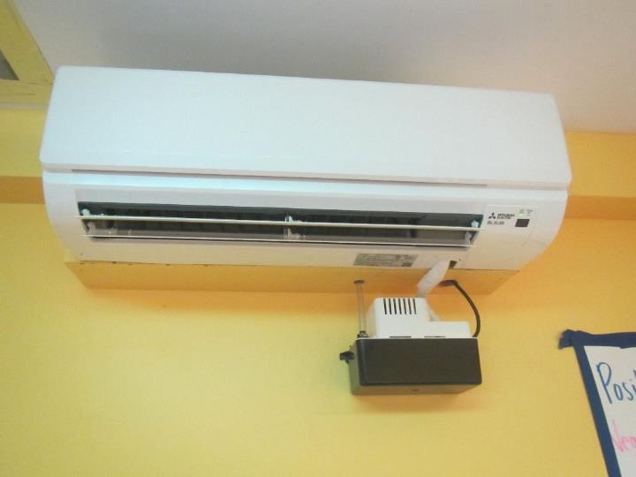
Ductless air conditioner with condensate pump
Picture 2
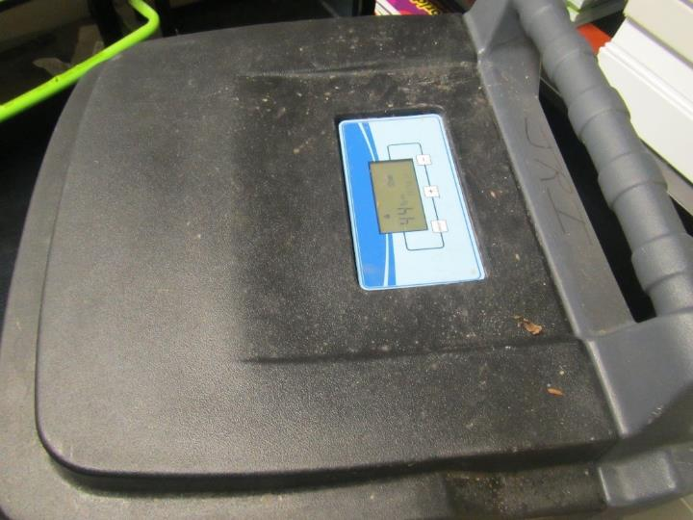
Heavy-duty dehumidifier
Picture 3
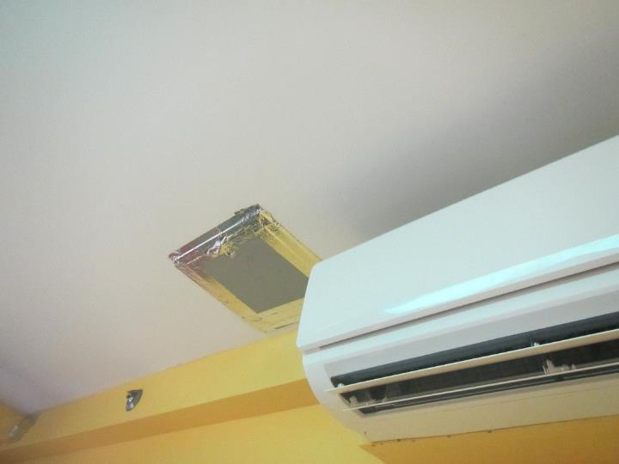
Sealed square hole in the ceiling adjacent to ductless air conditioner
Picture 4
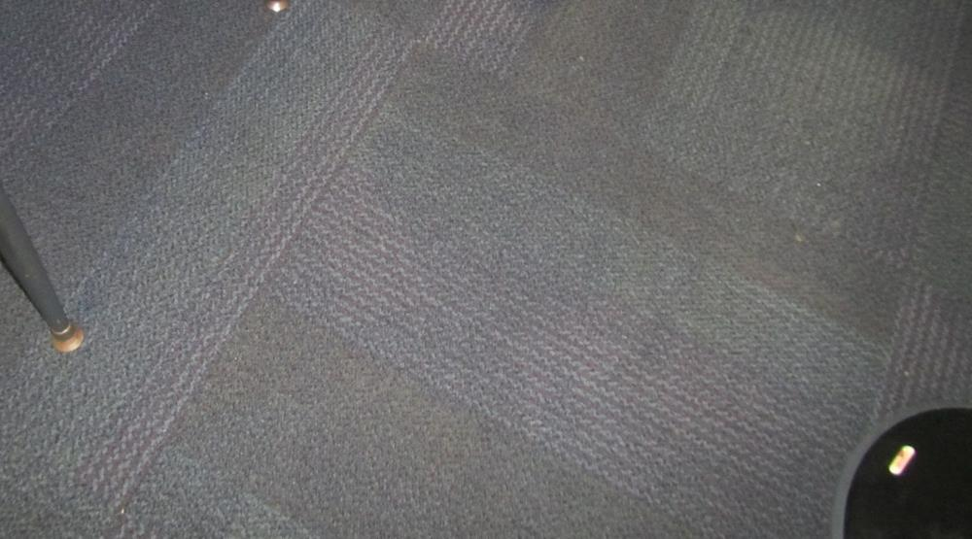
Carpet tile squares
Picture 5
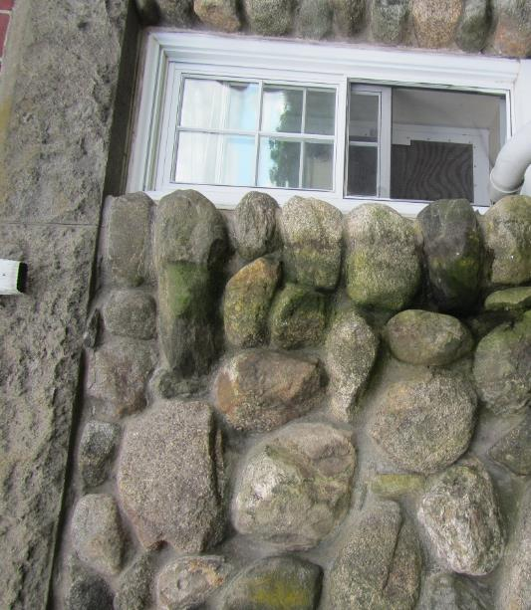
Downspout terminus and wet stone wall
Picture 6
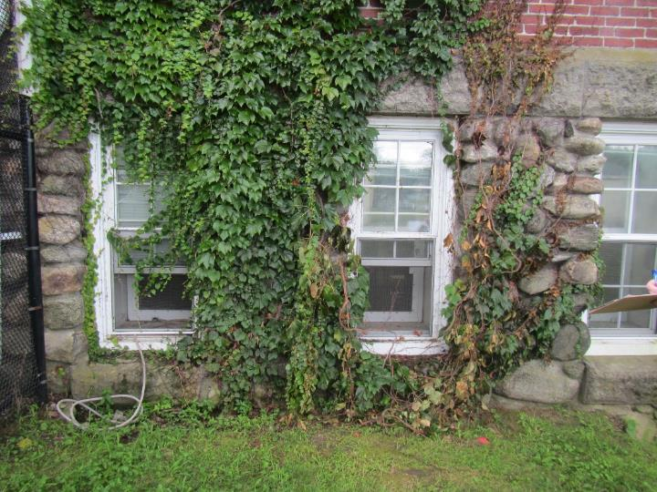
Ivy clinging to walls
Location | Carbon Dioxide  (ppm) | Carbon Monoxide (ppm) | Temp  (°F) | Relative  Humidity  (%) | Floor Temp  (°F) | PM2.5  (µg/m³) | Occupants | Window  Openable | Ventilation |  | Remarks
 |  |  |  |  |  |  |  |  | Supply | Exhaust
Background (outside) | 372 | ND | 76 | 56 |  | 4 |  |  |  |  | Sunny
Classroom (middle of three) | 391 | ND | 73 | 51 | 69-70 | 3 | 0 | Y open | N | N | Ductless AC (on), dehumidifier (on), carpet squares
Classroom 2 | 368 | ND | 72 | 51 | 69-71 | 3 | 0 | Y open | N | N | Ductless AC (on), Dehumidifier (on), carpet squares
Classroom | 399 | ND | 71 | 58 | 67-68 | 5 | 2 | Y open | N | N | Ductless AC, carpet squares
Office | 437 | ND | 72 | 62 | 71 | 5 | 0 | Y | N | N
Family | 429 | ND | 72 | 56 |  | 4 | 0 | N | N | N | Wood floor on slab
Dining | 495 | ND | 71 | 59 |  | 12 | 4 | Y not open | N | N | Ductless AC (on), window AC in windows (to be removed) food/cooking odors, not carpeted

BUREAU OF ENVIRONMENTAL HEALTH
Indoor Air Quality Program

Preventing Mold Growth in Massachusetts Schools
During Hot, Humid Weather

June 2004

Background/Statement of the Problem
During the summers of 2002 and 2003, schools and other municipal buildings experienced significant mold problems. As a result, at least thirty school systems have experienced delayed school openings and/or have spent substantial funds on cleaning and remediating mold growth in schools. These mold growth problems are directly related to unusual weather patterns in New England (e.g., extended periods of hot, humid weather).

Mold growth in a building can produce eye, nose, throat, and respiratory irritation. Mold may also exacerbate pre-existing respiratory problems (e.g., asthma) and cause symptoms in hypersensitive individuals. For these reasons, it is recommended that mold contaminated materials be removed or cleaned, where feasible (US EPA, 2001).

This document provides guidance on preventing or minimizing mold growth within a building. Most mold prevention steps can be employed in any building. However, certain steps involving dehumidification can only be achieved with dehumidifiers and/or heating, ventilating, and air-conditioning (HVAC) equipment

Understanding Dew Point
In general, two water phases - liquid and vapor - can create conditions conducive to fungal colonization of vulnerable materials. Leaks through the building envelope (e.g., roof, exterior wall components, foundation) or plumbing problems are obvious water sources. If the indoor environment is improperly managed, high relative humidity combined with hot weather can also cause damage. Under certain conditions, condensation can accumulate and moisten materials, especially porous, carbon-containing items (e.g., gypsum wallboard, carpeting, cloth, paper, cardboard).

The key to managing condensation within a building is understanding dew point. When warm, moist air passes over a cooler surface, condensation can form. Condensation is the collection of moisture on a surface at or below the dew point. The dew point is the temperature that air must reach for saturation to occur. If a building material/component has a temperature below the dew point, condensation will accumulate on that material. Over time, condensation can collect and form water droplets.

For example, at a temperature of 76ºF and relative humidity of 30%, the dew point temperature at which condensation can collect on a surface is approximately 42ºF. At temperatures less than 43ºF, water vapor can condense and form droplets on a surface. During humid weather, when the temperature is 85ºF and relative humidity is 90%, the dew point is approximately 82ºF. Therefore, surfaces with a temperature below 83ºF are prone to condensation formation.

According to American Society of Heating, Refrigerating and Air-Conditioning Engineers (ASHRAE), if relative humidity exceeds 70%, mold growth may occur due to wetting of building materials (ASHRAE, 1989). It is recommended that porous material be dried with fans and heating within 24 to 48 hours of becoming wet (US EPA, 2001, ACGIH, 1989). If porous materials are not dried within this time frame, mold growth may occur. Water-damaged porous materials cannot be adequately cleaned to remove mold growth. To prevent condensation formation, the following points are recommended:
Action Step: Monitor weather through extended weathercasts to determine if hot, humid weather for more than 2 days is predicted. Many web-based weather services will provide a dew point listing.
Action Step: Monitor temperature of condensation prone building components with a laser thermometer. If the temperature of the building component is below the dew point during hot, humid weather, steps should be taken to decrease humidity levels.

Reducing Relative Humidity through Mechanical Means

Cooling
Cooling air is the easiest method to reducing airborne water vapor. Window-mounted air conditioners and most HVAC systems are equipped with cooling coils. Each of these cooling efforts operates by drawing air over cooling coils that are set to a temperature below the dew point. As a result, condensation forms. In this manner, moisture is removed, before air is provided to a room. Although this method is the easiest for reducing indoor relative humidity, two disadvantages exist. First, drainage for condensation must be adequate to remove water at a sufficient rate. If a significant amount of water accumulates and lingers in the drip pan, the operation of HVAC system fans can reintroduce the moisture into the air stream. In addition, stagnant water can provide a medium for mold growth and associated odors.
Action Step: If systems equipped with cooling coils are used to remove moisture, ensure drain pans are operating as designed. Drain pans should not rely on evaporation to remove condensation; rather, water should drain rapidly. If pans are draining improperly, the drainage should be repaired. If proper drainage cannot be provided, this method of relative humidity reduction should be avoided.
Another problem associated with using cooling coils to reduce relative humidity is the potential for condensation generation on building components. This occurs when the HVAC system chills building components below the dew point. Most problems experienced in schools occurred in August 2003, when the buildings were unoccupied. HVAC systems are typically configured for occupied rooms, where room occupants generate heat. However, lack of building occupancy reduces the waste heat in a room. If the HVAC system operates at settings for occupied rooms during extended periods of vacancy, the chilling system operates at a temperature below the design. In this manner, building components are chilled below the dew point, causing condensation to form. Under these circumstances, monitoring of building component temperatures is vital to preventing/ minimizing condensation development.
Action Step: Monitor temperature of condensation prone building components with a laser thermometer. If the temperature of building components is below the dew point, raise the HVAC system set point to elevate the temperature of building materials above the dew point. The temperature of insulated chilled water pipes and HVAC components in contact with chilled air should also be monitored.

Dehumidifying
As with window-mounted air conditioners and HVAC systems, dehumidifiers also remove moisture from an indoor environment by cooling air drawn into the system. Although this method is effective, the dehumidification process also has limitations. Condensation usually drips into a collection well. If the water in the collection well becomes stagnant, it can provide the potential for mold growth.
Action Step: Clean and maintain dehumidifiers as per manufacturer’s instructions. Some dehumidifiers are also equipped with condensation drain hoses. Measures should be taken to ensure water is draining out of hoses when dehumidifiers are operating.
Action Step: Ensure drain hoses are pointed downwards into a suitable receptacle (e.g., sink) and away from porous materials. Monitor draining when the dehumidifier is actively operating.

Heating
Although counterintuitive, the application of heat to building components (e.g., slab floors and foundation in contact with soil, below grade areas) can reduce condensation generation and prevent mold growth. This method is typically employed in areas lacking mechanical ventilation (e.g., storage rooms).
Action Step: Use carpet-drying fans to apply heat to slab floors with carpeting and below grade occupied areas with carpeting, gypsum wallboard, particleboard, plywood, or ceiling tiles.

Increasing airflow
By increasing the airflow of a building, accumulation of hot, moist air can be reduced, decreasing the opportunity for porous materials to become wet. Areas particularly prone to elevated moisture include storage closets and occupied spaces without mechanical ventilation.
Action Step: Implement the following methods to promote increased airflow:
- Open all interior doors between rooms and closets.
- Operate HVAC systems not equipped with chilling components (e.g., unit ventilators, or univents) with the fresh air intake vents closed.
- Operate general exhaust ventilation system normally.
- Arrange floor fans in hallways to circulate air.

Operating specialized exhaust ventilation
Activities in some non-classroom areas can generate water vapor. These areas include pools, kitchens, restrooms, and locker rooms/showers. Specially designed exhaust ventilation systems in these areas should be provided to remove both odors and water vapor. This equipment is designed to prevent migration of odors and water vapor to other areas of a building.
Action Step: Operate exhaust vents in restrooms and locker rooms/showers during hot, humid weather to remove water vapor. The pool exhaust ventilation should be operating at all times.

Removing Porous Materials from Exposure to Water Vapor
To prevent mold growth in buildings, a number of mitigation steps can be taken. Measures may include the removal of porous materials from areas likely to be in contact with surfaces that have a temperature below the dew point, or removal of porous materials from hot, humid areas.
Action Step: The following measures can be used to reduce fungal growth of porous materials.
- Avoid placing wall-to-wall carpeting or other porous materials on slab in contact with soil or on floors in below grade areas.
- Avoid placing porous materials on temperature bridges. A temperature bridge is a structure that allows cooler temperatures to transfer between two areas. Furniture made of metal is more likely to be susceptible to temperature fluctuations. Avoid storing porous materials on metal objects that are low and in contact with floor or foundation walls.
- Store porous materials in airtight, hard plastic containers.
- Avoid placing porous materials between fresh air supply vents and exhaust vents. The air between this equipment is likely to hold moisture since these systems are used to remove water vapor from a building interior.

Preventing Moisture Intrusion

Separating occupied areas from unoccupied areas
A crawlspace is an unoccupied area that typically consists of a dirt floor, which holds moisture. As a result, this area is prone to high relative humidity and mold growth. The crawlspace is often used as a chase way to run pipes and electrical services to rooms through a building. Crawlspaces are usually present in schools that are equipped with univents connected to heating pipes. Spaces and holes in walls and floors provide a pathway for crawlspace air to penetrate classrooms. Breaches around pipes also provide a means for crawlspace air and associated odors/particles to be drawn and distributed to classrooms via univents. In order to prevent moisture and potential fungal pollutant migration from the crawlspace to occupied areas, penetrations should be rendered airtight.
Action Step: Seal holes/breaches with an appropriate fire-rated sealant compound to prevent air draw from the crawlspace.

Reducing the Water Load on the Building Envelope
Breaches in the building envelope or water pooling on/against a building structure can also result in water penetration and subsequent mold growth. Buildings are typically designed for minimal water impingement via building envelope components, including the roof, exterior walls, foundation, and other penetration points through the structures. For example, exterior wall systems should be designed weep holes and drainage plans to prevent moisture accumulation penetration.

An exterior wall system of many buildings contains an exterior curtain wall. Behind the curtain wall is an air space that allows for water to drain downward and for the exterior cladding system to dry. At the base of the curtain wall should be weep holes that allow for water drainage. Opposite the exterior wall and across the air space is a continuous, water-resistant material adhered to the back up wall that forms the drainage plane.

The purpose of the drainage plane is to prevent moisture that crosses the air space from penetrating the interior building system. The plane also directs moisture downwards toward the weep holes. The drainage plane can consist of a number of water-resistant materials, such as tarpaper or, in newer buildings, plastic wraps. The drainage plane should be continuous. Where breaks exist in the drainage plane (e.g., window systems, door systems and univent fresh air intakes), additional materials (e.g., copper flashing) are installed as transitional surfaces to direct water to weep holes. If the drainage plane is discontinuous, missing flashing or lacking air space, rainwater may accumulate inside the wall cavity and lead to water vapor/moisture penetration into the building.

In order to allow water to drain from the exterior brick wall system, a series of weep holes is customarily installed at or near the foundation slab/exterior wall system junction. Weep holes allow for accumulated water to drain from a wall system (Dalzell, 1955). Lack of weep holes in brickwork or burial of weep holes below grade will allow water to accumulate in the base of walls, resulting in seepage and possible moistening of building components.

Unless a structure is designed to be in contact with pooling water, efforts should be made to prevent water from pooling for extended periods. For example, standing water on flat roofs as well as water in contact with foundations and floor slabs should be removed. Mitigation efforts may include modifications to the building design and construction.
Action Step: Reduce pooling water around the building envelope and around the exterior wall system through the following methods:
- Install gutters and downspouts to direct rainwater at least five feet away from the foundation. Gutters should extend along the entire roof edge.
- Remove foliage and wood chips to no less than five feet from the foundation.
- Improve the grading of the ground away from the foundation at a rate of 6 inches per every 10 feet (Lstiburek & Brennan, 2001).
- Install a water impermeable layer (e.g., clay cap) on ground surface to prevent water saturation of ground near foundation (Lstiburek & Brennan, 2001).
- Remove trees in close proximity to building to increase drying of exterior walls.
- Ensure weep holes in exterior walls are not blocked with wicks or buried below grade. Weep holes must be free of blockage and located above grade to allow water to drain and air to penetrate and aid in drying into the drainage plane. Configure the weep hole opening to prevent insect entry into the drainage plane.
Questions
If you have any questions concerning these guidelines, please contact:

Massachusetts Department of Public Health
Bureau of Environmental Health
Indoor Air Quality Program
250 Washington Street, 7th Floor
Boston, MA 02108

Phone: (617) 624-5757
Fax: (617) 624-5777
Document Reviewed: August 2008
References
ACGIH. 1989. Guidelines for the Assessment of Bioaerosols in the Indoor Environment. American Conference of Governmental Industrial Hygienists, Cincinnati, OH.
ASHRAE. 1989. Ventilation for Acceptable Indoor Air Quality. American Society of Heating, Refrigerating, and Air-Conditioning Engineers, Atlanta, GA. ANSI/ASHRAE 62-1989.
Dalzell, J.R. 1955. Simplified Masonry Planning and Building. McGraw-Hill Book Company, Inc. New York, NY.
Lstiburek, J. & Brennan, T. 2001. Read This Before You Design, Build or Renovate. Building Science Corporation, Westford, MA. U.S. Department of Housing and Urban Development, Region I, Boston, MA
US EPA. 2001. Mold Remediation in Schools and Commercial Buildings. US Environmental Protection Agency, Office of Air and Radiation, Indoor Environments Division, Washington, D.C. EPA 402-K-01-001. March 2001. http://www.epa.gov/iaq/molds/mold_remediation.html

