INDOOR AIR QUALITY ASSESSMENT
MOLD INVESTIGATION

Tewksbury Hospital
Old Administration Building
DMH Office Server Room
365 East Street
Tewksbury, MA

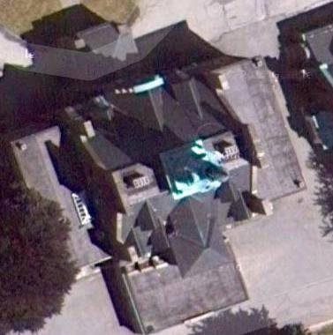

Prepared by:
Massachusetts Department of Public Health
Bureau of Environmental Health
Indoor Air Quality Program
December 2012

Background/Introduction
In response to a request by Paul Lamothe, Director of Facility and Core Service, Northeast/Suburban Areas for the Massachusetts Department of Mental Health (DMH), the Massachusetts Department of Public Health (MDPH), Bureau of Environmental Health (BEH) provided assistance and consultation regarding concerns of mold growth in a second floor DMH server room located in the Old Administration Building (OAB) at the Tewksbury Hospital campus, 365 East Street, Tewksbury, Massachusetts. On October 11, 2012, Ruth Alfasso, an Environmental Engineer/Inspector within BEH’s Indoor Air Quality (IAQ) Program, visited the OAB to conduct an IAQ assessment. Ms. Alfasso was accompanied by Mr. Lamothe during the assessment. The investigation was limited to the server room and the adjacent hallway.

Methods
General IAQ tests for carbon dioxide, carbon monoxide, temperature and relative humidity were conducted with the TSI, Q-Trak, IAQ Monitor, Model 7565. Surface temperature monitoring was conducted with a Ryobi laser thermometer. BEH/IAQ staff also performed visual inspection of building materials for water damage and/or microbial growth.

Results
As mentioned, testing was conducted in the server room and adjacent hallway. Background measurements were taken outdoors for comparison purposes. The server room is not typically occupied for extended periods of time, but may be visited daily for equipment maintenance. There are no windows in the server room, but windows in other parts of the OAB are openable. Results appear in Table 1.

Discussion

Ventilation
It can be seen from Table 1 that carbon dioxide levels were measured at 900 parts per million (ppm) in the server room, which is above the MDPH guidance level of 800 ppm indicating less than optimal fresh air ventilation serving the room. The server room has a dedicated air-conditioning system located in the ceiling. Cooled air from the air-handling unit (AHU) is provided by flexible ductwork connected to two supply vents (Picture 1). It appears that air for the server room’s AHU is drawn from intake vents located in the hallway (Picture 2). Exhaust ventilation is provided through ceiling-mounted exhaust grills. The air-conditioning was operating at the time of the visit. Other parts of the building examined do not have mechanical ventilation and rely on open windows to provide fresh air.
To maximize air exchange, the MDPH recommends that both supply and exhaust ventilation operate continuously during periods of occupancy. In order to have proper ventilation with a mechanical supply and exhaust system, the systems must be balanced to provide an adequate amount of fresh air to the interior of a room while removing stale air from the room. It is recommended that heating, ventilation and air conditioning (HVAC) systems be re-balanced every five years to ensure adequate air systems function (SMACNA, 1994).
Minimum design ventilation rates are mandated by the Massachusetts State Building Code (MSBC). Until 2011, the minimum ventilation rate in Massachusetts was higher for both occupied office spaces and general classrooms, with similar requirements for other occupied spaces (BOCA, 1993). The current version of the MSBC, promulgated in 2011 by the State Board of Building Regulations and Standards (SBBRS), adopted the 2009 International Mechanical Code (IMC) to set minimum ventilation rates. Please note that the MSBC is a minimum standard that is not health-based. At lower rates of cubic feet per minute (cfm) per occupant of fresh air, carbon dioxide levels would be expected to rise significantly. A ventilation rate of 20 cfm per occupant of fresh air provides optimal air exchange resulting in carbon dioxide levels at or below 800 ppm in the indoor environment in each area measured. MDPH recommends that carbon dioxide levels be maintained at 800 ppm or below. This is because most environmental and occupational health scientists involved with research on IAQ and health effects have documented significant increases in indoor air quality complaints and/or health effects when carbon dioxide levels rise above the MDPH guidelines of 800 ppm for schools, office buildings and other occupied spaces (Sundell et al., 2011). The ventilation must be on at all times that the room is occupied. Providing adequate fresh air ventilation with open windows and maintaining the temperature in the comfort range during the cold weather season is impractical. Mechanical ventilation is usually required to provide adequate fresh air ventilation.
Carbon dioxide is not a problem in and of itself. It is used as an indicator of the adequacy of the fresh air ventilation. As carbon dioxide levels rise, it indicates that the ventilating system is malfunctioning or the design occupancy of the room is being exceeded. When this happens, a buildup of common indoor air pollutants can occur, leading to discomfort or health complaints. The Occupational Safety and Health Administration (OSHA) standard for carbon dioxide is 5,000 parts per million parts of air (ppm). Workers may be exposed to this level for 40 hours/week, based on a time-weighted average (OSHA, 1997).
The MDPH uses a guideline of 800 ppm for publicly occupied buildings. A guideline of 600 ppm or less is preferred in schools due to the fact that the majority of occupants are young and considered to be a more sensitive population in the evaluation of environmental health status. Inadequate ventilation and/or elevated temperatures are major causes of complaints such as respiratory, eye, nose and throat irritation, lethargy and headaches. For more information concerning carbon dioxide, consult Appendix A.
The temperature in the server room was 68°F (Table 1), which is slightly below the MDPH recommended range. As mentioned previously, this area is not occupied for long periods and the cool temperature is maintained for the computer equipment. The MDPH recommends that indoor air temperatures be maintained in a range of 70°F to 78°F in order to provide for the comfort of building occupants. In many cases concerning indoor air quality, fluctuations of temperature in occupied spaces is typical, even in a building with an adequate fresh air supply.
The relative humidity measured in the server room and the hallway outside was 55 percent (Table 1). Although this is within the MDPH recommended comfort range of 40 to 60 percent, note that outdoor relative humidity was 25 percent on the day of the assessment (Table 1). Even with the air-conditioning operating in this room, the relative humidity in the server room was significantly elevated above background levels. This appears to be related to the lack of fresh air and exhaust ventilation in the building as a whole as well as to the interior server room. The average humidity for October 10, 2012, the day prior to the assessment, was approximately 90% due to precipitation; rain and high humidity levels were also experienced in the previous ten days (Weather Underground, 2012).
Relative humidity levels in the building would be expected to drop during the winter months due to heating. The sensation of dryness and irritation is common in a low relative humidity environment. Low relative humidity is a very common problem during the heating season in the northeast part of the United States.

Microbial/Moisture Concerns
As noted earlier, the assessment was prompted by the presence of mold and staining on walls in the server room (Pictures 1 and 3). According to Mr. Lamothe, this condition occurred rapidly in the weeks prior to the assessment. During the assessment, BEH/IAQ staff observed mold growth and staining on two of the walls inside the server room. Both walls are adjacent to a supply vent that blows directly on them (Picture 1). Mold/staining was also observed on trim for the closet door and along the edges of fire alarm equipment. The walls in the server room appear to be composed of plaster with one or more coats of thick glossy paint. Plaster walls are not typically as vulnerable to penetration by microbial growth as gypsum wallboard or other porous materials. Instead, mold will grow on the surface of the plaster wall. Patches of mold/staining examined could be removed with a small amount of rubbing, suggesting that the mold growth is superficial and removable via cleaning with an anti-microbial cleansing agent and friction/abrasion. Where growth is found to be more deeply imbedded, such as in the wooden door trim, the surface may require sanding/scraping before it is cleaned with an antimicrobial cleaner.
Prior to the BEH/IAQ visit, the air-conditioning system had been inspected by a heating, ventilation and air conditioning (HVAC) contractor who expressed the opinion that the system was in need of major overhaul or replacement due to clogged drains and mold colonization (Cooling and Heating Specialists, Inc., 2012). The interior of ductwork hoses to the server room’s AHU were not examined by BEH/IAQ staff. If water is condensing or collecting inside these hoses or mold growing inside the system, then these conditions would need to be remediated in order to prevent mold growth and distribution in the server room.
Based on BEH/IAQ staff observations and considering the timing of the mold growth on the plaster walls, it appears that the mold growth may be accelerated by condensation forming along the walls. If a surface in contact with the air has a temperature at or below the dew point, it will collected condensed moisture and become wet. Dew point is another way of representing humidity; the dew point is the temperature at which the water vapor in the air will start to condense. Surface temperatures measured on the affected walls ranged from 62°F to 65°F (Table 1), below the temperature of the air in the room. Given the temperature and humidity described above, the dew point for the server room would be approximately 51°F. This suggests that under more humid conditions, air from the supply vent blowing directly on the wall could have reduced the wall temperature below the dew point and allowed moisture to condense there. Dust settling on these damp surfaces can lead to mold growth. Since the temperature of the top side of the supply vent was approximately 45°F (below the dew point of 51°F), this surface may also be subject to condensation under the conditions observed. However, at the time of assessment, the supply vent did not appear to be wet. The distribution of moisture, excessively/unevenly chilled air, and/or mold spores by a malfunctioning air-conditioning system can result in the rapid spread of the mold observed in this room.
According to the American Society of Heating Refrigeration and Air-Conditioning Engineers (ASHRAE), sustained relative humidity indoors of 70 percent or greater can result in the moistening of building components, resulting in fungal growth (ASHRAE, 1989).
Additional water staining was noted on the wall opposite the side with the mold colonies, and some of the ceiling tiles there were water-damaged (Picture 4). This staining reportedly resulted from an air conditioner condensation leak that had occurred several months previous to the BEH/IAQ visit. There was no sign of mold growth around these water stained spots at this time; however, water staining and damage should be cleaned and repaired as soon as the condition leading to the water leak is discovered and remediated.

Other Conditions
The room has several other features that can make it vulnerable to water damage and other indoor air issues. There is an old fireplace in the room (Picture 5) that has been blocked off and not in use for a long time. It is unknown whether the chimney has been removed, blocked or maintained in the intervening years. Old chimneys can become a conduit for moisture from outside or elsewhere in the building and a pathway for pests.
An access hatch in the closet of the server room provides access to a wall cavity. Breaches to the wall can also allow movement of odors, materials and moisture from other areas of the building to penetrate the server room. Several breaches were observed in the ceiling tile system. These breaches can also serve to allow materials to move into the server area from the ceiling plenum system.
The server room is used to house computer equipment and other supplies for the Information Technology (IT) staff. The room was noted to be cluttered with equipment and items, some of which was dusty. Although the metal and plastic materials of the computer equipment do not generally support mold colonization, dust (e.g. skin cells and other organic particles) settled on these surfaces can be a medium for mold growth. Regular cleaning of equipment with a High Efficiency Particle Arrestance (HEPA)-equipped vacuum cleaner with a computer-safe brush attachment or treated microfiber cloths may help to remove dust and other particles that are sources of mold growth and/or skin and respiratory system irritants. The vents in the hallway through which makeup air is drawn were also dusty and should be cleaned (Picture 2). Improved storage of equipment inside this room and regular general cleaning will also reduce any impacts from dust.
BEH/IAQ staff was also informed that the computers and equipment in this room may be consolidated with other servers elsewhere on campus, and therefore be removed from this room. Prior to relocation, all equipment should be cleaned in a manner consist to that discussed above to prevent movement/aerosolization of these materials. Any porous items needing to be moved, such as cases and manuals, should be inspected individually before they are moved to ensure they are clean and free from microbial growth.

Conclusions/Recommendations
In view of the findings at the time of the visit, the following recommendations are made:
- Continue to work with the HVAC technician to repair or replace any compromised HVAC equipment. Ensure that humidity levels in the server room can be kept low enough via fresh air ventilation and exhaust to reduce the likelihood of condensation. Check condensation pans and other equipment regularly for signs of leaks.
- Change the four-way supply vent fixture to one with only one or two sides, both facing towards the middle of the room rather than the walls.
- If a non-ducted air conditioning system is installed, ensure that some method of ventilation is provided for this room to both supply fresh air and remove moisture, odors and pollutants. Ensuring the door remains open while the room is occupied may be necessary.
- Clean the staining and mold-colonization from the walls using an anti-microbial cleaner and sanding/scraping if needed.
- Replace any water-damaged ceiling tiles.
- Ensure that any holes or breaches in the ceiling above the tile system are repaired. Inspect the old fireplace for evidence of water intrusion or pests and repair as needed. Inspect the inside of the closet for breaches and pathways as well.
- Clean computer equipment with a HEPA-equipped vacuum cleaner with an applicable attachment, microfiber cleaning cloths or other equipment that may be recommended by the computer manufacturer.
- Increase general cleaning in the server room and hallway outside, and improve storage of other materials, removing anything that is not needed.
- If the equipment in this room is going to be moved to another location, clean and inspect items as they are removed to ensure that materials entering the new location are free of dust and microbial growth.
- Contact the BEH’s IAQ Program if further advice/investigation is needed.

References
ASHRAE. 1989. Ventilation for Acceptable Indoor Air Quality. American Society of Heating, Refrigeration and Air Conditioning Engineers. ANSI/ASHRAE 62-1989.
BOCA. 1993. The BOCA National Mechanical Code/1993. 8th ed. Building Officials & Code Administrators International, Inc., Country Club Hills, IL.
Cooling and Heating Specialists, Inc. 2012. HVAC Service Order Invoice #63625. Newton, Massachusetts.
IMC, 2009. 2009 International Mechanical Code. International Code Council Inc., Country Club Hills, IL.
OSHA. 1997. Limits for Air Contaminants. Occupational Safety and Health Administration. Code of Federal Regulations. 29 C.F.R 1910.1000 Table Z-1-A.
SBBRS. 2011. Mechanical Ventilation. State Board of Building Regulations and Standards. Code of Massachusetts Regulations, 8th edition. 780 CMR 1209.0.
SMACNA. 1994. HVAC Systems Commissioning Manual. 1st ed. Sheet Metal and Air Conditioning Contractors’ National Association, Inc., Chantilly, VA.
Sundell, J., H. Levin, W. W. Nazaroff, W. S. Cain, W. J. Fisk, D. T. Grimsrud, F. Gyntelberg, Y. Li, A. K. Persily, A. C. Pickering, J. M. Samet, J. D. Spengler, S. T. Taylor, and C. J. Weschler. 2011. Ventilation rates and health: multidisciplinary review of the scientific literature. Indoor Air, Volume 21: pp 191–204.
Weather Underground, The. 2012. Weather History for Tewksbury, Massachusetts, October, 2012. Available at: http://www.wunderground.com/history/airport/KBED/2012/10/15/MonthlyHistory.html#calendar
Picture 1

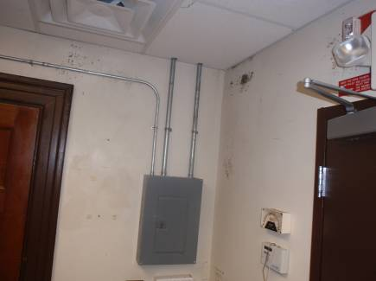

Supply vent (arrow), with vents facing wall with mold-staining
(Note: image provided by Paul Lamothe)

Picture 2

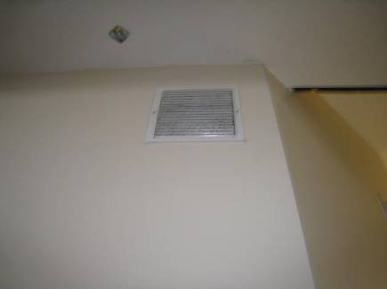

Air intake for server room located in hall outside (note dust on grill)

Picture 3

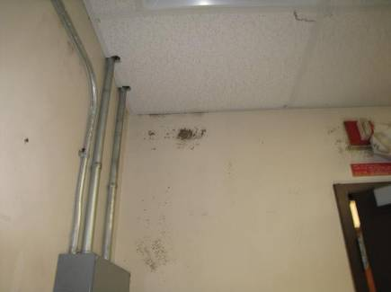

Mold staining on walls (dark spots)

Picture 4

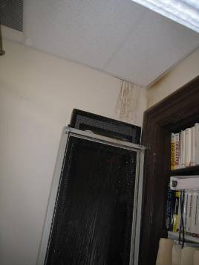

Water damage/stains on wall in server room
Picture 5

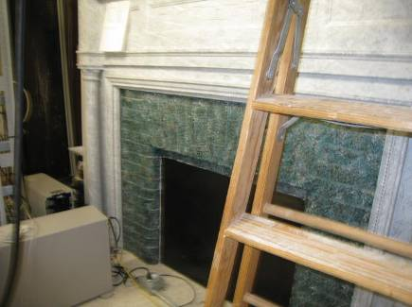

Old fireplace in the server room
Location | Carbon  Dioxide  (ppm) | Temp  (°F) | Relative  Humidity  (%) | Occupants  in Room | Windows  Openable | Ventilation |  | Remarks
Background | 436 | 65 | 25 |  |  |  |  | Clear and sunny
Inside Server Room | 900 | 68 | 55 | 0 | N | Y | Y | DO, WD-CT, mold staining on walls, fireplace (boarded up), computer equipment, dry erase markers. Wall surface temperatures next to supply vent: 62-65°F. Surface temperature of outflow (bottom) of supply vent: 60°F. Surface temperature of top of supply vent: 45°F.
Hallway outside server room |  | 70 | 55 | 0 | Y | Y | Y | Dusty vent in wall for intake to server room.

