INDOOR AIR QUALITY ASSESSMENT

**Tewksbury Hospital**

**Saunders Building**

**365 East Street**

**Tewksbury, MA**

**B400 and B500 Wings (DMH offices)**

**August 2025**

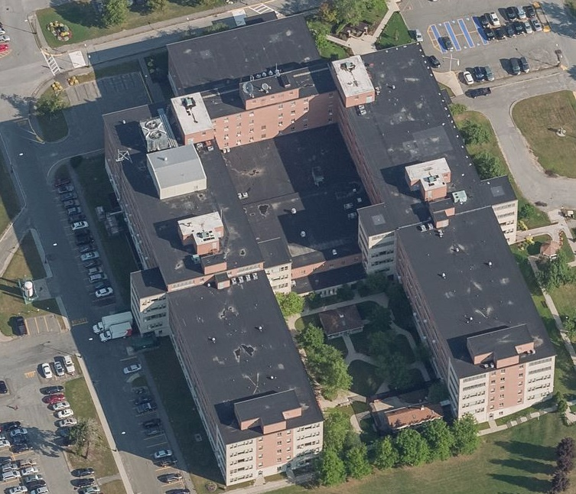

Prepared by:

Massachusetts Department of Public Health

Bureau of Climate and Environmental Health

Division of Environmental Health Regulations and Standards

# CONTENTS

CONTENTS 2

BACKGROUND 3

RESULTS AND DISCUSSION 3

Ventilation 4

HVAC System Maintenance 5

Water Damage and Moisture Concerns 6

Sources of Respiratory Irritants/Possible Asthma Triggers 8

Other Issues 9

CONCLUSIONS AND RECOMMENDATIONS 9

REFERENCES 13

PICTURES 14

Ventilation Pictures 14

Water Damage Pictures 17

Respiratory irritants pictures 20

Table 1 21

Table 2A 24

Table 2B 25

Table 2C 26

Table 3 27

Table 4 29

# BACKGROUND

|  |  |
| --- | --- |
| Building: | Tewksbury Hospital, Saunders Building  B400 and B500 Wings (DMH offices) |
| Address: | 365 East Street, Tewksbury, MA |
| Coordinated Via: | Bartley J. Larkin, CSL/MCPPO, Director of Facilities,  Tewksbury Hospital |
| Reason for Request: | Follow-up from a previous report to assess the building during hot, humid weather |
| Date of Assessment: | July 28, 2025 |
| Massachusetts Department of Public Health/Bureau of Climate and Environmental Health/**Division of Environmental Health Regulations and Standards** (MDPH/BCEH/EHRS) Staff Conducting Assessment: | Ruth Alfasso, Indoor Air Quality (IAQ) Outreach and Education Unit, EHRS |
| Building Description: | The Saunders Building is a U-shaped, five-story building with a flat rubber membrane roof. It was originally built in the 1960s with additional wings added in the early 1970s. |
| Windows: | Windows in the building are mostly openable. |

Note that this building has been visited several times in the past for IAQ assessments. This visit was done as a follow-up to a previous visit conducted in April of 2024 where issues regarding water damage, asbestos, and cancer were discussed. The cover letter for that visit’s report, which includes information relative to cancer concerns, is attached as Appendix A below. The report from that visit is included as Appendix B. Other reports on this building can be found at: <https://www.mass.gov/info-details/indoor-air-quality-reports-cities-and-towns-t#tewksbury>

# RESULTS AND DISCUSSION

The following is a summary of indoor air testing results (Table 1)

|  |  |  |
| --- | --- | --- |
| * ***Carbon dioxide (CO2)*** | *a measure of the adequacy of ventilation* | Levels were below the MDPH guideline of 800 parts per million (ppm) in all areas surveyed, indicating adequate air exchange at the time of assessment. Note that most offices were not fully occupied. |
| * ***Temperature*** | *a measure of comfort* | It was within or close to the upper level of the MDPH recommended range of 70°F to 78°F. Occupants reported temperature control issues in both summer and winter. |
| * ***Relative humidity*** | *a measure of comfort and, when in excess for an extended period, a way to reflect the potential for mold and fungal growth* | It was mostly above the MDPH recommended range of 40 to 60% in areas tested. High humidity can increase feelings of heat and discomfort during hot weather. |
| * ***Carbon monoxide***   ***(CO)*** | *a product of combustion that can result in acute and long term cardiovascular, respiratory, and neurological symptoms* | Levels were non-detect (ND) in all areas tested. |
| * ***Particulate matter (PM2.5)*** | *a way to measure inhalable particle distribution in the air* | Concentrations were below the National Ambient Air Quality Standard (NAAQS) of 35 micrograms per cubic meter (μg/m3) in all areas tested indoors. Outdoor PM2.5 levels were measured at 29-36 μg/m3 due to wildfire smoke impacts. |
| * ***Total Volatile Organic Compounds (TVOCs)*** | *VOCs are carbon-containing substances that can evaporate at room temperature. Frequently, exposure to low levels of total VOCs (TVOCs) may produce eye, nose, throat and/or respiratory irritation in some sensitive individuals.* | Levels were ND in all areas assessed apart from the B500 hallway (1.0 ppm), which had a similar low level as outside (1.3 ppm). |

## Ventilation

Ventilation refers to both the supply of fresh air and the removal of stale air from a room. The introduction of fresh air into an occupied space will dilute normally occurring pollutants that are generated by occupancy and other activities. In addition, a heating, ventilation and air conditioning (HVAC) system will remove pollutants from a building if operating appropriately. All ventilation systems throughout the building should operate continuously during periods of occupancy.

Most rooms in this area of the Saunders Building have no supply of fresh air. A few offices had supply and return vents (Pictures 1 and 2) which bring in air from air handling units located nearby. In most offices in the areas examined, the only sources of fresh air are openable windows. Openable windows are also present in the hallway. It is likely that when the building was first built, these were intended to be used together for cross-ventilation. Most rooms were equipped with either a window-mounted air conditioner (Picture 3) or a portable air conditioner (Picture 4). In rooms with windows, either the window air conditioner was in the only window, or the portable air conditioner exhaust vent was connected through the window, meaning that the window can no longer be opened for fresh air or cross ventilation. Some of the portable air conditioner exhausts were directed into the ceiling plenum (Picture 5). Facility staff report that these direct the exhaust to the roof.

It was reported that most or all of the air conditioners are in place year-round. Air conditioners are reported to be used in the winter when the steam radiators, located along the exterior wall of rooms, are active, as the temperature is otherwise too hot.

Some of the rooms on each floor have an attached restroom. Each restroom is equipped with an exhaust vent (Picture 6) attached to a fan on the roof. All exhaust vents were working at the time of the assessment. However, this arrangement does not provide exhaust ventilation for all offices. Exhaust vents are important to remove water vapor and odors from restrooms and, especially as they also serve as general exhaust vents, they should be on at all times the area is occupied.

**Balancing**

To have proper ventilation with a mechanical supply and exhaust system, a system must be balanced to provide an adequate amount of fresh air to the interior of a room while also removing stale air from the room. It is recommended that HVAC systems be re-balanced every five years to ensure adequate air systems function (SMACNA, 1994).

It is recommended that HVAC systems be re-balanced every five years to ensure adequate air systems function (SMACNA, 1994). It is unlikely that the current system can be balanced for most offices.

The various types of ventilation components as well as devices that can move/redirect airflow that were identified in the building are listed in Table 2A, Table 2B and Table 2C.

### HVAC System Maintenance

* Portable and window-mounted air conditioners found in offices were all of different brands, and ages. Some may be beyond their service life or inadequate for the cooling needs of the occupants.
* Most window-mounted air conditioners have a filter in them which can be removed for cleaning. One was examined and found to be clean and facility staff reported that there is a schedule for cleaning these filters. However, one had the “clean filter” light on (Picture 7). Although these filters provide minimal filtration they should be cleaned periodically to remove dust that can impair function or lead to odors.

(see Ventilation pictures)

## Water Damage and Moisture Concerns

Please note that the MDPH does not recommend conducting mold testing in a typical water damage remediation. For details, please consult [Guidance Regarding Testing for Mold in Water-Damaged Public Buildings](https://www.mass.gov/info-details/guidance-regarding-testing-for-mold-in-water-damaged-public-buildings) | Mass.gov

The application of a mildewcide to moldy porous materials is not recommended.

Molds are found naturally in our environment both indoors and outdoors. Inside, mold growth may occur when items, particularly porous products such as paper or gypsum wallboard, are exposed to moisture. Typical water sources include leaks, floods, and condensation. To avoid mold growth, dry all water-damaged items and affected areas within 24-48 hours and reduce indoor humidity. Some people with chronic respiratory conditions, such as asthma, are more likely to experience health symptoms associated with molds, including allergic reactions and respiratory irritation. Controlling moisture is the key to preventing mold growth and potential health symptoms. [Climate fact sheet: mold growth | Mass.gov](https://www.mass.gov/info-details/climate-fact-sheet-mold-growth)

Hot, humid summers are becoming more frequent due to climate change. Massachusetts has experienced hot, humid, and rainy summers in 2018, 2021, and 2023. July of 2021 was the wettest ever recorded in Massachusetts, and the three-month period from June through August, known as the meteorological summer, was the fourth wettest on record, according to the National Oceanic and Atmospheric Administration’s (NOAA) Centers for Environmental Information (NOAA, 2021). The summers of 2023 and 2024 were also hot, and wet, with 2023 being measured as the second rainiest on record (WBUR, 2023). Several heat waves with temperatures above 90°F have already happened in 2025. These conditions are challenging for buildings, particularly those without central air conditioning.

During these hot and wet summers, extended periods of outdoor relative humidity above 70% occurred. Under this weather, public buildings experienced extended periods of water vapor exposure from high relative humidity. When exposed to these conditions, porous materials such as gypsum wallboard, cardboard, and other materials may become prone to developing mold colonization, particularly if located in areas that are prone to developing condensation on floors and walls (e.g., below grade space).

**Mold Growth**

Porous materials (e.g., gypsum wallboard, ceiling tiles and carpeting) can be dried with fans and heating within 24 to 48 hours of becoming wet (US EPA, 2008).

If porous materials are not dried within this time frame, mold growth may occur.

Moldy materials should be cleaned following the guidance in EPA’s Mold Remediation in Schools and Commercial Building (US EPA, 2008).

In order to remove mold from buildings, of primary importance is to identify, repair and/or limit the moisture source causing damage in the building. Once the moisture source is remediated, then discarding and/or cleaning of mold contaminated materials can be completed.

All areas examined were assessed for the presence of mold, moisture, visible water damage, and other conditions that may lead to water damage and mold growth. The following issues were noted:

* **A single water-damaged ceiling tile was noted in the B500 wing hallway (Picture 8).** Facility staff report that roof leaks in this wing are still common as the roof above this area is in need of replacement. Ceiling tiles are replaced when they are found damaged.
* **Occupants reported a leak from the radiator in the B400 hallway earlier this year.** A stain was noted on the carpet around this unit, but carpeting was dry, and no musty or moldy odor was detected.
* **An occupant reported that the mini refrigerator in her room had leaked over a weekend,** leading to a stain on the carpeting. This carpeting also was dry and had no odor.
* **Many rooms contained small refrigerators and water dispensers which can leak and lead to water damage to carpeting.** Some of the refrigerator gaskets had debris and staining that may be mold (Picture 9). These should be cleaned.
* **Along with the refrigerators, rooms contained appliances such as microwaves, coffee makers, toasters, as well as food storage (Table 1).** Crumbs and food debris can lead to smoke and odors, and food can be attractive to pests.
* **Condensation was noted on one portable air conditioning unit (Picture 10).** Condensation means that the surface of the air conditioning unit is below the dew point of the air. To reduce the potential for condensation, the humidity in the office should be reduced or the temperature of the air conditioner surface should be increased. Since this was the only portable air conditioner with visible condensation, this unit may not function well enough to reduce humidity in the room.
* **Some of the seams between window-mounted air conditioners or portable air conditioner exhausts had signs of water damage or dust accumulation.** These areas should be sealed with waterproof material and be cleaned periodically, as dust accumulation can grow mold if moistened.
* **Bowing ceiling tiles were noted in the hallway ceilings (Picture 11) and some rooms.** This is a sign that the tiles have been subject to high humidity for a period of time. Bowed ceiling tiles are not a mold source, but they are a reminder that humidity is high in the building and condensation may occur. One likely source of increased humidity in hallways and offices is opening of hallway windows during hot, humid weather.
* **Plants were noted in some offices (Picture 12).** Plants can be a source of pollen, odors, and mold, especially if not well cared for. Plants should not be overwatered and should be kept on non-porous drip pans that are cleaned regularly. Airflow from items such as air conditioners can blow odors and pollen from plants around the office.

(see Water Damage Pictures)

## Sources of Respiratory Irritants/Possible Asthma Triggers

Asthma is a lung disease that can make breathing difficult. Without careful management of asthma, some people can have symptoms, like a tight feeling in the chest, shortness of breath, coughing, or wheezing. Although there is no cure for asthma, people with asthma can live healthy, active lives. A safe and healthy environment helps to reduce asthma symptoms.

* **Dust, a common respiratory and eye irritant, can collect on surfaces and items.** Although janitorial and maintenance staff perform routine cleaning, they may not be able to clean as effectively if accumulated items are not picked up or surfaces are cluttered.
* Even with a properly functioning ventilation system, it is necessary to **reduce the use of materials that can be a source of respiratory irritants** to prevent symptoms in individuals who have sensitivity to such pollutants.

Possible asthma triggers and/or airborne pollutants exist in the building. These are listed below as well as in (Table 4).

(see Sources of Respiratory Irritant Pictures)

* **Exposure to low levels of total volatile organic compounds (TVOCs) may produce eye, nose, throat, and/or respiratory irritation in some sensitive individuals.** To determine if measurable levels of VOCs were present, EHRS staff took measurements of TVOCs and all but one measurement was non-detect (ND). The one location with measured levels of TVOC was the B500 hallway which had slightly lower levels of TVOC than outside, and an open window.
* **EHRS staff also examined rooms for products containing VOCs,** and noted hand sanitizers, air fresheners, and other products in use (Table 1). These products have the potential to be irritants to the eyes, nose, throat, and respiratory system of sensitive individuals.
* **Some offices had large amounts of items stored on the floor (Picture 13)** which makes it difficult to clean the floors effectively. Piles of items can also provide harborage for pests.
* **Many areas were carpeted.** Carpets should be vacuumed regularly with a high efficiency particulate arrestance (HEPA) filter-equipped vacuum cleaner and cleaned annually (or semi-annually in soiled/high traffic areas) in accordance with Institute of Inspection, Cleaning and Restoration Certification (IICRC) recommendations, (IICRC, 2012). Some carpeting was old, wrinkled, or stained. It is known that most carpets were placed on top of asbestos-containing floor tiles so replacing carpet will involve potential asbestos remediation.
* **Small lines of dust were noted at the corners of ceiling tiles in some areas (Picture 14).** One possible source of this is that air is blowing out of the ceiling tile plenum. If so, the flow of air could lead to a static electric charge that would attract airborne dust to settle in the areas near the corners. This would happen because the plenum is pressurized. Ductwork inside the plenum, including the exhaust vents from portable air conditioners, should not be leaking and should be tied into the applicable supply or exhaust ducts and not be blowing into the ceiling plenums.

## Other Issues

Appendix A is the cover letter to that report which includes information about breast cancer risk factors, as well as links to further information on cancer and environmental exposures. Additional information on what was found related to asbestos is contained in the report from that visit, which is attached as Appendix B.

No specific examination for asbestos-containing materials (ACM) was conducted, as EHRS does not perform such inspections, however no materials that appeared to be friable ACM were noted. Identification and remediation of ACM should be conduted by certified and trained personnel.

A sign was noted on a microwave indicating that neighboring air conditoners need to be shut off during microwave operation. This suggests that the electrical system in the building is already used beyond it’s capacity. This will limit the ability to make changes to increase comfort and reduce humidity in the building.

# CONCLUSIONS AND RECOMMENDATIONS

|  |  |  |  |
| --- | --- | --- | --- |
|  | **HVAC System** | | **Helpful Links** |
| 1. If | Ensure all restroom exhaust vents are on and operating continuously during occupied periods. Check the function of supply and exhaust vents in areas which have them. |  | |
|  | Change HVAC filters 2-4 times a year, or per the manufacturers’ recommendations, using MERV 8 or the best MERV-rating that can work with current equipment. | [ANSI/ASHRAE Standard 52.2-2017](https://www.ashrae.org/File%20Library/Technical%20Resources/COVID-19/52_2_2017_COVID-19_20200401.pdf) | |
|  | During filter changes, clean dust and debris from the inside of HVAC cabinets. |  | |
|  | Clean dust and debris from vents, ceiling fans, and personal fans periodically. |  | |
|  | Have the HVAC system balanced if it has been more than 5 years since the last balancing and if it can be balanced. |  | |
|  | Use air conditioners as needed for cooling and dehumidification. Window air conditioners can often be used in “fan” mode to provide outside air without cooling during cooler weather. |  | |
|  | Consider replacing older air conditioners with units that are more energy-efficient and provide increased cooling for the same or less energy use. Some newer window-mounted units allow the window to be opened while the air conditioner is installed as an alternative for fresh air. |  | |
|  | Ensure the filters in air conditioners are cleaned periodically in accordance with manufacturers’ instructions. |  | |
|  | Ensure window air conditioners and the vents of portable air conditioners are sealed into windows using waterproof materials that are cleaned periodically to prevent mold growth. |  | |
|  | Use hallway windows judiciously. They can be opened for fresh air during cooler, dryer weather. Consider opening them in the early morning on warmer days, and then leaving them closed the rest of the day. Having open windows near where air conditioners are in use makes the air conditioners work harder and may lead to condensation on units, leading to water damage. |  | |
|  | Consider designating people to be responsible for specific windows to ensure they are not left open when the office is unoccupied or the weather is hot and humid. |  | |
|  | Use ceiling fans where available to mix air and provide a breeze. |  | |
|  | Examine the area above ceiling tiles in rooms where dust is showing at the corners to see if there are any unconnected ducts that may be pressurizing the ceiling plenum and repair any found, |  | |
|  | **Water damage** | | |
|  | Continue with plans to repair or replace the roof for this section of the building. |  | |
|  | Dry and monitor any areas that become wet due to leaks from appliances, plumbing, or the building envelope. A moisture meter may be useful to ensure drying is complete. | <https://www.mass.gov/info-details/use-of-moisture-measuring-devices-for-evaluating-water-damage-in-buildings> | |
|  | Ensure there is a system for reporting and monitoring leaks. Building occupants should ensure they report active leaks to building management for investigation and repairs. |  | |
| 1. Cl | Inspect and clean refrigerator gaskets periodically. If they cannot be adequately cleaned, replace. |  | |
|  | Consider moving refrigerators and water coolers to non-porous surfaces or using a waterproof mat to prevent mold growth on carpeting. |  | |
|  | Consider consolidating appliances and food preparation activities into fewer offices, or creating designated break areas, to reduce the potential for leaks, and the load on the electrical system. |  | |
|  | Keep appliances free from spills and crumbs to reduce odors. |  | |
|  | Store food in pest-resistant containers, and clean food wrappers and debris frequently. |  | |
|  | Keep plants in good condition, avoid overwatering, and ensure they are on a waterproof drip pan that is cleaned periodically. |  | |
|  | **Respiratory Irritants/Possible Asthma Triggers** | | |
|  | Reduce clutter. Periodically remove unwanted items. Store the remaining items neatly and off the floor. Where rooms have a history of moisture issues, consider storing items in waterproof totes. |  | |
|  | Reduce the use of products and equipment that create irritating volatile organic compounds (VOCs) and only use in well-ventilated areas. Minimize the use of air fresheners (e.g., plug-ins), deodorizers, and scented products. | [Clean Air Is Odor Free](https://www.mass.gov/doc/clean-air-is-odor-free-removing-fragrances-to-improve-indoor-air-quality-in-schools-and-offices-0/download) | |
|  | Clean carpeting annually (or semi-annually in soiled high traffic areas) as per recommendations of the Institute of Inspection, Cleaning and Restoration Certification (IICRC, 2012). |  | |

|  |  |  |
| --- | --- | --- |
|  | **Other issues** | |
|  | Consult Appendices A and B for additional information on asbestos and cancer. |  |
|  | Contact BCEH’s Environmental Epidemiology Program (EEP) (at 617-624-5757) who specialize in evaluating cancer incidence and/or other chronic disease concerns. |  |

# REFERENCES

IICRC. 2012. Institute of Inspection Cleaning and Restoration Certification. Institute of Inspection, Cleaning and Restoration Certification. Carpet Cleaning: FAQ.

NOAA. 2021. Summer 2021 neck and neck with Dust Bowl summer for hottest on record. National Oceanic and Atmospheric Administration, 1401 Constitution Avenue NW, Room 5128, Washington, DC 20230 <https://www.noaa.gov/news/summer-2021-neck-and-neck-with-dust-bowl-summer-for-hottest-on-record>

SMACNA. 1994. HVAC Systems Commissioning Manual. 1st ed. Sheet Metal and Air Conditioning Contractors’ National Association, Inc., Chantilly, VA.

US EPA. 2008. Mold Remediation in Schools and Commercial Buildings. US Environmental Protection Agency, Office of Air and Radiation, Indoor Environments Division, Washington, D.C. EPA 402-K-01-001. <http://www.epa.gov/mold/mold-remediation-schools-and-commercial-buildings-guide>.

WBUR. 2023. “It’s been a summer of rain and flooding misery in Mass.” WBUR local news. September 12, 2023. <https://www.wbur.org/news/2023/09/12/summer-flooding-rain-massachusetts>

(Click to link back to report)

# PICTURES

## Ventilation Pictures

**Picture 1**

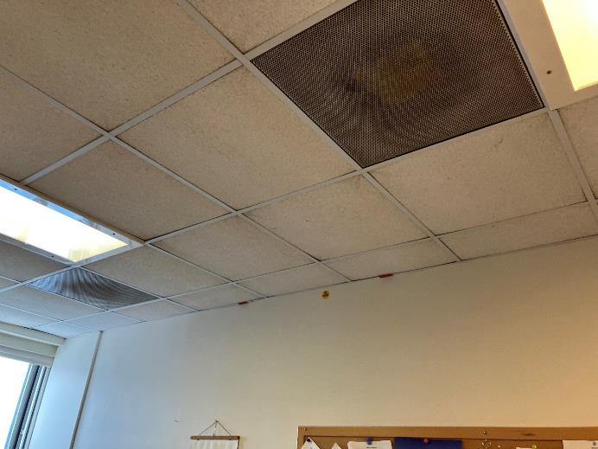

**Supply vent under a ceiling grill**

**Picture 2**

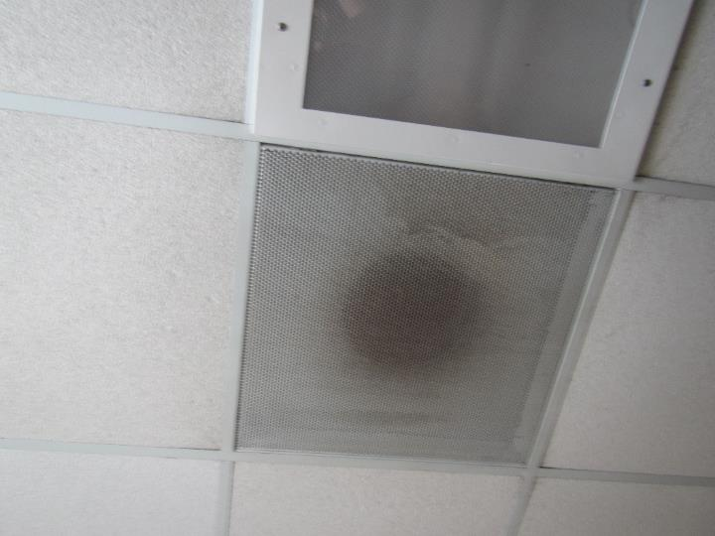

**Exhaust vent under a ceiling grill**

**Picture 3**

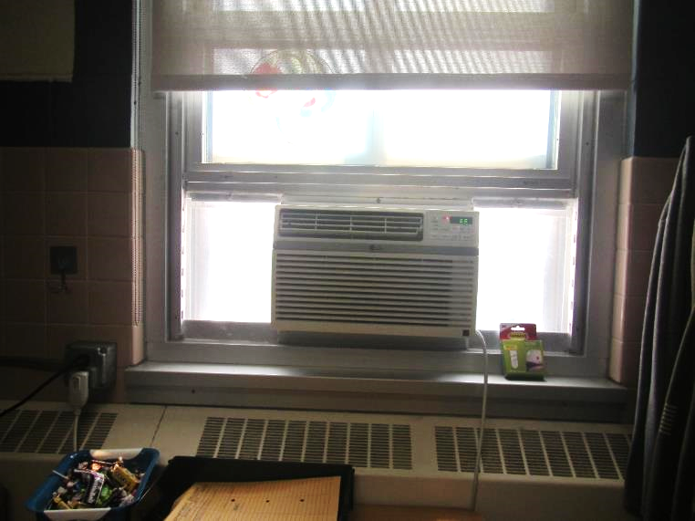

**Window-mounted air conditioner**

**Picture 4**

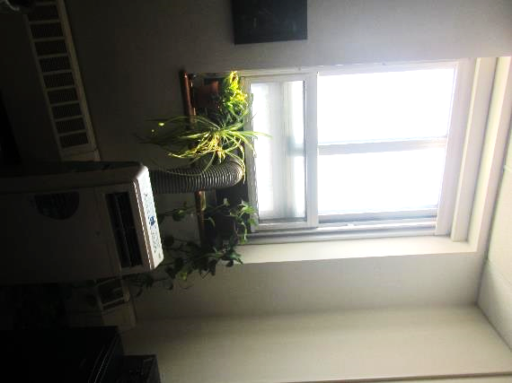

**Portable air conditioner with exhaust out the window**

**Picture 5**

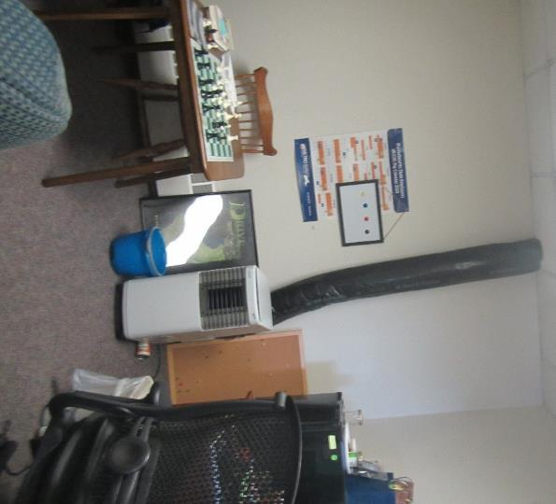

**Portable air conditioner with exhaust into ceiling**

**Picture 6**

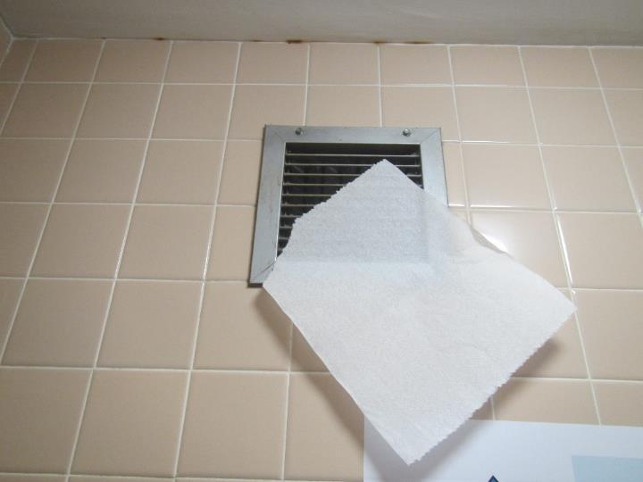

**Exhaust vent in a restroom; note paper being drawn into vent showing it’s working**

**Picture 7**

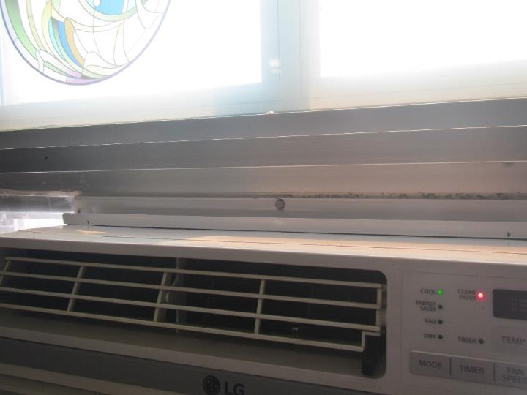

**“Clean filter” light (red) on air conditioner**

## Water Damage Pictures

**Picture 8**

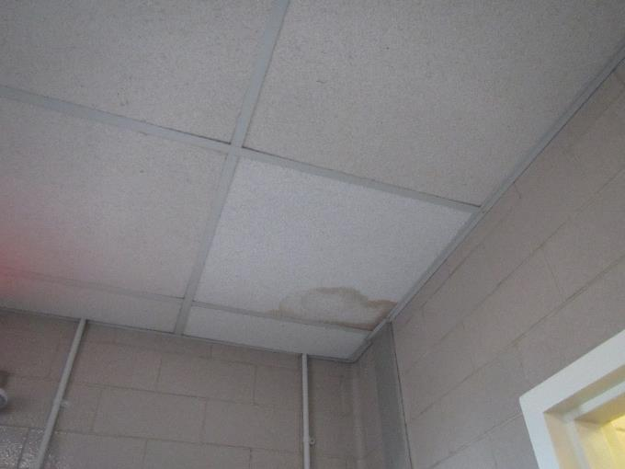

**Water-damaged ceiling tile in the ceiling of the B500 wing**

**Picture 9**

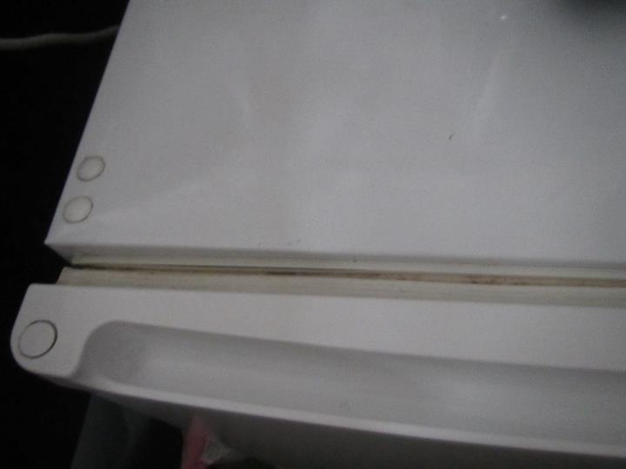

**Stained refrigerator gasket**

**Picture 10**

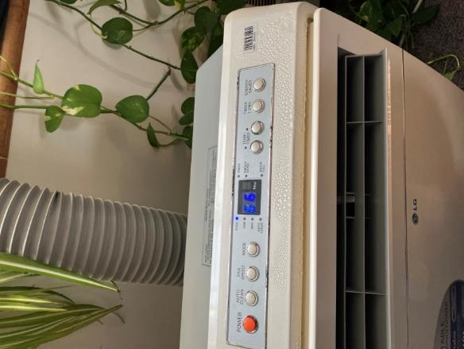

**Condensation on a portable air conditioner**

**Picture 11**

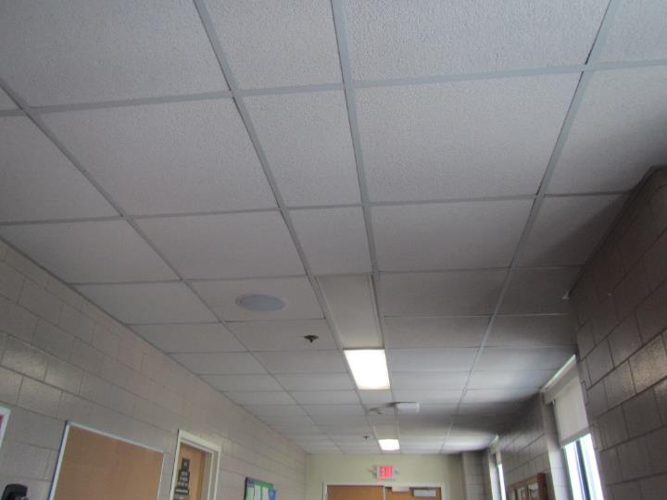

**Slightly bowed ceiling tiles in the hallway**

**Picture 12**

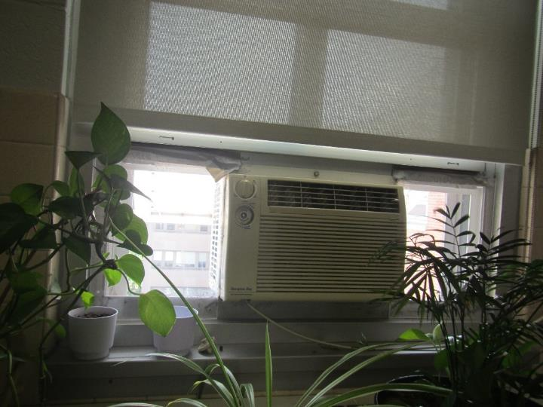

**Plants in an office, in front of the air conditioner**

## Respiratory irritants pictures

**Picture 13**

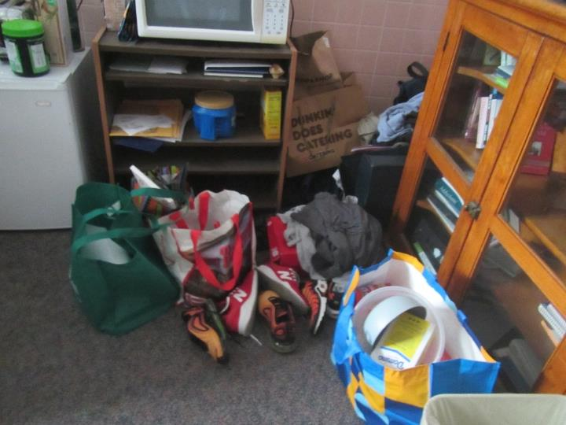

**Items on floor in an office**

**Picture 14**

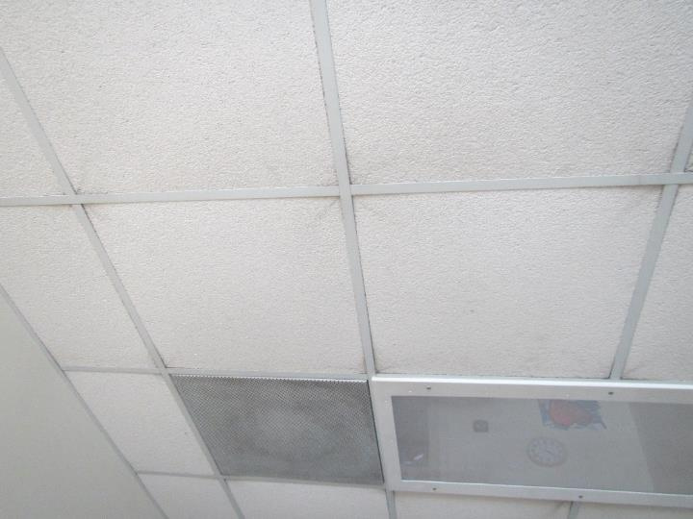

**Dust lines at the corners of ceiling tiles**

Click to link back to report

# Table 1

| **Location** | **Carbon**  **Dioxide**  **(ppm)** | **Carbon Monoxide**  **(ppm)** | **Temp**  **(°F)** | **Relative**  **Humidity**  **(%)** | **PM2.5**  **(g/m3)** | **TVOC (ppm)** | **Occupants**  **in Room** | **Windows**  **Openable** | **Ventilation** | | **Remarks** |
| --- | --- | --- | --- | --- | --- | --- | --- | --- | --- | --- | --- |
| **Supply** | **Exhaust** |
| Outside (background) | 384 | ND | 88 | 51 | 29-36 | 1.3 | 0 | Y | N | N | Hot, muggy, with wildfire smoke impacts |
| B500s hallway | 567 | ND | 83 | 51 | 28 | 1.0 | 0 | Y | N | N | Carpeted, one water-damaged ceiling tile in corner |
| B501 | 446 | ND | 79 | 51 | 24 | ND | 0 | Y | N | N | Plants, WAC in only window |
| B501B | 429 | ND | 78 | 54 | 26 | ND | 3 | Y | N | N | WAC in only window, water cooler on carpet, ceiling fan |
| B502 | 546 | ND | 77 | 58 | 28 | ND | 0 | Y | N | N | WAC in only window, not carpeted |
| B504 | 504 | ND | 75 | 62 | 26 | ND | 0 | Y | N | N | Ceiling fan, fridge and microwave, |
| B505A |  |  |  |  |  |  | 0 | No window | N | Y | Exhaust on in restroom |
| B505 | 488 | ND | 75 | 60 | 30 | ND | 0 | Y | N | N | Portable AC, plants, carpet |
| B506 | 551 | ND | 75 | 52 | 26 | ND | 0 | Y | N | N |  |
| B507 | 501 | ND | 75 | 67 | 31 | ND | 0 | Y |  |  | Plants, fridge and microwave, portable AC connected through window |
| B508 | 591 | ND | 77 | 65 | 29 | ND | 2 | No window | Y | Y | Vents are dusty, portable AC into plenum/exhaust system |
| B509 | 517 | ND | 77 | 59 | 26 | ND | 0 | Y |  |  | Portable AC in window, items on floor, fridge, plants |
| B509A |  |  |  |  |  |  | 0 | No window | N | Y | Exhaust on in restroom, scented items |
| B400 hallway |  |  |  |  |  |  |  |  |  |  | Bowed ceiling tiles, leak reported from a few months ago from radiator. Carpet appears dry and has no odor or other signs of mold |
| B409 | 428 | ND | 78 | 70 | 28 | ND | 0 | Y | N | N | WAC in only window, plush couch, carpeted, exhaust in bathroom on |
| B408 | 426 | ND | 78 | 68 | 30 | ND | 0 | No window |  |  | Portable AC, fridge on carpet |
| B407 | 443 | ND | 77 | 65 | 33 | ND | 2 | Y | Y | Y | Portable AC, food, plants |
| B406 | 506 | ND | 78 | 65 | 29 | ND | 2 | Y |  |  | WAC in only window, plants, fridge and microwave |
| B405A |  |  |  |  |  |  |  | N | N | Y |  |
| B405 | 516 | ND | 78 | 65 | 29 | ND | 2 | Y | N | N | Portable AC, fridge leaked in the past, carpet appears dry and no odor |
| B404 | 414 | ND | 79 | 66 | 31 | ND | 0 | Y | N | N | Portable AC in window |
| B404A |  |  |  |  |  |  |  | N |  | Y | Exhaust on |
| B402 | 499 | ND | 79 | 64 | 24 | ND | 0 |  |  |  | Photocopier |
| B402C | 525 | ND | 78 | 57 | 25 | ND | 0 | Y |  |  | Ceiling fan |
| B401 | 525 | ND | 76 | 61 | 30 | ND | 3 | Y | N | N | WAC in only window, fridge and microwave |

(Click to link back to report)

# Table 2A

|  |  |  |  |  |  |
| --- | --- | --- | --- | --- | --- |
| **Equipment Present in Building**  **(X = Yes)** | **Type of Heating/Cooling Ventilation**  **Equipment** | **Fresh**  **Air**  **Supply**  **(X = Yes)** | **Type of Location(s)** | **Air Filters Installed**  **MERV Rating**  **(1-15, U*)**  **(X = Yes)** | **Comments** |
|  | Univents |  |  |  |  |
| X | Rooftop Air Handling Units | X |  | U |  |
|  | Outdoor, Ground-Installed Air Handling Units |  |  |  |  |
|  | Attic/Crawlspace Air Handling Units |  |  |  |  |
|  | Ceiling-Mounted Air Handling Units (including inside plenum) |  |  |  |  |
|  | Basement/Crawlspace-Installed Air Handling Units |  |  |  |  |
|  | Mechanical Room-installed Air Handling Units |  |  |  |  |
|  | Fan Coil Units |  |  |  |  |
| X | Window-Mounted Air Conditioners | X |  | NA |  |
| X | Portable air conditioners | No |  | NA |  |
|  | Wall Louver-Controlled Gravity Air Supply |  |  |  |  |
| X | Windows | X |  | NA |  |
|  | Fan in window (blowing in) |  |  |  |  |
|  | Built in wall fan (switched) |  |  |  |  |
|  | Heat recovery ventilator unit |  |  |  |  |
|  | Energy recovery ventilator unit |  |  |  |  |
|  | Chilled Beam |  |  |  |  |
|  | Passive combustion supply vent in basement/boiler room |  |  |  |  |

*U = Filter Rating underdetermined due to inaccessibility during building visit

# Table 2B

|  |  |  |  |  |
| --- | --- | --- | --- | --- |
| **Equipment Present in Building**  **(X = Yes)** | **Type of Exhaust Ventilation**  **Equipment** | **Ducted**  **To Outdoors**  **(X = Yes)** | **Type of Location(s)** | **Comments** |
| X | Rooftop Motors/Fans | X | Maybe some offices |  |
|  | Unit Exhaust |  |  |  |
|  | Ceiling Return Vent |  |  |  |
| X | Ceiling Return Vent, Plenum | Unknown |  |  |
|  | Wall Return Vent |  |  |  |
|  | Ceiling fan |  |  |  |
|  | Kitchen Stove Hood |  |  |  |
| X | Restroom Exhaust Vent | X | All restrooms in offices | All were working |
|  | Photocopier Exhaust Vent |  |  |  |
|  | Garage |  |  |  |
|  | Chemical Hood(s) |  |  |  |
|  | Locker Rooms |  |  |  |
|  | Showers |  |  |  |
|  | Clothes Dryers |  |  |  |
|  | Gas Water Heaters |  |  |  |
|  | Furnace-Flue to Chimney |  |  |  |
|  | Furnace/Boiler direct vent or power vent (no combustion air supply) |  |  |  |
|  | Kiln, Pottery |  |  |  |
|  | Dark Room |  |  |  |
|  | Generator Room |  |  |  |
|  | Wood Shop Dust Collector |  |  |  |
|  | Spray Paint Booths |  |  |  |
|  | Fan in window (blowing out) |  |  |  |

# Table 2C

|  |  |  |  |
| --- | --- | --- | --- |
| **Equipment Present in Building**  **(X = Yes)** | **Type of Equipment** | **Type of Location(s)** | **Comments** |
|  | Floor Fans, pedestal |  |  |
| X | Floor Fans, portable |  |  |
|  | Air Purifier (HEPA, other) |  |  |
|  | Floor heaters, portable |  |  |
|  | Refrigerators, Cold Beverage Vending Machines |  |  |
|  | Radiator, wall-mounted |  |  |
|  | Radiator, floor-mounted |  |  |
|  | Passive Vents (Wall/Door) |  |  |

(Click to link back to report)

# Table 3

| **Found in Building**  **X = Yes** | **Water-Damaged Materials, Building Components or Stored Materials** | **Location** | **Visible Microbial Growth?**  **X = Yes** | **Musty odor detected?**  **X = Yes** | **Comments** |
| --- | --- | --- | --- | --- | --- |
|  | Books-other bound materials |  |  |  |  |
|  | Brick walls – broken, missing mortar |  |  |  |  |
|  | Brick walls – blocked weep holes |  |  |  |  |
|  | Cardboard boxes |  |  |  |  |
| X | Carpet tiles |  | No | No |  |
|  | Carpet - area rugs |  |  |  |  |
|  | Carpet wall-to-wall |  |  |  |  |
|  | Ceiling tiles - affixed directly to ceiling surface |  | No | No |  |
| X | Ceiling tiles - bowing-in suspended ceiling |  |  |  |  |
|  | Ceiling tiles - water-stained in splined ceiling |  |  |  |  |
| X | Ceiling tiles - water-stains in suspended ceiling | B500 hallway |  |  | Roof leaks are known to occur |
|  | Chairs - laminated |  |  |  |  |
|  | Cloth |  |  |  |  |
|  | Countertops (around sinks) |  |  |  |  |
|  | Curtains |  |  |  |  |
|  | Dust/debris within AHU, uninvent, HVAC, chilled beam units, etc. (WD through condensation, humidity, or leaks) |  |  |  |  |
|  | Efflorescence (i.e., mineral deposits) |  |  |  |  |
|  | Engineered woods - particleboard, plywood, Masonite |  |  |  |  |
|  | Flooring – loosened tiles |  |  |  |  |
|  | Flooring - wooden |  |  |  |  |
|  | Furniture - laminated |  |  |  |  |
|  | Furniture - upholstered |  |  |  |  |
|  | Gypsum wallboard - ceiling |  |  |  |  |
|  | Gypsum wallboard - restroom wall |  |  |  |  |
|  | Gypsum wallboard - interior wall |  |  |  |  |
|  | Gypsum wallboard – located on exterior wall |  |  |  |  |
|  | HVAC drain pan – lack of draining |  |  |  |  |
|  | HVAC filters |  |  |  |  |
|  | Insulation- attic (paper-backed) |  |  |  |  |
|  | Insulation - inside air handling unit |  |  |  |  |
|  | Insulation - on pipe(s) fiberglass |  |  |  |  |
|  | Insulation - on pipe(s) other/plaster-like material |  |  |  |  |
|  | Insulation - wall cavity |  |  |  |  |
|  | Insulation – ceiling plenum |  |  |  |  |
|  | Modular furniture – walls/cloth partitions |  |  |  |  |
|  | Musical instrument cases |  |  |  |  |
|  | Plaster ceilings |  |  |  |  |
|  | Records/files |  |  |  |  |
| X | Refrigerator - door gasket | One office | X | No |  |
|  | Refrigerator - drip pan |  |  |  |  |
|  | Refrigerator - Interior surfaces |  |  |  |  |
|  | Room divider - ceiling-mounted, sliding |  |  |  |  |
|  | Sink backsplash |  |  |  |  |
|  | Tables – laminated |  |  |  |  |
|  | Wallpaper |  |  |  |  |
|  | Wood - attic/roof materials |  |  |  |  |
|  | Wood - floor joists in basement ceiling |  |  |  |  |
|  | Wood - wall framing |  |  |  |  |
|  | Wood - window sills |  |  |  |  |
|  | Wood - window-mounted air conditioner framing |  |  |  |  |
|  | OTHER |  |  |  |  |

WHAT ARE ENVIRONMENTAL ASTHMA TRIGGERS?

Asthma triggers are any chemical, pollutant, or allergen that can make your asthma worse. Asthma triggers can also be strong chemical smells, dust, or pets. Your asthma triggers may be different from those of other people. Not all asthma triggers affect people the same way. Environmental asthma triggers are found both indoors and outdoors. DPH link: [Asthma and Your Environment (mass.gov)](https://www.mass.gov/doc/asthma-and-your-environment-english/download)

(click to link back to report)

# Table 4

| **Condition Present**  **X = Yes** | **Possible asthma symptom-inducing environmental pollutant** | **Recommendation to reduce or eliminate the pollutant** |
| --- | --- | --- |
| X | Water Damage and/or Mold  (allergen) | Identify water source and repair to eliminate.  Clean non-porous materials.  Remove and replace porous materials susceptible to mold growth.  Perform regular water damage assessments as a tool to ensure timely mitigation as needed.  Use NIOSH water damage assessment protocol as a guide: [NIOSH water damage assessment guideline](https://www.cdc.gov/niosh/docs/2019-115/pdfs/2019-115.pdf?id=10.26616/NIOSHPUB2019115&inf_contact_key=241b5c2ed98c27d94b530dedc36f1623f651f238aa2edbb9c8b7cff03e0b16a0). |
|  | Moistening of building components during hot, humid weather (>2 days in length) (mold, allergen) | Remove materials not dried in <2 days in a manner consistent with [US EPA Mold Removal in Commercial Buildings guideline](https://www.epa.gov/mold/pdf-version-checklist-mold-remediation-mold-remediation-schools-and-commercial-buildings).  Use dehumidification in occupied basement areas and other areas with chronic dampness. |
|  | Vegetation against exterior of building (water damage-mold) | Remove all vegetation preventing building exterior drying.  Remove all vegetation capable of falling onto a building or depositing debris onto the roof. |
|  | Personal humidifiers (lack of proper maintenance)  (pollutant and allergen) | Clean and maintain properly.  Use distilled water to eliminate metal and water treatment odors.  Maintain hydration by increasing water consumption. |
|  | Drains: Floor drains, Sink drains (abandoned use)  Water bubblers (abandoned use) | If in use, pour water into drain at least twice a week.  If not in use, seal the drain with appropriate material in accordance with the Massachusetts Plumbing Code (248 CMR 10.00). |
|  | Live Animals (turtles, gerbils, birds, rabbits, etc.) | Ensure cleanliness or remove animals from the location. |
|  | Improperly maintained aquariums and terrariums (allergen) | Maintain such equipment properly to eliminate odor.  Discontinue use. |
| X | Plants and flowers  (allergen and mold) | Keep indoor plants well maintained and not overwatered. Monitor for signs of mold and pests.  Ensure water for cut flowers does not become stagnant.  Ensure dried plant material is free of odors, mold, and pests and handled carefully  If asthma risks are high, eliminate plants and flowers. |
|  | HVAC system moisture issues  (mold, allergen) | Consult ASHRAE’s minimum standards for HVAC maintenance and inspection of commercial HVAC systems (<https://www.ashrae.org/technical-resources/bookstore/standards-180-and-211>). |
|  | HVAC system contaminant issues (allergen) | Consult ASHRAE’s minimum standards for HVAC maintenance and inspection of commercial HVAC systems (<https://www.ashrae.org/technical-resources/bookstore/standards-180-and-211>). |
|  | Indoor swimming pool odors outside of swimming pool (mold, chemical) | Maintain and operate pool HVAC systems to vent odors from building.  Ensure locker room exhaust vents operate during building hours.  All doors leading to the pool should be rendered airtight and be closed. |
|  | Pollen (allergen) | Recommend installation of MERV 8 or better filters if HVAC engineer confirms HVAC system can be so equipped without adversely affecting function.  Cut grass after hours.  Cut grass in a pattern to direct clippings away from exterior wall.  Remove trees and shrubs from in front of windows and air intakes. |
|  | Dry air | Maintain hydration.  Avoid overheating of air. |
| X | Dust mites  (allergen) | Recommendation to remove non-official upholstered furniture, area rugs, pillows, cushions, etc.  Cleaning with use of HEPA-filtered vacuum cleaner.  Eliminating clutter, storing items in dust and moisture-proof containers, and regularly removing dust through wet wiping. |
| reported | Pests, including rodents and cockroaches  (allergen) | Use of integrated pest management guidelines, including:   * Proper disposal of food containers * Proper storage of food products in airtight containers * Elimination of use of food as art projects * Remove pest harborages/clutter * Regular monitoring for pests   [EPA IPM guideline link](https://www.epa.gov/ipm/introduction-integrated-pest-management) |
|  | Latex-containing materials | Remove tennis balls from furniture legs. |
| X | Fragrances  (chemical) | Eliminate point sources, such as:   * Plug-in air fresheners * Aroma/oil reed diffusers * Scented sprays * Discontinue use of other scented materials * Consult DPH fragrance guideline: [*Clean air is odor-free*](https://www.mass.gov/doc/clean-air-is-odor-free-removing-fragrances-to-improve-indoor-air-quality-in-schools-and-0/download) |
|  | Strong smells from /use of Chemicals (such as cleaning products)  (chemical) | Use building-issued cleaning products.  Use products in accordance with manufacturer’s instructions including dilution, application, and ventilation.  Avoid using products that are stronger than needed for the situation. |
|  | Strong odors from new building materials (carpeting/furniture)  (chemical) | Use low VOC-emitting materials.  Air out materials (outside or in an unoccupied area) prior to installation. |
|  | Tobacco smoke  Secondhand Smoke  (pollutant) | Eliminate tobacco smoking.  Seal all shared wall penetrations. |
|  | Products with strong odor such as paint, perfume, hairspray, air fresheners, bug-spray, laminators, candles, wax melters, dry erase markers and other VOC-containing products  (chemical) | If essential:   * Provide proper exhaust ventilation to eject aerosolized products directly outdoors. * Avoid/reduce use during occupied hours.   If not necessary, remove and eliminate. |
|  | Vehicle exhaust  (pollutant) | Enforce anti-idling regulations and post signs to give notice.  Relocate vehicles away from fresh air intakes.  Require cars to park face-in at building walls.  [MA anti-idling law FAQs](https://www.mass.gov/files/documents/2018/02/20/idling-faq.pdf#:~:text=The%20Massachusetts%20Anti-Idling%20Law%20The%20goal%20of%20the,sometime%20wonder%20when%20idling%20might%20be%20considered%20necessary.) |
|  | Vapors and or fumes from gas, oil, or kerosene stoves  (pollutant) | Operate stove hood when stove is in use.  Install stove hood if not present.  Ensure the equipment is in good working order. |
|  | Ozone (pollutant) | Eliminate use of ozone generating equipment. |
| X | Window Air Conditioners (if not properly maintained) (allergen) | Equip with proper filter and clean periodically.  Clean drip pans.  Install in window with weathertight, non-mold-growth sustaining material. |
|  | Pottery (pollutant) | Do not operate kiln during occupied hours.  Operate kiln with exhaust system activated.  Seal all seams and holes in kiln vent.  Ensure kiln exhaust discharge terminates outdoors. |
| X | Carpeting (allergen) | Clean carpeting in a manner consistent with IICRC standards, including regular vacuuming with a high efficiency particulate air (HEPA) filtered vacuum in combination with annual cleaning or semi-annual cleaning in soiled high traffic areas. |
|  | Sweeping/dusting vs HEPA vacuuming/wet wiping  (allergen or pollutant) | Refrain from using feather dusters or brooms.  Utilize HEPA vacuums and wet wiping to minimize aerosolizing particulate matter. |
|  | Lack of adequate air exchange/mechanical ventilation | Make repairs as necessary and ensure all HVAC system components are operating continuously when building is occupied. |
|  | Lack of local exhaust at source of pollution (vocational shop activities, kitchen exhaust hood) (all) | Recommend installation of exhaust ventilation to direct pollutants directly outdoors. |
|  | Renovating buildings while occupied  (chemical) | Use all SMACNA guidelines for Renovation While Buildings Are Occupied. For information, visit <https://www.mass.gov/service-details/construction-and-renovation-generated-pollutants-in-occupied-buildings>. |
|  | Chemistry program chemical storage  (chemical) | Repair (if needed) and operate chemical storeroom vents appropriately.  Reduce or eliminate unneeded or overstocked chemicals.  Store all chemicals in a manner to separate incompatible chemicals.  Keep chemical storerooms clean. |
| X | Photocopiers/duplicating machines | All machines should have dedicated exhaust vents. |

KATHLEEN E. WALSH

Secretary

ROBERT GOLDSTEIN, MD, PhD Commissioner

**Tel: 617-624-6000**

**www.mass.gov/dph**

MAURA T. HEALEY

Governor

KIMBERLEY DRISCOLL

Lieutenant Governor

The Commonwealth of Massachusetts

Executive Office of Health and Human Services

Department of Public Health

Bureau of Climate and Environmental Health

250 Washington Street, Boston, MA 02108-4619

Phone: 617-624-5757 Fax: 617-624-5777

TTY: 617-624-5286

August 21, 2024

Pamela H. Couchon

Project Manager, Facilities for Public Health Hospitals

MA Department of Public Health

Western Massachusetts Hospital

128 East Mountain Road

Westfield, MA 01085 (electronic copy)

Dear Ms. Couchon:

Enclosed is a copy of the report by our Indoor Air Quality (IAQ) Program on their assessment of portions of the 2nd and 4th floors of the Saunders Building on Tewksbury Hospital Campus, 365 East Street.

In response to concerns that were raised by Hospital staff about breast cancer and asbestos, I spoke to staff in our Environmental Epidemiology Program (EEP) who specialize in evaluating cancer incidence. Asbestos is a carcinogen that has been linked conclusively to certain cancers, such as mesothelioma and lung cancer. Studies generally do not show a correlation between exposure to asbestos and breast cancer, though a few limited studies suggest an increased rate of breast cancer among female factory workers in high-exposure jobs (e.g., manufacturing of insulating material with a high asbestos content for more than two years) (Dalsgaard et al., 2022)[1]. Evidence suggests that if chronic exposure to asbestos were occurring, one would expect to see at least some diagnoses of mesothelioma, for which the association is so strong that this cancer type is considered a sentinel tumor or marker of asbestos exposure (Thun et al., 2017)[2].

Attached is a [summary of risk factors](https://www.mass.gov/info-details/cancer-risk-factor-summaries) for breast cancer, including medical conditions and treatments, hereditary conditions, and lifestyle factors. Please feel free to share this with concerned staff and let them know that they may reach out with additional questions to our EEP staff at 617-624-5757.

If you have any questions regarding the report or if we can be of further assistance in this matter, please feel free to call us at (617) 624-5757.

Sincerely,

Michael A. Feeney, B.Pharm, R.Ph., J.D., C.H.O.

Director, Indoor Air Quality Program

Cc: Bartley Larkin, Director of Facilities, Tewksbury Hospital (electronic copy)

(Enclosure)

**INDOOR AIR QUALITY ASSESSMENT**

Water Damage Assessment

**Tewksbury Hospital**

**Saunders Building, DMH Offices, and other locations**

**365 East Street**

**Tewksbury, MA**

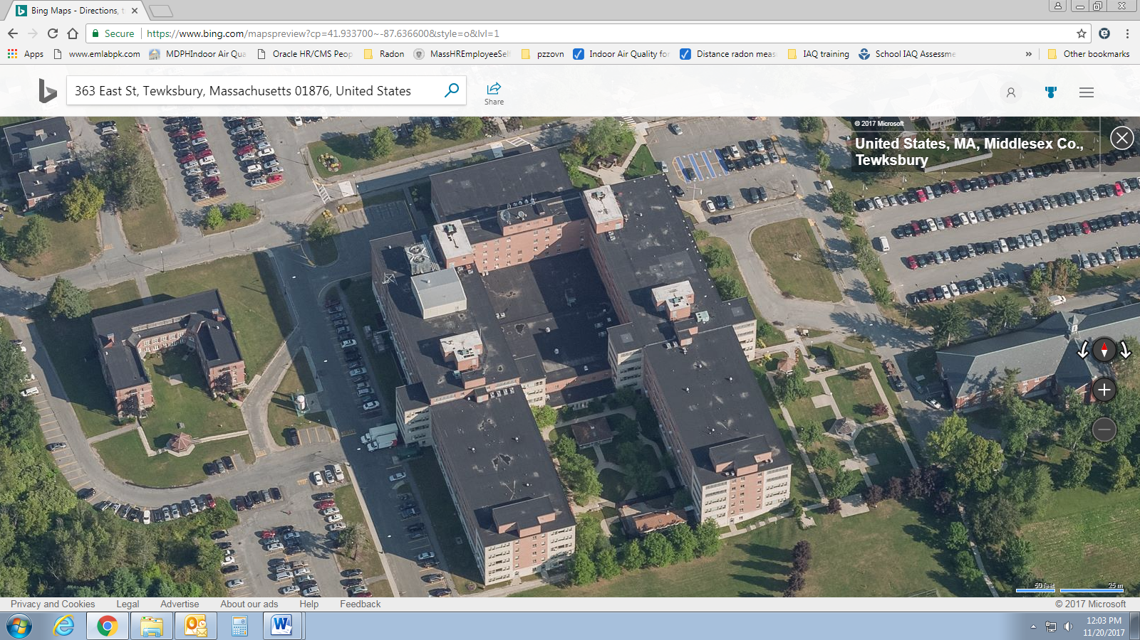

Prepared by:

Massachusetts Department of Public Health

Bureau of Climate and Environmental Health

Indoor Air Quality Program

August 2024

**BACKGROUND**

|  |  |
| --- | --- |
| **Building:** | Tewksbury Hospital (TH), Saunders Building (SB) |
| **Address:** | 365 East Street, Tewksbury, MA |
| **Assessment Requested by:** | Pamela Couchon, MCPPO  Facilities Project Manager for Public Health Hospitals |
| **Reason for Request:** | Mold, concerns regarding asbestos-containing materials (ACM), and health concerns. |
| **Date of Assessment:** | April 19, 2024 |
| **Massachusetts Department of Public Health/Bureau of Environmental Health (MDPH/BCEH) Staff Conducting Assessment:** | Michael Feeney Director, Indoor Air Quality (IAQ) Program |
| **Building Description:** | The Saunders Building is a U-shaped, five-story building with a flat rubber membrane roof. It was originally built in the 1960s with additional wings added in the early 1970s. |
| **Windows:** | Openable |

**EXECUTIVE SUMMARY**

Michael Feeney, IAQ Program Director, inspected various locations on the 2nd and 4th floors of the TH SB to assess the presence of water damage to building components and determine whether ACM was in a friable (easily crumbled) condition. Water-damaged ceiling tiles were noted, and ACM was intact and being maintained in a manner consistent with asbestos laws and regulations. IAQ staff observed conditions that may cause damage to floor tiles during extreme hot, humid weather.

The IAQ Program offered to assess the SB during hot, humid weather to observe the effect of water accumulation and possible damage to heating, ventilation, and air conditioning (HVAC) system components (fresh air supply vents) and ACM floor tile due to opening of windows when air chilling systems are activated. Condensation may cause damage and loosening of ACM floor tiles and tile adhesive.

**BACKGROUND**

The SB was constructed as a hospital with individual patient rooms and multi-patient wards. Each floor has two parallel hallways with a nurse’s station in the center of each floor. Hallways have suspended ceiling systems with removable tiles (Picture 1). Observed areas above the suspended ceiling (called a ceiling plenum) have cement roof/floor decking with no applied spray-on insulation. Floors are covered with tile installed when the SB was constructed (Picture 2). Some hallways and offices have carpeting (Picture 3). Patient rooms and hallways have openable windows that are either sash (Picture 4) or awning/flush casement operated by crank (Picture 5). The SB has a mechanical HVAC system with air chilling capacity (for a description, please see a previous report on this building at <https://www.mass.gov/doc/tewksbury-hospital-saunders-building-july-2011-0/download>).

The purpose of this visit was to examine water damage to potentially asbestos-containing materials (ACM) and other material that may have mold growth, with a focus on areas with water-damaged ceiling tiles. Air testing conducted in DMH-occupied offices will be the subject of a subsequent report.

**METHODS**

Visual examination of various water-damaged materials (ceiling tiles and flooring) was conducted.

**RESULTS AND DISCUSSION**

**Microbial/Moisture Concerns**

IAQ staff examined areas where water-stained ceiling tiles were reported. Each area did not have visible mold growth or odors that are associated with mold colonization (musty odors). A number of locations had water-damaged ceiling tiles with brownish stains (Picture 6), which indicates water exposure, but is not mold growth. Water staining to ceiling tiles is likely from the following sources:

* Plumbing leaks,
* Heating system radiator hot water supply pipe joints,
* Roof leaks on topmost floors, and/or
* Condensation on cold surfaces due to high relative humidity in the building.

Note that plumbing and heating pipes were mostly installed when the SB was constructed (more than 40 years ago). As such systems age, water leaks will occur at pipe joints, steam traps, or water-using fixtures (sinks, toilets, showers, and radiators). When such systems leak, water damage to ceiling tiles may occur; this is often the first sign that a leak above the ceiling system has occurred. After pipe leaks are repaired, the water-damaged ceiling tiles should be replaced.

The underside of the roof and floor decks is made of cement slabs (Picture 7). Picture 7 also shows signs of repeated water penetration that has damaged cement decking. The white material around the water penetration is efflorescence. When cement, brick, or mortar is exposed to water, some of the water-soluble salts dissolve and travel to the surface of the material. Once the solution dries, these salts appear as a white coating/powder called efflorescence. If observed, it is a telltale sign of water exposure to cement, which in turn indicates the source of moisture wetting materials, such as ceiling tiles. Efflorescence is not, however, indicative of mold colonization.

**Asbestos-Containing Materials (ACM)**

Floor tile in all areas examined was found intact and adhered to floors. Intact floor tile does not release asbestos with ordinary use. If ACM floor tiles are stripped using mechanical floor buffing equipment, the friction of the pad may cause release of asbestos. TH facilities staff know of this issue and comply with US Occupational Safety and Health Administration (OSHA) regulations. OSHA regulations require ACM floor tiles to be maintained to remain intact and that routine cleaning does not cause damage to these materials (OSHA, 2019). These OSHA regulations include:

1. Prohibiting the sanding of asbestos-containing floor material.
2. Stripping of finishes shall be conducted using low abrasion pads at speeds lower than 300 rpm and wet methods.
3. Burnishing or dry buffing may be performed only on asbestos-containing flooring which has sufficient finish so that the pad cannot contact the asbestos-containing material. 29 CFR 1910.1001(k)(7). <https://www.ecfr.gov/current/title-29/subtitle-B/chapter-XVII/part-1910/subpart-Z/section-1910.1001>

TH facilities staff reported that they are aware of the regulations and implement the required cleaning procures listed above to prevent floor tile damage.

In the SB, one condition that can adversely affect ACM floor tile is the opening of windows during hot, humid weather when the building’s HVAC system is providing chilled air. Open windows allow air with high relative humidity into the building. This can lead to condensation on cold surfaces. If surfaces are not dried within 24 hours, mold growth may occur. Condensation may also damage floor tiles and adhesive, which may result in the release of asbestos when damage occurs.

While some floor tiles showed typical water stains from condensation during the assessment, IAQ Program staff did not observe damaged or loose floor tiles at the locations visited. Bartley Larkin, TH Facility Director, confirmed that floors are maintained in a manner consistent with OSHA floor tile regulations.

Due to the possible wetting of floor tile from condensation during hot, humid weather, The IAQ Program offers to schedule a follow-up visit to assess locations with possible water accumulation due to condensation during hot, humid weather that is a result of open windows when the TH HVAC system is chilling air.

**CONCLUSIONS AND RECOMMENDATIONS**

Due to the age of construction of the building and mechanical ventilation equipment, the Saunders Building space has limited ability to reduce relative humidity indoors**. These conditions become exacerbated if windows are opened during hot and humid weather.** It is important to note that if extreme relative humidity and rain occur, management of the building in such weather can be challenging. The following documents can provide guidance that can be used to reduce the impact of hot, humid weather in buildings:

* Mold growth Prevention during Hot, Humid Weather <https://www.mass.gov/service-details/preventing-mold-growth-in-massachusetts-schools-during-hot-humid-weather>
* Remediation and Prevention of Mold Growth and Water Damage in Public Schools [Remediation and prevention of mold growth and water damage in public schools and buildings to maintain air quality | Mass.gov](https://www.mass.gov/info-details/remediation-and-prevention-of-mold-growth-and-water-damage-in-public-schools-and-buildings-to-maintain-air-quality) and
* Methods for Increasing Comfort in Non-air-conditioned Schools <https://www.mass.gov/doc/methods-for-increasing-comfort-in-non-air-conditioned-schools/download>

In view of the findings at the time of the visit, the following recommendations are provided:

1. Continue to comply with OSHA ACM floor tile management regulations.
2. If ACM floor tiles are exposed to water, examine tiles for damage or loosening. If damaged or loosened, remove, and replace the ACM floor tile in a manner consistent with all Federal and state asbestos laws and regulations.
3. Continue to repair water leaks from plumbing and heating system as reported.
4. Replace water-damaged ceiling tiles after pipe repairs are completed.
5. Refer to resource manual and other related IAQ documents located on the MDPH’s website for further building-wide evaluations and advice on maintaining public buildings. These documents are available at: <http://mass.gov/dph/iaq>.

**REFERENCES**

OSHA, 2019.§ 1910.1001 Asbestos.Title 29 Subtitle B Chapter XVII Part 1910 Subpart Z § 1910.1001. <https://www.ecfr.gov/current/title-29/subtitle-B/chapter-XVII/part-1910/subpart-Z/section-1910.1001>

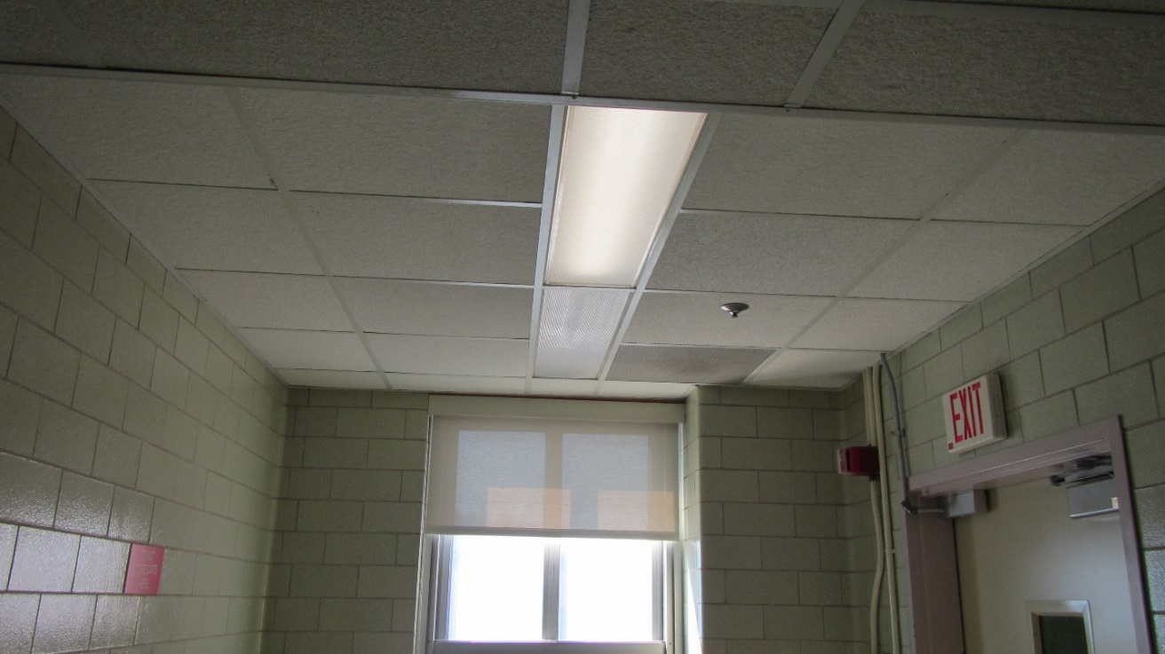**Picture 1**

**Suspended ceiling with removable tiles**

**Picture 2**

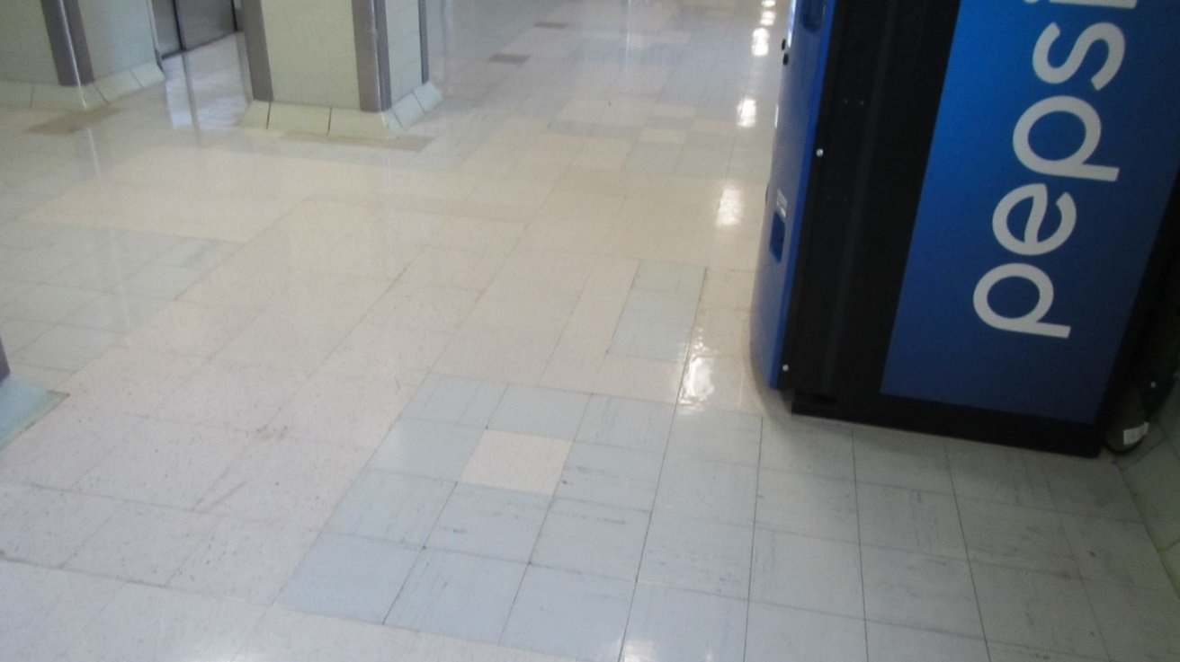

**Hallway with floor tiles**

**Picture 3**

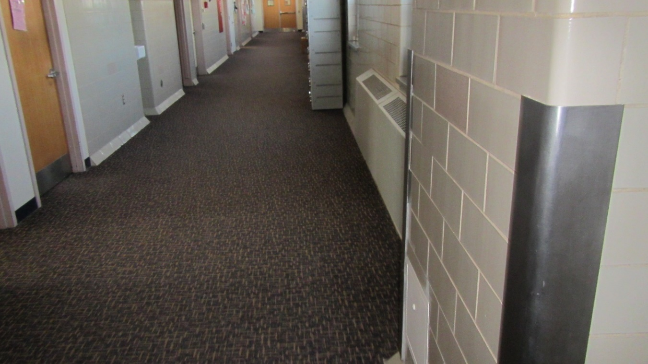

**Hallway with carpeting**

**Picture 4**

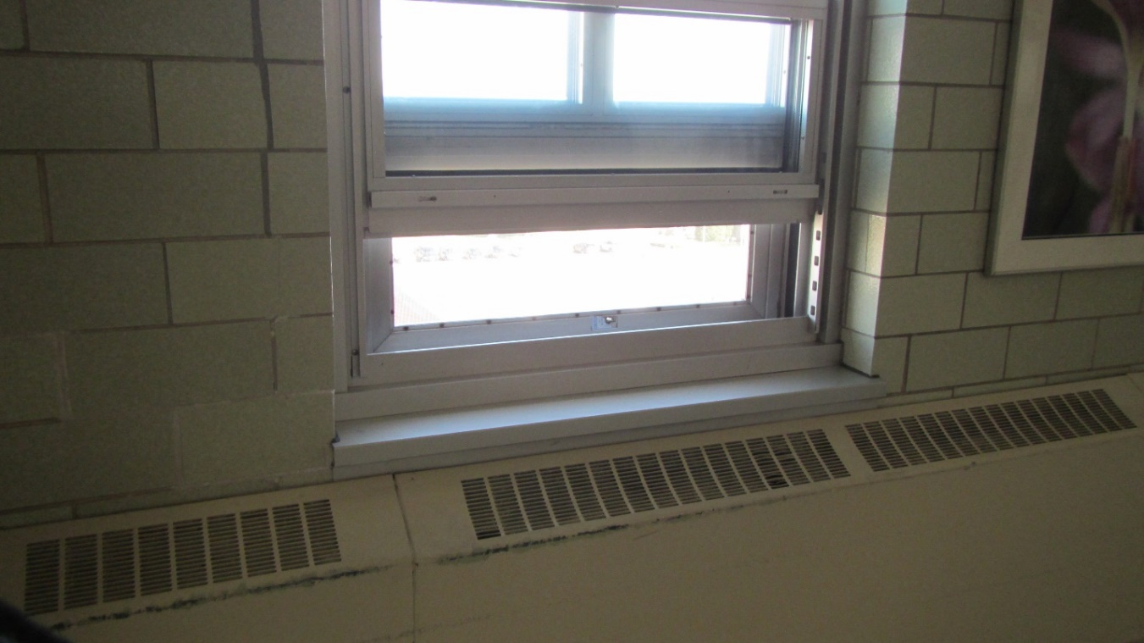

**Sash window**

**Picture 5**

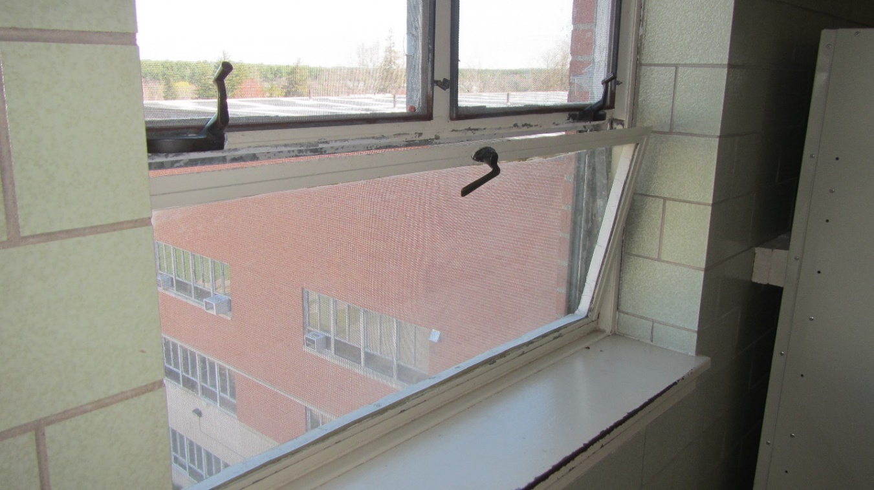

**Awning/flush casement window operated by crank**

**Picture 6**

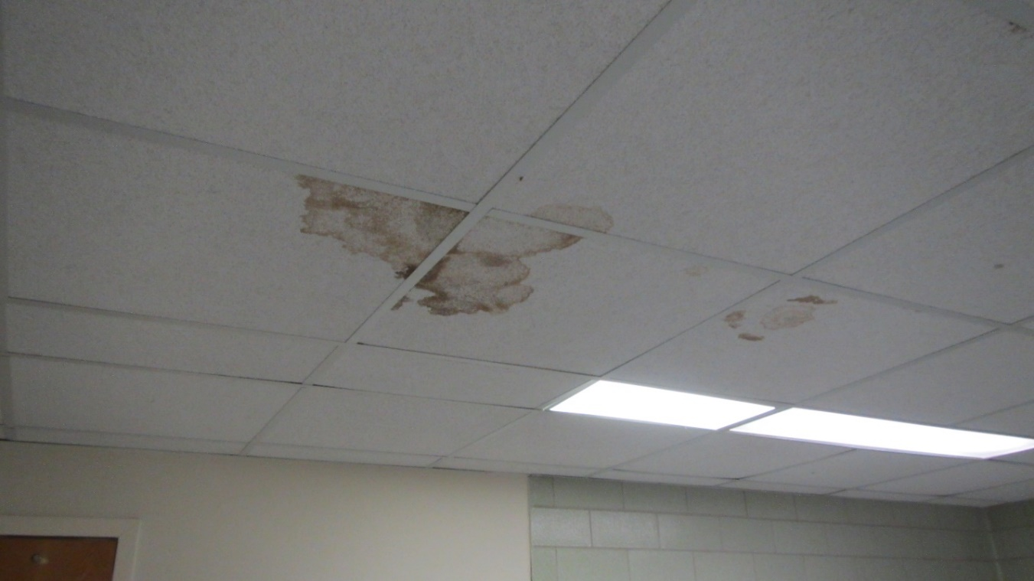

**Ceiling tiles with brown stains**

**Picture 7**

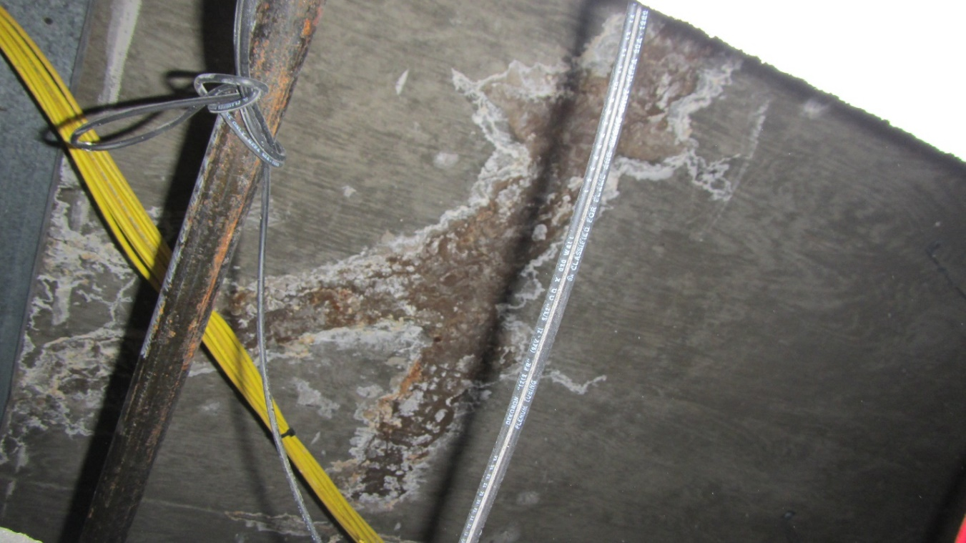

**Water-damaged cement slab below roof with efflorescence**

1. Dalsgaard, S. B., Würtz, E. T., Hansen, J., Røe, O. D., & Omland, Ø. (2022). A Cohort Study on Cancer Incidence among Women Exposed to Environmental Asbestos in Childhood with a Focus on Female Cancers, including Breast Cancer. International journal of environmental research and public health, 19(4), 2086. <https://doi.org/10.3390/ijerph19042086>
2. Thun, Michael, and others (eds), Cancer Epidemiology and Prevention, 4th edn (New York, 2017; online edn, Oxford Academic, 21 Dec. 2017), <https://doi.org/10.1093/oso/9780190238667.001.0001>, accessed 17 July 2024.