INDOOR AIR QUALITY ASSESSMENT

Tewksbury Hospital
Saunders Building, Social Services
B-Wing, First Floor
365 East Street Tewksbury, MA

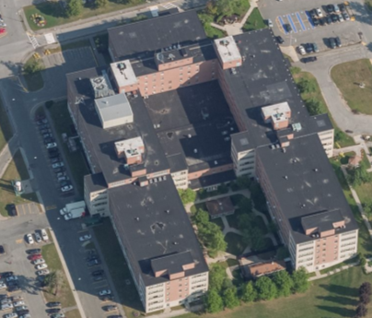

Prepared by:
Massachusetts Department of Public Health
Bureau of Environmental Health
Indoor Air Quality Program
November 2017

Background
Building: | Tewksbury Hospital, Saunders Building
Address: | 365 East Street, Tewksbury, MA
Assessment Requested by: | Scott J. Consaul, J.D., CPHQ, CHSP, CSL  Interim Director of Facilities Management/Director of Environment of Care Department
Reason for Request: | General Indoor Air Quality (IAQ) and health concerns
Date of Assessment: | November 14, 2017
Massachusetts Department of Public Health/Bureau of Environmental Health (MDPH/BEH) Staff Conducting Assessment: | Jason Dustin, Environmental Analyst, indoor air quality (IAQ) Program
Building Description: | The offices examined are on the 1st floor of a U-shaped, five-story building with a flat rubber membrane roof. It was originally built in the 1960s with additional wings added in the early 1970s.
Windows: | Not openable

Methods
Please refer to the IAQ Manual for methods, sampling procedures, and interpretation of results (MDPH, 2015).

IAQ Testing Results
The following is a summary of indoor air testing results (Table 1).
- Carbon dioxide levels were below 800 parts per million (ppm) in all areas surveyed, indicating adequate air exchange.
- Temperature was within or just below the recommended range of 70°F to 78°F in all areas tested.
- Relative humidity was below the recommended range of 40 to 60% in the areas tested which is typical during the heating season.
- Carbon monoxide levels were non-detectable (ND) in all areas tested.
- Fine particulate matter (PM2.5) concentrations measured were below the National Ambient Air Quality (NAAQS) limit of 35 μg/m³ in all areas tested.
- Total Volatile Organic Compound (TVOC) levels were ND in all areas surveyed.

Ventilation
A heating, ventilating and air conditioning (HVAC) system has several functions. First it provides heating and, if equipped, cooling. Second, it is a source of fresh air. Finally, an HVAC system will dilute and remove normally-occurring indoor environmental pollutants by not only introducing fresh air, but by filtering the airstream and ejecting stale air to the outdoors via exhaust ventilation. Even if an HVAC system is operating as designed, point sources of respiratory irritation may exist and cause symptoms in sensitive individuals.
Fresh air is supplied by air handling units (AHU) and delivered to supply vents located in the ceilings of rooms (Picture 1). The building uses 100% fresh air so that no air is returned to the AHUs. Stale air is drawn through grates and ejected out of the building through roof-mounted exhaust units. Note that this area was recently reconfigured with modular walls and the only exhaust vent noted was located in room C151G (Picture 2). It was reported that this door is typically kept open as well as the door leading to the hallway in the former payroll office. With adequate supply air and doors slightly undercut, this condition should allow for ample air exchange, which is also indicated by the low carbon dioxide levels shown in Table 1.
The MDPH typically recommends that HVAC systems be re-balanced every five years to ensure adequate air systems function (SMACNA, 1994). It is not known when the last time these systems were balanced. Balancing should also occur when the space is significantly rearranged.

Microbial/Moisture Concerns
A water-damaged ceiling tile was observed (Picture 3) in the former code compliance area. This stained tile was reportedly due to a historic leak that has since been repaired. Water-damaged ceiling tiles should be replaced during unoccupied hours once a leak is repaired.

Other IAQ Evaluations
Exposure to low levels of total volatile organic compounds (TVOCs) may produce eye, nose, throat, and/or respiratory irritation in some sensitive individuals. To determine if VOCs were present, BEH/IAQ staff examined rooms for products containing VOCs. BEH/IAQ staff noted cleaners, hand sanitizers, air fresheners and other products in use within the building (Table 1). All of these products have the potential to be irritants to the eyes, nose, throat, and respiratory system of sensitive individuals.
The relative humidity readings were below the MDPH recommended comfort range the day of the assessment. The MDPH recommends a comfort range of 40 to 60 percent for indoor air relative humidity. Relative humidity in the building would be expected to drop during the winter months due to heating. The sensation of dryness and irritation is common in a low relative humidity environment. “Extremely low (below 20%) relative humidity may be associated with eye irritation [and]…may affect the mucous membranes of individuals with bronchial constriction, rhinitis, or cold and influenza related symptoms” (Arundel et al., 1986). Low relative humidity is a common problem during the heating season in the northeast part of the United States.
Also note that some desks in the former payroll department are located directly in the air stream from the HVAC system, which may lead to feelings of draftiness and may increase the sensation of dry eyes. Failure to take regular breaks from viewing the computer monitors may also increase the chance of eye irritation.
The Director’s office was noted to have a hole in the concrete floor which appeared to lead to an unconditioned area (Picture 4). The hole should be sealed to prevent the intrusion of moisture, odors, particulates and pests.
In some areas, stored materials and accumulated items make it more difficult for custodial staff to clean. Items should be stored neatly and moved periodically to allow for wet-wiping and vacuuming of surfaces.

Conclusions/Recommendations
Based on observations at the time of assessment, the following is recommended:
- Change out or reconfigure the supply air diffuser in the former payroll area so that the air streams do not directly impact occupants.
- Eliminate/reduce the use of hand sanitizers, air fresheners, harsh or scented cleaning products and dry erase materials in the office since all of these products have the potential to be irritants to the eyes, nose, throat, and respiratory system of sensitive individuals.
- Seal the hole in the floor noted in the Director’s office. Any other pathways leading to unconditioned areas should also be properly sealed.
- Replace water-damaged ceiling tiles.
- Continue to keep the door to the hallway in the former payroll area open as well as the door to room C151G. If privacy becomes a concern, ensure doors are undercut enough to draw air to both the exhaust vents in the hall and in C151G. Alternatively, passive grilles/vents could be added to allow the free flow of air to the exhaust vents or a new exhaust vent could be installed in the former payroll area.
- For buildings in New England, periods of low relative humidity during the winter are often unavoidable. Therefore, scrupulous cleaning practices should be adopted to minimize common indoor air contaminants whose irritant effects can be enhanced when the relative humidity is low. To control for dusts, a high efficiency particulate arrestance (HEPA) filter equipped vacuum cleaner in conjunction with wet wiping of all surfaces is recommended. Avoid the use of feather dusters. Drinking water during the day can help ease some symptoms associated with a dry environment (throat and sinus irritations).
- Reduce the amount of items stored on flat surfaces to allow regular cleaning.
- Have the HVAC system balanced every 5 years in accordance with SMACNA recommendations (SMACNA, 1994). Consider a rebalancing when the building layout is changed.
- Encourage occupants to periodically take a break from viewing monitors which may also contribute to eye strain/irritation.
- Refer to resource manual and other related IAQ documents located on the MDPH’s website for further building-wide evaluations and advice on maintaining public buildings. These documents are available at: http://mass.gov/dph/iaq.

References
Arundel et al. 1986. Indirect Health Effects of Relative Humidity on Indoor Environments. Env. Health Perspectives 65:351-361.
MDPH. 2015. Massachusetts Department of Public Health. Indoor Air Quality Manual: Chapters I-III. Available at: http://www.mass.gov/eohhs/gov/departments/dph/programs/environmental-health/exposure-topics/iaq/iaq-manual/.
SMACNA. 1994. HVAC Systems Commissioning Manual. 1st ed. Sheet Metal and Air Conditioning Contractors’ National Association, Inc., Chantilly, VA.

Picture 1
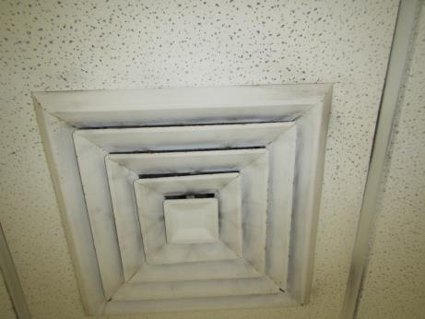
Supply air diffuser
Picture 2
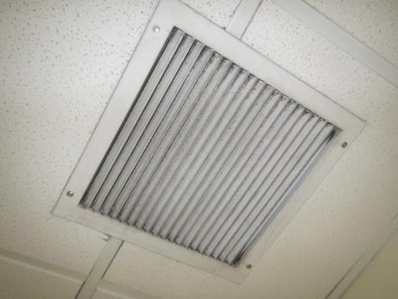
Ceiling-mounted exhaust vent in room C151G
Picture 3
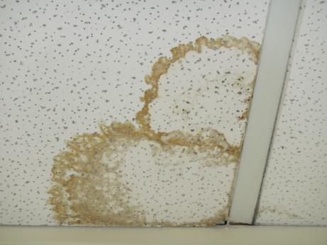
Water-damaged ceiling tile
Picture 4
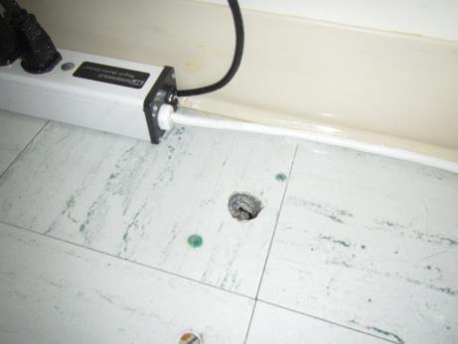
Hole in floor of Director’s office
Location | Carbon  Dioxide  (ppm) | Carbon Monoxide  (ppm) | Temp  (°F) | Relative  Humidity  (%) | PM2.5  (µg/m³) | TVOCs  (ppm) | Occupants  in Room | Windows  Openable | Ventilation |  | Remarks
 |  |  |  |  |  |  |  |  | Supply | Exhaust
Background- Outside | 349 | ND | 40 | 59 | 8 | ND | - | - | - | - | Overcast
B-Wing Hallway | 522 | ND | 71 | 25 | 7 | ND | 2 | N | Y | Y
Former Payroll- Right | 437 | ND | 70 | 21 | 5 | ND | 5 | N | Y | N | HS, CPs, PC, old vault, door open to hall
Former Payroll- Left | 422 | ND | 70 | 22 | 4 | ND | 5 | N | Y | N | HS
Director | 468 | ND | 70 | 22 | 4 | ND | 3 | N | Y | N | PF, AF, hole in floor
Former code compliance | 411 | ND | 69 | 21 | 5 | ND | 1 | N | Y | N | DEM, WD CT x1
C151F | 427 | ND | 69 | 21 | 4 | ND | 1 | N | Y | N | AI, aerosol duster
C151G | 432 | ND | 70 | 21 | 5 | ND | 1 | N | Y | Y | HS
Conference | 407 | ND | 68 | 20 | 7 | ND | 3 | N | Y | N

