INDOOR AIR QUALITY ASSESSMENT

Tewksbury Hospital Saunders Building
Chapel Area Offices
365 East Street
Tewksbury, MA

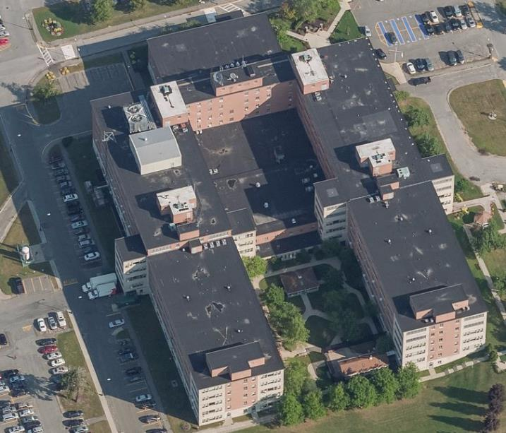

Prepared by:
Massachusetts Department of Public Health
Bureau of Environmental Health
Indoor Air Quality Program
June 2022

BACKGROUND
Building: | Tewksbury Hospital Saunders Building, Chapel Area offices
Address: | 365 East Street, Tewksbury, MA
Assessment Requested by: | Patty-Jo Hanley, Compliance Officer  Department of Public Health, Tewksbury Hospital
Reason for Request: | Concerns about respiratory irritation and general indoor air quality (IAQ) issues
Date of Assessment: | May 17, 2022
Massachusetts Department of Public Health/Bureau of Environmental Health (MDPH/BEH) Staff Conducting Assessment: | Ruth Alfasso Environmental  Engineer/Inspector, IAQ Program
Building Description: | The Saunders building is a large hospital building on the Tewksbury Hospital campus. The area examined include several interior offices along the hallway adjacent to the Chapel.
Windows: | There are no windows in this area.

METHODS
Please refer to the IAQ Manual for methods, sampling procedures, and interpretation of results (MDPH, 2015).

RESULTS AND DISCUSSION
The following is a summary of indoor air testing results (Table 1):
- Carbon Dioxide was below the MDPH recommended guideline of 800 parts per million (ppm) in all areas assessed. Note that many areas have low occupancy, as employees are on a hybrid work schedule. Carbon dioxide levels may be higher with increased occupancy.
- Temperature was within the MDPH recommended range of 70°F to 78°F in all areas tested.
- Relative Humidity was within or close to the lower end of the MDPH recommended range of 40 to 60% in the areas tested.
- Carbon Monoxide was not detected (ND) in the areas assessed.
- Particulate matter (PM2.5) concentrations measured were below the National Ambient Air Quality (NAAQS) level of 35 μg/m³ in all areas tested.

Ventilation
A heating, ventilating and air conditioning (HVAC) system has several functions. First, it provides heating and, if equipped, cooling. Second, it is a source of fresh air. Finally, an HVAC system will dilute and remove normally occurring indoor environmental pollutants by not only introducing fresh air, but by filtering the airstream and ejecting stale air to the outdoors via exhaust ventilation. Even if an HVAC system is operating as designed, point sources of respiratory irritation may exist and cause symptoms in sensitive individuals.
Fresh air in the areas assessed is provided by air-handling units (AHUs) located on a section of the roof. These areas were not accessible during the visit. Fresh air is drawn into the AHUs from outside, filtered, and delivered to occupied space via supply diffusers (Picture 1) located in each room. There is a single return grate in the hallway serving the rooms tested (Picture 2). It appears that office doors had originally been equipped with transfer air vents, which have since been sealed (Picture 3). Such conditions were also noted by IAQ Program staff during an IAQ assessment at the Shattuck Hospital (MDPH, 2002). According to the Shattuck Hospital staff, transfer air vents were sealed due to recommendations made by the hospital certification/accreditation body (now known as The Joint Commission) indicating that the facility should meet current fire codes. It would be likely that such activities were done in all DPH Hospitals (including Tewksbury Hospital) to meet this Joint Commission recommendation. As a result, there is little means for air to be exhausted from individual offices if the doors are closed. This may prevent effective removal of stale air from offices unless doors are opened during occupancy.
To maximize air exchange, the IAQ program recommends that both supply and exhaust ventilation operate continuously during periods of occupancy. To have proper ventilation with a mechanical ventilation system, the systems must be balanced after installation to provide an adequate amount of fresh air to the interior of a room while removing stale air from the room. It is recommended that HVAC systems be re-balanced every five years to ensure adequate air systems function (SMACNA, 1994).

Moisture/Microbial Issues
Peeling paint was noted in office C131C and on the ceiling in the hallway (Pictures 4 and 5). Paint peeling in this manner is frequently the result of moisture working its way through the wall material. Moisture measurements of wall surfaces in office C131C showed that they were dry. No moldy odor or mold staining were noted. The wall/ceiling materials are mostly plaster, which does not readily support mold growth. No known incident of flooding was reported in this area that might account for the peeling paint; it may have occurred a long time before the visit. Peeling paint and flaking plaster are unsightly and may contribute to irritating dusts in the office so the areas should be scraped and repainted when feasible.
A portable air conditioner was found in office C131Q (Picture 6). This unit has an exhaust hose that reportedly connects to the area exhaust system (Picture 7). A bucket for collecting condensation was found behind the unit. When the unit is in use, this bucket needs to be emptied and rinsed daily to prevent odors from stagnant water.
Food was noted in one office on the desktop. Food should not be stored in offices, as it can be attractive to pests.

Other issues
Items were observed on a number of flat surfaces, such as floors, windowsills, tabletops, counters, bookcases, and desks. Items stored in offices provide a source for dusts to accumulate and make it difficult for custodial staff to clean.
The hallway was carpeted. Carpets should be cleaned annually (or semi-annually in soiled/high traffic areas) in accordance with Institute of Inspection, Cleaning and Restoration Certification (IICRC) recommendations, (IICRC, 2012).

CONCLUSIONS AND RECOMMENDATIONS
In view of the findings at the time of the visit, the following recommendations are made:

Ventilation Recommendations
- Operate supply and exhaust ventilation continuously when the building is occupied.
- Continue with regular filter changes for AHUs using the best quality/highest Minimum Efficiency Reporting Value (MERV) rated filters that can be used with current equipment.
- Consider if adding an additional return/exhaust vent to the hallway and/or undercutting doors slightly might improve air circulation in the offices.
- Consider adopting a balancing schedule of every 5 years for all mechanical ventilation systems, as recommended by ventilation industrial standards (SMACNA, 1994).

Water Damage Recommendations
- Scrape and repaint areas where the paint is flaking. Monitor areas where paint is flaking for signs of moisture and find/repair any leaks that may be leading to damage in these areas.
- Ensure any condensation collection buckets are emptied and rinsed every day when the air conditioner is in use.

Other Recommendations
- Store items neatly and off the floor to assist with cleaning.
- Keep food stored in tightly closed pest-proof containers.
- Clean filters for air conditioners periodically to remove dust.
- Clean carpets in accordance with IIRC recommendations and the terms of the lease.
- Refer to the resource manual and other related indoor air quality documents located on the MDPH’s website for further building-wide evaluations and advice on maintaining public buildings. These documents are available at http://mass.gov/dph/iaq.

REFERENCES
IICRC. 2012. Institute of Inspection, Cleaning and Restoration Certification. Carpet Cleaning: FAQ.
MDPH. 2002. Indoor Air Quality Assessment, Lemuel Shattuck Hospital Complex. Massachusetts Department of Public Health, Bureau of Environmental Health Assessment, Boston, MA. April, 2002.
MDPH. 2015. Massachusetts Department of Public Health. Indoor Air Quality Manual: Chapters I-III. Available at: https://www.mass.gov/lists/indoor-air-quality-manual-and-appendices#indoor-air-quality-manual-
SMACNA. 1994. HVAC Systems Commissioning Manual. 1st ed. Sheet Metal and Air Conditioning Contractors’ National Association, Inc., Chantilly, VA.

Picture 1
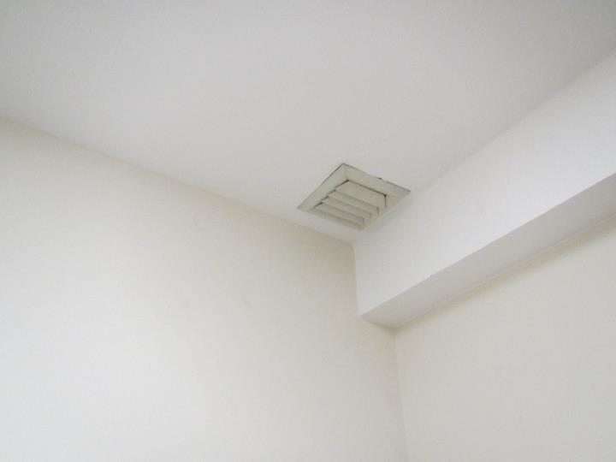
Supply diffuser for one of the rooms examined
Picture 2
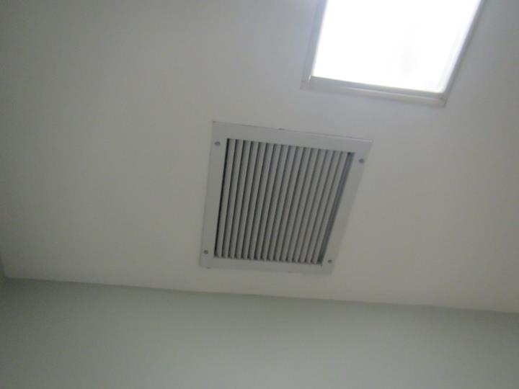
Return vent grate at end of hallway
Picture 3
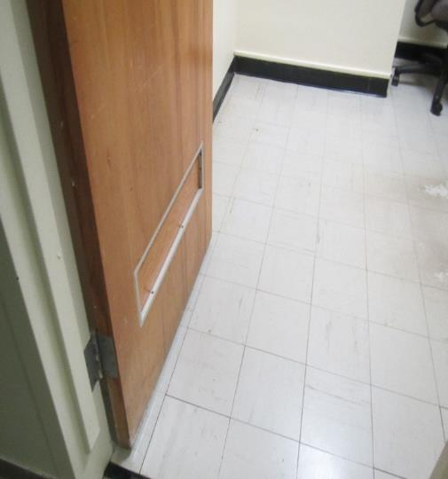
Sealed transfer air vent in office door (arrow)
Picture 4
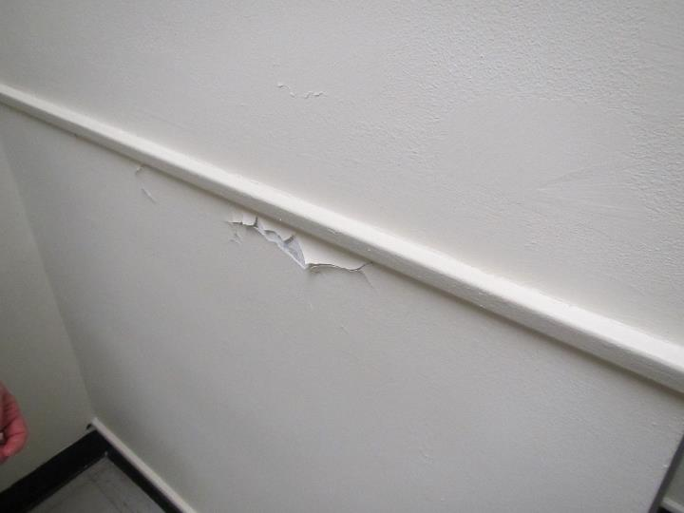
Peeling paint in office C131C
Picture 5
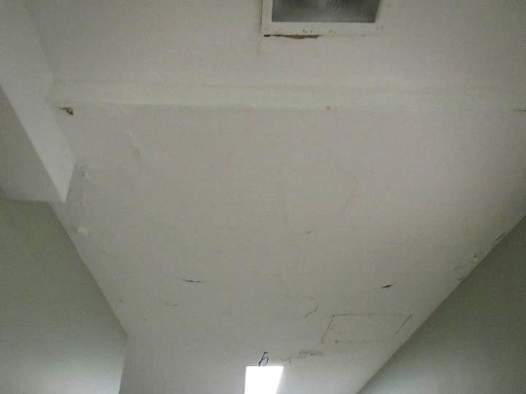
Peeling paint and possible water stains on hallway ceiling
Picture 6
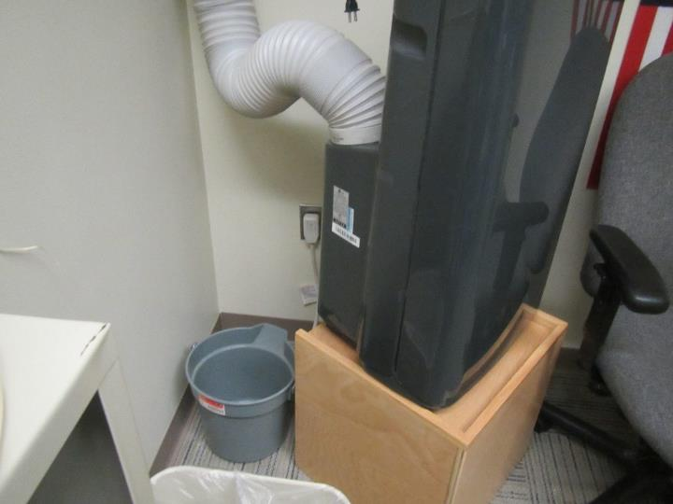
Portable air conditioner (note bucket behind unit)
Picture 7
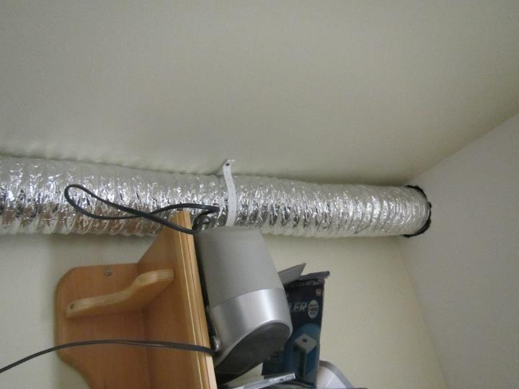
Hose from portable air conditioner, reportedly attached to the exhaust system

Location/ Room | Carbon  Dioxide  (ppm) | Carbon Monoxide  (ppm) | Temp  (°F) | Relative  Humidity  (%) | PM2.5  (µg/m³) | Occupants  in Room | Windows  Openable | Ventilation |  | Remarks
 |  |  |  |  |  |  |  | Supply | Exhaust
Background | 396 | ND | 71 | 40 | ND |  |  |  |  | Breezy
C131C | 461 | ND | 76 | 38 | 1 | 0 | N | Y | N | Peeling paint on walls, walls measured as dry
C131D | 681 | ND | 77 | 42 | ND | 0 | N | Y | N
C131H | 564 | ND | 76 | 43 | 1 | 1 | N | Y | N
C131J | 527 | ND | 75 | 42 | 1 | 0 | N | Y | N | Food on desk
C131Q | 438 | ND | 75 | 42 | 2 | 0 | N | Y | N | Portable air conditioning unit with exhaust into exhaust system
Chapel | 421 | ND | 75 | 39 | 1 | 0 | N | Y | Y
Hallway |  |  |  |  |  |  | N | N | Y | Peeling paint on ceiling, new-looking carpet

