INDOOR AIR QUALITY ASSESSMENT

Tewksbury Hospital, Saunders Building
365 East Street
Tewksbury, Massachusetts

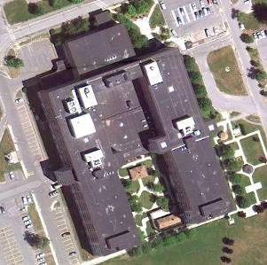

Prepared by:
Massachusetts Department of Public Health
Bureau of Environmental Health
Indoor Air Quality Program
July 2011

Background/Introduction
To assist Tewksbury Hospital with meeting Joint Commission on Accreditation of Healthcare Organizations (JCAHO) requirement for evaluation of adequacy of the operation of the heating, ventilating and air-conditioning (HVAC) system, the Massachusetts Department of Public Health (MDPH), Bureau of Environmental Health (BEH) conducted air measurements of carbon dioxide, temperature and relative humidity in the Saunders Building at Tewksbury Hospital (THSB), located at 365 East Street, Tewksbury, Massachusetts. The air sampling was done in cooperation with Mr. Scott Consaul, Director of Environment of Care for Tewksbury Hospital. On March 25, 2011, and April 22, 2011, Ruth Alfasso, Environmental Engineer/ Inspector for BEH’s IAQ Program visited to the THSB to conduct the air sampling with Scott Consaul, Director of Environment of Care for Tewksbury Hospital.
The THSB is a U-shaped, five-story building with a flat rubber membrane roof. It was originally built in the 1960s with additional wings added in the early 1970s.

Methods
Air tests for carbon monoxide, carbon dioxide, temperature and relative humidity were conducted with the TSI, Q-Trak, IAQ Monitor, Model 7565.

Results
The THSB has approximately 320 medical and 130 psychiatric services beds, with approximately 1,000 staff over three shifts. Tests were taken during typical operations. Results from the March 25, 2011 visit appear in Table 1. Results from the April 22, 2011 visit appear in Table 2.

Discussion

Ventilation
It can be seen from Table 1 that carbon dioxide levels were below 800 parts per million (ppm) in all but four (of forty-seven) areas surveyed on March 25, 2011. All forty-eight areas surveyed on April 22, 2011, were below 800 ppm (Table 2). These numbers indicate adequate air exchange throughout the majority of the building at the time it was assessed. As previously mentioned, many locations tested, particularly during the March 25, 2011 visit, were empty or sparsely populated which may result in lower carbon dioxide concentrations than would be experienced during periods of higher occupancy.
The HVAC system consists of air-handling units (AHU) located on the roof of the building and in various places in each wing. Fresh air is ducted into rooms via supply vents (Pictures 1 and 2) and stale air is removed via exhaust vents (Picture 3). Additional heat is provided via radiators which use steam from a central steam plant (Pictures 4 and 5). Some areas, particularly in the patient wings, receive cooling via the ducted AHU systems, while others, mostly the first floor and basement offices, utilize window-based air conditioning units (Picture 5). New chillers were added for the patient care units during 2004 and 2005; fan coil units service these areas.
Most of the windows in the areas of THSB that were surveyed are openable. Ceiling fans are present and operational in many of the common rooms and nurses’ station areas (Picture 2). Some offices in the basement and subbasement are not equipped with supply and/or exhaust ventilation, relying on corridors, and windows where available, to provide fresh air (EB 12/Table 2).
Several locations, including the laboratory, the kitchen and the dishwashing areas have local exhaust ventilation (e.g., hoods) to directly remove moisture and/or contaminants produced or released in these areas. In addition, the laboratory wing (C basement) has its own separate HVAC system, and is kept at negative pressure to prevent release of contaminants to other areas of the building.
The Massachusetts Building Code requires that each room have a minimum ventilation rate of 20 cubic feet per minute (cfm) per occupant of fresh outside air or openable windows (SBBRS, 1997; BOCA, 1993). The ventilation must be on at all times that the room is occupied. Providing adequate fresh air ventilation with open windows and maintaining the temperature in the comfort range during the cold weather season is impractical. Mechanical ventilation is usually required to provide adequate fresh air ventilation.
Carbon dioxide is not a problem in and of itself. It is used as an indicator of the adequacy of the fresh air ventilation. As carbon dioxide levels rise, it indicates that the ventilating system is malfunctioning or the design occupancy of the room is being exceeded. When this happens, a buildup of common indoor air pollutants can occur, leading to discomfort or health complaints. The Occupational Safety and Health Administration (OSHA) standard for carbon dioxide is 5,000 parts per million parts of air (ppm). Workers may be exposed to this level for 40 hours/week, based on a time-weighted average (OSHA, 1997).
The MDPH uses a guideline of 800 ppm for publicly occupied buildings. A guideline of 600 ppm or less is preferred in schools due to the fact that the majority of occupants are young and considered to be a more sensitive population in the evaluation of environmental health status. Inadequate ventilation and/or elevated temperatures are major causes of complaints such as respiratory, eye, nose and throat irritation, lethargy and headaches. For more information concerning carbon dioxide, please see Appendix A.
During the March 25, 2011 visit, temperatures ranged from 69 ºF to 75 ºF, which were within or very close to the lower end of the MDPH recommended comfort guidelines. During the April 22, 2011 visit, temperatures ranged from 66 ºF to 75 ºF. Four of the locations tested were slightly below the MDPH comfort guidelines; the one location measured at 66 ºF was the guard lobby next to the frequently-opened main entrance door. The MDPH recommends that indoor air temperatures be maintained in a range of 70 ºF to 78 ºF in order to provide for the comfort of building occupants. In many cases concerning indoor air quality, fluctuations of temperature in occupied spaces are typically experienced, even in a building with an adequate fresh air supply.
During the March 25, 2011 visit, relative humidity measurements ranged from 12 to 22 percent (Table 1). During the April 22, 2011 visit, relative humidity measurements ranged from 14 to 39 percent (Table 2). All of the measurements during both visits were below the MDPH recommended comfort range; the area that measured 39 percent was the dish room, in which a higher relative humidity would be expected. The MDPH recommends a comfort range of 40 to 60 percent for indoor air relative humidity. The sensation of dryness and irritation is common in a low relative humidity environment. Low relative humidity is a very common problem during the heating season in the northeast part of the United States.

Conclusions/Recommendations
In view of the findings at the time of the visits, the following recommendations are made to improve indoor air quality:
Maintain the HVAC system (e.g., filter replacement) in accordance with manufacturer’s instructions and hospital good practice.
For areas in the basement and subbasement where mechanical ventilation is indirect or unavailable, ensure that windows can be opened as needed and that sufficient supply air is introduced. Consider providing additional ventilation for these areas (e.g., EB 12/Table 2).

References
BOCA. 1993. The BOCA National Mechanical Code-1993. 8th ed. Building Officials & Code Administrators International, Inc., Country Club Hills, IL.
OSHA. 1997. Limits for Air Contaminants. Occupational Safety and Health Administration. Code of Federal Regulations. 29 C.F.R 1910.1000 Table Z-1-A.
SBBRS. 1997. Mechanical Ventilation. State Board of Building Regulations and Standards. Code of Massachusetts Regulations. 780 CMR 1209.0
Picture 1

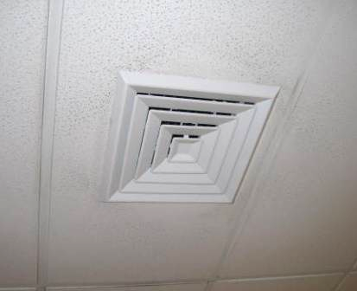

Typical Supply Vent (note dust along air path)

Picture 2

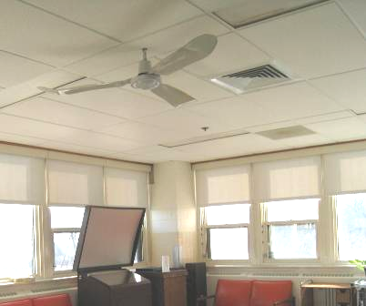

Typical Supply Vent (arrow) with Ceiling Fan
Picture 3

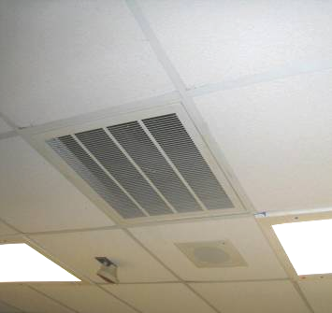

Typical Exhaust Vent (arrow)

Picture 4

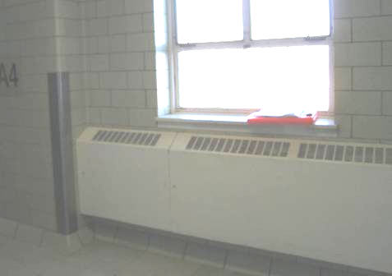

Typical Steam Radiator in Corridor

Picture 5

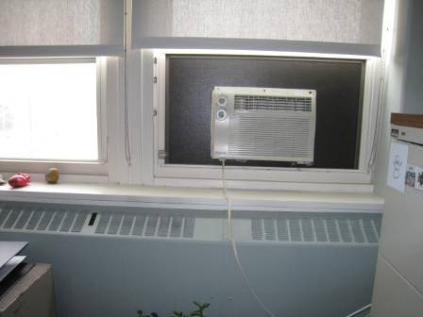

Window Air Conditioner and Steam Radiator
Location/ Room | Carbon Dioxide (ppm) | Temp (°F) | Relative Humidity (%) | Occupants  in Room | Windows Openable | Ventilation |  | Remarks
 |  |  |  |  |  | Supply | Exhaust | Remarks
Background | 410 | 44 | 20 |  |  |  |  | (Saunders C parking lot)
A1 (conference) | 430 | 74 | 13 | 0 | Y | Y | Y | Office areas nearly empty in this section
A2 elevator area | 590 | 73 | 14 | 0 | Y | Y | Y
A3 elevator area | 540 | 74 | 16 | 0 | Y | Y | Y
A3 nurses | 624 | 75 | 17 | 6 | N | Y | Y
A4 elevator lobby | 530 | 73 | 13 | 0 | Y | Y | Y | Radiator on
A4 nurses | 385 | 74 | 12 | 1 | N | Y | Y | This section is closed for renovation, HVAC is off and isolated from other floors
A4/E4 elevator lobby | 517 | 74 | 15 | 1 | N | Y | Y
A5 elevator lobby | 558 | 74 | 17 | 0 | Y | Y | Y | Office area, no office occupants, today being used for training
A5 end | 475 | 73 | 15 | 0 | N | Y | Y
A5 nurses | 510 | 73 | 15 | ~3 (passing through) | N | Y | Y | Sounds like no air being supplied
B1 elevator area | 436 | 71 | 14 | 0 | Y | Y | Y
B3 | 488 | 70 | 15 | 0 | N | Y | Y | New tile floor
B5 | 484 | 73 | 14 | 3 | N | Y | Y | DMH offices, carpeted
C1 elevator area | 473 | 70 | 14 | 0 | Y | Y | Y | “Clinic Area”
C2 nurses | 502 | 73 | 15 | 0 | N | Y | Y | Not currently used
C2/D2 elevator area | 618 | 75 | 17 | 0 | N | N | N
C3 elevator area | 494 | 69 | 17 | 1 | Y | Y | Y
C3 nurses’s station | 583 | 70 | 19 | 5 | N | Y | Y | Contains running office equipment, adjacent food prep area
C3/D3 elevator area | 695 | 72 | 19 | 0 | N | Y | Y
C4 nurses station | 546 | 72 | 16 | 2 | N | Y | Y
C5 elevator area | 685 | 69 | 22 | 1 | Y | Y | Y
C5/D5 elevator area | 690 | 71 | 20 | 0 | N | Y | Y
D1 “solarium room” | 461 | 73 | 15 | 0 | Y | N | N | Storage of wheelchairs
D1 end | 480 | 73 | 16 | 0 | N | Y | Y | Storage of wheelchairs in this area
D1 nurses | 881 | 72 | 17 | 3 | N | Y | Y | No central AC in this area, window AC available in outer rooms
D2 end | 599 | 74 | 17 | 4 | N | Y | Y
D2 nurses station | 662 | 74 | 17 | 3 | N | Y | Y | CF (off)
D3 end | 747 | 73 | 19 | 0 | N | Y | Y
D3 group room | 656 | 74 | 18 | 0 | Y | Y | Y | Hot from solar gain
D3 nurses station | 630 | 74 | 17 | 4 | N | Y | Y | CF (off)
D4 end @ stairs | 578 | 72 | 17 | 0 | N | Y | Y
D4 nurses station | 624 | 72 | 17 | 1 | N | Y | Y
D5 end | 631 | 71 | 19 | 0 | N | Y | Y
D5 nurses station | 683 | 72 | 20 | 1 | N | Y | Y
Dialysis office | 869 | 72 | 21 | 8 | Y | Y | Y | This area has a separate ventilation system
E1 | 446 | 72 | 16 | 0 | N | Y | Y | Offices and day use areas in this section
E1 end | 443 | 72 | 16 | 0 | N | Y | Y | Empty day use area
E1 solarium (meeting room) | 573 | 73 | 16 | 0 | Y | Y | Y | Contains radiators for heat; sink, ceiling fans
E2 elevator area | 455 | 75 | 15 | 0 | Y | Y | Y
E2 end | 716 | 74 | 19 | 3 | N | Y | Y | CF on in adjacent solarium
E2 nurses | 896 | 75 | 19 | 6 | N | Y | Y | CF (on)
E3 end | 672 | 72 | 22 | 2 | N | Y | Y | CF on in each side room
E3 nurses | 809 | 73 | 19 | 7 | N | Y | Y
E3/A3 elevator area | 705 | 75 | 18 | 0 | N | Y | Y
E4 end | 494 | 73 | 14 | 3 | N | Y | Y
E4 nurses | 636 | 74 | 16 | 3 | N | Y | Y
Patient/  employee gym area | 455 | 70 | 15 | 0 | N | Y | Y | 2 portable AC (running)

Location/ Room | Carbon Dioxide (ppm) | Temp (°F) | Relative Humidity (%) | Occupants  in Room | Windows Openable | Ventilation |  | Remarks
 |  |  |  |  |  | Supply | Exhaust | Remarks
Background | 404 | 49* | 41* |  |  |  |  | (Saunders parking lot)  *Temperature and relative humidity taken from wunderground.com weather history for Tewksbury, MA
103C | 438 | 75 | 16 | 0 | Y | N | N | CF (on)
A center outside industrial therapy | 434 | 71 | 22 | 0 | Y | N | N
A1 corridor | 437 | 71 | 18 | 0 | N | N | N | Openable windows at end of corridor
A1 elevator lobby | 499 | 71 | 18 | 0 | Y | N | N | Baseboard radiator
AB-B elevator lobby | 507 | 71 | 19 | 0 | N | N | N | End of corridor has openable window
Auditorium | 431 | 73 | 14 | 0 | N | Y | Y | Dirty supply vents and ceiling
Auditorium foyer | 463 | 72 | 16 | 0 | N | Y | N
B wing hallway first floor | 459 | 71 | 17 | 0 | N | Y | Y
B1 center | 440 | 71 | 16 | 0 | N | N | N
B1 end | 465 | 72 | 15 | 0 | Y | N | N
B17 | 473 | 74 | 17 | 2 | Y | N | N | DO
C basement end | 433 | 70 | 17 | 0 | N | N | N
C wing @B1 middle hallway | 540 | 69 | 18 | 0 | N | N | N
C132 Chapel | 472 | 72 | 17 | 0 | N | Y | Y | Dirty exhaust
C151D, Code compliance office | 505 | 69 | 22 | 0 | N | Y | Y | WD CT
C155, near B1 center | 540 | 71 | 17 | 1 | N | Y | N
C157B | 496 | 72 | 18 | 1 | N | Y | Y | dirty exhaust
C173 middle | 470 | 71 | 18 | 1 | Y | N | N | Window AC
CG14 vestibule | 444 | 71 | 19 | 0 | N | Y | N | DO
D basement elevator | 450 | 73 | 17 | 0 | N | N | N
D basement end | 464 | 72 | 19 | 0 | N | N | N
D1 corridor | 601 | 71 | 20 | 0 | N | Y | N
D1 end | 514 | 74 | 18 | 0 | Y | N | N | Storage of electric wheelchairs
D1 middle | 632 | 72 | 19 | 2 | N | Y | Y | CF (off)
Dish wash station | 463 | 72 | 39 | 4+ | N | Y | Y | Contains dish washing line equipment with direct (hood) exhaust ventilation
DMH admin office | 466 | 74 | 17 | 1 | Y | N | N | Half old chapel room  AC ducted through window, DO
E basement “nurses station” area | 492 | 70 | 21 | 0 | N | Y | Y
E basement elevator lobby | 449 | 71 | 19 | 0 | N | N | N | Next to loading dock
E basement wing end | 461 | 70 | 18 | 0 | Y | N | N | Doors open to outside from here and were open
EB 16 | 477 | 73 | 19 | 1 | Y | N | N | DO, window AC, PF
EB 17 | 527 | 74 | 17 | 1 | Y | N | N | DO, window AC
EB12 back right office | 510 | 72 | 20 | 0 | Y | N | N | Window AC  EB12 office occupants concerned about lack of ventilation, all doors open to corridor
EB12 center back office | 557 | 73 | 19 | 0 | Y | N | N | Window AC
EB12 center left office | 562 | 72 | 19 | 0 | Y | N | N | Steam radiator
EB12 central area | 580 | 72 | 20 | 2-3 | N | N | N | Steam heat radiator
Electrical shop SG9A | 498 | 74 | 20 | 2 | N | Y | Y | DO
Front lobby guard station | 527 | 66 | 24 | 2 | Y | Y | Y | Adjacent to frequently opened door to outside
HR office | 609 | 74 | 17 | 2 | N | Y | Y | PF, photocopier
Industrial therapy room | 469 | 71 | 21 | 2 | Y | Y | Y | Window AC
Lab center | 453 | 70 | 21 | 1 | N | Y | Y | Dedicated supply and exhaust ventilation for lab wing to keep negative pressure, lab DO to corridor
Lab services room | 526 | 72 | 22 | 0 | N | Y | Y | Storage of CO₂ in this room, DO
Old lobby | 458 | 73 | 15 | 0 | Y | Y | N | Radiator against outside wall, hand sanitizer
Plumbing shop | 735 | 70 | 29 | 3 | N | N | N | CO₂ stored in adjacent closet/storeroom, DO
SG10A | 485 | 75 | 19 | 0 | N | Y | Y
SG12 | 499 | 72 | 25 | 1 | N | Y | Y | Ventilation system non-standard add-on by occupants
Subbasement Elevator 3 lobby | 407 | 69 | 23 | 0 | N | N | N
Sub-basement hallway | 431 | 70 | 20 | 0 | N | Y | N
Subbasement near elevator 10 | 471 | 69 | 22 | 0 | N | N | N

