INDOOR AIR QUALITY ASSESSMENT

Tewksbury Police Department
918 Main Street
Tewksbury, MA 01876



Prepared by:
Massachusetts Department of Public Health
Bureau of Environmental Health
Indoor Air Quality Program
June 2008

Background/Introduction
At the request of Lou Anne Clement, Director of Public Health for the town of Tewksbury, the Massachusetts Department of Public Health (MDPH), Bureau of Environmental Health (BEH) provided assistance and consultation regarding indoor air quality concerns at the Tewksbury Police Department (TPD), 918 Main Street, Tewksbury, Massachusetts. The request was prompted by occupant complaints of poor indoor air quality in the dispatch area.
On April 23, 2008, a visit to conduct an assessment was made to the TPD by Mike Feeney, Director of BEH’s Indoor Air Quality (IAQ), and Susan Koszalka, a Regional Indoor Air Inspector within BEH’s IAQ Program. BEH staff was accompanied by Ms. Clement and Jack Crowe, Tewksbury Police Facilities Department during the assessment.
The TPD is a two-story, multi-level, brick building with a metal roof that was constructed in 1997 (Picture 1). The ground floor contains the dispatch area, offices and conference rooms; the second floor contains offices, conference rooms, a mechanical room and computer room; the basement contains a two bay police vehicle garage, cell area, evidence store room, boiler room and locker rooms. Windows are openable throughout the building, and the facility is equipped with central air conditioning.

Methods
Air tests for carbon monoxide, carbon dioxide, temperature and relative humidity were conducted with the TSI, Q-Trak, IAQ Monitor, Model 8551. BEH staff also performed visual inspection of building materials for water damage and/or microbial growth.

Results
The TPD is staffed 24 hours a day, seven days a week and has an employee population of approximately 50. The tests were taken under normal operating conditions and results appear in Table 1.

Discussion
Ventilation
It can be seen from Table 1 that carbon dioxide levels were below 800 parts per million (ppm) in all areas surveyed, indicating adequate air exchange at the time of the assessment. The heating, ventilating and air conditioning (HVAC) system for the TPD building consists of an air-handling unit (AHU) located on the second floor in the mechanical room. The AHU draws in fresh air through outdoor air intakes and distributes it to occupied areas via ceiling-mounted air diffusers. Return air is ducted back to AHUs via ceiling/wall-mounted grills.
Several areas in the TPD building (including the dispatch area) are designed to have air exhausted through return vents located in the restrooms. However, restroom doors are not undercut and did not have passive vents. Therefore, air is not allowed to flow freely (Picture 2). BEH staff found restroom vents deactivated at the time of the assessment.
For the cell block and locker rooms, air is exhausted through wall or ceiling-mounted vents that are ducted to four exhaust motors located in the attic. Many of the vents in the cell block area were not drawing air during the assessment. After consulting the blueprints for the TPD, BEH staff concluded that exhaust motor #3 had been deactivated, which rendered cell block exhaust vents as well as the restroom vents in the main section of the TPD and dispatch room inoperable. Without adequate exhaust ventilation, excess heat and environmental pollutants can build up and lead to indoor air/comfort complaints.
To maximize air exchange, the MDPH recommends that both supply and exhaust ventilation operate continuously during periods of school occupancy. In order to have proper ventilation with a mechanical supply and exhaust system, the systems must be balanced to provide an adequate amount of fresh air to the interior of a room while removing stale air from the room. It is recommended that HVAC systems be re-balanced every five years to ensure adequate air systems function (SMACNA, 1994). The system at the TPD was reportedly balanced in March 2008.
The Massachusetts Building Code requires that each room have a minimum ventilation rate of 20 cubic feet per minute (cfm) per occupant of fresh outside air or openable windows (SBBRS, 1997; BOCA, 1993). The ventilation must be on at all times that the room is occupied. Providing adequate fresh air ventilation with open windows and maintaining the temperature in the comfort range during the cold weather season is impractical. Mechanical ventilation is usually required to provide adequate fresh air ventilation.
Carbon dioxide is not a problem in and of itself. It is used as an indicator of the adequacy of the fresh air ventilation. As carbon dioxide levels rise, it indicates that the ventilating system is malfunctioning or the design occupancy of the room is being exceeded. When this happens, a buildup of common indoor air pollutants can occur, leading to discomfort or health complaints. The Occupational Safety and Health Administration (OSHA) standard for carbon dioxide is 5,000 parts per million parts of air (ppm). Workers may be exposed to this level for 40 hours/week, based on a time-weighted average (OSHA, 1997).
The MDPH uses a guideline of 800 ppm for publicly occupied buildings. A guideline of 600 ppm or less is preferred in schools due to the fact that the majority of occupants are young and considered to be a more sensitive population in the evaluation of environmental health status. Inadequate ventilation and/or elevated temperatures are major causes of complaints such as respiratory, eye, nose and throat irritation, lethargy and headaches. For more information concerning carbon dioxide, consult Appendix A.
Temperature measurements inside the building ranged from 69° F to 81° F, which were within the MDPH recommended range in the majority of areas surveyed (Table 1). The MDPH recommends that indoor air temperatures be maintained in a range of 70º F to 78º F in order to provide for the comfort of building occupants. In many cases concerning indoor air quality, fluctuations of temperature in occupied spaces are typically experienced, even in a building with an adequate fresh air supply.
The relative humidity measured in the building ranged from 31 to 45 percent at the time of the assessment, which was below or at the lower end of the MDPH recommended comfort range (Table 1). The MDPH recommends a comfort range of 40 to 60 percent for indoor air relative humidity. Relative humidity levels in the building would be expected to drop during the winter months due to heating. The sensation of dryness and irritation is common in a low relative humidity environment. Low relative humidity is a very common problem during the heating season in the northeast part of the United States.

Microbial/Moisture Concerns
Several potential sources of water damage and mold growth were observed. BEH staff observed water damage to ceilings and walls throughout the building. Water penetration into the building interior has caused paint to peel in numerous areas (Picture 3). Several areas had water-damaged ceiling tiles which can indicate sources of water penetration (Picture 4). Water-damaged ceiling tiles can provide a source of mold and should be replaced after a water leak is discovered and repaired.
Throughout the building, caulking around the interior and exterior windowpanes was crumbling, missing or damaged (Picture 5). Air infiltration was noted around windows, which can result in water penetration through the window frames. Water penetration through window frames can lead to mold growth under certain conditions. Repairs of window leaks are necessary to prevent further water penetration.
It was reported that the TPD has recurring water problems in the winter months related to ice dams forming on the roof. Ice dams are created when snow in contact with the roof melts to form water on the upper section of the roof which is then refrozen on the lower portion of the roof. The roof is heated by air from the occupied spaces and/or from attic HVAC equipment that is not properly insulated. The heated air gathers in the peak of the roof, which warms the roofing material above water’s melting point (32º F). As water rolls down the sloped roof, it freezes into ice when it comes into contact with materials on the lower section of the roof that is below 32º F. The ice then creates a dam, which subsequently collects and holds melting snow or rainwater against the roof shingles. Pooling water can then penetrate through the roof materials via cracks and crevices, resulting in wetting of the interior.
In order to prevent ice dams, a combination of methods are generally used. The floor of the attic space is insulated to prevent air movement and heat loss from the occupied space. Ridge vents (installed along the roof ridge) are installed to exhaust heat from the attic space. Soffit vents (located beneath the eave of the roof) provide a source of cold outdoor air to replace the heated air that escapes through the ridge vent. This allows for heat to escape so that the attic space has a temperature that is roughly equal to the outdoor temperature, thereby preventing the formation of ice dams. If attic insulation is inadequate, or ridge/soffit vents are sealed, heat can accumulate in the roof peak and start the ice dam cycle. At the TPD, no ridge vents could be identified; however, a series of ice barriers was noted.
Vents were observed in the attic (Picture 6); however, these appear to be louvers which will not readily remove heated air unless appropriate wind conditions exist. Another likely confounding problem is the moistening of insulation from ice dams. The ability of insulation to prevent temperature transfer is reduced if the material becomes moistened. The loss of temperature control can result in more heat transfer into the attic space, creating larger ice dams and causing more water penetration.
BEH staff noted visible mold growth on gypsum wallboard in the basement boiler room (Picture 7). A malfunctioning/undersized sump pump has caused flooding of the basement and repeated moistening of the gypsum wallboard. Coving at the base of the wall holds moisture against the gypsum wallboard, preventing the wall from drying. In addition, BEH staff found standing water on the floor of the evidence store room that was adjacent to the basement boiler room.
The US Environmental Protection Agency (US EPA) and the American Conference of Governmental Industrial Hygienists (ACGIH) recommend that porous materials be dried with fans and heating within 24 to 48 hours of becoming wet (US EPA, 2001; ACGIH, 1989). If not dried within this time frame, mold growth may occur. Once mold has colonized porous materials, they are difficult to clean and should be removed/discarded.

Other IAQ Evaluations
Indoor air quality can be negatively influenced by the presence of respiratory irritants, such as products of combustion. The process of combustion produces a number of pollutants. Common combustion emissions include carbon monoxide, carbon dioxide, water vapor and smoke (fine airborne particle material). Of these materials, exposure to carbon monoxide can produce immediate, acute health effects upon exposure. To determine whether combustion products were present in the indoor environment, BEH staff obtained measurements for carbon monoxide.

Carbon Monoxide
Carbon monoxide is a by-product of incomplete combustion of organic matter (e.g., gasoline, wood and tobacco). Exposure to carbon monoxide can produce immediate and acute health affects. Several air quality standards have been established to address carbon monoxide and prevent symptoms from exposure to these substances. The MDPH established a corrective action level concerning carbon monoxide in ice skating rinks that use fossil-fueled ice resurfacing equipment. If an operator of an indoor ice rink measures a carbon monoxide level over 30 ppm, taken 20 minutes after resurfacing within a rink, that operator must take actions to reduce carbon monoxide levels (MDPH, 1997).
The American Society of Heating Refrigeration and Air-Conditioning Engineers (ASHRAE) has adopted the National Ambient Air Quality Standards (NAAQS) as one set of criteria for assessing indoor air quality and monitoring of fresh air introduced by HVAC systems (ASHRAE, 1989). The NAAQS are standards established by the US EPA to protect the public health from six criteria pollutants, including carbon monoxide and particulate matter (US EPA, 2006). As recommended by ASHRAE, pollutant levels of fresh air introduced to a building should not exceed the NAAQS levels (ASHRAE, 1989). The NAAQS were adopted by reference in the Building Officials & Code Administrators (BOCA) National Mechanical Code of 1993 (BOCA, 1993), which is now an HVAC standard included in the Massachusetts State Building Code (SBBRS, 1997). According to the NAAQS, carbon monoxide levels in outdoor air should not exceed 9 ppm in an eight-hour average (US EPA, 2006).
Carbon monoxide should not be present in a typical, indoor environment. If it is present, indoor carbon monoxide levels should be less than or equal to outdoor levels. On the day of assessment, outdoor carbon monoxide concentrations were non-detect (ND) (Table 1). Carbon monoxide levels measured in the school were also ND.

Vehicle Exhaust
Under normal conditions, several sources of environmental pollutants can be present in a building with ground-level vehicle garages. These sources of pollutants can include:
- Vehicle exhaust containing carbon monoxide and soot;
- Vapors from fuel, motor oil and other vehicle liquids which contain volatile organic compounds; and
- Rubber odors from new vehicle tires
In general, common combustion emissions can include carbon monoxide, carbon dioxide, water vapor and smoke. The TPD vehicle bays are not equipped with a mechanical exhaust system to remove exhaust during vehicle idling; police vehicles enter the bays, where vehicle exhaust is released. These pollutants can then enter the TPD offices through doors or utility holes observed in the wall of the bay. Each of these conditions can serve as pathways for vehicle exhaust and other pollutants to migrate into other occupied areas.
In order to explain how vehicle bay pollutants may be impacting the adjacent areas, the following concepts concerning heated air and creation of air movement must be understood.
- Heated air will create upward air movement (called the stack effect).
- Cold air moves to hot air, which creates drafts.
- As heated air rises, negative pressure is created, which draws cold air to the equipment creating heat (e.g., vehicle engines).
- Combusted fossil fuels contain heat, gases and particulates that will rise in air. In addition, the higher the heated air rises becomes the greater airflow increases.
Each of the aforementioned properties can influence the movement of air. As motor vehicles operate indoors, the production of vehicle exhaust in combination with cold air moving from outdoors through open exterior doors into the warmer engine bays can place the bays under positive pressure. Positive pressure within a room will force air and pollutants through spaces around doors, utility pipes and other holes in walls, doors and ceilings. To reduce airflow into the adjacent areas, sealing/reduction of these pollutant pathways and the installation of exhaust vents should be considered.
The outside of the building is infested with hornets. The most likely path for hornets to gain entrance to the building is through the soffit vents. Sections of the soffit vents and metal roof were displaced, and gaps were noted in the sealant of several windows (Pictures 5, 8 and 9). Under current Massachusetts law (effective November 1, 2001) the principles of integrated pest management (IPM) must be used to remove pests in state buildings (Mass Act, 2000). Although not a state building, the principals of IPM can be used in any facility. Pesticide use indoors can introduce chemicals into the indoor environment that can be sources of eye, nose and throat irritation. The reduction/elimination of pathways for pest migration should be the first step taken to prevent or eliminate this infestation.
The AHU at the TPD provides air-conditioning throughout the building during warm months. AHUs that provide air-conditioning require the installation of condensation drains to prevent water build up inside the casing and ductwork. The condensation drains for these units terminate above a floor drain that is connected to the building’s drainage system (Picture 10). Both condensation and floor drains are usually designed with traps to prevent sewer odors/gases from penetrating into occupied spaces. When water enters a drain, the trap fills and forms a watertight seal. Without periodic input of water (e.g., every other day), traps can dry out, breaking the watertight seal. Odors or other material can travel up the drain and enter the occupied space if traps are not wet. At the time of the assessment, the AHU in the second floor mechanical room was found to be drawing air into the unit through the condensation drain (Picture 10). This condition occurs, especially during the heating season because the AHU is not producing condensation which normally creates a watertight seal in the drain. With the condensation drain acting as a vacuum, odors from the floor drain can be drawn into the AHU and be distributed to occupied areas in the building.
BEH staff noted air fresheners and deodorizers in several areas throughout the building. Air fresheners and deodorizers contain chemicals that can be irritating to the eyes, nose and throat of sensitive individuals. Furthermore, deodorant agents do not remove materials causing odors, but rather mask odors that may be present in the area.
Lastly, an Ionic Pro air purifier was found in the dispatch area. The Ionic Pro is an ozone generator that is sold as an air cleaner. As a result, ozone can accumulate in the indoor air (US EPA, 2003). Ozone is a respiratory irritant (Schmidt Etkin, 1992). Ozone is generally ineffective in controlling indoor air pollution (US EPA, 2003). It is recommended that proven methods of controlling indoor air pollution be used. These methods include eliminating or controlling pollutant sources, increasing outdoor air ventilation, and using proven methods of air cleaning (US EPA, 2003).

Conclusions/Recommendations
In view of the findings at the time of the assessment, the following recommendations are made:
- Undercut all restroom doors by at least 1 inch in order to provide adequate transfer air for restroom exhaust vents to operate.
- Ensure that all restroom vents are operating to provide exhaust ventilation.
- Inspect exhaust motors and belts for proper function. Repair and replace as necessary.
- Use openable windows in conjunction with mechanical ventilation to facilitate air exchange. Care should be taken to ensure windows are properly closed at night and weekends to avoid the freezing of pipes and potential flooding.
- Consider adopting a balancing schedule of every 5 years for all mechanical ventilation systems, as recommended by ventilation industrial standards (SMACNA, 1994).
- Change filters for air-handling equipment (e.g., univents, AHUs and ACs) as per the manufacturer’s instructions or more frequently if needed. Vacuum interior of units prior to activation to prevent the aerosolization of dirt, dust and particulates. Ensure filters fit flush in their racks with no spaces in between allowing bypass of unfiltered air into the unit.
- For buildings in New England, periods of low relative humidity during the winter are often unavoidable. Therefore, scrupulous cleaning practices should be adopted to minimize common indoor air contaminants whose irritant effects can be enhanced when the relative humidity is low. To control for dusts, a high efficiency particulate arrestance (HEPA) filter equipped vacuum cleaner in conjunction with wet wiping of all surfaces is recommended. Avoid the use of feather dusters. Drinking water during the day can help ease some symptoms associated with a dry environment (throat and sinus irritations).
- Remove/replace water damaged ceiling tiles.
- Repair interior water damaged surfaces. Sources of water damage should be identified and remedied.
- Consider replacing window systems to prevent air infiltration and water penetration.
- Consider installing either a fan to vent the roof peak or install ridge vents to prevent ice dams.
- Examine the feasibility of increasing the sump pump capacity to prevent lower level flooding.
- Conduct mold remediation activities in a manner consistent with recommendations in “Mold Remediation in Schools and Commercial Buildings” published by the US Environmental Protection Agency (US EPA, 2001). This document can be downloaded from the US EPA website: http://www.epa.gov/iaq/molds/mold_remediation.html.
- Install weather stripping and a door sweep on the garage interior door. Ensure that spaces/holes that exist in the garage interior walls are properly sealed in the vehicle bays to eliminate pollutant pathways.
- Consider installing mechanical exhaust ventilation in the garage area.
- Use IPM to remove pests from the building. Activities that can be used to eliminate pest infestation may include the following activities.
  - Consult a licensed pesticide applicator on the most appropriate method to end infestation.
  - Reduction/elimination of pathways/food sources that are attracting pests.
  - Reduce harborages (plants/cardboard boxes) where pests may reside (MDFA, 1996).
- Refrain from using air fresheners and deodorizers.
- Consider discontinuing the use of the ozone generating air purifier.
- Refer to resource manual and other related indoor air quality documents located on the MDPH’s website for further building-wide evaluations and advice on maintaining public buildings. These documents are available at: http://mass.gov/dph/indoor_air.
References

ACGIH. 1989. Guidelines for the Assessment of Bioaerosols in the Indoor Environment. American Conference of Governmental Industrial Hygienists, Cincinnati, OH.
ASHRAE. 1989. Ventilation for Acceptable Indoor Air Quality. American Society of Heating, Refrigeration and Air Conditioning Engineers. ANSI/ASHRAE 62-1989
BOCA. 1993. The BOCA National Mechanical Code/1993. 8th ed. Building Officials and Code Administrators International, Inc., Country Club Hill, IL.

Mass. Act. 2000. An Act Protecting Children and families from Harmful Pesticides. 2000 Mass Acts c. 85 sec. 6E.
MDFA. 1996. Integrated Pest Management Kit for Building Managers. Massachusetts Department of Food and Agriculture, Pesticide Bureau, Boston, MA.
MDPH. 1997. Requirements to Maintain Air Quality in Indoor Skating Rinks (State Sanitary Code, Chapter XI). 105 CMR 675.000. Massachusetts Department of Public Health, Boston, MA.
OSHA. 1997. Limits for Air Contaminants. Occupational Safety and Health Administration. Code of Federal Regulations. 29 C.F.R 1910.1000 Table Z-1-A.
Schmidt Etkin, D. 1992. Office Furnishings/Equipment & IAQ Health Impacts, Prevention & Mitigation. Cutter Information Corporation, Indoor Air Quality Update, Arlington, MA.
SBBRS. 1997. Mechanical Ventilation. State Board of Building Regulations and Standards. Code of Massachusetts Regulations. 780 CMR 1209.0
SMACNA. 1994. HVAC Systems Commissioning Manual. 1st ed. Sheet Metal and Air Conditioning Contractors’ National Association, Inc., Chantilly, VA.

US EPA. 2001. Mold Remediation in Schools and Commercial Buildings. US Environmental Protection Agency, Office of Air and Radiation, Indoor Environments Division, Washington, DC. EPA 402-K-01-001. March 2001.
US EPA. 2003. “Ozone Generators That Are Sold As Air Cleaners. An assessment of Effectiveness and Health Consequences”. Indoor Environments Division, Office of Radiation and Indoor Air Programs, Office of Air and Radiation (6604j). Washington, DC. Available at http://www.epa.gov/iaq/pubs/ozonegen.html
US EPA. 2006. National Ambient Air Quality Standards (NAAQS). US Environmental Protection Agency, Office of Air Quality Planning and Standards, Washington, DC. http://www.epa.gov/air/criteria.html.
Picture 1

Tewksbury Police Department

Picture 2

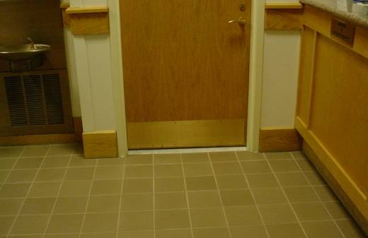

Restroom Door

Picture 3

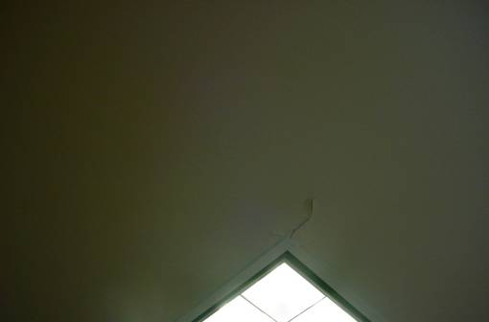

Peeling Paint

Picture 4

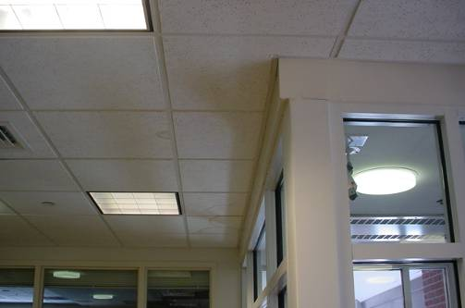

Water Damaged Ceiling Tiles, Front Foyer

Picture 5

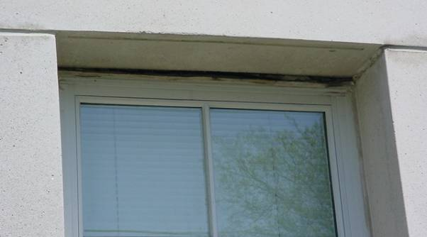

Damaged Caulking Around Windows

Picture 6

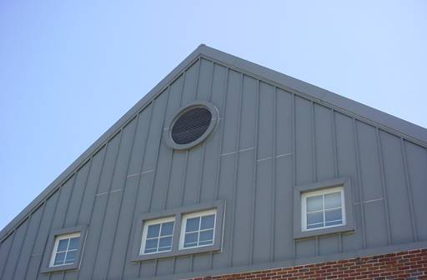

Attic Vent, Note Space Above Vent Where Heat May Accumulate

Picture 7

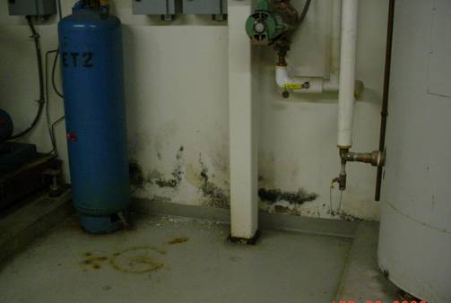

Mold Growth in Basement Boiler Room

Picture 8

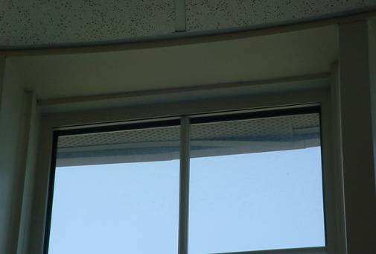

Damaged Soffit Vent

Picture 9

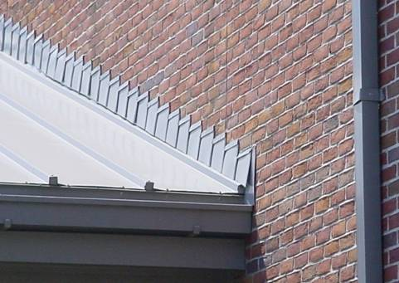

Unsealed Gap in Flashing on Side of Metal Roof

Picture 10

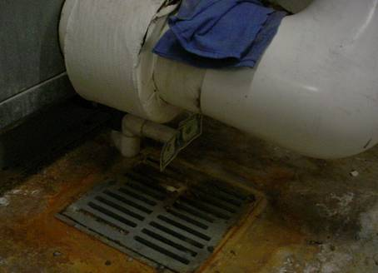

Condensation Pipe Located Above Floor Drain
Note Dollar Bill, Air is Drawn Into Pipe
Location | Occupants  in Room | Carbon  Dioxide  (ppm) | Temp  (°F) | Relative  Humidity  (%) | Carbon Monoxide  (ppm) | Windows  Openable | Ventilation |  | Remarks
 |  |  |  |  |  |  | Supply | Exhaust | Remarks
background |  | 422 | 73 | 35 | ND
Lobby | 0 | 536 | 77 | 34 | ND | Y | Y | Y | 8 water damaged ceiling tiles
Training/Community Room | 0 | 534 | 77 | 34 | ND | Y | Y | Y | 3 water damaged ceiling tiles; peeling paint near light fixture
Computer Room | 1 | 568 | 78 | 35 | ND | Y | Y | Y | Window air conditioner; mainframe tied to main vent system; Window open.
Detectives’ Room (2 readings) | 0 | 574 | 80 | 33 | ND | Y | Y | Y | Window open
Detectives’ Room | 0 | 482 | 81 | 32 | ND | Y | Y | Y | 3 water damaged ceiling tiles; Double-hung windows hot to the touch,  Window open
HVAC | 0 | 548 | 79 | 34 | ND | N | Y | Y | Pleated filters in unit; pressurized condensation drain
Lab | 0 | 476 | 79 | 31 | ND | Y | Y | Y | DEM; paint; fingerprint kits; fume hood
Interview Room | 0 | 502 | 78 | 33 | ND | N | Y | Y | 6 water damaged ceiling tiles in hallway
Conference Room #1, 2nd Floor | 0 | 485 | 78 | 34 | ND | N | Y | Y
Detectives’ Rest Room | 0 | 644 | 78 | 45 | ND | N | N | off | Strong odor of air fresheners
Matty’s Office | 1 | 554 | 78 | 35 | ND | N | N | off
Conference Room #2, Second Floor | 0 | 523 | 79 | 34 | ND | Y | Y | Y | Hornets inside and out; damaged soffits outside
Rest Room-Admin. Area | 0 | 657 | 81 | 33 | ND | Y | N | off | 2 water damaged ceiling tiles in hallway by file cabinets in rest room area.
Fingerprint Room-1st Floor | 0 | 490 | 79 | 33 | ND | N | Y | Y | Personal heater
Records Room | 3 | 533 | 79 | 33 | ND | Y | Y | Y | Personal heater and humidifier (running);  Window open
Deputy Chief’s Office | 1 | 555 | 78 | 33 | ND | Y | Y | Y
Lt. Columbus’ Office | 0 | 565 | 78 | 34 | ND | Y | Y | Y
Cell Area | 0 | 516 | 76 | 35 | ND | N | Y | Y | Exhaust off in all but 1 cell
Garage Area | 0 | 456 | 70 | 38 | ND | N | N | N | Garage unvented; Garden hose connected through drywall; ATVs; motorcycles; snowblower
Fingerprint Room-Booking Area | 0 | 490 | 73 | 39 | ND | N | Y | Y
Ted Sullivan’s Office | 0 | 629 | 74 | 40 | ND | Y | Y | Y | 5 water damaged ceiling tiles; peeling paint; water damaged wallboard; food containers
Dispatch | 2 | 608 | 73 | 40 | ND | N | Y | N | Ionic Pro air purifier; toaster oven; refrigerator; microwave
Officer in Charge Office | 0 | 637 | 74 | 41 | ND | N | Y | Y | Personal fan
Basement Kitchen | 0 | 483 | 75 | 35 | ND | N | Y | Y
Boiler Room | 0 | 497 | 73 | 41 | ND | N | N | N | Sump pumps; ceiling exhaust fan; mold on wallboard

