Water Damage/Mold Investigation

Tewksbury Senior Center
175 Chandler Street
Tewksbury, Massachusetts

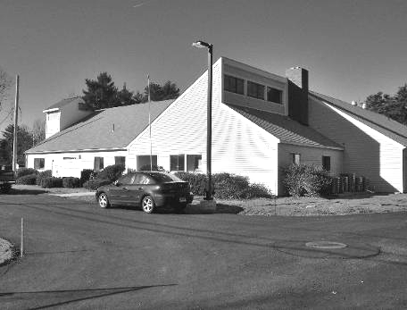

Prepared by:
Massachusetts Department of Public Health
Center of Environmental Health
Emergency Response/Indoor Air Quality Program
January 2007

Background/Introduction

At the request of LouAnn Clement, Health Agent, Tewksbury Board of Health (TBH), the Center for Environmental Health (CEH) of the Massachusetts Department of Public Health (MDPH) provided assistance and consultation regarding building conditions at the Tewksbury Senior Center (TSC), 175 Chandler Street, Tewksbury, Massachusetts. The request was prompted by reports of water damage and possible mold colonization of building materials.
On December 29, 2006 Michael Feeney, Director of Emergency Response/Indoor Air Quality (ER/IAQ), CEH performed a site visit to the TSC, which was undergoing renovations. The focus of the investigation was to assess possible water exposure to building components that were reportedly moistened by rainstorms during renovations of the building.
The TSC is a one-story wood frame structure built in the 1980s-1990s. As part of the renovations, a new addition is being constructed at the rear of the building. The new addition encloses parts of the original building’s roof. The original roofing material was covered with plywood, upon which part of the new addition roof support rests (Picture 1).

Methods
CEH staff performed a visual inspection of building materials for water damage and/or microbial growth. Moisture content of porous building materials (i.e., gypsum wallboard, wood), was measured with Delmhorst, BD-2000 Model, Moisture Detector with a Delmhorst Standard Probe.

Results/Discussion
As reported by Tewksbury officials, water penetration through a variety of openings in the original building/new addition junction is the likely source that moistened building materials (i.e., portions of the original building’s roof, gypsum wallboard) (Picture 2). The edge of the original buildings roof appeared to be degraded from water exposure (Picture 3).
In order for building materials to support mold growth, a source of moisture is necessary. Identification and elimination of water moistening building materials is necessary to control mold growth. Identification of building materials with increased moisture content over normal concentrations may indicate a possible source for mold growth.
As mentioned previously, moisture content was measured with a Delmhorst Moisture Detector equipped with a Delmhorst Standard Probe. The Delmhorst probe is equipped with three lights that function as visual aids to indicate moisture level. Readings that activate the green light indicate a sufficiently dry or low moisture level, those that activate the yellow light indicate borderline conditions and those that activate the red light indicate elevated moisture content.
Please note moisture content is detected as a real-time measurement of the conditions present in the building at the time of assessment. The building was evaluated on a cold, clear day, with an outdoor temperature of 31 º F and relative humidity of 41 percent. Moisture content of materials may increase or decrease depending on the building and weather conditions. For example, moisture can be introduced into a building through open doors and/or during the normal operation of a heating, ventilating and air-conditioning (HVAC) system. As indoor relative humidity levels increase, porous building materials, such as GW, plywood or carpeting can absorb moisture. The moisture content of materials can fluctuate with increases or decreases in indoor relative humidity.
Normal moisture levels (non-detectable-8.8 %) were measured in all wood roofing materials tested. These measurements indicate that the materials were dry and not likely to support mold growth. No visible mold growth was observed on the original roof/plywood covering at the time of the assessment. GW also had moisture measurements indicating that the materials were dry (< 5 %). However, visible mold growth was observed on the wall immediately beneath the original building’s roof edge (Picture 4) and beneath wall coving in the restrooms (Picture 5).
Water damage to porous building materials (e.g., GW) can result in microbial growth. The US Environmental Protection Agency (US EPA) and the American Conference of Governmental Industrial Hygienists (ACGIH) recommend that porous materials be dried with fans and heating within 24 to 48 hours of becoming wet (US EPA, 2001; ACGIH, 1989). If not dried within this time frame, mold growth may occur. Once mold has colonized porous materials, they are difficult to clean and should be removed.

Conclusions/Recommendations
Mold colonized/water damaged materials were observed in the TSC, however conditions appeared to be repairable. Once the integrity of the building envelope is established, water penetration with the potential to lead to microbial growth should be eliminated. In view of the findings at the time of the inspection, the following recommendations are made:
- Remove all GW that shows signs of water damage or mold colonization, since these materials cannot be adequately disinfected.
- Remove GW in both existing restroom walls to a height of approximately 1-foot above the floor to remove water damaged materials.
- Remove the degraded section of the original roof. Consider sealing the edge of these materials with an appropriate water sealing compound.
References
ACGIH. 1989. Guidelines for the Assessment of Bioaerosols in the Indoor Environment. American Conference of Governmental Industrial Hygienists, Cincinnati, OH.

US EPA. 2001. Mold Remediation in Schools and Commercial Buildings. US Environmental Protection Agency, Office of Air and Radiation, Indoor Environments Division, Washington, D.C. EPA 402-K-01-001. March 2001.
http://www.epa.gov/iaq/molds/mold_remediation.html

The Weather Underground. 2006. Weather History for Tewksbury, Massachusetts, December 29, 2006. http://www.wunderground.com/history
Picture 1

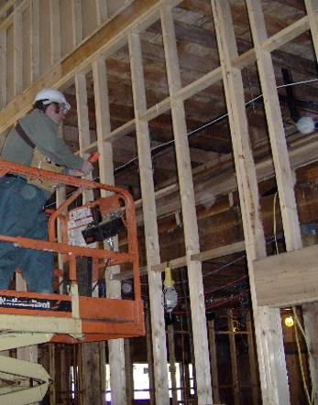

New Addition Included the Construction of an Addition, Which Encloses Parts of the Original Building’s Roof (Arrow) inside the New Wing

Picture 2

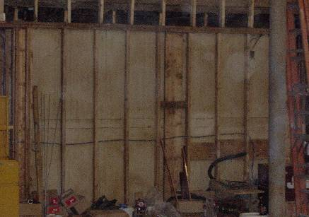

Existing Restroom Walls below Water Exposed Roof Materials

Picture 3

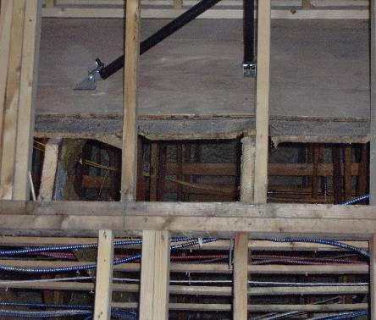

Original Buildings Roof Materials Appeared to Be Degraded from Water Exposure

Picture 4

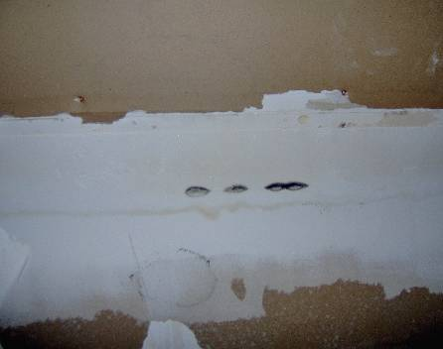

Mold Colonies in Restroom Wall GW

Picture 5

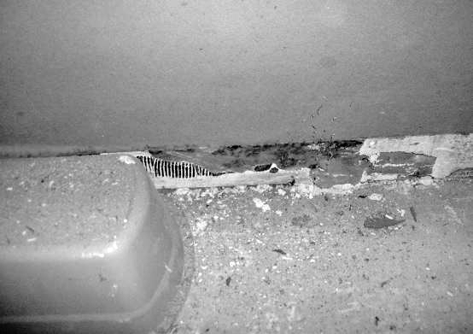

Mold Colonized GW beneath Wall Coving

