INDOOR AIR QUALITY ASSESSMENT

Tewksbury Town Hall Annex
11 Town Hall Avenue
Tewksbury, Massachusetts 01876



Prepared by:
Massachusetts Department of Public Health
Bureau of Environmental Health
Indoor Air Quality Program
September 2009

Background/Introduction
At the request of LouAnn Clement, Health Agent, Tewksbury Board of Health, the Massachusetts Department of Public Health (MDPH), Bureau of Environmental Health (BEH) conducted an indoor air quality assessment at Tewksbury Town Hall Annex (TTHA), 11 Town Hall Avenue, Tewksbury, Massachusetts. On April 17, 2009, the TTHA was visited by Mike Feeney, Director of BEH’s Indoor Air Quality Program (IAQ) Program. Mr. Feeney was accompanied by Ms. Clement during the assessment. The assessment was prompted by concerns about water damage to interior walls due to roof leaks from the building’s skylight.
The TTHA is a one-story building originally constructed as a library in the 1960s. Prior to occupancy by town offices, the building was renovated to subdivide the floor space into offices and hallways using gypsum wallboard (GW) and suspended ceilings. At that time, a number of componenets were added to the existing heating, ventilating and air-conditioning (HVAC) system. Rooms contain wall-to-wall carpeting and windows are not openable in most locations. A carpeted foyer that is not connected to the main HVAC system serves as the main entrance. The TTHA also has a large skylight that exists in the center of the building, to form an upper and lower roof. The walls of the skylight consist of a metal framed window system.
Methods
Air tests for carbon dioxide, carbon monoxide, temperature and relative humidity were conducted with the TSI, Q-TRAK™ IAQ Monitor, Model 7565. BEH staff also performed a visual inspection of building materials for water damage and/or microbial growth. Moisture content of porous building materials was measured with a Delmhorst, BD-2000 Model, Moisture Detector equipped with a Delmhorst Standard Probe.
Results
The TTHA houses approximately 20 employees and can be visited by over 100 people daily. Tests were taken during normal operations and results appear in Table 1.
Discussion
Ventilation
It can be seen from Table 1 that carbon dioxide levels were below 800 parts per million (ppm) in all areas surveyed, indicating adequate ventilation in the building at the time of the assessment. It is important to note that several areas were sparsely populated or unoccupied, which can greatly reduce carbon dioxide levels. Carbon dioxide levels would be expected to be higher with full occupancy.
Mechanical ventilation is provided by rooftop air-handling units (AHUs) (Picture 1). Fresh air is drawn through AHU intakes on the roof and distributed via air diffusers in the suspended ceiling. Exhaust air is draw into the ceiling plenum through vents installed in the suspended ceiling and exhausted via rooftop motors. Vents from the original construction also exist along the perimeter wall of the building, which appear to be connected to the rooftop AHUs by ductwork inside the cement slab. In some areas, dividing walls were erected over these ducts (Picture 2).
To maximize air exchange, the MDPH recommends that both supply and exhaust ventilation operate continuously during periods of occupancy. In order to have proper ventilation with a mechanical supply and exhaust system, the systems must be balanced to provide an adequate amount of fresh air to the interior of a room while removing stale air from the room. It is recommended that HVAC systems be re-balanced every five years to ensure adequate air systems function (SMACNA, 1994). The mechanical ventilation systems were reportedly balanced in 1996-1997 following renovations.
The Massachusetts Building Code requires that each room have mechanical ventilation with an outside air or openable windows. The ventilation must be on at all times that the room is occupied. Providing adequate fresh air ventilation with open windows and maintaining the temperature in the comfort range during the cold weather season is impractical. Mechanical ventilation is usually required to provide adequate fresh air ventilation.
Carbon dioxide is not a problem in and of itself. It is used as an indicator of the adequacy of the fresh air ventilation. As carbon dioxide levels rise, it indicates that the ventilating system is malfunctioning or the design occupancy of the room is being exceeded. When this happens, a buildup of common indoor air pollutants can occur, leading to discomfort or health complaints. The Occupational Safety and Health Administration (OSHA) standard for carbon dioxide is 5,000 parts per million parts of air (ppm). Workers may be exposed to this level for 40 hours/week, based on a time-weighted average (OSHA, 1997).
The MDPH uses a guideline of 800 ppm for publicly occupied buildings. A guideline of 600 ppm or less is preferred in schools due to the fact that the majority of occupants are young and considered to be a more sensitive population in the evaluation of environmental health status. Inadequate ventilation and/or elevated temperatures are major causes of complaints such as respiratory, eye, nose and throat irritation, lethargy and headaches. For more information concerning carbon dioxide, consult Appendix A.
Temperature measurements the day of the assessment ranged from 70º F to 77º, which were within the MDPH recommended comfort range (Table 1). The MDPH recommends that indoor air temperatures be maintained in a range of 70º F to 78º F in order to provide for the comfort of building occupants. In many cases concerning indoor air quality, fluctuations of temperature in occupied spaces are typically experienced, even in a building with an adequate fresh air supply.
The relative humidity measured in the building ranged from 17 to 21 percent, which was below the MDPH recommended comfort range (Table 1). The MDPH recommends a comfort range of 40 to 60 percent for indoor air relative humidity. Relative humidity levels in the building would be expected to drop during the winter months due to heating. The sensation of dryness and irritation is common in a low relative humidity environment. Low relative humidity is a very common problem during the heating season in the northeast part of the United States.
Microbial/Moisture Concerns
A strong musty odor was detected in the main hallway of the TTHA. This odor was likely attributable to the carpeting in the foyer. The foyer contains a heating unit, but is not connected to the HVAC air handling system. If a connection did exist, an air supply would heat and cool the foyer (i.e., a chilling system), which serves an important function in preventing condensation within the building during warm weather. Without a chilling system, hot/humid air enters when the exterior door is opened and lingers within the foyer, since this area lacks a return/exhaust vent.
During the course of the assessment, a number of possible moisture sources were identified:
- The most likely source of moisture wetting interior walls is leaks through the skylight system or roof penetrations for the rooftop AHUs. The skylights are formed by a metal framed window system (Picture 3), which requires flashing to transfer rain from the windows onto the roof for drainage. If the flashing is damaged or window gaskets are missing or ill fitting, rainwater can enter into the building to moisten ceiling tiles and GW. Caulking around windows appeared to be damaged. In addition, the membrane of the skylight roof appeared to be damaged (Picture 4).
- GW in a storeroom in the treasurer’s office directly below a rooftop AHU had saturated GW, which has resulted in mold colonization (Picture 5). The ceiling plenum side of this GW appeared to have plastic sheeting placed over the ceiling material, a likely effort to prevent further water damage (Picture 6). Beaded water on the surface of the plastic sheet facing the GW indicates that the plastic is preventing water evaporation, keeping the GW moistened and increasing the likelihood of mold growth.
- Another possible water source may be from a non-functioning ductwork system that was part of the original construction of the TTHA. Along the floor of the building are a series of vents that are connected to ductwork that exists either within or beneath the slab of the building. When the building was renovated, a complete system of rooftop AHUs, fresh air supply and return ducts was installed, including ceiling mounted fresh air diffusers directly above windows (Picture 7). The installation of this system rendered the floor-mounted ducts superfluous for heating and cooling of the building. Unfortunately, these ducts do not appear to have been properly abandoned and may be a source of excess moisture in the building. Slab or subsurface ductwork can be prone to generating condensation, wetting carpet and damaging floor tile (Picture 8). When warm, moist air passes over a surface that is colder than the air, condensation can collect on the cold surface. Over time, water droplets can form. Condensation is the collection of moisture on a surface at or below the dew point. The dew point is the temperature that air must reach for saturation to occur. The dew point is a temperature determined by air temperature and relative humidity. If a surface has a temperature equal to or below the dew point, condensation will accumulate. For example, at a temperature of 80º F and indoor relative humidity of 80 percent, the dew point for water to collect on a surface is approximately 76 º F (IICRC, 2000). Therefore, any surface that has a temperature below this range of dew points would be prone to generating condensation. These conditions would be expected to exist in un-insulated ductwork buried in the cement slab, particularly during hot, humid weather.
- Also of note is GW that was installed over these floor vents in a number of areas (Picture 2). This GW may also be repeatedly moistened. Repeated water damage to porous building materials (e.g., GW, carpeting) can result in microbial growth.
- The final moisture source identified is related to the HVAC system. The roof of the TTHA has four separate AHUs (Pictures 9 and 10). The blueprint for the building indicates that each AHU has the capacity to supply 3,000 cfm (Blueprint 1). Based on input from TTHA staff, it was indicated that the building has a usual maximum occupancy of 20 individuals, the HVAC equipment installed has 600% more capacity than what is needed to provide for fresh air and temperature comfort for building occupants (Figure 1). Over capacity of HVAC system equipment can lead to the following problems:
  - Lack of temperature control - most areas have 2 thermostats, one of which is inoperable. It is likely that the inoperable thermostats were disconnected in an effort to provide better control for the HVAC system.
  - The AHUs do not have the capacity to exhaust air. Each AHU has a fresh air intake with no corresponding exhaust vent (Picture 9). The TTHA has a ceiling plenum return system where the space between the roof decking and suspended ceiling is used in the place of ductwork to draw air through the plenum to be expelled from the building by two exhaust vent motors located at the rear of the roof (Picture 11). The ceiling plenum is small and is lined with fiberglass insulation (Picture 12). Since the ceiling plenum is narrow and its’ surfaces rough, it would seem that air and water vapor from the Assessor’s and Treasurer’s offices (located in the front of f the TTHA) is limited. This is evidenced by higher relative humidity level for offices closest to the exhaust vent (e.g., the Auditor’s Office (Table 1). Based on the design of the HVAC system, moist air can be introduced by all four AHUs while limited means for that moisture to exit the building exists.
  - Increased introduction of airborne water vapor, which can lead to condensation on cold building components which will moisten porous materials that can grow mold. Of note in that the relative humidity inside the TTHA was 1-5 % higher (range 17-21 %) than the outdoor relative humidity (16 %). One major factor that can increase relative humidity indoors is occupancy. Since the building had only 8 occupants the day of the assessment, it is highly unlikely that this increase can be attributed to occupancy, which can indicate the AHUs as a major source of moisture.
  - The lobby, which had a distinct musty odor, has two fresh air vents that are connected to two separate AHUs without a return vent. Usually an area, such as an enclosed lobby, has air provided by a single AHU to maintain temperature control. In this situation, moist air from two AHUs is directed into the lobby and accumulates, since no return vents exist in this area.
In order to remediate the musty odor detected in the TTHA, each of these moisture sources should be eliminated, since each can lead to further dampening of building materials, and subsequently lead to mold growth.
The US Environmental Protection Agency (US EPA) and the American Conference of Governmental Industrial Hygienists (ACGIH) recommends that porous materials (e.g., carpeting, GW) be dried with fans and heating within 24 to 48 hours of becoming wet (US EPA, 2001; ACGIH, 1989). If porous materials are not dried within this time frame, mold growth may occur. Cleaning cannot adequately remove mold growth from water-damaged porous materials. The application of a mildewcide to mold contaminated, porous materials is not recommended.
BEH staff also observed plants in several areas. Moistened plant soil and drip pans can be a source of mold growth. Plants should be equipped with drip pans; the lack of drip pans can lead to water pooling and mold growth on windowsills. Plants are also a source of pollen. Plants should be located away from the air stream of ventilation sources to prevent the aerosolization of mold, pollen or particulate matter.

Other IAQ Evaluations
Disconnected ductwork was found in the Treasurer’s storeroom (Picture 13). Open ductwork can be a pathway for odors to migrate from one area to another. Proper ductwork abandonment procedure would be to seal all open ends of unused ductwork if it is abandoned in place.
Conclusions/Recommendations
Several issues were identified as part of the MDPH inspection that can affect indoor air quality. In view of the findings at the time of the assessment, the following recommendations are made to improve indoor air quality:
- Remove all water damaged and mold colonized GW in a manner consistent with recommendations in “Mold Remediation in Schools and Commercial Buildings” published by the US Environmental Protection Agency (US EPA, 2001). This document is available from the US EPA website:
http://www.epa.gov/mold/mold_remediation.html.
- Seal all floor vents with an appropriate material. The interior of all GW wall installed over these vent should be examined and removed if water damaged and/or mold colonized.
- Seal one fresh air supply to the building lobby so that heat and air-conditioning is provided by one AHU instead of two. Disconnect the duct connected to the sealed vent from the main HVAC system. Seal both disconnected duct openings with an appropriate permanent material.
- Seal the open vent in the ceiling to the Treasurer’s storeroom with an appropriate permanent material.
- Remove wall-to-wall carpeting in contact with vents and windows. Replace the carpeting with an appropriate flooring material.
- Wall-to-wall carpeting in the foyer should be removed and replaced with a floor material that can readily dry and is mold resistant.
- Water leaks through the roof and sky light window system must be repaired to prevent further water damage.
- Consider adopting a balancing schedule for mechanical ventilation systems every 5 years, as recommended by ventilation industrial standards (SMACNA, 1994).
- For buildings in New England, periods of low relative humidity during the winter are often unavoidable. Therefore, scrupulous cleaning practices should be adopted to minimize common indoor air contaminants whose irritant effects can be enhanced when the relative humidity is low. To control for dusts, a high efficiency particulate arrestance (HEPA) filter equipped vacuum cleaner in conjunction with wet wiping of all surfaces is recommended. Drinking water during the day can help ease some symptoms associated with a dry environment (e.g., throat and sinus irritations).
- Ensure plants have drip pans. Examine drip pans periodically for mold growth and disinfect with an appropriate antimicrobial where necessary. Remove plants from the air stream of mechanical ventilation.
- Refer to resource manuals and other related indoor air quality documents for further building-wide evaluations and advice on maintaining public buildings. Copies of these materials are located on the MDPH’s website: http://mass.gov/dph/iaq.

Long Term Recommendations
- Consideration should be given to abandoning at least two of the AHUs on the roof to provide for better temperature and relative humidity control. This activity would require connecting the ductwork for areas formerly serviced by abandoned AHUs to the remaining AHUs.
- Consider installing ductwork to connect exhaust vent directly to each area serviced inside the ceiling plenum to improve removal of water vapor and other normally occurring pollutants.
- Consideration should be given to replacing the roof membranes and replacing the existing skylight window systems.

References
ACGIH. 1989. Guidelines for the Assessment of Bioaerosols in the Indoor Environment.
American Conference of Governmental Industrial Hygienists, Cincinnati, OH.
IICRC. 2000. IICRC S001 Reference Guideline for Professional On-Location Cleaning of Textile Floor Covering Materials Institute of Inspection, Cleaning and Restoration Certification.
Institute of Inspection Cleaning and Restoration, Vancouver, WA.

OSHA. 1997. Limits for Air Contaminants. Occupational Safety and Health Administration.
Code of Federal Regulations. 29 C.F.R 1910.1000 Table Z-1-A.
SMACNA. 1994. HVAC Systems Commissioning Manual. 1st ed. Sheet Metal and Air Conditioning
US EPA. 2001. “Mold Remediation in Schools and Commercial Buildings”. Office of Air and Radiation, Indoor Environments Division, Washington, DC. EPA 402-K-01-001. March 2001.
Available at: http://www.epa.gov/mold/mold_remediation.html.
US EPA. 2006. National Ambient Air Quality Standards (NAAQS). US Environmental Protection Agency, Office of Air Quality Planning and Standards, Washington, DC.
http://www.epa.gov/air/criteria.html.
Blueprint 1

CFM Total for Four AHUs = 12CFM

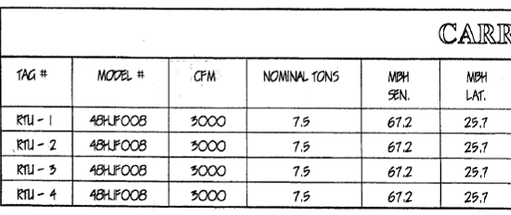
Figure 1

Assumptions

- HVAC system will provide a ratio of 20% fresh air to 80% recycled air.
- HVAC system must provide 20 cfm/occupant of fresh air per existing MA Building Code in 1999.
- Each AHU has the capacity to provide 3,000 cfm.

Calculations

20 occupants x 20 cfm of fresh air = 400 cfm total fresh air required

400 cfm total fresh air (20% fresh air) 1,600 cfm (80% recycled air) = 2,000 cfm total air required for TTHA population

3,000 cfm capacity (see Blueprint 1) x 4 AHU – 12,000 cfm total capacity of HVAC system

12,000 cfm total capacity of HVAC system/2,000 cfm total air required for TTHA population = 6.

Therefore, the TTHA HVAC system is providing 600% more air capacity than needed to provide for the comfort of the TTHA population.

Conclusion

The renovation of the TTHA had 3 AHU installed that are unnecessary.

The fresh air supply and comfort of TTHA employees could be provided by 1 of the existing rooftop AHUs, provided that all ductwork is connected to that single AHU.

Picture 1

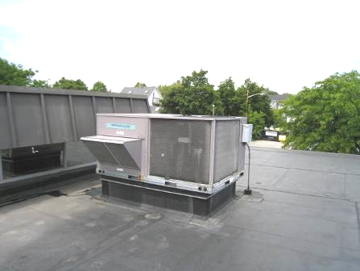

Rooftop AHU, Note Fresh Air Intake, No Exhaust Vent

Picture 2

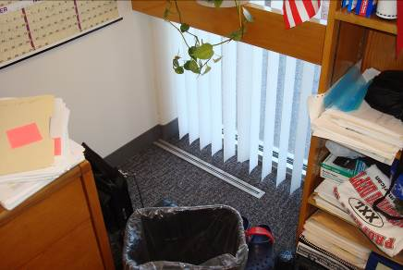

GW Installed over Floor Vent
Picture 3

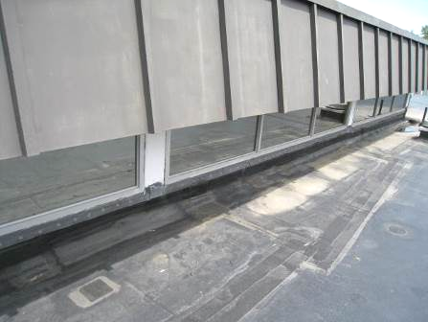

Skylight Window System

Picture 4

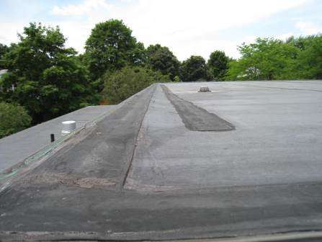

Seam in the Skylight Roof Section
Picture 5

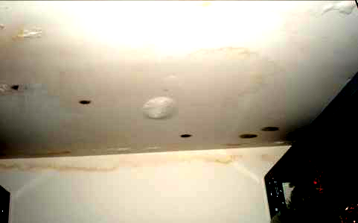

Storeroom in the Treasurer’s Office Directly below Rooftop AHU
Dark Stains Indicate Mold Colonization of GW

Picture 6

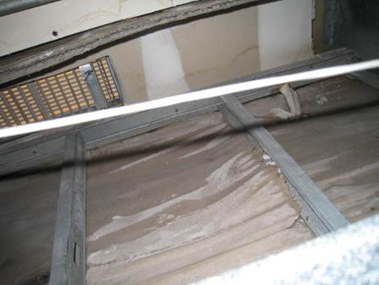

Plastic Sheeting Placed over the Ceiling Material in an Effort to Prevent Further Water Damage, Note Beading Water on the Underside of the Plastic
Picture 7

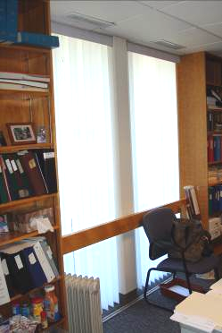

Fresh Air Supply Vent Installed in Suspended Ceiling, Note Floor Vent

Picture 8

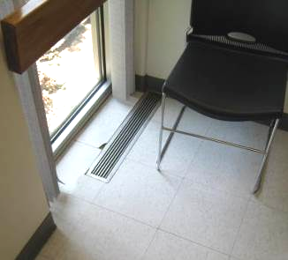

Damaged Floor Tile around Vent
Picture 9

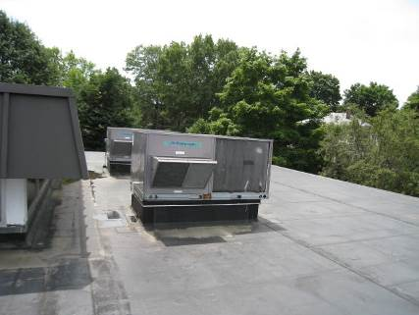

Two AHUs on West Side of Roof, Note Standing Water on Roof

Picture 10

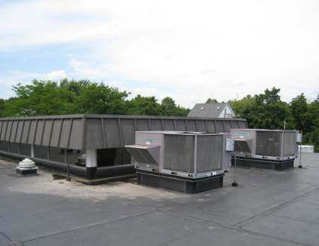

Two AHUs on East Side of Roof, Note Dirt on Roof Which Indicates Location of Likely Pooling Water
Picture 11

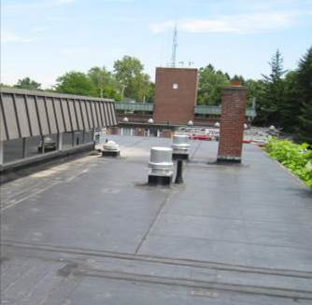

Exhaust Vents On Roof

Picture 12

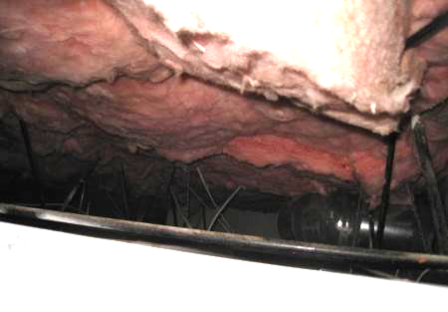
Ceiling Plenum, Note Insulation and Narrowness of the Plenum Space
Which Restricts Free Air Movement
Picture 13

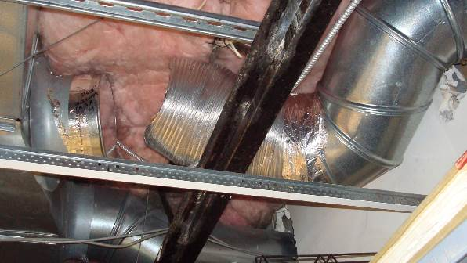

Disconnected Ductwork Found above the Ceiling Plenum
in the Treasurer’s Storeroom
Location | Occupants  in Room | Temp  (°F) | Relative  Humidity  (%) | Carbon  Dioxide  (ppm) | Windows  Openable | Ventilation |  | Remarks
 |  |  |  |  |  | Supply | Exhaust | Remarks
Outside  (Background) |  | 77 | 17 | 556
Assessor’s Main Office | 3 | 70 | 21 | 695 | N | Y | Y | Musty odor  4 water damage ceiling tiles  Buckling carpet around floor vents
Assessor’s Private Office | 0 | 70 | 21 | 638 | N | Y | N | Musty odor  DO
Lobby | 0 | 72 | 20 | 599 | N | Y | N | Musty odor
Treasurer’s Main Office | 2 | 73 | 21 | 542 | N | Y | Y
Treasurer’s Private Office | 0 | 72 | 21 | 582 | N | Y | Y | DO
19 | 0 | 73 | 21 | 577 | N | Y | Y | DO
Treasurer’s Store Room | 0 | 74 | 21 | 508 | N | Y | Y
Water Office | 0 | 75 | 19 | 534 | N | Y | Y
Computer Room | 0 | 77 | 18 | 491 | N | Y | Y
Lunch room | 0 | 76 | 18 | 604 | N | Y | Y
Auditor’s Main Office | 2 | 76 | 17 | 531 | N | Y | Y
Auditor’s Private Office | 1 | 77 | 17 | 556 | N | Y | Y

