March 22, 2024

Hello,

Thank you for participating in our Visions of Collaboration Conference. I am thrilled to have you join us for this informative and collaborative event. I hope you find the presentations valuable and insightful.

I want to extend a big thank you to the tremendous team who put a lot of work into organizing this conference:

- Paula Barry, Massachusetts Commission for the Blind
- Carrie Brasier, Massachusetts Accessible Instructional Materials Library
- Ally Bull, Massachusetts Commission for the Blind
- Adrienne Callaghan, Massachusetts Commission for the Blind
- Kristen Clark, Perkins School for the Blind
- Martha Daigle, Massachusetts Department of Elementary and Secondary Education
- Brendan Foley, South Coast Educational Collaborative
- Lisa Fournier, South Coast Educational Collaborative
- Marianne Gilmore, The Carroll Center for the Blind
- Dahlia James, Massachusetts Commission for the Blind
- Mayanne MacDonald-Briggs, Massachusetts Commission for the Blind
- Justin McCarthy, Massachusetts Commission for the Blind
- Tom Miller, Boston College
- Mariesa Mills, New Bedford Public Schools
- Dina Rosenbaum, The Carroll Center for the Blind
- Nita Rossow, Collaborative for Educational Services
- Nancy Sharon, The Carroll Center for the Blind
- Kara Sittig, Massachusetts Commission for the Blind
- Brittany Taylor, Massachusetts Commission for the Blind
This conference goes a long way in supporting our mission of life-long independence and full community participation for the people we serve.

As we strive to continuously improve this conference and our other events, we would love to hear your feedback. We will be sending out a survey by email and encourage you to share any thoughts or suggestions you may have. We value your input.

Once again, thank you for your time and interest. We look forward to staying in touch and providing more valuable informational sessions in the future.

Best Regards,
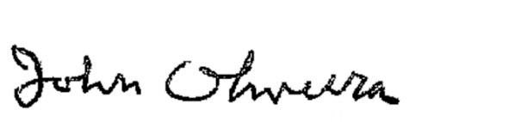
John Oliveira
Commissioner, Massachusetts Commission for the Blind

