The Commonwealth of Massachusetts
Executive Office of Health and Human Services
Department of Public Health
250 Washington Street, Boston, MA 02108-4619
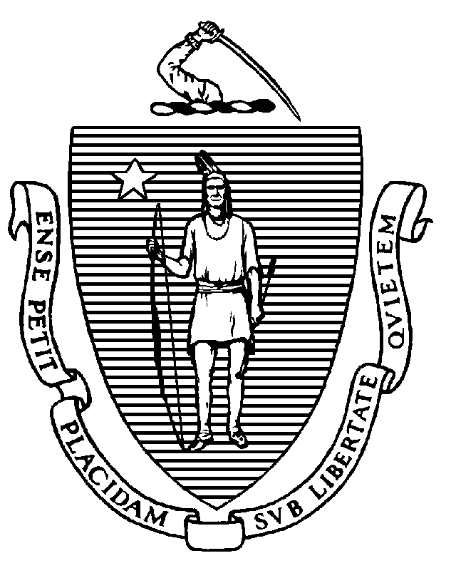

MARYLOU SUDDERS
Secretary
MARGRET R. COOKE Acting Commissioner

Tel: 617-624-6000
www.mass.gov/dph

CHARLES D. BAKER
Governor
KARYN E. POLITO
Lieutenant Governor

TO: Massachusetts Public and Non-Public Schools

FROM: Karen Robitaille, Director, MDPH School Health Services

SUBJECT: The Administration of Naloxone in Schools

DATE: September 6th, 2022

Naloxone is an opioid antagonist that blocks the effects of opioids such as heroin, oxycodone, hydrocodone, fentanyl, codeine, and methadone. Naloxone can reverse the life-threatening effects of overdose from heroin or opioid painkillers and has been used to save thousands of lives in Massachusetts.
Naloxone is the only Schedule VI controlled substance in Massachusetts that can be prescribed to someone other than the ultimate user. The Massachusetts Controlled Substances Act, M.G.L. c. 94C, §19(d), authorizes naloxone to be prescribed or dispensed to a person for use on someone else “so long as that person is in a position to assist a person at risk of experiencing an opiate-related overdose”. In addition, M.G.L. c. 94C, §§ 19B(g) and 34A(e) permits anyone acting in good faith to receive a prescription for naloxone, possess it, and administer it to anyone appearing to experience an opiate-related overdose. Pursuant to M.G.L. c. 94C, § 19B, the Department of Public Health issued a statewide standing order to authorize the dispensing of naloxone in the Commonwealth by any licensed pharmacists. The statewide standing order authorizes licensed pharmacists to dispense naloxone without a prescription to any person at risk of experiencing an opioid-related overdose, as well as persons in a position to assist an individual experiencing an opioid-related overdose.
Because naloxone is treated differently than any other prescription medication, and because any person can possess and administer naloxone, pursuant to the standing order, it is the policy of the School Health Unit (SHU) that individual possession and use of naloxone is not covered by 105 CMR 210.000. This means that an individual school community member may carry and administer naloxone on school grounds or at school events, as permitted within M.G.L.c.94C, §§ 19(d) and 34A(e). Additionally, DPH SHU registered schools/districts can purchase and store naloxone, but in this instance only authorized healthcare providers may administer naloxone to someone believed to be experiencing an opiate-related overdose per 105 CMR 210.000.
For more information about naloxone and its availability in Massachusetts, please visit: https://www.mass.gov/stop-an-overdose-with-naloxone

