The Commonwealth of Massachusetts
Executive Office of Health and Human Services Department of Public Health
250 Washington Street, Boston, MA 02108-4619

CHARLES D. BAKER
Governor
KARYN E. POLITO
Lieutenant Governor
MARYLOU SUDDERS
Secretary
MARGRET R. COOKE
Commissioner

Tel: 617-624-6000
www.mass.gov/dph

December 15, 2022
Steven T. James House Clerk
State House Room 145 Boston, MA 02133
Michael D. Hurley Senate Clerk
State House Room 335 Boston, MA 02133

Dear Mr. James and Mr. Hurley:

Pursuant to Massachusetts General Law Chapter 111K, Section 11, please find enclosed a report from the Department of Public Health entitled, The Catastrophic Illness in Children Relief Fund Annual Report Fiscal Year 2021.
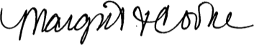
Sincerely,
Margret R. Cooke Commissioner
Department of Public Health

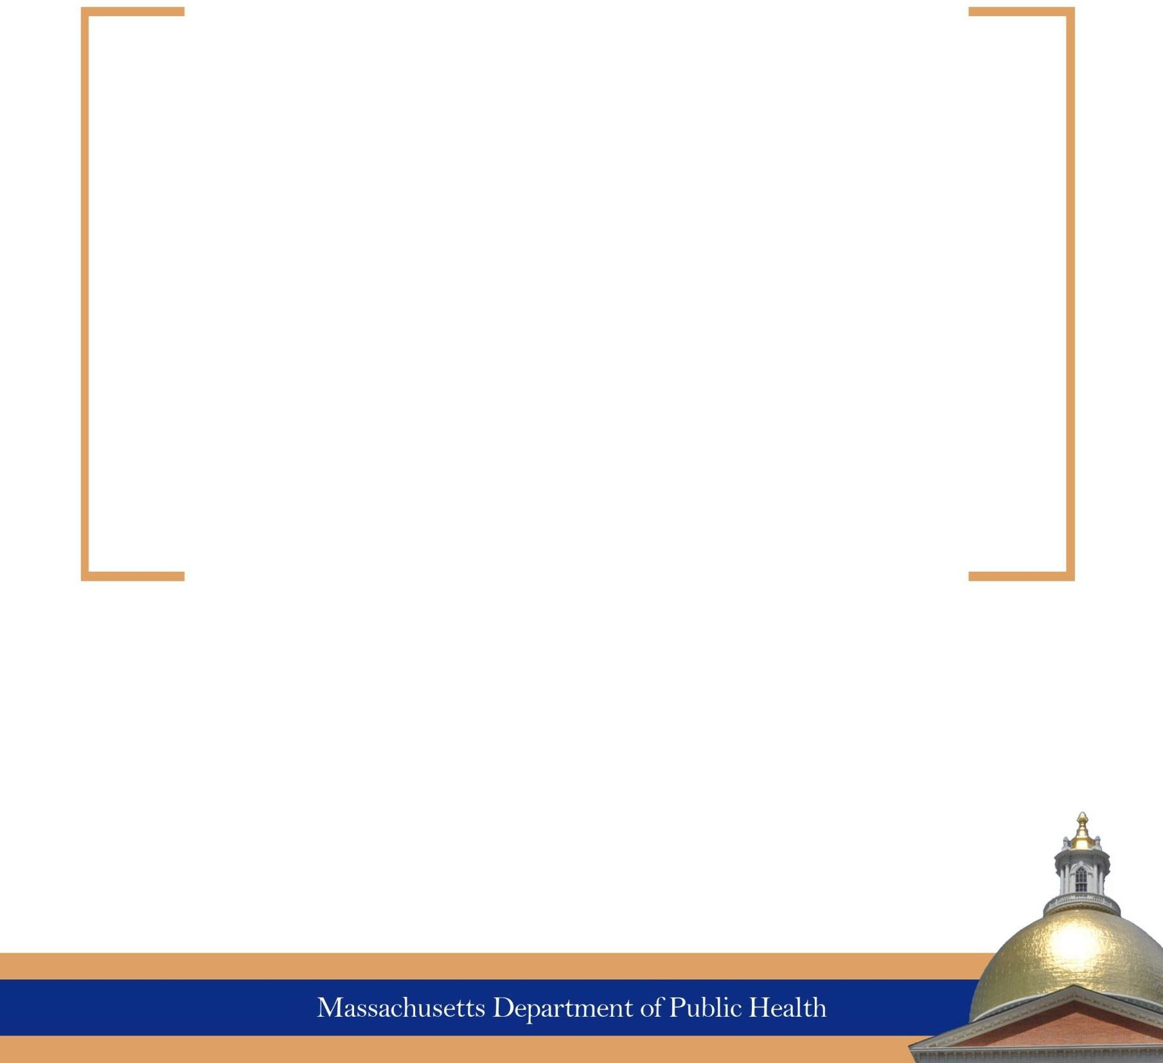

The Catastrophic Illness in Children Relief Fund
Annual Report
Fiscal Year 2021

Legislative Mandate

Chapter 111K: Section 11. Annual report

Section 11. The commission shall report annually to the governor and the senate and house committees on ways and means. The report shall include information about the number of participants in the program, average expenditures per participant, the nature and type of catastrophic illnesses for which the fund provided financial assistance and the average income and expenditures of families who receive financial assistance under the program. The commission shall also make recommendations for changes in the law and regulations governing the fund.

i

October 2022
On behalf of the Catastrophic Illness in Children Relief Fund (CICRF) Commission, we are pleased to provide this annual report for Fiscal Year 2021 pursuant to Chapter 111K, Section 11.
The final quarter of FY2020 brought unprecedented challenges due to the COVID-19 pandemic which continued throughout FY2021. The CICRF Commission meetings were held remotely as a video conference consistent with St. 2021, c. 20, s. 20, which provides for certain modifications to the Massachusetts Open Meeting Law due to COVID-
19. Staff worked a hybrid schedule of in-office and telework while leveraging technology and quality improvement tools to reduce paper-based documentation to better assist financially stressed families. Staff remained deeply committed to helping families while balancing their own health and safety concerns in commuting during the surge of the virus during the winter of 2021.

In November 2020, the Department of Public Health (DPH) was notified by the State Auditor’s Office (SAO) that SAO would be conducting a routine audit of the Fund. The audit began in FY2021 and was completed in FY2022. During that period, CICRF staff regularly met with the DPH internal audit team and SAO. SAO requested and reviewed data, paper and electronic records, and other information to assess data integrity and to ensure Fund policies and procedures were followed. The Fund Director and other staff prioritized responding to all SAO requests in a timely fashion.

It is noteworthy that, despite the challenges of FY2021, CICRF provided financial assistance of approximately $1.93 million in FY2021 directly to families or to vendors on behalf of families for the medically related expenses for their children and youth with special health needs.

The Commission welcomes your comments, feedback and ideas as we seek to improve our ability to serve children and families.

Sincerely,
John S. Maypole, MD ErinKate Greeley
Co-Chair, CICRF Commission Co-Chair, CICRF Commission

EXECUTIVE SUMMARY

Purpose of the Fund

The Catastrophic Illness in Children Relief Fund (CICRF) was established by legislation for FY2001 to provide assistance to families for catastrophic medical and related expenses that are not covered by insurance, public benefits, or other financial sources.
Massachusetts families with children 21 years of age and younger whose medical and related expenses for one child exceed 10% of the first $100,000 plus 15% thereafter of the family’s annual income, are eligible to apply for assistance from the CICRF. The CICRF continues to support some of the most vulnerable children in Massachusetts, improving financial stability for eligible families. Between FY2001 and FY2021, the CICRF has provided over $34.8 million in reimbursements to the families of 2,564 children.

Fiscal Year 2021 Data Highlights
- During FY2021, 166 families received approximately $1.93 million in reimbursements. The median reimbursement was $6,065 per family.

- The children assisted by the CICRF have a variety of diagnoses, typically come from families with lower incomes, and have health insurance coverage. Most notably, during FY2021, approximately 76% of the families who received assistance had annual incomes of less than 200% of the federal poverty level and approximately 48% of the children who were helped during this period were under age five at the time the application was submitted.

- If a child is not covered by health insurance, the CICRF supports a wide variety of services, including medical equipment, medical services, hospital and physician services, medications, family support, and home and vehicle modifications that enable children to remain at home and a part of their communities, rather than in residential or institutional care.

- CICRF also provides referrals and technical assistance related to accessing other financial supports. In FY2021, Fund staff identified and reimbursed 41 families directly impacted by the pandemic a total of $15,981 from the Emergency Family Support Funding program developed by the Division for Children & Youth with Special Health Needs at the Department of Public Health (DPH).

- Five out of six CICRF program coordinators speak languages other than English (Spanish, Haitian-Creole and Portuguese), improving program capacity to explain documentation needs and complex Fund policies directly to families.

- The CICRF ended FY2021 with a balance of $6,021,578.41.

TABLE OF CONTENTS
Legislative Mandate i
Letter from the Commission Co-Chairs ii
Executive Summary iii
Table of Contents iv
- Introduction 1
- Catastrophic Illness in Children Relief Fund Program 2
Eligibility 2
Eligible Services 2
Commission Responsibilities 3
- Data 3
Fund Accomplishments and Highlights 3
Applications Received in Fiscal Year 2021 4
Families Receiving Financial Assistance in Fiscal Year 2021 4
Reimbursements to Families 5
Diagnoses 6
Funded Services 7
Income Level 9
Insurance Status 10
Geography 11
Age 11
Race 12
- Revenue and Expenditures 13
- Conclusion 15
- Commission Member List 16

INTRODUCTION
The Catastrophic Illness in Children Relief Fund (CICRF) was established by state legislation in July 2000 to help families bear the excessive financial burdens associated with the care of children with significant medical and related expenses. It provides last resort financial assistance for families in Massachusetts who are struggling to pay for medical or related expenses not covered by a private insurer, federal or state health care assistance, or any other financial source.
The CICRF was established within the Department of Public Health (DPH), in accordance with
M.G.L. Chapter 29, Section 2ZZ, and is administered by the CICRF Commission, which was established and is governed by M.G.L. Chapter 111K. A catastrophic illness is defined as “any illness or condition treated at a pediatric specialty hospital, including ambulatory care and services provided by or ordered through such a hospital, the medical and related expenses of which are not covered by any other state or federal program…or any insurance contract and which exceed 10 percent of the first $100,000 of annual income of a family and 15 percent of any family income in excess of $100,000.” Originally created for families of children ages 18 and under, in FY2007 Chapter 111K was amended to expand age eligibility for the Fund through age 21.

The Fund is overseen by a Commission consisting of 11 members (four state agency ex-officio members and seven public members) and is staffed by DPH. The Fund is financed by quarterly transfers from the Commonwealth Care Trust if sufficient funds are available.

The cost of caring for a chronically ill child can be overwhelming, even to a family with health insurance. High insurance premiums, deductibles, co-insurance and co-payments, combined with medical and related expenses incurred because of coverage limitations and exclusions, can result in a serious drain of a family’s financial resources. The bills incurred can send the family into extreme debt and cause severe emotional stress. According to the Kaiser Family Foundation, medical debt – and a host of related problems – can result when people cannot afford to pay their medical bills. While the chances of falling into medical debt are greater for people who are uninsured, most people who experience difficulty paying medical bills have health insurance.
Medical debt can arise when people must pay out-of-pocket for care not covered by health insurance or to which cost-sharing (such as deductibles and co-insurance) applies. Medical debt also might result from health insurance premiums that individuals find difficult to afford. The consequences of medical debt can be severe. People with unaffordable medical bills report higher rates of other problems – including difficulty affording housing and other basic necessities, credit card debt, bankruptcy, and barriers accessing health care.¹ In the 2019-2020 National Survey of Children’s Health (NSCH), 13.3% of families with children with special
health needs in Massachusetts reported having problems paying for their child’s medical or health care bills within the past 12 months.²

¹ K. Pollitz, C. Cox et alia, Medical Debt Among People with Health Insurance, January 2014. https://kaiserfamilyfoundation.files.wordpress.com/2014/01/8537-medical-debt-among-people-with-health- insurance.pdf
² Child and Adolescent Health Measurement Initiative. 2019-2020 National Survey of Children’s Health, Data Resource Center for Child and Adolescent Health website, http://www.childhealthdata.org/

The impact of a child’s illness can have severe ripple effects. The time and energy necessary to care for a sick child often place further debilitating strain on a family and often result in loss of employment of one or both parents. In the NSCH, 17.1% of Massachusetts families with children with special health needs reported having to cut back or stop working due to their child’s condition.² In such situations, the family loses not only income, but frequently also loses
continuity of health benefits, since access to health insurance is often through one’s employer. The family must then identify other insurance coverage, which may involve accessing a different provider network for their child and paying higher health insurance premiums, further adding to family stress. There are also many expenses resulting from a child’s medical condition that are not covered by insurance. In the NSCH, 23.7% of Massachusetts families of children with special health needs reported having to pay between $1,000 and $5,000 in out of pocket medical, health, dental and vision care during the past 12 months, and only 65.5% reported having continuous and adequate private and/or public insurance to pay for the services they need.² The CICRF thus provides valuable, stabilizing financial and emotional relief for families facing incredible life challenges.

CATASTROPHIC ILLNESS IN CHILDREN RELIEF FUND PROGRAM

Eligibility
For a family to be eligible for assistance, they must have a child who:
  - Is 21 years of age or younger
  - Is a Massachusetts resident
  - Is under the care of a licensed health care provider who has staff privileges at a hospital which is licensed or accredited to provide pediatric or neonatal care
  - Has catastrophic medical or related expenses, which is defined as annual out-of-pocket
expenses totaling more than 10% of the first $100,000 of the family’s income plus 15% of any income in excess of $100,000, after all other avenues of reimbursement have been exhausted

Eligible Services
Consistent with the Community First Olmstead Plan and the Administration’s support of community-based rather than institutional care, the CICRF support children to remain at home in their communities to the maximum extent feasible. It therefore considers reimbursement to families for a broad range of medical and related services and expenses that may not be reimbursable under traditional health insurance policies, or for which the family does not have coverage, including but not limited to:
  - Medically-related home and vehicle modifications
  - Travel and incidental expenses associated with a child’s admissions and outpatient care
  - Insurance co-payments, co-insurance and deductibles
  - Mobility equipment and other medical supplies

  - Medications
  - CommonHealth and MassHealth premiums
  - Funeral expenses

Following a special review, experimental treatment or medications, assistive technology, alternative or complementary treatment, home health care and other medically related services may be considered for reimbursement.

Generally, families who apply to the Fund seek assistance with multiple expenses. As a payor of last resort, the CICRF ensures that private and public insurance coverage is sought first. Some reimbursements reflect partial payments for medical and related services, such as co-payments and deductibles for physician visits, hospitalizations, medications, and rehabilitation therapies.

Commission Responsibilities

The CICRF Commission consists of 11 members (see current Commission Member list), including designees of the Secretary of Health and Human Services, the Commissioner of Public Health, the Commissioner of Insurance, the State Treasurer and seven public members (including a representative of the AFL-CIO and three providers of health care services to children in Massachusetts, and a parent of a child with special health needs). The Commission is responsible for establishing the policies and procedures necessary for administration of the CICRF, including application to the Fund, application review, determination of eligibility for services, and
reimbursement. The Commission’s goal is to act in the best interest of the child while ensuring the Fund remains the payor of last resort.

The Department of Public Health is responsible for the general management and administration of the program, including maintaining confidential records for each child, determining eligibility and the amount of reimbursement, and preparing application or case materials for review by the entire Commission. DPH staff devotes significant resources to case management and referral activities. If, upon review of an application, the applicant is found to be potentially eligible for funding through other sources or programs, DPH staff assists the applicant in applying for alternate benefits and resources.

DATA

Fund Accomplishments and Highlights

From its inception through FY2021, the CICRF provided funds to 2,564 children with a wide array of medical conditions and diagnoses. Their families come from across the state, from all income levels, and are largely insured either through private coverage and/or MassHealth.
Families have been reimbursed for a variety of eligible expenses including hospital and physician services, medication, medical equipment and supplies, travel and lodging, funeral expenses, special therapies, accessible vehicle purchases, home and vehicle modifications, and expenses incurred while caring for a sick child in the hospital.

CICRF has proven to be an invaluable resource for families struggling with the need to preserve family life in the face of substantial financial obligations. The Fund has assisted families from a variety of income levels with a wide range of awards in proportion to their need. Payments to an individual family in FY2021 ranged from a low of $435 to a high of $45,375.³ The median amount was $6,050; the mean was $11,612 (later sections in this report provide more information on services supported and reimbursements). Some families have been eligible to receive CICRF assistance over multiple fiscal years.

Applications Received in Fiscal Year 2021

From FY2001 through FY2021, 5,671 applications were submitted to the CICRF. Table 1 shows the number of applications submitted each year for the last five years. The number of first-time applicants was 65% of applications received in FY2021, which indicates that new families are aware of the help the Fund can provide. The COVID-19 pandemic lockdown starting in March 2020 and continuing through 2021 resulted in fewer new children being referred to CICRF.

TABLE 1: Applications Submitted

 | FY 2017 | FY 2018 | FY 2019 | FY 2020 | FY 2021 | FY 2001- 2021
First-time applicants | 244 | 223 | 232 | 243 | 149 | 4,194
Re-applicants (first application received in a previous year or earlier that year) | 103 | 95 | 89 | 109 | 81 | 1,477
TOTAL applications | 347 | 318 | 321 | 352 | 230 | 5,671
% of applications received that were from families applying for the first time | 70% | 70% | 72% | 69% | 65% | 74%

CICRF staff has determined the eligibility status for all applications submitted to the Fund in FY2021. Of the 230 applications submitted to the Fund in FY2021, 63% (145) were eligible and resulted in payments to the family. Another 27% (63) were determined ineligible because they did not meet the financial, age or residency criteria, while 9% (21) of applications initiated were not completed by the family or other resources were found.

Families Receiving Financial Assistance in Fiscal Year 2021⁴

Unless otherwise indicated, the data below are based on the 166 families who received financial assistance from the Fund (“families served”) in FY2021.

³ For some families, a majority of the reimbursements were received in a prior fiscal year. For others, payment in FY2021 could include expenses incurred over several years.

⁴ For all FY2001-FY2021 charts, the total number of unique children is 2,564; for FY2021 charts, the total number of children is 166. All data are derived from the Massachusetts Department of Public Health Catastrophic Illness in Children Relief Fund database, 2021.

Applications may be received in one fiscal year and associated reimbursements may not occur until the following fiscal year due to the timing of receipt of applications and the documentation required for eligibility determination. Also, one application may result in multiple payments over time, sometimes in multiple fiscal years.

Reimbursements to Families

Total reimbursements to families in FY2021, and in all years since the creation of the Fund, are shown in Tables 2 and 3. From July 1, 2020, through June 30, 2021, the Fund reimbursed 166 families nearly $1.92 million.

TABLE 2: Reimbursements to Families

 | FY 2021 | FY 2001 – 2021*
Minimum | $ 435 | $ 30
Maximum | $ 45,375 | $ 102,821
Average | $ 11,612 | $ 13,602
Median | $ 6,065 | $ 7,921
25th percentile | $ 4,202 | $ 4,696
75th percentile | $ 14,412 | $ 17,935
Total # families | 166 | 2,564

* FY2001-2021 figures represent total payments made to families when all years are combined. It represents an unduplicated number of families, taking into consideration that some families receive payments over multiple years.

TABLE 3: Reimbursements to Families since the Inception of the Fund

 | Total Amount Reimbursed ($) | Number of Families Receiving Assistance | Average Amount per Family ($)
FY 2001 | 63,062 | 2 | 31,531
FY 2002 | 70,861 | 13 | 5,451
FY 2003 | 1,144,335 | 121 | 9,457
FY 2004 | 3,108,764 | 303 | 10,260
FY 2005 | 1,219,532 | 186 | 6,557
FY 2006 | 1,437,730 | 187 | 7,688
FY 2007 | 1,180,503 | 139 | 8,493
FY 2008 | 1,699,299 | 211 | 8,054
FY 2009 | 2,277,800 | 261 | 8,727
FY 2010 | 2,561,725 | 286 | 8,957
FY 2011⁵ | 1,946,417 | 248 | 7,848
FY 2012 | 1,467,282 | 171 | 8,581
FY 2013 | 1,993,984 | 197 | 10,122
FY 2014 | 1,634,726 | 163 | 10,029
FY 2015 | 1,780,983 | 182 | 9,786
FY 2016 | 2,056,724 | 210 | 9,794
FY 2017 | 1,663,413 | 171 | 9,728
FY 2018 | 1,620,321 | 190 | 8,528
FY 2019 | 1,928,442 | 191 | 10,097
FY 2020 | 2,090,867 | 169 | 12,372
FY 2021 | 1,927,509 | 166 | 11,612

Diagnoses

The CICRF provides support for children with a wide variety of serious medical conditions. The broad categories of diagnoses of CICRF applicants include anoxic brain injuries and cerebral palsy, neuromuscular conditions (such as muscular dystrophy), genetic and metabolic conditions, cancers, primary neurologic disorders, developmental disorders, psychiatric disorders, prematurity and associated sequelae, and traumatic injuries. Most of these diagnoses have a number of associated conditions that dramatically impact the lives of the children who have

⁵ As explained in the FY2010 Annual Report, in mid-FY2010, faced with decreased revenues and increased applications, the Commission made significant changes to reimbursement policy, with the intended effect of reducing per-family reimbursements. The Commission’s aim was to assist as many families as possible while ensuring funds remained to assist families in FY2011 and beyond. This is partly responsible for the decrease in total reimbursements after FY2010.

them. Examples of associated conditions include seizure disorders, vision and hearing loss, incontinence, respiratory conditions, and inability to eat safely by mouth. Often children with these challenges are entirely dependent on others for aspects of daily living, such as getting dressed, toileting, or rolling over in bed. Many use wheelchairs or have substantial mobility impairments. The scope of impact of these medical conditions on the quality of life of the children and families who apply for support from CICRF cannot be overstated.

The chart below summarizes the types of conditions of the children assisted by the CICRF in FY2021. The six categories of conditions comprising 80% of the children supported by the Fund were: genetic and metabolic disorders, anoxic brain injuries and cerebral palsy, prematurity and associated conditions, congenital anomalies, primary neurologic disorders and cancer. Numerous children assisted by the Fund had multiple diagnoses that would fit into more than one diagnostic category. Many of the conditions are chronic and require significant, ongoing medical care and/or pharmaceutical regimens. Other conditions severely impact mobility, resulting in families needing to make their living space and modes of transportation accessible to the child, in order to allow the child to live and participate fully in the community.
FY 2021: Primary Diagnoses
Psychiatric, 1%
Trauma, 2%
Neuromuscular conditions, 5%
Cancer, 8%
Genetic & metabolic disorders, 27%
Primary neurologic disorders, 8%
Other, 10%
Anoxic brain injuries & cerebral palsy, 14%
Congenital anomalies, 11%
Prematurity & associated sequelae, 12%

Funded Services

The Fund reimburses families for a diverse set of medical and related services and expenses. Reimbursable expenses are defined in the Fund’s policies set by the Commission. The Commission – with Fund staff support – reviews policies regularly to respond to feedback from families and referral sources as well as changes in medical practice, technology, insurance coverage and available monies in the Fund. After analyzing the financial impact of any policy change on the Fund, the Commission must vote to approve the policy change. In general, if a

family meets the eligibility criteria for the Fund, then CICRF reimburses the family according to the Fund sliding fee scale.⁶

Examples of eligible expenses include medical supplies and equipment, such as stair lifts; physical, occupational, and speech therapy; hospital and physician services; per diem travel and related expenses during inpatient hospitalizations; and some alternative or complementary treatments (following an in-depth review by the Commission). Most families receive reimbursement from the Fund for more than one type of expense. Some expenditures reflect partial payment for medical and related services, such as co-payments and deductibles.

Financial support from the Fund allows many families to avoid residential or institutional care by enabling them to make structural or other modifications that are necessary in order to care for their child at home (such as an accessible bathroom or a wheelchair accessible home entrance/exit). The Fund also assists families who need an accessible vehicle to transport their child to medical visits and elsewhere within the community.⁷ The largest percent of payments to families in FY2021 was for expenses related to vehicle purchases and/or modifications, accounting for over half (54.2%) of all reimbursements to families.

The next highest (28%) was for Family Support, a per diem stipend toward expenses parents incur while being with and caring for a sick child in the hospital or expenses incurred by driving to outpatient appointments, such as in-state transportation costs, parking, meals, etc. Many children have multiple and/or lengthy hospitalizations – sometimes for months at a time – and
the presence of parents at the hospital and parental involvement in the child’s care team are critical components to the child’s care, making this support essential.
TABLE 4: FY 2021 Expenditures by Expense Category

Expense Category | FY 2021 Amount | Percent of total expenditures*
Vehicle purchase and/or modification | $ 1,045,334.97 | 54.2%
Family support | $ 538,810.00 | 28.0%
Equipment and medical supplies | $ 97,915.80 | 5.1%
Funeral expenses | $ 80,852.41 | 4.2%
Home modification | $ 63,519.21 | 3.3%
Medical expenses | $ 44,374.24 | 2.3%
Medication | $ 21,309.76 | 1.1%
Family travel & lodging (primarily related to out-of-state treatment) | $ 13,617.41 | 0.7%
Other (ancillary services, medical transport, MassHealth premiums) | $ 21,774.72 | 1.1%
Total Expenditures | $ 1,927,508.52 | 100.0%

⁶ There are additional limitations to the amount of reimbursement for certain types of expenses, including home and vehicle modifications, vehicle purchases, funeral expenses, whole house generators and short-term placements.
⁷Vehicle purchases and modifications are reimbursed according to a sliding scale based on income; families have a lifetime limit on the total amount that the Fund will reimburse for these types of expenditures which is also determined by a sliding scale.

As children grow, their needs change, and families may reapply to the Fund for additional assistance. For example, as children get older, they outgrow certain equipment, such as leg braces and wheelchairs, which require replacement or modification in order to continue to
meet the child’s needs. Parents who may have been able to lift their child into a vehicle when the child was smaller may now require a wheelchair lift. Also, equipment simply wears out over time. For example, an eight-year old wheelchair accessible van may no longer be roadworthy and may need to be replaced.

Income Level

The CICRF provides assistance to families at all income levels, but the majority of families helped by the CICRF in FY2021 (85.5%) had incomes under 300% of the federal poverty level (FPL); this is a measure of family income that is calculated each year by the U.S. Department of Health and Human Services (USDHH). It is used to determine financial eligibility for a variety of programs, for example, MassHealth eligibility for children extends to 300% of FPL. These guidelines are a simplified version of the “poverty thresholds” developed by the U.S. Census Bureau.⁸ In Calendar Year 2021, 300% of FPL was $79,500 for a family of four.

Often a family with a catastrophically ill child had large, immediate expenses which, in conjunction with their low-income level, made traditional loans unavailable or unaffordable. For some families, the Fund represented a major and sometimes sole source of hope and support.

TABLE 5: Family Income, by Percent of Federal Poverty Level (FPL)

% of FPL | FY 2021
 | Number | % of Total Families Served*
≤ 200% | 126 | 75.9%
201-300% | 16 | 9.6%
301-400% | 5 | 3.0%
401-600% | 9 | 5.4%
601-800% | 6 | 3.6%
>800% | 4 | 2.4%
Total | 166 | 100%
Average income | $43,683
Median income | $24,451
*Percentages may not total 100% due to rounding.

⁸ http://aspe.hhs.gov/poverty/faq.shtml.

Insurance Status

All children assisted by the CICRF in FY2021 had health insurance.⁹ Nevertheless, these families still had catastrophic medical or related expenses. Often this is because the insurance did not cover certain services or expenses, such as home and vehicle modifications. Families with private insurance can have significant co-payments, co-insurance, or deductibles associated with care. Medically complex children and youth seeing multiple ancillary providers (e.g., physical therapy, occupational therapy, speech therapy) can reach benefit limits under private insurance depending upon the individual plan. Other times, families with private health insurance do not qualify for secondary MassHealth insurance right away. Since Fund staff consider expenses incurred up to 24 months prior to the date of the application, a family might not have secondary insurance when an expense was incurred but does have secondary insurance at the time of their CICRF application, when insurance type is entered into the Fund database. Fund staff make every effort to ensure insurance is used first and the Fund is the payor of last resort.

The table below shows the insurance coverage of the families reimbursed by CICRF in FY2021. Most families with private insurance had secondary state Medicaid (MassHealth) coverage.
Almost all families had some form of MassHealth as a primary or secondary insurer.
As noted in the chart, a small percentage of children had MassHealth Limited, which is emergency medical coverage for non-citizens who meet MassHealth eligibility except for their immigration status. While most of those children were also covered by the Children’s Medical
Security Plan (CMSP), which provides basic health coverage, these two plans alone do not meet all of the service, medication and equipment needs of children with chronic or complex medical conditions.

TABLE 6: Primary Insurance

 | FY 2021
Primary Insurance | Number | Percent*
MassHealth Standard | 118 | 71.1%
Private/Other | 34 | 20.5%
MassHealth Limited | 14 | 8.4%
Total | 166 | 100.0%
Number of privately insured with secondary MassHealth10 coverage | 29
% with MassHealth as primary or secondary insurer | 97.0%

⁹ If a family applies to the CICRF and staff learns that the child does not have health insurance, CICRF staff refers the family to the appropriate resource(s), to ensure all children have insurance coverage for which they are eligible. ¹⁰ Includes MassHealth Standard, CommonHealth and Kaileigh Mulligan.

Geography

The CICRF serves children and families from across all regions of Massachusetts. Fund staff conducts outreach activities in collaboration with the DPH Division for Children & Youth with Special Health Needs. Most of the children served are located outside of the Greater Boston area, and often must travel to Boston to receive specialized care (a significant family expense when many visits or hospitalizations are required). The map below shows the number of families served living in each region since the Fund’s inception and for FY2021.The first number reflects the number of families served between FY2001 and FY2021, for a total of 2,564 families receiving reimbursement. The number below in parentheses is the number of families served in FY2021, for a total of 166 families.

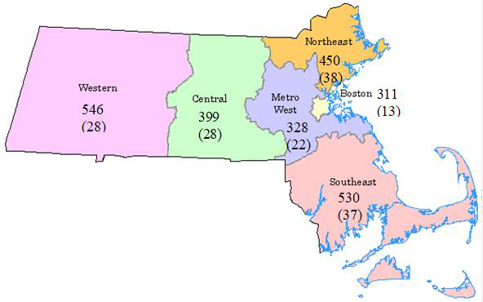

Age

The table below shows the breakdown of children’s age at time of application for the children reimbursed in FY2021. The average age was 7.6 years in FY2021. Approximately 47.6% of the children served in FY2021 were under age five. Many families apply to the Fund for assistance with costs associated with visiting their child in the hospital on a regular basis over an extended period of time.

Race
TABLE 7: Age at Time of Application

 | FY 2021
 | Number | Percent
Under age 1 | 38 | 22.9%
1 – 4 years | 41 | 24.7%
5 – 9 years | 28 | 16.9%
10 – 14 years | 20 | 12.0%
15 – 18 years | 28 | 16.9%
19 – 21 years | 11 | 6.6%
Total | 166 | 100.0%

The table below shows the breakdown of families served by child’s race, as reported on the application.

TABLE 8: Families Served, by Race ª

 | FY 2021
 | Number | Percent*
Hispanic/Latino/Black, Hispanic/Latino/White, Hispanic/Latino/Other | 65 | 39.2%
White, non-Hispanic | 49 | 29.5%
Black, non-Hispanic | 19 | 11.4%
Other | 8 | 4.8%
Asian | 7 | 4.2%
Unknown | 15 | 9.0%
Multi-racial b | 3 | 1.8%
Total | 166 | 100.0%
a Based on what is written on the application, either by the family or a referral source who may have helped the family with the application. Response options provided on the current application are: American Indian or Alaska Native; Asian; Black; Hispanic/Latino/Black; Hispanic/Latino/White; Hispanic/Latino/Other; Native Hawaiian or Other Pacific Islander; White; and Other.
b Multi-racial is not a response option on the application. The child was considered multi-racial if more than one of the other response options were checked on the application.

REVENUE AND EXPENDITURES
CICRF is funded by quarterly transfers made from employers’ contributions to the Commonwealth Care Trust if funds are available after other obligations have been met.^{11,12} In approving the annual Fund budget each year, the Commission agreed that there should always be at least one year’s reserve on hand since the amount of transfers into the Trust each year is unknown and not guaranteed.

In FY2021, four transfers were made into the CICRF Trust. Total deposits (transfers plus interest) were approximately $2.9 million, while total expenditures for payments to families, staffing and other expenses were $2.7 million. FY2021 ended with a balance of $6.0 million.

Table 9 on the next page lists a breakdown of annual revenue and expenditures from the CICRF Trust.

TABLE 9: Annual Revenue and Expenditures from CICRF Trust

¹¹ Prior to January 1, 2014: Chapter 111K, Section 9 of the Massachusetts General Laws provides that funding is to come through an employer’s contribution to the office of employment and training, as $1 annually for each
employee “whose wages determine such employer’s total unemployment health insurance contribution” under Chapter 151A section 14G of the General Laws.
¹² As of January 1, 2014: Chapter 111K, Section 9 of the Massachusetts General Laws provides that funding is to come through an employer’s medical assistance contribution under section 189 of chapter 149, “$1 annually for each employee whose wages determine such employer's total employer medical assistance contribution.”

 | Balance from Prior Fiscal Year ($) | Deposits (includes interest) ($) | Expenditures (includes administrative costs) ($) | Balance Forward to  Next Fiscal Year ($)
FY 2001 | -- | 2,762,950 | 63,062 | 2,699,888
FY 2002 | 2,699,888 | 2,519,271 | 120,149 | 5,099,010
FY 2003¹³ | 5,099,010 | 720,771 | 1,208,507 | 4,611,274
FY 2004¹³ | 4,611,274 | 47,260 | 3,171,764 | 1,486,769
FY 2005 | 1,486,769 | 2,606,336 | 1,242,563 | 2,850,541
FY 2006 | 2,850,541 | 2,799,303 | 1,489,261 | 4,160,584
FY 2007 | 4,160,584 | 2,845,088 | 1,292,183 | 5,713,488
FY 2008 | 5,713,488 | 2,841,943 | 1,819,146 | 6,736,284
FY 2009¹³ | 6,736,284 | 2,070,541 | 2,487,524 | 6,319,302
FY 2010¹³ | 6,319,302 | 23,293 | 3,051,570 | 3,291,025
FY 2011¹³ | 3,291,025 | 16,066 | 2,425,395 | 881,695
FY 2012^{13,14} | 881,695 | 2,098 | 639,952 | 243,842
FY 2013^{13,14} | 243,842 | 572 | 228,907 | 15,507
FY 2014^{13,14} | 15,507 | 3,323,428 | 615,421 | 2,723,515
FY 2015 | 2,723,515 | 2,903,247 | 2,233,697 | 3,393,064
FY 2016 | 3,393,064 | 3,033,103 | 2,612,305 | 3,813,862
FY 2017 | 3,813,862 | 3,046,230 | 2,286,280 | 4,573,812
FY 2018 | 4,573,812 | 3,075,178 | 2,328,516 | 5,320,473
FY 2019 | 5,320,473 | 3,135,460 | 2,774,665 | 5,681,268
FY 2020 | 5,681,268 | 3,177,630 | 3,001,912 | 5,856,986
FY 2021 | 5,856,986 | 2,892,775 | 2,728,183 | 6,021,578

¹³ During FY2003, FY2004, and from FY2009-FY2013 the Fund did not receive the full amount of anticipated transfers from the Medical Security Trust. In FY2004 and from FY2010-FY2013, no transfers were made; deposits reflect interest payments only. Transfers resumed in FY2014; five transfers were received in FY2014 because the 4th quarter FY2013 transfer was made in early FY2014.
¹⁴ As explained on the previous page, state appropriated funds were used to supplement CICRF Trust funds in FY2012-FY2014; only those expenditures from the CICRF Trust are represented here.

CONCLUSION
The Catastrophic Illness in Children Relief Fund provides vital support to families of children with varied and significant health conditions and special health care needs throughout Massachusetts. The Fund allows children with significant health problems to remain with their families and as a part of their communities. In addition, the illnesses or injuries of the children the Fund assists demand a wide range of medical services.

The diverse needs the Fund encounters attest to the value of this unique safety net. Ultimately, the Fund serves to improve the quality of life for many children and their families.

The Commission is proud of the assistance the Fund has provided to families over the past 21 years.

COMMISSION MEMBER LIST
As of October 2022

Public Members John S. Maypole, MD Co-chair
ErinKate Greeley
Co-chair
Elizabeth Childs, MD, MPA Laura-Jean Hickey, MEd
AFL-CIO Representative Donna Nimec, MD Jorge Pagan-Ramos Victoria Pulos, JD

Ex Officio Members Designee
Deborah B. Goldberg Emily Kowtoniuk
Treasurer and Receiver General Office of the State Treasurer

Marylou Sudders Carolyn Kain
Secretary
Executive Office of Health and Human Services

Margret R. Cooke Elaine Fitzgerald Lewis, DrPH, MIA
Commissioner
Department of Public Health

Gary D. Anderson Marie Exantus
Commissioner Division of Insurance

Commissioner Emerita
Marcia Huttner, MLS

