**INDOOR AIR QUALITY**

**POST-OCCUPANCY ASSESSMENT**

**The Children’s Trust Fund**

**155 Federal Street, Suite 500**

**Boston, MA**

Prepared by:

Massachusetts Department of Public Health

Bureau of Climate and Environmental Health

Division of Environmental Health Regulations and Standards

April 2025

# BACKGROUND

|  |  |
| --- | --- |
| Building: | The Children’s Trust Fund (CTF) |
| Address: | 155 Federal Street, Suite 500,  Boston, MA |
| Assessment Requested by: | Christine Cannon, Project Manager Division of Capital Asset Management & Maintenance (DCAMM), Office of Leasing and State Office Planning |
| Reason for Request: | Post-occupancy indoor air quality (IAQ) assessment. The CTF moved from a different location in downtown Boston. |
| Date of Assessment: | April 22, 2025 |
| Massachusetts Department of Public Health/Bureau of Climate and Environmental Health (MDPH/BCEH) Staff Conducting Assessment: | Ruth Alfasso, Environmental Inspector, Division of Environmental Health Regulations and Standards (EHRS) |
| Building Description: | The CTF is located on the 5th floor of a high rise building constructed in the 1980s. The office has workstations, a classroom area, meeting rooms and a storage area. The space was outfitted with new carpeting, workstations, paint, kitchen appliances, and other items. |
| Windows: | Windows are not openable |

# METHODS

Please refer to the IAQ Manual for methods, sampling procedures, and interpretation of results (MDPH, 2015).

# RESULTS AND DISCUSSION

The following is a summary of indoor air testing results (Table 1).

* ***Carbon dioxide*** measurements were below the MDPH guideline of 800 parts per million (ppm) in all areas tested, indicating adequate air exchange at the time of assessment. However, note that the suite was almost unoccupied, and carbon dioxide may be higher with higher occupancy.
* ***Temperature*** was within the recommended range of 70°F to 78°F in all areas.
* ***Relative humidity*** was within the recommended range of 40% to 60% in all areas examined.
* ***Carbon monoxide*** levels were non-detectable (ND) in all indoor areas tested.
* ***Fine particulate matter (PM2.5)*** concentrations were below the National Ambient Air Quality Standard (NAAQS) level of 35 μg/m3 in all areas tested.
* ***Total Volatile Organic Compounds***were ND in all areas tested.

## Ventilation

A heating, ventilating, and air conditioning (HVAC) system has several functions. First, it provides heating and, if equipped, cooling. Second, it is a source of fresh air. Finally, an HVAC system will dilute and remove normally occurring indoor environmental pollutants by not only introducing fresh air but also filtering the airstream and ejecting stale air outdoors via exhaust ventilation. Even if an HVAC system is operating as designed, point sources of respiratory irritation may exist and affect symptoms in sensitive individuals.

Fresh air is supplied to the CTF offices and common areas through supply vents in the ceiling (Picture 1). Air is drawn back to the air handling units (AHUs) through ceiling-mounted return vents (Picture 2). Radiators are located in offices along the exterior walls (Picture 3). In some rooms, radiators were blocked by stored items (Picture 4). Without a free flow of air, heat from radiators may not circulate properly to all areas of the room; in addition, items may become heated and emit odors or become damaged. Note that the Wellness Room did not have an exhaust/return vent which may decrease airflow in this room and allow odors to linger, particularly when the door to the room is closed.

Two thermostats were found in the suite, one on a pillar near the middle of the room (Picture 5) and one near the entrance to the suite (Picture 6). The thermostat in Picture 6 appeared to be turned off, the time was incorrectly set, and it also did not match the one shown in Picture 5. It is likely the thermostat is no longer operational; if so, it should be removed. If, however, this thermostat is still in use, it should be programmed for the correct time and activated.

Note that the thermostat in Picture 5 showed the system was set for an “occupied” setting and the fan was on. Having the fan on is preferred because it allows for a continual exchange of air regardless of the need for temperature adjustment. Night and weekend unoccupied settings can be used to save energy.

The air handling units (AHUs) for this building were not accessed during this visit. The MDPH EHRS program recommends that AHU filters be changed 2-4 times a year (or in accordance with the manufacturers’ recommendations) and be at least minimum efficiency reporting value (MERV) 8, as these are adequate to filter out pollen, mold, and similar particulates (ASHRAE, 2012).

It is recommended that HVAC systems be re-balanced every five years to ensure adequate air systems function (SMACNA, 1994). While it is likely these systems were balanced prior to occupancy, that information was not available at the time of the assessment.

## Microbial/Moisture Concerns

No water-damaged materials were found during this assessment. The kitchen area with sink, refrigerator and water dispenser had a section of non-porous flooring (Picture 7), which will prevent spills/leaks from damaging carpeting and make the area easier to keep clean. However, there is also a sink and refrigerator in the Wellness Room which have carpeting underneath them (Picture 8). The area under sinks is a potentially wet environment and carpeting is likely to become water-damaged. Carpeting under refrigerators may also be subject to leaks and spills.

## Other IAQ Concerns

Testing was conducted for total volatile organic compounds (TVOCs). All measurements were non-detect (ND). An examination was conducted for products that may be a source of VOCs in indoor air. Products such as hand sanitizers were noted (Table 1). VOCs from these products can build up and lead to irritation of the mucous membranes.

Some items in the storage area were on the floor and there were items in boxes on the floor in the Wellness Room (Picture 9). While this is likely temporary due to the move, staff should be made aware that storage of items on the floor makes it more difficult to clean. Boxes can also become harborage for rodents.

The layout of the office suite does not separate the kitchen area from the training room (Picture 10) and this area is open to the rest of the cubicle workstations. In addition, no direct-vented exhaust was found for the kitchen. This means that odors or smoke from cooking/heating food will easily penetrate the rest of the office. Occupants should be careful not to overcook anything, and equipment such as the toaster oven and microwave need to be cleaned regularly to prevent crumbs or debris.

Personal fans, air purifiers, and heaters were noted in several offices (Picture 11; Table 1), and more were found in a supply closet. These items need to be kept clean, as dust on this equipment can be redistributed during use. In addition, the air purifiers have filters that need to be changed in accordance with the manufacturer’s instructions.

In a few rooms, ceiling tiles were missing or ajar (Picture 12; Table 1), likely due to incomplete installation or removal to pull wires or other setup/maintenance. Ceiling tiles should fit snugly in the ceiling tile grid to keep any debris from falling into occupied areas. Items should not be hung from the ceiling.

Note that some areas in the building are vacant or under renovations for new tenants. Renovations in nearby parts of the building should be conducted following the guidance in [Construction and renovation generated pollutants in occupied buildings](https://www.mass.gov/info-details/construction-and-renovation-generated-pollutants-in-occupied-buildings).

Finally, most areas of the office are carpeted. Carpets should be cleaned regularly in accordance with Institute of Inspection, Cleaning and Restoration Certification (IICRC) recommendations (IICRC, 2012).

# CONCLUSIONS/RECOMMENDATIONS

In view of the findings at the time of the visit, the following recommendations are made:

## Ventilation recommendations

1. Ensure the AHU and other HVAC system filters are at least a MERV rating of 8 and are changed at least twice a year.
2. Ensure the control system is configured to have the fan on during occupied periods regardless of the need for heating or cooling.
3. If the thermostat in Picture 6 is still in use, ensure the time is set properly and that it has the fan on during occupied periods. If it is no longer in use, it should be removed.
4. Consider adding a return vent to the Wellness Room as this room may often be used with the door closed. If not possible, ensure the door is undercut sufficiently to allow air circulation.
5. Ensure that radiators are not blocked by items and that items that may be damaged by heat or emit odors when heated are not stored close to radiators.
6. It is recommended that HVAC systems be re-balanced every five years to ensure adequate air systems function (SMACNA, 1994).

## Water damage recommendations

1. Consider removing carpet under the Wellness Room sink and refrigerator and replacing with non-porous flooring. If not possible, cover these areas with waterproof, cleanable materials such as mats.

## Other recommendations

1. Use VOC-containing products in areas with good ventilation and keep tightly closed when not in use. Avoid products with strong scents and avoid mixing incompatible products.
2. Keep the kitchen appliances clean and take care to avoid creating smoke or odors during use of the kitchen.
3. Clean supply and return vents and radiators periodically to remove dust.
4. Keep fans, heaters, and air purifiers clean and change air purifier filters as recommended by the manufacturer.
5. Ensure paper and boxes are stored in appropriate locations as soon as possible to make thorough cleaning easier.
6. Ensure all ceiling tiles are installed flush with the ceiling tile grid.
7. Use guidance in [construction and renovation generated pollutants in occupied buildings](https://www.mass.gov/info-details/construction-and-renovation-generated-pollutants-in-occupied-buildings) to prevent issues when nearby spaces are under renovations.
8. Clean carpeting in accordance with IICRC recommendations (IICRC, 2012); annually (or semi-annually in soiled/high traffic areas).
9. Refer to resource manual and other related IAQ documents located on the MDPH’s website for further building-wide evaluations and advice on maintaining public buildings. These documents are available at: <http://mass.gov/dph/iaq>.

# REFERENCES

ASHRAE. 2012. American Society of Heating, Refrigeration and Air Conditioning Engineers (ASHRAE) Standard 52.2-2012 -- Method of Testing General Ventilation Air-Cleaning Devices for Removal Efficiency by Particle Size (ANSI Approved).

IICRC. 2012. Institute of Inspection, Cleaning and Restoration Certification. Carpet Cleaning: FAQ.

MDPH. 2015. Massachusetts Department of Public Health. Indoor Air Quality Manual: Chapters I-III. Available at: <https://www.mass.gov/lists/indoor-air-quality-manual-and-appendices>.

SMACNA. 1994. HVAC Systems Commissioning Manual. 1st ed. Sheet Metal and Air Conditioning Contractors’ National Association, Inc., Chantilly, VA.

**Picture 1**

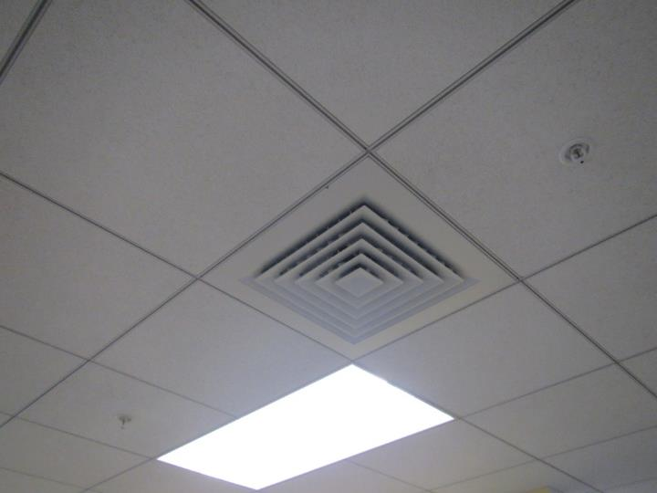

**Supply vent**

**Picture 2**

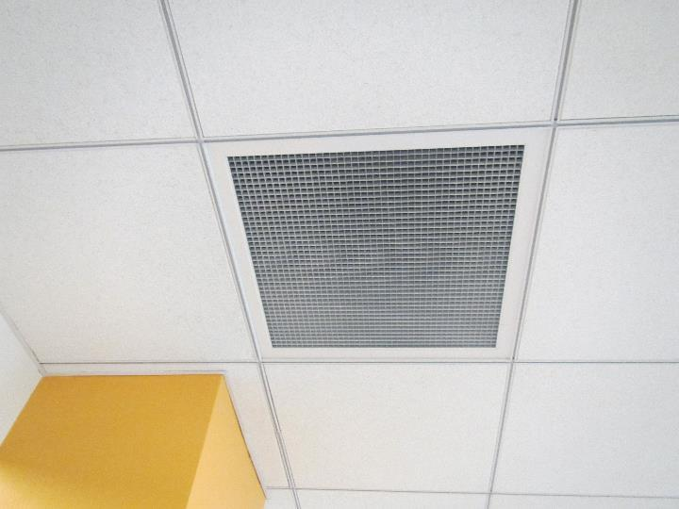

**Return vent**

**Picture 3**

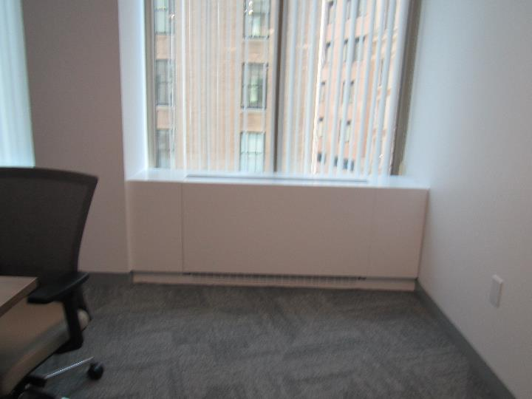

**Radiator**

**Picture 4**

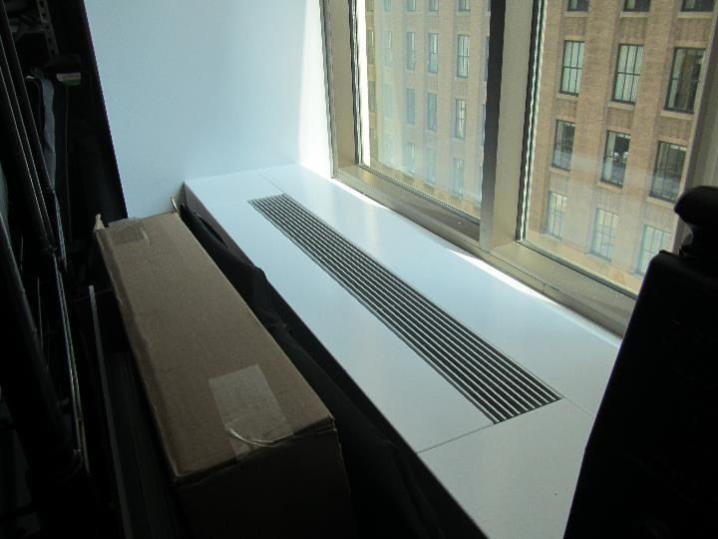

**Items in front of radiator**

**Picture 5**

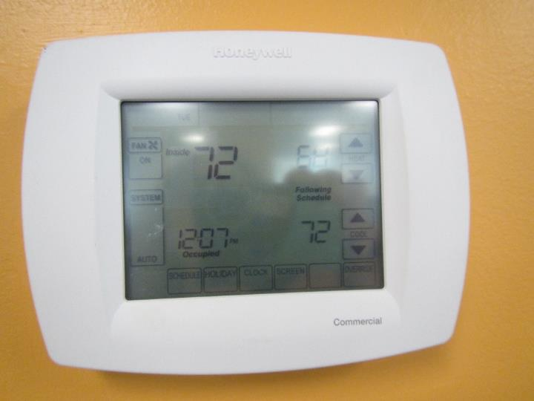

**Thermostat which appears to be active and is set to the correct time**

**Picture 6**

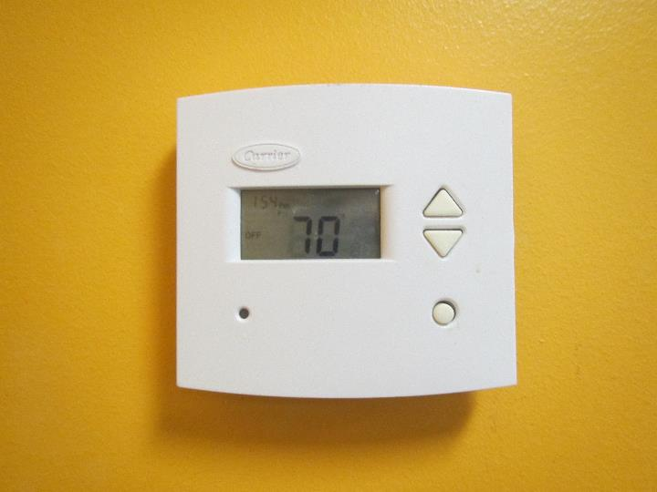

**Thermostat which appears to be inactive and the time is wrong**

**Picture 7**

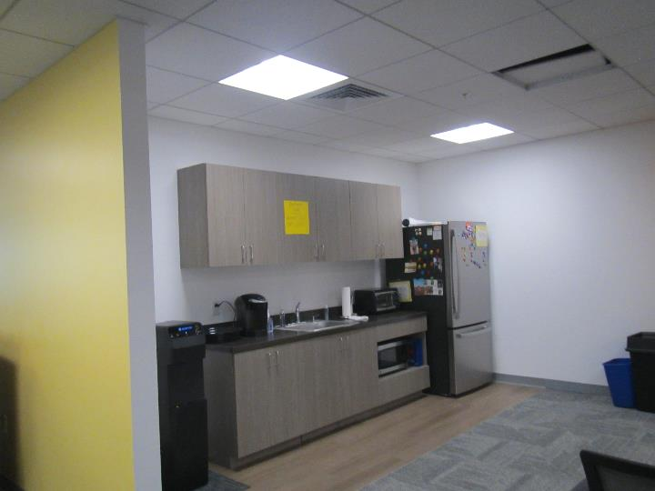

**Area of non-porous flooring next to the kitchen sink and appliances**

**Picture 8**

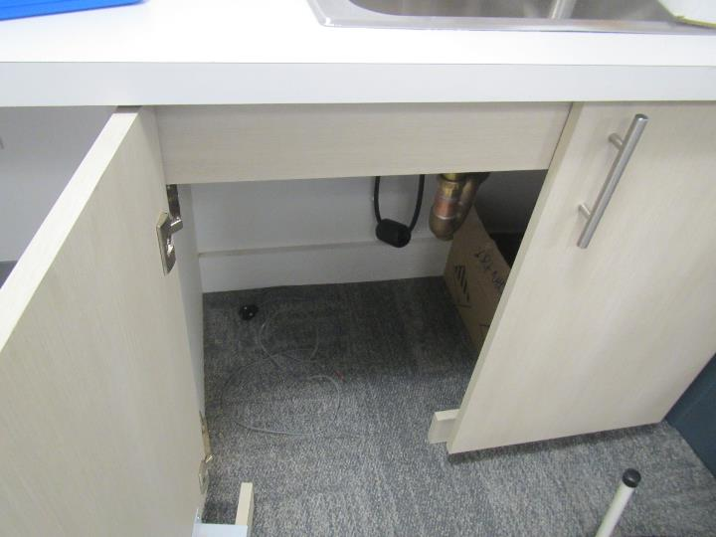

**Carpeting under the sink in the Wellness Room**

**Picture 9**

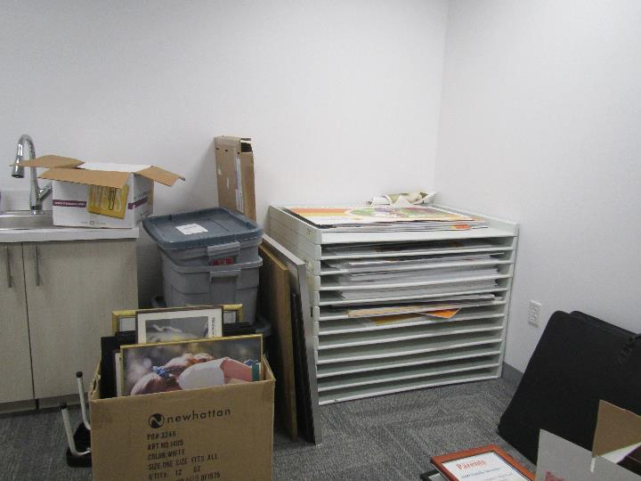

**Boxes and items on the floor in the Wellness Room**

**Picture 10**

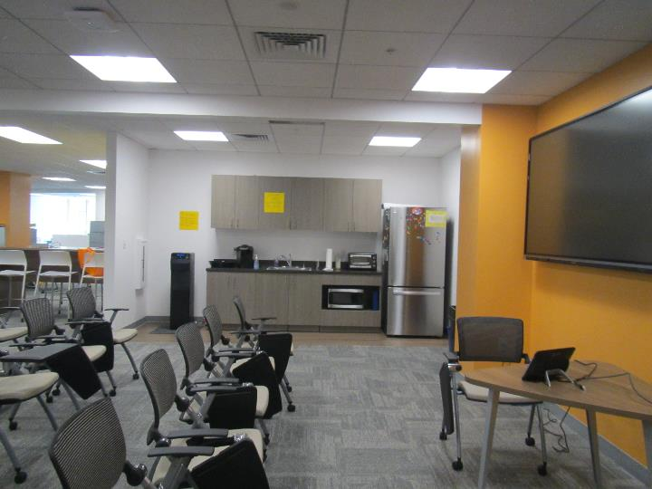

**Location of kitchen area with no separation to training area**

**Picture 11**

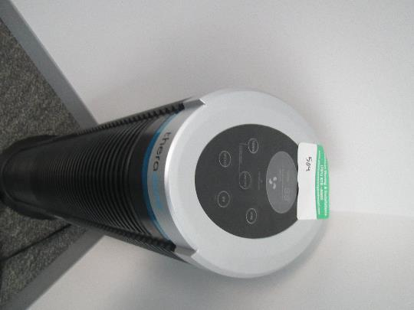

**Air purifier**

**Picture 12**

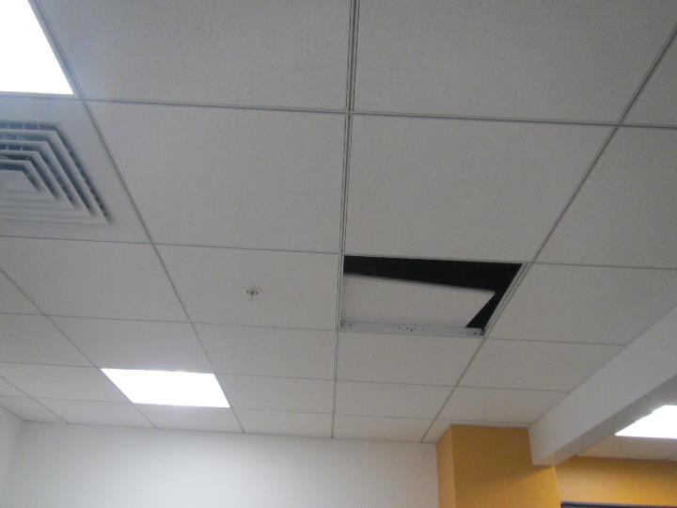

**Ajar ceiling tile**

| **Location** | **Carbon**  **Dioxide**  **(ppm)** | **Carbon Monoxide**  **(ppm)** | **Temp**  **(°F)** | **Relative**  **Humidity**  **(%)** | **PM2.5**  **(µg/m3)** | **TVOC**  **(ppm)** | **Occupants**  **in Room** | **Windows**  **Openable** | **Ventilation** | | **Remarks** |
| --- | --- | --- | --- | --- | --- | --- | --- | --- | --- | --- | --- |
| **Supply** | **Exhaust** |
| Training/classroom | 552 | ND | 72 | 42 | 4 | ND | 0 | N | Y | Y | Open area with chairs in classroom format, near kitchen equipment, carpeted, thermostat is off (may be decommissioned, does not match the other). |
| Kitchen area | 554 | ND | 72 | 41 | 6 | ND | 0 | N | Y | Y | Open to classroom and main area, not carpeted right next to sink and appliances, fridge, toaster and microwave |
| 506 Wellness | 534 | ND | 72 | 40 | 3 | ND | 0 | N | Y | N | Carpet, sink over carpet, small fridge, items/storage, HS |
| 505 Storage | 430 | ND | 72 | 41 | 7 | ND | 0 | N | Y | Y | Storage items mostly on shelving, carpeted |
| 504 Huddle | 553 | ND | 72 | 40 | 4 | ND | 0 | N | Y | Y | Carpet, HS, AP (not plugged in) |
| Copy/Mail area | 562 | ND | 72 | 40 | 6 | ND | 0 | N | Y | Y | Photocopier |
| 502 Meeting | 529 | ND | 72 | 40 | 4 | ND | 0 | N | Y | Y | Personal fan, AP, heater, HS, carpet |
| 501 Conference | 536 | ND | 72 | 40 | 4 | ND | 0 | N | Y | Y | Carpet, HS |
| W540 area (cubes) | 589 | ND | 72 | 40 | 3 | ND | 0 | N | Y | Y | 3 missing tiles overhead, carpet, HS |
| W533 area (cubes) | 534 | ND | 72 | 41 | 4 | ND | 0 | N | Y | Y | Carpet |
| W524 area (cubes) | 542 | ND | 71 | 41 | 5 | ND | 1 | N | Y | Y | Carpet, HS |
| W522 area (cubes) | 604 | ND | 71 | 42 | 5 | ND | 0 | N | Y | Y | Carpet |