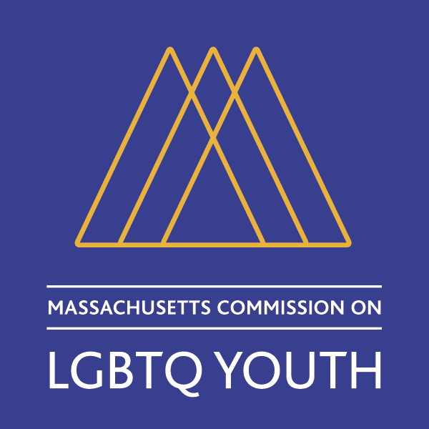

The Massachusetts Commission on LGBTQ Youth
Member and Staff Directory
2018

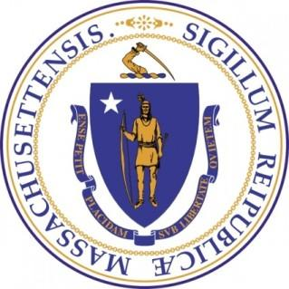

Officers
Alexander Nally, Chair
Sasha Goodfriend, Vice Chair

Members
Zeke Acevedo
Michel Anteby
Joe Baeta
Gary Bailey
Sam Barrak
Steven Belec
Roger Bourgeois
Courtney Chelo
Mason Dunn
Aspen Eberhardt
Athena Edmonds
Sonya Epstein
Erik Fearing
Valerie Frias
Shavon Fulcher
Paul Gels
Zuleny Gonzalez
Sasha Heggie
Tanekwah Hinds
Nicolas John
Harold Jones

Staff

Corey Prachniak-Rincón, Director
Maxwell Nashashuk, Program Assistant

Rachel Kahn
Stewart Landers
Allen Lin
Engie Mota
Katie Omberg
Elijah Oyenuga
Tyler Rainer
Susan Rees
Erika Rickard
Kayla Shanks
Spencer Shannon
Taj Smith
Grace Sterling Stowell
Brianna Suslovic
Kendra Taylor
Timothy Wang
Ashley Waterberg
Jeffry Wright

Officers

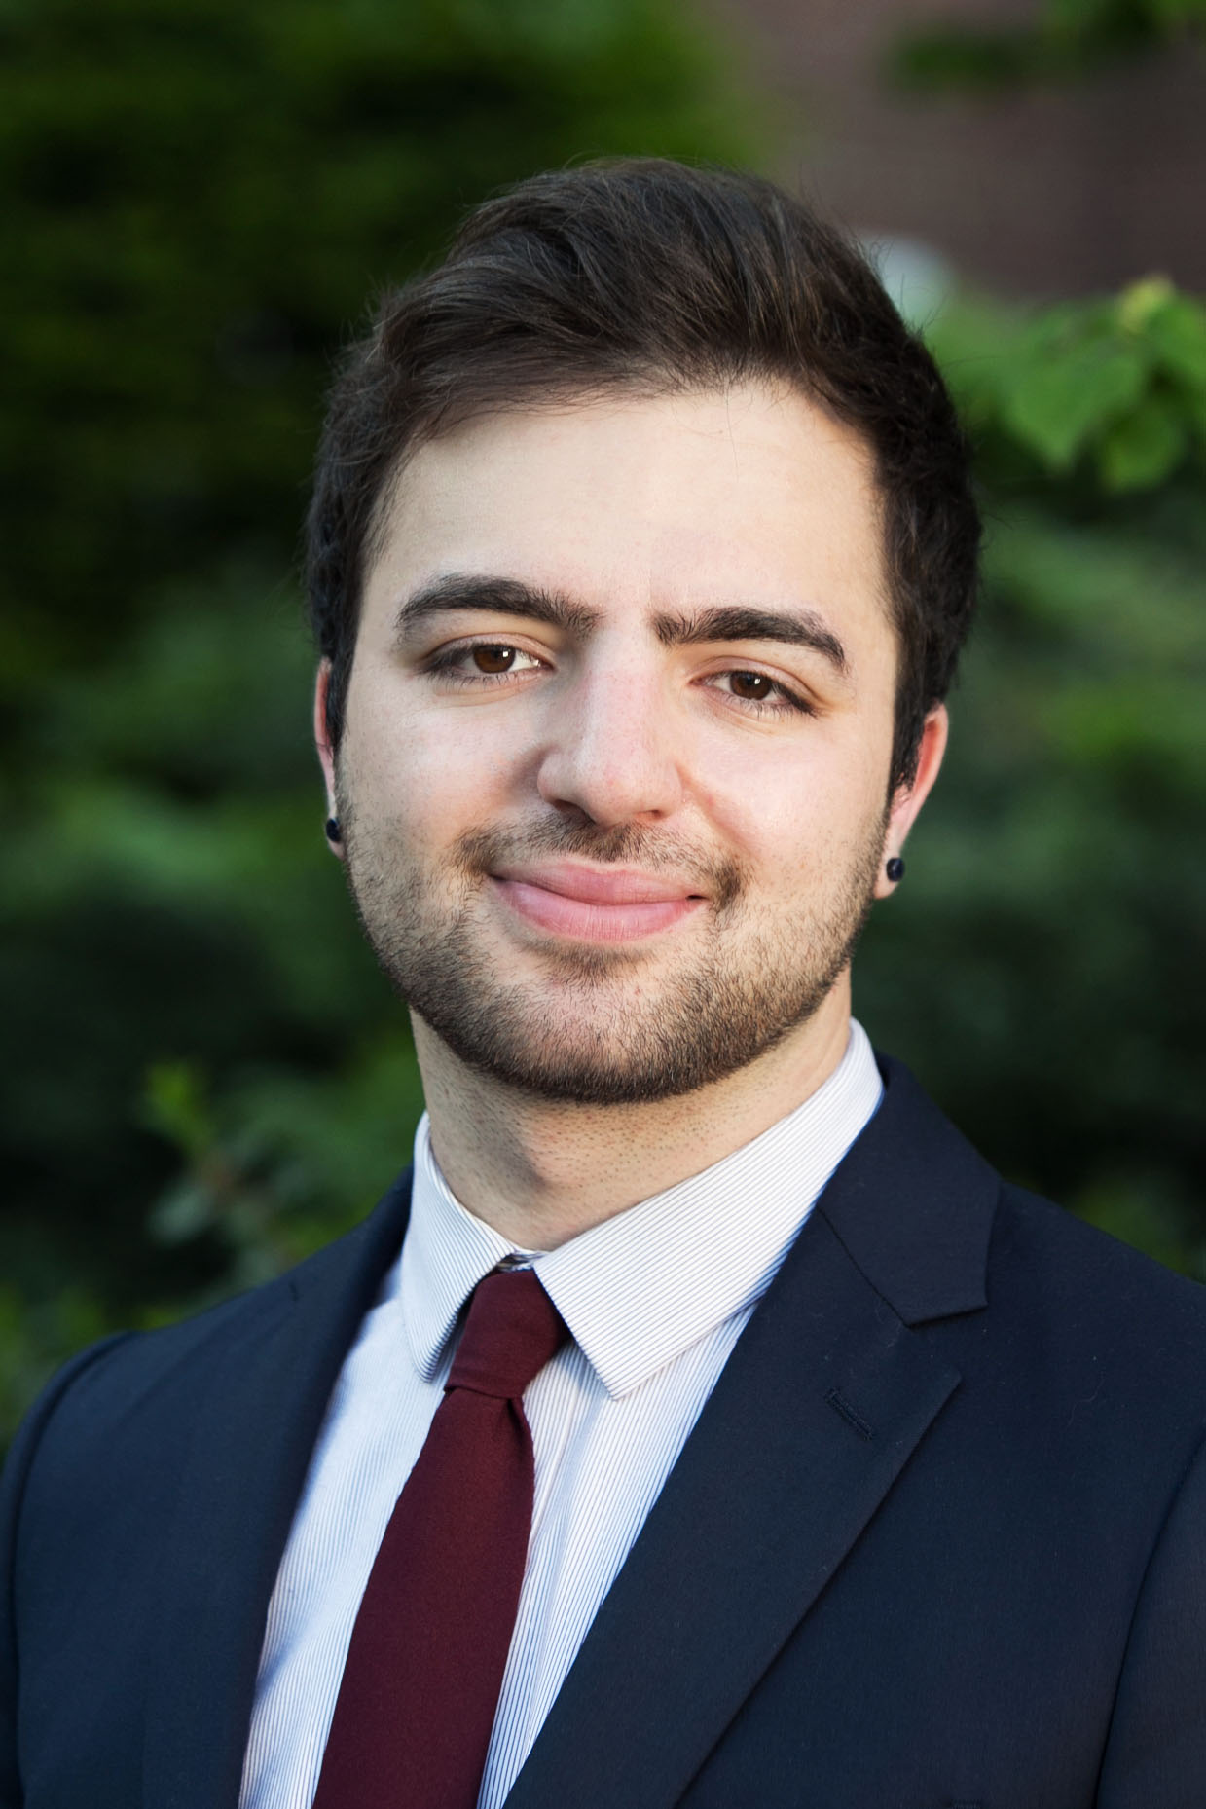
Alexander Nally
Commission Chair
They/Them/Theirs or He/Him/His

Alexander Armand Ribeiro Nally is a JD/MS candidate at Northeastern University School of Law and an honors graduate of the Massachusetts College of Art and Design. Alex first joined the Commission in 2014 to advocate for the needs of transgender & gender non-conforming youth and homeless LGBTQ+ youth. Alex grew up in Springfield and moved to Boston for college in 2012 to pursue a career in graphic design and law & public policy. Recognized for their civic engagement on the Commission, the Massachusetts Department of Higher Education awarded Alex the "29 Who Shine" award in 2016. Last year, Alex was awarded the prestigious Rappaport Law & Public Policy Fellowship for their work in protecting DACA students from deportation, safeguarding students from taking on debt they cannot afford, and ensuring that in Massachusetts LGBTQ+ students continue to be protected under Title IX on college campuses.

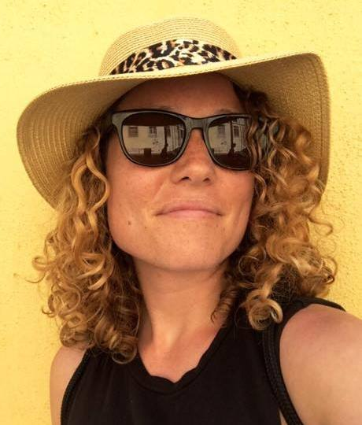
Sasha Goodfriend
Commission Vice Chair
She/Her/Hers

Sasha Goodfriend works at Simmons College as the Government Relations Coordinator, connecting the College to federal, state and local government, fostering relationships with elected and appointed officials through strategic communications and coordinated campus visits. She is President of the Massachusetts National Organization for Women and vice chair of the Massachusetts Commission on LGBTQ Youth. Goodfriend holds an MA in Public Policy from Simmons and a BA in International Relations from Boston University.

Staff

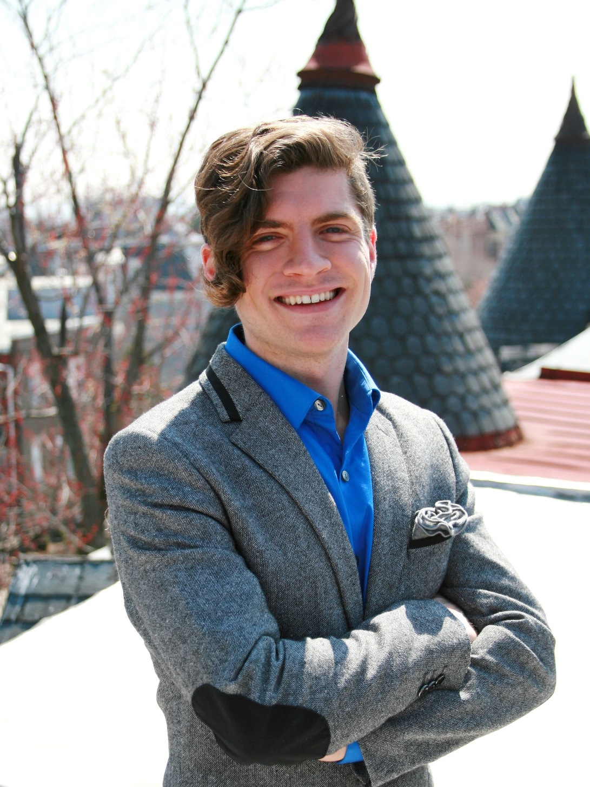
Corey Prachniak-Rincón
Director
They/Them/Theirs

Corey Prachniak-Rincón, Esq., serves as the Director of the Commission on LGBTQ Youth. Before beginning this role, Corey was a research fellow with Harvard University and the Center for Reproductive Rights, leading an international investigation on the Zika epidemic and its intersection with gender and human rights. Corey previously worked as a law clerk and then attorney at Whitman-Walker Health, an LGBTQ- and HIV-focused nonprofit in Washington, DC, where they focused on discrimination and healthcare law. Corey earned their undergraduate and Juris Doctor degrees from Georgetown University, and their Master in Public Health degree from Harvard University, where they also served as a Zuckerman Fellow at the Center for Public Leadership and as a visiting scientist with the Women & Health Initiative.

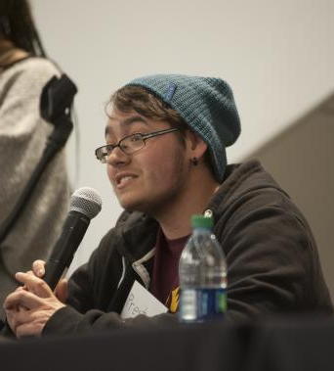
Maxwell Nashashuk
Program Assistant
He/Him/His or They/Them/Theirs

Maxwell Nashashuk attended Dean College, where he found his love of volunteering and working within the LGBT+ community. In 2017, Maxwell moved to Boston, where he began advocating for LGBT homeless youth. He has attended the Massachusetts Youth Count Conference, A Conversation on LGBT Youth Homelessness, the Trans Housing Instability/Homelessness panel, and many more. Maxwell has also assisted in trainings for DCF and Y2Y Harvard Square staff, and most recently, graduated from More Than Words. Maxwell has additionally been nominated for both the Trans Activism Award and the TruColors Award for his activism with queer homelessness. Recognized by a multi-billion dollar company for his activism, Maxwell continues to fight for equal rights and housing for young adults everywhere.
Members

Zeke Acevedo
Co-Chair, Safe Schools
They/Them/Theirs

Zeke Acevedo has been a member of the commission since January 2017. They are an active member of the Safe Schools Committee and had been part of the GSA Student Leadership Council for two years. In addition to their work on the commission they are a member of their high school’ss robotics team, vice president of their GSA and an avid figure skater. They are currently a junior at Ipswich High School.

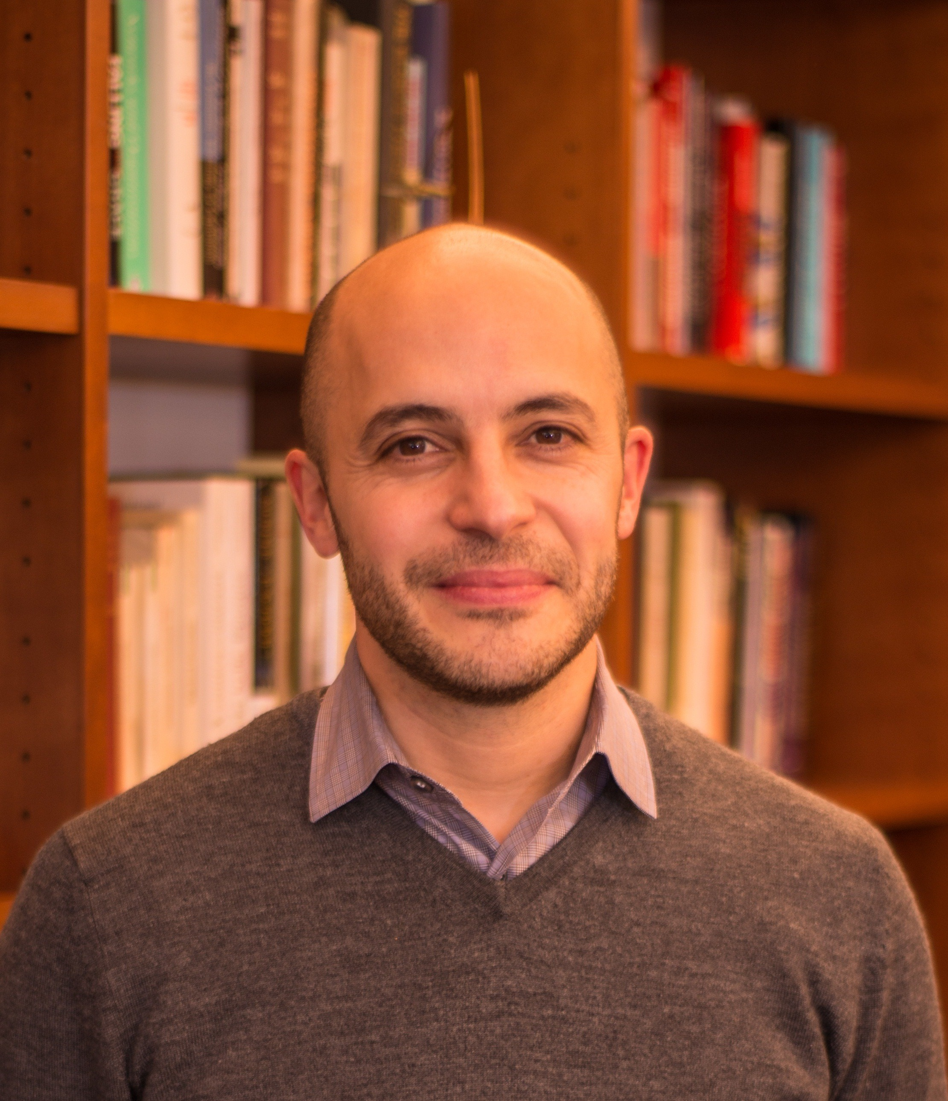
Michel Anteby
He/Him/His

Michel is an Associate Professor of Organizational Behavior and Sociology at Boston University. His research looks at how individuals relate to their work, their occupations, and the organizations they belong to. Michel examines more specifically the practices people engage in at work that help them sustain their chosen cultures or identities. He grew up in France and previously volunteered as a mediator at the LGBT Community Center in New York.

Joseph F. Baeta
He/Him/His

Joeb has been a public-school educator for 26 years. His experience includes 10 years in the classroom and the last 16 years in administration. The last 9 have been as Superintendent of Schools. He is one of the MA Association of School Superintendents representatives to the Commission, and has been involved with the LGBTQQ community since 1993 as a lead teacher and advisor.

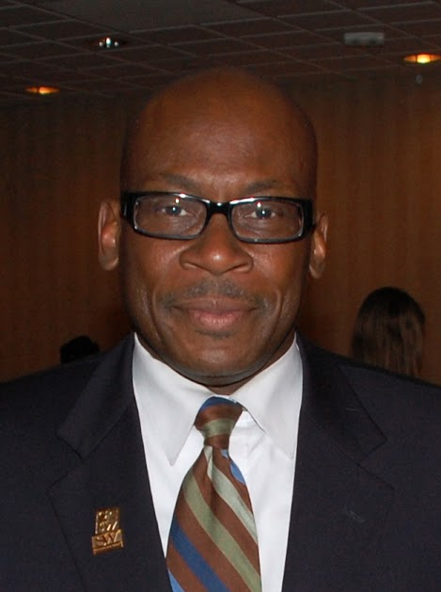
Gary Bailey
He/Him/His

Gary Bailey is currently a Professor of Practice at the Simmons College Graduate School of Social Work, where he chairs the Certificate Program in Urban Leadership and Clinical Social Work and coordinates the school’s Dynamics of Racism and Oppression sequence. He also has an appointment at the Simmons School of Health Sciences where he serves as Special Assistant to the Dean for Inter-Professional Education activities. He is also a Faculty Affiliate at Harvard Medical Schools Center for Primary Care.
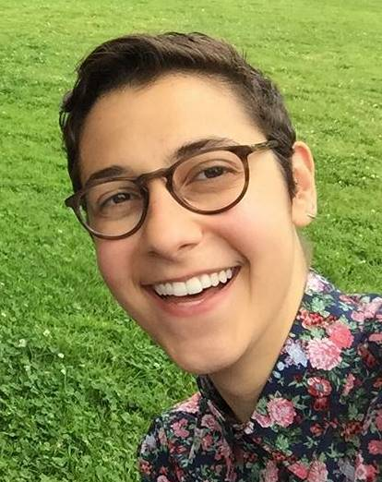
Sam Barrak
Co-Chair, Safe Schools
They/Them/Theirs

Sam Barrak graduated from the Boston University School of Management in 2010 and shortly thereafter began a career in business technology. While at work, Sam participates as a member of a small task force dedicated to increasing LGBTQ inclusiveness. When not in the private sector, Sam is passionate about community work, particularly working with at-risk and marginalized youth. Sam spent two years working directly with youth as a music mentor for the Boys & Girls Club in Dorchester, MA and has experience conducting program evaluation for a local organization that works with visually impaired and blind youth in conflict-affected regions. Sam is also a queer, independent musical artist and has performed live for various LGBTQ clubs at colleges around Massachusetts (Wellesley College, Clark University). Born in Lebanon and raised in Connecticut, Sam currently resides in Jamaica Plain, MA.

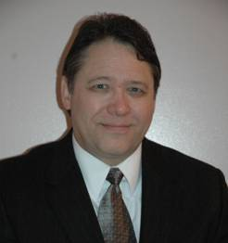
Roger Bourgeois
He/Him/His

Roger Bourgeois is a retired school superintendent with over 37 years of experience in vocational, technical, and agricultural education as a teacher and administrator. He worked diligently throughout his career to foster positive school cultures that are welcoming, accepting, and supportive of ALL students, and spearheaded efforts in schools to create a supportive environment for LGBTQ students. He believes that a safe and nurturing school climate is a foundational prerequisite for students to achieve and succeed at high levels. Mr. Bourgeois has spoken widely to school communities as a parent of a gay son. His family’s story was featured on WCVB TV’s Chronicle: Growing Up Gay in February, 2011. He and his wife, Robin, live in Middleton, Massachusetts. They are the proud parents of three children and four grandchildren.

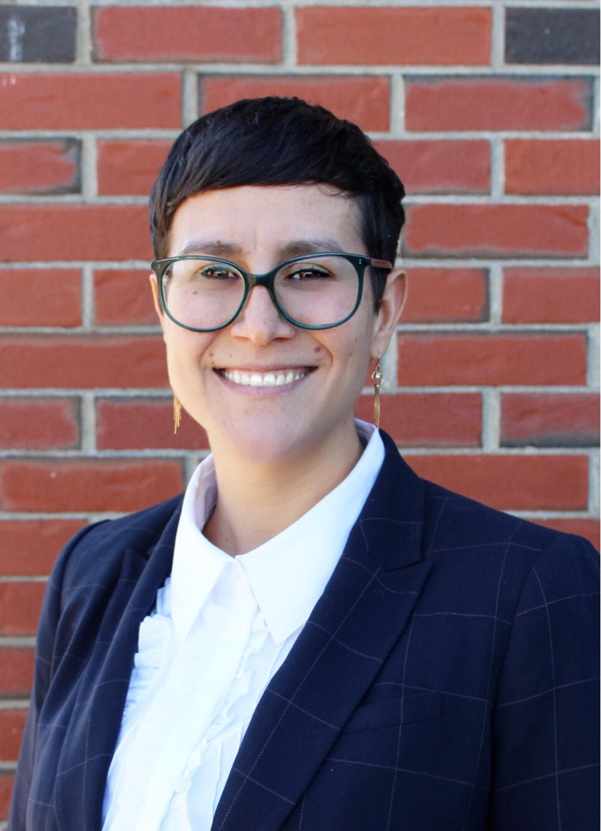
Courtney Chelo
Co-Chair, Government Relations
She/Her/Hers

Courtney Chelo is the Children’s Behavioral Health Project Manager at the Massachusetts Society for the Prevention of Cruelty to Children (MSPCC). In that role she coordinates the work of the Children’s Mental Health Campaign, a coalition of families, advocates, health care providers, educators, and consumers from across Massachusetts dedicated to comprehensive reform of the children’s mental health system. Prior to joining the MSPCC, she served as a Policy Coordinator at Health Care For All, where she worked to expand access to quality, affordable oral health care and coverage for vulnerable populations. She is a graduate of the University of New Hampshire with a B.S. in Environmental and Resource Economics. Originally from Rhode Island, Courtney resides in Somerville.

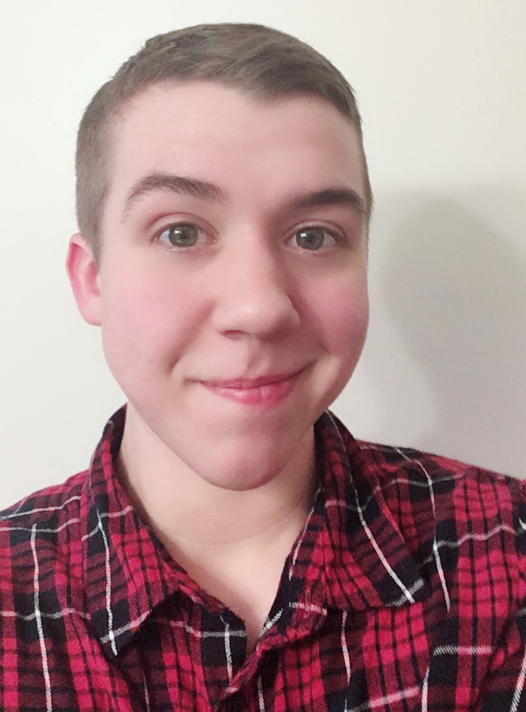
Aspen Eberhardt
They/Them/Theirs

Aspen is originally from rural New Hampshire. Upon moving to Boston, they were immediately called to LGBTQ activism and education in the local community. They have spent countless hours volunteering with Greater Boston PFLAG to provide LGBTQ education and sensitivity training for schools, workplaces, and communities. They also volunteer with Freedom for all Massachusetts to advocate for transgender equality.

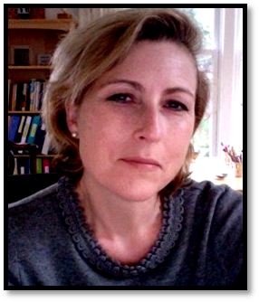
Athena Edmonds
She/Her/Hers

Athena is an advocate for LGBTQ Youth, a speaker, and a writer. Her focus is advocacy in medical institutions to address LGBTQ healthcare disparities. She is currently serving on the Board of Directors of Greater Boston PFLAG, and is Poet Laureate of Everett High School through a Mass Poetry and Mass Cultural Council grant. She has also taught incarcerated men in the PEN New England program, as well as co-founded and taught a weekly poetry course in the Concord Massachusetts Correctional Institution.

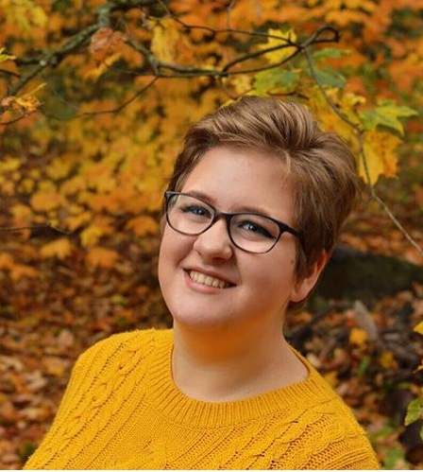
Sonya Epstein
They/Them/Theirs

Sonya is part of the Belmont High School class of 2018 and the University of Massachusetts, Amherst class of 2022, majoring in Social Thought and Political Economy. They are a member of the GSA State Leadership Council and the Safe and Supportive Schools Commission. They are also a leader of Belmont High School's GSA, drumline, and costumes crew for the theatre program. Sonya is excited to continue their advocacy work in college and learn how to create a more inclusive and equal society.

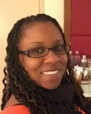
Shavon Fulcher
She/Her/Hers

Shavon is a Licensed Independent Clinical Social Worker with years of experience working with children, youth and families. She also spends time educating MSW social workers in a variety of courses, as well as providing clinical therapeutic services in a private practice. Shavon is a lifelong Massachusetts residence and thrives on giving back to the future (youth). Shavon is an avid reader and when there is time, a passionate writer.

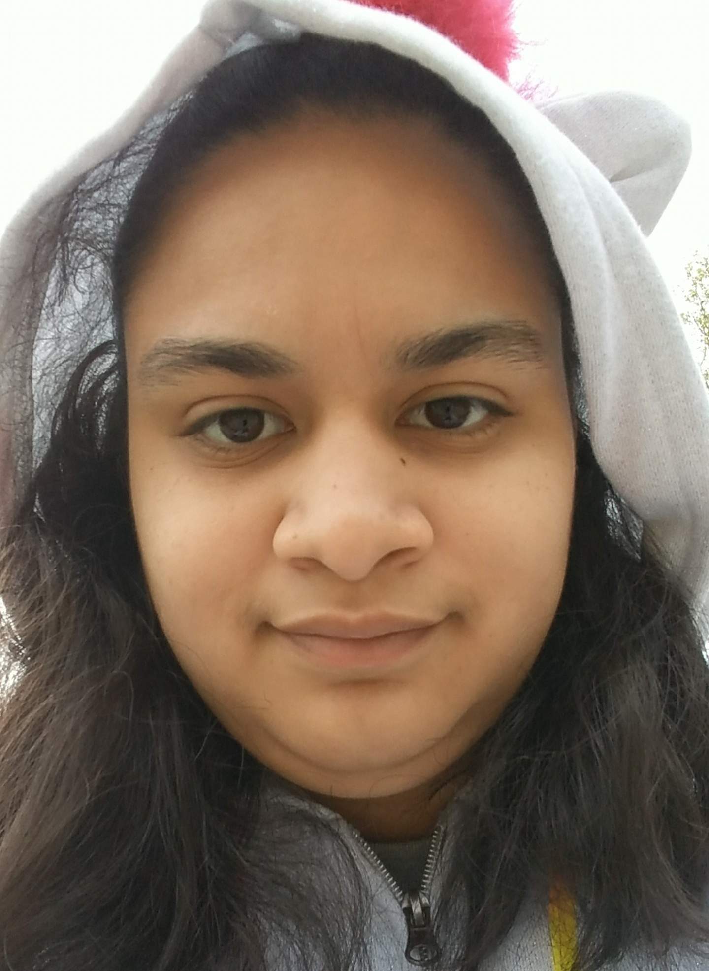
Zuleny Gonzalez
Co-Chair, Community Relations
She/Her/Hers or They/Them/Theirs
Zuleny is a 21-year-old disabled non-binary person. They have been on the Commission in high school and are currently part of community relations and safe schools groups. On their own time they like to paint, draw, and read.

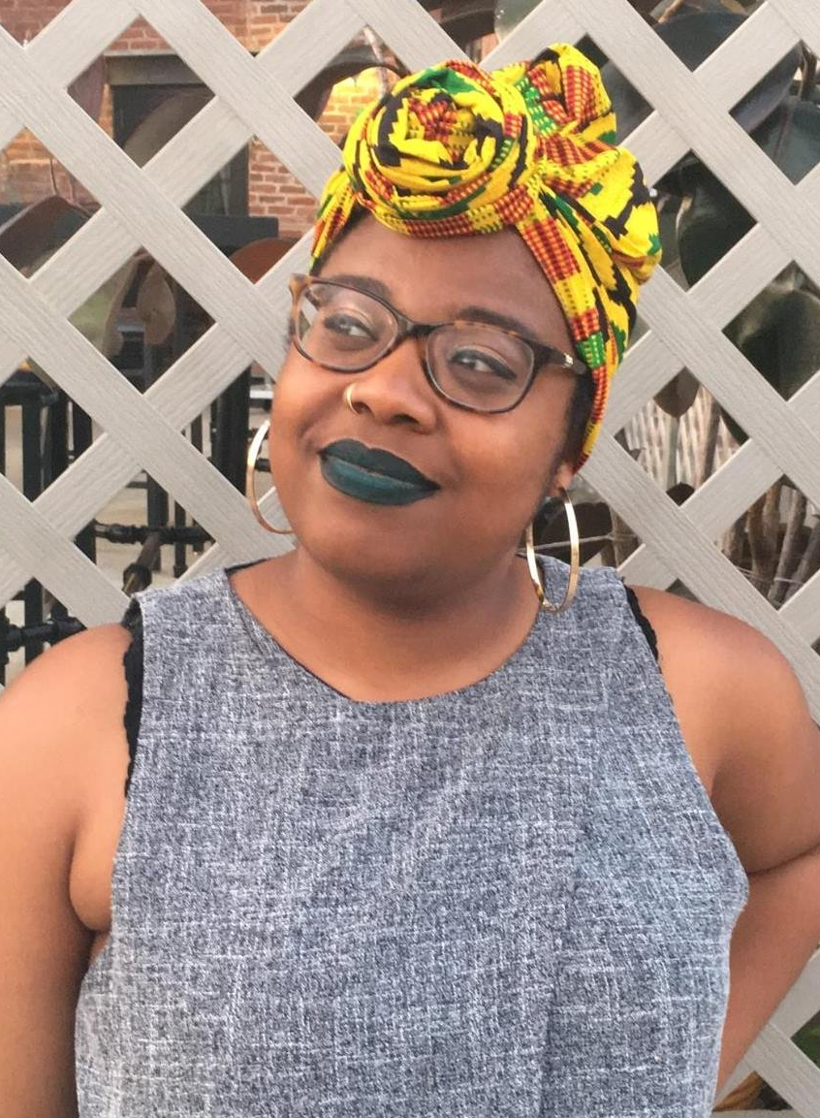
Tanekwah Hinds
Co-Chair, Community Relations
She/Her/Hers

As the Women’s Health Program Coordinator at Fenway Health, Tanekwah Hinds collaborates with community organizations to plan outreach events for Boston LGBTQ+ women, manages the tobacco cessation program as a counselor, and coordinates research projects on HPV vaccinations, intimate partner violence, and contraception. She recently received the Healthy Community Leadership Award from Boston Alliance for Community Health (BACH). Tanekwah's work in the community has also been published in Vice and Feminist Formations. During her free time, she enjoys reading BuzzFeed articles and watching Love and Hip Hop.

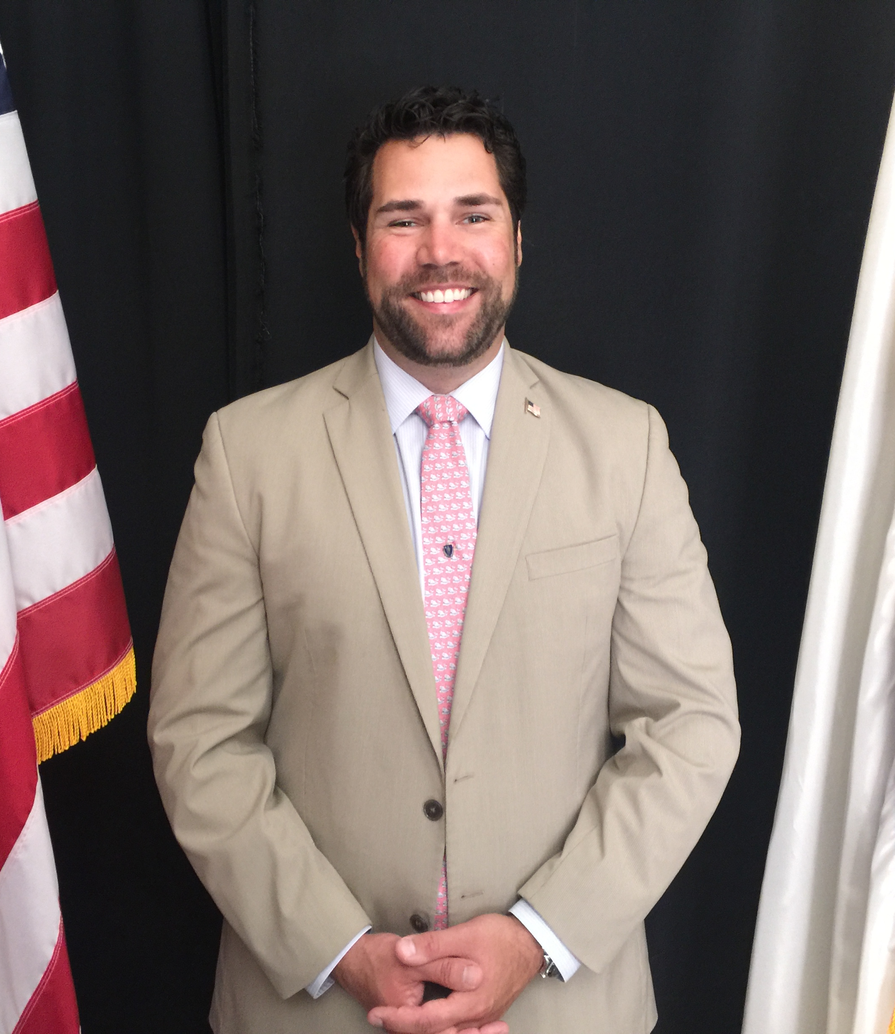
Nicolas John
He/His/Him

Nicolas has worked in Massachusetts State Government in various capacities over the last seven years. Most recently, he served as Chief of Staff to the Vice Chair of the House Committee on Ways and Means. He has been proud to serve as a member of the Massachusetts Commission on LGBTQ Youth since 2012. He uses his government background and knowledge of the state budget process to help advise and advance the Commission's legislative and budget priorities. He sought membership on this Commission as a way to put his knowledge and expertise to good use to advance the broad and diverse community to which he belongs. It has been an honor and a privilege for him to be part of such a passionate and dedicated group.

Harold Jones
He/Him/His

Harold is an attorney at the American Federation of Teachers Massachusetts. He graduated from the University of Pittsburgh and Northeastern University School of Law. Harold resides in Cambridge.

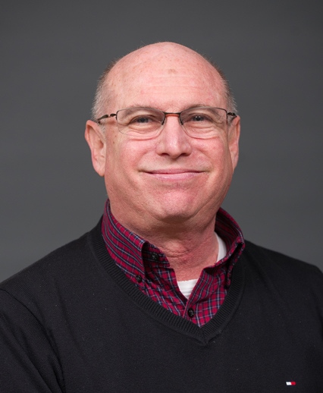
Stewart Landers
He/Him/His

Stewart Landers, JD, MCP, has been a senior consultant at John Snow, Inc. (JSI) since 1994. He current serves as Director, US Health Services, Boston Office for JSI. Mr. Landers consults on issues related to HIV/AIDS, lesbian, gay, bisexual, and transgender (LGBT) health, HIV/AIDS, health care reform, health promotion, and mental health/substance use disorder prevention and treatment. Throughout his career, Mr. Landers has been an activist for LGBT rights and health, and was co-convener of the 2004 National LGBTI Health Summit. In addition to his consulting duties, Mr. Landers serves as an associate editor of AJPH (the American Journal of Public Health) for LGBT Health, HIV/AIDS, community-based participatory research and evaluation studies. Mr. Landers received his BS and Master in City Planning from MIT in 1978 and his Juris Doctor from Harvard in 1982.

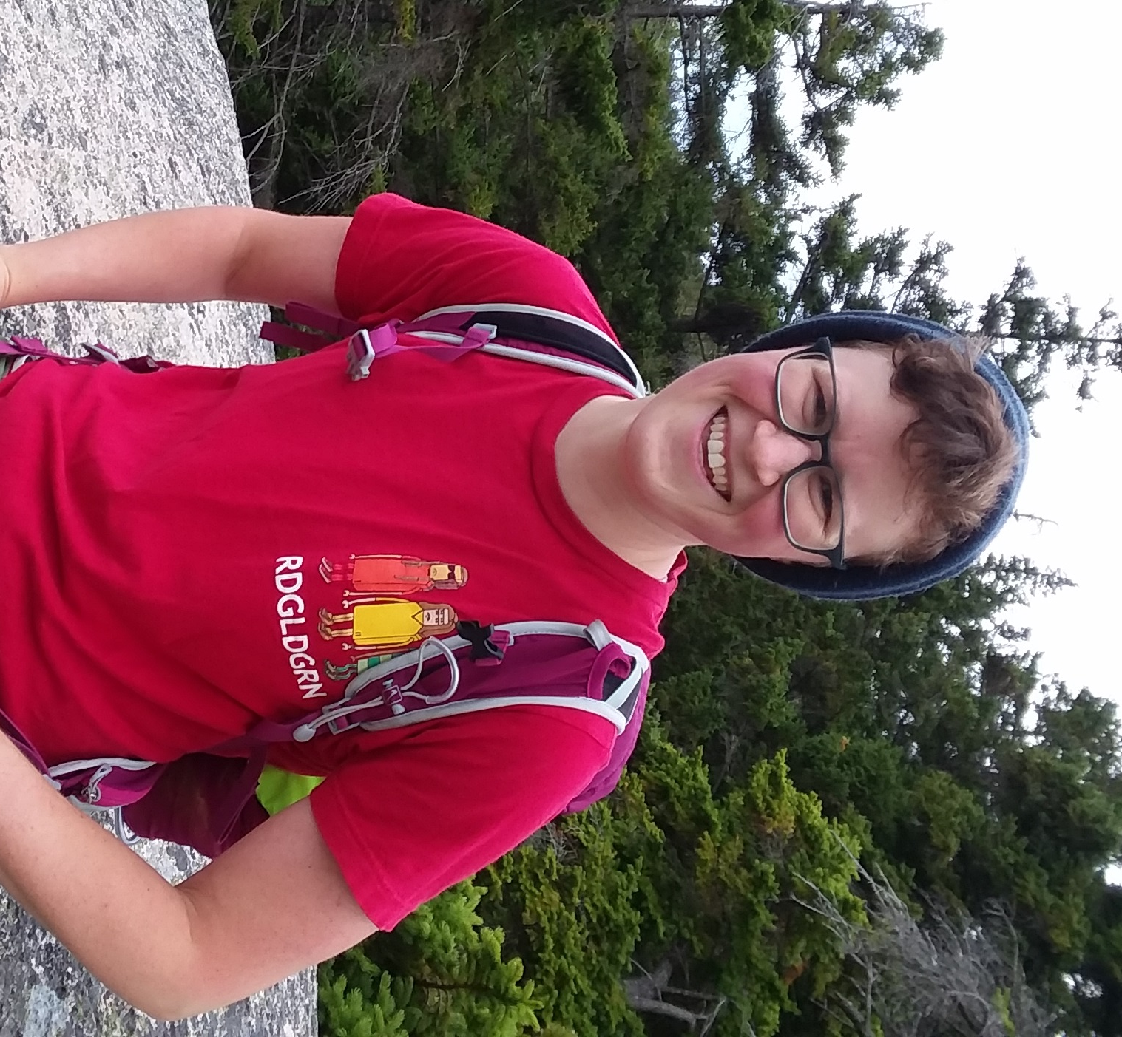
Katie Omberg
She/Her/Hers or They/Them/Theirs

Katie Omberg moved to Cambridge over four years ago to get a Masters in Divinity from Boston University, and is in the ordination process of the United Church of Christ, a progressive Christian denomination. A native of Washington, DC, Katie works as the Director of Community Engagement at City Mission, Boston, and serves as the Community Minister at First Church in Somerville, UCC. Outside of work, Katie is involved in the Boston chapter of Black & Pink, a national prison abolition "open family" of LGBTQ/HIV+ prisoners, formerly incarcerated people, and outside members. They enjoy watching Steven Universe, hanging out with their partner and their housemates, and baking.

Tyler Rainer
She/Her/Hers

Tyler graduated from Williams College in 2011 with a B.A. in Psychology. She went on to join Temple University School of Medicine where she led the Student's National Medical Association and LGBTQ student organizations. As a student leader, she participated in medical education curricular changes to design and facilitate lectures and small group sessions about health disparities and cultural humility. She recently began pediatric residency at the Boston Combined Residency Program where she works at both Boston Children's Hospital and Boston Medical Center. She is currently involved in the Diversity and Inclusion Committee, Health Equity Rounds, and Resident Wellness Committee. She currently lives in JP with her partner and their dog. In her spare time, she enjoys remaining creative through hobbies like photography and storytelling.

Susan S. Rees
She/Her/Hers

Susan S. Rees has spent her career working with teachers and school administrators to advance the rights and lives of children. She was the Executive Director of the ACCEPT Education Collaborative and currently serves as the Executive Director of the Massachusetts Urban Project, a leadership development organization committed to improving outcomes for students with disabilities. With over 30 years of experience in the field of education, Susan has served as a teacher, Director of Special Education, college instructor and educational consultant. She represents the Massachusetts Association of School Superintendents on the Commission and was the co-chair of the Commission’s Safe Schools Program from 2013 - 2017.

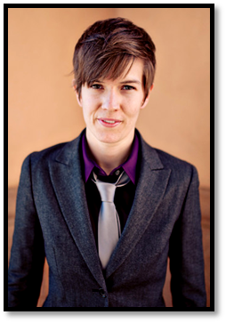
Erika Rickard, J.D.
She/Her/Hers

Erika Rickard has served on the Commission since 2011. She has served as the government relations chair, vice chair, and is currently an at-large commission member. Rickard also serves on the Massachusetts Access to Justice Commission, and is a lawyer and researcher at Harvard Law School. She lives in Jamaica Plain with her wife and two tiny children.

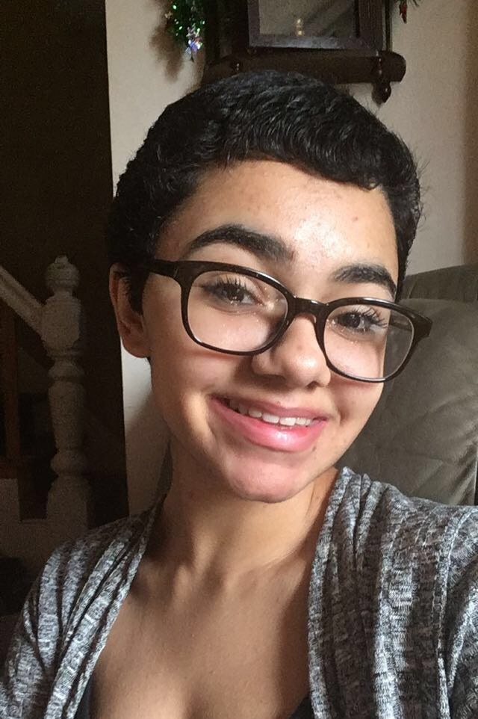
Kayla Shanks
She/They/He

Lala Shanks is a young queer girl of color that loves advocating for marginalized groups and creating art. She is a writer of poetry, short fiction and essays and aims to publish a novel one day. The topics she covers in her writing are those that are not often shed light on. Lala incorporates intersectionality into every decision she makes, and hopes to share this ideology with her community in aims of creating more accepting and accommodating spaces for LGBTQ youth and other minorities.

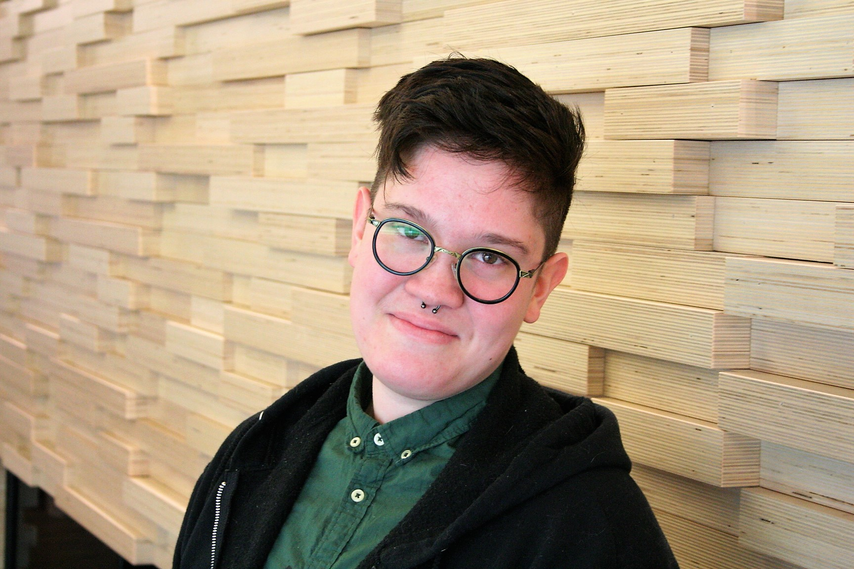
Spencer Shannon
They/Them/Theirs

A graduate of Emerson College, Spencer is a writer and user experience strategist. They spent several years working in Boston's nonprofit theatre scene, reporting on the intersections between theatre, art, and social justice on behalf of queer and trans artists of color for 90.9 WBUR. They have led panels and workshops at the Boston Asian American Film Festival, the 2016 IvyQ conference at Harvard University, and at Launch Academy's 2017 coding boot camp. They are a biracial person of Filipino descent, and a non-binary transmasculine person. Spencer is passionate about intersectional approaches to collective liberation, inclusive career support for emerging young LGBTQ professionals, and continued advocacy for people all along the gender spectrum in the conversation on equality.

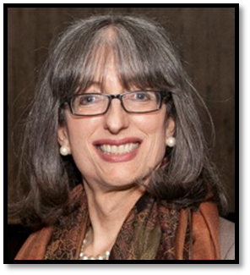
Grace Sterling Stowell
She/Her/Hers

Grace Sterling Stowell She/Her/Hers Grace has been a pioneering activist and leader in the social justice and lesbian, gay, bisexual, transgender (LGBT) youth communities for over 35 years. She is the founding executive director of the Boston Alliance of Gay, Lesbian, Bisexual, Transgender Youth (BAGLY), one of the oldest and largest LGBT youth organizations in the nation. She is a founding member of several local and national LGBT youth advocacy organizations, and she currently serves as an Executive Committee member of the Massachusetts Commission on LGBT Youth and Steering Committee member of the Massachusetts Transgender Political Coalition (MTPC). Grace is also a nationally known advocate and leader on the issues facing transgender youth and young adults. Grace received a B.A. in English from Curry College in Milton, MA and a M.A. in Counseling Psychology from Lesley University in Cambridge, where she resides. While Grace has served many roles in her community work over the past three decades, she is particularly honored to be known as “Mother” (and now “Grandmother!”) by three generations of greater Boston’s LGBT youth.

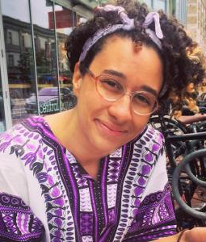
Brianna Suslovic
She/Her/Hers

Brianna is a second-year MSW student at Smith College School for Social Work and a recent graduate of Harvard College. She is passionate about reproductive justice, trauma and recovery, prison abolition, and racial justice. Her involvement with organizations like Sisters Unchained, Boston Abortion Support Collective, the Eastern Massachusetts Abortion Fund, and BLM Cambridge reflects her investment in intersectional justice for queer and trans people of all ages and identities.

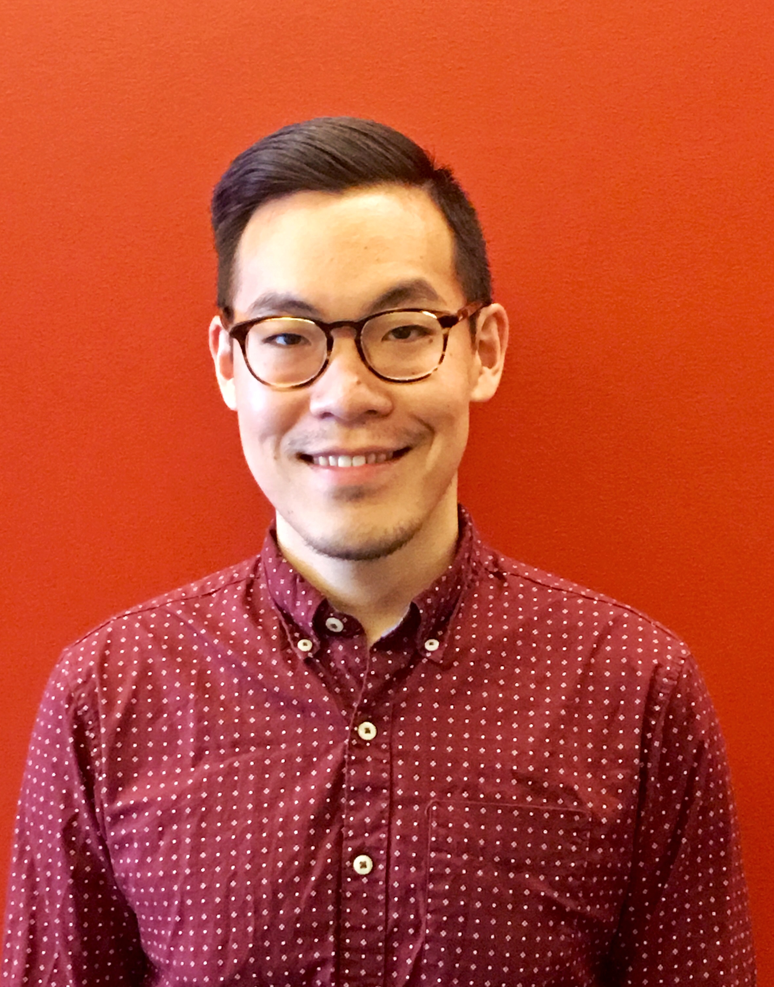
Tim Wang
He/Him/His

Tim Wang is a health policy analyst in the Department of Health Policy Research at the Fenway Institute. In this role, Tim works on a variety of projects involving LGBTQ health equity and HIV policy with the Centers for Medicare and Medicaid Services, Centers for Disease Control and Prevention, and other funders. Tim has previously created research analysis tools, educational resources, and advocacy materials regarding numerous state and federal level health policy issues affecting the health and well-being of LGBTQ people. Tim got his Master of Public Health degree from Brown University. His other interests include trying new foods and binge-watching Netflix series.
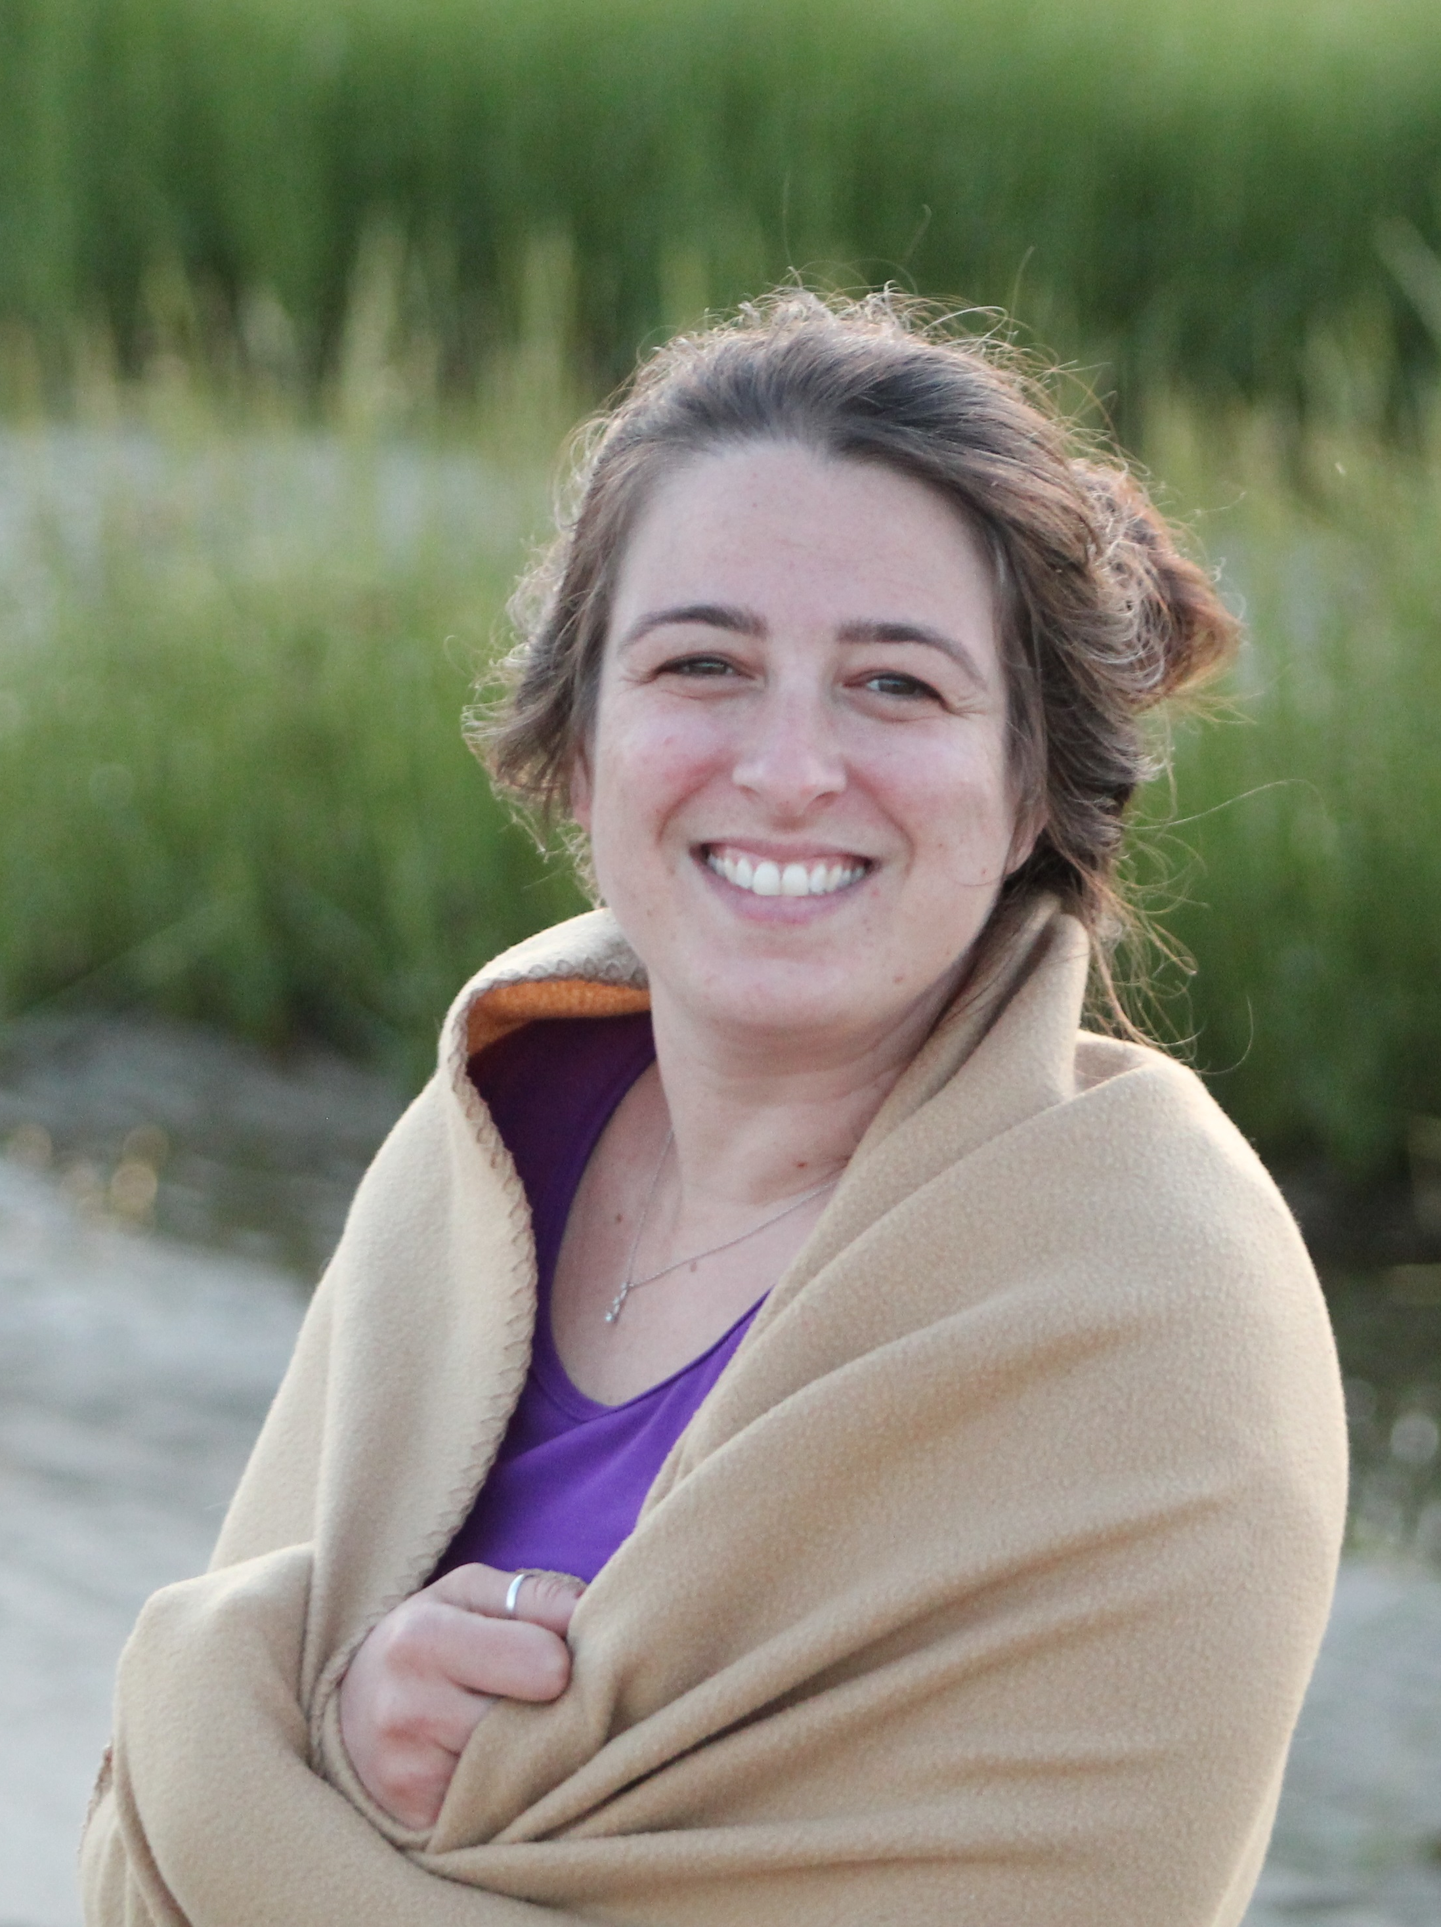
Ashley Waterberg
She/Her/Hers

Ashley works as a middle school social worker in the Revere Public School system where she has helped to implement a GSA in all three middle schools. She is one of three representatives of the National Association of Social Workers (NASW) on the Commission. During her spare time, she enjoys hiking, biking, dancing, snowshoeing, road trips and exploring new places. Ashley received her CAGS in Educational Administration at UMass Boston, her Master’s degree in Social Work at Washington University in St. Louis and her undergraduate degree in Human Development and Family Studies at the University of Vermont. She currently lives in the fabulous City of Salem with her partner.

Jeffry Wright
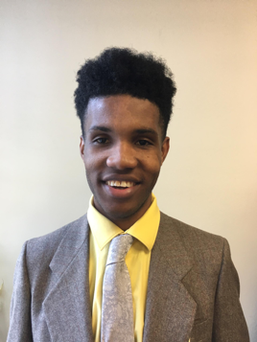
He/Him/His

Jeffry Wright is an asylum seeker from Jamaica. He taught at the primary/elementary school level at one of the most recognized primary schools in Montego Bay, Jamaica but had to give up on his job because being gay is illegal. He migrated to the US in 2015 and promised himself that he would work in a field where he could tackle issue surrounding Human Rights and Gay Rights. He became certified as a Community Health worker where he began working closely with the Worcester Health and Human Services Department and communities in the city of Worcester and alliance towns at large. In June of 2015 he was appointed by the Worcester Juvenile Court as a Special Advocate for children in the State of Massachusetts care and will soon be looking on finishing up some more studies to get into law school.

