Executive Office of Health and Human Services
Massachusetts Department of Public Health

Health Professions Data Series
Dental Hygienist 2013
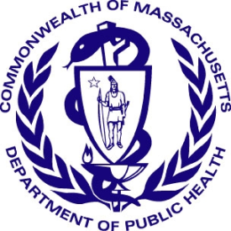

Deval L. Patrick, Governor
John W. Polanowicz, Secretary
Cheryl Bartlett, Commissioner

November 2014

Massachusetts Health Professions Data Series:
Dental Hygienist 2013
OVERVIEW
The Massachusetts Health Professions Data Series: Dental Hygienist 2013 Report provides data on the workforce demographics of Dental Hygienists licensed to practice in Massachusetts. This report is part of the Department of Public Health’s Health Professions Data Series, which currently reports on seven licensed health professions: dentists, dental hygienists, pharmacists, physicians, physician assistants, registered nurses, and licensed practical nurses.
The Massachusetts Health Professions Data Series: Dental Hygienist 2013 Report represents data from the second cycle of Massachusetts’ health professional workforce data collection. This data series was launched during the 2010 clinician license renewal cycle in coordination with the Division of Health Professions Licensure and its biennial clinician renewal cycle.
The data series responds to the need for quality and timely data on demographics and employment characteristics of the Commonwealth’s healthcare workforce. With a response rate of 91%, the 2013 report is a timely source of robust data.
Chapter 224 of the Acts of 2012: An Act Improving the Quality of Health Care and Reducing Costs Through Increased Transparency, Efficiency and Innovation continues and expands the work of the Health Care Workforce Center established initially in the Acts of 2008. The publication of this data series is a significant step toward fulfilling the mandates of Chapter 224. It complements and contributes to ongoing health care access and payment reform initiatives in the Commonwealth, and federal efforts including the National Center for Health Workforce Analysis Assessment.
The data series characterizes the workforce from a supply perspective. It enhances the Commonwealth’s ability to identify trends and patterns in the Commonwealth’s healthcare workforce that will impact access to health care professionals and the services they provide. The data is integral to current and future decisions about healthcare workforce development, education, training, recruitment, and retention. It will also help to ensure the availability of a highly qualified, diverse, and culturally and linguistically competent workforce to meet the current and future needs of all Massachusetts residents.
¹ Chapter 224 of the Acts of 2012: An Act Improving Quality of Health Care and Reducing Costs Through Increased Transparency, Efficiency and Innovation: http://malegislature.gov/Laws/SessionLaws/Acts/2012/Chapter224
¹ Chapter 224 of the Acts of 2012: An Act Improving Quality of Health Care and Reducing Costs Through Increased Transparency, Efficiency and Innovation: http://malegislature.gov/Laws/SessionLaws/Acts/2012/Chapter224

Background
During the 2013 license renewal cycle, dental hygienists were sent a renewal notice with the option to renew online or by mail. Dental hygienists who renewed their license online completed 25 workforce survey questions. The survey included questions related to demographics, education, and employment characteristics and future work plans. A total of 6,602 dental hygienists renewed their license, of those 6,020 (91%) dental hygienists completed the online survey, of which 4,337 (72%) reported Massachusetts as their primary practice setting.
The following data represents the responses of 6,020 Dental Hygienists who completed an online renewal between January 1, 2013 and June 30, 2013.
Demographics n=6,020
Gender:

Race:
White, Non-Hispanic (NH) | 86%
Asian, NH | 3%
Black, NH | 1%
American Indian / Alaska Native, NH | <1%
Native Hawaiian / Pacific Islander, NH | <1%
Hispanic/Latino/Spanish | 3%
Multiracial | <1%
Decline to Answer | 6%

Patient Language Barriers and Access to Care:
Oral health is an integral component to overall health and well-being. Preventive dental care and good oral hygiene are the foundation of positive oral health outcomes.
Research indicates that patients who experience language barriers when receiving health care are at increased risk for adverse health outcomes.
Patients who receive health services from providers who do not speak the patients’ primary language:
² Language fluency defined as ability to communicate with and provide adequate care to patients without the use of a translator (n=6,020).
³ Source: US Census Bureau, 2008-2012 American Community Survey. These are the 4 most common non-English languages spoken at home in Massachusetts
- Are less likely to access primary care
- Are less likely to access preventive care
- Have decreased patient compliance

Education n=6,020
Loan repayment program: Loan repayment programs (LRP) partially repay school loans for certain health professionals in return for working for an organization that serves disadvantaged patients or is located in an underserved community. 65% of respondents reported that they would have participated had they been aware of such programs.
⁴ Percentages do not add up to 100% due to respondents’ ability to report more than one academic degree completed

Future Plans n=6,020
Plans Regarding Dental Hygiene Practice within the Next Five Years⁵
No Change in Work Status | 47% |  | Leave of Absence | <1%
Increase Hours | 18% |  | Change Careers | 1%
Reduce Hours | 10% |  | Plan to Retire | 3%
Seek Additional Education | 9% |  | Other | 2%
⁵ Percentages do not add up to 100%. 8% of dental hygienists chose not to respond to this question.
⁶ Percentages do not add up to 100%. The remaining 6% declined to answer.

Employment Characteristics
Figure 5. Dental Hygienist Employment Status
4,337 - Primary Employment in MA
6,020 Total Respondents
799 Employed in Other US State

884 Not Currently Practicing Dental Hygiene, Unemployed, or Did Not Report an Employment Location
Full-time: 48%
Part-time: 50%
Per Diem: 2%

The following data represent responses from the 4337 Dental Hygienists who reported working full-time, part-time, or per diem in dental hygiene in Massachusetts.
Practice Setting: Respondents were asked to identify their primary practice setting. Figure 6 shows the most commonly reported primary practice settings. Work settings that received less than 1% of the responses are not included in the figure. These settings include: Correctional Facilities, Government, Hospital, Long-term Care Facilities, Military/VA, Mobile Dental Program, Pharmaceutical/Dental Sales, or Schools.
70% of the 4,337 dental hygienists working in Massachusetts reported having 1 location of practice, 23% reported 2 locations, and 6% reported 3 or more.

Clinician | 92.9%
Educator | 3.6%
Public Health | 1.3%
Administrator/Manager | 0.8%
Practice Role: Respondents were asked to identify the role which best described their primary dental hygiene position. The adjacent table displays the 4 most common practice roles reported. All other answer choices received less than 0.5% of responses. These include: Advocate, Researcher, and Sales. The distribution of practice roles did not vary significantly by age group.
25% of Dental Hygienists reported volunteering in some capacity in 2012.
Dental Public Health n=4,337
- Only 27% of dental hygienists practicing in Massachusetts reported that their primary practice accepts MassHealth.
- 10.4% reported that their primary practice offers patients a sliding fee scale.
- 97% reported that their primary practice is accepting new patients.
Public Health Dental Hygienists: A public health dental hygienist (PHDH) is a practicing registered dental hygienist who enters into a collaborative agreement with a licensed dentist and may perform dental hygiene procedures in a public health setting without the supervision or direction of a dentist.
- 45 Dental Hygienists reported currently practicing as a PHDH.
- Of the remaining 4,292 dental hygienists that are not practicing as a PHDH:
  - 22% reported that they were somewhat likely to pursue PHDH training in the next 5 years. 7% reported they were very likely.
  - 20% reported that they were somewhat likely to practice as a PHDH in the next 5 years. 4% reported they are very likely.

Geographic Distribution n=4,337
Figure 7. Dental Hygienist Primary Practice Distribution by County
<1%
1 – 5%
6 – 10%
11 – 15%
16 – 25%
Percent of All Primary Practices Located in County
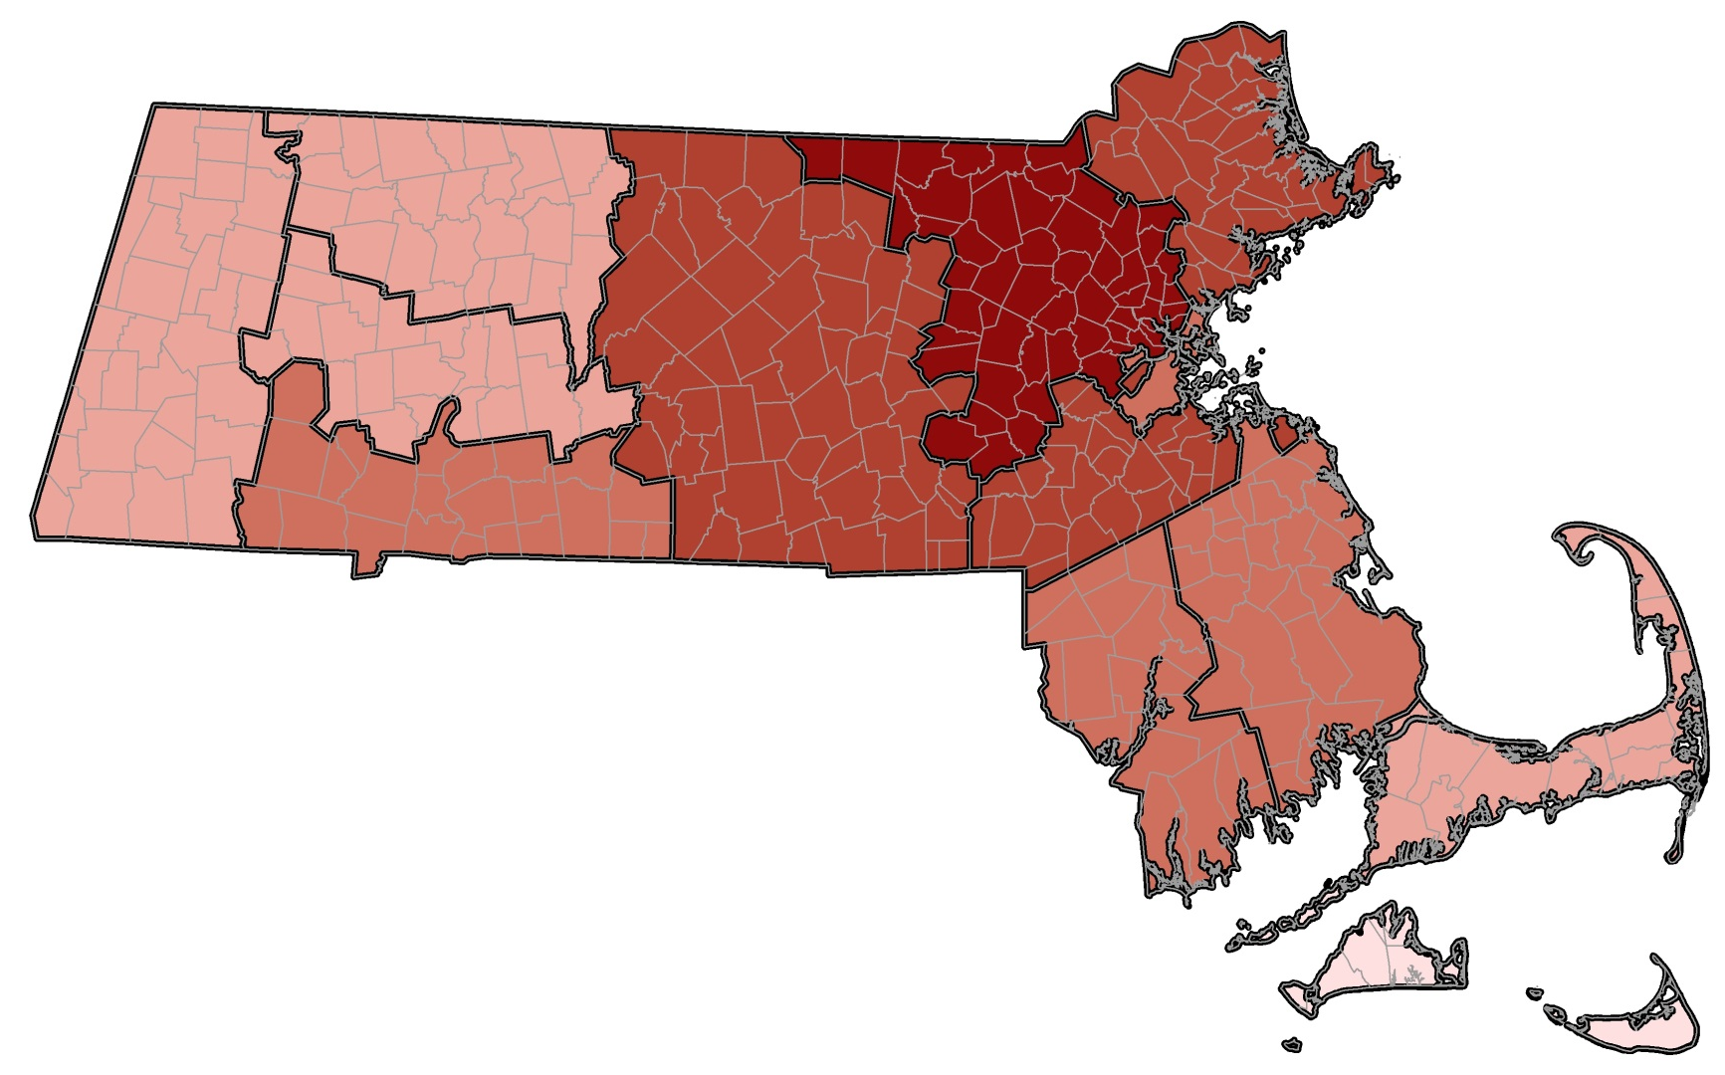
Berkshire
2.1%
Hampshire
2.6%
Essex
12.1%
Suffolk
8.1%
Norfolk
13.0%

Hampden
6.2%
Franklin
.9%
Worcester
12.4%
Middlesex
23.6%
Plymouth6.5%
Bristol
7.5%

Barnstable
4.6%
Dukes
0.3%

Nantucket
0.2%

This report was developed by the
Massachusetts Department of Public Health

Bureau of Community Health and Prevention
Health Care Workforce Center

Bureau of Health Care Safety and Quality
Division Health Professions Licensure
Board of Registration in Dentistry

For additional information about the Health Professions
Data Series or this Dental Hygienist Report
Please contact the
Massachusetts Health Care Workforce Center
at the
Massachusetts Department of Public Health

Website: mass.gov/dph/hcworkforcecenter
Email: HCWorkforceCenter@state.ma.us

