Data Brief:
Health Professions Data Series –
Dentist 2014
Massachusetts Department of Public Health December 2016
The Massachusetts Health Professions Data Series: Dentist 2014 Report provides data on workforce characteristics of dentists licensed to practice in Massachusetts. This report is part of the Department of Public Health’s Health Professions Data Series, which currently reports on seven licensed health professions: dentists, dental hygienists, pharmacists, physicians, physician assistants, registered nurses, and licensed practical nurses.
The Massachusetts Health Professions Data Series: Dentist 2014 Report represents data from the third cycle of the health professional workforce data collection. This initiative was launched during the 2010 licensure renewal cycle in coordination with the Division of Health Professions Licensure.
BACKGROUND
The dentist data in the Health Professions Data Series is derived from an online workforce survey that accompanies the online license renewal application for dentists licensed in Massachusetts (MA). Dentists renew their license every two years on even numbered years. The data presented in this report is derived from the 2014 renewal cycle.
Dentists who were administered a 2014 dentist workforce survey:
- Dentists who renewed their license during the 2014 renewal cycle and completed their license renewal application online through the MA Department of Public Health Online Licensing System.
Dentists that were not administered a 2014 dentist workforce survey:
- Dentists who renewed their license using a paper license renewal application form instead of the online licensing system.
- Dentists who received their initial MA license after January 1, 2014. These dentists were not required to renew their license during the 2014 renewal cycle.
During the 2014 renewal cycle, a total of 6,488 dentists renewed their license. Of those, 5,998 Dentists completed the 2014 dentist workforce survey (92% of renewals) from January 1, 2014 through June 30, 2014. The response rates for dentists completing the workforce survey are consistent across all age groups except for dentists under the age of 35. This group is underrepresented because dentists who received their first MA license after January 1, 2014 are not required to renew their license until the next renewal cycle.
The 2014 Dentist workforce survey is administered as part of the online license renewal process. The survey consists of 34 questions divided into 4 sections: demographics, education, employment and practice characteristics, and future plans.
DEMOGRAPHICS
Figure 1 and Table 1 display the breakdown of dentists by sex and race/ethnicity, respectively. Dentists in MA are predominately white (non-Hispanic) and male, with approximately 49% identifying as both. This is similar to the breakdown of dentists in the United States as a whole, which is 77.3% male and 76.5% white, non-Hispanic.
Table 1. 2014 MA Dentists by Race and Hispanic/Latino Origin
Female
Male

Race/Ethnicity | Dentists  n=5,389* | MA  Population²
White, non-Hispanic (NH) | 74.0% | 75.0%
Asian, NH | 19.5% | 5.7%
Black, NH | 1.7% | 6.4%
American Indian/Alaska Native, NH | <1% | 0.1%
Native Hawaiian/Pacific Islander, NH | <1% | <0.1%
Hispanic/Latino | 3.8% | 10.2%
Multiracial | <1% | 0.6%
Other | 0% | 1.9%
Overall Diversity Index³ | 41.2 | 41.9
Table 1 shows the breakdown of dentists and MA residents by race and Hispanic/Latino origin compared. The table indicates that several racial and ethnic groups are underrepresented in the dental workforce, including those of Hispanic/Latino origin and Black, non-Hispanics. Asian, non-Hispanics are overrepresented in the workforce.
Diversity index is a measure of racial and ethnic diversity within a population on a scale of 0 to 100, with a higher value indicating higher racial and ethnic diversity within a group. The Dentist population in MA has a diversity index of 41.2, compared to the MA resident population diversity index of 41.9.
* 10.2% of survey respondents declined to answer
Table 2. 2014 MA Dentist Language Fluency⁴ and Language Spoken at Home by MA Residents
Language | Dentists | MA Population²
Arabic | 3.6% | 0.5%
Chinese* | 4.3% | 1.8%
French* | 5.1% | 1.0%
Korean | 2.9% | 0.3%
Portuguese* | 1.3% | 2.9%
Russian | 2.5% | 0.6%
Spanish* | 8.1% | 8.3%
Vietnamese  * These are the four most common non-English languages spoken at home in Massachusetts | 1.5% | 0.6%
Table 2 displays the language fluency of dentists compared to residents in MA that speak those languages at home².
- Over 500,000 residents of MA speak Spanish at home (8.3%), which is similar to the percentage of Dentists that are fluent in Spanish (8.1%).
- The majority of dentists are not fluent in a language other than English (61.7%).
- Approximately 5% of dentists reported being fluent in multiple languages other than English.

Figure 2 displays the age distribution of dentists that completed the workforce survey. Dentists under the age of 35 are underrepresented in this sample because those that received their initial license after January 1, 2014 were not required to renew their license during the 2014 renewal cycle and were not administered a workforce survey.

EDUCATION
Location of Dental Training
There are three schools of dental medicine in MA: Boston University, Harvard, and Tufts University. The majority of dentists licensed in the state reported completing their DMD/DDS degree in MA (Figure 3).
American Dental Association Specialties
Approximately 32% of Dentists in MA reported having an American Dental Association (ADA) specialty for which they are board certified or eligible. Figure 4 displays the percentage of all dentists with each ADA specialty.
- Orthodontics is the most prevalent specialty among MA dentists (22.1% of all dentists who reported having an ADA specialty).
- Of the dentists with an ADA specialty, the majority reported that their practice is limited to their specialty (80.9%).
Loan repayment program
Loan repayment programs (LRP) partially repay school loans for certain professionals in return for working for an organization that serves disadvantaged patients or is located in an underserved community. Of the respondents, 12% reported that they participated in a Federal LRP and 4% in a State program.
EMPLOYMENT CHARACTERISTICS
Figure 5 displays a breakdown of the Dentists that completed the workforce survey by employment status.
Figure 5. 2014 MA Dentists by Employment Status
5,998
Total Survey Respondents
951
Primary Practice Location Outside of MA

543
Not Currently Practicing Dentistry
(unemployed, retired, or employed in non-dental field)
Full-time: 84.7%
Part-time: 15.6%
Per diem: <1%
Volunteer: <1%

5,455
Currently Practicing Dentistry
4,504
Primary Practice Location in MA

The following data represents responses from the 4,504 Dentists who reported working full-time, part-time, per diem, or volunteering in dentistry in Massachusetts.

Primary Practice Setting
The majority of dentists reported having only one practice location in MA (68.5%), while 22.0% reported having two locations and 9.5% have more than two.
Figure 6 displays the breakdown of primary practice settings of dentists practicing in MA.
- The large majority of Dentists reported that their primary practice setting is either solo or group practice.
- Practice settings in the “Other” category include: correctional health facilities, long-term care facilities, military/VA, and mobile dental facilities.
- Fewer than 15% of dentists reported that their primary practice offers patients a sliding fee scale.
Scope of Practice: General Dentistry and Specialty Care
Figure 7 displays the breakdown of the scope of practice of primary practice settings reported by dentists practicing in MA.
- The large majority of dentists reported general dentistry as their scope of practice.
- Scope of practice did not vary by age of dentist. The percentage of dentists that reported general dentistry as their scope of practice was roughly equal amongst dentists under the age of 45 and those 45 and older.
Time Allocation - Job Activities
Dentists were asked to estimate the percentage of time per week spent on the following job activities during an average work week: direct patient care, administrative duties, lab work, and teaching.
- Direct Patient Care
  - The majority of dentists reported spending most of their time performing direct patient care during an average work week. Approximately 70% of dentists reported spending more than 75% of their time on direct patient care (Figure 8).
  - The percentage of time dentists spend on direct patient care varied by primary practice setting. Only 19% of dentists working in dental schools and 27% of dentists working in hospitals reported spending more than 75% of their time on direct patient care.
- Administrative Duties
  - Approximately 72% of dentists reporting spending between 1-25% of their time peforming administrative duties and 18% reported performing no administrative duties.
- Lab Work
  - The majority of dentists reported spending between 1-25% of their time on lab work (54%).
  - Approximately 44% of dentists reported doing no lab work during an average work week.
- Teaching
  - Fewer than 24% of dentists reported spending any time teaching during the average work week.

STAFFING IN PRIMARY PRACTICE SETTING
Figure 9 displays the percentage of dentist primary practice settings that employ or contract for various staff positions.
- Nearly 80% of dentists reported that their primary practice setting employs either a dental assistant or dental hygienist.

MASSHEALTH (MEDICAID) PROVIDERS
According to the Centers for Medicare & Medicaid Services (CMS), there were 668,111 individuals under the age of 21 who were enrolled in MassHealth for at least 90 continuous days in the 2015 federal fiscal year. Of those, only 368,272 (55.1%) received any dental or oral health services indicating that there are nearly 300,000 individuals under the age of 21 in MA that did not receive any oral health care during this time period.
Non-MassHealth Providers

Despite the large number of MassHealth patients requiring care, the proportion of dental providers that accept MassHealth insurance remains low. Figure 10 displays the percentage of dentists practicing in MA that reported treating patients with MassHealth insurance in 2014. Fewer than half reported treating patients with MassHealth (44.8%), compared to 41.7% of dentists from the 2012 renewal cycle.
MassHealth Providers

Although there was a slight increase in the percentage of dentists that are MassHealth providers, MassHealth patients continue to make up a small percentage of the patient population for a majority of MassHealth dentists.
- Approximately 4 in 10 MassHealth dentists reported that patients with MassHealth insurance make up 10% or less of their total patient population (39.0%).
- Only 27.5% of MassHealth dentists reported that patients on MassHealth insurance make up more than half of their patient population. This represents only 12.3% of all dentists practicing in MA.

Of the dentists that did not report treating patients with MassHealth, 83.3% reported no interest in becoming a MassHealth provider.

MassHealth Providers by Age
Figure 11 displays the percentage of dentists practicing in MA that have patients with MassHealth insurance broken down by age group.
- Dentists under the age of 45 are more likely to treat patients with MassHealth compared to dentists that are 45 years or older (58.0% dentists under 45 compared to 38.3% of dentists 45 or older).

MassHealth Providers by Primary Practice Setting
The distribution of MassHealth providers also differs by primary practice setting.
- 97.5% of dentists working in community health centers, 88.6% of dentists working in hospitals, and 64.0% of dentists working in dental schools reported treating patients with MassHealth insurance.
- Only 44.3% of dentists working in group practice and 39.4% of dentists working in solo practice reported treating patients with MassHealth insurance.

PATIENTS WITH SPECIAL NEEDS AND DISABILITIES
Dentists were asked what trainings they would be interested in attending regarding treating patients with disabilities (results in figure 12).
- Approximately 64% of dentists reported that they would be interested in attending some training regarding patients with disabilities.
- Interest in disability trainings varied by age. Approximately 76% of dentists under the age of 45 reported interest in trainings compared to 58% of dentists 45 years and older.
Dentists were asked to estimate the percent of their patient population that have special needs.
- 3.8% reported having no patients with special needs.
- 38.0% reported less than 1% of their patients have special needs.
- 47.6% reported 1-5% of their patients have special needs.
- 10.7% reported 6% or more of their patients have special needs.
PUBLIC HEALTH DENTAL HYGIENISTS
A public health dental hygienist (PHDH) is a practicing registered dental hygienist who enters into a collaborative agreement with a licensed dentist and may perform dental hygiene procedures in a public health setting without supervision or direction of a dentist.
- Less than 1% of dentists practicing in MA reported having a PHDH agreement (0.5%).
- Less than 1% of dentists practicing in MA had a PHDH agreement in the past but not currently (0.5%).
- Of the dentists that do not currently have a PHDH agreement, 8% expressed they would be willing to enter into an agreement and 25% expressed they may be willing.

AGE OF FIRST DENTAL EXAM
The American Dental Association recommends that children have their first dental exam no later than 12 months of age. Dentists were asked at what age they routinely see children for their first dental exam (results in figure 13).
- Less than 8% of dentists that treat children in MA reported that they routinely see children for their first dental exam before age 1.
- Of the dentists that reported pedodontics as their scope of practice, 92% routinely see children for their first exam before the age of 2.
  - 25% reported they routinely see children for their first dental exam before age 1.
  - 67% reported they routinely see children for their first dental exam between 12-23 months of age.

FUTURE PLANS
Dentists were asked to report on their plans regarding their dentist practice within the next 5 years (results in Figure 14).
- Of the dentists that are under the age of 45, 20% were looking to increase their hours of practice.
- Of the dentists that are 65 and over and currently practicing, 31% reported that they were planning on retiring in the next five years.
GEOGRAPHIC DISTRIBUTION
Figure 15 displays a map of the Dentist to population ratios at the city/town level. Communities with a higher provider to population ratio are depicted in darker shades of blue, while communities with a lower provider to population ratio are in light blue. Communities where no dentists reported a primary practice location are depicted in white with red stripes.
Figure 15. 2014 Number of Dentists per 1,000 Population at City/Town Level
n=4,503
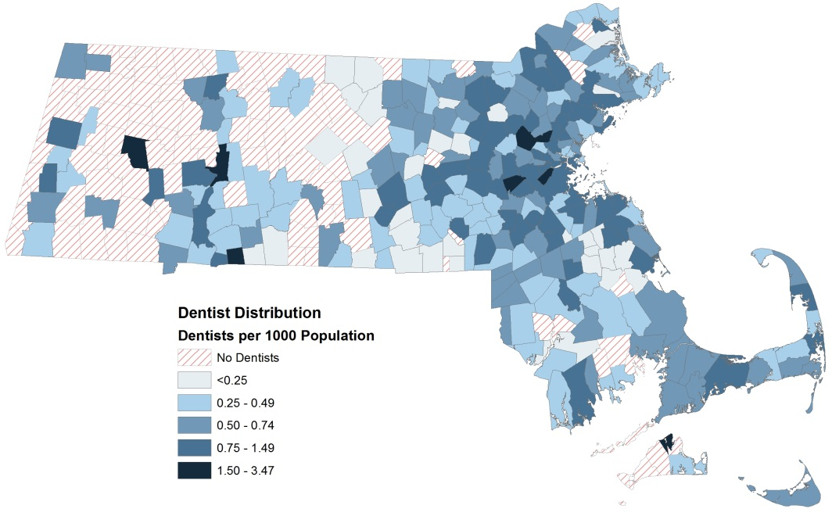

Figure 16 shows a hot spot analysis of dentist to population ratios at the city/town level. The analysis identifies significant clusters of communities with high dentist to population ratios (depicted in red) and low ratios (depicted in blue). Clusters of communities with higher provider density are predominately located in the Boston, Metro West, and Northeast regions of the state, while clusters with lower dentist density are located in the Western and Central regions.
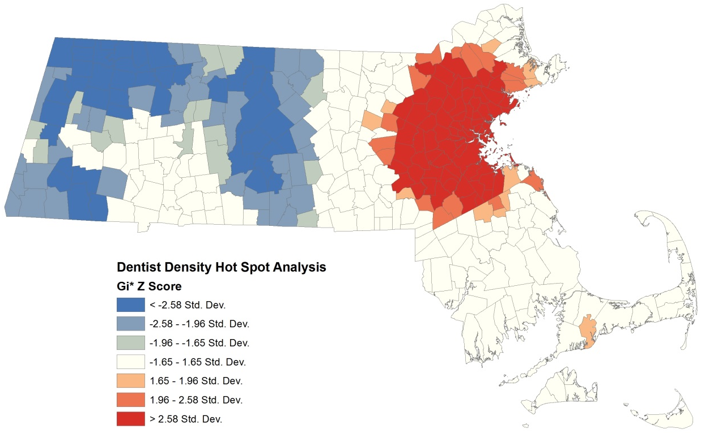
Cluster of Communities with Lower Dentist to Population Ratios
Cluster of Communities with Higher Dentist to Population Ratios
Figure 16. 2014 Clusters of Communities with High and Low Dentist to Population Ratios
n=4,503

This report was developed by the
Massachusetts Department of Public Health

Bureau of Community Health and Prevention
Division of Health Access
Health Care Workforce Center

Bureau of Health Professions Licensure
Board of Registration in Dentistry

For additional information about the Health Professions Data Series or this Dentist Report, please contact:

Massachusetts Health Care Workforce Center
at the
Massachusetts Department of Public Health

Website: mass.gov/dph/hcworkforcecenter
Email: HCWorkforceCenter@state.ma.us

Source: U.S. Census Bureau, 2006-2010 American Community Survey
Source: U.S. Census Bureau, 2010-2014 American Community Survey
Diversity index is the likelihood that two persons chosen at random will differ by race/ethnicity. This is calculated by taking the sum of the squares of the percentages for each race/ethnicity category and then subtracting the total value from 100.
Language fluency is defined as the ability to communicate with and provide adequate care to patients without a translator. Respondents can choose more than one language. Languages that received less than 1% of responses were excluded from Table 2. These languages include: Albanian, ASL, Cape Verdean, Haitian Creole, Khmer, and Somali.
Percentages do not add up to 100%. Respondents were able to report more than one ADA specialty.
Percentages do not add up to 100%. Respondents are able to report more than one employment status.
For dentists with multiple practice settings, the primary practice setting is defined as the setting where the dentist works the most hours per month on average.
Data is derived from the 2015 Form CMS-416. Individuals receiving dental or oral health service include those that received a dental service by or under the supervision of a dentist or received an oral health service by a qualified health care practitioner. The 2015 federal fiscal year is from October 1, 2014 through September 30, 2015.
Percentages do not add up to 100%. Dentists were able to choose more than one response option.
Special needs populations was defined as “patients who have mental, physical, or developmental disabilities, sensory or behavior disorders, et cetera”
American Dental Association Statement on Early Childhood Caries: http://www.ada.org/en/about-the-ada/ada-positions-policies-and-statements/statement-on-early-childhood-caries
Only includes dentists that reported treating children. Dentists that reported not treating children or did not provide an answer were excluded.
Reported dentist primary practice locations are used to calculate provider to population ratios for each city/town. The calculations do not take into account secondary practice locations.
Hot spot analysis (Getis-Ord GI*) was conducted in ArcGIS 9.3.1, using a zone of indifference method.

