Data Brief:
Health Professions Data Series –
Licensed Practical Nurse 2015
Massachusetts Department of Public Health June 2018
The Massachusetts Health Professions Data Series: Licensed Practical Nurse 2015 Report provides data on workforce characteristics of licensed practical nurses licensed to practice in Massachusetts. This report is part of the Department of Public Health’s Health Professions Data Series, which currently reports on seven licensed health professions: dentists, dental hygienists, pharmacists, physicians, physician assistants, registered nurses, and licensed practical nurses.
The Massachusetts Health Professions Data Series: Licensed Practical Nurse 2015 Report represents data from the third cycle of the health professional workforce data collection. This initiative was launched by the Bureau of Community Health and Prevention’s Health Care Workforce Center during the 2011 licensure renewal cycle in coordination with the Bureau of Health Professions Licensure.
BACKGROUND
The licensed practical nurse (LPN) data in the Health Professions Data Series is derived from an online workforce survey that accompanies the online license renewal application for LPNs licensed in Massachusetts (MA). LPNs in MA are due to renew their license every two years, during odd numbered years on their birthday. The data presented in this report represents the 2015 renewal cycle.
LPNs who were administered a 2015 LPN workforce survey:
- LPNs who were due to renew their license during the 2015 cycle and completed their license renewal application online through the MA Department of Public Health Online Licensing System.

LPNs that were not administered a 2015 LPN workforce survey:
- LPNs who submitted a paper license renewal application either in person or through the mail.
- LPNs who received their first MA LPN license during the 2015 cycle and have a birthday within three months of the license issue date were exempt from renewing their license during this cycle.

The 2015 LPN workforce survey is administered during the online license renewal process. The survey consists of 30 questions divided into 4 sections:
- Demographics
- Education
- Employment Characteristics
- Future plans

NURSES SURVEYED
As of March 31, 2016, there were a total of 21,074 LPNs with an active MA license. During the 2015 renewal cycle, a total of 17,440 LPNs completed the 2015 LPN workforce survey. This represents all LPNs who renewed their LPN license online and completed a workforce survey from October 2014 through March 2016.
Figure 1 displays a breakdown of which LPNs were administered a workforce survey out of all LPNs with an active MA License during the 2015 renewal cycle.
21,074
LPNs with Active MA License¹

19,912
Renewed License During 2015 Cycle
1,162
Exempt from Renewing License During 2015 Cycle²
(LPNs Not Surveyed)

2,472
Did Not Renew License Online
(LPNs Not Surveyed)

17,440
Renewed License Online
(LPNs Surveyed)

Figure 1. Total LPNs with Active MA License and LPNs Surveyed During the 2015 Renewal Cycle
- Out of the 21,074 LPNs with an active MA license, 19,912 renewed their license and approximately 1,162 nurses were exempt from renewing during this cycle.
- Out of the 19,912 LPNs that renewed their license, 17,440 LPNs renewed online and were administered a workforce survey.
  - This represents 87.5% of renewals and 82.8% of all LPNs with an active MA license.
  - The remaining 2,472 LPNs completed their license renewal using a paper application and were not administered a workforce survey.
Survey Response Rate by Age Group
The overall response rate, the percentage of all LPNs completing the 2015 workforce survey, was 82.8%. This rate varied by age group.
- LPNs under 30 have a slightly lower survey response rate compared to the overall rate. This age group comprises of several recent graduates from LPN programs in 2015 that were exempt from renewing their license that renewal year.
- LPNs 65 years and older also have a lower response rate relative to the overall rate. A higher percentage of LPNs in this age category opted to complete their license renewal using a paper application.
DEMOGRAPHICS
Figure 3 shows the breakdown of LPNs by sex. The majority of LPNs in MA are female, with only 10.4% reporting as male.
- The MA registered nurse (RN) workforce is also predominately female (93.2%).
- The percentage of male LPNs licensed in MA is higher than the national percentage of 7.6%.

Table 1. 2014 MA LPNs by Race and Hispanic/Latino Origin
n=17,440
Race and Hispanic/Latino Origin | LPNs | MA  Population ⁷
White, non-Hispanic (NH) | 69.6% | 62.8%
Black, NH | 18.8% | 12.2%
Asian, NH | 1.4% | 4.9%
American Indian/Alaska Native, NH | <1% | 0.7%
Native Hawaiian/Pacific Islander, NH | <1% | 0.2%
Hispanic/Latino | 3.7% | 16.9%
Multiracial | 1.1% | 2.1%
Other | 1.0% | 0.2%
Decline to Answer | 4.1% | -
Overall Diversity Index ⁸ | 43.3 | 44.1
Table 1 displays a comparison between LPNs and the MA population as a whole by race and Hispanic/Latino origin. Certain minority groups are underrepresented in the LPN workforce compared to the MA population, including those of Hispanic/Latino origin and Asian, non-Hispanics (NH). Black, NH LPNs are overrepresented.
Diversity index is a measure of racial and ethnic diversity within a population on a scale of 0 to 100, with a higher value indicating higher racial and ethnic diversity within a group. The LPN workforce is one of the more diverse health care workforces in MA. The diversity index of LPNs is very similar to that of the MA population as a whole and higher than that of RNs, who have a diversity index of only 18. Nearly 85% of RNs reported being White, non-Hispanic, compared to 70% of LPNs ⁴.
Despite a relatively high diversity index, there are relatively few MA LPNs of Hispanic/Latino origin. This is especially true in urban centers. Figure 4 takes a closer look at the percentage of practicing LPNs and residents that identify as Hispanic/Latino in the five most populated cities in Massachusetts. All five cities have a higher percentage of residents that are Hispanic/Latino compared to practicing LPNs.
Language | MA Population | LPNs
Spanish | 8.3% | 5.0%
Portuguese | 2.9% | 2.6%
Chinese | 1.8% | <1%
French | 1.1% | 5.4%
Vietnamese | 0.6% | <1%
Only Speak English | 77.8% | 78.1%
Table 2 displays the languages most commonly spoken at home by MA residents compared to the percentage of LPNs that are fluent in those languages.
Table 2. Most Common Languages Spoken at Home by MA Residents ⁹ and MA LPN Language Fluency ¹⁰
- The most frequently reported languages in which LPNs are fluent were: French (5.4%), Haitian Creole (5.3%), and Spanish (5.0%).
- Approximately 5% of LPNs reported fluency in multiple languages other than English.

Figure 5 displays the age distribution of all LPNs with an active MA license by age group. The LPN workforce in MA is older than the national LPN workforce overall; the average age of MA LPNs is 48.3 years, compared to 43.6 nationally.

EDUCATION
Non-Nursing Education
Figure 6 displays the level of non-nursing education completed by MA LPNs. Nearly 28% of LPNs have an associate degree or higher in a non-nursing field.
LPN Education
The large majority of LPNs in MA qualified for their first U.S. practical/vocational nursing license through the completion of a diploma or certificate LPN program (95.4%), compared to 4.6% of LPNs that completed an associate degree program. Nearly 86% of LPNs practicing in MA completed their initial LPN education within the state.
Figure 7 displays the breakdown of LPNs with health care education certificates.
- More LPNs reported having a health care education certificate during the 2015 cycle compared to 2013 (29% compared to 27%).
- Approximately 7% of LPNs reported having more than one certificate.
RN Education
LPNs were asked if they are currently enrolled or were taking steps to enroll in an RN education program (results in Figure 8).
- Of the LPNs that completed the workforce survey, 30.9% reported either being currently enrolled or making plans to enroll in an RN education program.
Figure 9 takes a closer look at the LPNs that reported currently being enrolled in an RN Education Program. The figure displays a breakdown of the types of programs that LPNs are currently enrolled in.
- The majority of LPNs in RN programs reported being enrolled in an Associate Degree program.

Mental Health and Disability Training
LPNs were asked what trainings they would be interested in to help them better care for patients with disabilities (results in Figure 10).
- Nearly 69% of LPNs expressed interest in attending some training regarding patients with disabilities.
- LPNs in younger age groups reported interest more frequently than LPNs in older age groups. Over 75% of LPNs under the age of 45 expressed interest in training, compared to 59% of LPNs 45 and older.

EMPLOYMENT CHARACTERISTICS
17,440
Total LPNs Completing Workforce Survey

14,953
LPNs Currently Practicing Nursing

2,487
LPNs Not Currently Practicing

784
Primary Practice Location Outside of MA

13,375
Primary Practice Location in MA
Full-time: 74%
Part-Time: 17%
Per Diem: 9%
Volunteer: <1%

Figure 11. 2015 MA LPNs by Employment Status ¹⁵
Employed in Non-Nursing Field: 29%
Unemployed: 42%
Retired: 25%
Unknown Employment Status: 5%
794
Did Not Report Practice Location

Figure 11 displays a breakdown of the reported employment status of LPNs that completed the 2015 workforce survey. Of the 17,440 LPNs surveyed, 13,375 (77%) reported that they were currently practicing in the field with a primary practice location in MA. The remaining nurses are either not currently practicing nursing, have a primary practice location outside of MA, or did not report a practice location.
Primary Practice Setting
LPNs were asked to identify the practice setting that best describes their primary nursing position. Figure 12 displays the summary of responses for LPNs practicing in MA.
- Skilled nursing/extended care is the most frequently reported primary practice setting (39% of LPNs).
- Hospitals (Chronic Care/Rehab, Community/Inpatient, and Hospital-based Ambulatory/OPD) are the primary practice setting for 11% of LPNs.
Primary Nursing Role
LPNs were asked to identify the role that best describes their primary nursing position (results in figure 13).
- The majority of LPNs reported that they are staff nurses in their primary practice (52%). A greater proportion of nurses in younger age groups reported being a staff nurse compared to older age groups (56% of LPNs under 45 compared to 48% of LPNs 45 years and older).
- Approximately 88% of LPNs reported that they routinely provide direct patient care in their primary nursing position. This percentage varied by nursing role: 44% of case managers, 25% of consultants, 50% of nurse administrators, and 66% of managers/directors routinely provide direct patient care.

Secondary Nursing Position
Out of the MA LPNs who are currently practicing, 17% reported having a secondary nursing position. Of those LPNs with a secondary position:
- Approximately 78% have secondary practice locations located in MA.
- The majority reported working on a per diem basis (61%), while 32% reported working part-time and 7% working full-time.
- Approximately 3% of LPNs reported having a secondary practice setting within MA, but a primary practice setting located outside of MA.

Patient Populations Treated
Figure 14 displays the percentage of LPNs that treat specific patient population age groups in their primary nursing position.
- 12% of LPNs reported treating all age groups in their primary position.
- Approximately 92% of LPNs reported treating adults and/or elders.

Area of Practice
Figure 15 displays the reported areas of practice that best describe LPN primary nursing positions.
- Long term care was the most frequently reported area of practice for LPNs (36%), compared to 5% of RNs.
- Acute care was the most frequently reported area of practice for RNs (18%), compared to only 3% of LPNs.

Unemployment
Of the LPNs that completed the workforce survey, 5.9% reported being currently unemployed. Figure 16 displays the breakdown of the major reason for unemployment among these LPNs. Approximately 44% of LPNs who reported being unemployed are over 54 years old.

Future Plans
LPNs were asked to report on their plans regarding their nursing practice within the next five years (results in figure 17).
- A large percentage of LPNs reported that they were planning on seeking additional education (34%).
- Less than 1% of LPNs reported that they were planning on leaving the nursing field but not retire.

GEOGRAPHIC DISTRIBUTION
Figure 18. 2015 Practicing LPNs per 1,000 Population at City/Town Level ²⁰
n=13,345
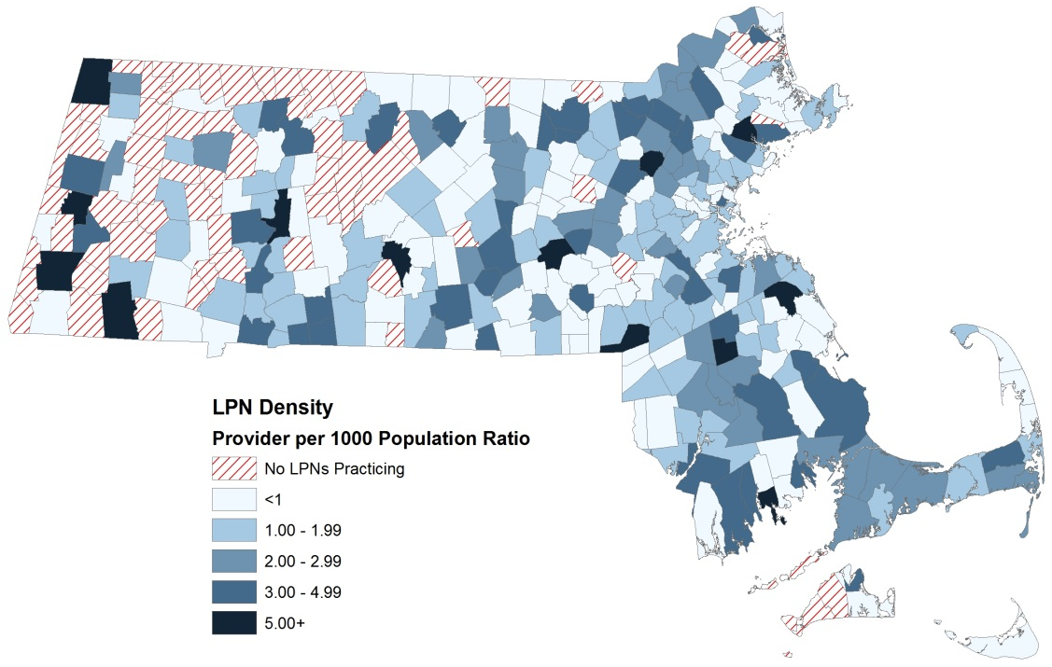
Figure 18 displays a map of practicing LPNs to population ratio at the city/town level in MA. Communities with a higher density of practicing LPNs per population are depicted in darker shades of blue, while communities with lower densities of LPNs are in lighter shades of blue.
Communities where no LPNs reported practicing are shown with red and white stripes. These communities are predominately located in Western and Central MA.
Figure 19. 2015 Hot Spot Analysis of Practicing LPNs per Population at City/Town Level ²¹
n=13,345
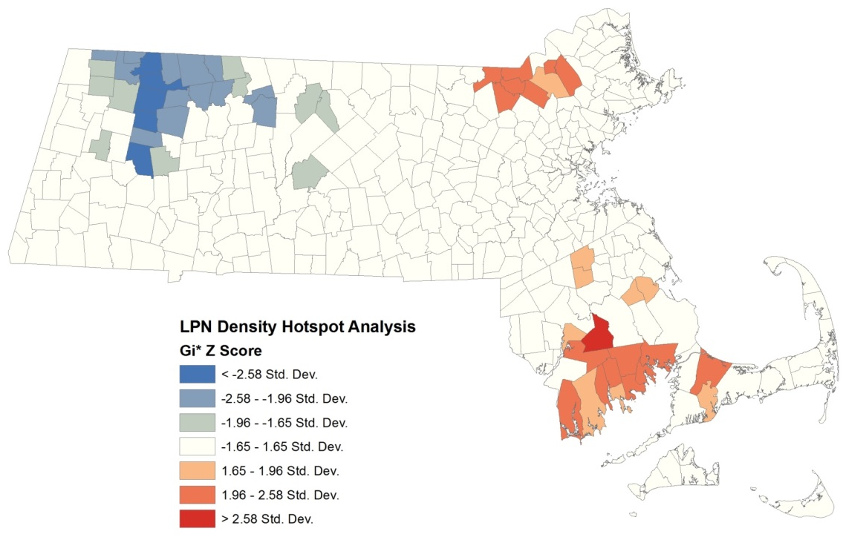
A hot spot analysis of LPN to population ratios at the city/town level in MA was conducted to identify geospatial trends in distribution and density of practicing LPNs within the state (figure 19). This analysis identifies significant clusters of communities with higher LPN to population ratios (depicted in shades of red) and lower LPN to population ratios (depicted in shades of blue). Communities in white represent communities where no significant clusters of either high or low LPN to population ratios were found.
Cluster of Communities with Lower LPN to Population Ratios
Cluster of Communities with Higher LPN to Population Ratios
The analysis identified two main clusters of communities with significantly higher LPN to population ratios (hot spots), one located in the northeastern region of the state and the other in the southeastern region. One large cluster of communities with low LPN to population ratios (cold spot) was identified in the northwestern region. There are many towns/cities in the western and central portion of MA where no LPNs reported practicing.

This report was developed by the
Massachusetts Department of Public Health

Bureau of Community Health and Prevention
Division of Health Access
Health Care Workforce Center

Bureau of Health Professions Licensure
Board of Registration in Nursing

For additional information about the Health Professions Data Series or this LPN Report, please contact:

Massachusetts Health Care Workforce Center
Massachusetts Department of Public Health

Website: mass.gov/dph/hcworkforcecenter
Email: HCWorkforceCenter@state.ma.us

Data from the Bureau of Health Professions Licensure as of March 31, 2016.
LPNs who received their first MA LPN license during the 2015 cycle and have a birthday within three months of the issue date were exempt from renewing their license during this renewal cycle. The number is an approximation based upon the total number of LPN renewal applications received and the total number of LPNs as of March 31, 2016.
Response rates by age group were calculated using the total number of survey respondents in each age group as the numerator and total number of LPNs with an active license in each age group as the denominator.
45 LPNs declined to report their sex or reported ‘Other’ and are not included in the figure.
Health Professions Data Series: Registered Nurse 2014 Report, Health Care Workforce Center, Massachusetts Dept. of Public Health
US Nursing Workforce: Trends in Supply and Education, Health Resources and Services Administration, Bureau of Health Professions, National Center for Health Workforce Analysis, October 2013.
Source: U.S. Census Bureau, 2010-2014 American Community Survey.
Diversity index is the likelihood that two persons chosen at random will differ by race/ethnicity. https://www.esri.com/library/whitepapers/pdfs/diversity-index-methodology.pdf
Source: U.S. Census Bureau, 2010-2014 American Community Survey.
Language fluency is defined as the ability to communicate with and provide adequate care to patients without a translator.
Data from the Bureau of Health Professions Licensure as of March 31, 2016. The figure displays the age distribution of all LPNs with an active LPN license, including those that did not complete a workforce survey.
US Nursing Workforce: Trends in Supply and Education, Health Resources and Services Administration, Bureau of Health Professions, National Center for Health Workforce Analysis, October 2013.
Percentages do not equal 100%. Some LPNs reported possessing more than one health care education certificate.
Percentages do not add up to 100%. LPNs were able to choose more than one training topic they would be interested in.
LPNs are able to choose more than one employment status. Percentages within the figure do not add up to 100%.
The figure includes LPNs that reported practicing and have a primary practice location in MA. Work settings that received less than 1% of responses were collapsed into the “Other” category. These include: academic medical center, academic nursing program, hospice, insurance organization, occupational/employee health, outpatient surgery center, public health department, self-employment, student health (college), telenursing, and temporary/nursing agency.
Percentages do not add up to 100%. LPNs were able to report more than one population group that they treat. 12% of LPNs reported treating all age groups and were included in each of the specific population categories.
Areas of practice that received less than 1% of responses were included in the “Other” category.
Health Professions Data Series Registered Nurse 2014 Report, Health Care Workforce Center, Massachusetts Department of Public Health.
Figure displays the total number of LPNs that reported a primary practice location within each city/town boundary per 1,000 population. 30 LPNs reported a PO box for their primary practice location zip code and were excluded from the above figure.
Hot spot analysis (Getis-Ord GI*) was conducted using a zone of indifference method in ArcGIS 9.3.1.

