
Executive Office of Health and Human Services
Massachusetts Department of Public Health

Health Professions Data Series
Pharmacist 2012
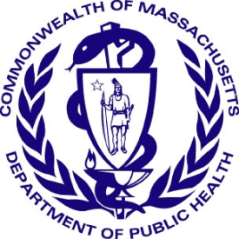

Deval L. Patrick, Governor
John W. Polanowicz, Secretary
Cheryl Bartlett, Commissioner

November 2014

Massachusetts Health Professions Data Series:
Pharmacists 2012
OVERVIEW
The Massachusetts Health Professions Data Series: Pharmacist 2012 Report provides data about workforce demographics of pharmacists licensed to practice in Massachusetts. This report is part of the Department of Public Health’s Health Professions Data Series, which currently reports on seven licensed health professions: dentists, dental hygienists, pharmacists, physicians, physician assistants, registered nurses, and licensed practical nurses.

The Massachusetts Health Professions Data Series: Pharmacist 2012 Report represents data from the second cycle of Massachusetts’ health professional workforce data collection. This initiative was launched during the 2010 clinician license renewal cycle in coordination with the Division of Health Professions Licensure and its biennial clinician renewal cycle.
The data series responds to the need for quality and timely data on demographics and employment characteristics of the Commonwealth’s healthcare workforce. With a response rate of 95% the 2012 report is a timely source of robust data.
Chapter 224 of the Acts of 2012: An Act Improving the Quality of Health Care and Reducing Costs Through Increased Transparency, Efficiency and Innovation continues and expands the work of the Health Care Workforce Center established initially in the Acts of 2008. The publication of this data series is a significant step toward fulfilling the mandates of Chapter 224. It complements and contributes to ongoing health care access and payment reform initiatives in the Commonwealth, and federal efforts including the National Center for Health Workforce Analysis Assessment.
The data series characterizes the workforce from a supply perspective. It enhances the Commonwealth’s ability to identify trends and patterns in the Commonwealth’s healthcare workforce that will impact access to health care professionals and the services they provide. The data is integral to current and future decisions about healthcare workforce development, education, training, recruitment, and retention. It will also help to ensure the availability of a highly qualified, diverse, and culturally and linguistically competent workforce to meet the current and future needs of all Massachusetts residents.

¹ Chapter 224 of the Acts of 2012: An Act Improving Quality of Health Care and Reducing Costs Through Increased Transparency, Efficiency and Innovation: http://malegislature.gov/Laws/SessionLaws/Acts/2012/Chapter224
¹ Chapter 224 of the Acts of 2012: An Act Improving Quality of Health Care and Reducing Costs Through Increased Transparency, Efficiency and Innovation: http://malegislature.gov/Laws/SessionLaws/Acts/2012/Chapter224

Background
During the 2012 license renewal cycle, pharmacists were sent a renewal notice with the option to renew online or by mail. Pharmacists who renewed their license online completed 31 workforce survey questions. The survey included questions related to demographics, employment characteristics, and future work plans. A total of 10,692 pharmacists renewed their license, of those 10,158 (95%) renewed online and completed the online survey. Of the 10,158 who renewed online, 5,811 (58%) reported their primary practice setting in Massachusetts.
The following data represents the responses of Pharmacists who completed an online renewal between October 1, 2012 and December 31, 2012.
Demographics n=10,158
Gender:

Race:
White, Non-Hispanic (NH) | 69%
Asian, NH | 16%
Black, NH | 3%
American Indian / Alaska Native, NH | <1%
Native Hawaiian / Pacific Islander, NH | <1%
Hispanic | 2%
Other | 2%
Decline to Answer | 8%

² Language fluency defined as ability to communicate with and provide adequate care to patients without the use of a translator (n=10,158).
³ Source: US Census Bureau, 2008-2012 American Community Survey. These are the 4 most common non-English languages spoken at home in Massachusetts
Education n=10,158
Location of initial pharmacy degree / credential: 73% of respondents reported completing their first pharmacy degree-credential in Massachusetts. 24% completed their first degree in another US state, 3% in a foreign country, and less than 1% in a US territory. 11% indicated that they would seek additional education in the next 5 years.
Additional training and education attained: 753 (7%) of pharmacists reported that they completed a pharmacy fellowship. 1,556 (15%) of pharmacists completed a residency.
Loan repayment program: 50% of respondents would have been interested in working full-time for 2 years for an organization serving disadvantaged patients or located in an underserved community in exchange for loan repayment if it had been available to them.
Nationally Recognized Credentials: 1,072 (11%) reported having a nationally recognized credential. The most common credential reported was a Board Certified Pharmacotherapy Specialist (BCPS) in Pharmacotherapy (393).
Future Plans n=10,158
Plans Regarding Pharmacy Practice within the Next Five Years
No Change in Work Status | 53% |  | Return to Pharmacy | 3%
Increase Hours | 5% |  | Leave Pharmacy | 1%
Reduce Hours | 8% |  | Plan to Retire | 6%
Seek Additional Education | 11% |  | Other/Decline to Answer | 13%

Employment Characteristics
Figure 5. Pharmacist Employment Status
5,811 – Employed in Pharmacy Field
5,899 - Primary Employment in MA
10,158 Total Respondents
3,041 Employed in Other US State

1,218 Working in a Foreign Country, Unemployed, or Did Not Report an Employment Location
88 – Employed in Non-Pharmacy Field
Full-time: 85%
Part-time: 12%
Per Diem: 5%
Volunteer: <1%

4

⁴ Percentages do not add up to 100% due to respondents’ ability to report more than one employment status.
The following data represent responses from the 5,811 Pharmacists who reported working full-time, part-time, per diem, or volunteering in Massachusetts.
Primary Practice Setting: Respondents were asked to identify the setting which best describes their primary pharmacy position. Figure 6 shows the most commonly reported primary practice settings. Work settings that represent less than 4% of the responses are not included in the figure. These settings include government agencies, home care, hospice, military, nuclear pharmacy, pharmaceutical industry, and schools/colleges of pharmacy.
Primary Practice Role: Respondents were also asked to identify the role that best describes their primary pharmacy position. The table below lists the most commonly reported responses.
Staff/Employee Pharmacist | 57%
Manager/Director | 19%
Clinical Pharmacist Practitioner | 12%
Owner/Pharmacist | 3%
The other primary pharmacy roles that received fewer than 3% of responses include consultant, faculty/educator, and resident/fellow.

Figure 7 displays the percentage of pharmacists providing certain services at their primary practice setting.

⁵ Percentages do not add up to 100% due to respondents’ ability to select more than one answer.
Pharmacy and Public Health
4.8% of Pharmacists reported participating in a Collaborative Drug Therapy Management Agreement ⁶.
2,361 (40.6%) pharmacists indicated that they personally administer immunizations at their primary work setting (Figure 7). Figure 8 below shows which immunizations these pharmacists are administering.
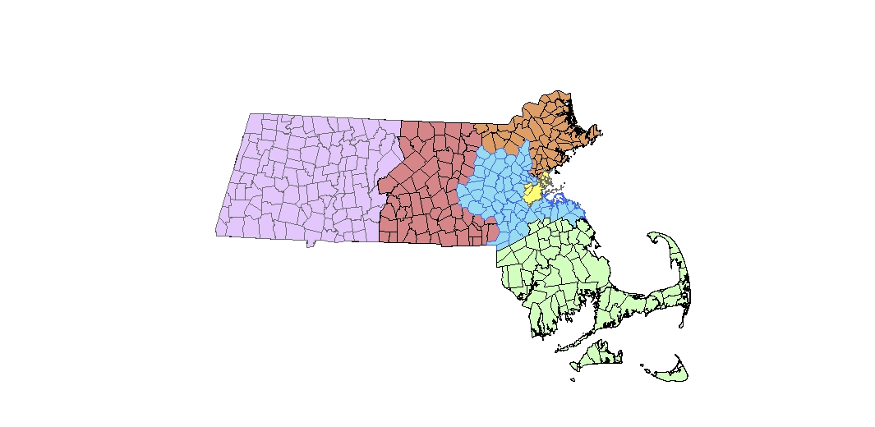
⁶ A qualified pharmacist may initiate, monitor, modify and discontinue a patient’s drug therapy in certain settings in accordance with the terms of the written renewable collaborative practice agreement the pharmacist has entered with a supervising physician, as specially authorized by Massachusetts General Laws Chapter 112, section 24B1/2 (effective April 15, 2009) and further described in Board of Registration in Pharmacy regulations 247 CMR 16.00 (effective June 25, 2010).
Western Region
Central Region
Northeast Region
Boston Region
Southeast Region
Metrowest Region
The percentage of pharmacists personally administering immunizations did vary geographically by county. Only 22.9% of the 273 pharmacists who work in Suffolk County personally administer immunizations.
Figure 9. Percentage of Pharmacists That Administer Immunizations by County
n=5,811
0 - 25%
26 - 35%
36 - 45%
46 - 55%
Over 55%
Percent of Pharmacists Immunizing by County
Berkshire
44.3%
Hampshire
47.4%
Essex
47.7%
Suffolk
22.9%
Norfolk
49.7%

Hampden
45.9%
Franklin
36.7%
Worcester
38.4%
Middlesex
39.9%
Plymouth
46.4%
Bristol
58.5%

Barnstable
57.9%
Dukes
66.7%

Nantucket
50.0%

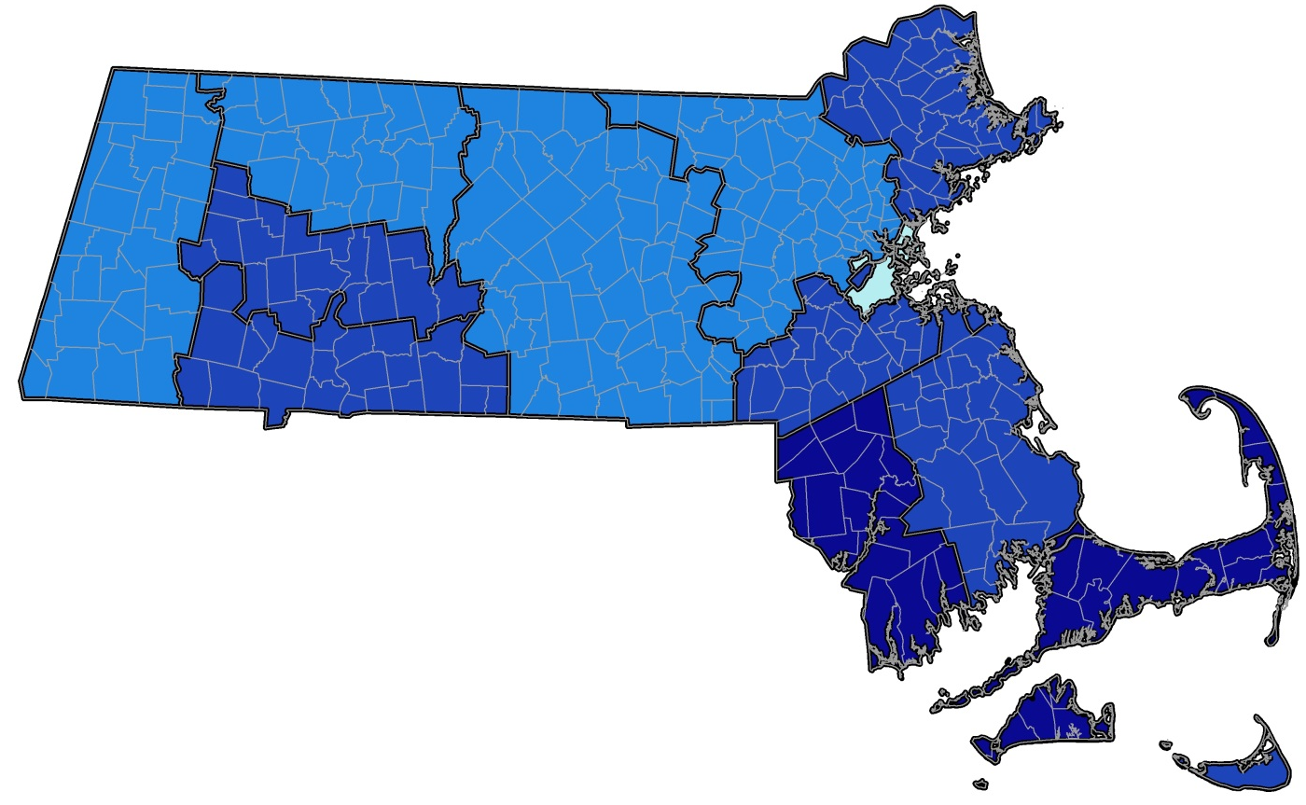

Geographic Distribution n=5,811
Figure 10. Pharmacist Primary Practice Distribution by County
<0.5%
0.5 - 5%
6 - 10%
11 - 15%
16 - 25%
Percent of All Primary Practices Located in County
Berkshire
1.7%
Hampshire
1.6%
Essex
9.7%
Suffolk
20.6%
Norfolk
9.2%

Hampden
6.4%
Franklin
0.5%
Worcester
12.4%
Middlesex
21.2%
Plymouth
6.4%
Bristol
7.4%

Barnstable
2.6%
Dukes
0.2%

Nantucket
0.2%

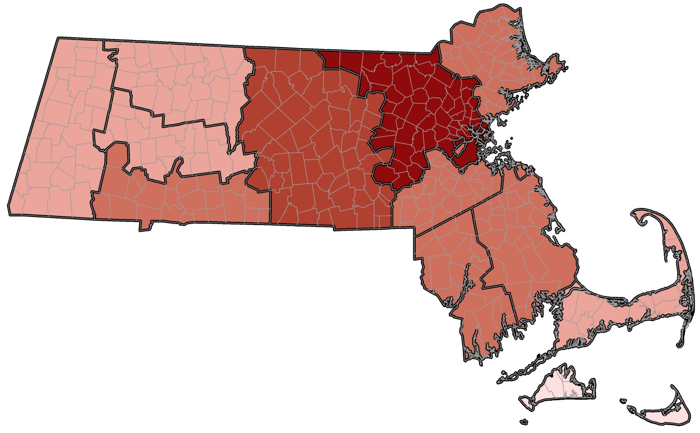

This report was developed by the
Massachusetts Department of Public Health

Bureau of Community Health and Prevention
Health Care Workforce Center

Bureau of Health Care Safety and Quality
Division Health Professions Licensure
Board of Registration in Pharmacy

For additional information about the Health Professions
Data Series or this Pharmacist Report

Please contact the Massachusetts Health Care
Workforce Center at the
Massachusetts Department of Public Health

Website: mass.gov/dph/hcworkforcecenter
Email: HCWorkforceCenter@state.ma.us

