Data Brief:
Health Professions Data Series –
Pharmacist 2014
Massachusetts Department of Public Health June 2018
The Massachusetts Health Professions Data Series: Pharmacist 2014 Report provides data on workforce characteristics of pharmacists licensed to practice in Massachusetts. This report is part of the Department of Public Health’s Health Professions Data Series, which currently reports on seven licensed health professions: dentists, dental hygienists, pharmacists, physicians, physician assistants, registered nurses, and licensed practical nurses.
The Massachusetts Health Professions Data Series: Pharmacist 2014 Report represents data from the third cycle of the health professional workforce data collection. This initiative was launched during the 2011 licensure renewal cycle in coordination with the Division of Health Professions Licensure.
BACKGROUND
The pharmacist data in the Health Professions Data Series is derived from an online workforce survey that accompanies the online license renewal application for pharmacists licensed in Massachusetts (MA). Pharmacists in MA renew their license every two years on even numbered years. The data presented in this report represents responses from the 2014 renewal cycle.
Pharmacists who were administered a 2014 pharmacist workforce survey:
- Pharmacists who renewed their license during the 2014 renewal cycle and completed their license renewal application online through the MA Department of Public Health Online Licensing System.

Pharmacists that were not administered a 2014 Pharmacist workforce survey:
- Pharmacists who renewed their license using a paper license renewal application instead of the online system.
- Pharmacists who received their initial MA pharmacist license after September 30, 2014. These individuals were not required to renew their license during this cycle.

During the 2014 renewal cycle, a total of 11,177 pharmacists renewed their license. Of those, 10,789 (96.5%) completed the 2014 pharmacist workforce survey from October 1, 2014 through December 31, 2014.
The 2014 pharmacist workforce survey is administered during the online license renewal process. The survey consists of 35 questions divided into 4 sections:
- Demographics
- Education
- Employment Characteristics
- Future plans

DEMOGRAPHICS
Sex
Figure 1 and Table 1 display the breakdown of pharmacists by sex and race/ethnicity, respectively. Pharmacists in MA are predominately white, non-Hispanic (NH) and female, with approximately 39% identifying as both. The national percentage of pharmacists that are female is 52.7%.
Race/Ethnicity
Table 1. 2014 MA Pharmacists by Race and Ethnicity

Race/Ethnicity | Pharmacists  n=10,030* | MA  Population²
American Indian/Alaska Native, NH | <1% | 0.1%
Asian, NH | 17.7% | 5.7%
Black, NH | 3.4% | 6.4%
Hispanic/Latino | 2.3% | 10.2%
Native Hawaiian/Pacific Islander, NH | <1% | 0.0%
White, NH | 73.6% | 75.0%
Multiracial | <1% | 0.6%
Other | 1.8% | 1.9%
Overall Diversity Index ³ | 42.5 | 41.9
Table 1 shows the breakdown of pharmacists and MA residents by race and ethnicity. Diversity index is a measure of racial and ethnic diversity within a population on a scale of 0 to 100, with a higher value indicating higher racial/ethnic diversity. The pharmacist population in MA has a diversity index of 42.5 compared to the resident population index of 41.9.
Despite having a similar diversity index value to the population as a whole, several racial/ethnic groups are underrepresented in the pharmacist workforce, particularly those of Hispanic/Latino origin and black, non-Hispanics. Asian, non-Hispanics are overrepresented in the workforce.
Table 2. 2014 MA Pharmacist Language Fluency⁴ and Language Spoken at Home by MA Residents
* 7.0% of survey respondents declined to answer

Language | Pharmacists | MA Population²
Arabic | 2.3% | 0.5%
Chinese* | 4.4% | 1.8%
French* | 2.6% | 1.0%
Greek | 1.0% | 0.4%
Italian | 1.1% | 0.6%
Korean | 1.0% | 0.3%
Portuguese* | 1.3% | 2.9%
Russian | 1.4% | 0.6%
Spanish* | 4.0% | 8.3%
Vietnamese  * These are the four most common non-English languages spoken at home in Massachusetts | 4.1% | 0.6%
Language
Table 2 displays the language fluency of pharmacists compared to language spoken at home by MA residents.
- Approximately 30% of pharmacists reported being fluent in a language other than English.
- Over 500,000 residents of MA speak Spanish at home (8.3%), but only 4.0% of pharmacists reported being fluent in Spanish.
- Roughly 3% of pharmacists reported being fluent in more than one non-English language.
Age
Figure 2 displays the age distribution of pharmacists that completed the workforce survey. The average age of licensed pharmacists during this cycle was 46.6 years old, compared to 45.4 during the 2012 renewal cycle.

EDUCATION
Initial Education
Figure 3 displays a breakdown of where pharmacists completed their first degree that qualified them to practice pharmacy in the US.
- The majority of pharmacists licensed in MA obtained their initial pharmacy education within the state (72.3%).
Approximately 61% of pharmacists licensed in MA reported a bachelor’s degree in pharmacy as the degree that qualified them to practice in the US, while 37% obtained a doctor of pharmacy.
Highest Pharmacy Degree
Figure 4 displays a breakdown of the highest pharmacy degree obtained by pharmacists that completed the 2014 workforce survey.
- The percentage of pharmacists that reported having a doctorate in pharmacy increased from the 2012 cycle (39% in 2012 compared to over 45% in 2014)
Non-Pharmacy Degree | %
Bachelor’s Degree | 16.6%
Master’s Degree | 6.0%
MBA | 4.4%
MPH | 0.9%
Doctoral Degree | 2.0%
Other Degree | 7.4%
No Non-Pharmacy Degree | 70.4%
Non-Pharmacy Degree
Table 3. 2014 MA Pharmacist –
Non-Pharmacy Degrees Obtained ⁵
n=10,789
Table 3 displays the non-pharmacy degrees obtained by pharmacists that completed the 2014 workforce survey.
- Approximately 30% of pharmacists reported having a non-pharmacy degree.
- 2% of pharmacists reported having more than one non-pharmacy degree.

Pharmacy Residency and Fellowships
Table 4. 2014 MA Pharmacist –
Residencies and Fellowships Completed ⁶
n=10,789
Residencies and Fellowships Completed | %
Residency
Postgraduate Year (PGY)-1 in MA | 7.8%
PGY-1 Outside MA | 5.2%
PGY-2 in MA | 1.5%
PGY-2 Outside MA | 2.2%
No Residency | 85.7%
Fellowship
Clinically Oriented in MA | 5.6%
Clinically Oriented Outside MA | 2.1%
Pharmacy Industry in MA | 1.5%
Pharmacy Industry Outside MA | 0.7%
Other Fellowship | 4.6%
No Fellowship | 85.4%
Completed Both Residency and Fellowship | 5.4%
Approximately 24% of pharmacists in MA reported completing a pharmacy residency and/or fellowship. Table 4 displays a breakdown of the type of residencies and fellowships pharmacists completed.
- Of the pharmacists that completed a residency, 25.6% completed a postgraduate year 2 program.
- Pharmacists in younger age groups more frequently completed a residency but less frequently completed a fellowship compared to older age groups.
  - 20.1% of pharmacists under the age of 35 completed a residency compared to 9.6% of pharmacists 35 and older.
  - 12.8% of pharmacists under the age of 35 completed a fellowship compared to 16.0% of pharmacists 35 and older.

Certifications, Credentials, and Specialties
Table 5. 2014 MA Pharmacist –
Certifications, Credentials, and Specialties ⁷
n=10,789
Certifications , Credentials, Specialties | %
Board of Pharmacy Specialties (BPS)
Ambulatory | 0.7%
Oncology | 0.7%
Pharmacotherapy | 4.7%
Other BCPS Specialties | 0.8%
Commission for Certification in Geriatric Pharmacy (CCGP)
Certified Geriatric Pharmacist | 0.8%
Certified Diabetes Educator (CDE) | 1.0%
Other Specialties
Anticoagulation | 1.5%
Asthma | 0.7%
Diabetes | 2.9%
HIV | 0.9%
Immunization | 20.4%
Medication Therapy Management | 4.3%
Other | 4.3%
No Certification, Credential, or Specialty | 66.4%
Table 5 displays the certifications, credentials, and specialties pharmacists reported holding. Of the pharmacists that completed the 2014 workforce survey, 33.6% reported having at least one pharmacy certification, credential, or specialty.
- 6.6% of pharmacists reporting being certified by the Board of Pharmacy Specialties (BPS). Pharmacotherapy was the most frequently reported BPS certification attained by MA pharmacists.
- Immunization was the most frequently reported specialty that MA pharmacists hold credentials in (20.4%).
- A higher proportion of female pharmacists reported having a certification, credential, or specialty compared to male pharmacists (34.8% compared to 31.8%).

EMPLOYMENT CHARACTERISTICS
10,789
Total Pharmacists Completing Workforce Survey

9,299
Pharmacists Currently Practicing

1,490
Pharmacists Not Currently Practicing

3,185
Primary Practice Location Outside of MA

6,114
Primary Practice Location in MA
Full-time: 85.5%
Part-Time: 11.0%
Per Diem: 5.2%
Volunteer: <1%

Figure 5. 2014 MA Pharmacists by Employment Status ¹⁰
Employed in Non-Pharmacy Field: 36.7%
Unemployed: 35.6%
Retired: 23.5%
Unknown Employment Status: 6.0%

Figure 5 displays a breakdown of reported employment status of pharmacists that completed the 2014 workforce survey. Of the 10,789 pharmacists surveyed, 6,114 (56.7%) reported that they were currently practicing in the field with a primary practice location in MA. The remaining pharmacists reported either having a primary practice location outside of MA or not currently practicing pharmacy.
Primary Practice Setting
Figure 6 displays a breakdown of reported primary practice settings of pharmacists with a primary practice location in MA.
- 39.2% of pharmacists with a primary practice location in MA reported pharmacy chain store as their primary practice setting.
  - This percentage is higher for pharmacists under the age of 35 (46.3%)
- Primary practice settings that received less than 1% of responses were included in the “Other” category. These settings include: nuclear pharmacy, home care, critical access hospital, hospice, veterinary, and military.
Primary Role
Figure 7 displays a breakdown of MA pharmacist roles in their primary MA practice settings.
- The majority of pharmacists reported staff/employee pharmacist as their primary role.
- The percentage of pharmacists reporting manager/director as their primary role varied by education level.
  - 29.7% of pharmacists with a master’s degree in pharmacy reported being a manager/director, compared to 22.2% with a bachelor’s degree and 19.4% with a doctoral degree.
Programs and Services Provided
Figure 8 displays a breakdown of programs and services personally provided by pharmacists in their primary MA practice settings.
- The majority of pharmacists (56.6%) provide patient counseling at their primary practice.
- Of the pharmacists that provide syringes over the counter, 86.1% reported pharmacy chain store as their primary practice location.
Compounding Type | %
Non-Sterile Compounding (Simple/Moderate) | 50.5%
Non-Sterile Compounding (Complex) | 4.6%
Sterile Compounding (Low/Medium Risk) | 16.5%
Sterile Compounding (High Risk) | 4.8%
Not Personally Compounding | 41.5%
- Of the pharmacists that provide Naloxone rescue by physician standing order, 60.6% practice in a pharmacy chain store, 12.3% in a community health center/clinic, and 9.8% in an inpatient hospital.
Table 6. 2014 MA Pharmacist – Compounding Provided ¹²
n=6,114
Table 6 displays the types of compounding provided by MA pharmacists. The majority of MA pharmacists (58.5%) personally provide some type of compounding at their primary practice setting. Of these pharmacists, 54.0% reported a primary practice setting in a pharmacy chain store and 21.9% in an inpatient hospital.
Approximately 54.6% of practicing MA pharmacists reported being certified to administer vaccinations. Figure 9 displays the types of vaccinations these pharmacists are administering in their primary practice setting.
- Approximately one out of four certified pharmacists reported not administering vaccinations in their primary practice setting (24.4%).
- Nearly three out of four certified pharmacists reported giving flu vaccines in their primary practice setting (72.8%).
Reasons for Choosing Primary Position
MA Pharmacists were asked to report the primary factors in choosing their current primary practice position (results in figure 10).
- Pharmacists in younger age groups more frequently cited salary as a factor in choosing their current practice (44.4% of pharmacists under the age of 35 compared to 31.0% of pharmacists 35 and over).

Improvements to Primary Practice Settings
Practicing MA pharmacists were asked to report potential improvements to their primary practice setting that would enhance their ability to provide optimal services (results in figure 11).
- Adequate staffing and workload are the two most frequently reported potential improvements to their primary practice.

Secondary Practice
Table 7. 2014 MA Pharmacist – Secondary Position
n=630
Secondary Pharmacy Practice | %
Secondary Practice Setting
Hospital – Inpatient | 36.8%
Pharmacy Chain Store | 19.4%
School/College of Pharmacy | 10.3%
Other | 33.5%
Secondary Role
Staff/Employee Pharmacist | 67.5%
Educator/Faculty | 11.4%
Other | 21.1%
Of the pharmacists currently practicing, 6.8% reported having a secondary pharmacy position. Table 7 displays a breakdown of reported secondary practice settings and roles.
- A slightly higher percentage of pharmacists under the age of 35 reported having a secondary practice position compared to pharmacists 35 and older (8.7% compared to 6.2%).
- 1.3% of pharmacists with a primary practice location outside of MA reported a secondary practice within MA.

Prescription Monitoring Program (PMP)
Table 8. 2014 MA Pharmacist – Prescription Monitoring Program Registration Status
n=6,114
PMP Registration Status | %
Registered and actively viewing patient files | 35.6%
Registered, not actively viewing patient files | 11.7%
Not Registered | 52.6%
The MA Prescription Monitoring Program (PMP), established in 1992, collects dispensing information on MA Schedule II through V controlled substances dispensed through a prescription. Table 8 displays the PMP registration status of MA pharmacists.
- 41.8% of pharmacists under 35 reported being registered for PMP and actively viewing patient files compared to 33.5% of pharmacists 35 and over.

Collaborative Drug Therapy Management (CDTM)
Table 9. 2014 MA Pharmacists - Collaborative Drug Therapy Management Settings
n=6,114
CDTM Settings | %
Retail Drug Business | 19.2%
Hospital | 7.3%
Other | 5.7%
No CDTM Agreement | 67.8%
Collaborative drug therapy management (CDTM) is a multidisciplinary process for selecting appropriate drug therapies, educating and monitoring patients, and assessing outcomes of therapy. 32.2% of MA pharmacists reported participating in a CDTM agreement. Table 9 displays the practice settings where pharmacists are participating in such an agreement.

Unemployment
Approximately 5% of licensed MA pharmacists reported being unemployed. The percentage of pharmacists that reported being unemployed varied by age group. Only 2.2% of pharmacists under 35 reported being unemployed compared to 5.6% of pharmacists 35 and older. The majority of unemployed pharmacists are between 45 and 64 years old (58% of unemployed).
Of those unemployed, the most frequently reported reasons for unemployment include: taking care of home/family (34.7%), unable to find pharmacy position (26.5%), and disability (8.9%).

Mental Health and Disability Training
Pharmacists practicing in MA were asked what training topics they would be interested in to help them better care for patients with disabilities (results in figure 12).
- Roughly half of all practicing MA pharmacists reported interest in at least one mental health or disability training topic (50.1%).
- 56.8% of pharmacists under the age of 35 reported interest in training compared to 41.5% of pharmacists 55 years and older.
- Female pharmacists expressed more interest in training than male pharmacists (53.1% compared to 45.8%)

FUTURE PLANS
Table 10. 2014 MA Pharmacists – Future Plans within Next Five Years ¹⁴
n=6,114
Plans within Next Five Years | %
Currently Working as Pharmacist in MA (n=6,114)
No Change | 59.6%
Increase Practice Hours | 6.7%
Reduce Practice Hours | 10.9%
Change Pharmacy Practice | 11.7%
Leave Pharmacy Practice (Not Retiring) | 1.7%
Seek Additional Education | 13.9%
Retire | 4.8%
Other/No Response | 15.7%
Currently Working in Non-Pharmacy Field or Unemployed (n=1,071)
No Change | 13.1%
Return to Pharmacy | 23.2%
Seek Additional Education | 7.7%
Retire | 3.9%
Other/No Response | 66.6%
Currently Retired (n=349)
Return to Pharmacy | 6.6%
Remain in Retirement | 93.4%
Pharmacists were asked to report on their future plans regarding their pharmacy practice within the next five years. The results, grouped by current employment status, are shown in table 10.
- Of the pharmacists that are currently practicing in the state:
  - 6.5% are planning to either leave the field or retire.
  - Of pharmacists 65 years and older, 37.4% reported they are planning to retire and 27.9% reported they plan on reducing hours of practice.
  - Of pharmacists under 35 years old, 20.2% reported they are planning to seek additional education.
- Of pharmacists that are either currently employed in a non-pharmacy field or are unemployed, 23.2% reported they are planning to return to the pharmacy field within the next 5 years.
- The majority of licensed pharmacists that are retired plan on remaining in retirement (93.4%).
GEOGRAPHIC DISTRIBUTION
Figure 13. 2014 Practicing MA Pharmacists per 10,000 Population at City/Town Level ¹⁶
n=6,104
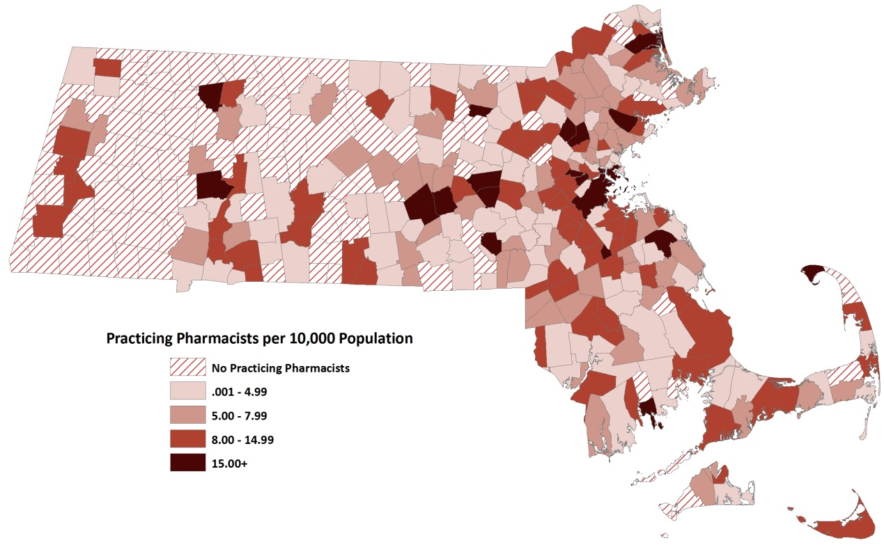
Figure 13 displays a map of practicing pharmacists to population ratio at the city/town level in MA. Communities with higher provider to population ratios are depicted in darker shades of red while communities with lower ratios are in lighter shades.
Communities where no pharmacists reported practicing are shown in red and white stripes and are predominately located in Western and Central MA.
Figure 14. 2014 Hot Spot Analysis of Practicing MA Pharmacists per 10,000 Population at City/Town Level ¹⁷
n=6,104
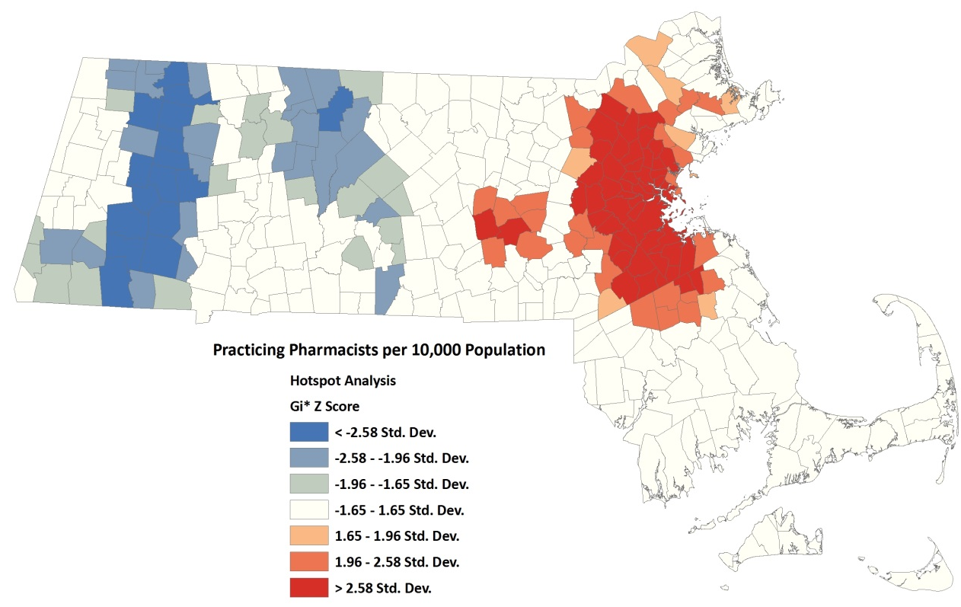
A hot spot analysis of pharmacist to population ratio at the city/town level was conducted to identify geospatial trends in the distribution and density of practicing pharmacists within the state (results in figure 14). The analysis identifies significant clusters of communities with higher provider to population ratios (hot spots, depicted in shades of red) and lower provider to population ratios (cold spots, depicted in shades of blue).
Cluster of Communities with Lower Pharmacist to Population Ratios
Cluster of Communities with Higher Pharmacist to Population Ratios
The analysis identified two main clusters of hotspots (both located in the eastern portion of the state) and two main clusters of cold spots (one spanning much of western MA and one in the central portion of the state). These indicate an unequal distribution of providers in certain areas of MA.

This report was developed by the
Massachusetts Department of Public Health

Bureau of Community Health and Prevention
Division of Health Access
Health Care Workforce Center

Bureau of Health Professions Licensure
Board of Registration in Pharmacy

For additional information about the Health Professions Data Series or this Pharmacist Report, please contact:

Massachusetts Health Care Workforce Center
Massachusetts Department of Public Health

Website: mass.gov/dph/hcworkforcecenter
Email: HCWorkforceCenter@state.ma.us

Source: National Pharmacist Workforce Study 2014, American Association of Colleges of Pharmacy.
Source: U.S. Census Bureau, 2010-2014 American Community Survey
Diversity index is the likelihood that two persons chosen at random will differ by race/ethnicity. This is calculated by taking the sum of the squares of the percentages for each race/ethnicity category and then subtracting the total value from 100.
Language fluency is defined as the ability to communicate with and provide adequate care to patients without a translator. Respondents can choose more than one language. Languages that received less than 1% of responses were excluded from Table 2.
Percentages do not add up to 100% because several pharmacists reported having multiple non-pharmacy degrees.
Percentages for sections within the table do not add up to 100%. Pharmacists were able to report completing more than one residency and/or fellowship.
Percentages in the table do not add up to 100%. Pharmacists were able to report having more than one certification/credential.
BCPS Specialties that received less than 0.5% of responses were included in the “Other” category. These include: nuclear, nutrition, and psychiatry.
Other specialties that received less than 0.5% of responses were included in the “Other” category. These include: information systems/information technology, lipids, pain management, poison information, and toxicology.
Percentages within the figure do not add up to 100%. Respondents were able to choose more than one employment status.
The percentages in the figure represent programs and services provided personally by pharmacists in their primary MA practice setting. Percentages do not add up to 100%. Pharmacists were able to report multiple programs/services provided.
Percentages in the table do not add up to 100%. Pharmacists were able to report more than one type of compounding provided.
Only pharmacists that reported being certified to administer vaccinations were included in this figure. Abbreviations used in figure include: Human Papilloma Virus (HPV), Inactivated Polio Vaccine (IPV), Measles, Mumps, and Rubella (MMR), Pneumococcal Polysaccharide Vaccine (PPV).
Percentages do not add up to 100%. Pharmacists were able to choose more than one training topic.
Percentages within the table do not add up to 100%. Pharmacists were able to report more than one future plan.
Maps created using ArcGIS 9.3.1. This figure displays the total number of pharmacists that reported a primary practice location within each city/town boundary per 10,000 population. 10 Pharmacists reported a PO Box for their primary practice location zip code and were excluded from figures 13 and 14.
Hot spot analysis (Getis-Ord GI*) was conducted using a zone of indifference method in ArcGIS 9.3.1.

