Executive Office of Health and Human Services
Massachusetts Department of Public Health

Health Professions Data Series
Physician Assistant 2013
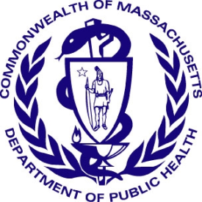

Deval L. Patrick, Governor
John W. Polanowicz, Secretary
Cheryl Bartlett, Commissioner

November 2014

Massachusetts Health Professions Data Series:
Physician Assistant 2013
OVERVIEW
The Massachusetts Health Professions Data Series: Physician Assistant (PA) 2013 Report provides data about workforce demographics of PAs licensed to practice in Massachusetts. This report is part of the Department of Public Health’s Health Professions Data Series, which currently reports on seven licensed health professions: dentists, dental hygienists, pharmacists, physicians, physician assistants, registered nurses, and licensed practical nurses.
The Massachusetts Health Professions Data Series: Physician Assistant 2013 Report represents data from the second cycle of Massachusetts’ health professional workforce data collection. This initiative was launched during the 2010 clinician license renewal cycle in coordination with the Division of Health Professions Licensure and its biennial clinician renewal cycle.
The data series responds to the need for quality and timely data on demographics and employment characteristics of the Commonwealth’s healthcare workforce. With a response rate of 96% the 2013 report is a timely source of robust data.
Chapter 224 of the Acts of 2012: An Act Improving the Quality of Health Care and Reducing Costs Through Increased Transparency, Efficiency and Innovation continues and expands the work of the Health Care Workforce Center established initially in the Acts of 2008. The publication of this data series is a significant step toward fulfilling the mandates of Chapter 224. It complements and contributes to ongoing health care access and payment reform initiatives in the Commonwealth, and federal efforts including the National Center for Health Workforce Analysis Assessment.
The data series characterizes the workforce from a supply perspective. It enhances the Commonwealth’s ability to identify trends and patterns in the Commonwealth’s healthcare workforce that will impact access to health care professionals and the services they provide. The data is integral to current and future decisions about healthcare workforce development, education, training, recruitment, and retention. It will also help to ensure the availability of a highly qualified, diverse, and culturally and linguistically competent workforce to meet the current and future needs of all Massachusetts residents.
¹ Chapter 224 of the Acts of 2012: An Act Improving Quality of Health Care and Reducing Costs Through Increased Transparency, Efficiency and Innovation: http://malegislature.gov/Laws/SessionLaws/Acts/2012/Chapter224
¹ Chapter 224 of the Acts of 2012: An Act Improving Quality of Health Care and Reducing Costs Through Increased Transparency, Efficiency and Innovation: http://malegislature.gov/Laws/SessionLaws/Acts/2012/Chapter224

Background
During the 2013 license renewal cycle, physician assistants (PA’s) were sent a renewal notice with the option to renew online or by mail. PA’s who renewed their license online completed 29 workforce survey questions. The survey included questions related to demographics, education, employment characteristics, and future work plans. A total of 2,286 physician assistants renewed their license, of those 2,191 (96%) completed the online survey. Of those that renewed online, 1,888 (86%) reported their primary practice setting in Massachusetts.
The following data represents the responses of 2,191 physician assistants who completed an online renewal between December 1, 2012 and June 30, 2013.
Demographics n=2,191
Gender:

Race:
White, Non-Hispanic (NH) | 84%
Asian, NH | 4%
Black, NH | 1%
American Indian / Alaska Native, NH | <1%
Native Hawaiian / Pacific Islander, NH | <1%
Hispanic/Latino/Spanish | 3%
Other | 1%
Decline to Answer | 7%

² Language fluency defined as ability to communicate with and provide adequate care to patients without the use of a translator (n=2,191).
³ Source: US Census Bureau, 2008-2012 American Community Survey. These are the 4 most common non-English languages spoken at home in Massachusetts
Education n=2,191
Location of initial physician assistant degree / credential:
45% of respondents reported completing their first physician assistant degree-credential in Massachusetts. 55% completed their first degree in another US state and less than 1% in a US territory. 5% indicated that they would seek additional education in the next 5 years.
⁴ Percentages do not add up to 100%. 31 physician assistants reported having a doctoral degree, and are not represented in figure 3
Post-Graduate Training: 202 (9%) of physician assistants reported that they completed post-graduate training. Figure 4 below shows the most commonly reported post-graduate training specialties.
⁴ Percentages do not add up to 100% due to respondents’ ability to choose more than one response
Loan repayment program: Loan repayment programs (LRP) partially repay physician assistant school loans in return for working for an organization that serves disadvantaged patients or is located in an underserved community. 13% reported that they participated in a Federal LRP and 1% in a State LRP. Of the 1,859 physician assistants that did not participate in a LRP, 35% indicated that they would be interested in participating.
Future Plans n=2,191
Plans Regarding Physician Assistant
Practice within the Next Five Years
No Change in Work Status | 67% |  | Return to PA Practice | 2%
Increase Hours | 7% |  | Leave PA Practice | 2%
Reduce Hours | 10% |  | Plan to Retire | 3%
Seek Additional Education | 5% |  | Other | 2%

Employment Characteristics
Figure 6. Physician Assistant Employment Status
⁵
1,888 - Primary Employment in MA
2,191 Total Respondents
191 Employed in Other US State

112 Not Practicing as PA, Unemployed, or Did Not Report an Employment Location
Full-time: 86%
Part-time: 12%
Per Diem: 7%
Volunteer: <1%

⁵ Percentages do not add up to 100% due to respondents’ ability to report more than one employment status.
The following data represent responses from the 1,888 Physician Assistants who reported working full-time, part-time, per diem, or on a volunteer basis in Massachusetts.
Practice Setting: Respondents were asked to identify the setting which best describes their primary physician assistant position. Figure 7 shows the most commonly reported primary practice settings. Work settings that represent less than 3% of the responses are not included in the figure. These settings include: Academic PA Program, Chronic Care / Rehab Hospital, Correctional Health Facility, Drug / Alcohol Treatment Facility, Government Agency / Military, Home Health Nursing Agency, Hospice, Insurance Organization, Mental Health Center, Occupational / Employee Health, Outpatient Surgery Center, Public Health Department, Skilled PA/Extended Care, Student Health, Temporary/Agency

Roles in Primary PA Position: 97% of respondents reported their primary position as a clinically practicing physician assistant. 1% reported working as an administrator. All other roles each had a response rate of less than 1%. These include: PA Educator, Public Health, and Researcher.
Figure 8 displays the programs and services provided by physician assistants at their primary practice setting.

⁶ Percentages do not add up to 100% due to respondents’ ability to select more than one answer.
Geographic Distribution n=1,888
Figure 9. Physician Assistant Primary Practice Distribution by County
<1%
1 - 5%
6 - 10%
11 - 15%
16 - 30%
Percent of All Primary Practices Located in County
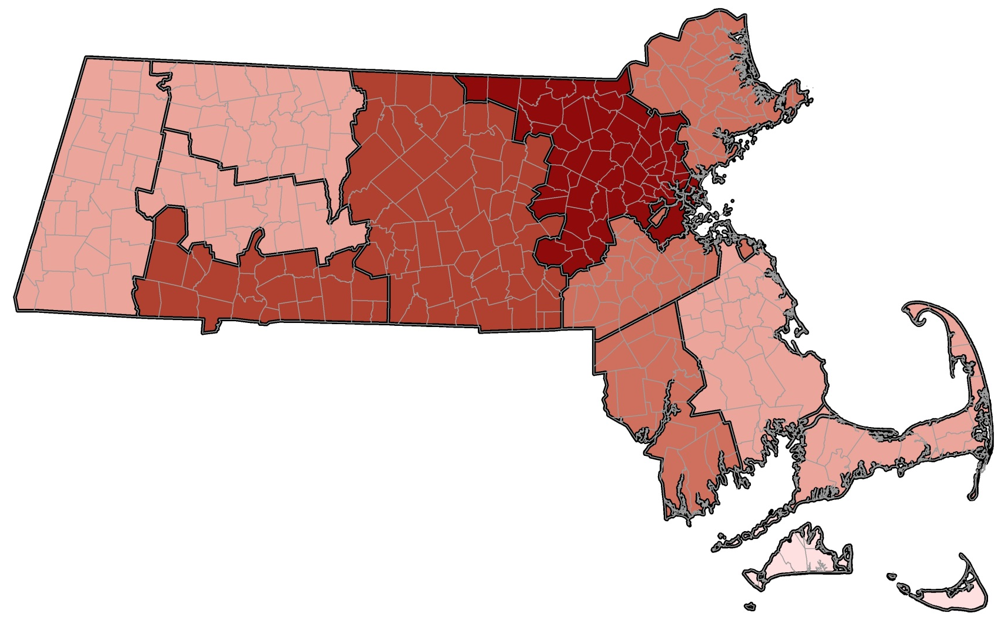
Berkshire
2.3%
Hampshire
1.7%
Essex
7.0%
Suffolk
27.1%
Norfolk
7.8%

Hampden
10.5%
Franklin
0.9%
Worcester
11.0%
Middlesex
17.7%
Plymouth
4.9%
Bristol
6.1%

Barnstable
2.7%
Dukes
<.1%

Nantucket
0.2%

This report was developed by the
Massachusetts Department of Public Health

Bureau of Community Health and Prevention
Health Care Workforce Center

Bureau of Health Care Safety and Quality
Division Health Professions Licensure
Board of Registration of Physician Assistants

For additional information about the Health Professions
Data Series or this Physician Assistant Report
Please contact the
Massachusetts Health Care Workforce Center
at the
Massachusetts Department of Public Health

Website: mass.gov/dph/hcworkforcecenter
Email: HCWorkforceCenter@state.ma.us

